21

**VIDE0 CHATTING WEBSITE**

VIDEO CHATTING WEBSITE

## A Writing Project

## Presented to :

## EXPOSYS DATA LABS

## By :

UNDER THE GUIDENCE OF:

EXPOSYS DATA LABS

# Table of Contents

* Abstract
* Introduction
* Existing Method
* Proposed method with Architecture
* Methodology
* Implementation
* Conclusion

# Abstract

Video Chatting Website (VCW) is a web-based video chat application that allows users anywhere in the world to join real-time streaming video chat rooms. This product is similar to social networking sites that allow web-based video Chatting. The main advantage of VCW compared to existing tools is that it is easy to use and does not require users to download and set up additional hardware. Since this product is a browser-based solution, it allows users from multiple platforms like Windows, Linux, or Mac to join a chat room. My VCW allows users to create new public or private chat rooms or enter into existing chat rooms with the click of a button. VCW allows users to share their live audio and video to all users in the chat room. It also allows users to see the list of attendees in the chat room. VCW users can invite their friends to join video chat rooms by sending a link to their email. Friends can click the link and directly enter chat room without creating an account in VCW. The users also have the option of sending video messages to other users. Adobe Flash Media Server is used as the back end for developing this web site.

A system and method is provided that allows participants in an electronic conference room to move to any spatial location in the electronic conference room by simply clicking and dragging, using a computer mouse, a graphical image representing the participant to any location in the electronic conference room. This allows participants to form small groups for communicating similar to a cocktail party situation. A communication media allows participants to communicate with one another within their particular groups. The participants can communicate though the graphical images either visually, audibly or both visually and audibly. Each user is provided visually with captions of other groups, which is reduced in size depending on the distance that particular group is from the user's location within the electronic conference room. In addition, each main user is provided with audible signals from other groups, which is attenuated based on the distance that particular group is from the user's location within the electronic conference room.

# Introduction

The demand for social networking sites is increasing day by day. A social networking site that allows you to video chat online is the primary inspiration for my project.Over the last decade, the demand for video Chatting has increased enormously. Video Chatting is a software technology that allows group of people anywhere in the world to meet in a virtual room by simply connecting to internet using their personal computer and sharing live webcam. Video Chatting has its application in online distance learning, virtual meeting rooms in business, and social networking sites. Online distance learning allows students and teachers to meet in a virtual classroom without the need to waste time and money on commuting. A virtual meeting room has significant benefits in the global market where the employees anywhere in the globe can share their ideas without needing to physically present in the company. A social networking site allows friends and families to connect and get in touch with their loved ones. Video Chatting in social networking sites allows friends and families to come together in a chat room and share their voice and video.

There is a lot of 3rd party services. we use that to create video calling website like agora,scaledroneandso on.we use scaledrone service to make video chat websitein this project. Scaledrone is a real-time messaging service and platform. Send live update,create chat rooms and collaborate tools.In this we create our channel that channel id is placed in our code and it have secret code .to run this we require a server for that we will create one server account we are using a free hosting that name is 000webhost.com.

the main technologies used for developing video Chatting in VCW. The following are the technologies used for creating Video Chatting Website:

# Technology Used

There are ‘n’ number of possibilities to create a video chat application. But we went for simple and easy way to build this application. We used Scaledrone and WebRTC in a simple JavaScript program.

# JavaScript

JavaScript is used to validate the user input in VCW Sign-up page and Login page before submitting the data to the back-end server-side scripts. Error messages are displayed if the required data field in the form input is left empty or if the format of input data is incorrect.

# Scaledrone

Scaledrone is a real-time messaging service and platform. Send live updates, create chatrooms and collaborative tools. By using the Scaledrone API we created a channel, where users can chat with others.

# Methodology

* A system for providing an electronic forum for allowing multiple users to communicate simultaneously with one another, the system comprising:
* a system interface,
* a plurality of computers coupled to the system interface.
* wherein the system interface provides each user of each of the plurality of computers with an electronic video conference room for communicating with one another, each user being represented by a graphic image in the electronic video conference room, and
* wherein the system interface allows each user to move about the electronic video conference room, form small groups for communicating, and receive visual background communication including captions from other groups, and
* wherein the system reduces the size of the captions based on an interface distance between the other groups and the user's respective group.
* A method for allowing multiple users to communicate electronically with one another, comprising:
* providing an electronic video conference room adapted to allow a plurality of computers to be coupled thereto.
* providing a plurality of graphical images representing users of the plurality of computers.
* allowing each user of the electronic video conference room to move their respective image to different locations within the electronic video conference room and to form small groups.
* providing each user with a visual communication medium for communicating with others within their respective group; and
* providing each user with the ability to receive visual background communication including captions from other groups,
* wherein the system reduces the size of the captions based on an interface distance between the other groups and the user's respective group.
* A system for providing an electronic forum for allowing multiple users to communicate simultaneously with one another, the system comprising:
* means for providing an interface.
* a plurality of computers coupled to the means for providing an interface.
* means for providing each user of the plurality of computers with a graphic image representing the user in an electronic video conference room.
* means for allowing each user to move their respective graphic image to form small groups with other graphical images; and
* means for communicating with other users within the respective small group and for receiving visual background communication including captions from other groups,
* wherein the interface system reduces the size of the captions based on an interface distance between the other groups and the user's respective group.

# Implementation

The following steps are in invold in the implementation of the video chat website.

### Step: 1

# Screenshot (29).png

**Scaledrone** is a tool in the Realtime Backend / API category of a tech.

Stack.First of all, we create an account on “scaledrone.com”as shown in

picture. Ifyou have already an account in that website, then login with your details in

that. In this way we create an account in scaledrone.com.

### Step: 2

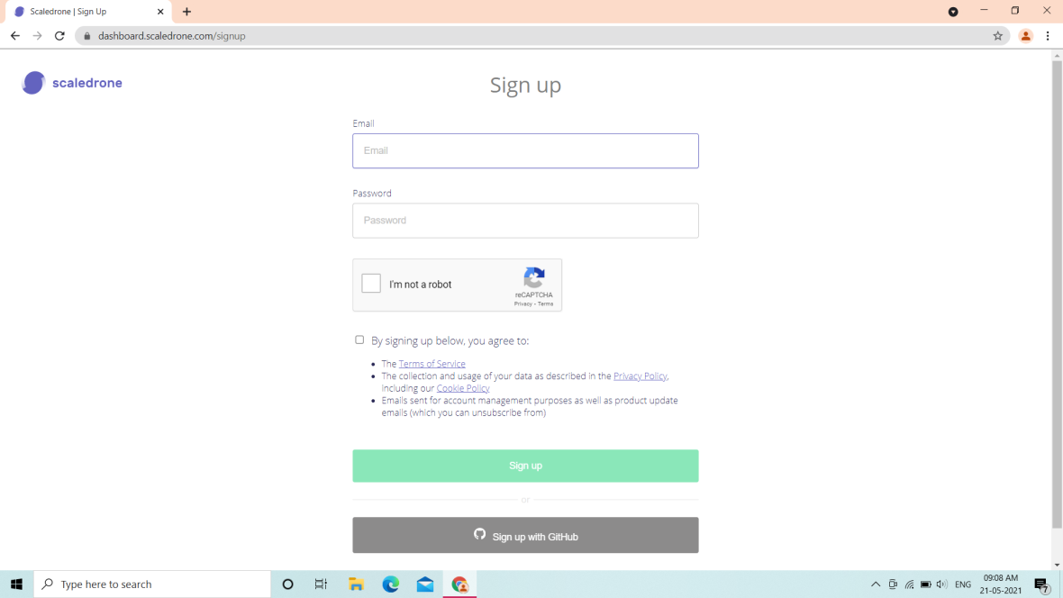Here we sign up the scaledrone account with our Email, then we need to agree their conditions.

### Step: 3

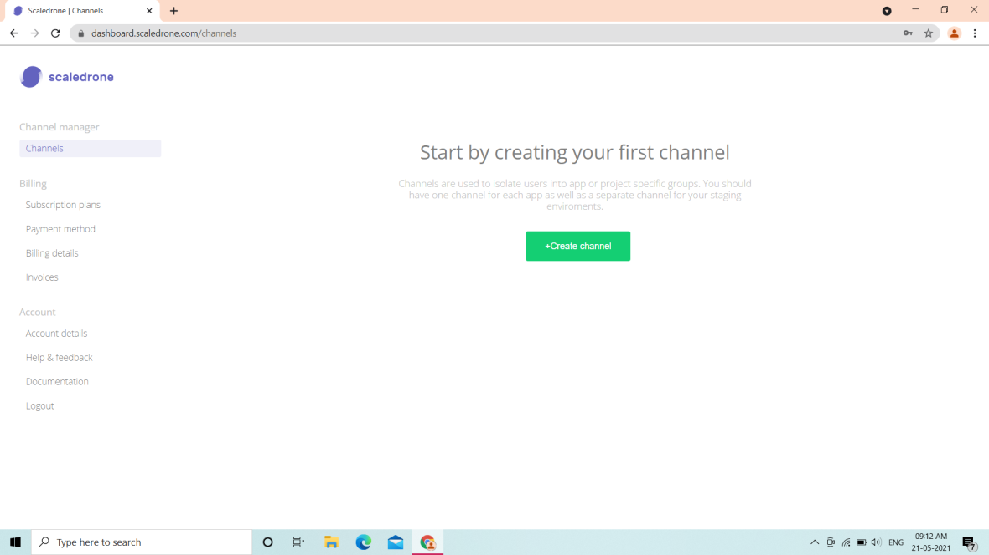

Here we create our own Channel byclick on “Create Channel”. Wecan createmore thanone channel here. Channels are used to isolate users into app or project specifying groups. You should have one channelfor each app as well as separate channelfor youfor your stating environments.

### Step: 4

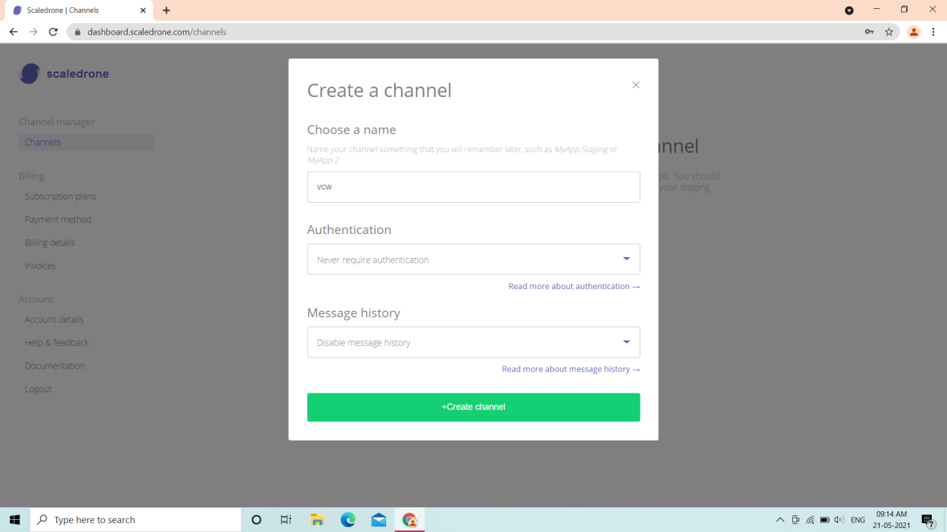

Here we can create our channel and choose some nameto our channel and we can remember it. Then we can have authentication herewe place never require authentication. **Authentication** is the process of recognizing a user's identity. ... The credentials provided are compared to those on a file in a database of the authorized user's information on a local operating system or within an **authentication** server. And then we have Message history we can disable or enable our message history then finally to create channel click on create channel button.

### Step: 5

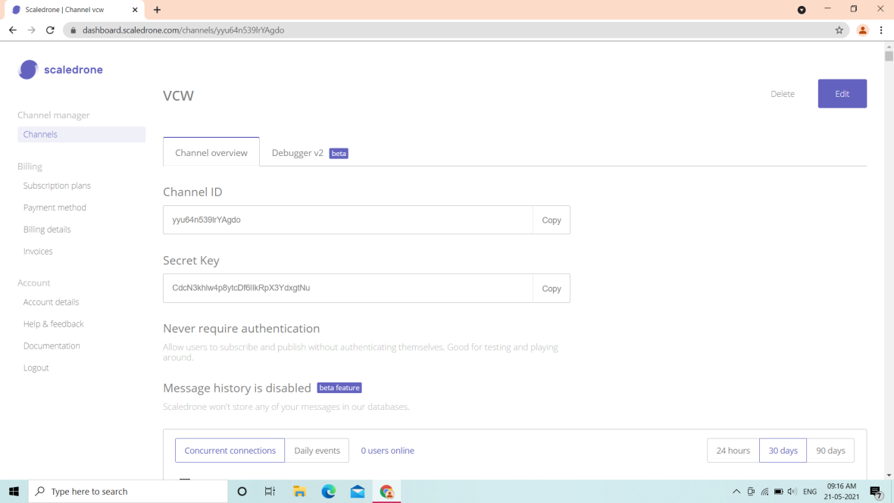

Here we have our channel id and secret key, copy that channel id and place it in our code that is JavaScript file. It produces our domain toconnect a call end-to-end.

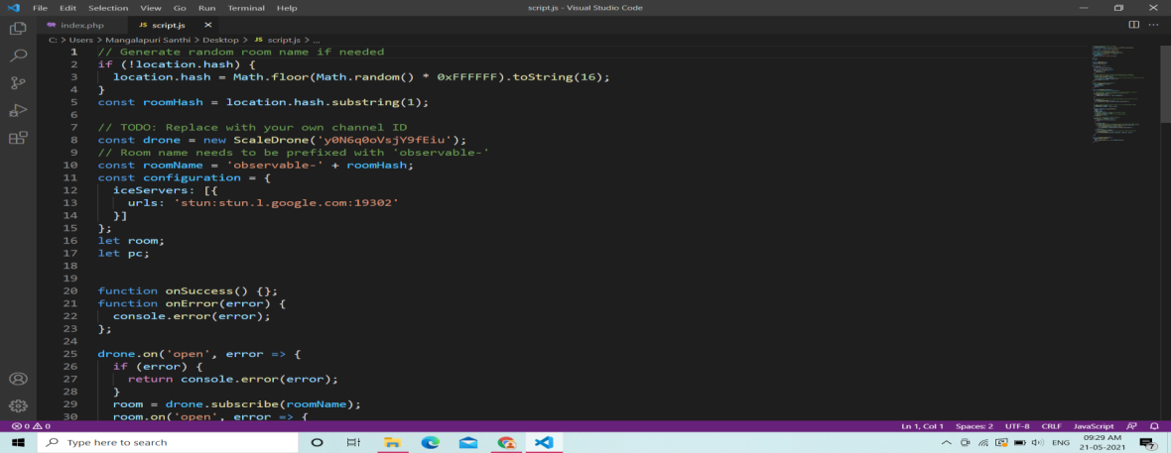

### Step: 6

Here we use 000webhost.comto host our code.**000Webhost** apologized and took measures. In fact, it has fixed all of the above issues quite quickly, so we could argue that **000Webhost** is actually much safer now than they were several years ago, specifically because of that breach.

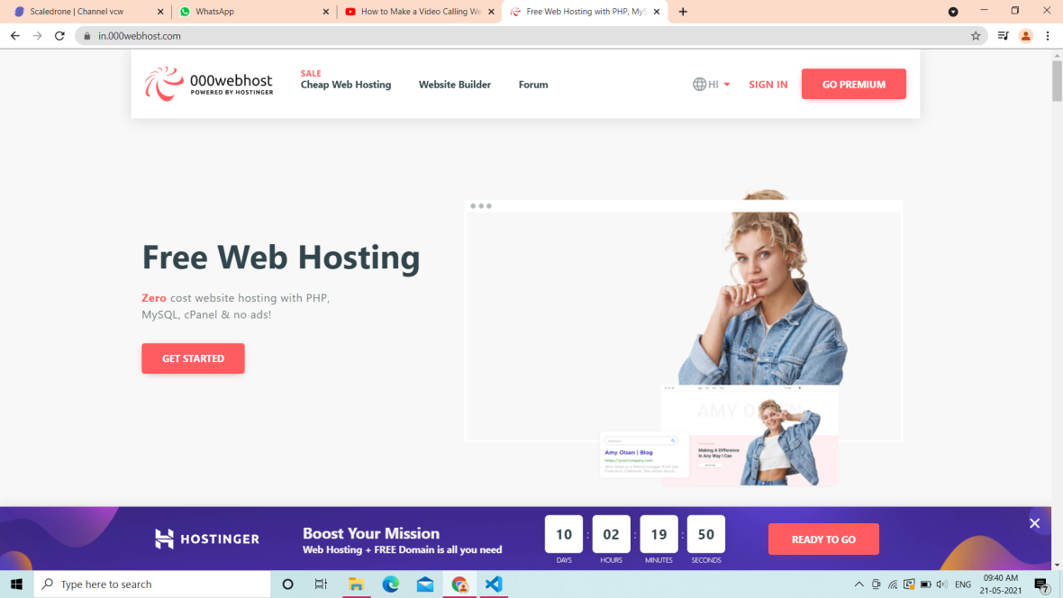

**000webhost** is best known for their free web hosting plans, but they also offer low-cost paid plans that have more disk space, more bandwidth, and live support. works like most other web hosting services. You can **use** its free website builder.

### Step: 7

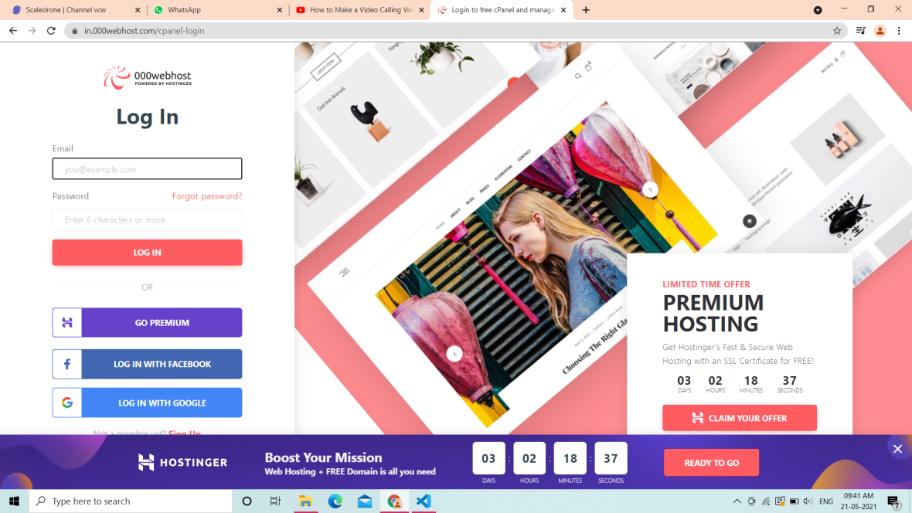

Here in this we have login options to login into 000webhost.you can pay and login or you can login with Facebook or we can login with Google.It’s our choice we can login with anyone. **000webhost** is best known for their free web hosting plans, but they also offer low-cost paid plans that have more disk space, more bandwidth, and live support.

### Step: 8

It is welcome page of 000webhost hosting sandbox.In this page we have awelcome message and then have two links one is let’s create magic and another is “it’s not my firsttake me to the panel”. Ignore first one and select second option to create website in this hosting service.

### Step: 9

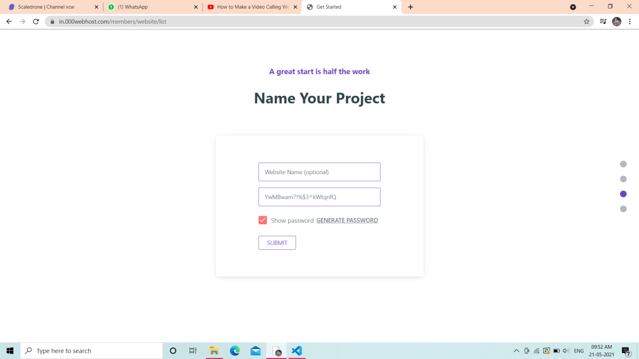

Here Simply give your website name and then submit.And here you want select any option for mass creation then select oterwise simply refresh it.

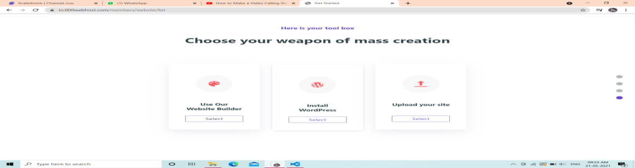

### Step: 10

For the creation of website select one option. Inthis for our project we should manage first one that is “VCW-Website” .it shows that status is running thatmeans it currently working. below we can have our domainwhich iscurrently running.To add our code run the domain for video chat website click on Manage Website.

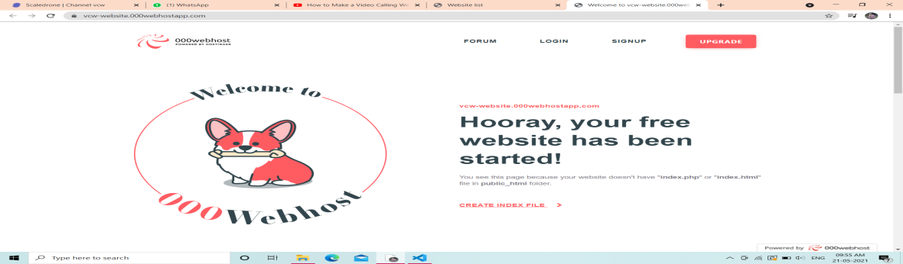

This is our website profile page. Our domain is VCW-Website.000webhostapp.com.

### Step: 11

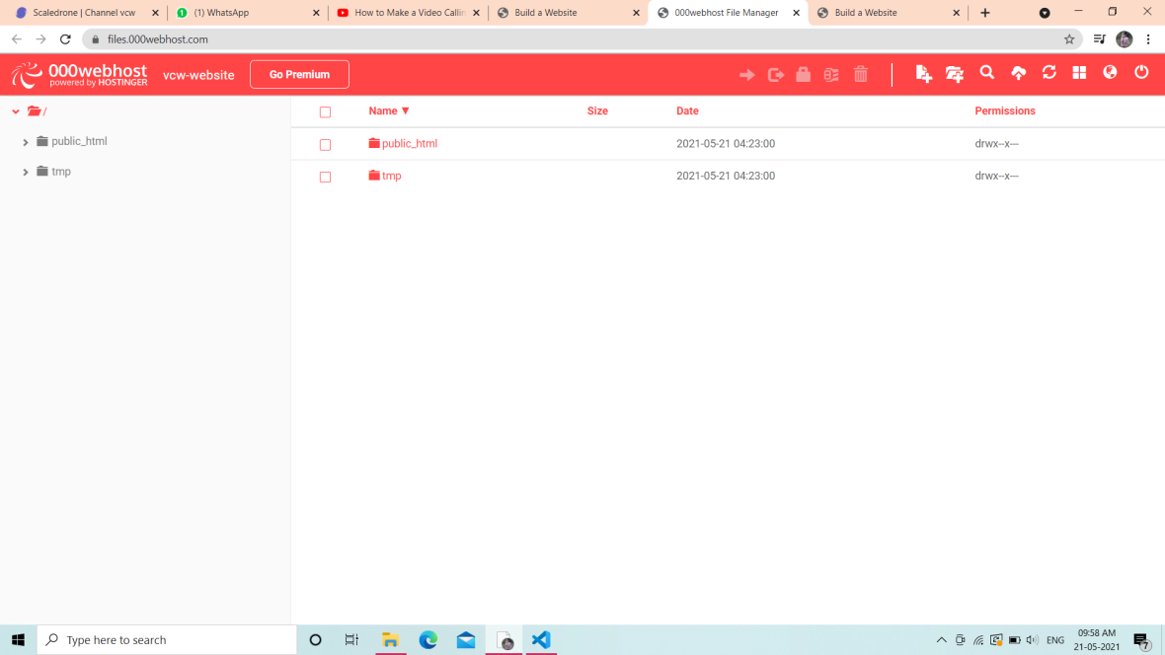

Here we can observe two folders in thatselect first folder to add our code simply open that folder.

Now refreshour website then we can open window which ask to share your URL to your friends. We can simply copy that URLshare to our friendsor family then talk in that.it is simple code and simple process to create online video chat website and very useful and easy to share.

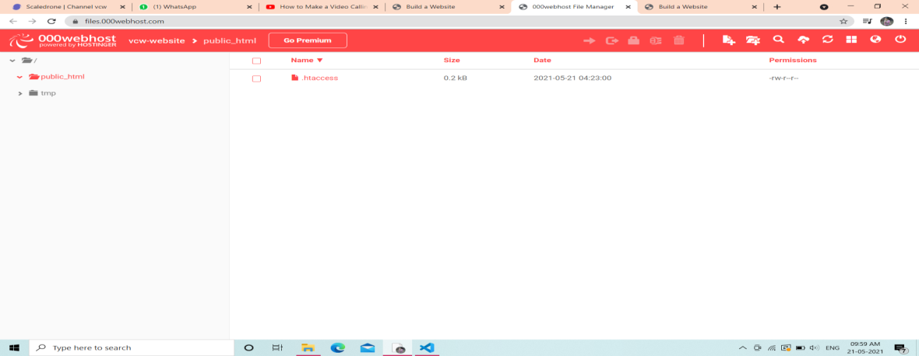

In this we observe another .htaccess file .Now we delete file and upload ourfile in that place.

### Step: 12

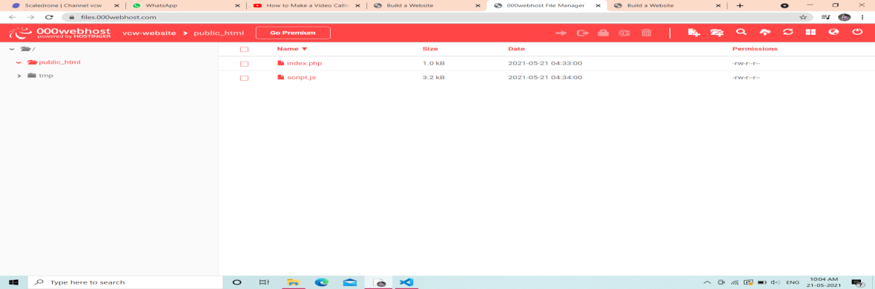

Now upload our “index.html and script.js “filesinto thepublichtml. These two files contain our code.we can refresh our website .

### Step: 13

### Testing

I developed my Video Chatting Website using Scaledrone Development Server. It is available for free download in the Scaledrone website, and it supports up to ten simultaneous connections. Each client-to-server, instance-to-instance, and server-to-server connection is counted as individual client connection by the Flash Media Server. I tested my video chat website with two users joining a chat room from a remote system.

Video Chatting is a many to many application in which each user will broadcast their own video and audio streams and receives the streams of others. The user publishes the video and audio streams and subscribes to other users published streams. The number of streams will increase exponentially with number of users in the chat room. For example, if there are four users joining a video conference room and each of the user publishes their streams and subscribes to three other streams, it makes a total of sixteen streams.

Video Chatting is a many to many application in which each user willbroadcast their own video and audio streams and receives the streams of others. The user publishes the video and audio streams and subscribes to other users published streams. The number of streams will increase exponentially with number of users in the chat room. For example, if there are four users joining a video conference room and each of the user publishes their streams and subscribes to three other streams, it makes a total of sixteen streams.

The formula for calculating server bandwidth (BW server) = (P*N) *S, where ‘P’ is the number of publishers, ‘N’ is the number of subscribers and ‘S’ is the stream encoded at constant kilobits per second(kbps). The formula for calculating client bandwidth (BW client) = (P*S), where ‘P’ is the number of publishers and ‘S’ is the stream encoded at constant kbps. The server bandwidth rises quadratically with number of users in a chat room and client bandwidth rises linearly with number of users in a chat room. Also, the server bandwidth drops if we limit the number of users in a chat room to two instead of four.

### Conclusion

Video Chatting has its application in almost every field including.

education, business, entertainment, etc. My main goal in this VCW project

was to develop an online video Chatting Website and I accomplished this goal by creating a server and client capable of multiple chat rooms with multiple users sharing their live video.

000webhost Server used in this project. During the initial phases of developing this project I faced several challenges in understanding some of the concepts in Adobe Flash Media Server like shared objects, multiple instances and streams. Lack of documentation was a big hurdle in understanding these technologies. I couldn’t find a good user guide that explains all these concepts in depth.

From this project, I learned a lot in building a Video Chatting Website using Adobe Flash Media server. I hope this report will help others as a user guide for developing new tools with 000webhost hosting server.

### References

Lesser, B., Guilizzoni, G., Lott J, Reinhardt R. & Watkins J. (2005). Programming

Flash Communication Server. California: O’Reilly Media Inc.

Lott, J. (2003). ActionScript Cookbook. O’Reilly Media Inc.

Towes, K. (2002). Macromedia® Flash™ Communication Server MX. Peach pit

Press.

Sanders, W.B. (2008).Learning Flash Media Server 3. O’Reilly Media Inc.

Noble, J. & Anderson, T. (2008). Flex 3 Cookbook. O’Reilly Media Inc.

Webster, S., McLeod, A. (2004). Developing Rich Clients with Macromedia Flex.

Macromedia Press.

Hock. C. (2007). Calculating your Bandwidth and Software License Needs of

Flash Media Server 2. Retrieved from Adobe.

Flex Live Documents. Retrieved June 16, 2008 from Adobe: Official Site Web

site: http://livedocs.adobe.com/

Flex Development Centre. Retrieved January 30, 2008 from Adobe: Official Site

Web site: http://www.adobe.com/devnet/flex/

Flash Media Server Development Centre. Retrieved January 30, 2008. from

Adobe Official Web site: http://www.adobe.com/devnet/flashmediaserver/

Flash Media Server Tutorials. Retrieved January 30, 2008. from Web site

http://fmsguru.com/tutorials.cfm