**Students’ Achievement Management**

1. **Introduction**

Welcome to this groundbreaking project that transforms the way we recognize student achievements in the digital era. With this innovative solution, we bring forth a user-friendly interface designed to seamlessly capture and showcase student accomplishments. Through a powerful Admin Dashboard, we have developed a comprehensive system that allows administrators like us to efficiently manage student achievements and user profiles. This project not only simplifies the process of organizing and acknowledging student successes but also empowers educators through the Faculty Dashboard. With this tool, updating student achievements and uploading relevant documents becomes effortless, fostering a vibrant culture of recognition and inspiration within educational institutions. Together, let's revolutionize the way we celebrate student accomplishments and contribute to a brighter future for education.

1. **Problems with the Existing System**

Fragmented Tracking:

The existing student achievement management system suffers from fragmented tracking due to the absence of a centralized database. Student accomplishments are scattered across various platforms, making it challenging to maintain a comprehensive and organized record.

Manual Errors and Delays:

Tedious manual processes contribute to errors and delays in managing student achievements. Paper-based systems and spreadsheets are prone to mistakes, leading to inaccuracies and inefficiencies in updating and recording student accomplishments.

Limited Accessibility and Communication:

Limited accessibility to achievement data and ineffective communication channels among faculty, administrators, and students hinder the efficient recognition of student achievements. Important updates may not reach the intended recipients promptly, leading to missed opportunities for acknowledgment.

Data Security Concerns:

Inadequate data security measures pose a significant risk to the confidentiality and integrity of student records. Unauthorized access and data breaches can compromise sensitive information, raising concerns about privacy and trust within the system.

Real-time Update Delays:

The absence of real-time updates means that achievements might not be reflected promptly. This delay impacts the immediate recognition and appreciation that students deserve for their hard work. Addressing these challenges is vital for creating a streamlined, efficient, and secure system for managing student achievements.

1. **Description of the Proposed System**

The proposed system, "Students Achievements Management," offers a comprehensive and streamlined solution to revolutionize the recognition and management of student accomplishments in educational institutions. Through a secure and user-friendly interface, the system caters to administrators, faculty members, and students, enhancing their overall experience and efficiency.

User Authentication and Security:

The system begins with a robust login mechanism, ensuring secure access for users. Students enter their username or email, while faculty and administrators use their respective passwords. Client-side validation guarantees accurate data entry, and an optional Two-Factor Authentication (2FA) adds an extra layer of security. The system also incorporates a "Forgot Password" link for easy password recovery.

Admin Dashboard:

Upon login, administrators access a feature-rich Admin Dashboard. Here, they can efficiently manage user accounts, create, modify, and deactivate profiles, ensuring smooth user management. The dashboard offers advanced achievement management tools, allowing administrators to view accomplishments based on various criteria such as class, student, and discipline. Detailed search options, including enrollment numbers and specific disciplines, facilitate quick data retrieval. Administrators can generate comprehensive reports with charts and graphs, offering valuable insights into achievements over different periods. Additionally, the system enables administrators to assign classes to faculty members for optimized task distribution.

Faculty Dashboard:

Faculty members benefit from a tailored dashboard designed for efficient achievement management within their specific classes. They can create, edit, and delete academic and non-academic achievements records, and upload relevant documents, enhancing the documentation process. The dashboard also allows faculty to manage students' document uploads, granting or denying permissions based on specific achievement categories. Faculty members can view achievement summaries for their classes, providing a consolidated and semester-wise overview of their students' progress.

Student Dashboard:

Students have access to a personalized dashboard that offers an Achievement Overview feature. Here, they can view their academic and non-academic accomplishments, upload related documents, and track their semester-wise progress. The dashboard includes a Notifications section, ensuring students receive timely updates and reminders to add new achievements, keeping them engaged and informed.

1. **Description and identification of the Functional Modules**

The "Students Achievements Management" system comprises several functional modules, each designed to address specific tasks and requirements within the system. These modules facilitate seamless operation and efficient management of student achievements. Here are the key functional modules:

1. User Authentication and Security Module:

- Handles user login, authentication, and authorization processes.

- Implements security measures such as client-side validation and optional Two-Factor Authentication (2FA) for user accounts.

- Manages password recovery mechanisms, including the "Forgot Password" functionality.

2. Admin Management Module:

- Allows administrators to create, modify, and deactivate user accounts.

- Provides tools for viewing and managing user profiles.

- Enables administrators to assign classes to faculty members for specific tasks and responsibilities.

3. Achievement Management Module:

- Admin Dashboard:

- Provides comprehensive tools for viewing achievements class-wise, student-wise, and discipline-wise.

- Allows administrators to create, modify, and delete achievements records.

- Facilitates detailed search options based on various criteria such as enrolment numbers, class, and discipline.

- Supports the generation of reports with charts and graphs (Yearly report, 3-years report, semester-wise report).

- Faculty Dashboard:

- Enables faculty members to create, edit, and delete academic and non-academic achievements records for their specific class.

- Allows faculty members to upload related documents for achievements and manage students' document uploads.

- Student Dashboard:

- Provides students with an overview of their academic and non-academic achievements.

- Allows students to upload related documents for achievements and view their semester-wise progress.

4. Notification Module:

- Sends notifications to users for updates, reminders, and alerts related to achievements.

- Ensures timely communication and keeps users informed about their achievements and system activities.

5. Reporting Module:

- Generates detailed reports with charts and graphs, providing insights into achievements over different periods (Yearly, 3-years, semester-wise).

- Supports customizable reporting options based on user requirements.

6. Document Management Module:

- Manages the upload, storage, and retrieval of documents related to student achievements.

- Ensures secure storage and easy access to documents for verification and reference purposes.

1. **Tools/Platforms**

In this chapter, we delve into the technical aspects of the project, outlining the hardware and software requirements necessary for the successful implementation of the comparative sales analysis using logistic regression.

* 1. **Hardware specification**

|  |  |
| --- | --- |
| Minimum Hardware Requirements | |
| Processor | Dual-core processor |
| CPU | 2.0 GHz or higher |
| Memory | At least 2.00 GB |
| Storage | 10 GB of Free Space |
| Display | Super VGA (1366 × 768) or higher resolution monitor |
| Input Devices | Keyboard, Mouse |

* 1. **Software specification**

|  |  |
| --- | --- |
| Minimum Software Requirements | |
| Frontend | HTML, CSS, Bootstrap, JavaScript |
| Backend | PHP, MySQL |
| Web Server | Apache |
| Tool | WAMP Server |

1. **Methodology**
   1. **SDLC Model to be used**

The Agile model is a customer-centric and iterative approach to software development that prioritizes adaptability, collaboration, and rapid response to changing requirements. In Agile, the project is broken down into small, manageable iterations, typically lasting a few weeks, where cross-functional teams work collaboratively to produce functional increments of the product. Regular and transparent communication between team members, stakeholders, and customers is paramount. The model thrives on flexibility, allowing for adjustments and refinements throughout the development process. Agile promotes continuous feedback, enabling teams to incorporate user insights and evolving business needs, ensuring that the end product not only meets customer expectations but also remains responsive to the dynamic demands of the market. Its iterative nature and focus on customer satisfaction make Agile an ideal choice for projects like "Students Achievements Management," where requirements might evolve, and user feedback is crucial for success.

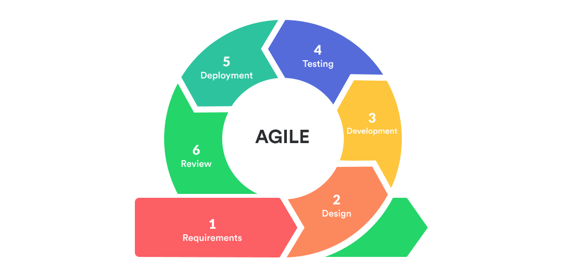

* 1. **Justification for Agile SDLC Model:**

The Agile software development lifecycle (SDLC) model is highly recommended. Agile is well-suited for projects that require flexibility, collaboration, and continuous feedback. Here's why Agile would be a good fit for your project:

Iterative Development: Agile allows for iterative development, meaning you can develop the project in small increments or iterations. This approach enables continuous improvements and allows you to adapt the project based on user feedback and changing requirements.

Flexibility: Agile is highly flexible and accommodates changes even in the later stages of development. Given that educational environments and requirements can evolve, Agile allows your team to respond to these changes effectively.

Collaboration: Agile emphasizes collaboration among team members and stakeholders. This is crucial for your project, as it involves multiple user roles (administrators, faculty, and students) with different needs. Regular communication ensures that everyone's requirements are considered and integrated into the system.

User Involvement: Agile encourages active involvement of end-users throughout the development process. In your case, involving faculty and students in the development process can help in refining the system based on their practical needs and feedback.

Early Deliveries: Agile promotes delivering a working product in short iterations. This means you can have a functional version of your system early in the development process, allowing stakeholders to see progress and provide feedback promptly.

Continuous Testing: Agile emphasizes continuous testing, ensuring that each iteration is thoroughly tested. This approach helps in identifying issues early and ensures a higher quality of the final product.

1. **Future Scope**

The Students' Achievements Management System have several potential future enhancements and expansions that could further improve the system's capabilities and benefits:

Machine Learning and AI-driven Insights: Implementing machine learning algorithms could enable the system to provide insightful analytics and recommendations based on patterns in achievement data.

Mobile Application: Developing a mobile application version of the system would offer greater accessibility and convenience for users on the go.

Gamification and Rewards System: Implementing gamification elements could incentivize students to actively participate in various activities and competitions, fostering a more engaging learning environment.

Social Media Integration: Allowing users to share their achievements on social media platforms can enhance the visibility of the institution and its students' accomplishments.

Integration with Learning Management Systems (LMS): Integrating with popular LMS platforms could provide seamless access to educational resources and facilitate a more comprehensive overview of a student's academic journey.

**Chapter 1: Introduction**

**Description of the Organisation:**

**Organization Name:** Institute of Information Technology & Management

**About:** The Institute of Information Technology & Management (IITM) is an educational institution that specializes in offering a wide range of short-duration skill enhancement and syllabus enrichment workshops. These workshops cover various areas of management specializations and emerging technologies. With a rich history and a strong commitment to education, IITM has established itself as a prominent player in the field of professional development.

One of IITM's key strengths lies in its extensive alumni network, which boasts over 4800 professionals. These alumni hold positions at various management levels in leading corporate houses across the country. This network serves as a testament to the institution's effectiveness in producing highly skilled and employable graduates.

**Mission:** The mission of IITM is threefold:

1. **To promote a learning environment that delivers employable students:** This entails equipping students with a robust analytical mindset, critical thinking abilities, and the entrepreneurial and organizational skills necessary to thrive in a dynamic professional environment.
2. **To foster strategic alliances with industry for applied research:** IITM recognizes the importance of collaboration with industry partners to engage in practical, applied research. This approach ensures that academic knowledge is translated into real-world solutions that benefit both the students and the industry.
3. **To inculcate ethical, social, and moral values amongst students:** Beyond technical skills, IITM places a strong emphasis on instilling a sense of ethics, social responsibility, and moral values in its students. This holistic approach aims to produce well-rounded professionals who are not only competent in their fields but also socially conscious citizens.

**Type of Institution:** College

**1.2 Introduction - Existing System**

The current system in place for managing student-related activities at the Institute of Information Technology & Management (IITM) relies heavily on manual paperwork. As of now, there is no dedicated software specifically designed for this purpose. This implies that various tasks related to student management, including enrollment, course registration, attendance tracking, grading, and record-keeping, are predominantly handled through physical documentation.

**Strengths of the Existing System:**

1. **Familiarity:** The reliance on paperwork may be familiar and comfortable for staff who have been using this system for an extended period.
2. **Low Initial Investment:** Since no specialized software has been implemented, there was no initial cost associated with procuring or developing student management software.
3. **No Technical Requirements:** As there is no software to install or maintain, there are no technical requirements beyond basic office equipment like paper, pens, and filing cabinets.

**Weaknesses of the Existing System:**

1. **Inefficiency and Time-Consuming:** Manual paperwork can be time-consuming and prone to errors. Tasks like data entry, record retrieval, and report generation are significantly slower compared to automated systems.
2. **Limited Accessibility and Collaboration:** Physical documents are typically confined to specific locations, making it challenging for multiple stakeholders to access and collaborate on student-related information simultaneously.
3. **Data Security and Integrity Concerns:** Paper-based records are susceptible to damage, loss, or unauthorized access. There may be risks associated with data security and integrity.
4. **Lack of Analytics and Reporting:** The absence of dedicated software means that advanced analytical tools and reporting capabilities, which are valuable for decision-making and tracking performance, are unavailable.
5. **Scalability Challenges:** As the institution grows or evolves, the manual system may struggle to handle an increasing volume of student-related data and activities.