**Week 1 (first lab) demo**

0) Introduce yourself, tell a little about who you are

1) Lab policies (Lab manual introduction)

Partners (If you have no partner for Lab 1, do it yourself. If you have no partner for Lab 3 we will explain what to do on Canvas)

Grading

How to turn in assignments (labs 1,2,3 pdf on Canvas)

Checkout sheets

2) Lab hours scheduled on zoom, see Canvas

~~EER 1.826 is scheduled for most hours of the week.~~

~~When it is not scheduled it is open for any engineering student~~

All of your development will be on your laptop away from campus

3) How to run Keil uVision simulator

Go to checkout and checkout a projector, show your laptop screen on wall.

Download and unzip many TM4C123 EE319Kware within the student’s working area

<http://users.ece.utexas.edu/~valvano/Volume1/EE319K_Install.exe>

Example code in Keil directory, but the EE319Kware folder can be moved

One in EE319Kware the first project (book program 3.2)

Open the project, show the windows, build, simulate

Watch window, single step

4) EE319K students must use their Laptop or PC. The installer should have put the file LaunchPadDLL.dll into Keil\ARM\BIN folder

Open the **InputOutput_4C123asm** project, and make this option

Dialog DLL **DCM.DLL** Parameter **-pCM4 -dLaunchPadDLL**

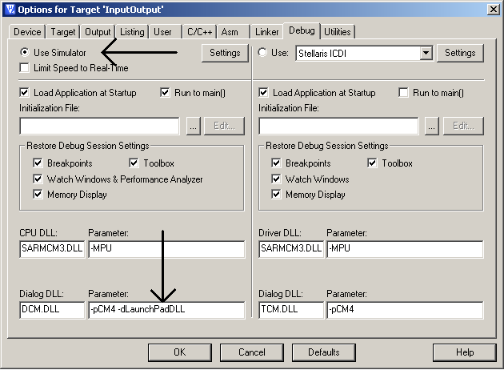

Look at Project->options, crystal should be 16 MHz, debugger is simulator

Build, debug, single step (look at PortF bits 4,3,2,1,0 in debugger, what is it doing?)

Look at View->PeriodicWindowUpdate

Will this software ever turn on all three LED colors (PF3,2,1 = 111)?

5) General questions they will want to discuss

How to find partner

How to buy a board

How to install Keil uVision on a Windows machine

How to install Keil uVision on a Macintosh

6) TAs and Professors may be demonstrating on the Digilent Analog Discovery, which is a $199 oscilloscope and logic analyzer, <https://store.digilentinc.com/analog-discovery-2-100msps-usb-oscilloscope-logic-analyzer-and-variable-power-supply/> The software associated with this tool is called Analog Waveforms.

7) Give them 15 minutes to meet and greet to pair up for partners. Explain that Lab 1 and 2 are practice. Labs 3-9 must be with the same partner. Lab 10 will have an option to use the same or different partner.

**Week 3 (showing the board) Demo Day Activities**

students bring boards and TAs bring flash drives with drivers, LaunchPadware

**Most important tasks**

**0) drivers installed on students laptop**

Once Keil and TExaS are installed you will need to install the windows drivers for the Texas Instruments TM4C123 LaunchPad. You will need the actual physical LaunchPad board to complete this step. So if you have ordered your board and it hasn't yet arrived, bookmark this page and come back once your board arrives. Installing drivers can be tricky so here are two alternative methods to installing drivers.

**Method 1** uses drivers that were saved on your HD when you installed TExaS in step 2). These slide shows demonstrate the process to install windows drivers for the LaunchPad board specific for your operating system: [**Windows XP**](http://users.ece.utexas.edu/~valvano/edX/InstallDriversXP.htm), [**Windows Vista**](http://users.ece.utexas.edu/~valvano/edX/InstallDriversVista.htm), [**Windows 7**](http://users.ece.utexas.edu/~valvano/edX/InstallDrivers7.htm), and [**Windows 8**](http://users.ece.utexas.edu/~valvano/edX/InstallDrivers8.htm).

**Method 2** uses the official Texas Instruments web site where you can [**download the drivers**](http://www.ti.com/tool/stellaris_icdi_drivers), and read the [**Stellaris Driver Installation Guide (Rev. C)**](http://www.ti.com/lit/ml/spmu287c/spmu287c.pdf) on how to download.

**0) Show Keil LA in simulation**

**1) running assembly code on board** (do not show printf)

**InputOutput_4C123asm** (use new one without bit specific addressing)

**Squarewaves_4C123asm** (use new one without bit specific addressing)

**2) Keil uVision debugging on board**

**Options to select** Stellaris In Circuit Debugger Interface (ICDI)

**View->PeriodicWindowUpdate**

**Break and single step, SystemViewer->PortF, P30 really PE0**

**3) Hand out bags**

**4) board safety (how to handle the board)**

**a) do not move wires with power on**

**b) simple way to turn power on/off (using the slide switch)**

**c) the microUSB socket is VERY fragile (no twisting or turning)**

**Things you can do with the power on**

Hit the reset button

Touch/release buttons on the board or protoboard

Connect/disconnect voltmeter to system

Plug and unplug the USB cable

**Things you should not do with the power on (the $13 learning experience)**

Plug/unplug the wires between circuit and LaunchPad

Connect/disconnect cables or wires to external devices

Insert/remove wires resistors or chips from the protoboard

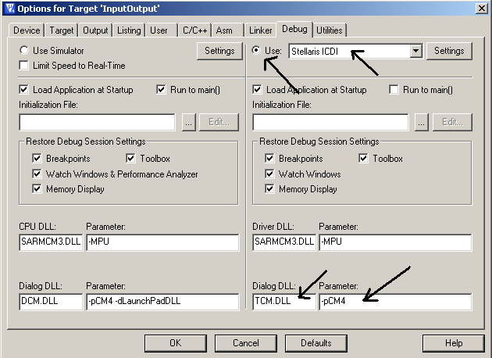

Touch bare wires or pins with your fingers

1) Experiment with single stepping features

**Reset**

**Single step** until LED comes on

2) Experiment with step over features

**Reset**

**Single step over** until LED flashes

3) Experiment with break point features

**Reset**

**Click on the assembly line that**

**outputs to LED, and**

**insert a breakpoint**

**Run** (notice it stops)

**Run** (notice it stops)

4) Experiment with embedded system mode features

Disconnect power to the board

Apply power to the board