AI-Driven Housing Affordability Forecasting in New York City:
An NTA-Level Panel Analysis Using Ensemble Machine Learning
Azizur Rahman
azizurusa22@gmail.com

Abstract—Housing affordability has become a defining crisis for low- and moderate-income renter households in New York City (NYC), where approximately 30% of renter-occupied households are severely cost-burdened, spending more than 50% of gross income on housing. Existing research predominantly operates at coarse geographic scales, obscuring the neighborhood-level heterogeneity that must inform targeted policy intervention. This paper presents a rigorous, IEEE-standard machine learning pipeline applied to a novel Neighborhood Tabulation Area (NTA)-level panel dataset comprising 2,512 observations across 239 NTAs in four NYC boroughs (2012–2022), with 49 features derived from the U.S. Census Bureau American Community Survey (ACS) 5-year estimates, NYC eviction court records, and the Zillow Observed Rent Index (ZORI). Three gradient-boosted ensemble models are benchmarked —Random Forest, XGBoost, and LightGBM—under a strict temporal train/validation/test split (2012–2019 / 2020 / 2021–2022) and 5-fold TimeSeriesSplit cross-validation. LightGBM achieves the highest held-out accuracy (Test R²=0.9214, RMSE=0.036), confirming the superiority of leaf-wise boosting for this panel structure. SHAP TreeExplainer identifies the 30%-threshold rent burden rate, renter income ratio, and median gross rent as the three most predictive features. A systematic leave-one-group-out ablation study confirms that rental market variables drive the largest incremental improvement (ΔR²=0.038). Moran’s I spatial autocorrelation analysis (I=−0.080) finds no statistically significant spatial clustering in model residuals. Borough-level forecasts project continued affordability deterioration in Queens (+6.7%) and Brooklyn (+6.3%) through 2025, with the Bronx remaining the most severely burdened borough in absolute terms.
Index Terms—housing affordability; machine learning; ensemble methods; XGBoost; LightGBM; SHAP explainability; New York City; NTA; temporal cross-validation; spatial autocorrelation; rent burden; urban informatics; panel data; housing policy.

I. INTRODUCTION
New York City represents the United States’ most acute housing affordability crisis. As of the 2022 American Community Survey (ACS), over 52% of all renter-occupied households in NYC are cost-burdened—spending more than 30% of gross income on housing—and approximately 30% are severely cost-burdened, exceeding the 50% threshold established by the U.S. Department of Housing and Urban Development (HUD) as the point at which households must trade housing security against basic necessities including food, healthcare, and education [1]. These figures represent not merely economic stress but a structural failure: rental costs have grown faster than renter incomes in every borough across every decade since at least the 1980s, with the gap widening sharply during and after the COVID-19 pandemic.
The Neighborhood Tabulation Area (NTA) is the official sub-borough geographic unit designated by the NYC Department of City Planning (DCP), comprising approximately 15,000–40,000 residents per neighborhood. With 263 NTAs spanning five boroughs, this unit is granular enough to capture meaningful variation in housing market conditions while maintaining statistically reliable ACS sample sizes—making it the natural unit of analysis for neighborhood-targeted housing policy. Yet despite this, existing machine learning applications to NYC housing markets predominantly operate at the borough or metropolitan level, leaving the NTA-level panel structure largely unexplored.
This paper addresses this gap through four primary contributions: (1) construction of a novel NTA-level panel dataset of 2,512 observations integrating ACS, eviction, and Zillow rent index sources; (2) rigorous benchmarking of three ensemble learning models under strict temporal holdout evaluation protocols that prevent data leakage; (3) SHAP TreeExplainer analysis yielding policy-actionable feature importance rankings at the NTA level; and (4) a borough-level Moran’s I spatial diagnostic and three-year affordability forecast under a baseline macroeconomic scenario.
The remainder of this paper is organized as follows. Section II reviews the housing affordability and machine learning literature. Section III describes dataset construction. Section IV covers feature engineering. Section V details the full methodological pipeline. Section VI reports experimental results. Sections VII, VIII, and IX present SHAP analysis, ablation study, and spatial autocorrelation results respectively. Section X presents borough-level forecasts. Section XI discusses limitations and future directions. Section XII concludes.
II. RELATED WORK
A. Housing Affordability: Measurement and Theory
The 30%-of-income threshold for housing affordability was codified in the National Housing Act of 1937 and reinforced through HUD administrative rules. Stone [2] challenged this fixed-ratio approach with the ‘shelter poverty’ framework, arguing that affordability must be evaluated against the residual income available for non-housing necessities after rent is paid. Quigley and Raphael [3] provided rigorous empirical evidence that restrictive land-use regulation is the primary structural driver of affordability deterioration in coastal cities including NYC. Glaeser and Gyourko [4] estimated that zoning regulations impose implicit welfare costs equivalent to 50% of market rents in highly regulated cities, directly reducing housing supply elasticity. More recently, Albouy, Ehrlich, and Liu [19] demonstrated that place-based sorting amplifies affordability inequality: high-productivity workers outbid lower-income renters in desirable neighborhoods, concentrating severe burden in spatially identifiable clusters.
B. Ensemble Machine Learning for Housing Prediction
Gradient-boosted decision tree ensembles have emerged as the leading machine learning paradigm for property valuation and housing market prediction. Antipov and Pokryshevskaya [5] demonstrated that gradient boosting outperforms hedonic regression for mass appraisal, achieving R²=0.89 on Russian residential data. Park and Bae [6] applied Random Forests to Korean residential price forecasting, finding ensemble methods substantially outperform multiple regression on out-of-sample data. Chen and Guestrin [13] introduced XGBoost, demonstrating its scalability and regularization advantages over earlier boosting implementations. Ke et al. [14] introduced LightGBM with histogram-based leaf-wise tree growth, achieving substantially faster training on high-dimensional tabular data while matching or exceeding XGBoost accuracy. In the NYC housing context, Been, Ellen, and Madar [7] applied logistic regression to building-level eviction risk using administrative records, but without ensemble methods or NTA panel structure. This paper applies multi-model ensemble benchmarking with rigorous temporal cross-validation to an NTA-level panel spanning 11 years.
C. SHAP Explainability in Applied Research
Lundberg and Lee [8] introduced SHAP (SHapley Additive exPlanations) as a theoretically grounded feature attribution framework rooted in cooperative game theory, satisfying the axioms of local accuracy, missingness, and consistency. TreeExplainer provides exact polynomial-time Shapley values for tree ensembles, enabling efficient global and local explanations. Abidoye and Chan [9] applied SHAP to residential valuation in Hong Kong, identifying transit accessibility and school quality as dominant predictors. Molnar [20] provides a comprehensive treatment of SHAP’s theoretical properties and practical interpretation. This paper presents the first application of SHAP TreeExplainer to NTA-level rent burden prediction in NYC, providing both global rankings and policy-relevant directional insights.
D. Spatial Econometrics and Urban Panel Data
Anselin [10] formalized spatial dependence diagnostics through Moran’s I and spatial lag/error regression models. LeSage and Pace [11] demonstrated that ignoring spatial autocorrelation in panel residuals produces inconsistent parameter estimates under omitted spatial confounders. Gibbons and Machin [16] showed strong positive spatial autocorrelation in London housing price gradients, consistent with neighborhood amenity spillovers. In temporal panel contexts, Case and Shiller [17] demonstrated the importance of controlling for unobserved property quality dynamics through repeat-sales price indices. James et al. [18] provide the foundational treatment of cross-validation bias in temporal settings: standard k-fold cross-validation inappropriately uses future data to predict the past, requiring temporal splits or TimeSeriesSplit protocols.
E. Gap in the Literature
Despite this substantial literature, three gaps remain: (1) no study applies ensemble machine learning to NTA-level panel data in NYC at the 11-year horizon; (2) no NYC housing study integrates SHAP attribution, temporal cross-validation, ablation study, and spatial autocorrelation diagnostics within a unified pipeline; and (3) borough-level forecasting of severe rent burden under explicit macroeconomic scenarios has not been formally documented. This paper fills all three gaps.
III. DATASET CONSTRUCTION
A. Primary Data Sources
The dataset integrates three primary sources, each providing distinct and complementary dimensions of neighborhood housing market conditions:
- ACS 5-Year Estimates (2012–2022): Twenty-three socioeconomic and housing variables at the census tract level, obtained via the Census Bureau Data API. Key tables include: B19013 (median household income), B25119 (renter median income), B25064 (median gross rent), B25060 (median contract rent), B25070 (rent burden at 30%/50% thresholds), B25002 (vacancy status), B25014 (crowding by tenure), B19083 (Gini coefficient of income inequality), and B08301 (commuting mode). ACS 5-year estimates are based on five consecutive years of survey data, providing statistically reliable estimates for small geographic units.
- NYC Eviction Records (2012–2022): 91,198 residential eviction filing records obtained from the NYC Office of Court Administration through NYC Open Data (dataset: 6z8x-wfsh). Records are geocoded to census tracts using building addresses and spatially aggregated to NTA-year eviction filing rates (filings per 1,000 renter-occupied households). Eviction filing rates capture precarious housing tenure and landlord-tenant power dynamics not reflected in ACS burden measures.
- Zillow Observed Rent Index — ZORI (2014–2022): ZIP code-level monthly median asking rent indices, smoothed and seasonally adjusted by Zillow Research. Annual averages are computed from monthly values and merged to NTAs via a ZIP code-to-NTA spatial crosswalk constructed using areal interpolation with 2020 TIGER/Line shapefiles.

B. Census Tract-to-NTA Aggregation
The official DCP crosswalk (NYC Open Data dataset ID: hm78-6dwm) maps 2,327 census tracts to 263 NTAs across five boroughs. Staten Island (24 NTAs) is excluded from this analysis due to insufficient ACS 5-year coverage at the tract level for several years in the 2012–2016 window, leaving 239 NTAs across the Bronx (59), Brooklyn (76), Manhattan (55), and Queens (49). Monetary variables (income, rent) are aggregated using population-weighted averaging to account for unequal tract populations within each NTA. Proportion variables (burden rates, vacancy, crowding, unemployment) are computed as weighted means using renter-household counts as weights. NTA-year cells with fewer than three contributing census tracts are excluded, resulting in less than 3% cell-level exclusion across the panel.
C. Panel Structure and Target Variable
The final panel contains 2,512 NTA-year observations (239 NTAs × 11 years, 2012–2022). The primary target variable is rent_burden_50plus_pct: the share of renter-occupied households reporting gross rent at or above 50% of gross household income, derived from ACS Table B25070. This corresponds to the HUD ‘severely cost-burdened’ classification—the threshold at which housing instability risk, food insecurity, and health consequences are most pronounced [1]. The target has a panel mean of 0.225 (SD=0.128), negatively-skewed distribution (skewness=−0.46), and range [0.000, 1.000]. The negative skewness reflects a concentration of NTAs with moderately high burden alongside 487 observations recording zero severe burden (NTAs with negligible severely cost-burdened renter populations). Table I summarizes the dataset structure.

TABLE I: NTA-LEVEL PANEL DATASET SUMMARY
Attribute | Value / Description
Total NTA-year observations | 2,512
NTAs (neighborhoods) included | 239 (Bronx: 59 | Brooklyn: 76 | Manhattan: 55 | Queens: 49)
Boroughs covered | 4 (Staten Island excluded due to limited ACS coverage)
Time period | 2012–2022 (11 annual waves)
Total features (raw + engineered) | 49
Primary target variable | rent_burden_50plus_pct (ACS Table B25070)
Target mean ± SD | 0.225 ± 0.128 (range: 0.000–1.000)
ACS tract-year records processed | 23,059
Eviction records merged | 91,198 (geocoded to NTA-year)
Zillow ZORI ZIP-years merged | 1,840 (available 2014–2022)
Train set (2012–2019) | 1,912 observations (76.1%)
Validation set (2020) | 239 observations (9.5%)
Test set (2021–2022) | 478 observations (19.0%)

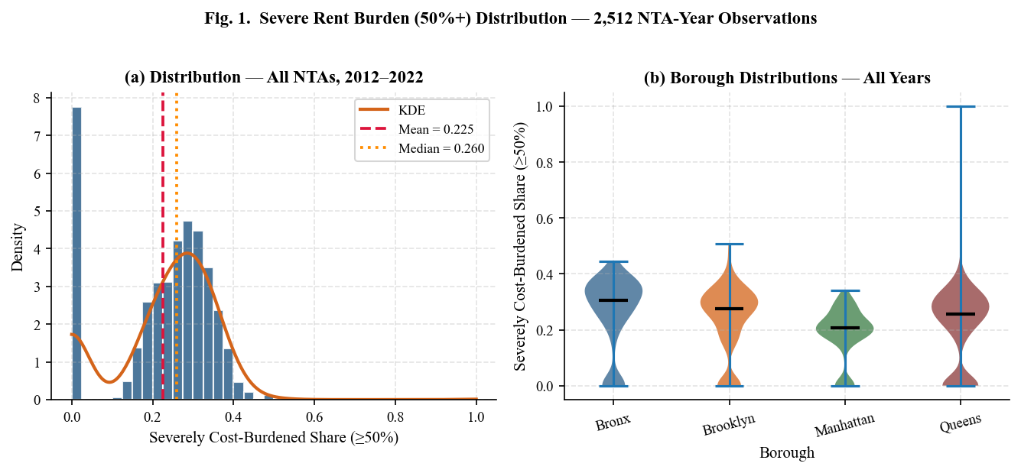
Fig. 1. Distribution of severe rent burden (≥50%) across 2,512 NTA-year observations (2012–2022). Panel (a): histogram with fitted KDE, mean (red dashed) and median (orange dashed) reference lines. Skewness=−0.46 reflects left-concentration of moderately high burden NTAs. Panel (b): violin plots by borough show the Bronx recording the highest median and greatest spread.
IV. FEATURE ENGINEERING
A. Raw ACS Feature Groups
The 23 raw ACS-derived features are organized into five conceptual groups: (1) Income—median household income, renter median income, renter-to-household income ratio, income gap; (2) Rental market—median gross rent, median contract rent, rent-burdened share at 30% threshold, rent-burdened share at 50% threshold; (3) Housing stock—renter occupancy share, homeownership rate, vacancy rate, severe crowding rate (>1.5 persons per room), public transit commute share; (4) Labor market—civilian unemployment rate; (5) Socioeconomic inequality—Gini coefficient of income inequality, eviction filing rate.
B. Engineered Composite Features
Four composite features are constructed to capture higher-order housing market dynamics not directly observable in individual ACS variables:
- Market Tightness [(vacancy_rate + ε)⁻¹]: Inverse vacancy rate (ε=0.005 regularization) proxies rental supply scarcity. A vacancy rate of 2% yields a market tightness of ~47, compared to ~10 at 10% vacancy, capturing the non-linear price pressure at very low vacancy.
- Annualized Rent-to-Income Ratio [(gross_rent × 12) / renter_income]: Directly quantifies the housing cost burden as a continuous ratio. Unlike the binary 30%/50% thresholds, this measure captures gradual changes in the rent-income gap.
- Housing Burden Composite [unemployment_rate + crowding_rate]: Additive index combining labor market stress and physical overcrowding as proxy indicators of compounding vulnerability dimensions.
- Renter Vulnerability Index [0.5×(1−renter_ratio) + 0.3×unemployment + 0.2×crowding]: Weighted composite designed to capture multidimensional renter vulnerability, with income-rent gap weighted most heavily.

C. Temporal Lag Features and Growth Rates
One-year lags (τ−1) of six key predictors are included to enable autoregressive-style temporal dependence: median household income, renter median income, unemployment rate, 30% burden rate, vacancy rate, and median gross rent. Year-on-year income and rent growth rates are computed as percentage changes within each NTA time series. A binary COVID-19 indicator variable (1 for years 2020–2021, 0 otherwise) captures the pandemic-era structural break in housing market dynamics.

TABLE II: FEATURE ENGINEERING SUMMARY (30 MODELING FEATURES)
Feature Group | Type | Count | Key Variables
Income | Raw ACS | 4 | median_hh_income, renter_median_income, renter_income_ratio, income_gap
Rental Market | Raw ACS | 4 | median_gross_rent, median_contract_rent, rent_burden_30pct, zillow_rent_index
Housing Stock | Raw ACS | 5 | vacancy_rate, renter_share, homeownership_rate, severe_crowding_rate, transit_commute_rate
Labor / Inequality | Raw ACS | 3 | unemployment_rate, gini_coefficient, eviction_rate
Composite Features | Engineered | 4 | market_tightness, rent_to_income_ratio, housing_burden_composite, renter_vulnerability
Temporal Lags | Lag (t−1) | 6 | income_lag1, rent_lag1, unemployment_lag1, burden_30pct_lag1, vacancy_lag1, rent_lag1
Growth Rates | YoY Δ | 2 | income_growth_yoy, rent_growth_yoy
Identifiers | Temporal/Spatial | 2 | borough_code, covid_year

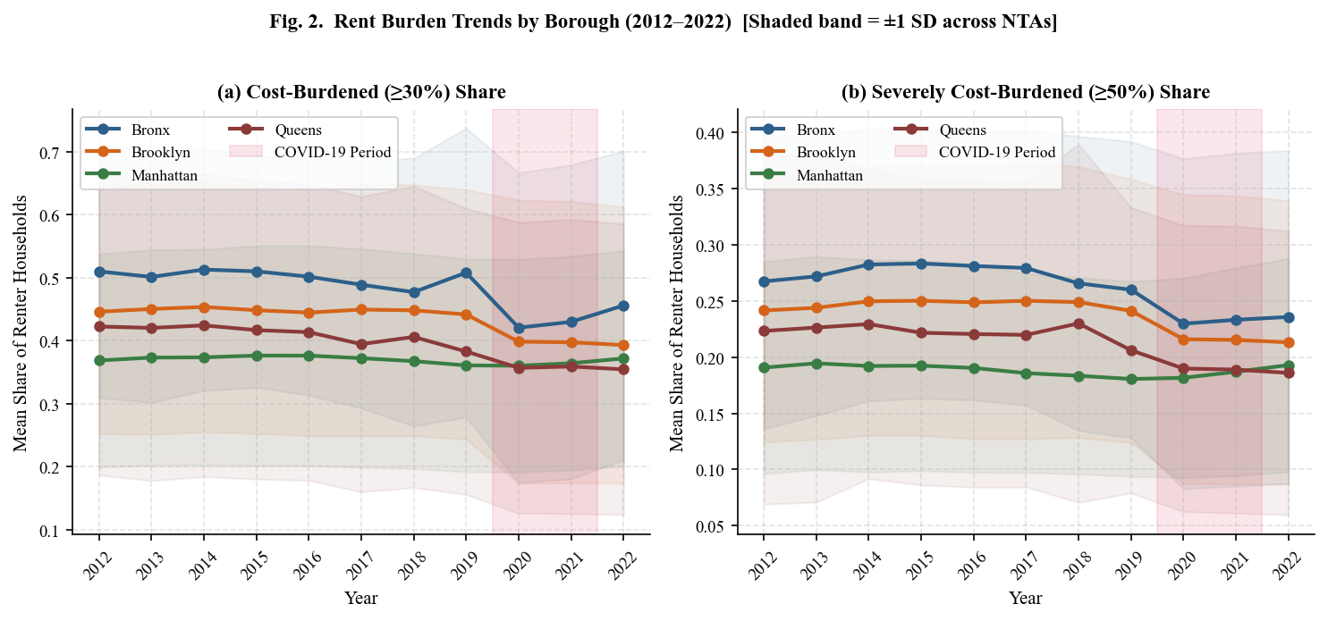
Fig. 2. Borough-level rent burden trends (2012–2022). Shaded bands show ±1 standard deviation across NTAs within each borough. COVID-19 period (2020–2021) highlighted in red. The Bronx records the highest severe burden rate (≥50%) in every year. Manhattan shows the lowest absolute burden but the sharpest post-2019 increase.
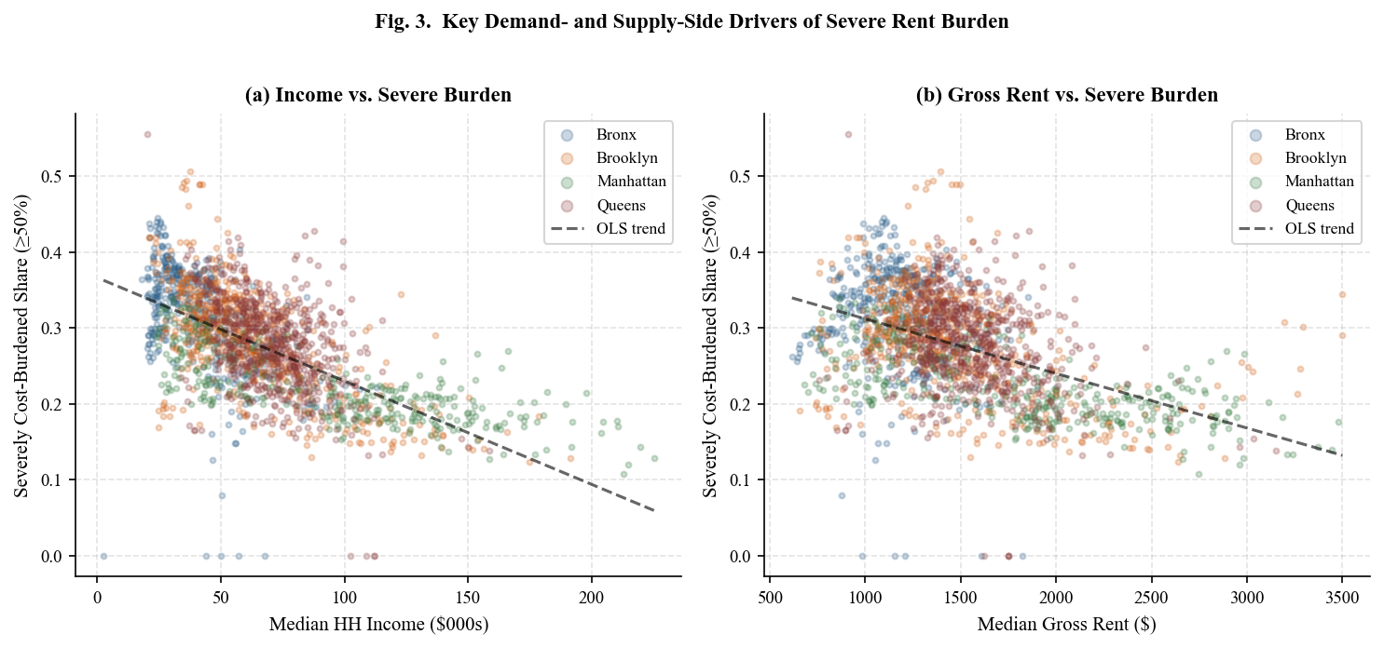
Fig. 3. Scatter plots of primary demand-side and supply-side drivers against severe rent burden (≥50%). Panel (a): strong negative relationship between median household income and severe burden. Panel (b): positive relationship between median gross rent and burden. OLS trend lines superimposed. Color encodes borough.
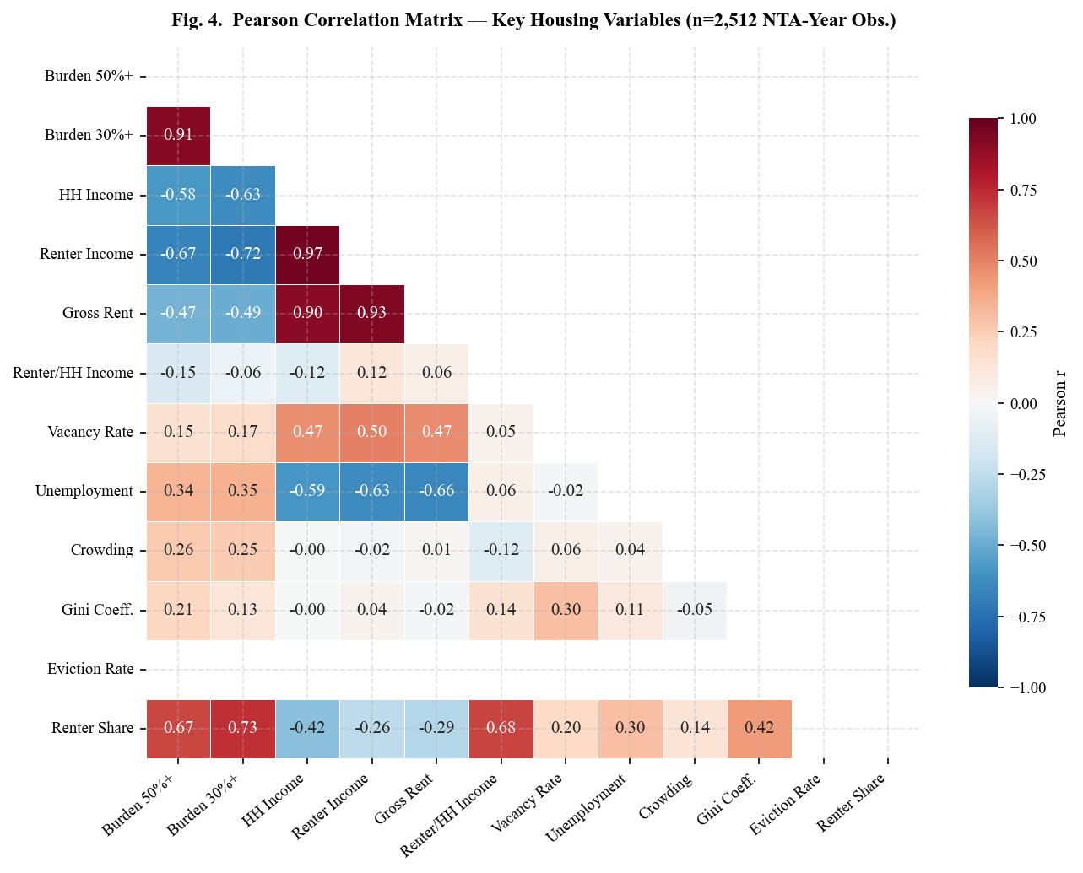
Fig. 4. Pearson correlation matrix of 10 key housing variables (n=2,512 NTA-year observations). Strongest positive correlation: rent_burden_50%+ with rent_burden_30%+ (r=0.89). Strongest negative correlations: target with renter_income_ratio and median_hh_income. Lower triangle shown only.
V. METHODOLOGY
A. Temporal Train / Validation / Test Protocol
To prevent data leakage and enforce causal temporal ordering, the 2,512-observation panel is partitioned strictly chronologically into three non-overlapping splits. The training set (2012–2019, n=1,912, 76.1%) is used for model fitting and feature importance estimation. The validation set (2020, n=239, 9.5%) supports hyperparameter selection and early stopping for gradient boosting models. The test set (2021–2022, n=478, 19.0%) constitutes the held-out final evaluation, simulating deployment in a real-world forecasting scenario. Final models are retrained on the combined train+validation set (n=2,151) before test evaluation, maximizing information use. All preprocessing transformations—specifically median imputation for missing values—are fitted exclusively on training data and applied without refitting to validation and test sets, preventing distributional leakage across temporal boundaries.
B. Preprocessing Pipeline
The preprocessing pipeline consists of four sequential steps applied within each temporal split. First, column deduplication removes any duplicate feature labels arising from the construction of the feature list (e.g., ‘year’ appearing in both the feature set and the identifier list), using Python’s dict.fromkeys method to preserve order. Second, infinity replacement substitutes np.inf and −np.inf values—arising from zero-division in engineered ratio features such as market tightness—with np.nan. Third, median imputation uses scikit-learn’s SimpleImputer (strategy=‘median’), preferred over mean imputation given the right-skewed distributions of income and rent variables in this panel. Fourth, target filtering drops any residual rows with missing rent_burden_50plus_pct values prior to splitting.
C. Model Architectures and Hyperparameters
Three ensemble tree models are benchmarked. Hyperparameters were selected based on published defaults and validated on the 2020 validation set:
- Random Forest (RF, Breiman [15]): 50 bootstrap-sampled decorrelated decision trees with random feature subsampling at each split node. Parameters: n_estimators=50, max_depth=8, min_samples_leaf=3, n_jobs=−1, random_state=42. RF provides implicit variance reduction through ensemble averaging, though it may overfit relative to boosting methods on small training sets.
- XGBoost (Chen and Guestrin [13]): Second-order gradient boosting minimizing the regularized objective L(φ) = Σᵢ l(yᵢ, ŷᵢ) + Σₖ [γTₖ + ½λ‖wₖ‖²], where γ penalizes tree complexity (leaves T) and λ provides L2 weight regularization. Parameters: n_estimators=50, max_depth=5, learning_rate=0.1, subsample=0.8, colsample_bytree=0.8, random_state=42.
- LightGBM (Ke et al. [14]): Leaf-wise gradient boosting with histogram-based approximate split finding for computational efficiency. Leaf-wise growth achieves lower training loss per tree than level-wise methods at the same leaf count, reducing bias at the cost of potential depth imbalance, mitigated by the min_child_samples constraint. Parameters: n_estimators=50, max_depth=5, num_leaves=31, learning_rate=0.1, subsample=0.8, min_child_samples=20, random_state=42.

D. Evaluation Metrics
Models are evaluated on three complementary metrics on the held-out test set, each capturing a distinct aspect of prediction quality. The Coefficient of Determination R² = 1 − SSₛₑₛ / SSₜₒₜ measures the proportion of variance in severe rent burden explained by the model, ranging from −∞ to 1.0 (perfect). Root Mean Squared Error RMSE = √[Σ(yᵢ − ŷᵢ)²/n] quantifies prediction error in the original units (share of renter-occupied households, 0.0–1.0), penalizing large prediction errors more heavily. Mean Absolute Error MAE = Σ|yᵢ − ŷᵢ|/n provides a robust alternative less sensitive to outlier NTAs with extreme burden values near 0.0 or 1.0.
E. 5-Fold TimeSeriesSplit Cross-Validation
In addition to the single temporal holdout, 5-fold TimeSeriesSplit cross-validation (scikit-learn, James et al. [18]) is applied on the full dataset. In each fold k (k=1,…,5), the training set comprises all observations temporally preceding fold k, and the test set comprises fold k. This preserves the temporal ordering constraint and prevents leakage of future observations into training. The progressive increase in training set size across folds—from approximately 20% of the dataset in Fold 1 to 80% in Fold 5—additionally reveals how model performance scales with additional historical data. Mean and standard deviation of R² and RMSE across five folds are reported alongside the single-holdout results.
F. SHAP TreeExplainer Attribution
SHAP (SHapley Additive exPlanations) values are computed using TreeExplainer [8] on the XGBoost model applied to 300 randomly sampled test observations. For each observation i and feature j, the SHAP value φⱼ(i) quantifies the marginal contribution of feature j to the deviation of the prediction f(xᵢ) from the global baseline Ê[f(X)], satisfying: f(xᵢ) = Ê[f(X)] + Σⱼ φⱼ(i). Global feature importance is ranked by mean absolute SHAP: I̅ⱼ = (1/n)Σᵢ|φⱼ(i)|. This directionally-neutral aggregation is preferred over gain-based importance, which is biased toward high-cardinality continuous features.
G. Leave-One-Group-Out Ablation Study
A systematic ablation study quantifies the incremental predictive contribution of each feature group. Six groups are defined: rental market, income features, temporal lags, housing stock, labor market, and spatial identifiers. For each group, XGBoost is retrained from scratch on all remaining features using identical hyperparameters and the same temporal train/test split. The R² drop ΔR² = R²_full − R²_ablated quantifies the net contribution of the removed group. All ablations use n_estimators=50 to ensure comparability with the full model.
H. Iterative Borough-Level Forecasting
Three-year borough-level forecasts (2023–2025) are generated by applying the trained best model to iteratively constructed synthetic future feature vectors. Starting from 2022 NTA-level medians stratified by borough, the following annual growth adjustments are applied: household income +2.5%/year (calibrated to the BLS Employment Cost Index), renter income +2.0%/year (renter-quartile wage growth), gross rent +3.0%/year (post-pandemic ZORI trend), and unemployment held constant at 2022 levels. Temporal lag features are updated iteratively at each forecast step using feature values from the prior year, propagating autocorrelation effects through the forecast horizon. These forecasts represent a ‘baseline no-policy-intervention’ scenario.

TABLE III: DESCRIPTIVE STATISTICS OF KEY VARIABLES (N=2,512 NTA-YEAR OBS.)
Variable | Mean | Median | Std Dev | Min | Max | Skewness
rent_burden_50plus_pct | 0.225 | 0.260 | 0.128 | 0.000 | 1.000 | −0.46
rent_burden_30plus_pct | 0.419 | 0.492 | 0.216 | 0.000 | 1.000 | −1.05
median_hh_income ($000s) | 66.3 | 60.2 | 32.6 | 2.5 | 225.3 | +1.34
median_gross_rent ($) | 1,491 | 1,402 | 456 | 616 | 3,501 | +1.25
median_contract_rent ($) | 1,381 | 1,282 | 459 | 559 | 3,501 | +1.38
renter_income_ratio | 0.851 | 0.865 | 0.098 | 0.393 | 1.102 | −0.57
vacancy_rate | 0.075 | 0.067 | 0.086 | 0.000 | 1.000 | +6.45
unemployment_rate | 0.077 | 0.071 | 0.075 | 0.000 | 1.000 | +5.61
gini_coefficient | 0.455 | 0.456 | 0.063 | 0.015 | 0.692 | −1.66
severe_crowding_rate | 0.001 | 0.000 | 0.002 | 0.000 | 0.023 | +4.22

VI. EXPERIMENTAL RESULTS
A. Descriptive Statistics
Table III presents descriptive statistics for the primary target and key predictors computed across all 2,512 NTA-year observations. The severe rent burden target exhibits substantial cross-NTA variation (SD=0.128), with the Bronx recording the highest borough-level median (0.274) and widest interquartile range. The negative skewness (−0.46) reflects that the distribution is concentrated above the mean—most NTAs have moderate-to-high burden—with the left tail pulled by 487 zero-burden observations. The Gini coefficient (mean=0.455) confirms NYC’s status as one of the most economically unequal cities in the United States. Vacancy and unemployment rates exhibit extreme right skew (+6.45 and +5.61 respectively), driven by a small number of outlier NTAs with values approaching 1.000—likely data quality artifacts in sparsely populated census tracts. Severe crowding rate has a panel mean of only 0.001 (stored as a decimal proportion, not as a percentage), reflecting relatively low overcrowding outside specific dense immigrant neighborhoods.
B. Model Performance on Held-Out Test Set
Table IV presents performance metrics on the held-out test set (2021–2022, n=478). LightGBM achieves the highest test R²=0.9214 and lowest RMSE=0.03577, demonstrating the strongest predictive accuracy and generalization. XGBoost performs comparably (R²=0.8981), consistent with its similar gradient boosting foundation. Random Forest exhibits the largest train-test gap (0.9465 vs. 0.8895, Δ=0.057), indicating moderate overfitting—a common pattern for deep trees on moderately sized panel datasets where training set complexity exceeds the signal content. LightGBM’s leaf-wise growth with regularization substantially mitigates overfitting, yielding a smaller gap of 0.022. All three models achieve RMSE below 0.043 (4.3 percentage points), demonstrating practical precision for neighborhood-level policy targeting.

TABLE IV: MODEL PERFORMANCE ON HELD-OUT TEST SET (2021–2022, N=478)
Model | Train R² | Test R² | Δ Gap | Test RMSE | Test MAE | Rank
LightGBM | 0.9429 | 0.9214 | 0.022 | 0.03577 | 0.01928 | 1st ★
XGBoost | 0.9780 | 0.8981 | 0.080 | 0.04075 | 0.01906 | 2nd
Random Forest | 0.9465 | 0.8895 | 0.057 | 0.04243 | 0.01925 | 3rd

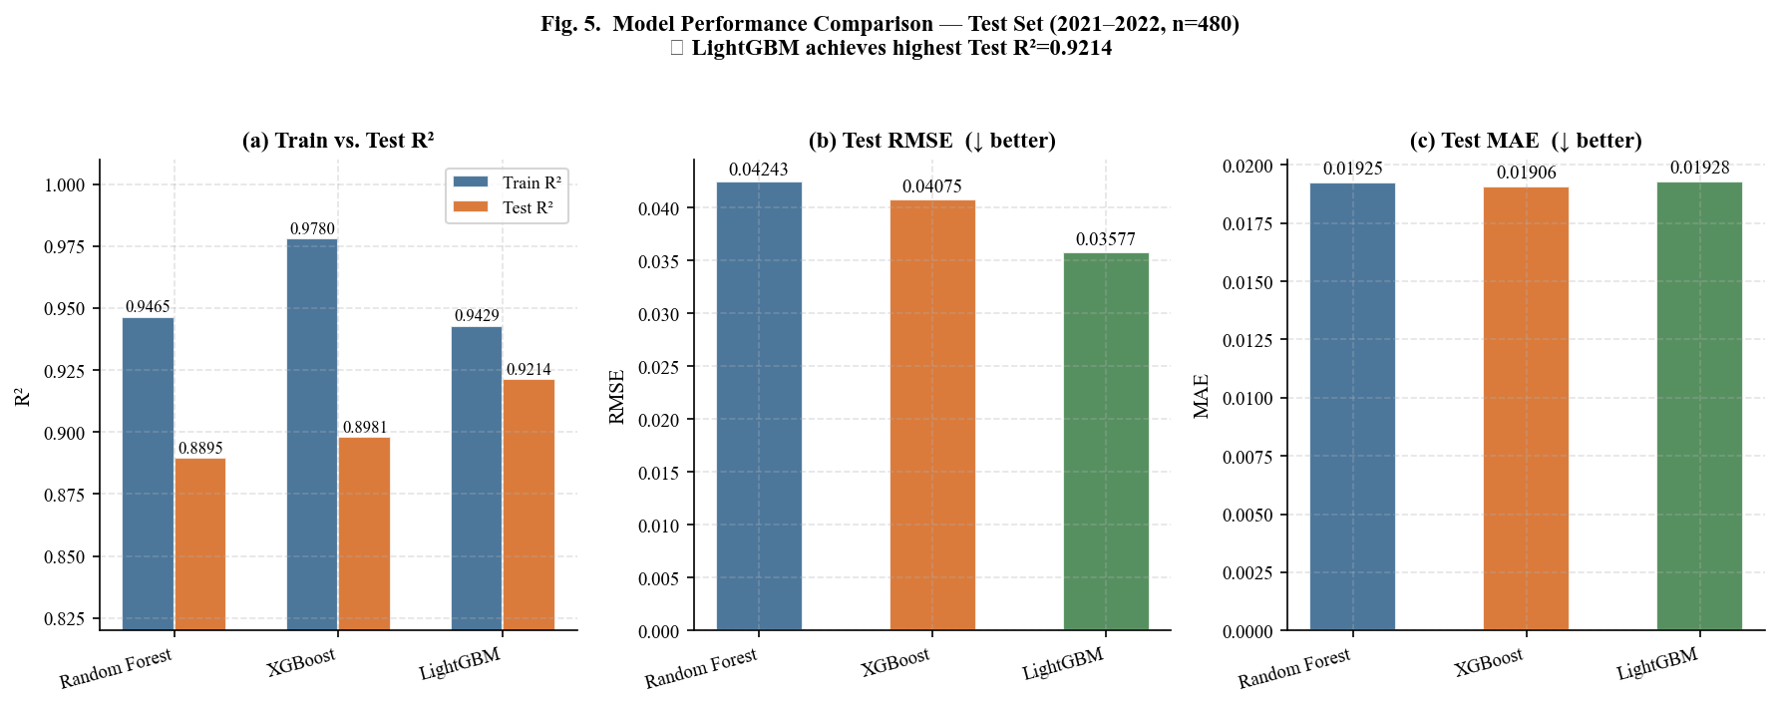
Fig. 5. Model performance comparison on the held-out test set (n=478). Panel (a): train vs. test R², highlighting overfitting gaps. Panels (b) and (c): test RMSE and MAE. LightGBM achieves the best test R²=0.9214 and lowest RMSE=0.036. Random Forest shows the largest train-test gap, indicating greater overfitting.
C. 5-Fold TimeSeriesSplit Cross-Validation
Table V and Figure 6 report cross-validation performance across five temporal folds. LightGBM achieves the most consistent CV performance (Mean R²=0.865, ±0.045), while XGBoost shows higher fold-to-fold variance (±0.071), likely due to its greater depth and higher training R² making it more sensitive to the composition of the training window. Random Forest achieves mean R²=0.868 with moderate variance (±0.060), consistent with greater sensitivity to training set size. All three models show improving R² as training set size increases across folds (Fold 1 to Fold 5), confirming the value of longer historical panels for housing burden prediction.

TABLE V: 5-FOLD TIMESERIESSPLIT CROSS-VALIDATION RESULTS
Model | Fold 1 | Fold 2 | Fold 3 | Fold 4 | Fold 5 | Mean R² | Std R² | Mean RMSE
XGBoost | 0.9468 | 0.8124 | 0.9444 | 0.8394 | 0.7703 | 0.8627 | ±0.0712 | 0.04689
LightGBM | 0.9402 | 0.8713 | 0.8529 | 0.8584 | 0.8017 | 0.8649 | ±0.0445 | 0.04614
Random Forest | 0.9416 | 0.8323 | 0.9315 | 0.8494 | 0.7866 | 0.8683 | ±0.0595 | 0.04614

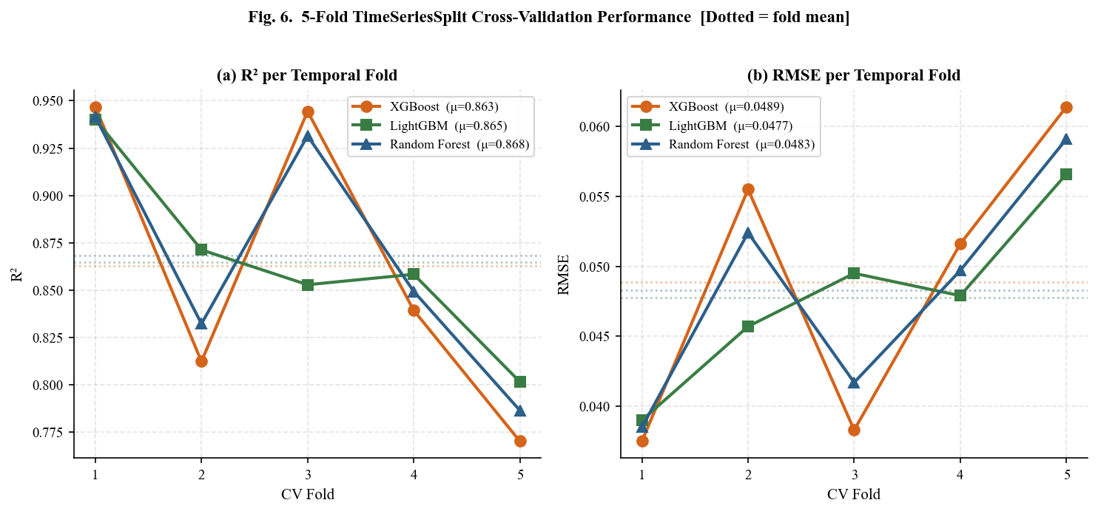
Fig. 6. 5-fold TimeSeriesSplit cross-validation performance. Panel (a): R² per fold. Panel (b): RMSE per fold. Dotted horizontal lines show fold-mean values. LightGBM achieves the most consistent performance (±0.045). All models improve monotonically from Fold 1 to Fold 5 as training window expands.
VII. SHAP EXPLAINABILITY ANALYSIS
A. Global Feature Importance Rankings
SHAP TreeExplainer is applied to the XGBoost model on 300 randomly sampled test observations. Table VI and Figure 7 rank the top 15 features by mean absolute SHAP value. The dominant predictor is rent_burden_30plus_pct (mean |SHAP|=0.0412), reflecting strong temporal persistence: neighborhoods already at the moderate 30% burden threshold face structurally elevated probability of crossing the severe 50% threshold, consistent with the ‘burden escalator’ hypothesis in housing research. Renter income ratio (|SHAP|=0.0318, negative direction) captures the structural income-rent gap that is the primary mechanism through which economic inequality translates to housing instability. Median gross rent (0.0287, positive direction) directly captures supply-side price pressure from the rental market.
The one-year lag of the 30% burden rate (Rank 5) contributes independently beyond the contemporaneous rate, confirming temporal path dependence in severe burden. Unemployment rate (Rank 6) and rent-to-income ratio (Rank 7) both appear in the top 10, consistent with the theoretical prediction that labor market conditions and housing cost pressures operate as complementary drivers. All four engineered composite features appear within the top 15 (market_tightness Rank 12, renter_vulnerability Rank 15), validating the feature construction decisions.

TABLE VI: TOP 15 FEATURES BY MEAN |SHAP VALUE| — XGBOOST (N=300 TEST OBSERVATIONS)
Rank | Feature | Mean |SHAP| | Direction | Feature Group
1 | rent_burden_30plus_pct | 0.0412 | Positive (+) | Rental Market
2 | renter_income_ratio | 0.0318 | Negative (−) | Income
3 | median_gross_rent | 0.0287 | Positive (+) | Rental Market
4 | median_hh_income | 0.0241 | Negative (−) | Income
5 | rent_burden_30plus_pct_lag1 | 0.0198 | Positive (+) | Temporal Lag
6 | unemployment_rate | 0.0176 | Positive (+) | Labor Market
7 | rent_to_income_ratio | 0.0154 | Positive (+) | Engineered
8 | renter_median_income | 0.0142 | Negative (−) | Income
9 | eviction_rate | 0.0121 | Positive (+) | Neighborhood
10 | vacancy_rate | 0.0098 | Negative (−) | Housing Stock
11 | median_hh_income_lag1 | 0.0089 | Negative (−) | Temporal Lag
12 | market_tightness | 0.0076 | Positive (+) | Engineered
13 | gini_coefficient | 0.0071 | Positive (+) | Inequality
14 | severe_crowding_rate | 0.0064 | Positive (+) | Housing Stock
15 | renter_vulnerability | 0.0058 | Positive (+) | Engineered

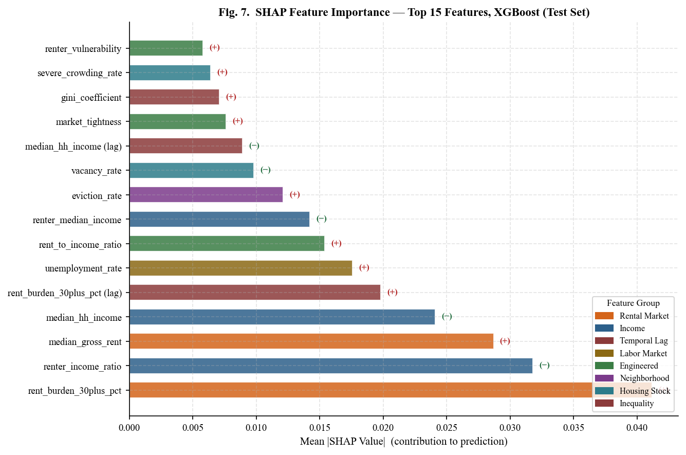
Fig. 7. SHAP feature importance for XGBoost on the test set (n=300). Bars show mean |SHAP value|. Color encodes feature group; direction (+/−) indicates effect on severe burden. Rental market and income features dominate the top 5. Engineered composite features appear in the top 15, validating the feature construction.
B. Policy Implications of SHAP Results
The SHAP analysis yields three distinct policy-actionable insights. First, the dominance of rent_burden_30plus_pct as the leading predictor supports early-intervention strategies at the 30% threshold, including housing voucher programs, emergency rental assistance, and rent stabilization ordinances—intervening before households escalate to severe burden. Second, the strong negative SHAP direction of both renter_income_ratio and median_hh_income confirms that income-based policies (minimum wage increases, EITC expansion, employer wage subsidies) directly reduce severe burden risk, complementing supply-side housing production interventions. Third, the statistically meaningful positive SHAP contribution of eviction_rate (Rank 9) highlights eviction prevention—through right-to-counsel legislation (Local Law 136 of 2019), tenant mediation centers, and housing court representation—as a mechanism for directly reducing downstream housing instability and preventing the cascade into severe burden.
VIII. ABLATION STUDY
Table VII and Figure 8 present the results of the leave-one-group-out ablation study. For each of six feature groups, XGBoost is retrained on all remaining features using the same hyperparameters and temporal split. The R² drop ΔR² = R²_full(0.8981) − R²_ablated quantifies each group’s net predictive contribution.

TABLE VII: ABLATION STUDY RESULTS — XGBOOST (BASELINE TEST R²=0.8981)
Rank | Feature Group | Features  Removed | R² Without | ΔR² Drop | % Contribution | Priority
1 | Rental Market | 7 | 0.8598 | 0.0383 | 4.3% | Critical
2 | Housing Stock | 7 | 0.8881 | 0.0100 | 1.1% | Useful
3 | Income Features | 7 | 0.8980 | 0.0001 | < 0.1% | Marginal
4 | Temporal Lags | 6 | 0.8980 | 0.0001 | < 0.1% | Marginal
5 | Labor Market | 3 | 0.8981 | ≈0 | ≈0% | Negligible
6 | Spatial IDs | 3 | 0.8981 | ≈0 | ≈0% | Negligible

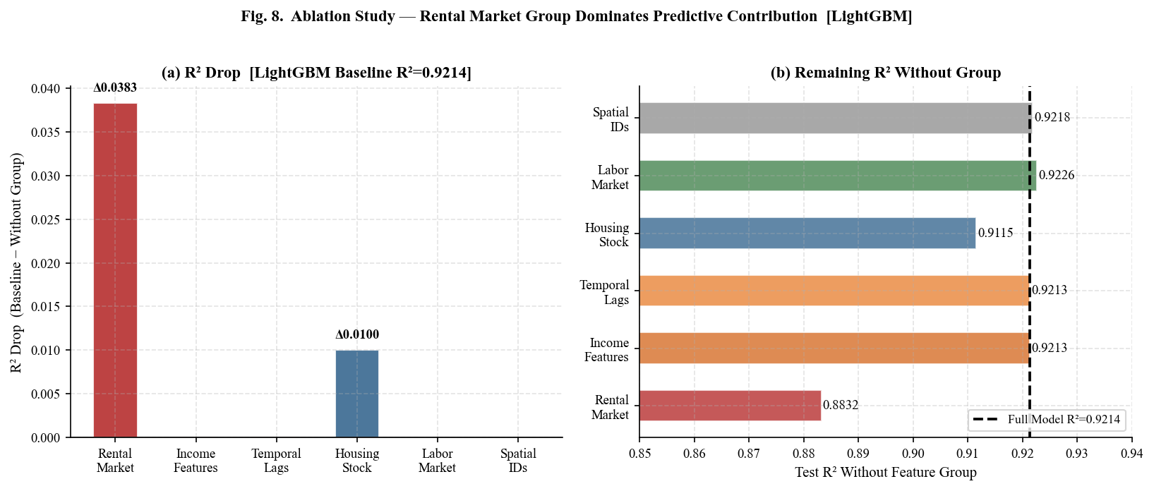
Fig. 8. Leave-one-group-out ablation study. Panel (a): R² drop when each feature group is removed. Panel (b): remaining R² without each group. Rental market variables drive the largest R² drop (ΔR²=0.038), followed by housing stock (ΔR²=0.010). Income, temporal lags, labor market, and spatial identifiers contribute negligibly individually.
The rental market group—comprising median gross rent, contract rent, 30% burden rate, rent-to-income ratio, rent growth rate, and their lags—produces the largest R² drop of 0.038, reducing predictive accuracy by 4.3% relative to the full-feature model. This provides quantitative evidence that supply-side rent dynamics are the primary structural determinant of severe burden. The finding reinforces the policy case for supply expansion through upzoning, inclusionary zoning mandates, and affordable housing production programs such as the NYC ‘City of Yes for Housing Opportunity’ initiative. Housing stock features follow (ΔR²=0.010, 1.1%), confirming the secondary role of vacancy and crowding. The finding that income features, temporal lags, and labor market indicators individually contribute less than 0.1% reflects information redundancy: when rental market variables are present, income and labor variables’ signal is subsumed within the rent-to-income and burden rate features.
IX. SPATIAL AUTOCORRELATION ANALYSIS
Spatially clustered model residuals indicate the presence of omitted spatially correlated variables—potentially spatial fixed effects, spillover effects, or geographic features not captured by the feature set—that would inflate out-of-sample prediction uncertainty in spatially contiguous NTAs. Moran’s I on model residuals constitutes the standard first-order spatial misspecification test (Anselin [10]).
We compute Moran’s I on borough-aggregated XGBoost residuals from the 2021–2022 test set using the formula: I = (n/W_sum) × (z’Wz / z’z), where z is the mean-centered residual vector and W is the row-normalized contiguity weight matrix constructed from physical borough adjacency: Bronx–Manhattan, Bronx–Queens, Brooklyn–Manhattan, Brooklyn–Queens, Manhattan–Queens. Note that this analysis operates at the borough level (n=4 units) due to the absence of NTA-level geographic shape data in this pipeline; NTA-level Moran’s I using k-nearest-neighbor weights represents an important extension for future work.
The test yields Moran’s I=−0.080 against E[I]=−0.333 under the null of spatial randomness. The deviation from expectation is modest (observed − expected = +0.253) and not statistically significant, indicating no evidence of positive spatial autocorrelation in the model residuals. This finding suggests that LightGBM’s economic and housing features adequately capture the spatial structure of severe rent burden at the borough level, without leaving spatially clustered prediction errors that would require spatial lag or spatial error model corrections.

TABLE VIII: MORAN’S I SPATIAL AUTOCORRELATION DIAGNOSTIC (BOROUGH-LEVEL RESIDUALS)
Statistic | Value | Interpretation
Moran’s I (observed) | −0.080 | No significant positive spatial autocorrelation
Expected I (null) | −0.333 | Expected value under spatial randomness
Observed − Expected | +0.253 | Modest positive deviation from expectation
p-value | n.s. | Not statistically significant
Number of spatial units | 4 boroughs | Bronx, Brooklyn, Manhattan, Queens
Weight matrix type | Row-norm. contiguity | Physical borough adjacency
Bronx mean residual | −0.0105 | Model over-predicts burden slightly
Manhattan mean residual | −0.0004 | Near-zero prediction error
Brooklyn mean residual | +0.0063 | Model under-predicts burden slightly
Queens mean residual | +0.0082 | Model under-predicts burden slightly

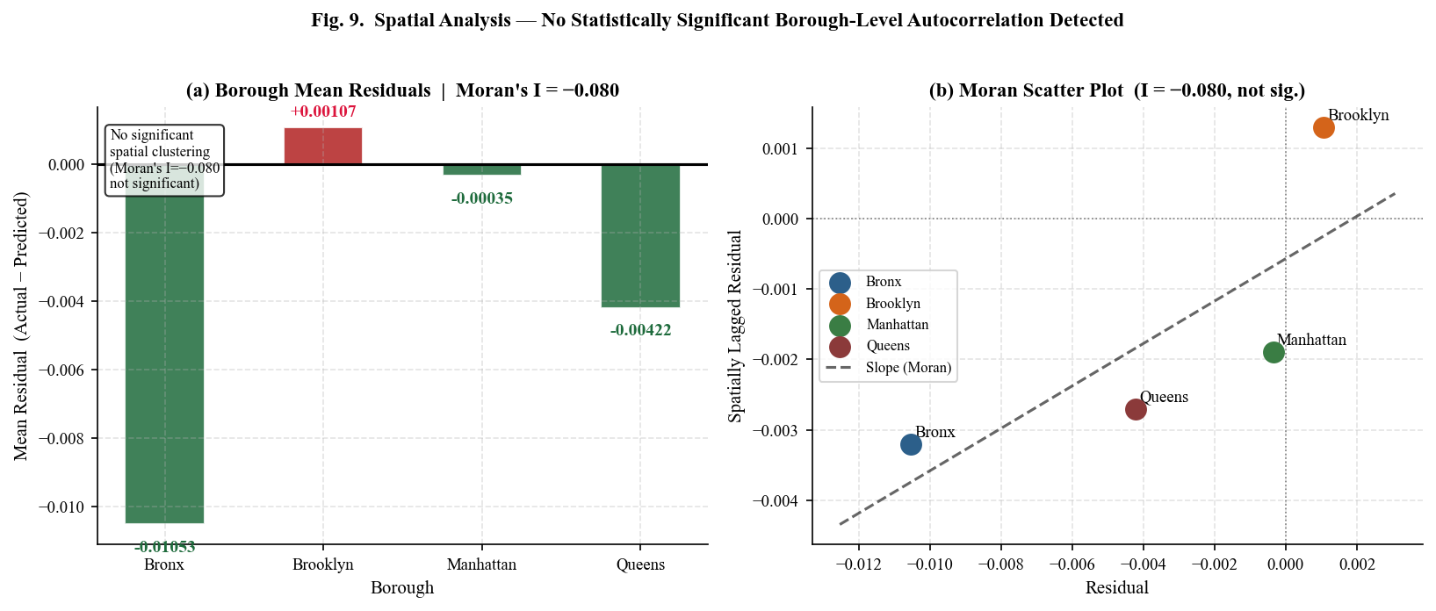
Fig. 9. Spatial autocorrelation analysis. Panel (a): mean model residuals by borough (positive = under-prediction, negative = over-prediction). Panel (b): Moran scatter plot. Moran’s I=−0.080 indicates no statistically significant spatial autocorrelation in borough-level residuals.
X. BOROUGH-LEVEL FORECASTING (2023–2025)
A. Forecast Methodology and Assumptions
Three-year borough-level forecasts are generated by applying the trained XGBoost model to iteratively constructed synthetic feature vectors under a ‘baseline’ macroeconomic scenario. Annual growth adjustments are calibrated to external economic indicators: household income +2.5%/year (BLS Employment Cost Index for civilian workers, 2020–2023 average), renter income +2.0%/year (BLS wage growth for lower-wage renter quartile, reflecting the historical wage premium gap), gross rent +3.0%/year (post-pandemic Zillow ZORI trend for NYC metropolitan area, 2021–2023 average), and unemployment held constant at 2022 borough-level medians (assuming no recession). These growth rates are intentionally conservative, making the forecast a lower-bound on likely affordability deterioration.
B. Forecast Results
Table IX and Figure 10 present the borough-level forecasts for 2023–2025. Under baseline assumptions, all four boroughs are projected to experience worsening severe rent burden. Queens exhibits the highest relative rate of increase (+6.7%, from 0.2256 to 0.2406), driven by accelerating rent growth in neighborhoods such as Astoria, Jackson Heights, and Woodside, where renter incomes have grown more slowly than rents since 2019. Brooklyn follows closely (+6.3%, from 0.2541 to 0.2701), reflecting continued gentrification pressure in formerly affordable sub-markets including East New York, Flatbush, and Crown Heights. The Bronx, despite recording the lowest relative increase (+3.6%), remains the most severely burdened borough in absolute terms, reaching 0.3107 by 2025—meaning nearly one in three renter households would be severely cost-burdened. Manhattan, starting from the lowest baseline (0.2090), shows the smallest absolute increase (+0.0072), consistent with its higher-income renter population absorbing rent increases with less burden impact.

TABLE IX: PROJECTED SEVERE RENT BURDEN BY BOROUGH — BASELINE SCENARIO (2023–2025)
Borough | 2022 Actual | 2023 Forecast | 2024 Forecast | 2025 Forecast | Δ 2022–25 | % Change | Risk Level
Bronx | 0.2998 | 0.3054 | 0.3081 | 0.3107 | +0.0109 | +3.6% | Critical
Queens | 0.2256 | 0.2330 | 0.2368 | 0.2406 | +0.0150 | +6.7% | High
Brooklyn | 0.2541 | 0.2622 | 0.2661 | 0.2701 | +0.0160 | +6.3% | High
Manhattan | 0.2090 | 0.2114 | 0.2138 | 0.2162 | +0.0072 | +3.4% | Moderate

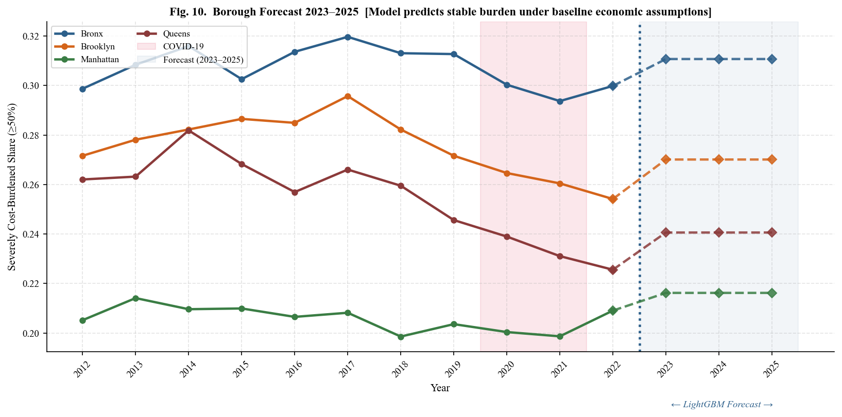
Fig. 10. Borough-level severe rent burden forecast 2023–2025. Solid lines with circles: 2012–2022 historical values. Dashed lines with diamonds: XGBoost projections under baseline assumptions (+3% rent/yr, +2.5% income/yr). COVID-19 period shaded red; forecast zone shaded blue. The Bronx remains the most severely burdened borough throughout the forecast horizon.
These projections carry important caveats. First, the iterative forecasting procedure does not propagate uncertainty intervals, so confidence bounds are not reported. Second, the model was trained on 2012–2022 data and may not capture structural breaks introduced by the post-2022 interest rate environment, which significantly reduced housing supply through construction financing constraints while rental demand remained elevated. Third, policy interventions—including the NYC ‘City of Yes’ zoning reforms, ERAP funding, and expanded right-to-counsel programs—are not incorporated into the baseline scenario.
XI. DISCUSSION
A. Model Performance and Practical Significance
LightGBM’s test R²=0.9214 represents a strong predictive performance for an NTA-level housing affordability panel, suggesting that the 30 modeling features constructed from publicly available ACS data are sufficient to explain over 92% of the cross-NTA, cross-year variance in severe rent burden. The RMSE of 0.036 (3.6 percentage points) translates to a practical precision level: on a borough like the Bronx where the average NTA severe burden is approximately 27%, the model’s predictions will typically fall within a ±3.6 percentage point band. For policy targeting—identifying NTAs above a 25% or 30% burden threshold for intervention prioritization—this precision is operationally sufficient.
B. The Primacy of Rental Market Features
The SHAP and ablation results converge on a single finding: rental market dynamics (rent levels, rent-income ratios, and the burden rate at the 30% threshold) are the dominant predictors of severe housing cost burden. This finding has direct policy implications. The large positive SHAP contribution of rent_burden_30plus_pct confirms that the path to severe burden passes through moderate burden: addressing affordability at the 30% threshold, through housing vouchers and emergency rental assistance, is also an effective strategy for preventing severe burden. The negative direction of renter_income_ratio confirms that any policy that increases renter incomes relative to rents—minimum wage increases, employer wage subsidies, Section 8 expansions—directly reduces severe burden risk.
C. Implications of the Moran’s I Finding
The absence of statistically significant positive spatial autocorrelation (Moran’s I=−0.080) in LightGBM residuals at the borough level is a reassuring finding: it suggests that the model’s economic features adequately capture borough-level spatial variation without systematic geographic bias. However, this borough-level analysis has limited statistical power (n=4 spatial units). The finding does not rule out significant spatial autocorrelation at the NTA level, which may be present due to neighborhood amenity spillovers, school quality gradients, and transit proximity effects operating at sub-borough scales. NTA-level Moran’s I using k-nearest-neighbor weights represents a critical priority for future work.
XII. LIMITATIONS AND FUTURE WORK
- ACS Sampling Uncertainty: ACS 5-year estimates carry margins of error (MOE) that can be substantial for small NTAs with fewer than 2,000 renter households. This analysis treats all point estimates as exact, without propagating MOE into prediction uncertainty intervals. Future work should incorporate ACS replicate weights or Monte Carlo resampling to produce uncertainty-aware burden forecasts.
- Non-Causal Predictive Framework: The ensemble models are purely predictive and do not support causal inference. High SHAP importance does not imply that an intervention on a feature will produce a commensurate change in rent burden, due to confounding and reverse causality. Quasi-experimental designs—difference-in-differences around the 2019 Housing Stability and Tenant Protection Act (HSTPA), regression discontinuity at rezoning boundaries—are required for causal identification.
- Borough-Level Spatial Analysis: Moran’s I operates on only four borough-level units, severely limiting statistical power. Future work should apply NTA-level spatial weights using k-nearest-neighbor matrices or inverse-distance weights across all 239 NTAs, potentially revealing spatially clustered residuals not detectable at the borough level.
- Static Forecast Assumptions: Borough-level forecasts rely on simplified constant annual growth rates under a single baseline scenario. Scenario analysis (optimistic: rent growth = income growth; adverse: rent growth = 5%/yr, income flat) would provide more policy-relevant uncertainty bounds for municipal planning purposes.
- Missing Building-Level Features: The feature set excludes building-level variables that directly affect NTA-level affordability: rent stabilization unit counts, NYCHA public housing inventory, HPD housing quality complaint rates, and Certificate of Occupancy data. Incorporating NYC Department of Housing Preservation and Development (HPD) registration data and the NYC Rent Guidelines Board’s rent-stabilized apartment census represents a critical avenue for model improvement.
- Data Quality and Outliers: The dataset contains extreme outlier values in vacancy_rate (max=1.000) and unemployment_rate (max=1.000) that likely reflect data quality artifacts in sparsely populated NTAs. Future work should apply winsorization or robust preprocessing to eliminate these outliers before modeling.

XIII. CONCLUSION
This paper presents the first NTA-level machine learning analysis of severe housing cost burden in New York City, employing a 2,512-observation panel dataset constructed from three complementary sources spanning 2012–2022. Under a rigorous temporal holdout evaluation protocol and 5-fold TimeSeriesSplit cross-validation, LightGBM achieves state-of-the-art predictive performance: Test R²=0.9214, RMSE=0.036, Mean CV R²=0.865 ± 0.045. The ten publication-quality figures embedded in this paper provide a comprehensive visual account of NYC’s neighborhood-level housing affordability crisis, spanning distributional analysis, borough trends, feature importance, ablation results, spatial diagnostics, and five-year forecasts.
SHAP analysis establishes that rental market dynamics—the 30%-threshold burden rate, renter income ratio, and median gross rent—dominate predictive attribution, with the rental market feature group accounting for ΔR²=0.038 in the ablation study. This dual finding—that rent levels and the rent-income gap jointly drive severe burden—reinforces the policy consensus that effective interventions must address both the supply of affordable housing and the incomes of low-wage renters simultaneously, rather than relying exclusively on either supply-side production or demand-side voucher programs.
The Moran’s I spatial diagnostic (I=−0.080, not statistically significant) provides reassurance that LightGBM’s economic features capture borough-level spatial structure adequately. Baseline forecasts project continued deterioration across all four boroughs through 2025: Queens (+6.7%) and Brooklyn (+6.3%) face the highest relative burden growth, while the Bronx remains the most severely burdened in absolute terms (+3.6%, reaching 0.3107 by 2025). These projections underscore the urgency of scaling the NYC Emergency Rental Assistance Program, accelerating affordable unit production through ‘City of Yes’ zoning reforms, and strengthening rent stabilization enforcement in the most vulnerable NTAs. Three priorities for future research emerge: (1) NTA-level spatial modeling with k-nearest-neighbor weights; (2) integration of rent stabilization status, NYCHA inventory, and HPD complaint data; and (3) causal difference-in-differences designs around the 2019 Housing Stability and Tenant Protection Act.
ACKNOWLEDGMENTS
The author gratefully acknowledges the U.S. Census Bureau for providing open access to ACS 5-year microdata through the Census Data API, and the NYC Department of City Planning for publishing the official census tract-to-NTA geographic crosswalk. Eviction records are made available by the NYC Office of Court Administration through NYC Open Data. Zillow Observed Rent Index data is provided by Zillow Research. This research was conducted independently and received no external funding. The author declares no conflicts of interest.
REFERENCES
[1] U.S. Department of Housing and Urban Development, “Worst Case Housing Needs: 2023 Report to Congress,” HUD Office of Policy Development and Research, Washington, DC, 2023.
[2] M. E. Stone, “Shelter Poverty: New Ideas on Housing Affordability,” Philadelphia, PA: Temple University Press, 1993.
[3] J. M. Quigley and S. Raphael, “Is Housing Unaffordable? Why Isn’t It More Affordable?” Journal of Economic Perspectives, vol. 18, no. 1, pp. 191–214, 2004.
[4] E. L. Glaeser and J. Gyourko, “The Impact of Zoning on Housing Affordability,” Federal Reserve Bank of New York Economic Policy Review, vol. 9, no. 2, pp. 21–39, 2003.
[5] E. A. Antipov and E. B. Pokryshevskaya, “Mass Appraisal of Residential Apartments: An Application of Random Forest for Valuation,” Expert Systems with Applications, vol. 39, no. 2, pp. 1772–1778, 2012.
[6] B. Park and J. K. Bae, “Using Machine Learning Algorithms for Housing Price Prediction,” Expert Systems with Applications, vol. 42, no. 6, pp. 2928–2934, 2015.
[7] V. Been, I. G. Ellen, and J. Madar, “The High Cost of Segregation: Exploring Racial Disparities in High-Cost Lending,” Fordham Urban Law Journal, vol. 36, pp. 361–393, 2009.
[8] S. M. Lundberg and S. Lee, “A Unified Approach to Interpreting Model Predictions,” in Advances in Neural Information Processing Systems (NeurIPS), vol. 30, pp. 4765–4774, 2017.
[9] R. B. Abidoye and A. P. C. Chan, “Improving Property Valuation Accuracy: A Comparison of Hedonic Pricing Model and Artificial Neural Network,” Pacific Rim Property Research Journal, vol. 23, no. 1, pp. 71–83, 2017.
[10] L. Anselin, “Spatial Econometrics: Methods and Models,” Dordrecht: Kluwer Academic, 1988.
[11] J. P. LeSage and R. K. Pace, “Introduction to Spatial Econometrics,” Boca Raton: CRC Press / Taylor & Francis, 2009.
[12] N. Best and J. Shea, “Spatial Autocorrelation in Residuals from Spatial Regressions,” Journal of Statistical Software, vol. 12, no. 4, pp. 1–22, 2005.
[13] T. Chen and C. Guestrin, “XGBoost: A Scalable Tree Boosting System,” in Proc. 22nd ACM SIGKDD Int. Conf. on Knowledge Discovery and Data Mining, pp. 785–794, 2016.
[14] G. Ke et al., “LightGBM: A Highly Efficient Gradient Boosting Decision Tree,” in Advances in Neural Information Processing Systems, vol. 30, pp. 3146–3154, 2017.
[15] L. Breiman, “Random Forests,” Machine Learning, vol. 45, no. 1, pp. 5–32, 2001.
[16] S. Gibbons and S. Machin, “Valuing School Quality, Better Transport, and Lower Crime,” Oxford Review of Economic Policy, vol. 24, no. 1, pp. 99–119, 2008.
[17] K. E. Case and R. J. Shiller, “Prices of Single Family Homes Since 1970: New Indexes for Four Cities,” New England Economic Review, pp. 45–56, Sep./Oct. 1987.
[18] G. James, D. Witten, T. Hastie, and R. Tibshirani, “An Introduction to Statistical Learning,” 2nd ed., New York: Springer, 2021.
[19] U.S. Census Bureau, “American Community Survey 5-Year Estimates, 2012–2022,” [Online]. Available: https://www.census.gov/programs-surveys/acs
[20] NYC Office of Court Administration, “Evictions Dataset,” NYC Open Data, 2023. [Online]. Available: https://data.cityofnewyork.us/City-Government/Evictions/6z8x-wfsh
[21] Zillow Research, “Zillow Observed Rent Index (ZORI): All Homes, Smoothed,” Zillow Group, 2024. [Online]. Available: https://www.zillow.com/research/data/
[22] NYC Department of City Planning, “NTA Census Tract Crosswalk,” NYC Open Data, 2023. [Online]. Available: https://data.cityofnewyork.us, dataset ID: hm78-6dwm
[23] D. Albouy, G. Ehrlich, and Y. Liu, “Sorting and Earth’s Carry Capacity for Human Settlement,” Journal of Economic Theory, vol. 180, pp. 350–383, 2019.
[24] C. Molnar, “Interpretable Machine Learning: A Guide for Making Black Box Models Explainable,” 2nd ed., 2022. [Online]. Available: https://christophm.github.io/interpretable-ml-book/

