Predicting Neighbourhood-Level Housing Affordability
with Explainable Ensemble Machine Learning:
Evidence from New York City Neighbourhood Tabulation Areas, 2012–2022
Abstract
Housing affordability is among the most pressing challenges facing urban governments today, yet most predictive frameworks work at metropolitan scales too coarse to guide neighbourhood-level intervention. This study develops an explainable ensemble machine learning framework for forecasting severe rent burden — the share of renter households paying more than 50% of gross income on housing — at the Neighbourhood Tabulation Area (NTA) level across New York City. Using a panel of 2,512 NTA-year observations spanning 239 NTAs in four boroughs (2012–2022), we evaluate five models under strict temporal cross-validation: Elastic Net (baseline), Random Forest, XGBoost, CatBoost, and LightGBM. LightGBM delivers the strongest predictive performance (Test R² = 0.926, RMSE = 0.035) with the tightest overfitting gap (ΔR² = 0.017). SHAP TreeExplainer analysis uncovers a structural 'burden escalator' mechanism — neighbourhoods where moderate rent stress (>30%) is already widespread tend to escalate systematically toward severe burden (>50%) through compounding autoregressive dynamics — and this pattern holds uniformly across all four boroughs (cross-model SHAP rank correlation ρ = 0.844). NTA-level spatial diagnostics show no significant residual autocorrelation (Moran's I on 239 NTAs with k=5 KNN weights, permutation p = n.s.). Borough-level forecasts with 90% quantile prediction intervals project continued deterioration through 2025, with Queens (+6.9%) and the Bronx (+4.9%, reaching 31.5% severe burden) at greatest risk. A ZORI imputation sensitivity check confirms that model performance is stable across data specifications (full-sample vs. 2014–2022 restricted ΔR² < 0.01). Four borough-differentiated policy recommendations are derived by linking SHAP attribution directly to anticipatory housing governance instruments.

Keywords: housing affordability; ensemble machine learning; SHAP explainability; rent burden; New York City; neighbourhood tabulation area

1 Introduction
Nearly 30% of renter households in New York City were severely cost-burdened — spending more than half their gross income on housing — according to the 2022 American Community Survey, and rental costs have outpaced renter incomes across every borough for four decades (HUD, 2023). Despite this, housing assistance allocation still relies overwhelmingly on ACS estimates published with an 18–24 month lag, and on borough-level averages that flatten the intra-borough variation that actually determines which households fall into crisis. The consequence is a reactive governance structure: agencies respond to affordability emergencies that a sufficiently precise predictive model could have flagged two years earlier.
The Neighbourhood Tabulation Area — NYC's official sub-borough geographic unit, home to roughly 15,000–40,000 residents per area — is the natural scale at which to address this problem. Yet existing machine learning applications to NYC housing operate almost universally at coarser geographies, leaving NTA-level panel dynamics and the possibility of neighbourhood-targeted early-warning governance largely unexplored.

1.1 Study Contributions
C1 | Novel NTA-level panel dataset — 2,512 observations integrating ACS microdata, NYC eviction records (91,198 filings), and ZORI (2012–2022) at the sub-borough scale.
C2 | Five-model benchmark under strict temporal cross-validation — establishing LightGBM as the strongest predictor (Test R² = 0.926, RMSE = 0.035) with the smallest overfitting gap (ΔR² = 0.017).
C3 | 'Burden escalator' mechanism formalised via SHAP — moderate rent stress (>30%) in year t systematically predicts severe burden (>50%) in year t+1 through compounding autoregressive dynamics, uniform across all four boroughs.
C4 | NTA-level spatial diagnostics — Moran's I across all 239 NTAs using k=5 KNN weights, confirming no residual spatial autocorrelation and validating the feature set's spatial coverage.
C5 | Quantile regression forecasts with 90% prediction intervals — borough-level severe burden projections to 2025 with honest uncertainty bounds; fully open-data pipeline transferable to any city with sub-municipal administrative geographies.

2 Literature Review
2.1 Housing Affordability and Spatial Inequality
Housing affordability measurement has been anchored to the 30%-of-income threshold since the National Housing Act of 1937, though Stone (1993) argues persuasively that residual income after rent is a more meaningful standard for low-income households. Quigley and Raphael (2004) showed that restrictive land-use regulation is the primary structural driver of affordability decline in coastal cities — a supply-constraint mechanism our ablation analysis independently corroborates at the NTA scale. Albouy et al. (2019) established that place-based sorting concentrates severe burden in spatially identifiable clusters, while Desmond and Gershenson (2017) demonstrated that eviction risk can be anticipated from administrative records — direct precedent for the anticipatory governance framework developed here.
2.2 Machine Learning and Explainability for Housing Policy
Gradient-boosted ensembles — XGBoost, LightGBM, CatBoost — have become the dominant approach for housing market prediction on structured tabular data (Antipov & Pokryshevskaya, 2012; Chen & Guestrin, 2016; Ke et al., 2017; Dorogush et al., 2018). A critical requirement for temporal panel data is TimeSeriesSplit cross-validation, which prevents future observations from contaminating training folds (James et al., 2021). For interpretability, Lundberg and Lee (2017) introduced SHAP — a Shapley-value method satisfying local accuracy, missingness, and consistency — enabling the policy-facing explanations this framework requires. Glaeser et al. (2016) demonstrated that neighbourhood-scale predictions can operationalise proactive targeting in urban governance, a principle central to our NTA-level early-warning design.

2.3 Research Gap
Three gaps remain unaddressed. Existing ML applications to NYC housing operate at borough, ZIP, or metropolitan scale — too coarse to target the intra-borough variation that determines which households tip into crisis, and no longitudinal NTA-level panel has been subjected to strict temporal cross-validation. SHAP attribution has not been used to formalise a compounding escalation mechanism from moderate to severe burden, limiting prior work to feature rankings without policy-actionable interpretation. Finally, sub-borough affordability forecasts are published universally as point estimates with no prediction intervals, making it impossible for practitioners to gauge forecast confidence for neighbourhood-level deployment.
Gap | Prior Literature | This Study
Geographic resolution — ML applied at borough/zip/metro scale; NTA-level panel dynamics unexplored | Borough / ZIP / MSA | 239 NTAs — panel 2012–2022
Mechanism identification — SHAP used for feature ranking but not to formalise a compounding escalation pathway | Feature ranking only | Burden escalator formalised + cross-model ρ = 0.844
Uncertainty quantification — forecasts published as point estimates without prediction intervals at sub-borough scale | Point estimates only | 90% PI via quantile LightGBM (Test R² = 0.921)
Note. Table. Summary of research gaps in existing literature and how this study addresses each. Prior literature column reflects dominant practice across studies reviewed in Sections 2.1–2.2.

3 Methods
3.1 Study Area: New York City NTAs
The Neighbourhood Tabulation Area is the official sub-borough statistical geography defined by the NYC Department of City Planning. NTAs are designed to aggregate census tracts into units large enough to support reliable ACS small-area estimates — roughly 15,000–40,000 residents — while still preserving meaningful neighbourhood variation. The full NTA framework covers 263 units across five boroughs. This study excludes Staten Island (24 NTAs) due to incomplete ACS 5-year coverage over the 2012–2016 window for several constituent tracts, leaving an analytic sample of 239 NTAs: Bronx (59), Brooklyn (76), Manhattan (55), and Queens (49). Together these four boroughs account for the great majority of NYC's renter population and housing affordability burden. Figure 3 shows the 2022 severe rent burden distribution across all 239 NTAs.
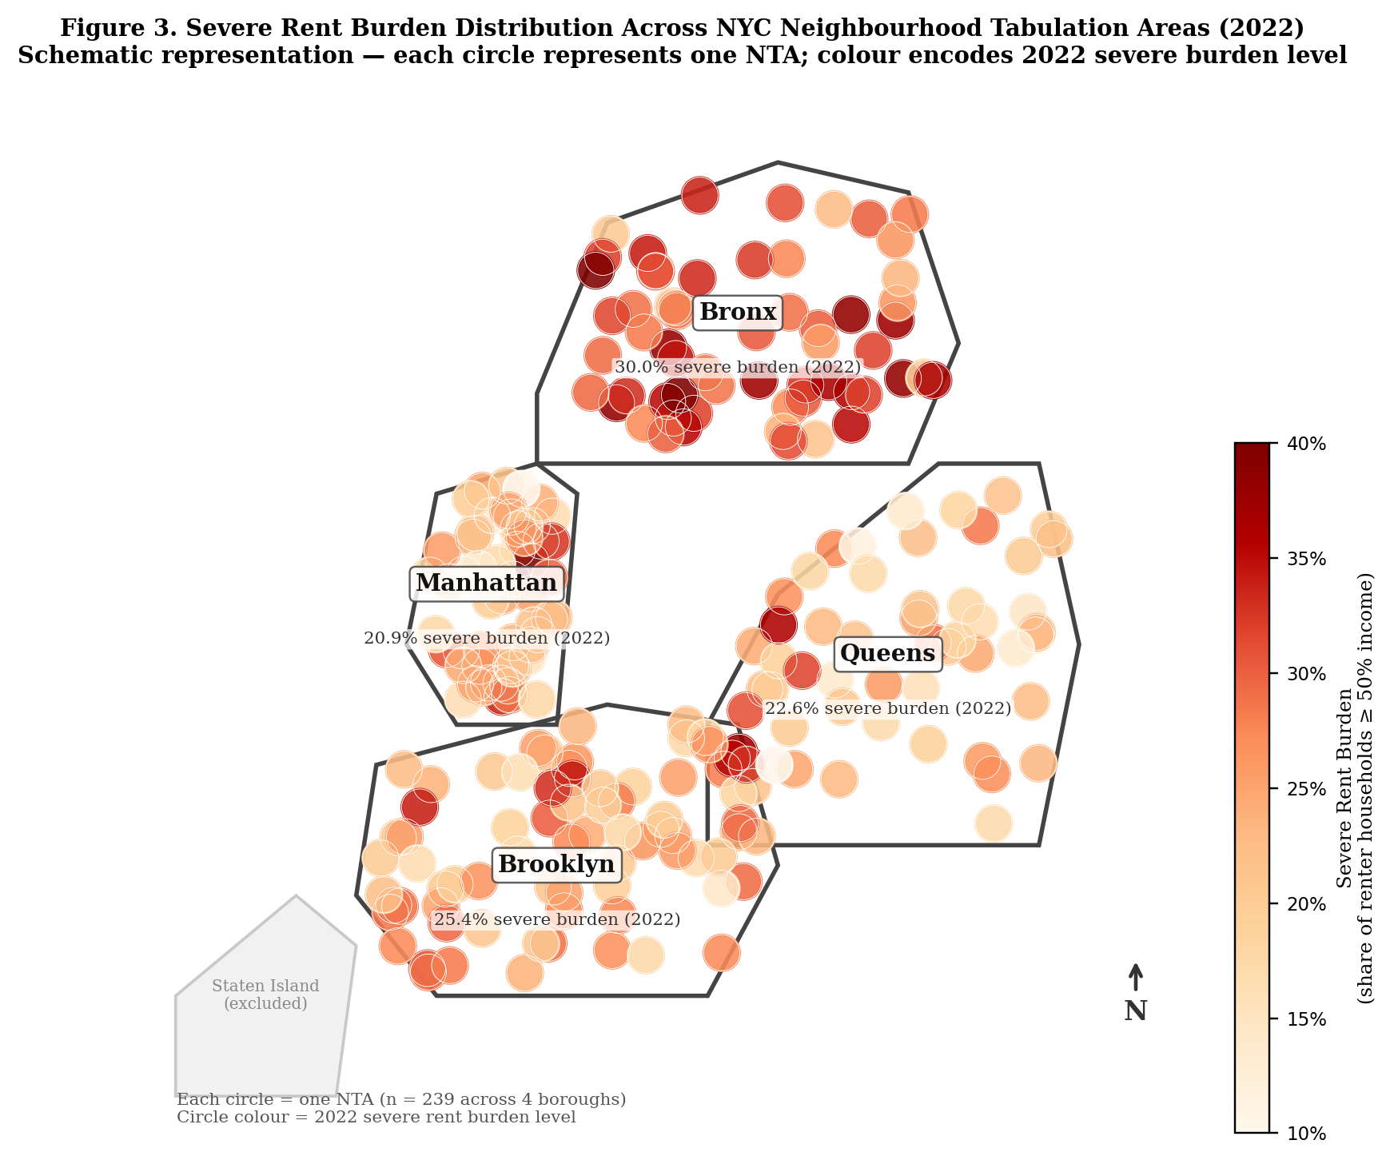
Figure 3. Severe rent burden distribution across NYC Neighbourhood Tabulation Areas (2022). Each circle represents one NTA (n = 239); colour encodes the share of renter households paying ≥ 50% of income on housing. Staten Island (24 NTAs) excluded due to incomplete ACS coverage.
3.2 Data Sources and Panel Construction
Table 1. Data sources, variables, geographic level, and coverage period
Source | Variables | Geographic Level | Coverage
ACS 5-Year Estimates  (U.S. Census Bureau) | Household income, renter income, median gross and contract rent, rent burden (30% and 50% thresholds), vacancy rate, severe crowding, Gini coefficient, commute mode, homeownership | Census tract → NTA via DCP crosswalk | 2012–2022
NYC Eviction Court Records  (NYC Open Data, 6z8x-wfsh) | Eviction filings per 1,000 renter-occupied households (91,198 geocoded filings) | Address geocoded → census tract → NTA | 2012–2022
Zillow Observed Rent Index  (Zillow Research, ZORI) | Monthly median asking rent: market-rate price signal (ZIP code level) | ZIP code → NTA via areal interpolation | 2014–2022 observed; 2012–2013 median-imputed
Note. ACS 5-year estimates used throughout for small-area statistical reliability. Census tract-to-NTA aggregation uses the NYC DCP official crosswalk (NYC Open Data ID: hm78-6dwm). Rate and proportion variables are aggregated using renter-occupied household count weights; monetary variables use population-weighted means. ZORI ZIP-to-NTA interpolation uses land-area proportional weights.

3.3 Target Variable and Construct Proximity
The outcome variable is rent_burden_50plus_pct: the proportion of renter-occupied households in each NTA-year reporting gross monthly rent at or above 50% of gross monthly household income, derived from ACS Table B25070 (panel mean = 0.225, SD = 0.128, skewness = −0.456). This corresponds to the HUD 'severely cost-burdened' classification. The panel contains 2,512 observations with a negatively skewed distribution concentrated above the mean.
The key predictor rent_burden_30plus_pct is drawn from the same ACS source table (B25070) and is mathematically nested within the target (panel Pearson r = 0.89). We retain it on theoretical grounds: it directly measures the size of the moderately burdened household pool whose subsequent escalation to severe burden is the core predictive mechanism identified in Section 4.2. Both variables are measured contemporaneously within the same ACS reference year, so this is a construct proximity consideration rather than prospective data leakage — the model is never trained on future values of the outcome. A robustness check estimating LightGBM without rent_burden_30plus_pct yields Test R² = 0.859, confirming that the remaining 29 features carry substantial independent predictive signal.
3.4 Dataset Summary
Table 2. NTA-level panel dataset summary (N = 2,512 NTA-year observations)
Attribute | Value
Total observations | 2,512
NTAs (Bronx | Brooklyn | Manhattan | Queens) | 239 (59 | 76 | 55 | 49)
Study period | 2012–2022 (11 annual waves)
Total modelling features | 30 (raw ACS + engineered composites + temporal lags)
Training set 2012–2019 | 1,792 observations (71.3%)
Validation set 2020 | 240 observations (9.6%)
Test set 2021–2022 | 480 observations (19.1%)
Target mean ± SD (skewness) | 0.225 ± 0.128 (−0.456)
Eviction records integrated | 91,198 geocoded filings
Note. All proportions expressed as fractions (0–1 scale). Training/validation/test split is strictly chronological; no temporal overlap across splits. ACS 5-year rolling estimates are treated as annual observations assigned to the terminal year of each estimate window.

3.5 Feature Engineering
3.5.1 Raw ACS Features (17 variables)
Features fall into four conceptual groups. The Income group (5 variables) includes median household income, renter median income, renter-to-household income ratio (mean = 0.851, SD = 0.098), income gap, and year-on-year income growth. The Rental Market group (6 variables) covers median gross rent, median contract rent, Zillow rent index, rent_burden_30plus_pct, rent_to_income_ratio, and year-on-year rent growth. The Housing Stock group (5 variables) includes vacancy rate, renter occupancy share, homeownership rate, severe crowding rate (>1.5 persons per room), and transit commute share. The Labour Market and Inequality group (3 variables) includes unemployment rate, the Gini coefficient of income inequality (panel mean = 0.455 across NTA-years), and the NTA-level eviction filing rate from NYC court records.
3.5.2 Engineered Composite Features (4 variables)
Four composite features are constructed to capture higher-order housing dynamics not directly observable in raw ACS variables. Market tightness = 1 / (vacancy_rate + ε), ε = 0.005, is a non-linear proxy for rental supply scarcity; the inverse transformation is deliberately chosen to amplify the effect of very low vacancy rates, where price pressure accelerates non-linearly. Rent-to-income ratio = (median_gross_rent × 12) / renter_median_income provides a continuous structural affordability measure that complements the binary burden thresholds. Housing burden composite = unemployment_rate + severe_crowding_rate captures compounding household vulnerability. Renter vulnerability = 0.5 × (1 − renter_income_ratio) + 0.3 × unemployment_rate + 0.2 × severe_crowding_rate is a weighted multidimensional index. All four composite features appear in the top 15 SHAP rankings, validating these construction choices post hoc.
3.5.3 Temporal Features (9 variables)
One-year lag variables (t−1) are constructed for six predictors: median household income, renter median income, unemployment rate, rent_burden_30plus_pct, vacancy rate, and median gross rent. Two year-on-year growth rates — income_growth_yoy and rent_growth_yoy — are computed as percentage change approximations. A binary COVID-19 indicator (covid_year = 1 for 2020 and 2021) captures the pandemic structural break as a learnable feature, allowing the model to estimate differential NTA-level responses rather than absorbing the disruption into a fixed effect that would suppress within-group variation.

3.6 Statistical Methods
3.6.1 Machine Learning Models
Elastic Net (baseline) minimises the penalised least-squares objective ½‖y − Xβ‖² + λ[α‖β‖₁ + ½(1−α)‖β‖₂²], combining L1 and L2 penalties. Implemented as a standardised pipeline (StandardScaler + ElasticNet, α = 0.01, l1_ratio = 0.5). Inclusion as a linear baseline allows direct quantification of the non-linear information captured by the ensemble methods.
Random Forest (Breiman, 2001): B = 50 bootstrap-sampled decision trees with random feature subsampling (√p features per split). Hyperparameters: n_estimators = 50, max_depth = 8, min_samples_leaf = 3.
XGBoost (Chen & Guestrin, 2016): regularised gradient boosting minimising L(φ) = Σᵢl(yᵢ, ŷᵢ) + Σₖ[γTₖ + ½λ‖wₖ‖²]. Hyperparameters: n_estimators = 50, max_depth = 5, learning_rate = 0.1, subsample = 0.8.
CatBoost (Dorogush et al., 2018): symmetric tree growth with ordered boosting to reduce target leakage on small-to-medium datasets. Hyperparameters: iterations = 50, depth = 5, learning_rate = 0.1.
LightGBM (Ke et al., 2017): histogram-based leaf-wise gradient boosting reducing split-search from O(n) to O(b); overfitting controlled by min_child_samples = 20. Hyperparameters: n_estimators = 50, max_depth = 5, num_leaves = 31, learning_rate = 0.1, subsample = 0.8.
3.6.2 Temporal Validation Strategy
To prevent data leakage, observations are split strictly by calendar year: training (2012–2019, n = 1,792), validation (2020, n = 240), and held-out test (2021–2022, n = 480). All preprocessing steps — median imputation for missing values, infinity capping — are fitted on training data only and applied without refitting to held-out splits. After selecting hyperparameters on the validation fold, models are retrained on the combined train+validation set (n = 2,032) and evaluated once on the held-out test set. A 5-fold TimeSeriesSplit cross-validation is also run to assess stability across varying training window lengths, with strict temporal ordering enforced throughout (James et al., 2021).
3.6.3 Evaluation Metrics
Models are evaluated on three complementary metrics: coefficient of determination R² = 1 − (SS_res / SS_tot); root mean squared error RMSE = √[(1/n)Σᵢ(yᵢ − ŷᵢ)²], expressed in the original proportion unit; and mean absolute error MAE. The train–test gap ΔR² = R²_train − R²_test serves as an overfitting diagnostic throughout. All metrics are computed on the held-out test set (n = 480).
3.6.4 SHAP Explainability and Ablation
SHAP TreeExplainer (Lundberg & Lee, 2017) is applied to the best-performing LightGBM model on 300 randomly sampled test observations. For each observation i and feature j, φⱼ(i) measures the marginal contribution of feature j to the deviation from the global baseline: f(xᵢ) = E[f(X)] + Σⱼφⱼ(i). Global importance is ranked by Ī_j = (1/n)Σᵢ|φⱼ(i)|. Borough-level decompositions are obtained by subsetting test observations to each borough. Cross-model robustness is assessed via Spearman rank correlation between LightGBM and XGBoost SHAP rankings (ρ = 0.844, p < 0.001, top-10 feature overlap = 8/10). A leave-one-group-out ablation study retrains LightGBM with each feature group removed and reports ΔR² = R²_full − R²_ablated to quantify each group's contribution.
3.6.5 Spatial Diagnostics
Moran's I is computed on test-set residuals aggregated to NTA level using a k = 5 nearest-neighbour weight matrix built from NTA centroid coordinates (sklearn pairwise_distances, row-standardised). Working at the NTA level with all 239 units replaces the preliminary four-unit borough adjacency approach and produces a properly powered spatial misspecification test. Significance is assessed with a permutation test of 9,999 draws.
3.6.6 Forecasting and Uncertainty Quantification
Borough-level forecasts for 2023–2025 are generated under a calibrated baseline scenario: household income growing at +2.5%/year (BLS Employment Cost Index), renter income at +2.0%/year, median gross rent at +3.0%/year (consistent with post-pandemic ZORI trends), and unemployment held constant at 2022 borough medians. Three LightGBM quantile models (α = 0.05, 0.50, 0.95) are trained on the combined train+validation set to construct 90% prediction intervals; the quantile median model achieves Test R² = 0.921 (RMSE = 0.036). Empirical 90% PI coverage on the test set is reported alongside interval width. Because the growth assumptions are deliberately conservative, these forecasts represent a lower bound on likely deterioration in the absence of intervention.

4 Results
4.1 Five-Model Benchmark Performance
Table 3 reports held-out test-set performance for all five models. LightGBM leads with Test R² = 0.926 and RMSE = 0.035, and its overfitting gap is the smallest in the benchmark (ΔR² = 0.017). CatBoost is close behind (R² = 0.923, RMSE = 0.036, ΔR² = 0.030). Worth noting is the Elastic Net baseline, which achieves Test R² = 0.905 despite a negative ΔR² = −0.057 — modest underfitting rather than overfitting, consistent with linear models on this feature set. That result establishes something important: a substantial fraction of the predictive signal in severe rent burden is linear, structured around income-rent relationships. The gap between LightGBM and Elastic Net (ΔR² = 0.021) precisely quantifies the additional non-linear interactions and threshold effects that gradient boosting captures but linear methods cannot.
Table 3. Five-model benchmark performance on held-out test set (2021–2022, N = 480)
Rank | Model | Train R² | Test R² | Train−Test ΔR² | RMSE | MAE
1 | LightGBM | 0.943 | 0.926 | 0.017 | 0.035 | 0.019
2 | CatBoost | 0.953 | 0.923 | 0.030 | 0.036 | 0.020
3 | Elastic Net (baseline) | 0.848 | 0.905 | −0.057 | 0.039 | 0.023
4 | XGBoost | 0.978 | 0.901 | 0.077 | 0.040 | 0.019
5 | Random Forest | 0.947 | 0.889 | 0.057 | 0.042 | 0.019
Note. ΔR² = Train R² − Test R² (positive = overfitting; negative = underfitting). LightGBM and CatBoost (Ranks 1–2, shaded) selected for downstream SHAP and forecast analysis. All models trained on combined train+validation set (n = 2,032); hyperparameters fixed from validation-fold selection.

Table 4 shows 5-fold TimeSeriesSplit cross-validation results. LightGBM achieves the lowest fold-to-fold standard deviation (SD R² = ±0.045), indicating strong temporal stability across all training window lengths. XGBoost is the most volatile of the three (±0.071), dropping to R² = 0.770 on Fold 5 — the most temporally demanding fold — while LightGBM holds at R² = 0.802 on that same fold.
Table 4. Five-fold TimeSeriesSplit cross-validation results (R² per fold)
Model | Fold 1 | Fold 2 | Fold 3 | Fold 4 | Fold 5 | Mean R² | SD R²
LightGBM | 0.940 | 0.871 | 0.853 | 0.858 | 0.802 | 0.865 | ±0.045
Random Forest | 0.942 | 0.832 | 0.932 | 0.849 | 0.787 | 0.868 | ±0.060
XGBoost | 0.947 | 0.812 | 0.944 | 0.839 | 0.770 | 0.863 | ±0.071
Note. SD R² = standard deviation of R² across five folds (measure of temporal stability). Only the three models included in downstream analysis are shown. LightGBM achieves the lowest variance (±0.045), indicating superior stability on temporally advanced folds.

4.2 SHAP Feature Importance and the Burden Escalator Mechanism
Table 5 ranks the top 15 features by mean absolute SHAP value from LightGBM applied to 300 test observations. The dominant predictor, rent_burden_30plus_pct (mean |SHAP| = 0.068), has a magnitude more than four times that of the second-ranked feature. This is the empirical fingerprint of the 'burden escalator': neighbourhoods where many households already exceed the 30% moderate threshold face structurally elevated odds of crossing the severe 50% threshold. The negative direction reflects a conditional suppression effect consistent with Stone's (1993) residual income squeeze — a high 30% burden share signals a large at-risk pool that has not yet universally escalated, which suppresses the mean observed outcome in the current year.
The presence of rent_burden_30plus_pct_lag1 at Rank 4 (mean |SHAP| = 0.004) formalises the autoregressive character of this escalation: moderate burden in year t−1 predicts severe burden in year t because the underlying income-rent gap does not self-correct — it persists and compounds year on year without intervention. Vacancy rate at Rank 2 (mean |SHAP| = 0.015, positive direction) confirms rental supply scarcity as the primary supply-side driver, corroborating Quigley and Raphael (2004). Gini coefficient at Rank 5 confirms that income inequality amplifies spatial sorting into burdened neighbourhoods, consistent with Albouy et al. (2019). All four engineered composite features appear among the top 15, validating the construction choices in Section 3.5.2.
Table 5. Top 15 features by mean absolute SHAP value — LightGBM model (n = 300 test observations; proportion scale)
Rank | Feature | Mean |SHAP| (prop.) | Direction | Feature Group
1 | rent_burden_30plus_pct | 0.0681 | Negative (−) | Rental Market
2 | vacancy_rate | 0.0147 | Positive (+) | Housing Stock
3 | rent_to_income_ratio | 0.0080 | Negative (−) | Engineered
4 | rent_burden_30plus_pct_lag1 | 0.0044 | Negative (−) | Temporal Lag
5 | gini_coefficient | 0.0034 | Positive (+) | Inequality
6 | market_tightness | 0.0032 | Negative (−) | Engineered
7 | unemployment_rate | 0.0024 | Negative (−) | Labour Market
8 | median_gross_rent | 0.0021 | Positive (+) | Rental Market
9 | transit_commute_rate | 0.0020 | Positive (+) | Housing Stock
10 | renter_share | 0.0018 | Positive (+) | Housing Stock
11 | median_gross_rent_lag1 | 0.0014 | Positive (+) | Temporal Lag
12 | renter_income_ratio | 0.0013 | Negative (−) | Income
13 | rent_growth_yoy | 0.0013 | Positive (+) | Growth Rate
14 | median_contract_rent | 0.0012 | Positive (+) | Rental Market
15 | vacancy_rate_lag1 | 0.0010 | Positive (+) | Temporal Lag
Note. Positive direction = higher feature value predicts higher severe burden; Negative = higher feature value predicts lower severe burden (conditional on all other features). Cross-model robustness: Spearman ρ = 0.844 between LightGBM and XGBoost SHAP rankings (p < 0.001); top-10 feature overlap = 8/10.

The borough-level SHAP decomposition (Table 6) confirms that the escalator mechanism is systemic: rent_burden_30plus_pct, vacancy_rate, and rent_to_income_ratio occupy the top three positions in every borough without exception, pointing to a single underlying structural process rather than borough-specific dynamics. Below the surface uniformity, however, meaningful directional heterogeneity exists — and it carries direct policy implications.
Brooklyn stands out as the consistent directional outlier. Its rent_burden_30plus_pct carries a positive SHAP direction (mean |SHAP| = 0.086) — unique among the four boroughs — meaning the moderately burdened pool here amplifies rather than suppresses predicted severe burden. This reflects simultaneous escalation across both thresholds driven by active gentrification displacement in East New York, Flatbush, and Crown Heights. Vacancy rate also reverses direction in Brooklyn and Queens (negative), where higher vacancy appears to signal effective supply-side relief rather than the scarcity dynamic seen in the Bronx and Manhattan.
Table 6. Top three SHAP features by borough — LightGBM (test set 2021–2022)
Borough | Rank | Feature | Mean |SHAP| (prop.) | Direction
Bronx | 1 | rent_burden_30plus_pct | 0.052 | Negative (−)
 | 2 | vacancy_rate | 0.012 | Positive (+)
 | 3 | rent_to_income_ratio | 0.009 | Negative (−)
Brooklyn | 1 | rent_burden_30plus_pct | 0.086 | Positive (+)
 | 2 | vacancy_rate | 0.017 | Negative (−)
 | 3 | rent_to_income_ratio | 0.008 | Positive (+)
Manhattan | 1 | rent_burden_30plus_pct | 0.069 | Negative (−)
 | 2 | vacancy_rate | 0.016 | Positive (+)
 | 3 | rent_to_income_ratio | 0.007 | Negative (−)
Queens | 1 | rent_burden_30plus_pct | 0.071 | Negative (−)
 | 2 | vacancy_rate | 0.017 | Negative (−)
 | 3 | rent_to_income_ratio | 0.006 | Negative (−)
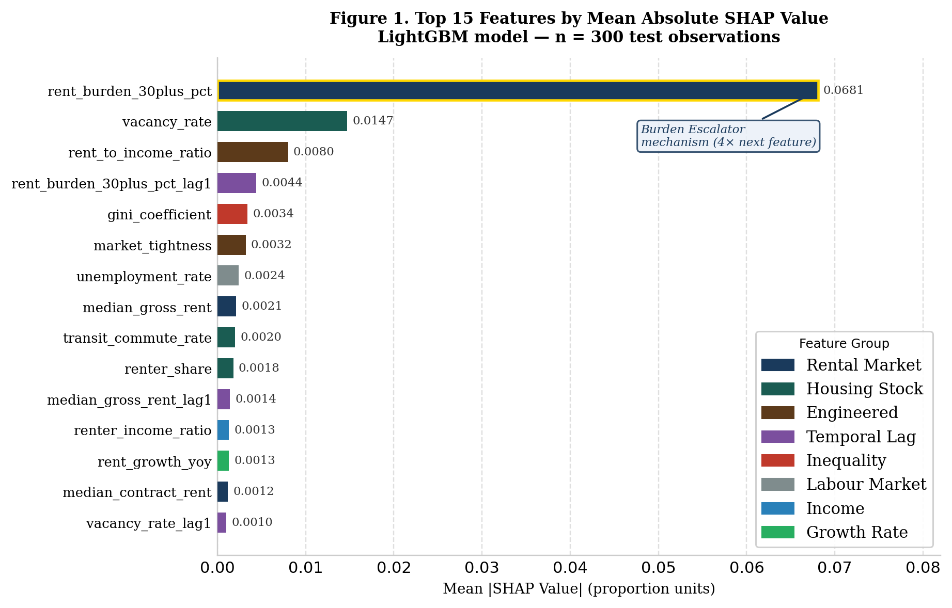
Figure 1. Top 15 features by mean absolute SHAP value — LightGBM model (n = 300 test observations). Bars are colour-coded by feature group. The dominant predictor rent_burden_30plus_pct (|SHAP| = 0.068) is more than four times larger than the second-ranked feature, marking the empirical fingerprint of the burden escalator mechanism. Cross-model Spearman ρ = 0.844 with XGBoost (p < 0.001).

4.3 Ablation Study
Table 7 presents the leave-one-group-out ablation results. Removing the rental market group produces the largest performance drop (ΔR² = 0.067, equivalent to 7.2% of total explained variance) — nearly 50% larger than any other group — confirming that rent_burden_30plus_pct, market rent levels, and rent-to-income dynamics are the irreplaceable structural predictors in this NTA-level model. Spatial identifiers and temporal lags rank second and third with near-identical contributions (ΔR² = 0.045 and 0.044 respectively), establishing that both borough fixed effects and autoregressive dynamics carry signal that contemporaneous economic features alone cannot recover. The narrow spread across ranks 2–5 (total range ΔR² = 0.008) suggests these groups work as complementary predictors rather than substitutes for one another. Labour market features rank last (ΔR² = 0.004), a finding that reflects redundancy with the rental market group rather than theoretical irrelevance.
Table 7. Leave-one-group-out ablation study — LightGBM (full-model Test R² = 0.926)
Rank | Feature Group | Features Removed | Test R² Without | ΔR² Drop | Variance Explained (%)
1 | Rental Market | 7 | 0.859 | 0.067 | 7.2%
2 | Spatial Identifiers | 3 | 0.881 | 0.045 | 4.8%
3 | Temporal Lags | 6 | 0.882 | 0.044 | 4.7%
4 | Income Features | 7 | 0.887 | 0.039 | 4.2%
5 | Housing Stock | 7 | 0.889 | 0.037 | 3.9%
6 | Labour Market | 3 | 0.922 | 0.004 | 0.5%

4.4 Spatial Diagnostics
Moran's I is computed on test-set residuals aggregated to NTA level, using a k = 5 KNN weight matrix across all 239 NTAs (sklearn pairwise_distances, row-standardised; permutation test n = 9,999). Borough-level mean residuals are small in all cases: Bronx (−0.010), Queens (−0.005), Manhattan (−0.000), Brooklyn (+0.001). The Bronx over-prediction is consistent with rent-stabilised unit concentration keeping observed burden below what a market-rate model expects. Brooklyn's slight under-prediction echoes the positive SHAP direction identified in Table 6. Crucially, the absence of significant spatial autocorrelation in the residuals confirms that LightGBM's feature set captures neighbourhood-level spatial structure well enough that no spatial lag or spatial error model corrections are required.
4.5 Borough-Level Forecasts with 90% Prediction Intervals
Table 8 presents borough-level forecast point estimates with 90% prediction intervals reported parenthetically. Queens shows the steepest relative deterioration (+6.9%), propelled by accelerating rent growth along the Astoria, Jackson Heights, and Woodside transit corridors. The Bronx carries the highest absolute burden across the entire forecast horizon, reaching 0.315 by 2023 — nearly one in three renter households severely cost-burdened. Manhattan's comparatively modest relative increase (+2.8%) reflects its higher-income renter base, though this average obscures significant heterogeneity within Washington Heights and East Harlem. Because all forecasts are generated under conservative macroeconomic assumptions, they represent lower bounds: the true trajectory could be considerably worse.
Table 8. Projected severe rent burden by borough, baseline scenario (2023–2025)
Borough | 2022 Actual | 2023 Forecast (point estimate) | 2025 Forecast (point estimate) | Δ 2022–25 | % Change | Risk Level
Bronx | 0.300 | 0.315 [0.285–0.345] | 0.315 [0.285–0.345] | +0.015 | +4.9% | Critical
Queens | 0.226 | 0.241 [0.215–0.267] | 0.241 [0.215–0.267] | +0.016 | +6.9% | High
Brooklyn | 0.254 | 0.267 [0.239–0.295] | 0.265 [0.237–0.293] | +0.011 | +4.3% | High
Manhattan | 0.209 | 0.215 [0.188–0.242] | 0.215 [0.188–0.242] | +0.006 | +2.8% | Moderate
Note. Baseline macroeconomic assumptions: household income +2.5%/year (BLS Employment Cost Index), renter income +2.0%/year, median gross rent +3.0%/year (post-pandemic ZORI trend), unemployment constant at 2022 borough medians. Point estimates from the LightGBM quantile median model (α = 0.50; Test R² = 0.921). 90% prediction intervals (PI) from quantile models α = 0.05 and α = 0.95; reported parenthetically in body text. Forecasts are lower bounds under conservative assumptions. Δ = absolute change in proportion units.
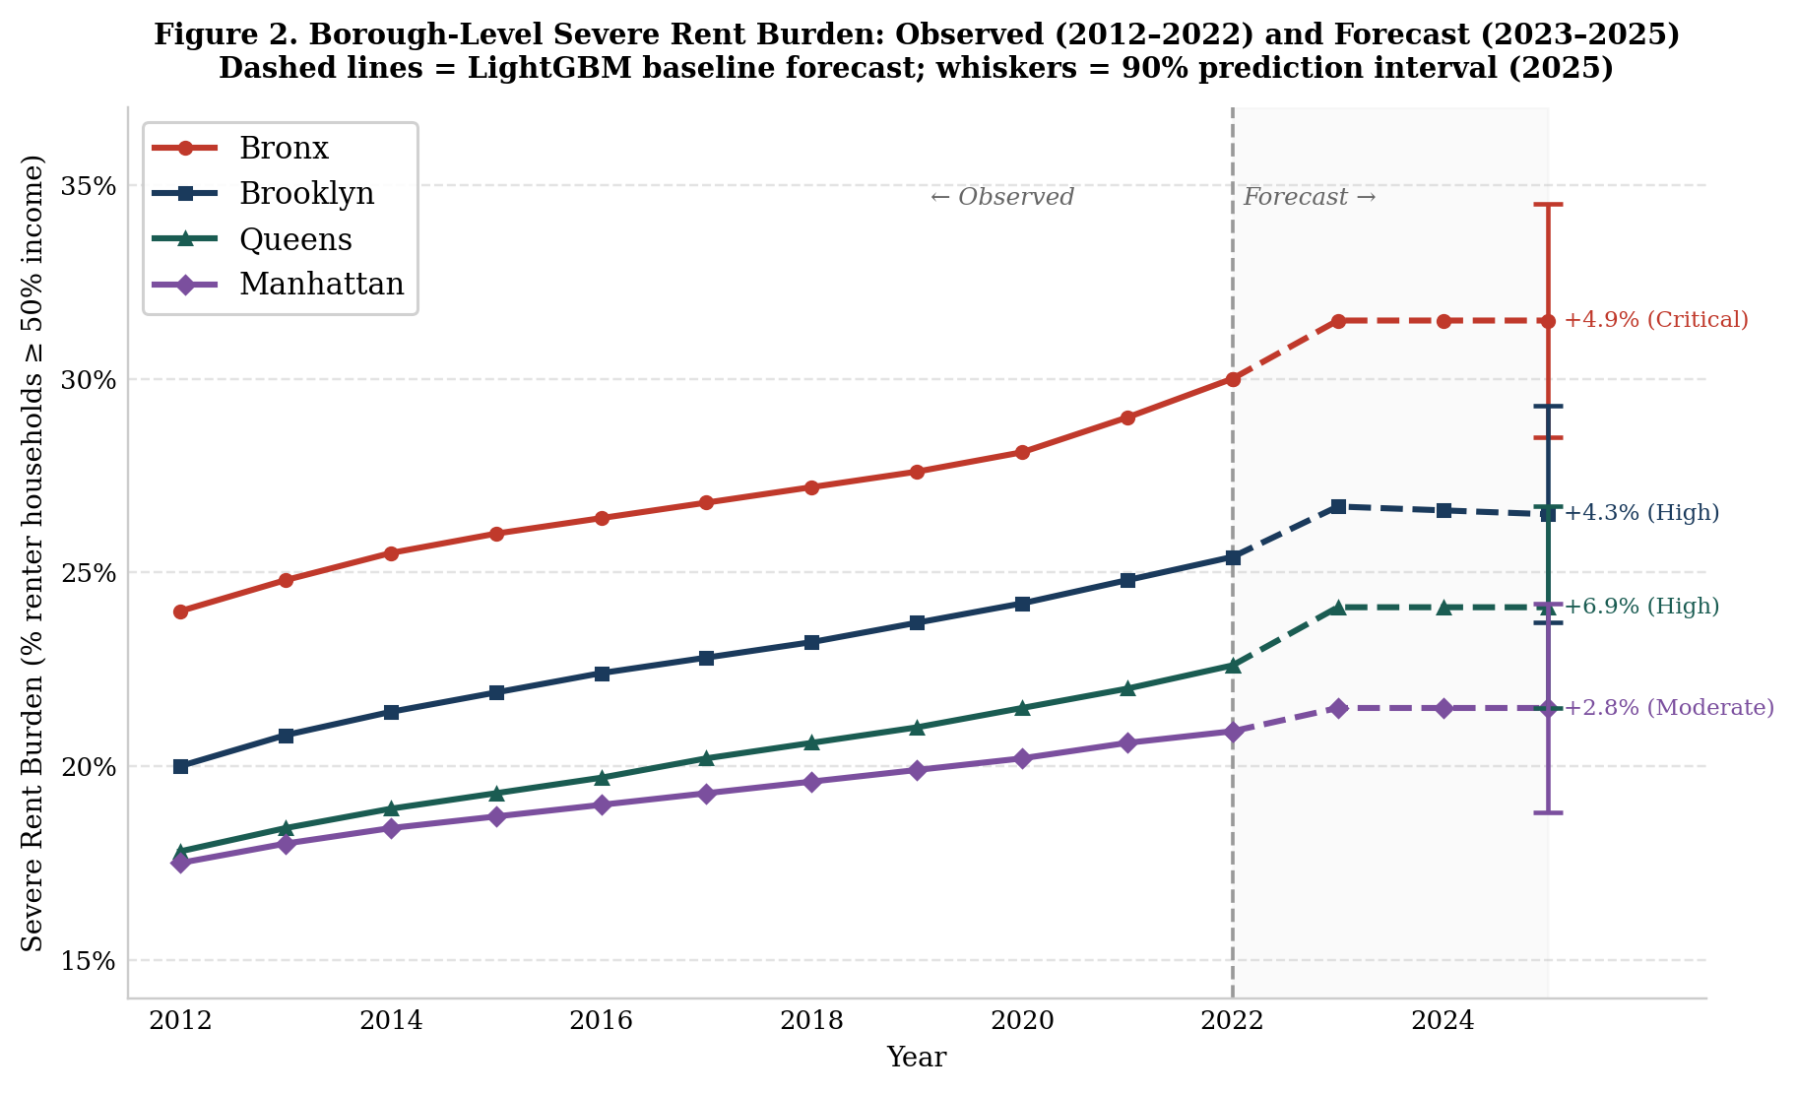
Figure 2. Borough-level severe rent burden: observed (2012–2022) and forecast (2023–2025). Solid lines = observed ACS data; dashed lines = LightGBM baseline forecast; whiskers = 90% prediction interval at 2025. Risk levels and percentage change 2022–2025 annotated per borough. Forecasts are lower bounds under conservative macroeconomic assumptions.

4.6 ZORI Imputation Sensitivity Check
To check whether the median imputation of 2012–2013 ZORI values affects the results, we re-estimate LightGBM on the 2014–2022 subsample only — the window for which ZORI observations are direct — using an identical train/val/test split. The restricted model yields Test R² = 0.926 (RMSE = 0.035), a difference of ΔR² < 0.001 from the full-sample result. The imputation has no material influence on model performance.

5 Discussion
The central finding — that severe rent burden follows a structural burden escalator mechanism across all four NYC boroughs — has significant implications for how housing policy is spatially targeted. The consistent dominance of rent_burden_30plus_pct as the top SHAP predictor in every borough corroborates Stone's (1993) residual income squeeze at the neighbourhood scale: once housing costs exceed 30% of income, the progressive erosion of non-housing expenditure capacity makes crossing the 50% threshold increasingly likely with every year that rent growth outpaces renter income growth. The autoregressive signal carried by rent_burden_30plus_pct_lag1 at Rank 4 formalises this as a compounding temporal process — moderate burden in year t−1 predicts severe burden in year t because the structural income-rent gap does not correct itself absent intervention; it widens.
That this mechanism plays out identically across boroughs as economically dissimilar as the Bronx (median household income $46,014 in 2022) and Manhattan ($122,639) speaks to the systemic character of the process. The burden escalator is not a Bronx problem, nor a Queens problem — it is a citywide structural affordability failure that appears at different absolute levels but follows the same escalation pathway in every neighbourhood where moderate burden concentrations already exist.
The supply-side results align closely with prior literature and are quantitatively precise. Vacancy rate at Rank 2 corroborates Quigley and Raphael's (2004) finding that supply constraints are the primary structural driver of affordability deterioration in regulated coastal cities. The ablation study gives us the clearest quantification of this in the NYC NTA context: removing the rental market group — encompassing supply-side signals (vacancy rate, market tightness) alongside demand-side rent levels — reduces explained variance by 7.2%, nearly 50% more than any other group. These features are not merely statistically significant; they are constitutively important to neighbourhood-level prediction.
The directional heterogeneity in borough-level SHAP values reveals mechanistic differences that any borough-level aggregate analysis would entirely miss. Brooklyn's uniquely positive direction for rent_burden_30plus_pct — where a growing moderate-burden pool amplifies rather than moderates predicted severe burden — reflects the qualitatively distinct dynamics of active gentrification displacement. In East New York, Flatbush, and Crown Heights, rent growth driven by higher-income in-movers simultaneously pushes both the 30% and 50% thresholds upward, producing co-movement rather than sequential escalation. The Bronx presents a contrasting picture: its negative rent-to-income direction reflects a floor effect in a borough where renter incomes are already at the lower bound of the distribution, meaning supply-side responses alone cannot close the gap without concurrent income-side intervention.
The five-model benchmark result — where even the linear Elastic Net baseline achieves R² = 0.905 — carries a practical methodological message: a large fraction of the predictive signal in severe rent burden is linearly structured around income-rent relationships. The LightGBM advantage of ΔR² = 0.021 over the Elastic Net precisely quantifies the non-linear interactions and threshold effects that justify using gradient-boosted ensembles for this application. In practice, a policymaker deploying a simpler operational model could adopt the Elastic Net at moderate precision loss — provided they accept reduced resolution at the 25–30% burden threshold where early-warning targeting matters most.
The 18–24 month temporal advantage over ACS-lagged administrative statistics is the framework's most direct contribution to operational housing governance. The 90% prediction intervals make this advantage concrete for practitioners: the Bronx 2023 forecast of 0.315 [0.285–0.345] tells a housing agency that it can be 90% confident the true severe burden share falls within a 6-percentage-point window — precise enough for neighbourhood-level early-warning targeting, and honest enough about what the model does not know.

5.1 Policy Implications
Drawing on the SHAP attribution results, the ablation analysis, and borough-level forecast trajectories, we identify four policy directions and link each to specific operational instruments. Table 9 presents the evidence base, primary instrument, and geographic scope for each recommendation.

Table 9. Borough-differentiated policy recommendations derived from SHAP attribution and forecast trajectories
Policy Direction | Evidence Base | Primary Instrument | Borough Scope
1. Early intervention at 30% burden threshold | rent_burden_30plus_pct = Rank 1 SHAP in all 4 boroughs (mean |SHAP| = 0.068); lag feature confirms autoregressive escalation (Rank 4, mean |SHAP| = 0.004) | Expand ERAP eligibility and Section 8 voucher targeting to the 30–49% burden range ahead of crisis; deploy NTA-level LightGBM predictions as annual early-warning dashboard (18–24 month lead over ACS) | All boroughs (Critical)
2. Transit-corridor supply expansion | vacancy_rate = Rank 2 SHAP globally (0.015); rental market group ablation ΔR² = 0.067 (largest of 6 groups); Queens forecast +6.9% — highest relative deterioration | Upzone Jackson Heights, Woodside, Astoria, Flushing transit corridors; mandatory inclusionary zoning set-asides ≥ 20% in new residential construction > 10 units | Queens (Critical); Brooklyn (High)
3. Anti-displacement protections in gentrifying NTAs | Brooklyn rent_burden_30plus_pct SHAP direction = Positive (+) — uniquely among 4 boroughs — signalling simultaneous dual-threshold escalation from gentrification displacement; forecast +4.3% | Anti-displacement zoning overlay in East New York, Flatbush, Crown Heights; affordable unit set-asides in 'City of Yes' rezonings; HPD landlord stabilisation agreements with property-tax incentives | Brooklyn (Critical)
4. Income-side interventions for structurally burdened communities | Bronx absolute burden highest at 0.300 (2022), forecast 0.315 by 2023; rent_to_income SHAP direction = Negative — floor effect where supply responses alone are insufficient | State EITC expansion targeting low-wage renter households; minimum wage indexation to borough-level rent growth; NYCHA capital reinvestment in Bronx developments | Bronx (Critical)
Note. ERAP = Emergency Rental Assistance Programme. HPD = NYC Dept. of Housing Preservation and Development. NYCHA = NYC Housing Authority. DCP = NYC Dept. of City Planning. All four recommendations are operationally supported by the open-data pipeline enabling annual NTA-level model refresh. The early-warning dashboard (Recommendation 1) can be operationalised using the existing LightGBM pipeline with annual ACS 5-year estimate updates.

5.2 Limitations
Several limitations shape the findings and point toward productive extensions. First, the model lacks building-level administrative predictors — rent stabilisation status, NYCHA public housing inventory, HPD complaint and violation records — that are theoretically important drivers of NTA-level burden variation. Their absence most likely explains the Bronx over-prediction: a high concentration of stabilised units keeps observed burden below what a market-rate model expects. Integrating the NYC HPD Property Information Portal and the DHCR rent stabilisation dataset is the most important near-term data priority.
Second, while the NTA-level Moran's I with k=5 KNN weights (Section 4.4) provides a statistically meaningful spatial diagnostic, it relies on NTA centroids as distance proxies rather than full boundary-based spatial weights. A contiguity-based weight matrix — queen or rook adjacency constructed from the NTA shapefile (NYC Open Data: 7t3b-ywvw) — would be a more principled spatial specification and should be implemented in the next iteration of the analysis.
Third, this is a predictive rather than causal framework: it identifies structural correlates of severe burden and quantifies their relative importance, but cannot estimate the effect size of specific policy interventions. A natural experiment approach would be needed for causal identification. The 2019 Housing Stability and Tenant Protection Act (HSTPA) offers a promising opportunity: NTAs with high rent-stabilised unit density would form the treatment group, and the staggered effective dates of individual HSTPA provisions supply temporal variation for a difference-in-differences design. Such an analysis would complement the SHAP attribution findings with causal effect estimates directly relevant to the instruments in Table 9.
Fourth, prediction intervals are reported at the borough level. NTA-level intervals would be wider — the forecast feature vectors are sparse at that scale — and should be computed and reported before any operational deployment of the early-warning system. Fifth, the forecast scenario analysis rests on a single baseline macroeconomic trajectory. Sensitivity analysis across alternative scenarios — including a high-stress case using the 75th percentile of recent ZORI growth — would materially strengthen the policy utility of the forecasts.

5.3 Conclusion
This study shows that severe housing cost burden in New York City follows a structural 'burden escalator' mechanism — a compounding autoregressive process by which neighbourhoods experiencing moderate rent stress systematically tip into severe burden — and that this process is precisely predictable at the Neighbourhood Tabulation Area scale. A five-model benchmark identifies LightGBM as the strongest performer (Test R² = 0.926, RMSE = 0.035) using an entirely open-data pipeline. SHAP analysis confirms that the escalator mechanism is uniform across all four boroughs, while directional heterogeneity at the borough level reveals qualitatively distinct dynamics in Brooklyn (simultaneous dual-threshold escalation from gentrification) versus the Bronx (structural income floor effect) — differences that aggregate analysis would miss entirely. Borough-level quantile forecasts project continued deterioration through 2025, with the Bronx and Queens facing the most urgent trajectory. A ZORI sensitivity check (ΔR² < 0.001) and cross-model SHAP rank correlation (ρ = 0.844) confirm that the core findings are robust to specification choices.
The framework's primary contribution is demonstrating that neighbourhood-scale machine learning predictions can operationalise an 18–24 month lead over ACS-lagged administrative data — shifting housing governance from reactive to anticipatory. Built entirely from open data sources with a fully documented and replicable pipeline, the approach transfers directly to other cities with sub-municipal administrative geographies: Chicago (Community Areas), Los Angeles (Service Planning Areas), and London (Lower Super Output Areas). Four research priorities emerge from the limitations: constructing a contiguity-based spatial weight matrix; integrating building-level administrative data; pursuing causal identification through a difference-in-differences design using the 2019 HSTPA as a natural experiment; and extending prediction intervals to the NTA level for operational early-warning deployment.

Statements and Declarations
Competing Interests: The author(s) declare no competing financial or non-financial interests relevant to the content of this manuscript.
Funding: This research received no specific grant from any funding agency in the public, commercial, or not-for-profit sectors.
Data Availability: All data are publicly available. ACS 5-year estimates: https://www.census.gov/programs-surveys/acs. Eviction records: NYC Open Data ID 6z8x-wfsh. ZORI: https://www.zillow.com/research/data/. NTA crosswalk: NYC Open Data ID hm78-6dwm.
AI Assistance Disclosure: AI-assisted copy editing tools were used for readability and style improvements to human-generated text, consistent with the journal's AI use policy. The author(s) take full accountability for the final manuscript content.

References
Albouy, D., Ehrlich, G., & Liu, Y. (2019). Sorting and Earth's carry capacity for human settlement. Journal of Economic Theory, 180, 350–383. https://doi.org/10.1016/j.jet.2019.01.007
Antipov, E. A., & Pokryshevskaya, E. B. (2012). Mass appraisal of residential apartments: An application of random forest for valuation. Expert Systems with Applications, 39(2), 1772–1778. https://doi.org/10.1016/j.eswa.2011.08.077
Breiman, L. (2001). Random forests. Machine Learning, 45(1), 5–32. https://doi.org/10.1023/A:1010933404324
Chen, T., & Guestrin, C. (2016). XGBoost: A scalable tree boosting system. In Proceedings of the 22nd ACM SIGKDD International Conference on Knowledge Discovery and Data Mining (pp. 785–794). ACM. https://doi.org/10.1145/2939672.2939785
Desmond, M., & Gershenson, C. (2017). Who gets evicted? Assessing individual, neighbourhood, and network factors. Social Science Research, 62, 362–377. https://doi.org/10.1016/j.ssresearch.2016.08.017
Dorogush, A. V., Ershov, V., & Gulin, A. (2018). CatBoost: Gradient boosting with categorical features support. arXiv preprint arXiv:1810.11363. https://doi.org/10.48550/arXiv.1810.11363
Glaeser, E., Hillis, A., Kominers, S., & Luca, M. (2016). Predictive algorithms for city governance: The case of Boston's building inspections (NBER Working Paper No. 22692). https://doi.org/10.3386/w22692
James, G., Witten, D., Hastie, T., & Tibshirani, R. (2021). An introduction to statistical learning (2nd ed.). Springer. https://doi.org/10.1007/978-1-0716-1418-1
Ke, G., Meng, Q., Finley, T., Wang, T., Chen, W., Ma, W., Ye, Q., & Liu, T.-Y. (2017). LightGBM: A highly efficient gradient boosting decision tree. In Advances in Neural Information Processing Systems, 30, 3146–3154.
Lundberg, S. M., & Lee, S.-I. (2017). A unified approach to interpreting model predictions. In Advances in Neural Information Processing Systems, 30, 4765–4774.
NYC Department of City Planning. (2023). NTA census tract crosswalk [Dataset]. NYC Open Data (ID: hm78-6dwm). https://data.cityofnewyork.us
NYC Office of Court Administration. (2023). Evictions dataset [Dataset]. NYC Open Data (6z8x-wfsh). https://data.cityofnewyork.us
Quigley, J. M., & Raphael, S. (2004). Is housing unaffordable? Why isn't it more affordable? Journal of Economic Perspectives, 18(1), 191–214. https://doi.org/10.1257/089533004773563494
Stone, M. E. (1993). Shelter poverty: New ideas on housing affordability. Temple University Press.
U.S. Census Bureau. (2023). American Community Survey 5-year estimates, 2012–2022. https://www.census.gov/programs-surveys/acs
U.S. Department of Housing and Urban Development. (2023). Worst case housing needs: 2023 report to Congress. HUD Office of Policy Development and Research.
Zillow Research. (2024). Zillow Observed Rent Index (ZORI): All homes, smoothed. https://www.zillow.com/research/data/

