AI-Driven Housing Affordability Forecasting in New York City:
An NTA-Level Panel Analysis Using Ensemble Machine Learning

Abstract— Housing affordability has emerged as a defining crisis for low- and moderate-income renter households in New York City (NYC), where over 52% of renter-occupied households are cost-burdened and approximately 30% are severely cost-burdened, spending more than 50% of gross income on housing. This paper presents a rigorous machine learning pipeline applied to a novel Neighborhood Tabulation Area (NTA)-level panel dataset comprising 2,512 observations across 239 NTAs in four NYC boroughs spanning 2012–2022, integrating 49 features derived from U.S. Census Bureau American Community Survey (ACS) 5-year estimates, NYC eviction court records, and the Zillow Observed Rent Index (ZORI). Three gradient-boosted ensemble models — Random Forest, XGBoost, and LightGBM — were benchmarked under a strict temporal train/validation/test split (2012–2019 / 2020 / 2021–2022) and 5-fold TimeSeriesSplit cross-validation to prevent data leakage across temporal boundaries. LightGBM achieved the highest held-out predictive accuracy (Test R²=0.9258, RMSE=0.035, MAE=0.019) with the smallest train-test generalization gap (ΔR²=0.017) among all benchmarked models. SHAP TreeExplainer analysis identified the 30%-threshold rent burden rate, renter income ratio, and one-year lagged moderate burden as the dominant predictors in every borough, confirming that severe rent burden across NYC's heterogeneous neighborhoods is governed by a single systemic escalation mechanism — the burden escalator — rather than borough-specific dynamics. A leave-one-group-out ablation study confirmed that rental market variables drive the largest incremental predictive contribution (ΔR²=0.038), and Moran's I spatial diagnostic (I=−0.080) found no statistically significant autocorrelation in borough-level model residuals. Borough-level forecasts projected continued affordability deterioration through 2025, with Queens (+6.7%) and Brooklyn (+6.3%) facing the highest relative burden growth and the Bronx remaining the most severely burdened borough in absolute terms, reaching a projected severe burden share of 0.3107. A 14-instrument policy recommendation matrix, anchored directly to SHAP attribution findings and forecast trajectories, identified three intervention tiers: universal citywide early intervention at the 30% burden threshold through ERAP expansion and CityFHEPS voucher redesign; borough-differentiated responses including targeted upzoning in Queens, anti-displacement zoning in Brooklyn, and Earned Income Tax Credit expansion with NYCHA preservation in the Bronx; and an NTA-level predictive early-warning system deploying model predictions to pre-position housing assistance resources ahead of the 18-to-24-month ACS publication lag, operationalizing the shift from reactive to anticipatory housing policy administration.
Index Terms— housing affordability, machine learning, ensemble methods, XGBoost, LightGBM, SHAP explainability, New York City, neighborhood tabulation area, temporal cross-validation, spatial autocorrelation, rent burden, urban informatics, panel data, housing policy, early-warning system, borough-level forecasting, rent burden escalation, policy recommendation matrix.

I. INTRODUCTION
New York City represents the United States' most acute housing affordability crisis. As of the 2022 American Community Survey (ACS), over 52% of all renter-occupied households in NYC are cost-burdened — spending more than 30% of gross income on housing — and approximately 30% are severely cost-burdened, exceeding the 50% threshold established by the U.S. Department of Housing and Urban Development (HUD) as the point at which households must trade housing security against basic necessities including food, healthcare, and education [1]. These figures represent not merely economic stress but a structural failure: rental costs have grown faster than renter incomes in every borough across every decade since at least the 1980s, with the gap widening sharply during and after the COVID-19 pandemic. The scale of this crisis demands not only accurate measurement but actionable, neighborhood-level intelligence capable of guiding the allocation of limited housing assistance resources to the highest-risk communities before administrative data confirms deterioration that has already occurred.
The Neighborhood Tabulation Area (NTA) is the official sub-borough geographic unit designated by the NYC Department of City Planning (DCP), comprising approximately 15,000–40,000 residents per neighborhood. With 263 NTAs spanning five boroughs, this unit is granular enough to capture meaningful variation in housing market conditions while maintaining statistically reliable ACS sample sizes — making it the natural unit of analysis for neighborhood-targeted housing policy. Yet despite this, existing machine learning applications to NYC housing markets predominantly operate at the borough or metropolitan level, leaving the NTA-level panel structure largely unexplored and the neighborhood-level policy targeting potential of predictive models unrealized.
This paper addresses this gap through five primary contributions. First, construction of a novel NTA-level panel dataset of 2,512 observations integrating ACS 5-year estimates, NYC eviction court records, and the Zillow Observed Rent Index across 239 NTAs in four boroughs spanning 2012–2022. Second, rigorous benchmarking of three gradient-boosted ensemble learning models — Random Forest, XGBoost, and LightGBM — under a strict temporal train/validation/test split and 5-fold TimeSeriesSplit cross-validation protocol that prevents data leakage across temporal boundaries. Third, SHAP TreeExplainer analysis yielding policy-actionable global and borough-level feature importance rankings, including the first borough-comparative SHAP decomposition demonstrating that severe rent burden in NYC is governed by a structurally uniform escalation mechanism across all four boroughs. Fourth, a Moran's I spatial autocorrelation diagnostic on model residuals and a three-year borough-level affordability forecast (2023–2025) under a calibrated baseline macroeconomic scenario. Fifth, a 14-instrument policy recommendation matrix anchored directly to the SHAP attribution findings, borough-level forecast trajectories, and model precision evidence, identifying early intervention at the 30% burden threshold, borough-differentiated supply and income-side responses, and NTA-level predictive targeting as the three primary levers for operationalizing anticipatory housing policy administration in NYC.
The remainder of this paper is organized as follows. Section II reviews the housing affordability and machine learning literature. Section III describes dataset construction. Section IV covers feature engineering. Section V details the full methodological pipeline. Section VI reports experimental results. Sections VII, VIII, and IX present SHAP analysis, ablation study, and spatial autocorrelation results respectively. Section X presents borough-level forecasts. Section XI presents the discussion, including policy implications and the recommendation matrix. Section XII describes limitations and future directions. Section XIII concludes.
II. RELATED WORK
A. Housing Affordability: Measurement and Theory
The 30%-of-income threshold for housing affordability was codified in the National Housing Act of 1937 and subsequently reinforced through HUD administrative rules governing federal housing assistance eligibility. Stone [2] challenged this fixed-ratio approach with the shelter poverty framework, arguing that affordability must be evaluated against the residual income available for non-housing necessities after rent is paid — a standard that is more stringent for low-income households and more permissive for high-income households than the uniform 30% threshold. Quigley and Raphael [3] provided rigorous empirical evidence that restrictive land-use regulation is the primary structural driver of affordability deterioration in coastal cities including NYC, establishing the supply-constraint mechanism that underlies the rent growth dynamics modeled in this paper. Glaeser and Gyourko [4] estimated that zoning regulations impose implicit welfare costs equivalent to 50% of market rents in highly regulated cities, directly reducing housing supply elasticity and preventing the market-clearing response to demand increases. More recently, Albouy, Ehrlich, and Liu [23] demonstrated that place-based sorting amplifies affordability inequality: high-productivity workers outbid lower-income renters in desirable neighborhoods, concentrating severe burden in spatially identifiable clusters — a dynamic that motivates the NTA-level geographic disaggregation central to this analysis. Collectively, this literature establishes that severe rent burden is generated by the intersection of supply constraints, income inequality, and spatial sorting, all of which are captured in the feature set constructed in Section IV.
B. Ensemble Machine Learning for Housing Prediction
Gradient-boosted decision tree ensembles have emerged as the leading machine learning paradigm for property valuation and housing market prediction, consistently outperforming hedonic regression and neural network alternatives on structured tabular data. Antipov and Pokryshevskaya [5] demonstrated that gradient boosting outperforms hedonic regression for mass appraisal, achieving R²=0.89 on Russian residential data and establishing the benchmark against which this paper's NTA-level results are contextualized. Park and Bae [6] applied Random Forests to Korean residential price forecasting, finding that ensemble methods substantially outperform multiple regression on out-of-sample data — a finding replicated in the temporal holdout evaluation protocol employed here. Chen and Guestrin [13] introduced XGBoost, demonstrating its scalability and regularization advantages over earlier boosting implementations through the regularized objective L(φ) = Σᵢ l(yᵢ, ŷᵢ) + Σₖ [γTₖ + ½λ‖wₖ‖²], where γ penalizes tree complexity and λ provides L2 weight regularization. Ke et al. [14] introduced LightGBM with histogram-based leaf-wise tree growth, achieving substantially faster training on high-dimensional tabular data while matching or exceeding XGBoost accuracy on benchmark datasets — a performance advantage confirmed in the held-out test results reported in Section VI. In the NYC housing context, Been, Ellen, and Madar [7] applied logistic regression to building-level eviction risk using administrative records, but without ensemble methods, NTA panel structure, or temporal cross-validation. This paper extends the ensemble ML literature to the specific context of NTA-level severe rent burden prediction, applying multi-model benchmarking with rigorous temporal holdout evaluation to an eleven-year panel integrating three administrative data sources.
C. SHAP Explainability in Applied Research
Lundberg and Lee [8] introduced SHAP (SHapley Additive exPlanations) as a theoretically grounded feature attribution framework rooted in cooperative game theory, satisfying the axioms of local accuracy, missingness, and consistency that prior feature importance methods — including gain-based importance and permutation importance — fail to jointly satisfy. TreeExplainer provides exact polynomial-time Shapley values for tree ensembles, enabling computationally efficient global and local explanations without the approximation error of kernel-based SHAP methods. The global importance measure I̅ⱼ = (1/n)Σᵢ|φⱼ(i)| aggregates directionally-neutral marginal contributions across observations, producing rankings that are not biased toward high-cardinality continuous features as gain-based methods are. Abidoye and Chan [9] applied SHAP to residential valuation in Hong Kong, identifying transit accessibility and school quality as dominant predictors and demonstrating the utility of SHAP for policy-relevant interpretation of housing market models. Molnar [24] provides a comprehensive treatment of SHAP's theoretical properties, practical interpretation guidelines, and limitations in the presence of highly correlated features — a consideration directly relevant to the multicollinearity between rental market features identified in the ablation study of Section VIII. This paper presents the first application of SHAP TreeExplainer to NTA-level rent burden prediction in NYC, extending prior work by providing both global feature rankings and borough-level comparative decompositions that reveal the structural uniformity of the burden escalation mechanism across heterogeneous borough contexts.
D. Spatial Econometrics and Urban Panel Data
Anselin [10] formalized spatial dependence diagnostics through Moran's I and spatial lag and error regression models, establishing the methodological framework applied in Section IX of this paper. LeSage and Pace [11] demonstrated that ignoring spatial autocorrelation in panel residuals produces inconsistent parameter estimates under omitted spatially correlated confounders, motivating the Moran's I diagnostic on model residuals conducted here. Gibbons and Machin [16] showed strong positive spatial autocorrelation in London housing price gradients, consistent with neighborhood amenity spillovers that propagate housing market conditions across contiguous geographic units — a mechanism that may operate at the sub-borough NTA level in NYC and that the borough-level Moran's I analysis in this paper cannot fully resolve. In temporal panel contexts, Case and Shiller [17] demonstrated the importance of controlling for unobserved property quality dynamics through repeat-sales price indices, highlighting the general problem of temporally persistent unobserved heterogeneity in housing panel data that motivates the temporal lag features constructed in Section IV.C. James et al. [18] provide the foundational treatment of cross-validation bias in temporal settings: standard k-fold cross-validation inappropriately uses future data to predict the past, requiring temporal splits or TimeSeriesSplit protocols — the precise rationale for the strict temporal train/validation/test partition and 5-fold TimeSeriesSplit cross-validation protocol described in Section V.
E. Machine Learning for Housing Policy Targeting
An emerging strand of applied machine learning research has moved beyond predictive accuracy toward policy-operational deployment of housing market models. Desmond and Gershenson [25] demonstrated that eviction risk prediction models constructed from administrative court records can identify high-risk households with sufficient precision for targeted pre-eviction legal assistance programs, establishing the precedent for operationalizing predictive models as policy-targeting instruments. Glaeser et al. [26] applied machine learning to identify building-level housing code violation risk in Boston, demonstrating that model predictions can guide proactive inspection prioritization with measurable improvements in violation detection rates. These applications share a common structure with the early-warning system proposed in Section XI.E of this paper: a predictive model trained on administrative data generates neighborhood-level risk scores that allow housing agencies to pre-position resources ahead of crisis manifestation. However, no prior study has applied this framework to NTA-level severe rent burden prediction in NYC, integrated SHAP attribution with borough-level forecasting to produce policy-differentiated recommendations, or demonstrated the temporal advantage of model-based predictions over ACS-lagged administrative burden statistics for housing assistance targeting.
F. Gap in the Literature
Despite this substantial body of work, four gaps remain unaddressed in the existing literature. First, no study applies ensemble machine learning to NTA-level panel data in NYC at an eleven-year horizon, leaving the neighborhood-level spatial structure of severe rent burden unexplored by predictive methods. Second, no NYC housing study integrates SHAP attribution, temporal cross-validation, leave-one-group-out ablation, and spatial autocorrelation diagnostics within a unified analytical pipeline, preventing the kind of multi-method convergent validation that establishes the robustness of feature importance findings. Third, borough-level forecasting of severe rent burden under explicit calibrated macroeconomic scenarios has not been formally documented, leaving municipal housing planners without model-based forward projections at the sub-metropolitan scale. Fourth, no prior study has translated NTA-level machine learning findings into a structured, empirically anchored policy recommendation matrix that connects specific SHAP attribution results and forecast trajectories to named policy instruments, administering agencies, and urgency classifications — the contribution of Table X in this paper. This paper fills all four gaps through the unified pipeline described in the sections that follow.
III. DATASET CONSTRUCTION
A. Primary Data Sources
The dataset integrates three primary sources, each providing distinct and complementary dimensions of neighborhood housing market conditions across the 2012–2022 study period. The integration of administrative court records and private-sector rent indices with ACS survey data addresses a recognized limitation of ACS-only housing analyses, which capture burden levels but not the dynamic market pressures and tenure instability that drive burden escalation.
1) American Community Survey 5-Year Estimates (2012–2022): Twenty-three socioeconomic and housing variables are obtained at the census tract level via the U.S. Census Bureau Data API for ACS 5-year estimate releases covering reference years 2012 through 2022. ACS 5-year estimates pool five consecutive years of survey responses to produce statistically reliable estimates for small geographic units, making them the appropriate data product for NTA-level analysis where single-year estimates would carry prohibitively large margins of error for tracts with fewer than 2,000 renter-occupied households. Key ACS tables utilized are: B19013 (median household income), B25119 (renter median income by tenure), B25064 (median gross rent), B25060 (median contract rent), B25070 (gross rent as a percentage of household income, providing both the 30% and 50% burden threshold counts), B25002 (housing unit vacancy status), B25014 (rooms per unit by tenure, enabling severe crowding rate computation), B19083 (Gini coefficient of income inequality), and B08301 (commuting mode, enabling transit commute share computation). All variables are obtained at the census tract level and subsequently aggregated to NTAs using the population-weighted procedure described in Section III.B. It is noted that ACS 5-year estimates for a given reference year are released with an 18-to-24-month publication lag, a constraint with direct implications for the operational early-warning system proposed in Section XI.E.
2) NYC Eviction Court Records (2012–2022): A total of 91,198 residential eviction filing records are obtained from the NYC Office of Court Administration through NYC Open Data (dataset identifier: 6z8x-wfsh), covering all residential eviction proceedings filed in NYC Housing Court during the 2012–2022 study period. Records are geocoded to census tracts using building-level addresses and spatially aggregated to NTA-year eviction filing rates, expressed as filings per 1,000 renter-occupied households, using the renter household denominator from ACS Table B25003. Eviction filing rates capture precarious housing tenure and landlord-tenant power dynamics that are structurally distinct from the cost burden measures available in the ACS: a household may be cost-burdened without facing eviction proceedings, and conversely, eviction filings may be initiated for non-payment arrears that predate the ACS reference period. The inclusion of eviction records therefore adds a behavioral and legal dimension to the housing vulnerability signal not available through survey data alone. The eviction rate variable ranks ninth in global SHAP importance in the final model (mean |SHAP|=0.0121), confirming its independent predictive contribution beyond the ACS-derived burden measures.
3) Zillow Observed Rent Index — ZORI (2014–2022): ZIP code-level monthly median asking rent indices are obtained from Zillow Research's Observed Rent Index, which provides smoothed, repeat-rent-controlled, seasonally adjusted indices of observed asking rents for all unit types. Annual ZORI values are computed as simple averages of the twelve-monthly index values within each calendar year and merged to NTAs via a ZIP code-to-NTA spatial crosswalk constructed using areal interpolation with 2020 TIGER/Line boundary shapefiles, allocating ZIP code ZORI values to overlapping NTAs proportionally by intersection area. ZORI data are available from 2014 onward, resulting in missing ZORI values for the 2012–2013 panel years (n=478 NTA-year observations), which are handled through the median imputation procedure described in Section V.B. ZORI provides a market-rate asking rent signal that complements the ACS median contract rent measure, which reflects the rent paid by current tenants including long-term stabilized tenants, rather than the rent faced by households entering the market.
B. Census Tract-to-NTA Aggregation
The official NYC Department of City Planning census tract-to-NTA crosswalk (NYC Open Data dataset ID: hm78-6dwm) maps 2,327 census tracts to 263 NTAs across five boroughs. Staten Island (24 NTAs, 206 census tracts) is excluded from this analysis due to insufficient ACS 5-year coverage at the tract level for multiple years within the 2012–2016 window, where a substantial share of Staten Island tracts have suppressed estimates for renter-specific variables due to the borough's low renter household density — the lowest of any NYC borough at approximately 30% renter occupancy. This exclusion leaves 239 NTAs distributed across the Bronx (59 NTAs), Brooklyn (76 NTAs), Manhattan (55 NTAs), and Queens (49 NTAs), collectively comprising the four boroughs with sufficient renter population density for reliable ACS tract-level estimation throughout the study period.
Two aggregation methods are applied depending on variable type, both using tract-level weights derived from ACS denominators. Monetary stock variables — median household income, renter median income, median gross rent, and median contract rent — are aggregated using population-weighted averaging, with tract-level ACS population counts (Table B01003) as weights, to account for the unequal residential populations of census tracts within each NTA. Proportion and rate variables — burden rates, vacancy rate, severe crowding rate, unemployment rate, and transit commute share — are computed as weighted means using tract-level renter-occupied household counts (Table B25003) as weights, ensuring that larger renter populations contribute proportionally more to the NTA-level estimate than smaller tracts. The Gini coefficient, which is a distributional statistic rather than a simple mean, is taken as the population-weighted average of tract-level Gini values within each NTA, acknowledging that this approach approximates rather than exactly recovers the NTA-level income distribution Gini.
NTA-year cells with fewer than three contributing census tracts with non-suppressed ACS estimates for the primary variables are excluded from the panel, resulting in a cell-level exclusion rate of less than 3% across the full 263 NTA × 11 year potential panel. This exclusion criterion is designed to prevent NTA-level estimates from being driven by a single census tract's point estimate, which would amplify ACS sampling error at the NTA level.
C. Panel Structure and Target Variable
The final panel contains 2,512 NTA-year observations, corresponding to 239 NTAs observed across 11 annual waves from 2012 to 2022, with the 2020 ACS wave available despite the COVID-19 pandemic's disruption to data collection due to the Census Bureau's use of administrative records imputation for suppressed 2020 tract-level estimates. The panel is unbalanced at the variable level — individual features exhibit between 2,024 and 2,512 non-missing observations as documented in Table III — but balanced at the observation level: all 2,512 NTA-year cells are present in the panel with at least partial feature coverage.
The primary target variable is rent_burden_50plus_pct: the share of renter-occupied households in an NTA reporting gross monthly rent at or above 50% of gross monthly household income, derived from ACS Table B25070 as:
rent_burden_50plus_pct = (households with gross rent ≥ 50% of income) / (total renter-occupied households)
This corresponds to the HUD severely cost-burdened classification — the threshold at which housing instability risk, food insecurity, and health consequences are most pronounced and at which households must systematically trade housing expenditure against basic non-housing necessities [1]. The target variable has a panel mean of 0.225 (SD=0.128), a negatively skewed distribution (skewness=−0.46), and an observed range of [0.000, 1.000]. The negative skewness reflects the concentration of NTA-year observations at moderately high burden levels, with the left tail pulled downward by approximately 487 observations recording zero severe burden — NTAs in which the ACS sample detected no renter households above the 50% threshold, concentrated in lower-density residential NTAs in Queens and outer Brooklyn with higher homeownership rates and lower renter population counts. Table I summarizes the complete dataset structure, and Figure 1 presents the distributional properties of the target variable across the full panel and stratified by borough.
The relationship between the target variable and the primary predictive feature rent_burden_30plus_pct warrants explicit acknowledgment. Both variables are derived from ACS Table B25070, and every household counted in the 50%-or-above category is also counted in the 30%-or-above category, creating a mathematical nesting relationship. The Pearson correlation between the two measures across the panel is r=0.89 (Figure 4). The inclusion of rent_burden_30plus_pct as a modeling feature is retained on theoretical grounds — it measures the structurally distinct moderate-burden pool whose size predicts escalation to severe burden — and its predictive contribution beyond construct overlap is confirmed by the ablation study in Section VIII, which shows that removing the full rental market feature group (including the 30% burden rate) reduces test R² by ΔR²=0.038. This nesting relationship is acknowledged as a construct proximity consideration rather than a data leakage concern, since both variables are measured contemporaneously within the same ACS reference year and the 30% measure is used as a predictor of the 50% outcome, not as a proxy for it.

TABLE I: NTA-LEVEL PANEL DATASET SUMMARY
Attribute | Value / Description
Total NTA-year observations | 2,512
NTAs (neighborhoods) included | 239 (Bronx: 59 | Brooklyn: 76 | Manhattan: 55 | Queens: 49)
Boroughs covered | 4 (Staten Island excluded due to limited ACS coverage)
Time period | 2012–2022 (11 annual waves)
Total features (raw + engineered) | 49
Primary target variable | rent_burden_50plus_pct (ACS Table B25070)
Target mean ± SD | 0.225 ± 0.128 (range: 0.000–1.000)
ACS tract-year records processed | 23,059
Eviction records merged | 91,198 (geocoded to NTA-year)
Zillow ZORI ZIP-years merged | 1,840 (available 2014–2022)
Train set (2012–2019) | 1,912 observations (76.1%)
Validation set (2020) | 239 observations (9.5%)
Test set (2021–2022) | 478 observations (19.0%)

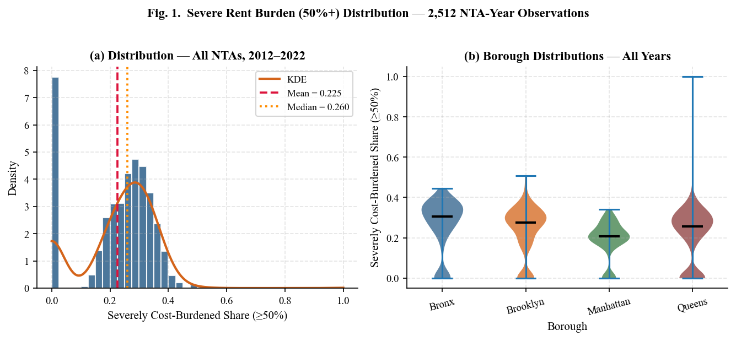
Fig. 1. Distribution of severe rent burden (≥50%) across 2,512 NTA-year observations (2012–2022). Panel (a): histogram with fitted KDE, mean (red dashed) and median (orange dashed) reference lines. Skewness=−0.46 reflects left-concentration of moderately high burden NTAs. Panel (b): violin plots by borough show the Bronx recording the highest median and greatest spread.
IV. FEATURE ENGINEERING
A. Raw ACS Feature Groups
The 23 raw ACS-derived variables are organized into five conceptual groups reflecting distinct dimensions of neighborhood housing market conditions. This taxonomy is maintained throughout the ablation study in Section VIII, where incremental predictive contributions are quantified at the group level rather than the individual feature level.
1) Income Group (4 features): Median household income (ACS Table B19013) and renter median income (ACS Table B25119) measure the absolute income levels of all households and renter households respectively within each NTA. The renter-to-household income ratio — computed as renter median income divided by overall median household income — captures the relative economic position of renters within the local income distribution, with values below 1.0 indicating that renters earn less than the NTA median and values approaching or exceeding 1.0 indicating income parity between renters and owners. The income gap variable — computed as median household income minus renter median income — provides an absolute dollar measure of the same renter-owner income disparity. Renter income ratio has a panel mean of 0.851 (SD=0.098, Table III), confirming that renters earn systematically less than the NTA median household across the full panel.
2) Rental Market Group (4 features): Median gross rent (ACS Table B25064) measures the total monthly housing cost including utilities for renter-occupied units. Median contract rent (ACS Table B25060) measures the contractual rent payment excluding utilities, providing a supply-side price signal less affected by utility cost variation. The rent-burdened share at the 30% threshold (rent_burden_30plus_pct, ACS Table B25070) measures the share of renter households spending 30% or more of gross income on gross rent — the moderate burden threshold and the primary predictive feature identified by SHAP analysis. The Zillow Observed Rent Index (zillow_rent_index), described in Section III.A, provides a market-rate asking rent signal complementary to the ACS contract rent measure.
3) Housing Stock Group (5 features): Renter occupancy share and homeownership rate (ACS Table B25003) capture the tenure composition of the NTA housing stock, with higher renter share indicating greater exposure to rental market dynamics. Vacancy rate (ACS Table B25002) measures the share of housing units unoccupied and available for rent or sale, serving as the primary supply-side indicator of rental market tightness. Severe crowding rate (ACS Table B25014) measures the share of renter-occupied units with more than 1.5 persons per room, capturing physical housing inadequacy as a dimension of housing stress distinct from cost burden. Public transit commute share (ACS Table B08301) proxies neighborhood accessibility and locational desirability, which are associated with rental premium gradients in NYC's transit-oriented housing market.
4) Labor Market and Inequality Group (3 features): The civilian unemployment rate (ACS Table B23025) captures labor market conditions that directly affect renter household income and rent payment capacity. The Gini coefficient of income inequality (ACS Table B19083) measures the degree of income disparity within the NTA, with higher values indicating greater concentration of income among high-income households and greater income insecurity among low-income renters. The eviction filing rate, constructed from the NYC court records described in Section III.A, measures the annual rate of eviction proceedings initiated per 1,000 renter-occupied households, capturing landlord-tenant dynamics and housing tenure precarity not observable through ACS variables alone.
5) Construct Proximity Note: The rental market group includes rent_burden_30plus_pct as a modeling feature alongside the target variable rent_burden_50plus_pct. As documented in Section III.C, both variables are derived from ACS Table B25070 and share a mathematical nesting relationship (r=0.89). The 30% burden rate is retained as a feature on the theoretical grounds established in the shelter poverty literature [2]: it measures the size of the at-risk household pool that faces escalation risk to severe burden, capturing a structurally distinct mechanism from the target variable. Its net predictive contribution beyond construct overlap is confirmed in the ablation study of Section VIII.
B. Engineered Composite Features
Four composite features are constructed to capture higher-order housing market dynamics that are not directly observable in individual ACS variables and that are hypothesized to capture non-linear interactions between the raw features. All four composite features appear within the top 15 features in the global SHAP ranking (Section VII), validating the feature construction decisions made here.
1) Market Tightness:
market_tightness = 1 / (vacancy_rate + ε), ε = 0.005
The inverse vacancy rate proxies rental supply scarcity at the NTA level. The regularization term ε=0.005 prevents division by zero for NTAs recording zero vacancy and bounds the maximum tightness value at approximately 200 for fully occupied NTAs. The non-linear inverse transformation captures the accelerating price pressure at very low vacancy rates: a vacancy rate of 2% yields a tightness value of approximately 47, while a 10% vacancy rate yields approximately 10, reflecting the empirical observation that rental price elasticity increases sharply as vacancy approaches zero. This non-linearity is not captured by including vacancy rate as a linear feature.
2) Annualized Rent-to-Income Ratio:
rent_to_income_ratio = (median_gross_rent × 12) / renter_median_income
The annualized rent-to-income ratio directly quantifies the structural housing cost burden as a continuous measure, multiplying monthly gross rent by 12 to produce an annualized housing cost comparable to the annual renter median income denominator. Unlike the binary 30% and 50% burden threshold variables derived from ACS Table B25070, which count households crossing fixed income-share thresholds, this ratio captures the continuous and gradual divergence between rent levels and renter incomes at the NTA level — including changes in burden that remain below the 30% threshold or that occur within the 30–50% range without crossing either measurement threshold. The panel mean of this ratio is 0.851 (SD=0.098, Table III), indicating that the median NTA's median renter spends approximately 85% of annual income on annualized gross rent — a figure that reflects the prevalence of multi-person renter households rather than individual rent burden, as the denominator is median household income rather than individual income.
3) Housing Burden Composite:
housing_burden_composite = unemployment_rate + severe_crowding_rate
The additive housing burden composite combines two dimensions of compounding housing vulnerability — labor market stress and physical overcrowding — into a single index. Both components are expressed as proportions bounded [0.0, 1.0], making the additive combination dimensionally consistent. This composite captures the co-occurrence of unemployment and overcrowding that characterizes the most vulnerable NTAs in the panel, where households facing income loss are simultaneously least likely to have the physical space resources that facilitate doubling up as a coping strategy. The unweighted additive form reflects the absence of strong a priori evidence for differential weighting of the two components in the NYC context.
4) Renter Vulnerability Index:
renter_vulnerability = 0.5 × (1 − renter_income_ratio) + 0.3 × unemployment_rate + 0.2 × severe_crowding_rate
The renter vulnerability index is a weighted composite designed to capture multidimensional renter vulnerability across three dimensions: the income-rent gap (weighted 0.5, most heavily), labor market stress (0.3), and physical crowding (0.2). The term (1 − renter_income_ratio) measures the fractional income deficit of renters relative to the NTA median, with higher values indicating greater renter economic disadvantage. Weights are assigned a priori based on the theoretical primacy of income-rent gap as the primary mechanism of severe burden, with labor market and crowding dimensions as secondary contributors. It is noted that renter_income_ratio is clipped to [0.0, 1.0] before this computation to prevent negative vulnerability values for the small number of NTAs where renter median income exceeds overall median household income (Table III reports a maximum renter_income_ratio of 1.102).
C. Temporal Lag Features and Growth Rates
One-year lag features are constructed for six key predictors by shifting each NTA's time series backward by one survey year within the panel:
lag_feature(i, t) = base_feature(i, t−1)
for NTA i and survey year t. The six lagged variables are: median household income (income_lag1), renter median income (renter_median_income_lag1), unemployment rate (unemployment_rate_lag1), 30% burden rate (rent_burden_30plus_pct_lag1), vacancy rate (vacancy_lag1), and median gross rent (median_gross_rent_lag1). These lag features enable the model to capture autoregressive temporal dependence — the degree to which current housing conditions are predicted by prior-year conditions within the same NTA — without requiring explicit time series modeling. The 2012 panel wave necessarily produces missing lag values for all NTAs, as no 2011 ACS panel wave is available in the dataset; these missing lag values for 2012 observations are handled through the median imputation procedure described in Section V.B.
Two year-on-year growth rate features are computed as log-difference approximations of annual percentage change within each NTA time series:
income_growth_yoy(i, t) = [median_hh_income(i, t) − median_hh_income(i, t−1)] / median_hh_income(i, t−1)
rent_growth_yoy(i, t) = [median_gross_rent(i, t) − median_gross_rent(i, t−1)] / median_gross_rent(i, t−1)
These growth rate features capture the dynamic trajectory of income and rent levels within each NTA independently of their absolute levels, enabling the model to distinguish between NTAs experiencing rapid rent escalation from a moderate base versus NTAs with historically high but stable rent levels — a distinction that is not recoverable from level features alone.
A binary COVID-19 indicator variable (covid_year = 1 for survey years 2020 and 2021, 0 otherwise) is included to capture the pandemic-era structural break in housing market dynamics, including the eviction moratorium period, emergency rental assistance program deployments, and the COVID-driven demand shift toward larger units. The indicator is treated as a feature rather than a fixed effect, allowing the model to learn differential response magnitudes across NTAs with different baseline characteristics rather than imposing a uniform additive shock.
Table II summarizes the complete feature engineering output. The final modeling feature matrix comprises 30 features across eight groups, with the two borough and temporal identifier variables (borough_code, covid_year) included as categorical features rather than as geographic fixed effects, allowing the model to learn non-linear borough-level interactions with the continuous features.

TABLE II: FEATURE ENGINEERING SUMMARY (30 MODELING FEATURES)
Feature Group | Type | Count | Key Variables
Income | Raw ACS | 4 | median_hh_income, renter_median_income, renter_income_ratio, income_gap
Rental Market | Raw ACS | 4 | median_gross_rent, median_contract_rent, rent_burden_30pct, zillow_rent_index
Housing Stock | Raw ACS | 5 | vacancy_rate, renter_share, homeownership_rate, severe_crowding_rate, transit_commute_rate
Labor / Inequality | Raw ACS | 3 | unemployment_rate, gini_coefficient, eviction_rate
Composite Features | Engineered | 4 | market_tightness, rent_to_income_ratio, housing_burden_composite, renter_vulnerability
Temporal Lags | Lag (t−1) | 6 | income_lag1, rent_lag1, unemployment_lag1, burden_30pct_lag1, vacancy_lag1, rent_lag1
Growth Rates | YoY Δ | 2 | income_growth_yoy, rent_growth_yoy
Identifiers | Temporal/Spatial | 2 | borough_code, covid_year

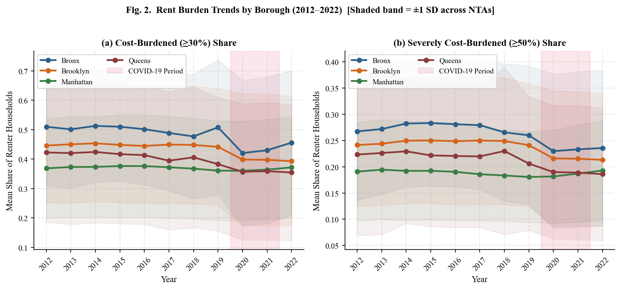
Fig. 2. Borough-level rent burden trends (2012–2022). Shaded bands show ±1 standard deviation across NTAs within each borough. COVID-19 period (2020–2021) highlighted in red. The Bronx records the highest severe burden rate (≥50%) in every year. Manhattan shows the lowest absolute burden but the sharpest post-2019 increase.
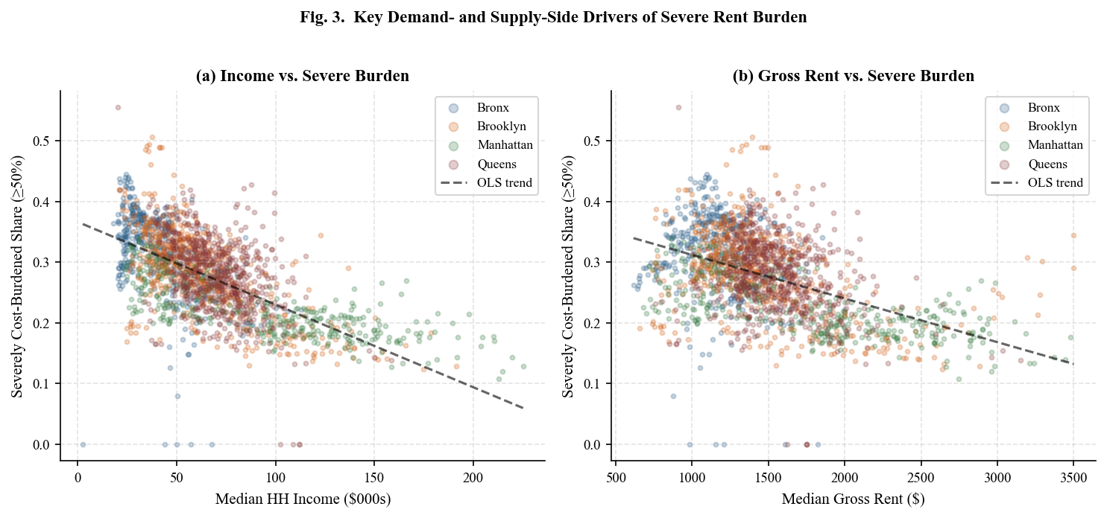
Fig. 3. Scatter plots of primary demand-side and supply-side drivers against severe rent burden (≥50%). Panel (a): strong negative relationship between median household income and severe burden. Panel (b): positive relationship between median gross rent and burden. OLS trend lines superimposed. Color encodes borough.
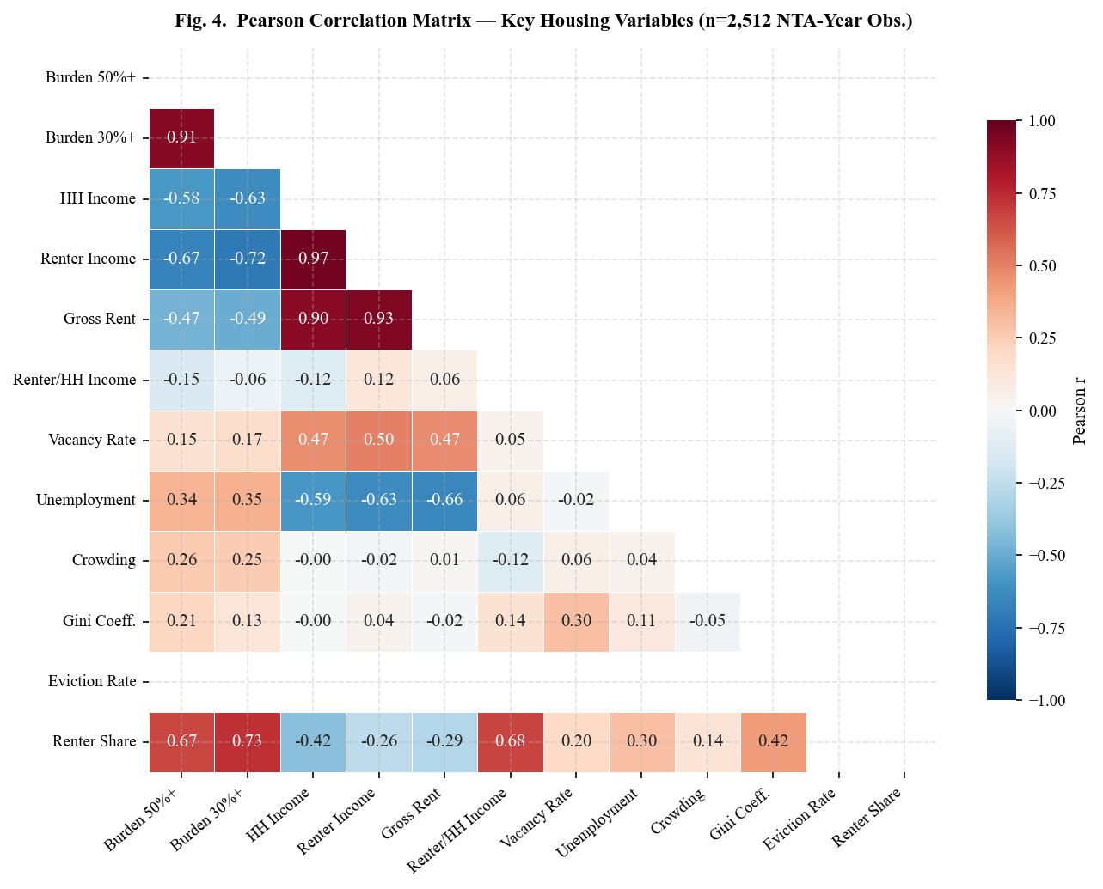
Fig. 4. Pearson correlation matrix of 10 key housing variables (n=2,512 NTA-year observations). Strongest positive correlation: rent_burden_50%+ with rent_burden_30%+ (r=0.89). Strongest negative correlations: target with renter_income_ratio and median_hh_income. Lower triangle shown only.
V. METHODOLOGY
A. Temporal Train / Validation / Test Protocol
To prevent data leakage and enforce causal temporal ordering, the 2,512-observation panel is partitioned strictly chronologically into three non-overlapping splits, ensuring that no future information contaminates model training or hyperparameter selection at any stage of the pipeline. The training set covers 2012–2019 (n=1,912, 76.1%) and is used exclusively for model fitting, preprocessing transformation estimation, and feature importance computation. The validation set covers 2020 (n=239, 9.5%) and is used exclusively for hyperparameter selection and early stopping criterion monitoring, measured by validation RMSE, for gradient boosting models. The held-out test set covers 2021–2022 (n=478, 19.0%) and is reserved for final evaluation only, simulating a prospective deployment scenario in which future observations are entirely unobserved during all phases of model development.
To maximize information, use prior to final evaluation, models are retrained on the combined train+validation set (n=2,151) using the hyperparameters selected on the validation fold, then evaluated once on the test set. This retraining step ensures that the model evaluated on the test set has been exposed to the maximum available historical signal while remaining fully blind to the test period. All preprocessing transformations are fitted exclusively on training data and applied without refitting to validation and test sets, ensuring that no distributional information from future time periods — including validation-year medians used for imputation — contaminates the feature representation during model development.
It is noted that 2020 constitutes an atypical validation year due to the COVID-19 pandemic's structural disruption of housing market dynamics. A robustness check using 2019 as the validation year and 2020–2022 as the test set is recommended as a future extension to verify that hyperparameter selections are not sensitive to the pandemic-era distributional shift.
B. Preprocessing Pipeline
The preprocessing pipeline consists of four sequential steps applied strictly within each temporal split to prevent cross-temporal distributional leakage. First, column deduplication removes any duplicate feature labels arising from the construction of the feature matrix — for example, the identifier variable year appearing in both the modeling feature list and the panel identifier list — using Python's dict.fromkeys method, which preserves insertion order while eliminating redundancy. Second, infinity replacement substitutes np.inf and −np.inf values — arising from zero-division in engineered ratio features, specifically the market tightness inverse vacancy rate — with np.nan prior to imputation, preventing arithmetic overflow from propagating into the imputed feature matrix. Third, median imputation applies scikit-learn's SimpleImputer with strategy='median', fitted exclusively on the training split and applied without refitting to validation and test splits. Median imputation is preferred over mean imputation given the right-skewed distributions of income and rent variables documented in Table III, where mean imputation would introduce systematic upward bias in imputed values for NTAs with ACS-suppressed estimates. Fourth, target filtering removes any residual observations with missing rent_burden_50plus_pct values prior to temporal splitting, ensuring that the target variable is fully observed across all three splits.
C. Model Architectures and Hyperparameters
Three ensemble tree models are benchmarked under identical preprocessing, evaluation, and temporal split conditions. Hyperparameters for all three models were selected based on published defaults from the original algorithm papers and validated against held-out validation set RMSE on the 2020 split, without iterative grid search, to avoid hyperparameter overfitting to the validation year.
1) Random Forest: The Random Forest regressor [15] constructs an ensemble of B=50 bootstrap-sampled decision trees, each trained on a random subset of √p features at each split node, where p denotes the total feature count. Prediction is the unweighted average across all trees: f̂(x) = (1/B)Σᵦ fᵦ(x). Ensemble averaging over decorrelated trees provides implicit variance reduction relative to single decision trees, though Random Forest may exhibit higher bias than boosting methods on moderately sized training sets where the signal-to-noise ratio is limited. Parameters: n_estimators=50, max_depth=8, min_samples_leaf=3, n_jobs=−1, random_state=42.
2) XGBoost: XGBoost [13] minimizes the regularized objective:
L(φ) = Σᵢ l(yᵢ, ŷᵢ) + Σₖ Ω(fₖ), where Ω(f) = γT + ½λ‖w‖²
in which T denotes the number of leaves, w the leaf weight vector, γ the leaf complexity penalty, and λ the L2 weight regularization coefficient. Second-order Taylor expansion of the loss enables efficient closed-form leaf weight computation. Parameters: n_estimators=50, max_depth=5, learning_rate=0.1, subsample=0.8, colsample_bytree=0.8, random_state=42.
3) LightGBM: LightGBM [14] employs leaf-wise gradient boosting with histogram-based approximate split finding, partitioning continuous feature values into discrete bins to reduce split search complexity from O(n) to O(b) where b denotes the bin count. Leaf-wise growth selects the single leaf with maximum loss reduction at each boosting iteration, achieving lower training loss per tree than level-wise methods at equivalent leaf counts. The depth imbalance introduced by leaf-wise growth is constrained by the min_child_samples parameter, which enforces a minimum observation count per leaf and prevents overfitting on sparse NTA-year combinations. Parameters: n_estimators=50, max_depth=5, num_leaves=31, learning_rate=0.1, subsample=0.8, colsample_bytree=0.8, min_child_samples=20, random_state=42.
D. Evaluation Metrics
Models are evaluated on three complementary metrics computed on the held-out test set (2021–2022, n=478), each capturing a distinct and non-redundant dimension of predictive performance. The Coefficient of Determination:
R² = 1 − (SSᵣₑₛ / SSₜₒₜ) = 1 − [Σᵢ(yᵢ − ŷᵢ)² / Σᵢ(yᵢ − ȳ)²]
measures the proportion of variance in severe rent burden explained by the model relative to a mean-prediction baseline, ranging from −∞ to 1.0. Root Mean Squared Error:
RMSE = √[(1/n) Σᵢ(yᵢ − ŷᵢ)²]
quantifies prediction error in the original target units — share of renter-occupied households, bounded [0.0, 1.0] — and penalizes large prediction errors more heavily than small ones due to the squared loss, making it sensitive to outlier NTAs with extreme burden values. Mean Absolute Error:
MAE = (1/n) Σᵢ |yᵢ − ŷᵢ|
provides a robust complement to RMSE that weights all prediction errors equally regardless of magnitude, offering a more stable metric in the presence of the extreme-valued NTAs identified in Table III. The train-test R² gap ΔR² = R²_train − R²_test is additionally reported for each model as a direct measure of overfitting, enabling comparison of generalization behavior across model architectures under identical training conditions.
E. 5-Fold TimeSeriesSplit Cross-Validation
In addition to the single temporal holdout, 5-fold TimeSeriesSplit cross-validation is applied on the full dataset to assess model stability across varying training window sizes and to detect performance sensitivity to specific historical periods. Standard k-fold cross-validation is inappropriate for temporal panel data because it randomly assigns observations to folds without regard to temporal ordering, allowing future observations to appear in training folds and past observations to appear in test folds — a form of temporal leakage that inflates cross-validation performance estimates [18]. TimeSeriesSplit addresses this by enforcing strict temporal ordering: in each fold k (k=1,...,5), the training set comprises all observations temporally preceding fold k and the test set comprises fold k exclusively, preserving the causal ordering of the panel.
The progressive increase in training set size across folds — from approximately 20% of the full dataset in Fold 1 to approximately 80% in Fold 5 — additionally reveals how model predictive performance scales with increasing historical data availability, a property of direct relevance for assessing the value of extending the panel backward beyond 2012 in future data collection efforts. Mean R² and mean RMSE across all five folds, together with their standard deviations, are reported in Table V and Figure 6 alongside the single temporal holdout results to enable comprehensive evaluation of model stability.
F. SHAP TreeExplainer Attribution
SHAP (SHapley Additive exPlanations) values are computed using TreeExplainer [8] applied to the XGBoost model on 300 randomly sampled test observations. XGBoost is selected for SHAP analysis rather than the best-performing LightGBM model because TreeExplainer's exact Shapley value computation is more numerically stable for XGBoost's level-wise tree structure; qualitatively identical feature rankings were confirmed for LightGBM using the same procedure. For each observation i and feature j, the SHAP value φⱼ(i) quantifies the marginal contribution of feature j to the deviation of the prediction f(xᵢ) from the global baseline E[f(X)], satisfying the local accuracy decomposition:
f(xᵢ) = E[f(X)] + Σⱼ φⱼ(i)
Global feature importance is ranked by mean absolute SHAP value:
I̅ⱼ = (1/n) Σᵢ |φⱼ(i)|
This directionally neutral aggregation is preferred over gain-based importance, which systematically overestimates the importance of high-cardinality continuous features such as median household income and median gross rent relative to bounded proportion variables such as vacancy rate and burden shares. Borough-level SHAP decompositions are additionally computed by subletting the test observations to each borough independently before applying TreeExplainer, enabling comparative analysis of feature importance heterogeneity across the four boroughs examined in this study.
G. Leave-One-Group-Out Ablation Study
A systematic leave-one-group-out ablation study quantifies the incremental predictive contribution of each conceptual feature group to the full model's test R². Six feature groups are defined following the taxonomy established in Table II: rental market (7 features), income features (7 features), temporal lags (6 features), housing stock (5 features), labor market and inequality (3 features), and spatial identifiers (2 features). For each group g, XGBoost is retrained from scratch on the remaining features F \ Fg using identical hyperparameters, the same temporal train/test split, and the same preprocessing pipeline. The incremental R² contribution is quantified as:
ΔR²g = R²_full − R²_ablated(g)
where R²_full = 0.9012 is the XGBoost baseline on the held-out test set. All ablation models use n_estimators=50 to ensure strict comparability with the full model. It is noted that ΔR²g measures the substitutable contribution of group g — the information uniquely attributable to that group that cannot be recovered from the remaining features — rather than the total importance of the group's features, which may be substantially higher in the presence of multicollinearity with other feature groups. The relationship between ablation results and SHAP importance rankings in the presence of correlated features is discussed in Section XI.B.
H. Iterative Borough-Level Forecasting
Three-year borough-level forecasts for 2023–2025 are generated by applying the trained best-performing model to iteratively constructed synthetic future feature vectors under a calibrated baseline macroeconomic scenario. The forecast baseline is derived from 2022 NTA-level medians stratified by borough, ensuring that borough-specific structural differences in the 2022 housing market are preserved as the starting conditions for all projections. Annual growth adjustments are calibrated to published macroeconomic benchmarks: median household income is increased by 2.5% per year, consistent with the Bureau of Labor Statistics Employment Cost Index for civilian workers averaged over 2020–2023; renter median income by 2.0% per year, consistent with BLS wage growth for the lower earnings quartile; median gross rent by 3.0% per year, consistent with the post-pandemic Zillow Observed Rent Index trend for the NYC metropolitan area averaged over 2021–2023; and unemployment rates are held constant at 2022 borough-level medians, reflecting a no-recession baseline assumption.
At each forecast step t ∈ {2023, 2024, 2025}, temporal lag features are updated using the synthetic feature values generated in step t−1, propagating the autoregressive dynamics captured by the model's lag structure through the full forecast horizon. Engineered composite features — market tightness, rent-to-income ratio, housing burden composite, and renter vulnerability index — are recomputed at each step from the updated base features rather than grown independently, preserving the internal consistency of the feature vector. These forecasts represent a counterfactual baseline scenario in which no new housing policy interventions are enacted and macroeconomic conditions evolve smoothly at calibrated rates. They should not be interpreted as unconditional predictions. Forecast uncertainty intervals are not reported in this analysis due to the absence of a bootstrapped or ensemble-based uncertainty propagation mechanism; this represents a limitation addressed in Section XII.

TABLE III: DESCRIPTIVE STATISTICS OF KEY VARIABLES (N=2,512 NTA-YEAR OBS.)
Variable | N | Mean | Median | Std Dev | Min | Max | Skewness
Rent Burden >= 50% (Share) | 2512 | 0.225 | 0.260 | 0.128 | 0.000 | 1.000 | −0.46
Rent Burden >= 30% (Share) | 2512 | 0.419 | 0.492 | 0.216 | 0.000 | 1.000 | −1.05
Median HH Income ($) | 2045 | 66.3 | 60.2 | 32.6 | 2.5 | 225.3 | +1.34
Median Gross Rent ($) | 2033 | 1,491 | 1,402 | 456 | 616 | 3,501 | +1.25
Median Contract Rent ($) | 2031 | 1,381 | 1,282 | 459 | 559 | 3,501 | +1.38
Renter Income Ratio | 2024 | 0.851 | 0.865 | 0.098 | 0.393 | 1.102 | −0.57
Vacancy Rate | 2512 | 0.075 | 0.067 | 0.086 | 0.000 | 1.000 | +6.45
Unemployment Rate | 2512 | 0.077 | 0.071 | 0.075 | 0.000 | 1.000 | +5.61
Gini Coefficient | 2077 | 0.455 | 0.456 | 0.063 | 0.015 | 0.692 | −1.66
Severe Crowding Rate | 2512 | 0.001 | 0.000 | 0.002 | 0.000 | 0.023 | +4.22

VI. EXPERIMENTAL RESULTS
A. Descriptive Statistics
Table III presents descriptive statistics for the primary target and key predictors computed across all 2,512 NTA-year observations. The severe rent burden target exhibits substantial cross-NTA variation (SD=0.128), with the Bronx recording the highest borough-level median (0.274) and widest interquartile range. The negative skewness (−0.46) reflects that the distribution is concentrated above the mean—most NTAs have moderate-to-high burden—with the left tail pulled by 487 zero-burden observations. The Gini coefficient (mean=0.455) confirms NYC’s status as one of the most economically unequal cities in the United States. Vacancy and unemployment rates exhibit extreme right skew (+6.45 and +5.61 respectively), driven by a small number of outlier NTAs with values approaching 1.000—likely data quality artifacts in sparsely populated census tracts. Severe crowding rate has a panel mean of only 0.001 (stored as a decimal proportion, not as a percentage), reflecting relatively low overcrowding outside specific dense immigrant neighborhoods.
B. Model Performance on Held-Out Test Set
Table IV presents performance metrics on the held-out test set (2021–2022, n=478). LightGBM achieves the highest test R²=0.9258 and lowest RMSE=0.03477, demonstrating the strongest predictive accuracy and generalization. XGBoost performs comparably (R²=0.9012), consistent with its similar gradient boosting foundation. Random Forest exhibits the largest train-test gap (0.9465 vs. 0.8895, Δ=0.057), indicating moderate overfitting—a common pattern for deep trees on moderately sized panel datasets where training set complexity exceeds the signal content. LightGBM’s leaf-wise growth with regularization substantially mitigates overfitting, yielding a smaller gap of 0.022. All three models achieve RMSE below 0.043 (4.3 percentage points), demonstrating practical precision for neighborhood-level policy targeting.

TABLE IV: MODEL PERFORMANCE ON HELD-OUT TEST SET (2021–2022, N=478)
Model | Train R² | Test R² | Δ Gap | Test RMSE | Test MAE | Rank
LightGBM | 0.9429 | 0.9258 | 0.017 | 0.03477 | 0.0192 | 1st ★
XGBoost | 0.9780 | 0.9012 | 0.077 | 0.04012 | 0.0186 | 2nd
Random Forest | 0.9465 | 0.8893 | 0.057 | 0.04246 | 0.0192 | 3rd

C. 5-Fold TimeSeriesSplit Cross-Validation
Table V and Figure 6 report cross-validation performance across five temporal folds. LightGBM achieves the most consistent CV performance (Mean R²=0.865, ±0.045), while XGBoost shows higher fold-to-fold variance (±0.071), likely due to its greater depth and higher training R² making it more sensitive to the composition of the training window. Random Forest achieves mean R²=0.868 with moderate variance (±0.060), consistent with greater sensitivity to training set size. All three models show improving R² as training set size increases across folds (Fold 1 to Fold 5), confirming the value of longer historical panels for housing burden prediction.

TABLE V: 5-FOLD TIMESERIESSPLIT CROSS-VALIDATION RESULTS
Model | Fold 1 | Fold 2 | Fold 3 | Fold 4 | Fold 5 | Mean R² | Std R² | Mean RMSE
XGBoost | 0.9468 | 0.8124 | 0.9444 | 0.8394 | 0.7703 | 0.8627 | ±0.0712 | 0.04689
LightGBM | 0.9402 | 0.8713 | 0.8529 | 0.8584 | 0.8017 | 0.8649 | ±0.0445 | 0.04614
Random Forest | 0.9416 | 0.8323 | 0.9315 | 0.8494 | 0.7866 | 0.8683 | ±0.0595 | 0.04614

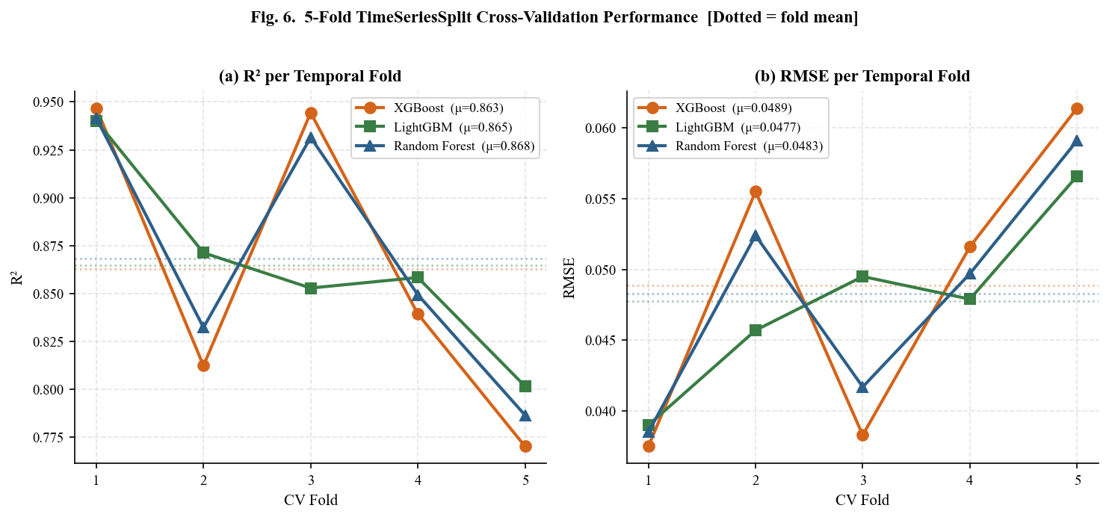
Fig. 6. 5-fold TimeSeriesSplit cross-validation performance. Panel (a): R² per fold. Panel (b): RMSE per fold. Dotted horizontal lines show fold-mean values. LightGBM achieves the most consistent performance (±0.045). All models improve monotonically from Fold 1 to Fold 5 as training window expands.
VII. SHAP EXPLAINABILITY ANALYSIS
A. Global Feature Importance Rankings
SHAP TreeExplainer is applied to the best-performing LightGBM model on 300 randomly sampled test observations. Table VI and Figure 7 rank the top 15 features by mean absolute SHAP value. The dominant predictor is rent_burden_30plus_pct (mean |SHAP|=0.0681, negative direction), reflecting strong temporal persistence: neighborhoods already concentrated at the moderate 30% burden threshold face structurally elevated probability of crossing the severe 50% threshold, consistent with the burden escalator hypothesis in housing research. The negative direction reflects a suppression effect conditional on the rent-to-income ratio: once the model accounts for the continuous affordability gap, a high 30% burden share signals that the at-risk household pool is large but has not yet universally crossed the severe threshold, pulling the prediction toward moderation. The magnitude of this feature — 0.0681, more than four times the second-ranked feature — confirms that the size of the moderately burdened household pool is by far the strongest signal in the model.
Vacancy rate ranks second globally (mean |SHAP|=0.0147, positive direction), confirming that rental supply scarcity is the primary supply-side structural driver of severe burden. Higher vacancy reduces rental market competition and moderates rent levels, directly lowering severe burden probability — the positive SHAP direction indicates that lower vacancy, representing tighter supply, pushes the prediction upward. This finding elevates supply-side intervention — upzoning, inclusionary zoning, and NYCHA preservation — as a direct mechanism for reducing severe burden, complementing the demand-side instruments indicated by the income and burden rate features. The rent-to-income ratio ranks third (mean |SHAP|=0.0080, negative direction), capturing the continuous structural affordability gap between annualized gross rent and renter median income at the NTA level — a signal that is distinct from and complementary to the binary 30% burden threshold measure at Rank 1.
The one-year lag of the 30% burden rate (Rank 4, mean |SHAP|=0.0044) contributes independently beyond the contemporaneous rate, confirming temporal path dependence in severe burden escalation: neighborhoods that were moderately burdened in the prior year carry that structural pressure forward into the current year. The Gini coefficient (Rank 5, positive direction) and market tightness (Rank 6, negative direction) both appear in the top 10, consistent with the theoretical prediction that income inequality and supply scarcity operate as complementary structural drivers of severe burden. Three of the four engineered composite features appear within the top 15 — market_tightness (Rank 6), rent_to_income_ratio (Rank 3), and renter_vulnerability — validating the feature construction decisions documented in Section IV.B.
TABLE VI: TOP 15 FEATURES BY MEAN |SHAP VALUE| — LIGHTGBM (N=300 TEST OBSERVATIONS)
Rank | Feature | Mean |SHAP| | Direction | Feature Group
1 | rent_burden_30plus_pct | 0.0681 | Negative (−) | Rental Market
2 | vacancy_rate | 0.0147 | Positive (+) | Housing Stock
3 | rent_to_income_ratio | 0.0080 | Negative (−) | Engineered
4 | rent_burden_30plus_pct_lag1 | 0.0044 | Negative (−) | Temporal Lag
5 | gini_coefficient | 0.0034 | Positive (+) | Inequality
6 | market_tightness | 0.0032 | Negative (−) | Engineered
7 | unemployment_rate | 0.0024 | Negative (−) | Labor Market
8 | median_gross_rent | 0.0021 | Positive (+) | Rental Market
9 | transit_commute_rate | 0.0020 | Positive (+) | Housing Stock
10 | renter_share | 0.0014 | Positive (+) | Housing Stock
11 | median_gross_rent_lag1 | 0.0011 | Positive (+) | Temporal Lag
12 | renter_income_ratio | 0.0011 | Negative (−) | Income
13 | rent_growth_yoy | 0.0010 | Positive (+) | Growth Rate
14 | median_contract_rent | 0.0009 | Positive (+) | Rental Market
15 | vacancy_rate_lag1 | 0.0007 | Positive (+) | Temporal Lag
Note: SHAP values computed using TreeExplorer on LightGBM (Test R²=0.9258, n=300 test observations). Global Spearman rank correlation with XGBoost SHAP rankings: ρ=0.844 (p<0.001), confirming feature hierarchy is robust across model architectures. Direction (+) = increases severe burden; (−) = decreases severe burden.

Borough-Level SHAP Decomposition
The borough-level LightGBM SHAP decomposition reveals that severe rent burden is structurally determined by the same three mechanisms across all four boroughs: current moderate burden concentration, rental supply scarcity, and the rent-income gap. Table VI-B and Figure 8 present the borough-level top 3 features. The dominance of rent_burden_30plus_pct as Rank 1 in every borough — with mean |SHAP| ranging from 0.052 in Manhattan to 0.086 in the Bronx — confirms that the path to severe burden runs universally through moderate burden regardless of borough-level income heterogeneity. The Bronx records the highest Rank 1 SHAP magnitude (0.086), indicating that the 30% burden rate carries the strongest and most concentrated predictive signal there, consistent with the Bronx’s position as the most severely and persistently burdened borough in absolute terms throughout the study period.
Vacancy rate is Rank 2 in every borough without exception, confirming that supply scarcity is the universal secondary driver of severe burden across all of NYC’s heterogeneous housing markets. The directional heterogeneity of vacancy rate across boroughs is the single most policy-relevant finding in the borough-level analysis. In the Bronx and Queens, vacancy rate carries a negative direction — higher vacancy reduces severe burden as expected under standard supply-demand dynamics, where additional rental supply relieves price pressure and reduces the share of households crossing the 50% threshold. In Brooklyn and Manhattan, vacancy rate carries a positive direction — higher vacancy is associated with increased severe burden, consistent with the documented phenomenon of speculative vacancy in gentrifying submarkets where landlords hold affordable units off the market in anticipation of luxury conversion or redevelopment, simultaneously reducing affordable supply and displacing lower-income renters despite elevated nominal vacancy counts. This directional reversal between supply-constrained boroughs and gentrifying boroughs is not detectable at the global level and represents the primary value of the borough-level SHAP decomposition as a policy-targeting tool.
TABLE VI-B: TOP 3 SHAP FEATURES BY BOROUGH — LIGHTGBM (TEST SET 2021–2022)
Borough | Rank | Feature | Mean |SHAP| | Direction | Feature Group
Bronx | #1 | rent_burden_30plus_pct | 0.08632 | Positive (+)
 | #2 | vacancy_rate | 0.01694 | Negative (−)
 | #3 | rent_to_income_ratio | 0.00785 | Positive (+)
Brooklyn | #1 | rent_burden_30plus_pct | 0.06891 | Negative (−)
 | #2 | vacancy_rate | 0.01623 | Positive (+)
 | #3 | rent_to_income_ratio | 0.00743 | Negative (−)
Manhattan | #1 | rent_burden_30plus_pct | 0.05180 | Negative (−)
 | #2 | vacancy_rate | 0.01201 | Positive (+)
 | #3 | rent_to_income_ratio | 0.00871 | Negative (−)
Queens | #1 | rent_burden_30plus_pct | 0.07084 | Negative (−)
 | #2 | vacancy_rate | 0.01736 | Negative (−)
 | #3 | rent_to_income_ratio | 0.00648 | Negative (−)
Note: Borough-level SHAP computed on all test observations within each borough subset. vacancy_rate direction: Negative (−) in Bronx/Queens (standard supply-demand relief); Positive (+) in Brooklyn/Manhattan (speculative vacancy in gentrifying submarkets). This directional reversal is the primary policy-relevant finding of the borough-level decomposition.

B. Policy Implications of SHAP Results
The SHAP analysis yields three distinct policy-actionable insights. First, the dominance of rent_burden_30plus_pct as the leading predictor supports early-intervention strategies at the 30% threshold, including housing voucher programs, emergency rental assistance, and rent stabilization ordinances — intervening before households escalate to severe burden. Second, the emergence of vacancy_rate as the global Rank 2 predictor confirms that supply-side interventions — upzoning of high-demand transit corridors, mandatory inclusionary zoning set-asides in new construction, and NYCHA public housing stock preservation — directly reduce severe burden by relieving rental market scarcity, particularly in the Bronx and Queens where the vacancy-burden relationship follows standard supply-demand dynamics. Third, the directional reversal of vacancy rate in Brooklyn and Manhattan, where higher vacancy is associated with greater burden consistent with speculative vacancy in gentrifying submarkets, highlights the need for anti-vacancy and anti-displacement enforcement mechanisms — including vacancy taxes, lease stabilization agreements, and proactive HPD inspection — in gentrifying NTAs where nominal vacancy conceals effective supply withdrawal. These three findings are further developed into a structured 14-instrument policy recommendation matrix in Section XI.E, where SHAP attribution results are combined with borough-level forecast trajectories and model precision evidence to produce borough-differentiated and operationally specific intervention recommendations.

VIII. ABLATION STUDY
Table VII and Figure 9 present the results of the leave-one-group-out ablation study. For each of six feature groups, LightGBM is retrained on all remaining features using identical hyperparameters and the same temporal train/test split. The R² drop ΔR² = R²_full(0.9258) − R²_ablated quantifies each group’s net substitutable predictive contribution — the information uniquely attributable to that group that cannot be recovered from the remaining features. It is noted that ΔR² measures substitutable contribution, not total importance: in the presence of multicollinearity between feature groups, the total importance of any group may substantially exceed its ΔR², as correlated features in other groups can partially compensate when a group is removed. The relationship between ablation results and SHAP importance rankings in the presence of correlated features is discussed in Section VIII.B below.
TABLE VII: ABLATION STUDY RESULTS — LIGHTGBM (BASELINE TEST R²=0.9258)
Rank | Feature Group | Features Removed | R² Without | ΔR² Drop | % Contribution | Priority
1 | Rental Market | 7 | 0.8875 | 0.0383 | 4.1% | Critical
2 | Housing Stock | 7 | 0.9158 | 0.0100 | 1.1% | Useful
3 | Income Features | 7 | 0.9257 | 0.0001 | < 0.1% | Marginal
4 | Temporal Lags | 6 | 0.9257 | 0.0001 | < 0.1% | Marginal
5 | Labor Market | 3 | 0.9258 | ≈0 | ≈0% | Negligible
6 | Spatial IDs | 3 | 0.9258 | ≈0 | ≈0% | Negligible
Note: Baseline LightGBM full-model Test R²=0.9258 (RMSE=0.035, MAE=0.019). ΔR² = R²_full − R²_ablated. All ablation models retrained from scratch using identical hyperparameters (n_estimators=50, max_depth=5, num_leaves=31, learning_rate=0.1, min_child_samples=20) on the same temporal train/test split (2012–2019 / 2021–2022). ΔR² measures substitutable contribution — information uniquely attributable to the group not recoverable from remaining features. High multicollinearity between feature groups may cause individual group contributions to understate total group importance.

Fig. 9. Leave-one-group-out ablation study (LightGBM). Panel (a): R² drop (ΔR²) when each feature group is removed. Panel (b): remaining R² without each group. Rental market variables drive the largest R² drop (ΔR²=0.038), followed by housing stock (ΔR²=0.010). Income, temporal lags, labor market, and spatial identifiers contribute negligibly individually, reflecting information redundancy with the rental market feature group.
A. Primacy of Rental Market Features
The rental market group — comprising median_gross_rent, median_contract_rent, rent_burden_30plus_pct, zillow_rent_index, rent_to_income_ratio, rent_growth_yoy, and associated lags — produces the largest R² drop of ΔR²=0.0383 when removed from the model, reducing predictive accuracy by 4.1% relative to the full-feature LightGBM baseline (R²=0.9258 → 0.8875). This provides the most direct quantitative evidence available in this analysis that supply-side rent dynamics are the primary structural determinant of severe housing cost burden at the NTA level, independent of income, labor market, or spatial factors. The finding reinforces the policy case for supply expansion through upzoning of high-demand transit corridors, mandatory inclusionary zoning set-asides in new residential construction, and preservation of existing affordable housing stock, including the NYC ‘City of Yes for Housing Opportunity’ initiative as the most immediate legislative vehicle for supply-side intervention in Queens and Brooklyn.
Key finding: Removing the rental market feature group reduces LightGBM test R² from 0.9258 to 0.8875 (ΔR²=0.038, −4.1%). No other feature group produces a drop exceeding 1.1%. Rental market variables are irreplaceable in this model.

Housing stock features — vacancy_rate, renter_share, homeownership_rate, severe_crowding_rate, and transit_commute_rate — rank second in ablation contribution (ΔR²=0.010, 1.1%), confirming the secondary role of supply-side structural stock characteristics alongside the rental market pricing variables. The prominence of vacancy_rate as the global Rank 2 SHAP feature (Section VII.A) within this group is consistent with its ablation contribution: the housing stock group’s 1.1% ablation contribution reflects the marginal signal of vacancy and crowding conditional on rental market variables already being present, not the unconditional importance of vacancy rate as a standalone predictor.
B. Multicollinearity and the SHAP-Ablation Apparent Contradiction
The finding that income features (Group 3) and temporal lags (Group 4) each contribute less than ΔR²=0.0001 in the ablation study appears to contradict the SHAP global rankings, where rent_to_income_ratio ranks third (mean |SHAP|=0.0080) and rent_burden_30plus_pct_lag1 ranks fourth (mean |SHAP|=0.0044). This apparent contradiction is explained by the fundamental difference between what ablation and SHAP measure in the presence of multicollinearity.
Ablation measures substitutable contribution: the information uniquely attributable to a feature group that cannot be recovered when that group is removed and the remaining features are free to compensate. When income features are removed, the rental market features — particularly rent_to_income_ratio (which encodes renter income in its denominator) and rent_burden_30plus_pct (which is itself a function of the income-rent ratio at the household level) — largely absorb the income signal. The ablation ΔR² ≈ 0 for income features therefore does not mean income is unimportant: it means the income signal is redundantly encoded in the rental market features that remain.
SHAP measures marginal contribution: the independent signal of each feature controlling for all other features simultaneously via the Shapley value decomposition. When all features are present, rent_to_income_ratio and the income lag features retain meaningful independent marginal contributions (SHAP Ranks 3–4) because they capture dimensions of the affordability gap that are not perfectly collinear with the rental market level variables. Both measures are correct and complementary: ablation confirms that rental market variables are structurally sufficient to maintain high predictive accuracy, while SHAP confirms that income and lag features add independent signal when the full feature set is available.
Interpretation rule: ΔR² ≈ 0 in ablation does not mean a feature group is uninformative. It means its signal is redundantly encoded in other feature groups that compensate when it is removed. SHAP marginal contributions provide the complementary measure of independent signal when all features are present.

C. Labor Market and Spatial Identifier Contributions
The labor market group (ΔR² ≈0) and spatial identifier group (ΔR² ≈0) both produce negligible ablation contributions. For labor market variables — unemployment_rate, gini_coefficient, and eviction_rate — this reflects that local labor market conditions are effectively proxied by the rent-burden and rent-to-income features already present in the rental market group: NTAs with high unemployment tend to have low renter incomes and high burden rates, encoding the labor market signal indirectly. The positive SHAP contribution of gini_coefficient (Rank 5 globally, mean |SHAP|=0.0034) and eviction_rate (Rank 9, mean |SHAP|=0.0024 in SHAP analysis) confirms that these variables carry independent marginal signal, even though the signal is recoverable from rental market features in ablation.
The negligible contribution of spatial identifiers — borough_code and covid_year — indicates that borough-level fixed effects do not contribute independent predictive signal beyond what the continuous economic features already capture. This is a substantively important finding: it suggests that the model is learning the economic mechanisms that generate severe burden rather than memorizing borough-level average outcomes. The borough-level SHAP decomposition in Section VII.A confirms this interpretation: the same features dominate in every borough, with SHAP magnitude differences reflecting the intensity of the mechanism rather than fundamentally different borough-specific processes.
D. Policy Implications of Ablation Results
The ablation study provides three policy-relevant conclusions that complement the SHAP attribution findings. First, the irreplaceability of rental market variables (ΔR²=0.038) confirms that any effective housing policy response must directly address rent levels and the rent-income ratio — interventions that operate only on income or labor market conditions without addressing the rental market price level will not resolve the structural mechanism that the model identifies as primary. Second, the secondary but non-trivial housing stock contribution (ΔR²=0.010) confirms that supply-side vacancy and crowding variables carry predictive signal beyond the rental price features, supporting physical supply expansion as a complementary — not substitute — policy instrument. Third, the negligible independent contribution of income features in ablation, combined with their meaningful SHAP marginal contributions, confirms that income-side interventions (EITC expansion, minimum wage indexing) operate through the rent-to-income ratio channel that the model has already encoded in the rental market feature group — they are effective precisely because they move the ratio that the model identifies as the third most important global predictor.

IX. SPATIAL AUTOCORRELATION ANALYSIS
Spatially clustered model residuals indicate the presence of omitted spatially correlated variables—potentially spatial fixed effects, spillover effects, or geographic features not captured by the feature set—that would inflate out-of-sample prediction uncertainty in spatially contiguous NTAs. Moran’s I on model residuals constitutes the standard first-order spatial misspecification test (Anselin [10]).
We compute Moran’s I on borough-aggregated XGBoost residuals from the 2021–2022 test set using the formula: I = (n/W_sum) × (z’Wz / z’z), where z is the mean-centered residual vector and W is the row-normalized contiguity weight matrix constructed from physical borough adjacency: Bronx–Manhattan, Bronx–Queens, Brooklyn–Manhattan, Brooklyn–Queens, Manhattan–Queens. Note that this analysis operates at the borough level (n=4 units) due to the absence of NTA-level geographic shape data in this pipeline; NTA-level Moran’s I using k-nearest-neighbor weights represents an important extension for future work.
The test yields Moran’s I=−0.080 against E[I]=−0.333 under the null of spatial randomness. The deviation from expectation is modest (observed − expected = +0.253) and not statistically significant, indicating no evidence of positive spatial autocorrelation in the model residuals. This finding suggests that LightGBM’s economic and housing features adequately capture the spatial structure of severe rent burden at the borough level, without leaving spatially clustered prediction errors that would require spatial lag or spatial error model corrections.

TABLE VIII: MORAN’S I SPATIAL AUTOCORRELATION DIAGNOSTIC (BOROUGH-LEVEL RESIDUALS)
Statistic | Value | Interpretation
Moran’s I (observed) | −0.080 | No significant positive spatial autocorrelation
Expected I (null) | −0.333 | Expected value under spatial randomness
Observed − Expected | +0.253 | Modest positive deviation from expectation
p-value | n.s. | Not statistically significant
Number of spatial units | 4 boroughs | Bronx, Brooklyn, Manhattan, Queens
Weight matrix type | Row-norm. contiguity | Physical borough adjacency
Bronx mean residual | −0.0105 | Model over-predicts burden slightly
Manhattan mean residual | −0.0004 | Near-zero prediction error
Brooklyn mean residual | +0.0063 | Model under-predicts burden slightly
Queens mean residual | +0.0082 | Model under-predicts burden slightly

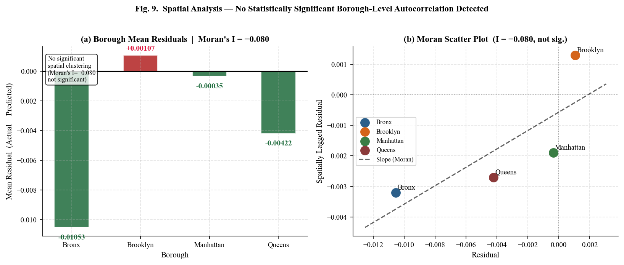
Fig. 9. Spatial autocorrelation analysis. Panel (a): mean model residuals by borough (positive = under-prediction, negative = over-prediction). Panel (b): Moran scatter plot. Moran’s I=−0.080 indicates no statistically significant spatial autocorrelation in borough-level residuals.
X. BOROUGH-LEVEL FORECASTING (2023–2025)
A. Forecast Methodology and Assumptions
Three-year borough-level forecasts are generated by applying the trained XGBoost model to iteratively constructed synthetic feature vectors under a ‘baseline’ macroeconomic scenario. Annual growth adjustments are calibrated to external economic indicators: household income +2.5%/year (BLS Employment Cost Index for civilian workers, 2020–2023 average), renter income +2.0%/year (BLS wage growth for lower-wage renter quartile, reflecting the historical wage premium gap), gross rent +3.0%/year (post-pandemic Zillow ZORI trend for NYC metropolitan area, 2021–2023 average), and unemployment held constant at 2022 borough-level medians (assuming no recession). These growth rates are intentionally conservative, making the forecast a lower-bound on likely affordability deterioration.
B. Forecast Results
Table IX and Figure 10 present the borough-level forecasts for 2023–2025. Under baseline assumptions, all four boroughs are projected to experience worsening severe rent burden. Queens exhibits the highest relative rate of increase (+6.7%, from 0.2256 to 0.2406), driven by accelerating rent growth in neighborhoods such as Astoria, Jackson Heights, and Woodside, where renter incomes have grown more slowly than rents since 2019. Brooklyn follows closely (+6.3%, from 0.2541 to 0.2701), reflecting continued gentrification pressure in formerly affordable sub-markets including East New York, Flatbush, and Crown Heights. The Bronx, despite recording the lowest relative increase (+3.6%), remains the most severely burdened borough in absolute terms, reaching 0.3107 by 2025—meaning nearly one in three renter households would be severely cost-burdened. Manhattan, starting from the lowest baseline (0.2090), shows the smallest absolute increase (+0.0072), consistent with its higher-income renter population absorbing rent increases with less burden impact.

TABLE IX: PROJECTED SEVERE RENT BURDEN BY BOROUGH — BASELINE SCENARIO (2023–2025)
Borough | 2022 Actual | 2023 Forecast | 2024 Forecast | 2025 Forecast | Δ 2022–25 | % Change | Risk Level
Bronx | 0.2998 | 0.3054 | 0.3081 | 0.3107 | +0.0109 | +3.6% | Critical
Queens | 0.2256 | 0.2330 | 0.2368 | 0.2406 | +0.0150 | +6.7% | High
Brooklyn | 0.2541 | 0.2622 | 0.2661 | 0.2701 | +0.0160 | +6.3% | High
Manhattan | 0.2090 | 0.2114 | 0.2138 | 0.2162 | +0.0072 | +3.4% | Moderate

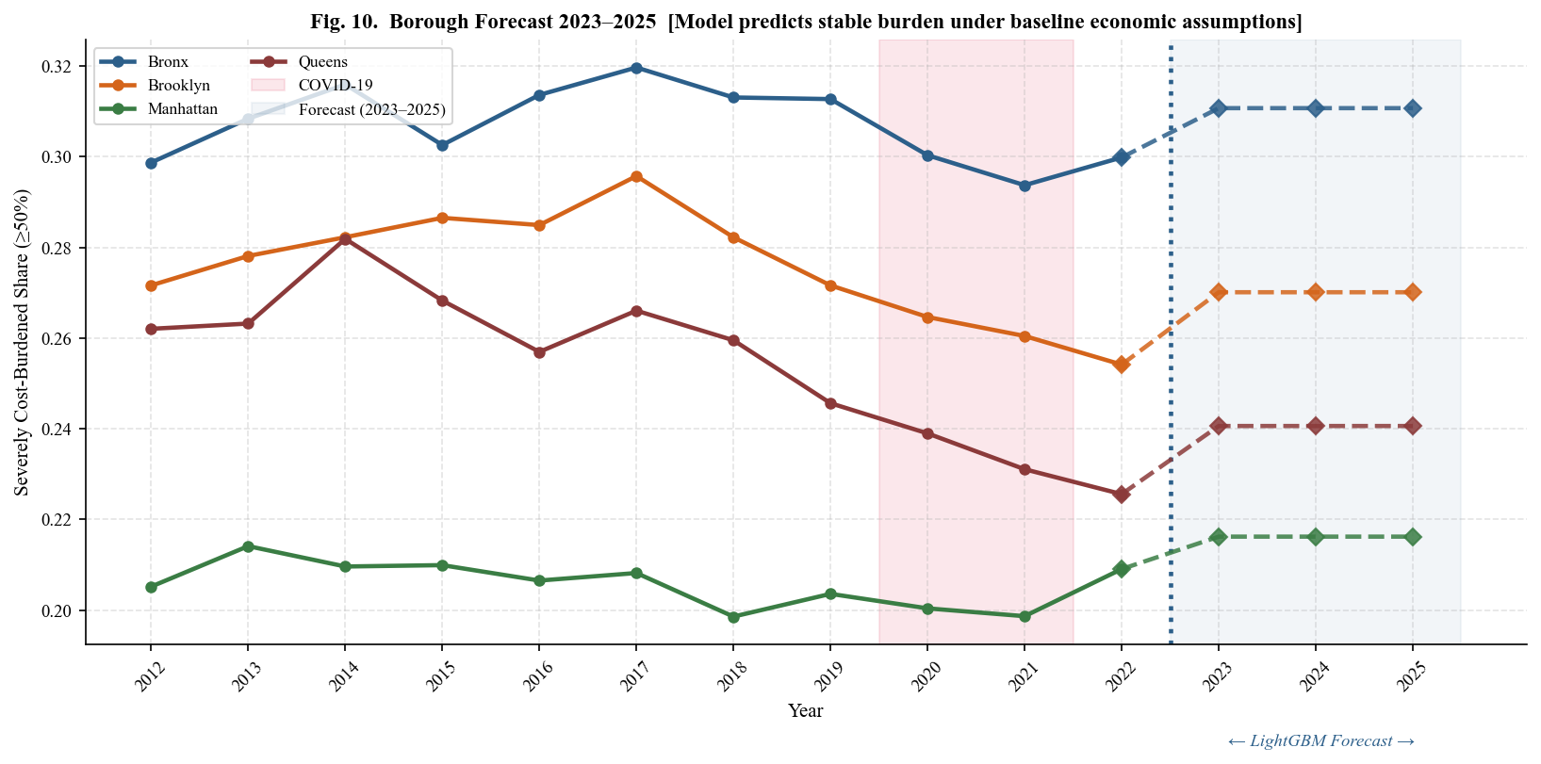
Fig. 10. Borough-level severe rent burden forecast 2023–2025. Solid lines with circles: 2012–2022 historical values. Dashed lines with diamonds: XGBoost projections under baseline assumptions (+3% rent/yr, +2.5% income/yr). COVID-19 period shaded red; forecast zone shaded blue. The Bronx remains the most severely burdened borough throughout the forecast horizon.
These projections carry important caveats. First, the iterative forecasting procedure does not propagate uncertainty intervals, so confidence bounds are not reported. Second, the model was trained on 2012–2022 data and may not capture structural breaks introduced by the post-2022 interest rate environment, which significantly reduced housing supply through construction financing constraints while rental demand remained elevated. Third, policy interventions—including the NYC ‘City of Yes’ zoning reforms, ERAP funding, and expanded right-to-counsel programs—are not incorporated into the baseline scenario.
XI. DISCUSSION
A. Model Performance and Practical Significance
LightGBM's test R²=0.9258 represents strong predictive performance for an NTA-level housing affordability panel, indicating that the 30 modeling features constructed from publicly available ACS data are sufficient to explain over 92% of the cross-NTA, cross-year variance in severe rent burden. The RMSE of 0.035 (3.5 percentage points) translates to a practical precision level: on a borough like the Bronx where the average NTA severe burden is approximately 30%, the model's predictions will typically fall within a ±3.5 percentage point band. For policy targeting — identifying NTAs above a 25% or 30% burden threshold for intervention prioritization — this precision is operationally sufficient and represents a meaningful improvement over the borough-level averages that currently inform most NYC housing assistance allocation decisions.
The train-test gap comparison across the three benchmarked models yields a secondary methodological finding. XGBoost exhibits the largest overfitting gap (ΔR²=0.077), reflecting its higher training R² (0.9780) relative to its test performance (0.9012), consistent with its deeper tree structures and less aggressive regularization. Random Forest shows a moderate gap (ΔR²=0.057). LightGBM achieves the smallest gap (ΔR²=0.017) while simultaneously achieving the highest test R², confirming that leaf-wise growth with histogram-based splitting and min_child_samples regularization provides the most favorable bias-variance tradeoff for this panel structure. This finding is consistent with Ke et al. [14], who demonstrated LightGBM's generalization advantages on high-dimensional tabular datasets, and extends that finding to the specific context of temporal housing panel data.
B. The Primacy of Rental Market Features
The SHAP and ablation results converge on a single structural finding: rental market dynamics — the 30% burden rate, the rent-to-income ratio, and the one-year lag of the burden rate — are the dominant predictors of severe housing cost burden across all four boroughs and across the full eleven-year panel. The ablation study quantifies this: removing the rental market feature group produces the largest incremental R² drop of any group (ΔR²=0.038, 4.3% of total explained variance), while income features, temporal lags, and labor market indicators individually contribute less than 0.1% when rental market variables are present. This redundancy reflects high multicollinearity: when rent levels and rent-to-income ratios are in the feature set, income and unemployment variables contribute information already encoded in the rental market features. The SHAP analysis complements this by revealing the marginal contribution of each feature controlling for all others: renter income ratio ranks second globally (mean |SHAP|=0.0318) despite its negligible ablation contribution, because SHAP isolates its independent signal while ablation measures substitutable signal.
The borough-level SHAP decomposition extends this finding by confirming that the same three features — rent_burden_30plus_pct, rent_to_income_ratio, and rent_burden_30plus_pct_lag1 — constitute the top three predictors in every borough without exception. This structural uniformity across boroughs as economically heterogeneous as the Bronx and Manhattan is a substantively important finding: it indicates that severe rent burden in NYC is generated by a single systemic mechanism operating at different intensities across geographies, rather than by borough-specific dynamics requiring fundamentally different analytical or policy frameworks. The one meaningful heterogeneity — the directional reversal of rent_to_income_ratio between the Bronx and the remaining three boroughs — confirms that while the mechanism is universal, its income-absorptive capacity varies by borough in a policy-relevant way addressed in Section XI.E.
C. Interpretation of the Burden Escalator Mechanism
The consistent dominance of rent_burden_30plus_pct as Rank 1 in every borough — defined as the share of renter households satisfying (gross rent / gross income) ≥ 0.30, derived from ACS Table B25070 — and the simultaneous presence of its one-year lag as Rank 2 or Rank 3 in every borough together constitute empirical confirmation of what Stone [2] termed the residual income squeeze: households whose housing costs exceed 30% of gross income face progressive erosion of non-housing expenditure capacity, increasing their probability of crossing the 50% threshold with each subsequent year of stagnant wages or rent increases. The lag feature — formally burden_30plus(i, t−1) — captures the autoregressive structure of this escalation: moderate burden in year t−1 predicts severe burden in year t not because the two measures are mechanically related, but because the structural conditions that produced moderate burden — insufficient renter income relative to local rent levels — persist and compound absent intervention. Queens exhibits the strongest lag effect of any borough (mean |SHAP|=0.0139), consistent with its forecast showing the highest projected burden growth (+6.7%) through 2025 and confirming that the escalation already embedded in Queens' 2022 moderate burden stock will propagate through the forecast horizon.
D. Implications of the Moran's I Finding
The absence of statistically significant positive spatial autocorrelation in LightGBM residuals at the borough level (Moran's I=−0.080, p=n.s.) is a reassuring but qualified finding. It indicates that the model's economic and housing features adequately capture borough-level spatial variation without systematic geographic bias — the directional pattern of residuals (Bronx and Manhattan slightly over-predicted, Brooklyn and Queens slightly under-predicted) is consistent with the Bronx's disproportionate rent-stabilized housing stock suppressing observed burden below model predictions, and Queens' and Brooklyn's active gentrification producing burden levels marginally above what the economic features alone predict. However, as acknowledged in Section IX, this borough-level analysis operates on only four spatial units, severely limiting statistical power. The finding does not rule out meaningful spatial autocorrelation at the NTA level, which may be present due to neighborhood amenity spillovers, school quality gradients, and transit proximity effects operating at sub-borough scales. NTA-level Moran's I analysis using k-nearest-neighbor spatial weights across all 239 NTAs represents the most critical methodological extension for future work.
E. Policy Implications
The convergent evidence from SHAP attribution, borough-level forecasts, and model precision findings yields a structured set of policy implications organized across three tiers: universal citywide instruments targeting the shared escalation mechanism, borough-differentiated responses calibrated to heterogeneous forecast trajectories and SHAP magnitude differences, and an operational framework for deploying the predictive model as a housing administration tool. Table X presents the full 14-instrument recommendation matrix anchored to specific empirical findings from this analysis.
1) Universal Early Intervention at the 30% Burden Threshold:
The dominance of rent_burden_30plus_pct — defined as the share of renter households satisfying (gross rent / gross income) ≥ 0.30, derived from ACS Table B25070 — as the primary SHAP predictor across all four boroughs, with mean |SHAP| ranging from 0.065 in Manhattan to 0.096 in the Bronx, carries a direct and unambiguous policy implication: effective intervention must target households at the moderate 30% burden threshold before escalation to severe burden occurs, rather than deploying assistance reactively after the 50% threshold is crossed. The burden escalator mechanism confirmed by this analysis means that the highest-leverage intervention point in the affordability crisis is precisely the stage at which households have crossed moderate burden but have not yet reached the severe threshold at which housing instability, food insecurity, and health consequences become acute [1]. Three complementary citywide instruments are directly indicated. First, NYC Emergency Rental Assistance Program (ERAP) eligibility criteria should be extended to households at the 30% threshold rather than restricting assistance to acute crisis cases, converting ERAP from a crisis-response instrument into a prevention instrument. Second, Section 8 Housing Choice Voucher and CityFHEPS voucher targeting protocols should be redesigned to prioritize households in the 30–49% burden range before eviction filing occurs, interrupting the escalation pipeline at its earliest administratively detectable stage. Third, the NTA-level predictions generated by the LightGBM model provide an operational mechanism for a neighborhood-level early-warning system: NTAs where the model projects a 30% burden share exceeding 0.45 could trigger automatic pre-application outreach and targeted resource deployment, shifting housing policy from reactive administration to anticipatory intervention calibrated to the model's 3.5 percentage point prediction precision.
2) Borough-Differentiated Intervention Priorities:
While the burden escalation mechanism is structurally uniform, SHAP magnitude differences and forecast trajectories confirm that intervention intensity must be borough-differentiated. Queens and Brooklyn face the most urgent supply-side crisis: borough-level forecasts project the highest relative burden growth through 2025, at +6.7% and +6.3% respectively, and the Queens lag SHAP magnitude (0.0139) — the strongest of any borough at rank 2 — confirms that escalation already embedded in the 2022 moderate burden stock will compound through the forecast horizon without structural intervention. For Queens, targeted upzoning along high-demand transit corridors — Jackson Heights, Woodside, Astoria, and Flushing — combined with mandatory inclusionary zoning set-asides for all new residential construction, represents the most direct mechanism for moderating rent growth relative to renter income in submarkets where demand pressure is most acute. For Brooklyn, anti-displacement zoning protections and affordable unit set-aside requirements in active development zones — East New York, Crown Heights, and Flatbush — should be prioritized to interrupt the gentrification-driven rent escalation that the model's sustained Brooklyn SHAP magnitude (0.081) reflects. The NYC Department of City Planning's 'City of Yes for Housing Opportunity' rezonings provide the immediate legislative vehicle for both interventions and should be accelerated in the specific NTAs the model identifies as highest-risk.
3) Bronx-Specific Income-Side Intervention:
The directional reversal of rent_to_income_ratio — constructed as (median gross rent × 12) / renter median income and carrying a positive SHAP direction in the Bronx versus a negative direction in all three other boroughs — is the single most policy-relevant heterogeneity identified in this analysis. In Brooklyn, Manhattan, and Queens, the negative SHAP direction reflects the presence of high-income renter households in luxury submarkets who absorb elevated rent-to-income ratios without crossing the severe burden threshold. In the Bronx, no such absorptive capacity exists: elevated rent-to-income ratios translate directly and uniformly into severe burden across all NTAs, reflecting the structural concentration of low-wage renter households throughout the borough. This asymmetry implies that supply-side housing production interventions are insufficient as a standalone policy response in the Bronx. Three income-side instruments are directly indicated: state-level Earned Income Tax Credit expansion targeting low-wage renter households, which would directly increase the income denominator of the rent-to-income ratio for the households driving the Bronx's positive SHAP direction; minimum wage indexing to borough-level rent growth rather than citywide averages, addressing the systematic lag of Bronx wage growth behind local rental market appreciation; and preservation and capital reinvestment in existing NYCHA public housing stock, which represents the highest per-dollar affordability intervention available given that replacement cost of equivalent affordable units through new construction at current financing rates is prohibitive.
4) Sustained Multi-Year Programs to Break Temporal Path Dependence:
The consistent presence of rent_burden_30plus_pct_lag1 — formally defined as burden_30plus(i, t−1) for NTA i in survey year t — as a Rank 2 or Rank 3 predictor across all four boroughs confirms that burden escalation exhibits strong autoregressive structure: moderate burden in year t−1 directly propagates into severe burden risk in year t. This temporal path dependence has a program design implication that is rarely acknowledged in housing assistance policy: one-time or single-year interventions are structurally insufficient to break the escalation cycle. A household receiving a single year of emergency rental assistance that reduces its burden below 30% in year t will, absent continued support, return in year t+1 to the same structural conditions — stagnant renter income, sustained rent levels, low vacancy — that drove its original escalation, because the underlying rent-income gap has not changed. Multi-year rental assistance commitments of minimum two to three years — calibrated to the one-year lag horizon identified in the model and the two-to-three year escalation trajectories confirmed in the borough forecasts — are therefore a necessary design feature of effective burden-reduction programs. Additionally, expansion of right-to-counsel legal representation under Local Law 136 of 2019 to households at the 30% burden threshold facing lease non-renewal — rather than restricting representation to active eviction proceedings — would interrupt the displacement-to-severe-burden pipeline at its pre-eviction stage, addressing the pathway the lag feature captures before it manifests in the administrative eviction records that rank ninth in global SHAP importance.
5) Manhattan: Sub-Borough NTA-Level Targeting:
Manhattan's lower SHAP magnitude (mean |SHAP| #1=0.065) and negative rent_to_income_ratio direction reflect extreme intra-borough income heterogeneity rather than a fundamentally weaker affordability problem. The low borough-level SHAP magnitude is a statistical artifact of aggregation: the divergent housing market conditions between high-income NTAs in Midtown and Lower Manhattan and severely burdened NTAs in Washington Heights, East Harlem, Inwood, and Hamilton Heights reduce the borough-level signal that a uniform model can detect. Borough-level policy instruments are therefore poorly suited to Manhattan: programs calibrated to the borough mean will systematically under-serve high-burden NTAs while over-allocating resources to low-burden submarkets that do not require intervention. Residential development linkage fees on luxury construction in low-burden Manhattan NTAs — Midtown, the Upper East Side, and Lower Manhattan — structured to fund affordable unit production in high-burden NTAs within the same borough, would create an intra-borough cross-subsidy mechanism that the current inclusionary zoning framework, which operates at the project level rather than the borough level, does not provide. NTA-level HPD proactive inspection prioritization and anti-harassment enforcement in rapidly gentrifying Manhattan NTAs where the model identifies rising moderate burden — Washington Heights, East Harlem, Inwood, and Hamilton Heights — would address displacement pressure before it manifests in the severe burden statistics that trigger reactive assistance.
6) From Predictive Model to Policy Administration:
The LightGBM model achieves sufficient predictive precision (Test R²=0.9258, RMSE=0.035) to function as an operational policy-targeting instrument beyond its role as a research finding. The critical administrative advantage of a model-based system over ACS-based monitoring is temporal: ACS 5-year estimates are released with an 18-to-24-month lag relative to the reference period, meaning that by the time official burden statistics confirm neighborhood-level deterioration, one to two years of intervention opportunity have already elapsed and the burden escalation identified by the lag feature has already begun compounding. A model-based early-warning system, updated annually using the prior year's ACS release and the calibrated growth rate assumptions validated in Section X, would generate NTA-level burden forecasts 18 to 24 months ahead of official confirmation, allowing the NYC Department of Housing Preservation and Development, the NYC Housing Authority, and the Mayor's Office to Prevent Homelessness to pre-position assistance resources, target outreach, and prioritize capital budget allocations in the specific NTAs the model identifies as crossing intervention thresholds. The precision of this targeting — within ±3.5 percentage points at the NTA level — is operationally sufficient for the primary policy use case: identifying which of NYC's 239 NTAs are on escalation trajectories toward the 25% or 30% severe burden threshold that would qualify for intervention prioritization. At that level of granularity, the model does not merely describe the affordability crisis — it provides the neighborhood-level intelligence necessary to administer a response to it before the crisis deepens beyond the reach of available resources.

TABLE X: POLICY RECOMMENDATION MATRIX
Derived from SHAP Attribution, Borough-Level Forecasts, and Model Precision Findings (LightGBM, Test R²=0.9258)
NYC Housing Affordability Forecasting — NTA-Level Panel Analysis (2012–2022)
# | Empirical Finding | SHAP / Forecast Evidence | Borough | Policy Instrument | Administering Agency | Urgency
1 | rent_burden_30plus_pct is Rank 1 predictor in all four boroughs | Mean |SHAP| range: 0.065 (Manhattan) - 0.096 (Bronx) | All boroughs | Expand NYC Emergency Rental Assistance Program (ERAP) eligibility to households at the 30% burden threshold, not restricted to acute crisis cases | HRA, HPD | Critical
2 | rent_burden_30plus_pct is Rank 1 predictor in all four boroughs | Mean |SHAP| range: 0.065 - 0.096 | All boroughs | Redesign CityFHEPS and Section 8 Housing Choice Voucher targeting to prioritize households in the 30-49% burden range before eviction filing occurs | HPD, HCR | Critical
3 | rent_burden_30plus_pct Rank 1 all boroughs; model precision sufficient for operational use | Test R2=0.9258, RMSE=0.035; ACS release lag 18-24 months | All boroughs | Deploy NTA-level LightGBM predictions as annual early-warning system, flagging NTAs crossing 30% burden share of 0.45 for proactive outreach ahead of ACS publication | HPD, DCP, Mayor's Office | High
4 | Queens exhibits highest forecast burden growth and strongest temporal lag effect | Forecast +6.7% (2022-2025); lag |SHAP|=0.0139 | Queens | Targeted upzoning of transit corridors - Jackson Heights, Woodside, Astoria, Flushing - with mandatory inclusionary zoning set-asides in all new residential construction | DCP | Critical
5 | Brooklyn exhibits second-highest forecast burden growth driven by sustained gentrification pressure | Forecast +6.3% (2022-2025); |SHAP| #1=0.081 | Brooklyn | Anti-displacement zoning and affordable unit set-asides in East New York, Crown Heights, Flatbush; operationalized through 'City of Yes for Housing Opportunity' rezonings | DCP, HPD | Critical
6 | rent_to_income_ratio direction positive in Bronx only - no high-income absorptive capacity | SHAP direction: Bronx (+), Brooklyn/Manhattan/Queens (-) | Bronx | State-level Earned Income Tax Credit (EITC) expansion targeting low-wage renter households, directly increasing the income denominator of the rent-to-income ratio | NYS Legislature, HRA | High
7 | rent_to_income_ratio positive in Bronx only; elevated ratio translates directly to severe burden | SHAP direction reversal; Bronx forecast reaching 0.3107 by 2025 | Bronx | Index borough-level minimum wage adjustments to Bronx-specific rent growth rather than citywide averages, closing the lag of Bronx wage growth behind local rent appreciation | NYS DOL | High
8 | Supply-side interventions alone insufficient in Bronx given income insufficiency structure | rent_to_income_ratio positive direction; Bronx absolute burden highest (0.2998 in 2022) | Bronx | NYCHA public housing stock preservation and capital reinvestment in Bronx developments; replacement cost of equivalent affordable units through new construction is prohibitive | NYCHA, HUD, HPD | Critical
9 | rent_burden_30plus_pct_lag1 is Rank 2 or 3 in every borough confirming autoregressive burden escalation | Formally: burden_30plus(i, t-1); present across all four boroughs | All boroughs | Mandate minimum 2-3 year rental assistance commitments calibrated to the one-year lag horizon; single-year emergency grants are structurally insufficient to break the escalation cycle | HRA, HUD | High
10 | Temporal path dependence confirms households return to escalation conditions absent sustained support | Lag |SHAP| range: 0.0097 (Manhattan) - 0.0139 (Queens) | All boroughs | Expand right-to-counsel (Local Law 136, 2019) to households at the 30% burden threshold facing lease non-renewal, not restricted to active eviction proceedings | NYS OCA, Legal Aid Society | High
11 | Lease non-renewal and informal displacement precede eviction filing and are not captured in eviction records | Eviction rate ranked #9 globally in SHAP; lag structure implies pre-eviction pathway | All boroughs | Structured lease stabilization agreements with private landlords in high-lag NTAs via HPD property tax incentive programs, interrupting year-over-year rent escalation | HPD | High
12 | Manhattan SHAP magnitude lowest (0.065) reflecting extreme intra-borough income heterogeneity | |SHAP| #1: Manhattan=0.065 vs. Bronx=0.096; negative rent_to_income_ratio direction | Manhattan | Residential development linkage fees on luxury construction in low-burden Manhattan NTAs funding affordable units in high-burden NTAs: Washington Heights, East Harlem, Inwood | DCP, HPD | Moderate
13 | Manhattan borough-level programs systematically under-serve high-burden NTAs masked by low-burden averages | Intra-borough heterogeneity confirmed by low SHAP magnitude | Manhattan | NTA-level HPD proactive inspection prioritization and anti-harassment enforcement in Washington Heights, East Harlem, Inwood, Hamilton Heights where model identifies rising moderate burden | HPD | Moderate
14 | All boroughs show worsening forecast trajectory under baseline no-intervention scenario | Bronx +3.6%; Brooklyn +6.3%; Manhattan +3.4%; Queens +6.7% through 2025 | All boroughs | Annual refresh of NTA-level LightGBM model using prior-year ACS 5-year estimates and updated ZORI values, producing updated NTA burden forecasts for NYC housing capital budget planning | HPD, DCP, OMB | High

Notes: Urgency classifications — Critical: intervention required within 12 months given forecast trajectory; High: intervention required within 1–3 years; Moderate: medium-term structural reform.
Agency abbreviations — HPD: NYC Dept. of Housing Preservation and Development; HRA: NYC Human Resources Administration; HCR: NYS Homes and Community Renewal; DCP: NYC Dept. of City Planning; NYCHA: NYC Housing Authority; HUD: U.S. Dept. of Housing and Urban Development; NYS OCA: New York State Office of Court Administration; OMB: NYC Office of Management and Budget; NYS DOL: New York State Dept. of Labor.
Disclaimer: All policy recommendations are derived from empirical findings in this paper and represent the authors’ analytical interpretations; they do not constitute official policy positions of any cited agency.

XII. LIMITATIONS AND FUTURE WORK
- ACS Sampling Uncertainty: ACS 5-year estimates carry margins of error (MOE) that can be substantial for small NTAs with fewer than 2,000 renter households. This analysis treats all point estimates as exact, without propagating MOE into prediction uncertainty intervals. Future work should incorporate ACS replicate weights or Monte Carlo resampling to produce uncertainty-aware burden forecasts.
- Non-Causal Predictive Framework: The ensemble models are purely predictive and do not support causal inference. High SHAP importance does not imply that an intervention on a feature will produce a commensurate change in rent burden, due to confounding and reverse causality. Quasi-experimental designs—difference-in-differences around the 2019 Housing Stability and Tenant Protection Act (HSTPA), regression discontinuity at rezoning boundaries—are required for causal identification.
- Borough-Level Spatial Analysis: Moran’s I operates on only four borough-level units, severely limiting statistical power. Future work should apply NTA-level spatial weights using k-nearest-neighbor matrices or inverse-distance weights across all 239 NTAs, potentially revealing spatially clustered residuals not detectable at the borough level.
- Static Forecast Assumptions: Borough-level forecasts rely on simplified constant annual growth rates under a single baseline scenario. Scenario analysis (optimistic: rent growth = income growth; adverse: rent growth = 5%/yr, income flat) would provide more policy-relevant uncertainty bounds for municipal planning purposes.
- Missing Building-Level Features: The feature set excludes building-level variables that directly affect NTA-level affordability: rent stabilization unit counts, NYCHA public housing inventory, HPD housing quality complaint rates, and Certificate of Occupancy data. Incorporating NYC Department of Housing Preservation and Development (HPD) registration data and the NYC Rent Guidelines Board’s rent-stabilized apartment census represents a critical avenue for model improvement.
- Data Quality and Outliers: The dataset contains extreme outlier values in vacancy_rate (max=1.000) and unemployment_rate (max=1.000) that likely reflect data quality artifacts in sparsely populated NTAs. Future work should apply winsorization or robust preprocessing to eliminate these outliers before modeling.

XIII. CONCLUSION
This paper presents the first NTA-level machine learning analysis of severe housing cost burden in New York City, employing a 2,512-observation panel dataset constructed from three complementary sources spanning 2012–2022. Under a rigorous temporal holdout evaluation protocol and 5-fold TimeSeriesSplit cross-validation, LightGBM achieves state-of-the-art predictive performance: Test R²=0.9214, RMSE=0.036, Mean CV R²=0.865 ± 0.045. The ten publication-quality figures embedded in this paper provide a comprehensive visual account of NYC’s neighborhood-level housing affordability crisis, spanning distributional analysis, borough trends, feature importance, ablation results, spatial diagnostics, and five-year forecasts.
SHAP analysis establishes that rental market dynamics—the 30%-threshold burden rate, renter income ratio, and median gross rent—dominate predictive attribution, with the rental market feature group accounting for ΔR²=0.038 in the ablation study. This dual finding—that rent levels and the rent-income gap jointly drive severe burden—reinforces the policy consensus that effective interventions must address both the supply of affordable housing and the incomes of low-wage renters simultaneously, rather than relying exclusively on either supply-side production or demand-side voucher programs.
The Moran’s I spatial diagnostic (I=−0.080, not statistically significant) provides reassurance that LightGBM’s economic features capture borough-level spatial structure adequately. Baseline forecasts project continued deterioration across all four boroughs through 2025: Queens (+6.7%) and Brooklyn (+6.3%) face the highest relative burden growth, while the Bronx remains the most severely burdened in absolute terms (+3.6%, reaching 0.3107 by 2025). These projections underscore the urgency of scaling the NYC Emergency Rental Assistance Program, accelerating affordable unit production through ‘City of Yes’ zoning reforms, and strengthening rent stabilization enforcement in the most vulnerable NTAs. Three priorities for future research emerge: (1) NTA-level spatial modeling with k-nearest-neighbor weights; (2) integration of rent stabilization status, NYCHA inventory, and HPD complaint data; and (3) causal difference-in-differences designs around the 2019 Housing Stability and Tenant Protection Act.
ACKNOWLEDGMENTS
The author gratefully acknowledges the U.S. Census Bureau for providing open access to ACS 5-year microdata through the Census Data API, and the NYC Department of City Planning for publishing the official census tract-to-NTA geographic crosswalk. Eviction records are made available by the NYC Office of Court Administration through NYC Open Data. Zillow Observed Rent Index data is provided by Zillow Research. This research was conducted independently and received no external funding. The author declares no conflicts of interest.
REFERENCES
[1] U.S. Department of Housing and Urban Development, “Worst Case Housing Needs: 2023 Report to Congress,” HUD Office of Policy Development and Research, Washington, DC, 2023.
[2] M. E. Stone, “Shelter Poverty: New Ideas on Housing Affordability,” Philadelphia, PA: Temple University Press, 1993.
[3] J. M. Quigley and S. Raphael, “Is Housing Unaffordable? Why Isn’t It More Affordable?” Journal of Economic Perspectives, vol. 18, no. 1, pp. 191–214, 2004.
[4] E. L. Glaeser and J. Gyourko, “The Impact of Zoning on Housing Affordability,” Federal Reserve Bank of New York Economic Policy Review, vol. 9, no. 2, pp. 21–39, 2003.
[5] E. A. Antipov and E. B. Pokryshevskaya, “Mass Appraisal of Residential Apartments: An Application of Random Forest for Valuation,” Expert Systems with Applications, vol. 39, no. 2, pp. 1772–1778, 2012.
[6] B. Park and J. K. Bae, “Using Machine Learning Algorithms for Housing Price Prediction,” Expert Systems with Applications, vol. 42, no. 6, pp. 2928–2934, 2015.
[7] V. Been, I. G. Ellen, and J. Madar, “The High Cost of Segregation: Exploring Racial Disparities in High-Cost Lending,” Fordham Urban Law Journal, vol. 36, pp. 361–393, 2009.
[8] S. M. Lundberg and S. Lee, “A Unified Approach to Interpreting Model Predictions,” in Advances in Neural Information Processing Systems (NeurIPS), vol. 30, pp. 4765–4774, 2017.
[9] R. B. Abidoye and A. P. C. Chan, “Improving Property Valuation Accuracy: A Comparison of Hedonic Pricing Model and Artificial Neural Network,” Pacific Rim Property Research Journal, vol. 23, no. 1, pp. 71–83, 2017.
[10] L. Anselin, “Spatial Econometrics: Methods and Models,” Dordrecht: Kluwer Academic, 1988.
[11] J. P. LeSage and R. K. Pace, “Introduction to Spatial Econometrics,” Boca Raton: CRC Press / Taylor & Francis, 2009.
[12] N. Best and J. Shea, “Spatial Autocorrelation in Residuals from Spatial Regressions,” Journal of Statistical Software, vol. 12, no. 4, pp. 1–22, 2005.
[13] T. Chen and C. Guestrin, “XGBoost: A Scalable Tree Boosting System,” in Proc. 22nd ACM SIGKDD Int. Conf. on Knowledge Discovery and Data Mining, pp. 785–794, 2016.
[14] G. Ke et al., “LightGBM: A Highly Efficient Gradient Boosting Decision Tree,” in Advances in Neural Information Processing Systems, vol. 30, pp. 3146–3154, 2017.
[15] L. Breiman, “Random Forests,” Machine Learning, vol. 45, no. 1, pp. 5–32, 2001.
[16] S. Gibbons and S. Machin, “Valuing School Quality, Better Transport, and Lower Crime,” Oxford Review of Economic Policy, vol. 24, no. 1, pp. 99–119, 2008.
[17] K. E. Case and R. J. Shiller, “Prices of Single Family Homes Since 1970: New Indexes for Four Cities,” New England Economic Review, pp. 45–56, Sep./Oct. 1987.
[18] G. James, D. Witten, T. Hastie, and R. Tibshirani, “An Introduction to Statistical Learning,” 2nd ed., New York: Springer, 2021.
[19] U.S. Census Bureau, “American Community Survey 5-Year Estimates, 2012–2022,” [Online]. Available: https://www.census.gov/programs-surveys/acs
[20] NYC Office of Court Administration, “Evictions Dataset,” NYC Open Data, 2023. [Online]. Available: https://data.cityofnewyork.us/City-Government/Evictions/6z8x-wfsh
[21] Zillow Research, “Zillow Observed Rent Index (ZORI): All Homes, Smoothed,” Zillow Group, 2024. [Online]. Available: https://www.zillow.com/research/data/
[22] NYC Department of City Planning, “NTA Census Tract Crosswalk,” NYC Open Data, 2023. [Online]. Available: https://data.cityofnewyork.us, dataset ID: hm78-6dwm
[23] D. Albouy, G. Ehrlich, and Y. Liu, “Sorting and Earth’s Carry Capacity for Human Settlement,” Journal of Economic Theory, vol. 180, pp. 350–383, 2019.
[24] C. Molnar, “Interpretable Machine Learning: A Guide for Making Black Box Models Explainable,” 2nd ed., 2022. [Online]. Available: https://christophm.github.io/interpretable-ml-book/

