**Git Commands**

Check version in cmd or vs code

Just type **git –version**



If Git Install first time then we need to tell the Git our email and user name

**git config --global user.name “your name here”**

**git config --global user.email “your email id here”**

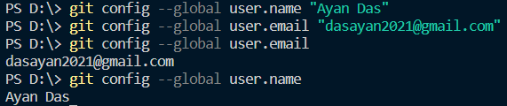

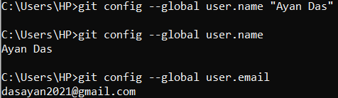

To check user name set or not we write 🡪 **git config --global user.name**

To check email set or not we write 🡪 **git config --global user.email**

**mkdir folder name 🡪** using that we can create a folder

**cd 🡪** using this we can change our directory

**cd D:\ 🡪** to change directory we use cd and directory name coloun front slash

**ls -a 🡪** it shows the Initialized empty Git repository folder .git

**git status 🡪**  it shows the status of repository what delete change ,, add etc shows everything

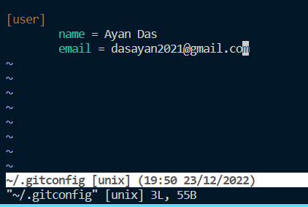If we want to edit our name / email

**git config --global –edit**



then it takes me to editing position for user name and email

we can change directly here 🡪

to save and exit from that editing part

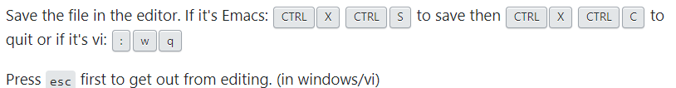

Directly Tracking to the folder from GitHub we have to initiate the folder track any changes made

**git init 🡪** The git init command creates a new Git repository. It can be used to convert an existing, unversioned project to a Git repository or initialize a new, empty repository

add any changes in github

**git add .**

then have commit or telling change

**git commit -m “created a readme file”**

now tell git where remotely the changes need to be done

**git remote add origin “paste link of folder created on GitHub”**

**git remote add origin** [**https://github.com/ayandas1234/Test-Project.git**](https://github.com/ayandas1234/Test-Project.git)

now at the end we have to push the changes in the account using push command

**git push -u origin master**

every changes happen in master branch , if we use that command first time then iit want the GitHub credentials for the first time

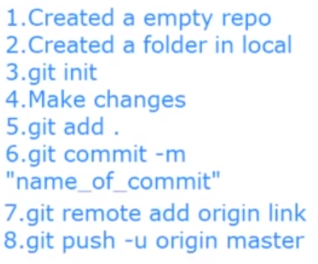

**Branching & Merging**

Branch means changes in code ,this branches holds whatever changes is made on the project through you or your team members.

Git Pull is a command to use for any changes made on projects it’s add to your local

**git pull**

every time we use this it directly made changes on the master branch which is basically a origin branch

but if we change directly to the master branch it’s going to be a disaster so we are going to change our destination branch

**git checkout testbranch (your branch name)**

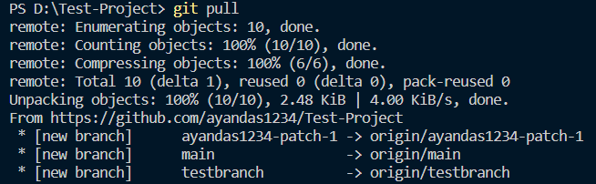**git checkout your branch name**

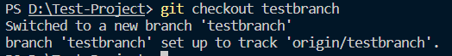

now we are going to change something to work it’s properly or not

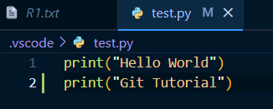we changes our python file add an one more line

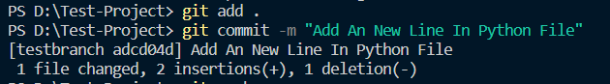then it mandatory to use this two command after that we use push command but not in the origin

we use use normal push to this branch

**git push**

This Changes doesn’t make any changes in the main file which are under the master branch

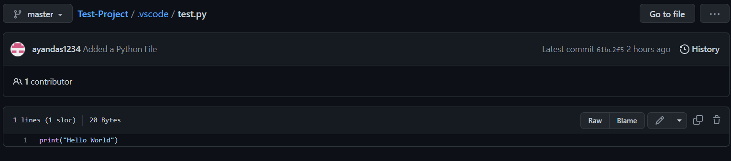 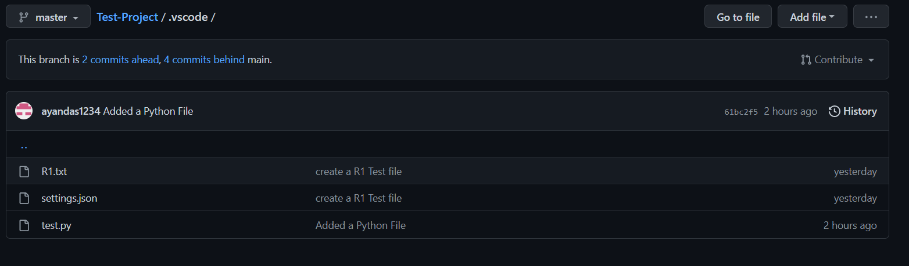

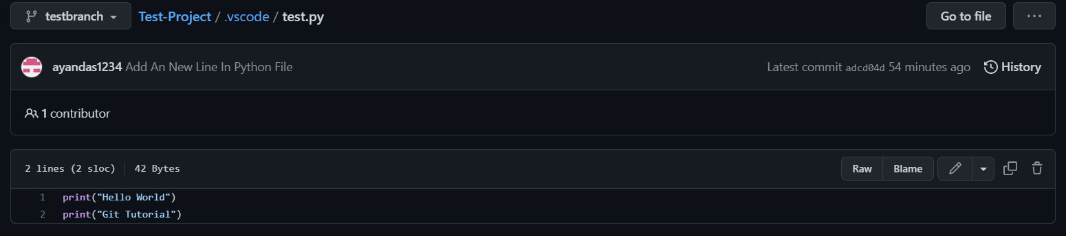

Pull Request

It use to request to the admin of the GitHub account holder or the admin who is basically maintain the master branch to telling him add the changes on the master branch

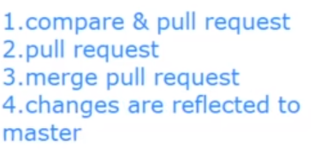After pull we compare the changes with the raw file which is under the master branch then we merge them through admin in the main GitHub Account

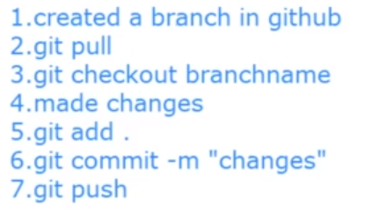

**Cloning Existing Repo**

When we cloning an existing repo we have to make sure that is have to be also a existing repository in the GitHub account

For cloning we use clone command

**git clone** **“paste link of folder created on GitHub”**

**git clone** <https://github.com/ayandas1234/Test-Project.git>

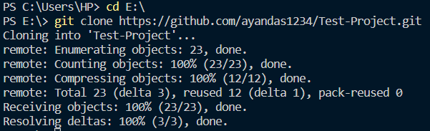

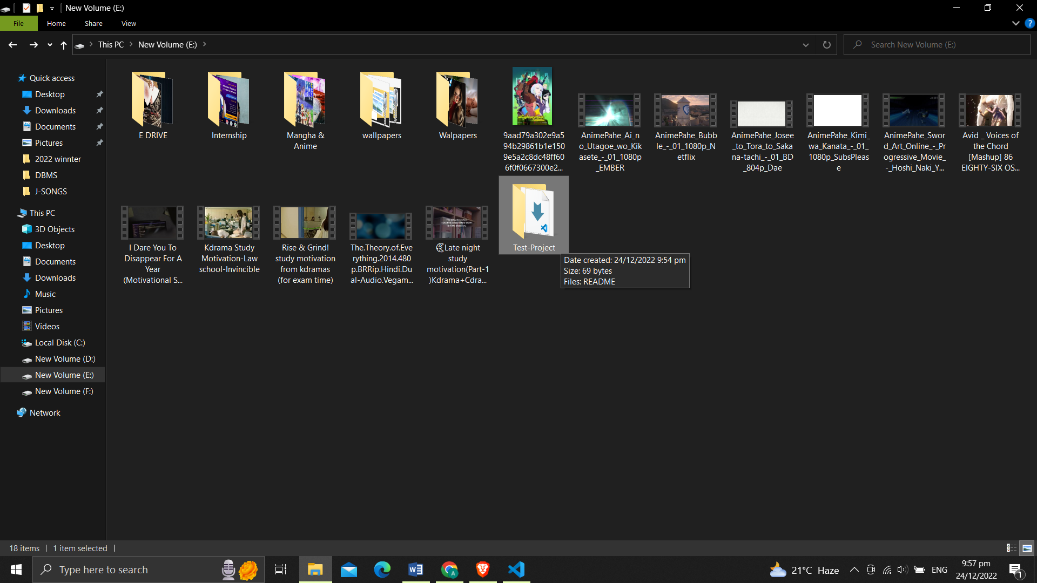

the cloning done in the E drive in my pc

Now go inside the folder

**cd “folder name”**

**git status 🡪** it shows which branch we are currently in

then we switch to another branch

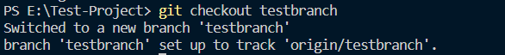

Git is a Distributed Version Control System to tracking and system managing in the programmers project

It can track every changes in the Particular code and that changes called as a version, and if we want to go back the previous version then we can go back or we can remain in the changeable version

we can also track which person is the one who make the changes in the code