SQL PROJECT- MUSIC STORE DATA ANALYSIS

CODE
-- 1. Who is the senior most employee based on job title?
select first_name,last_name from employee
order by levels desc
limit 1

-- 2. Which countries have the most Invoices?
select count(billing_country) AS count_billing,billing_country
from invoice
group by billing_country
order by count_billing desc
limit 1

-- 3. What are top 3 values of total invoice?
select total from invoice
order by total desc
limit 3

/* 4. Which city has the best customers? We would like to throw a promotional Music
Festival in the city we made the most money. Write a query that returns one city that
has the highest sum of invoice totals. Return both the city name & sum of all invoice
totals ! */
select sum(total) AS total_invoice_city,billing_city from invoice
group by billing_city
order by total_invoice_city desc
limit 1

/* 5. Who is the best customer? The customer who has spent the most money will be
declared the best customer. Write a query that returns the person who has spent the
most money */
select first_name,last_name,sum(total) as total_invoice from customer as c full join invoice as i
on c.customer_id=i.customer_id
group by c.customer_id
order by total_invoice desc
limit 1

/* 1. Write query to return the email, first name, last name, & Genre of all Rock Music
listeners. Return your list ordered alphabetically by email starting with A */

select first_name,last_name,email from customer as c full join
invoice as i on
c.customer_id = i.customer_id full join
invoice_line as il on
i.invoice_id = il.invoice_id
where track_id in(
select track_id from track full join genre
on track.genre_id = genre.genre_id
where genre.name like 'Rock')
order by email
limit 5

/* 2. Let's invite the artists who have written the most rock music in our dataset. Write a
query that returns the Artist name and total track count of the top 10 rock bands ! */

select a.artist_id,a.name,count(a.artist_id) as frequency
from artist as a full join
album as al on
a.artist_id = al.artist_id full join
track as t on
al.album_id = t.album_id full join
genre as g on
t.genre_id = g.genre_id
where g.name like 'Rock'
group by a.artist_id
order by frequency desc
limit 1

/* 3. Return all the track names that have a song length longer than the average song length.
Return the Name and Milliseconds for each track. Order by the song length with the
longest songs listed first */
select name, milliseconds from track
where milliseconds > (
select avg(milliseconds) as duration from track )
order by milliseconds desc
limit 10

/* 1. Find how much amount spent by each customer on artists? Write a query to return
artist name and total spent */
-- algo : create a temporary table with artist total cost, then join customer tabl then join both
-- temp table with the joined table to get the output.

with artist_total_cost As (
select artist.artist_id as artist_id,artist.name as artist_name,
sum(il.unit_price*il.quantity) as total_cost
from invoice_line as il
full join track on track.track_id = il.track_id full join
album on album.album_id = track.album_id full join
artist on artist.artist_id=album.artist_id
group by 1 -- artist.artist_id
order by 3 desc -- total_cost
)
select concat(c.first_name,c.last_name),atc.artist_name,
atc.total_cost
from customer as c full join invoice as i
on c.customer_id = i.customer_id
full join invoice_line as il
on i.invoice_id=il.invoice_id
full join track as t
on il.track_id=t.track_id
full join album
on album.album_id = t.album_id
full join artist_total_cost as atc -- full join with the temporary table -WITH
on album.artist_id = atc.artist_id
where atc.total_cost is not null
order by 3 desc
limit 5

/* 2. We want to find out the most popular music Genre for each country. We determine the
most popular genre as the genre with the highest amount of purchases. Write a query
that returns each country along with the top Genre. For countries where the maximum
number of purchases is shared return all Genres */
select * from invoice_line
where quantity > 1 -- Analysis all invoice line have one purchase quantity

with max_country_sales as (
select i.billing_country as country,genre.name,count(il.quantity),
row_number()over(partition by i.billing_country order by count(*) desc ) as index1
from invoice as i full join invoice_line as il
on i.invoice_id=il.invoice_id
full join track as t
on t.track_id=il.track_id
full join genre
on t.genre_id=genre.genre_id
group by 1,2
order by 1 asc, index1 asc
)
select * from max_country_sales where index1 <= 1

/* 3. Write a query that determines the customer that has spent the most on music for each
country. Write a query that returns the country along with the top customer and how
much they spent. For countries where the top amount spent is shared, provide all
customers who spent this amount */

-- cutomer country music type spend
with customer_country as (
select c.customer_id,c.first_name,c.last_name,i.billing_country,sum(i.total) as total_cost,
row_number()over(partition by billing_country order by sum(i.total) desc) as index1
from customer as c full join invoice as i
on c.customer_id = i.customer_id
group by 1,2,3,4
order by 4 asc,5 desc
)
select * from customer_country where index1 <= 1

-- ======================================================================

Q&A
Question Set 1 – Easy

1. Who is the senior most employee based on job title?
Ans. Madan Mohan
2. Which countries have the most Invoices?
Ans. USA , frequency =131

3. What are top 3 values of total invoice?
Ans.
23.759999999999998
19.8
19.8

4. Which city has the best customers? We would like to throw a promotional Music
Festival in the city we made the most money. Write a query that returns one city that
has the highest sum of invoice totals. Return both the city name & sum of all invoice
totals !
Ans.
"Prague" | total invoice : 273.

5. Who is the best customer? The customer who has spent the most money will be
declared the best customer. Write a query that returns the person who has spent the
most money !
Ans.
"first_name" | "last_name" | "total_invoice"
R | Madhav | 144.54000000000002
Question Set 2 – Moderate
1. Write query to return the email, first name, last name, & Genre of all Rock Music
listeners. Return your list ordered alphabetically by email starting with A !
Ans.
Top 5 output

first_name | last_name | email
Aaron | Mitchell | aaronmitchell@yahoo.ca
Aaron | Mitchell | aaronmitchell@yahoo.ca
Aaron | Mitchell | aaronmitchell@yahoo.ca
Aaron | Mitchell | aaronmitchell@yahoo.ca
Aaron | Mitchell | aaronmitchell@yahoo.ca

2. Let's invite the artists who have written the most rock music in our dataset. Write a
query that returns the Artist name and total track count of the top 10 rock bands !
Ans.

artist_id | name | frequency
22 | Led Zeppelin | 114

3. Return all the track names that have a song length longer than the average song length.
Return the Name and Milliseconds for each track. Order by the song length with the
longest songs listed first

Ans.
Top 10 Output

name | milliseconds
Occupation / Precipice | 5286953
Through a Looking Glass | 5088838
Greetings from Earth, Pt. 1 | 2960293
The Man With Nine Lives | 2956998
Battlestar Galactica, Pt. 2 | 2956081
Battlestar Galactica, Pt. 1 | 2952702
Murder On the Rising Star | 2935894
Battlestar Galactica, Pt. 3 | 2927802
Take the Celestra | 2927677
Fire In Space | 2926593

Question Set 3 – Advance

1. Find how much amount spent by each customer on artists? Write a query to return
customer name, artist name and total spent
Ans.
Top 5 output

concat | artist_name | total_cost
Puja Srivastava | Queen | 190.08
Niklas Schröder | Queen | 190.08
Dan Miller | Queen | 190.08
Terhi Hämäläinen | Queen | 190.08
Tim Goyer | Queen | 190.08

2. We want to find out the most popular music Genre for each country. We determine the
most popular genre as the genre with the highest amount of purchases. Write a query
that returns each country along with the top Genre. For countries where the maximum
number of purchases is shared return all Genres.
Ans.

country | name | count | index1
Argentina | Alternative & Punk | 17 | 1
Australia | Rock | 34 | 1
Austria | Rock | 40 | 1
Belgium | Rock | 26 | 1
Brazil | Rock | 205 | 1
Canada | Rock | 333 | 1
Chile | Rock | 61 | 1
Czech Republic | Rock | 143 | 1
Denmark | Rock | 24 | 1
Finland | Rock | 46 | 1
France | Rock | 211 | 1
Germany | Rock | 194 | 1
Hungary | Rock | 44 | 1
India | Rock | 102 | 1
Ireland | Rock | 72 | 1
Italy | Rock | 35 | 1
Netherlands | Rock | 33 | 1
Norway | Rock | 40 | 1
Poland | Rock | 40 | 1
Portugal | Rock | 108 | 1
Spain | Rock | 46 | 1
Sweden | Rock | 60 | 1
United Kingdom | Rock | 166 | 1
USA | Rock | 561 | 1
NULL | Latin | 0 | 1

Graphically
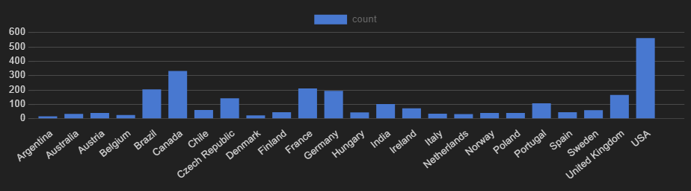
count according with country

3. Write a query that determines the customer that has spent the most on music for each
country. Write a query that returns the country along with the top customer and how
much they spent. For countries where the top amount spent is shared, provide all
customers who spent this amount !
Ans.

customer_id | first_name | last_name | billing_country | total_cost | index1
56 | Diego | Gutiérrez | Argentina | 39.6 | 1
55 | Mark | Taylor | Australia | 81.18 | 1
7 | Astrid | Gruber | Austria | 69.3 | 1
8 | Daan | Peeters | Belgium | 60.39 | 1
1 | Luís | Gonçalves | Brazil | 108.9 | 1
3 | François | Tremblay | Canada | 99.99 | 1
57 | Luis | Rojas | Chile | 97.02 | 1
5 | R | Madhav | Czech Republic | 144.54 | 1
9 | Kara | Nielsen | Denmark | 37.62 | 1
44 | Terhi | Hämäläinen | Finland | 79.2 | 1
42 | Wyatt | Girard | France | 99.99 | 1
37 | Fynn | Zimmermann | Germany | 94.05 | 1
45 | Ladislav | Kovács | Hungary | 78.21 | 1
58 | Manoj | Pareek | India | 111.87 | 1
46 | Hugh | O'Reilly | Ireland | 114.84 | 1
47 | Lucas | Mancini | Italy | 50.49 | 1
48 | Johannes | Van der Berg | Netherlands | 65.34 | 1
4 | Bjørn | Hansen | Norway | 72.27 | 1
49 | Stanisław | Wójcik | Poland | 76.23 | 1
34 | João | Fernandes | Portugal | 102.96 | 1
50 | Enrique | Muñoz | Spain | 98.01 | 1
51 | Joakim | Johansson | Sweden | 75.24 | 1
53 | Phil | Hughes | United Kingdom | 98.01 | 1
17 | Jack | Smith | USA | 98.01 | 1

Graphically
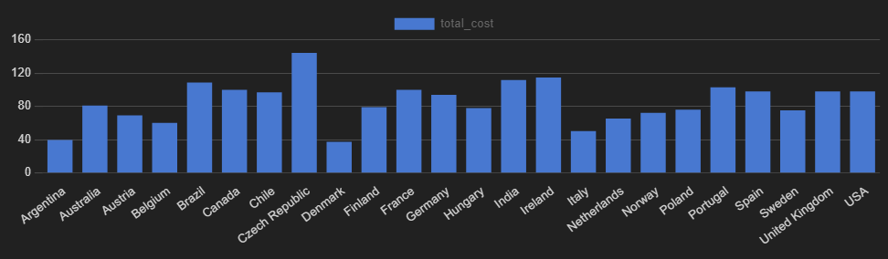
total_cost according to country

