Name: Ayan Nath

UID: 605910299

For step 5, I inputted 0 when the computer asked “How many games has your team won?” I also inputted 0 when the computer asked “How many games has your team lost?” and “How many games has your team tied?” As a result, I got the nonsensical result of “nan% of the Soccer games you played were won!” The computer probably gave this result because it was trying to divide 0 by 0. Below is screenshot of what the output looked like:

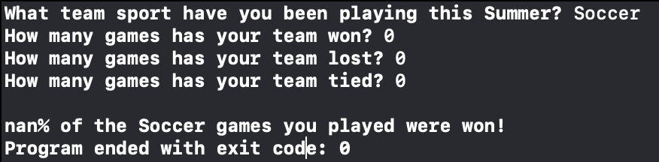

Another way to get a nonsensical result is if you input a negative value for number of games lost and tied. If lost and tied are negative and the sum of their absolute values is greater than the number of games won, the denominator for the variable winPercentage calculation will be negative, making the overall win Percentage negative. This is nonsensical as win percentages cannot be negative. Here is an example of this below:

Unlike the previous example however, there is code written in the program that checks to see if any of the win, loss, or tie variables are negative and lets the user know in the output after the program builds and runs.

For step 6, I changed the formula for the variable winPercentage from “100.0 \* won / (won + lost + tied)” to “200.0 \* won / (won + lost + tied)”. As a result, a successful build was not prevented, but most of the results were wrong. For example, if a team wins 10 games, loses 10 games, and ties 0 games, the result output should be “50.0% of the Soccer games you played were won!” However, with the logic error I Introduced, the output looked like:

The win percentage was 100.0% instead of 50.0%

For step 7, I commented out the declaration for three variables: won, lost, and tied. As a result, XCode gave me many “use of undeclared identifier” errors, leading the program to fail to compile correctly:

