What's good in the hood?



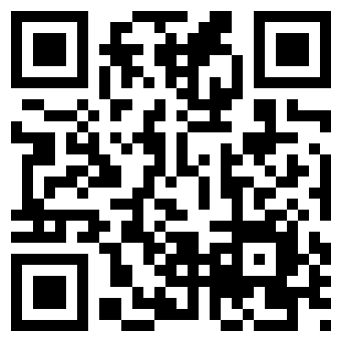



Share with people around your location



Talk with people around you…





Want to post to people around you?





Location based bulletin board





Post to people around you



