**Curriculum Vitae**

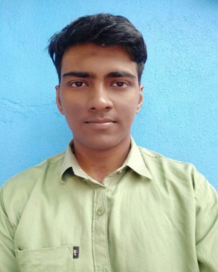

**Name : Ayan Koley**

**Address : Khagragachi, Singur, Hooghly**

**Pin – 712407**

**Mobile No. : 9051971504**

**Email Address :** [**ayankoley@gmail.com**](mailto:ayankoley@gmail.com)

**Website : ayank007.github.io/Portfolio**

**Academic Qualifications:**

|  |  |  |  |  |  |  |
| --- | --- | --- | --- | --- | --- | --- |
| **Degree / Certificate** | Degree | Discipline | Institute | Board /University | **Year of Passing** | **Aggregate % / CGPA** |
| Graduation | B-Tech | CSE | University of Engineering & Management, Kolkata | University of Engineering & Management, Kolkata | 2021 | **8.50**  **(up to 7th semester)** |
| 12th | 12 | Science | Beraberi SNM  High School | WBCHSE | 2017 | **79.6%** |
| 10th | 10 | General | Beraberi SNM  High School | WBBSE | 2015 | **84%** |

**Projects Undertaken:**

|  |  |  |
| --- | --- | --- |
| **Name of Institute / Organization** | **Project Title** | **Duration** |
| ICSS | SQL Injection | 8 weeks |
| Final Year Project | Online Banking Help as Chat Bot | 10 weeks |

**Skills:**

* Html, Css, JS, C, Python, Typescript, React, jQuery, Bootstrap, Node JS, Figma, MS Word, MS Excel, MS PowerPoint

**Additional Qualification / Achievements / Certifications:**

* Udemy Certification on Full-stack Development and React Native Development
* NPTL Certification on Soft skill and Proficiency on C
* Ethical Hacking on ICSS

**Subjects of Interest:**

* Database Management System
* Data Structure and Algorithm
* Operating System

**Computer Proficiency:**

* C
* Python
* JavaScript

**Hobbies:**

* Football
* Reading

**Personal Details:**

**Date of Birth :** 02/05/2000

**Gender** **:** Male

**Languages Known :** English, Bengali, Hindi