Project is designed with proper project structure.

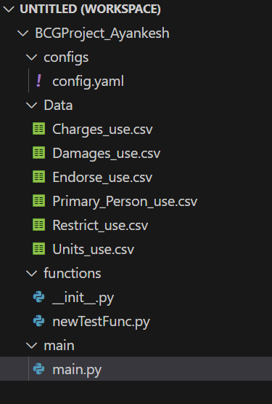

This project is developed in databricks workspace and test the output in Databrciks only. Post that moved to VScode for folder hierarchy creation.

Please change the config file path to fetch data from the IDE will be used for test the code.

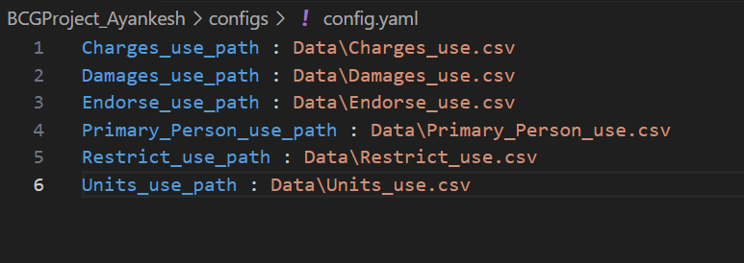

Change the project path as per the IDE relative path

sys.path.append('\Users\40103513\Desktop\BCGProject_Ayankesh')

#append the path of the project folder as required.I have used my local project folder location

PFB screen shot of output result executed by main.py in databrciks.

