Poverty Level in India: Trends, Causes, Impacts and Policy Solutions

Chapter 1: Introduction
Poverty refers to the condition where individuals lack the financial resources and essential services required to meet their basic needs such as food, shelter, healthcare, and education. Poverty is a multidimensional problem that affects economic development, social stability, and overall human well-being.
India has experienced rapid economic growth over the past few decades. Despite this growth, poverty remains a major concern. Millions of people still struggle to access basic services and opportunities.
The study of poverty is important because it helps policymakers understand the economic and social challenges faced by vulnerable populations. Effective poverty reduction strategies require comprehensive research and policy interventions.

Chapter 2: Literature Review
Many economists and researchers have studied poverty in India.
Early research focused mainly on income poverty and consumption levels. Scholars such as Amartya Sen introduced the concept of capability deprivation, which emphasizes the lack of opportunities and freedoms available to individuals.
International organizations such as the World Bank and the United Nations have developed frameworks for measuring poverty using indicators like education, health, and living standards.
Recent studies emphasize multidimensional poverty, which includes factors such as access to sanitation, electricity, housing quality, and education.

Chapter 3: Historical Background of Poverty in India
Poverty in India has historical roots dating back to colonial rule. During the colonial period, economic policies focused primarily on resource extraction rather than economic development.
After independence in 1947, India faced severe poverty due to:
- low industrial development
- low agricultural productivity
- high population growth
- limited infrastructure
Government policies such as land reforms, agricultural modernization, and industrial development programs helped reduce poverty over time.
The economic reforms of 1991 significantly accelerated economic growth and poverty reduction.

Chapter 4: Research Methodology
The research methodology used in this study is descriptive and analytical.

Data Sources
Primary Data
- surveys
- interviews
Secondary Data
- government reports
- World Bank statistics
- academic research papers

Analytical Tools
- statistical tables
- bar diagrams
- trend graphs
- flowcharts
These tools help analyze poverty trends and relationships between socio-economic factors.

Chapter 5: Poverty Trends in India
India has witnessed a steady decline in poverty levels over the past few decades.
This decline is largely due to economic growth, improved education, and government welfare programs.
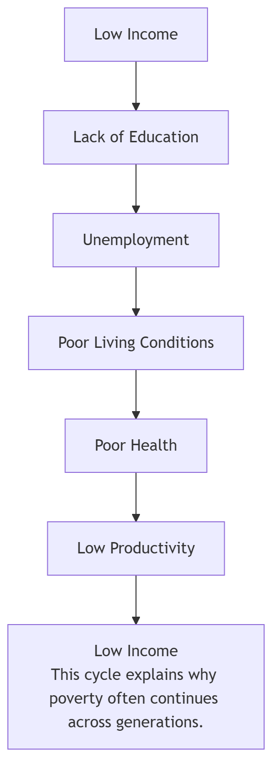
Poverty Rate (%)

Chapter 6: Rural Poverty in India
Rural poverty remains higher than urban poverty due to limited employment opportunities and dependence on agriculture.
Key causes include:
- low agricultural productivity
- lack of irrigation facilities
- limited access to markets
- poor infrastructure
Government rural development programs aim to address these issues.

Chapter 7: Urban Poverty in India
Urban poverty is mainly concentrated in slums and informal settlements.
Urban poor populations face challenges such as:
- unemployment
- overcrowding
- lack of sanitation
- limited access to healthcare
Migration from rural areas contributes to urban poverty.

Chapter 8: Causes of Poverty
Major causes of poverty include:
- unemployment
- population growth
- lack of education
- economic inequality
- low agricultural productivity
- social discrimination
These factors often interact with each other, making poverty difficult to eliminate.

Chapter 9: Impact of Poverty
Poverty has serious social and economic consequences.
Economic Impact
- low productivity
- reduced economic growth
Social Impact
- poor health conditions
- limited education
- social inequality
Environmental Impact
- overuse of natural resources
- poor sanitation and pollution

Chapter 10: Government Policies
The government of India has implemented several poverty alleviation programs.
Examples include:
- MGNREGA
- Public Distribution System
- Pradhan Mantri Awas Yojana
- Ayushman Bharat
These programs aim to improve employment opportunities, food security, housing, and healthcare.

Chapter 11: State-wise Poverty Analysis
Poverty levels vary across Indian states.
Higher poverty states
- Bihar
- Uttar Pradesh
- Jharkhand
- Madhya Pradesh
Lower poverty states
- Kerala
- Tamil Nadu
- Punjab
Regional development policies are required to reduce these disparities.

Chapter 12: Role of Education and Health
Education and healthcare are essential for poverty reduction.
Benefits include:
- improved employment opportunities
- increased productivity
- better quality of life
Investment in human capital is critical for sustainable development.

Chapter 13: Challenges in Poverty Reduction
Despite progress, several challenges remain.
- economic inequality
- unemployment
- climate change
- population growth
- regional disparities
These challenges require long-term policy solutions.

Chapter 14: Future Strategies
Strategies for reducing poverty include:
- improving education systems
- promoting entrepreneurship
- strengthening rural development
- increasing employment opportunities
- improving healthcare services

Chapter 15: Conclusion
India has made significant progress in reducing poverty levels over the past decades. Economic growth, technological development, and government welfare programs have improved living standards for millions of people.
However, poverty remains a complex challenge that requires continuous policy interventions and inclusive development strategies.
Future development policies must focus on reducing inequality, improving education and healthcare, and creating sustainable employment opportunities.

