THE PURE WORK

ANARKALI

1 --- FUSCHIA PINK YOG ANARKALI GOLDEN DABKA WORK WITH SHARARA SET AND DUPATTA

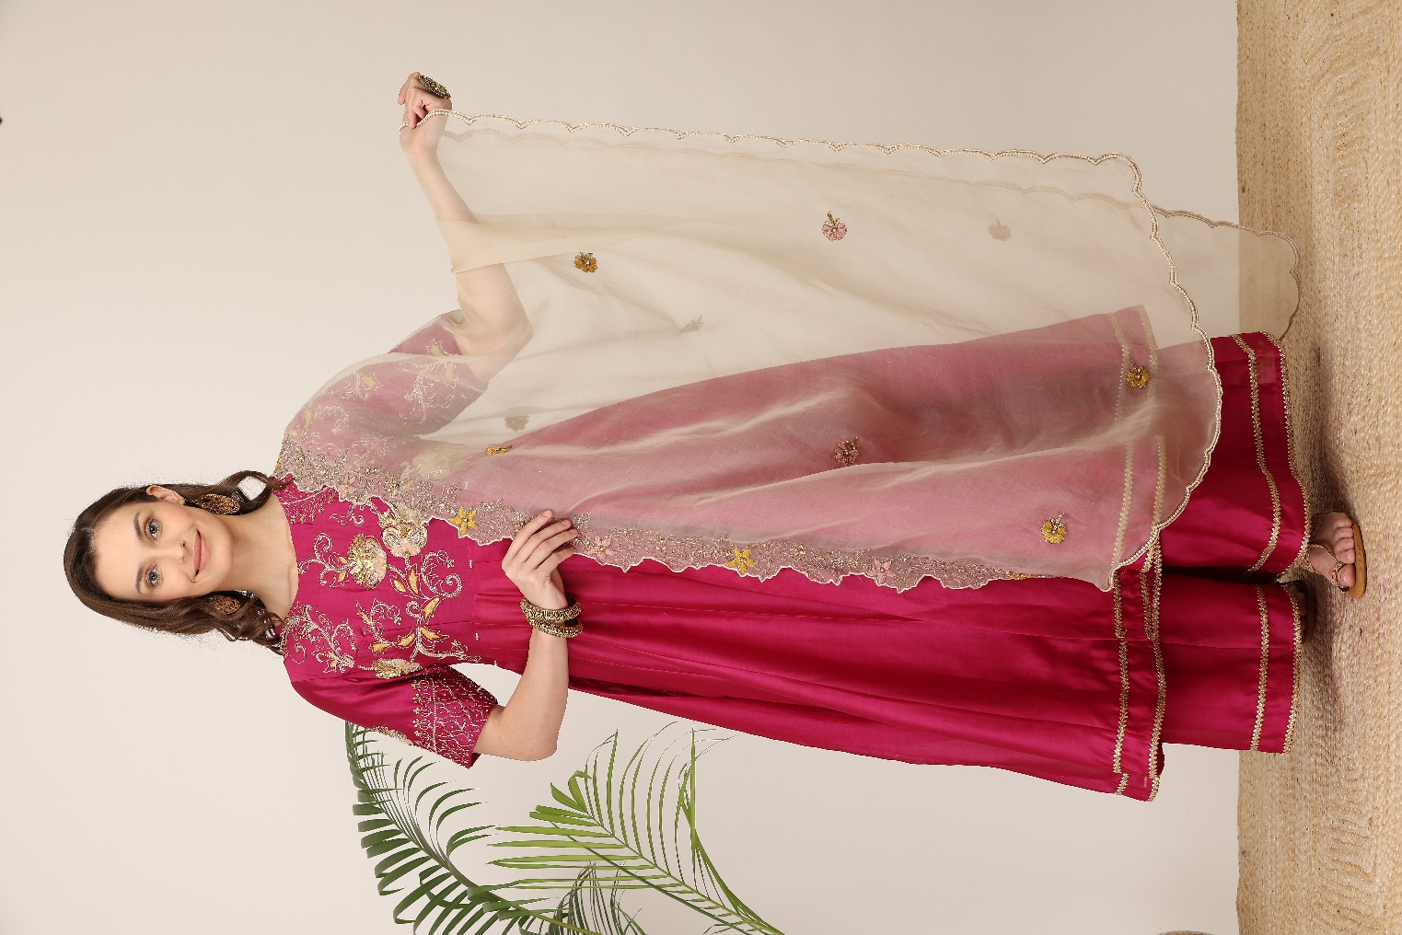

PRICE - 22900/-

SIZE – XS S M L XL 2XL 3XL

STYLE- ANARKALI

SIZE CHART

LEFT WITH THE SIZE CHART ADD THIS IMAGE



**QUANTITY** –

**COLOUR** – FUSCHIA PINK

**EMBROIDERY –** DABKA TREAD

**FABRIC** – SILK, ORGANZA

**NO. OF COMPONENTS** – 3

**DELIVERY TIME** – 2-3 WEEKS

**WASH CARE** – DRY CLEAN ONLY

ADD SHARE OPTION

2--- BUTTERSCOTCH RANI VAN MOTI WORK YOF ANARKALI SHARARA SET

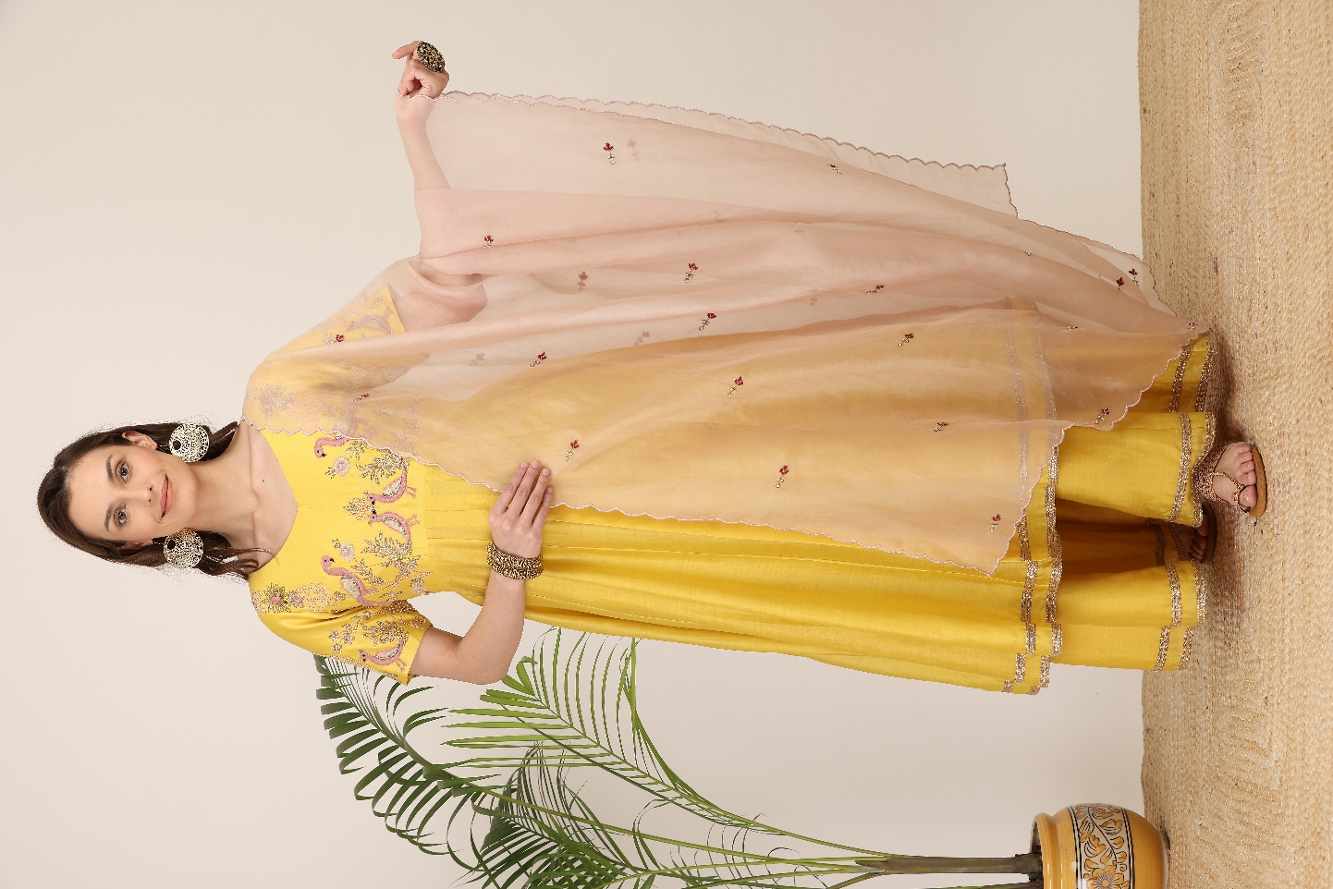

PRICE -22900 /-

SIZE – XS S M L XL 2XL 3XL

STYLE- ANARKALI

SIZE CHART

LEFT WITH THE SIZE CHART ADD THIS IMAGE



**QUANTITY** –

**COLOUR** – YELLOW

**EMBROIDERY –** MOTI

**FABRIC** – SILK, ORGANZA

**NO. OF COMPONENTS** – 3

**DELIVERY TIME** – 2-3 WEEKS

**WASH CARE** – DRY CLEAN ONLY

ADD SHARE OPTION

3--- DARK GREEN CIRCLE BOOTA DABKA THREAD WORK HEAVY ANARKALI SET

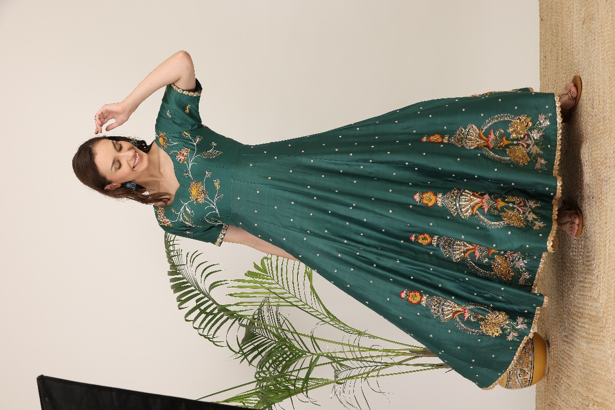

PRICE -39,900 /-

SIZE – XS S M L XL 2XL 3XL

STYLE- ANARKALI

SIZE CHART

LEFT WITH THE SIZE CHART ADD THIS IMAGE



**QUANTITY** –

**COLOUR** –DARK GREEN

**EMBROIDERY –** MOTI

**FABRIC** – SILK, ORGANZA

**NO. OF COMPONENTS** –2

**DELIVERY TIME** – 2-3 WEEKS

**WASH CARE** – DRY CLEAN ONLY

ADD SHARE OPTION

4—MUSTRAD YELLOW HEAVY THREAD WORK ANGRAKHA

ANARKALI WITH PANTS AND DUPATTA

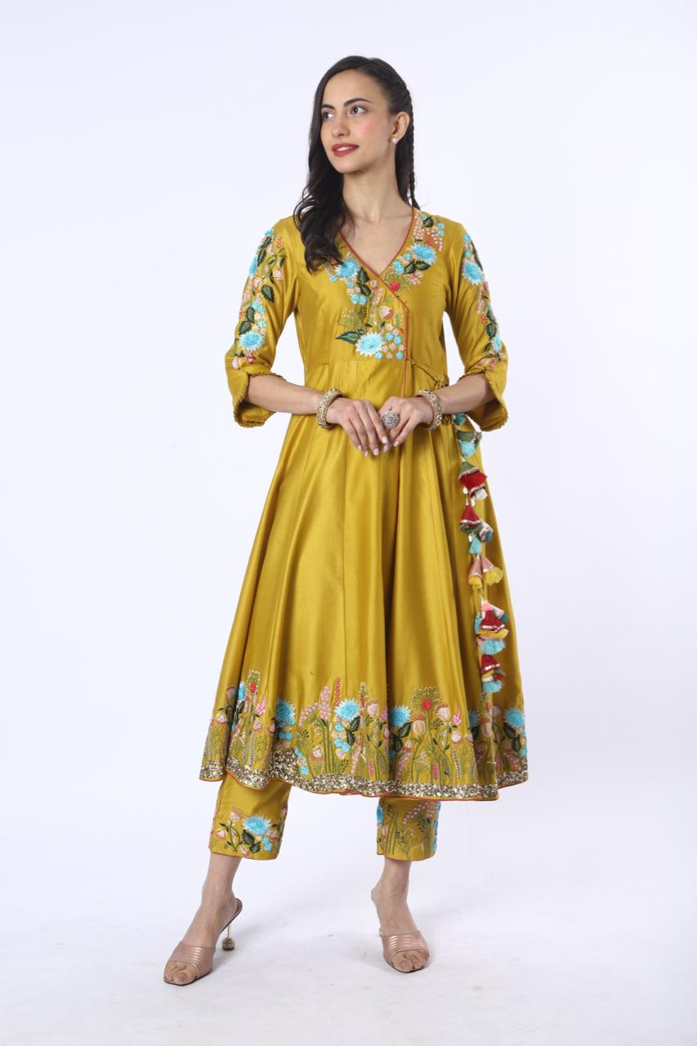

PRICE - 36900/-

SIZE – XS S M L XL 2XL 3XL

STYLE- ANARKALI

SIZE CHART

LEFT WITH THE SIZE CHART ADD THIS IMAGE



**QUANTITY** –

**COLOUR** – YELLOW

**EMBROIDERY –** MOTI

**FABRIC** – SILK, ORGANZA

**NO. OF COMPONENTS** – 3

**DELIVERY TIME** – 2-3 WEEKS

**WASH CARE** – DRY CLEAN ONLY

ADD SHARE OPTION

5---MEHENDI GREEN THREAD WORK ANARKALI WITH PANTS HEAVY DUPATTA

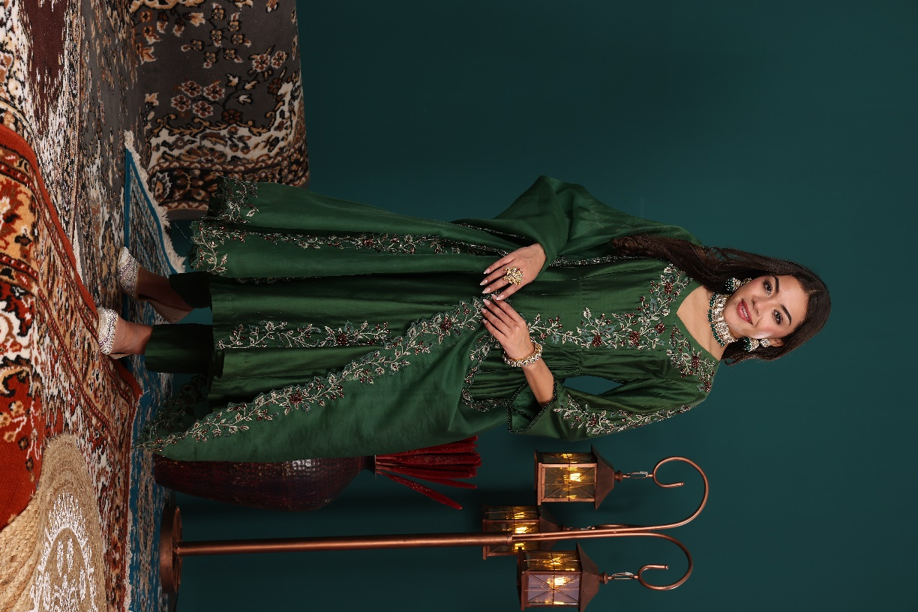

PRICE - 29,900/-

SIZE – XS S M L XL 2XL 3XL

STYLE- ANARKALI

SIZE CHART

LEFT WITH THE SIZE CHART ADD THIS IMAGE



**QUANTITY** –

**COLOUR** – MEHENDI GREEN

**EMBROIDERY – THREAD**

**FABRIC** – SILK, ORGANZA

**NO. OF COMPONENTS** – 3

**DELIVERY TIME** – 2-3 WEEKS

**WASH CARE** – DRY CLEAN ONLY

ADD SHARE OPTION

6---PURPLE GREY APPLIQUE NECK WORK ANARKALI WITH CONTRAST PANTS AND DUPATTA

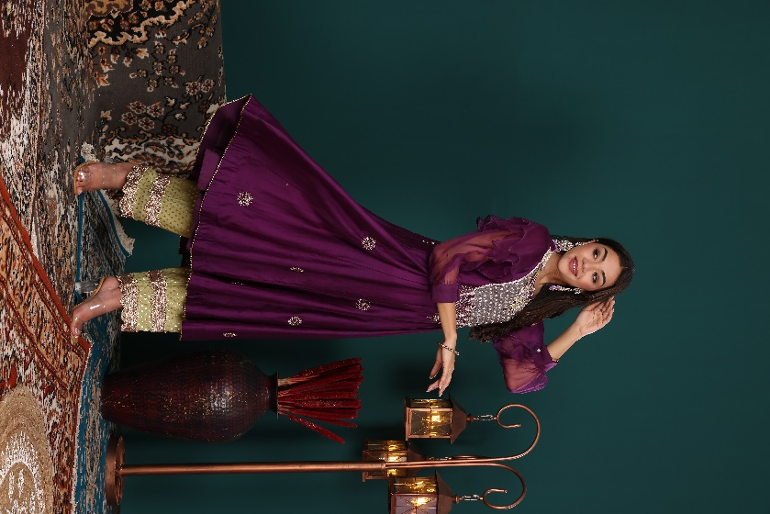

PRICE - 25,900/-

SIZE – XS S M L XL 2XL 3XL

STYLE- ANARKALI

SIZE CHART

LEFT WITH THE SIZE CHART ADD THIS IMAGE



**QUANTITY** –

**COLOUR** – PURPLE

**EMBROIDERY –** APPLIQUE

**FABRIC** – SILK, ORGANZA

**NO. OF COMPONENTS** – 3

**DELIVERY TIME** – 2-3 WEEKS

**WASH CARE** – DRY CLEAN ONLY

ADD SHARE OPTION

**7---**