RETAIL BANKING
CUSTOMER INTELLIGENCE & FINANCIAL
PERFORMANCE ANALYSIS

A Data-Driven Business Report on Customer Segmentation, Deposits, Lending and Advisory Performance

Prepared using SQL, Python and Power BI
Data Analytics Portfolio Project

By – Ayansh Singh

Table of Contents
1. Executive Summary 3
2. Problem Statement 3
2.1 Business Background 3
2.2 The Business Problem 3
2.3 Project Objectives 4
3. Dataset Overview 4
3.1 Data Structure 4
3.2 Data Quality Assessment 4
3.3 Descriptive Summary of Key Financial Variables 5
4. SQL Analysis 6
4.1 Schema Setup and Data Quality Checks 6
4.2 Business Questions Answered in SQL 6
5. Python Exploratory Data Analysis 8
5.1 Data Cleaning and Preparation 8
5.2 Univariate Analysis 8
5.3 Bivariate and Relationship Analysis 12
5.4 Summary of EDA Findings 17
6. Power BI Dashboard Analysis 18
6.1 Key Performance Indicators (KPI Cards) 18
6.2 Charts and Visuals 19
6.3 Interactive Filters (Slicers) 19
7. Consolidated Business Insights 21
8. Business Recommendations 21
9. Limitations 22
10. Future Scope 22
11. Conclusion 23

1. Executive Summary
This report presents a comprehensive business analysis of a retail banking customer dataset comprising 3,000 clients, developed using a three-stage analytics pipeline: PostgreSQL for structured querying, Python for data cleaning and exploratory data analysis (EDA), and Power BI for interactive executive reporting. The objective of the project is to convert raw customer, deposit, loan, savings and investment records into decision-ready insights that support customer segmentation, product strategy and advisor performance management.
The client base holds an average estimated income of approximately $171,305, average bank deposits of $671,560 and average bank loans of $591,386 per customer, with total deposits across the portfolio reaching approximately $2.01 billion and total loans of approximately $1.77 billion. The customer base is almost evenly split by gender (50.4% female, 49.6% male) and spans a wide age range from 17 to 85 years, with a mean age of 51 years.
Key findings show that deposit balances are strongly associated with checking and savings account balances, that Private Banking is the leading relationship segment by deposits, that European-nationality clients contribute the largest share of total deposits, and that age has almost no statistical relationship with income or deposit behaviour — indicating that wealth in this portfolio is driven more by occupation, relationship type and risk profile than by customer age alone.
The report concludes with a set of practical recommendations covering premium relationship management, occupation-based product design, cross-selling, and loyalty-segment strategy, intended to help the bank prioritise resources toward its highest-value customer relationships.

2. Problem Statement

2.1 Business Background
The banking industry generates massive volumes of customer data through everyday activity — transactions, loan applications, deposits, investments and advisor interactions. A modern retail bank offers a broad range of financial products including savings accounts, current accounts, credit cards, home loans, business loans, investment services, foreign currency accounts and wealth management. Different customers contribute differently to the bank's revenue: some maintain high deposit balances, others are primarily loan or investment clients. Understanding these patterns allows a bank to improve customer retention, increase cross-selling opportunities, reduce financial risk, optimise advisor performance and personalise the customer experience.

2.2 The Business Problem
The bank stores large volumes of customer information but lacks structured, actionable insight into customer behaviour and financial performance. Specifically, the organisation needs data-driven answers to questions such as: who are the highest-value customers; which segments contribute the most deposits; which banking relationship and advisor structures generate the most value; which occupations are associated with high income; and how loyalty tier relates to deposit and loan behaviour. Without such insight, business decisions rely on assumption rather than evidence.

2.3 Project Objectives
- Analyse customer demographics (age, gender, nationality, occupation).
- Understand banking product usage across deposits, loans, savings and credit cards.
- Identify high-value customers and the segments they belong to.
- Compare deposit and loan balances across customer groups.
- Study the distribution of customer income.
- Evaluate investment advisor and banking-relationship performance.
- Analyse the relationship between customer loyalty classification and financial value.
- Build an interactive Power BI dashboard for ongoing executive monitoring.
- Translate the analysis into concrete business recommendations.

3. Dataset Overview
The analysis is built on a relational data model consisting of one primary client table and three lookup (dimension) tables, imported into PostgreSQL and subsequently cleaned in Python. The design allows client-level financial data to be enriched with descriptive categories through SQL joins.

3.1 Data Structure
Table | Role | Key Fields
clients | Main fact table — one row per customer (3,000 rows, 25 columns) | Client ID, Name, Age, Nationality, Occupation, Estimated Income, Bank Deposits, Bank Loans, Saving/Checking Accounts, Credit Card Balance, Business Lending, Properties Owned, Risk Weighting
gender | Lookup table for gender category | gender_id, gender (2 rows)
banking_relationship | Lookup table for relationship segment | br_id, banking_relationship (4 rows: Retail, Institutional, Private Bank, Commercial)
investment_advisor | Lookup table for assigned advisor | ia_id, investment_advisor (22 advisors)

3.2 Data Quality Assessment
Before analysis, the dataset was validated in both SQL and Python:
- Completeness: 0 missing values were found across all 25 client attributes (income, deposits, loans and every other field are fully populated).
- Uniqueness: the dataset contains 0 fully duplicated rows; however, a small number of “Client ID” values recur across different customer records, meaning Client ID cannot be treated as a guaranteed unique primary key and should not be used alone for downstream joins without a surrogate key.
- Consistency: column names were standardised (lower-case, underscore-separated) and data types were verified — dates parsed as datetime, monetary fields as numeric, and categorical fields as text — prior to analysis.

3.3 Descriptive Summary of Key Financial Variables
Variable | Mean | Median | Min | Max | Std. Dev.
Age (years) | 51.0 | 51.0 | 17 | 85 | 19.9
Estimated Income ($) | 171,305 | 142,313 | 15,919 | 522,330 | 111,936
Bank Deposits ($) | 671,560 | 463,316 | 0 | 3,890,598 | 645,717
Bank Loans ($) | 591,386 | 479,793 | 0 | 2,667,557 | 457,557
Saving Accounts ($) | 232,908 | 164,087 | 0 | 1,724,118 | 230,008
Checking Accounts ($) | 321,093 | 242,816 | 0 | 1,969,923 | 282,080
Business Lending ($) | 866,760 | 711,315 | 0 | 3,825,962 | 641,230
Credit Card Balance ($) | 3,176 | 2,561 | 1.17 | 13,992 | 2,497
Risk Weighting (1–5 scale) | 2.25 | 2.0 | 1 | 5 | 1.13

Business Insight: Income and deposit/loan variables are all right-skewed — the mean sits well above the median in every case — confirming that a relatively small group of high-net-worth clients pulls the portfolio average upward. Segmentation strategy should therefore treat the client base as tiered rather than uniform.

4. SQL Analysis
PostgreSQL was used as the primary data store and analytical engine for the client dataset. The SQL script (Data_queries.sql) first defines the relational schema, performs data-quality checks, and then answers eleven core business questions using aggregation, filtering, sub-queries and joins across the fact and lookup tables. Each query is explained below in business terms rather than technical syntax.

4.1 Schema Setup and Data Quality Checks
Step | Business Purpose
Create clients, gender, banking_relationship, investment_advisor tables | Establishes a relational structure so that raw client records can be enriched with descriptive business categories (gender, relationship type, advisor) via joins, rather than storing repetitive text in the main table.
Row count check (SELECT COUNT(*)) | Confirms the scope of the analysis: the bank's dataset covers 3,000 customers.
Preview first 10 rows | A standard data-validation step to visually confirm that all fields loaded correctly before analysis begins.
NULL checks on Income, Deposits, Loans | Verifies that the three most business-critical financial fields are complete, so downstream averages and rankings are not distorted by missing data.
Duplicate Client ID check | Flags data-governance risk: if a Client ID appears more than once, it cannot safely be used as a unique customer key in reporting systems without further reconciliation.

4.2 Business Questions Answered in SQL
# | Business Question | SQL Technique | Business Interpretation
Q1 | How many customers does the bank serve? | A simple count of all client records. | The bank serves 3,000 customers, establishing the denominator for every ratio and average used elsewhere in this report.
Q2 | What is the average estimated income of customers? | Aggregates income across all customers with ROUND/AVG. | Average estimated income is approximately $171,305 — consistent with the Python and Power BI results — giving management a single benchmark figure for customer earning potential.
Q3 | Who are the top 10 customers by total bank deposits? | Sorts customers by deposit balance and returns the highest 10. | Identifies named, individually addressable clients (e.g. Ronald Reed, Harry Burns, Craig Hansen) who each hold between roughly $3.4M and $3.9M in deposits — candidates for the bank's highest tier of relationship management.
Q4 | Which occupations have the highest average income? | Groups customers by occupation and ranks by average income. | Surfaces the professional segments the bank should prioritise for premium, income-linked product offers such as wealth management and structured investment plans.
Q5 | Which nationality has the highest total bank deposits? | Groups and sums deposits by nationality. | European-nationality clients contribute the largest share of total deposits (approximately $874M), followed by Asian and American clients — informing geographic/cultural targeting of relationship-banking campaigns.
Q6 | What is the average loan amount by loyalty classification? | Groups customers by loyalty tier and averages loan balances. | Shows how borrowing behaviour differs across the bank's Jade, Gold, Silver and Platinum loyalty tiers, supporting tier-specific lending and credit-risk policies.
Q7 | Which customers have both high deposits and high loans? | Uses sub-queries to filter customers above the portfolio-average deposit AND above the portfolio-average loan balance. | Isolates a dual-value segment that is both loan-active and deposit-rich — ideal candidates for balance-sheet-friendly bundled pricing and relationship deepening.
Q8 | Which age group contributes the highest deposits? | Buckets customers into 18–29, 30–45, 46–60 and 60+ age bands and sums deposits per band. | The 60+ age group contributes the largest share of total deposits (consistent with the Power BI dashboard, where this band contributes roughly $725M), reflecting accumulated lifetime wealth among older clients.
Q9 | Who are the wealthiest customers based on deposits and savings? | Combines Bank Deposits and Saving Accounts into a single wealth figure and ranks customers. | Produces a broader, savings-inclusive view of customer wealth than deposits alone — useful for wealth-management referral lists.
Q10 | Which banking relationship type has the highest deposits? | Joins clients to the banking_relationship lookup table and sums deposits per relationship type. | Private Bank relationships hold the largest share of deposits (approximately $925M), confirming that private banking is the bank's most valuable relationship channel and should receive proportionate investment in service quality and staffing.
Q11 | Which investment advisors manage the most assets? | Joins clients to the investment_advisor lookup table and sums deposits under management per advisor. | Ranks all 22 advisors by assets under management, giving management an evidence base for advisor performance reviews, workload balancing and incentive design.

5. Python Exploratory Data Analysis
Following SQL validation, the client data (together with the merged lookup tables) was loaded into Python via pandas for deeper exploratory analysis and visualisation, using Matplotlib and Seaborn. The notebook (Banking_analysis.ipynb) performs data cleaning, univariate and bivariate analysis, and correlation analysis before exporting a clean, analysis-ready CSV file that was subsequently used as the source for the Power BI dashboard.

5.1 Data Cleaning and Preparation
The four source sheets (Clients, Gender, Banking Relationship, Investment Advisor) were merged into a single analytical table of 3,000 rows and 28 columns using left joins on GenderId, BRId and IAId. Column headers were standardised to lower-case, underscore-separated names to simplify downstream coding. As in the SQL layer, Python confirmed zero missing values across all fields and zero fully duplicated rows, while also confirming the presence of recurring (non-unique) Client ID values — reinforcing the data-governance finding from the SQL analysis. The cleaned dataset was exported as clean_banking_data.csv, which became the single source of truth feeding the Power BI dashboard.

5.2 Univariate Analysis

5.2.1 Estimated Income Distribution
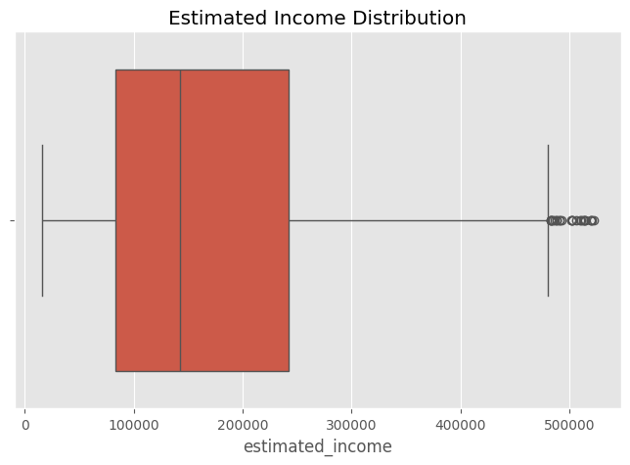
Figure 1. Boxplot of Estimated Income
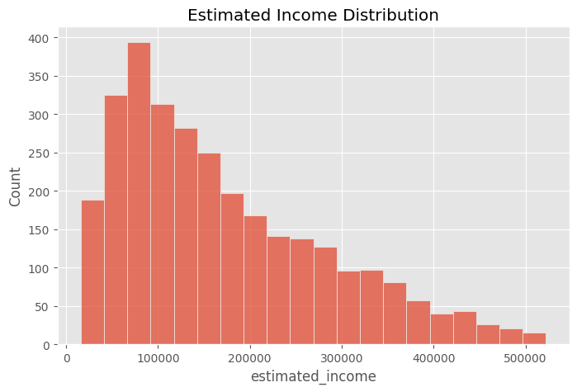
Figure 2. Histogram of Estimated Income
Business Insight: Customer income is positively (right) skewed: most clients earn between roughly $50,000 and $250,000, while a smaller number of high-income outliers pull the distribution's tail beyond $500,000. This confirms that a tiered income-banding strategy, rather than a single blanket product offer, will better match the bank's actual customer mix.

5.2.2 Customer Age Distribution
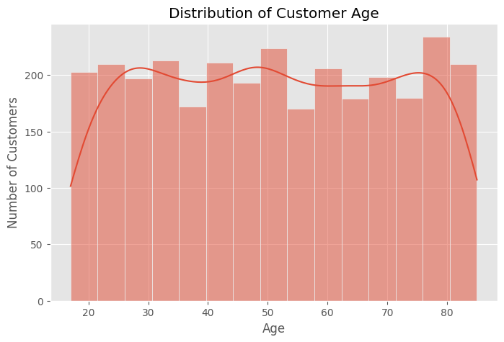
Figure 3. Distribution of Customer Age
Business Insight: Customer age is spread broadly across the working and retired population (17–85 years), with a noticeably higher concentration of clients in the 75–80 age bracket. This signals a substantial older, likely high-net-worth client base that will value estate-planning, retirement income and wealth-transfer services alongside standard banking products.

5.2.3 Gender Distribution
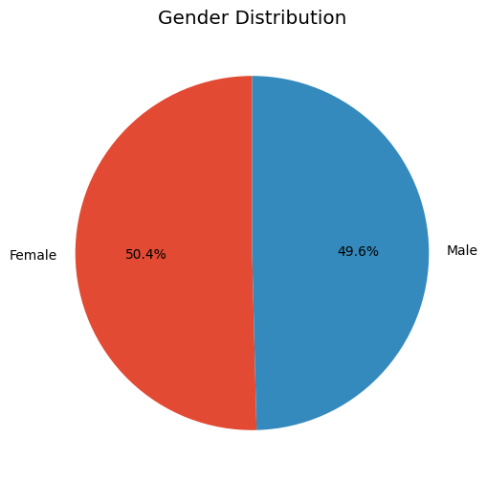
Figure 4. Gender Distribution
Business Insight: The customer base is almost perfectly balanced by gender (50.4% female, 49.6% male), so product design and marketing do not need to correct for gender skew — messaging can be developed for a balanced, mixed audience.

5.2.4 Top Occupations
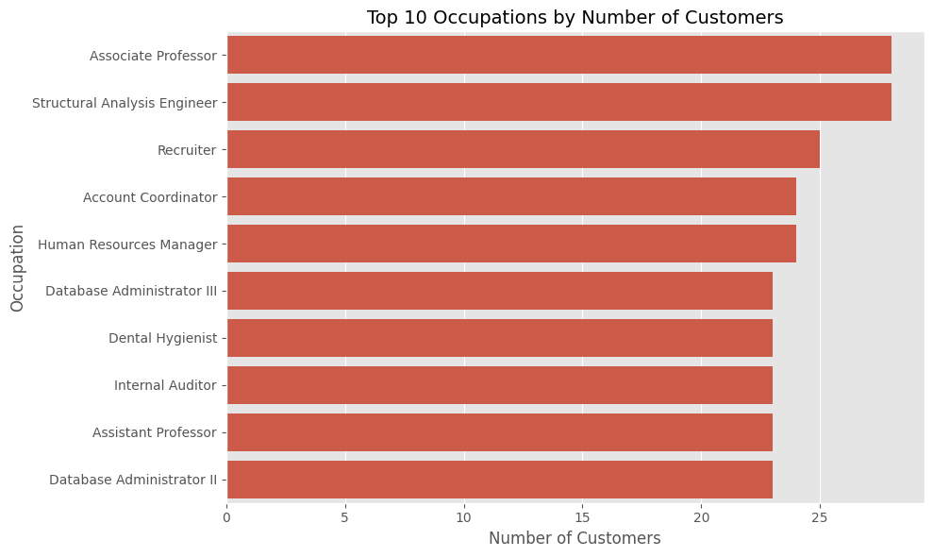
Figure 5. Top 10 Occupations by Number of Customers
Business Insight: Associate Professor and Structural Analysis Engineer are the two most common client occupations (28 customers each), followed closely by Recruiter, Account Coordinator and Human Resources Manager (23–25 customers each). No single occupation dominates the portfolio, indicating a professionally diverse, white-collar client base well suited to standardised professional/salaried banking packages rather than one narrow industry vertical.

5.2.5 Banking Relationship Distribution
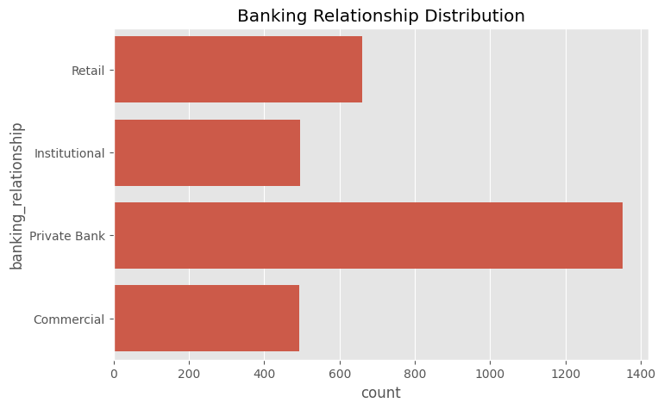
Figure 6. Banking Relationship Distribution
Business Insight: Private Bank is the most common relationship type, covering roughly 1,350 of the 3,000 customers — well ahead of Retail (~660), Institutional (~495) and Commercial (~490). This confirms private banking is both the largest and (per the SQL/Power BI deposit analysis) the highest-value relationship segment, making it the bank's core franchise.

5.2.6 Loyalty Classification
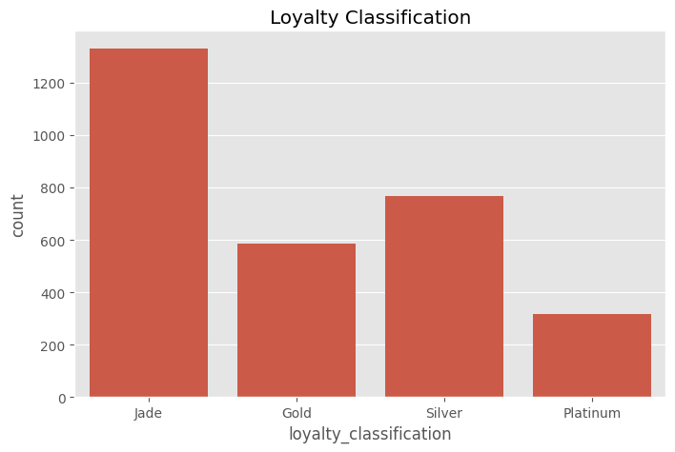
Figure 7. Loyalty Classification Distribution
Business Insight: The Jade tier is the largest loyalty segment (over 1,300 customers), followed by Silver (~770), Gold (~590) and Platinum (~320). With the majority of customers sitting in the entry-level Jade tier, there is a clear structural opportunity to grow Gold and Platinum membership through targeted loyalty-upgrade campaigns.

5.2.7 Risk Weighting Distribution
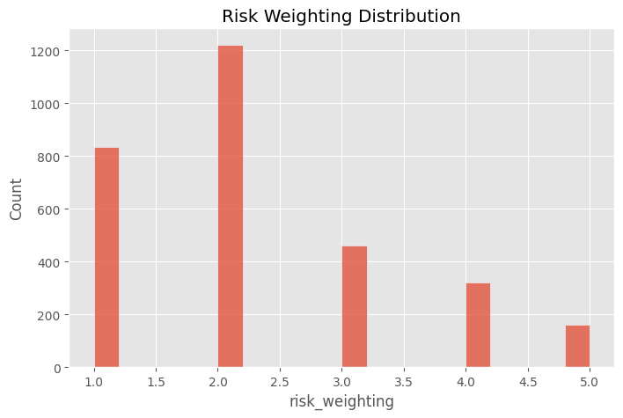
Figure 8. Risk Weighting Distribution
Business Insight: Most customers fall into risk-weighting bands 1 and 2 (over 2,000 of 3,000 customers combined), with progressively fewer clients in the higher-risk bands 3–5. The portfolio is therefore weighted toward lower-risk clients overall, which is a favourable starting position for the bank's credit risk profile.

5.2.8 Properties Owned
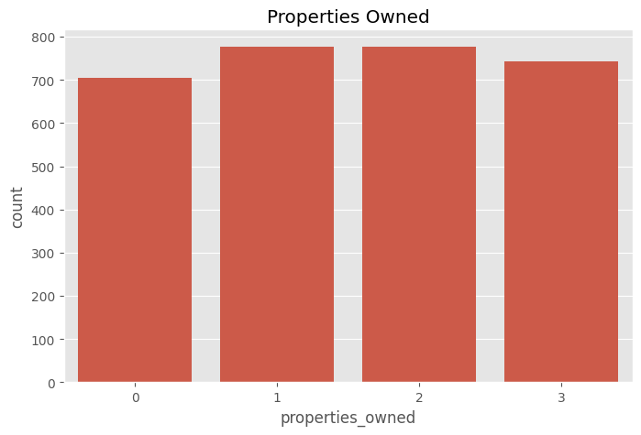
Figure 9. Number of Properties Owned
Business Insight: Property ownership is evenly distributed across 0, 1, 2 and 3 properties (roughly 700–780 customers in each band), suggesting property ownership is not concentrated in a small group and that mortgage/property-related cross-sell potential exists broadly across the client base.

5.2.9 Business Lending Distribution
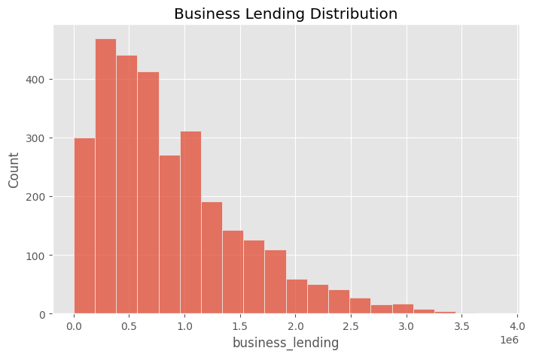
Figure 10. Business Lending Distribution
Business Insight: Business lending is strongly right-skewed: most customers carry business lending below roughly $1M, while a smaller tail of clients carries balances up to nearly $3.8M. This small group of heavy business-lending clients represents concentrated credit exposure that warrants closer monitoring.

5.3 Bivariate and Relationship Analysis

5.3.1 Deposits by Nationality
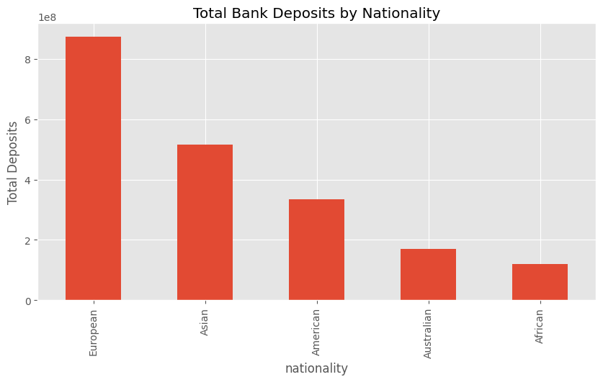
Figure 11. Total Bank Deposits by Nationality
Business Insight: European clients contribute by far the largest share of total deposits (~$874M), roughly 1.7x the Asian segment (~$515M) and more than double the American segment (~$335M). Australian and African clients contribute comparatively modest totals. This nationality concentration should inform where relationship-banking investment and localized marketing are prioritised.

5.3.2 Deposits vs. Loans
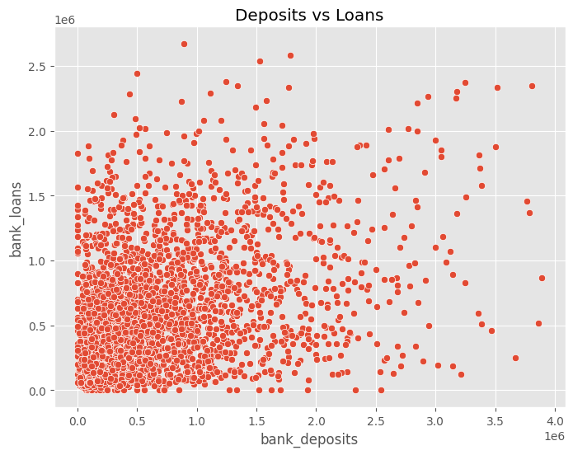
Figure 12. Deposits vs. Loans (scatter plot)
Business Insight: There is a mild, positive but noisy relationship between deposit and loan balances — customers with very high deposits (above roughly $2.5M) also tend to carry higher loan balances, but across the broader client base deposits and loans vary largely independently. This means loan exposure cannot be assumed from deposit size alone, and each should continue to be assessed separately in credit and relationship decisions.

5.3.3 Savings vs. Estimated Income
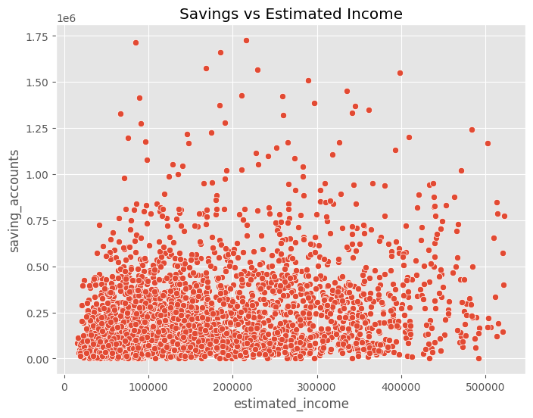
Figure 13. Savings vs. Estimated Income (scatter plot)
Business Insight: Savings balances increase only loosely with income — many mid-income customers hold substantial savings, while some higher earners hold comparatively little. Income alone is therefore not a reliable predictor of savings behaviour, suggesting other factors (age, financial discipline, life stage) also drive savings outcomes and should be considered in targeting savings products.

5.3.4 Credit Card Balance by Gender
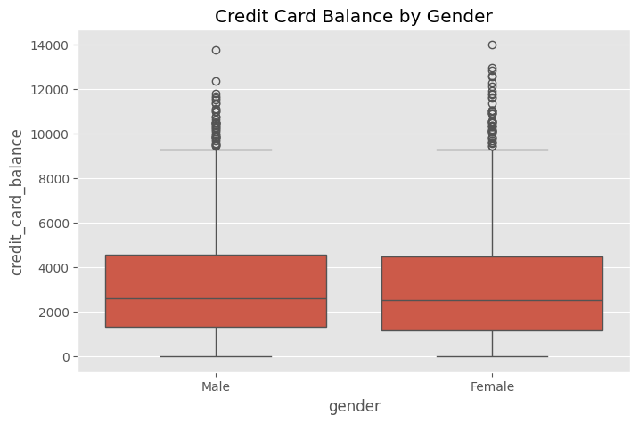
Figure 14. Credit Card Balance by Gender
Business Insight: Median and interquartile credit card balances are almost identical between male and female customers, confirming that credit card usage in this portfolio is not meaningfully differentiated by gender — credit card marketing and limit-setting can therefore be gender-neutral.

5.3.5 Correlation Analysis
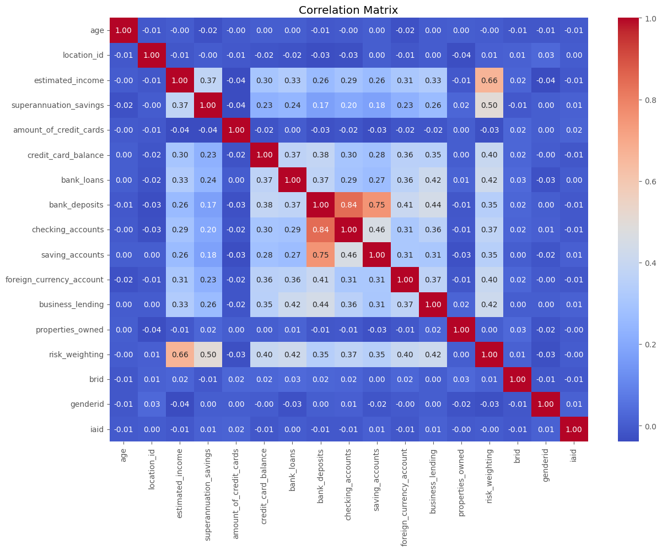
Figure 15. Correlation Matrix of Numeric Variables
The correlation heatmap quantifies how strongly each pair of numeric variables moves together (values range from -1 to +1). The clearest patterns are:
- Bank Deposits and Checking Accounts show a strong positive correlation (0.84) — customers who keep large checking balances also tend to hold large overall deposits, as expected given checking accounts form part of total deposits.
- Bank Deposits and Saving Accounts are also strongly correlated (0.75), reinforcing that deposit-rich customers are typically active savers as well as transactors.
- Estimated Income and Risk Weighting show a moderate-to-strong correlation (0.66), and Superannuation Savings and Risk Weighting are moderately correlated (0.50) — indicating the bank's internal risk-weighting methodology is closely tied to income and retirement savings levels.
- Age shows negligible correlation with every financial variable (correlations near 0.00), confirming the earlier observation that wealth and product usage in this portfolio are not simply a function of how old a customer is.
- Properties Owned is likewise uncorrelated with the other financial variables, suggesting property ownership is an independent customer attribute rather than a proxy for overall wealth in this dataset.

5.3.6 Top 10 Customers by Deposits
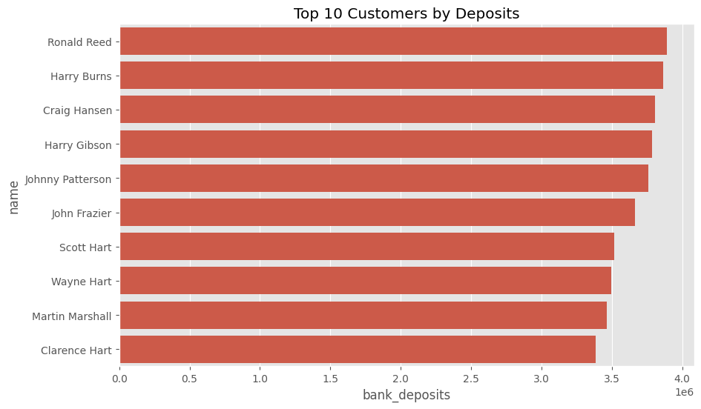
Figure 16. Top 10 Customers by Bank Deposits
Business Insight: The ten largest depositors — led by Ronald Reed (~$3.90M), Harry Burns (~$3.87M) and Craig Hansen (~$3.81M) — each hold deposit balances far above the $671,560 portfolio average. These named clients represent the bank's most valuable individual relationships and should be assigned dedicated relationship managers and priority service levels.

5.4 Summary of EDA Findings
The Python EDA confirms and extends the SQL findings: the client base is demographically diverse and gender-balanced, income and deposit variables are right-skewed with a small high-value tail, Private Banking and the Jade loyalty tier dominate by customer count, and deposit behaviour correlates strongly with transactional account balances but only weakly with age. These patterns directly informed the design of the Power BI dashboard described in the next section.

6. Power BI Dashboard Analysis
The cleaned dataset (clean_banking_data.csv) produced by the Python pipeline was loaded into Power BI to build the Retail Banking Customer Intelligence Dashboard — a single-page executive view combining six headline KPIs, six supporting visuals, and five interactive slicers. The dashboard is designed to let a business stakeholder move from a portfolio-level summary to a specific customer segment in a few clicks.
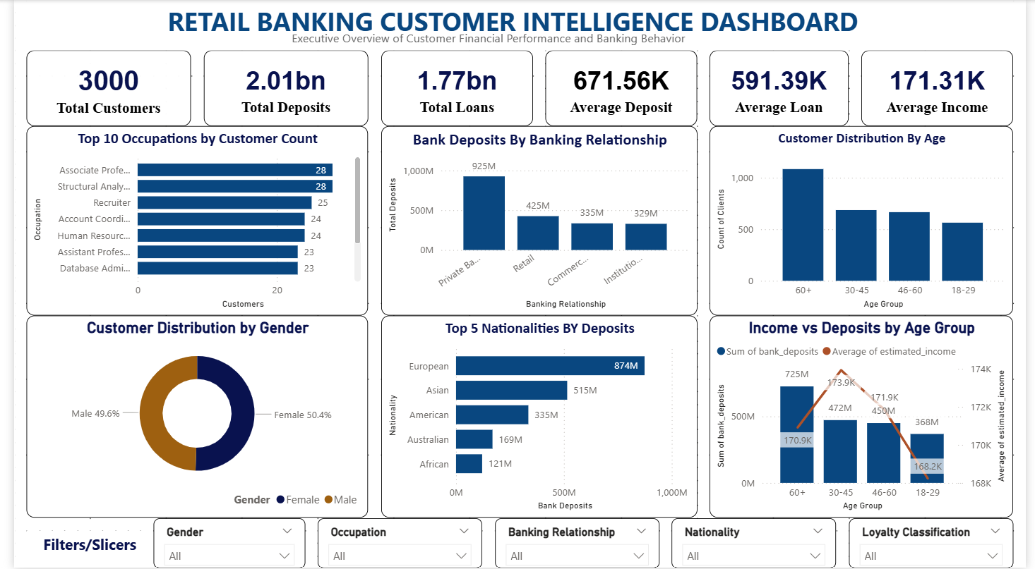
Figure 17. Retail Banking Customer Intelligence Dashboard — Executive Overview

6.1 Key Performance Indicators (KPI Cards)
KPI | Value | Business Meaning
Total Customers | 3,000 | The full size of the bank's managed retail/private banking client base covered by this dashboard.
Total Deposits | $2.01bn | The combined balance the bank holds on behalf of its customers — a core measure of the bank's funding base and balance-sheet strength.
Total Loans | $1.77bn | The combined lending exposure across the customer base — a core measure of interest income potential and credit risk.
Average Deposit | $671.56K | The typical deposit balance per customer, used as a benchmark to identify above- and below-average relationships.
Average Loan | $591.39K | The typical loan balance per customer, used to benchmark lending exposure per relationship.
Average Income | $171.31K | The typical estimated income per customer, used to gauge the earning power of the client base and to support income-based product targeting.

6.2 Charts and Visuals

6.2.1 Top 10 Occupations by Customer Count
A horizontal bar chart ranking occupations by number of customers. It confirms the Python finding that Associate Professor and Structural Analysis Engineer are the most common client occupations (28 each), giving marketing and product teams a live, filterable view of the bank's professional client mix.

6.2.2 Bank Deposits by Banking Relationship
A column chart summing total deposits for each of the four relationship types. Private Bank leads with approximately $925M in deposits, more than double Retail ($425M), and well ahead of Commercial ($335M) and Institutional ($329M) — visually reinforcing that private banking is the dominant value driver for the deposit book.

6.2.3 Customer Distribution by Age
A column chart grouping customers into four age bands (18–29, 30–45, 46–60, 60+). The 60+ band is the single largest group with just over 1,000 customers, while the remaining three bands are each in the 560–700 range — confirming the bank serves a notably large older/retired client segment.

6.2.4 Customer Distribution by Gender
A donut chart showing the near-even gender split (Male 49.6%, Female 50.4%), consistent with the Python analysis, confirming no gender-based targeting adjustment is required at the portfolio level.

6.2.5 Top 5 Nationalities by Deposits
A horizontal bar chart ranking the five nationalities in the dataset by total deposits. European clients contribute the most ($874M), followed by Asian ($515M), American ($335M), Australian ($169M) and African ($121M) clients — matching the Python nationality analysis and giving a quick, filterable geographic value view.

6.2.6 Income vs. Deposits by Age Group
A combination chart overlaying total deposits (columns) with average estimated income (line) for each age band. Deposits rise steadily with age — from $368M in the 18–29 band to $725M in the 60+ band — while average income is comparatively flat across age bands (roughly $168K–$174K). This is one of the dashboard's most important insights: older customers hold materially more in deposits despite having similar average income to younger customers, implying that deposit growth in this portfolio is driven by lifetime accumulation and relationship tenure rather than current income level.

6.3 Interactive Filters (Slicers)
Five slicers allow any dashboard user to filter every KPI and chart simultaneously, supporting self-service, ad-hoc segmentation without needing to write SQL or Python code:
- Gender — isolate male or female customers.
- Occupation — drill into a specific profession (e.g. compare Associate Professors against Recruiters).
- Banking Relationship — focus the whole dashboard on Private Bank, Retail, Commercial or Institutional clients only.
- Nationality — focus on a single nationality segment, e.g. to prepare for a market-specific campaign.
- Loyalty Classification — isolate the Jade, Silver, Gold or Platinum tier to evaluate tier-specific KPIs.
Together, the slicers turn the static analysis performed in SQL and Python into a live, reusable decision-support tool that business users can operate independently.

7. Consolidated Business Insights
- Deposit-rich clients are transactionally active: deposits correlate strongly with checking (0.84) and savings (0.75) account balances, so growing transactional-account engagement is a practical lever for growing total deposits.
- Wealth is concentrated: income, deposits, loans and business lending are all right-skewed, with mean values well above the median — a relatively small group of high-value clients (e.g. the top 10 depositors, each above $3.4M) contributes disproportionately to the bank's funding base.
- Private Banking is the core franchise: it is both the largest relationship segment by customer count (~1,350 customers) and the largest by deposits (~$925M), confirming it should remain the bank's primary investment priority for service quality and advisor resourcing.
- Older customers hold more deposits despite similar income to younger customers: the 60+ age band holds the highest total deposits ($725M) with average income comparable to other age bands, indicating deposit growth is driven by accumulation and tenure rather than current earnings.
- Nationality concentration exists: European clients alone contribute roughly 43% of the deposits held by the top five nationalities, making this segment strategically important for retention.
- The client base is low-to-medium risk overall: over two-thirds of customers fall into the two lowest risk-weighting bands, and risk weighting is closely tied to income and superannuation savings rather than to loan or deposit size.
- Loyalty tier is skewed toward the entry level: the Jade tier holds the largest share of customers (~1,350), representing a large pool of candidates for upgrade to Gold or Platinum through targeted engagement.
- Data governance gap: recurring (non-unique) Client ID values were identified in both the SQL and Python analysis, indicating the source system should introduce a guaranteed unique customer key before this data is used in automated decisioning.

8. Business Recommendations

8.1 Strengthen Private Banking leadership
Given Private Bank clients already generate the largest share of deposits, invest further in dedicated relationship managers, premium service tiers and retention programs for this segment to protect and grow the bank's core franchise.

8.2 Build a top-tier client program
Formalise a dedicated program for the highest-deposit customers (such as the top 10 identified in this analysis), with named relationship managers, priority service access and tailored wealth-management offers.

8.3 Design occupation-linked product bundles
Use the occupation and income analysis to create tailored offers for the bank's most common professional segments (e.g. academic and engineering professionals), rather than generic mass-market products.

8.4 Target the 60+ deposit-rich segment with retirement and wealth-transfer products
Since older customers hold disproportionately high deposits relative to income, proactively offer retirement income planning, estate planning and wealth-transfer advisory services to this group.

8.5 Run loyalty-tier upgrade campaigns
With the majority of customers in the entry-level Jade tier, design a clear upgrade path (e.g. deposit or product-holding thresholds) to migrate customers toward Gold and Platinum, increasing engagement and retention.

8.6 Deepen dual-value relationships
Prioritise cross-selling to the segment identified with both above-average deposits and above-average loans (Q7) — these clients already have breadth of engagement and are well positioned for further product bundling.

8.7 Prioritise relationship investment in leading nationality segments
Direct culturally and geographically tailored relationship-banking initiatives toward the European and Asian client segments, which together contribute the majority of deposits among the top five nationalities.

8.8 Use advisor performance data for coaching and incentive design
Apply the investment-advisor asset-under-management ranking (Q11) to identify top performers for best-practice sharing and to right-size workloads across the 22-advisor team.

8.9 Fix the Client ID data-quality issue
Introduce a guaranteed unique surrogate key in the source system to eliminate recurring Client ID values before this dataset is used for automated marketing, credit or compliance decisions.

8.10 Operationalise the Power BI dashboard
Roll out the dashboard to relationship managers and segment leads with scheduled data refreshes, so that the SQL/Python analysis performed here becomes a continuously updated management tool rather than a one-off study.

9. Limitations
- The dataset represents a single snapshot in time; it does not capture how deposits, loans or customer behaviour change over time, which limits trend and retention analysis.
- Client ID values are not guaranteed to be unique, which introduces a data-governance risk for any downstream system that assumes Client ID is a stable primary key.
- The dataset does not include transaction-level detail, product profitability, or cost-to-serve data, so recommendations on profitability are directional rather than precisely quantified.
- Correlation findings (e.g. between income, deposits and risk weighting) describe association, not causation, and should not be used alone to justify automated decisioning without further validation.
- The analysis reflects the data as provided and does not independently verify the accuracy of source values such as Estimated Income or Risk Weighting against external records.

10. Future Scope
- Extend the analysis with time-series data to track deposit, loan and loyalty-tier migration over multiple periods.
- Incorporate transaction-level and product-profitability data to move from balance-based insights to true customer profitability analysis.
- Build a predictive model (e.g. for loyalty-tier upgrade likelihood or deposit attrition risk) using the demographic and financial variables profiled in this report.
- Automate the SQL-to-Python-to-Power BI pipeline with scheduled refreshes so the dashboard reflects live production data.
- Resolve the Client ID uniqueness issue at the source-system level and introduce a formal data-quality monitoring process.
- Expand the dashboard with drill-through pages for individual advisors and individual top-tier clients to support day-to-day relationship management.

11. Conclusion
This project analysed customer demographics, banking relationships, deposits, loans and broader financial behaviour for a 3,000-customer retail banking portfolio using PostgreSQL, Python and Power BI. The analysis identified a clear core franchise in Private Banking, a concentrated group of high-value depositors, a loyalty base skewed toward the entry-level tier, and a client population whose deposit behaviour is driven more by relationship tenure and occupation than by age or gender. These insights, delivered through both a static analytical report and a live, filterable Power BI dashboard, give the bank's management team an evidence base for prioritising relationship investment, designing targeted products, and improving loyalty and cross-sell strategy. Addressing the identified data-quality gap around Client ID uniqueness is recommended as a near-term, low-cost step to strengthen the reliability of future analysis built on this data.

