# WEEK-2{ADVANCED SQL}_(Stored procedure)

## Exercise 1: Create a Stored Procedure

1. Define the stored procedure with a parameter for DepartmentID

CODE-

CREATE PROCEDURE sp_GetEmployeesByDepartment

@DeptID INT

AS

BEGIN

SELECT

e.EmployeeID,

e.FirstName,

e.LastName,

d.DepartmentName,

e.Salary,

e.JoinDate

FROM Employees e

INNER JOIN Departments d ON e.DepartmentID = d.DepartmentID

WHERE e.DepartmentID = @DeptID;

END;

1. Write the SQL query to select employee details based on the DepartmentID

CODE-

EXEC sp_GetEmployeesByDepartment @DeptID = 3;

OUTPUT-

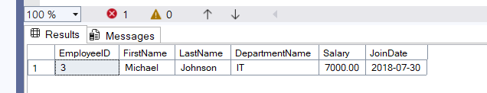

1. . Create a stored procedure named `sp_InsertEmployee` with the following code

CREATE PROCEDURE sp_InsertEmployee

@FirstName VARCHAR(50),

@LastName VARCHAR(50),

@DepartmentID INT,

@Salary DECIMAL(10,2),

@JoinDate DATE

AS

BEGIN

INSERT INTO Employees (FirstName, LastName, DepartmentID, Salary, JoinDate)

VALUES (@FirstName, @LastName, @DepartmentID, @Salary, @JoinDate);

END;

EXEC sp_InsertEmployee

@FirstName = 'Alex',

@LastName = 'Brown',

@DepartmentID = 3,

@Salary = 6200.00,

@JoinDate = '2022-05-10';

SELECT * FROM Employees;

Output-

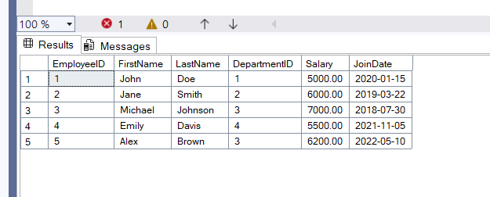

## Exercise 5: Return Data from a Stored Procedure

CREATE PROCEDURE sp_CountEmployeesByDepartment

@DepartmentID INT

AS

BEGIN

SELECT

COUNT(*) AS TotalEmployees

FROM

Employees

WHERE

DepartmentID = @DepartmentID;

END;

EXEC sp_CountEmployeesByDepartment @DepartmentID = 3;

