**Lab 1: Understanding ORM with a Retail Inventory System**

1.dotnet add package Microsoft.EntityFrameworkCore.SqlServer

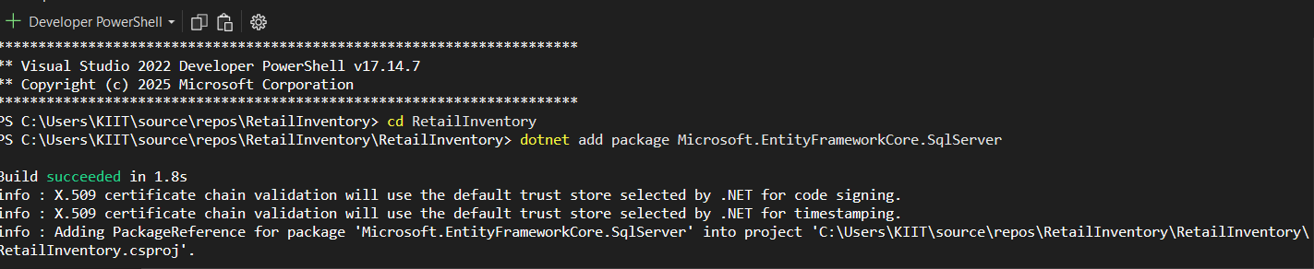

2.dotnet add package Microsoft.EntityFrameworkCore.Design

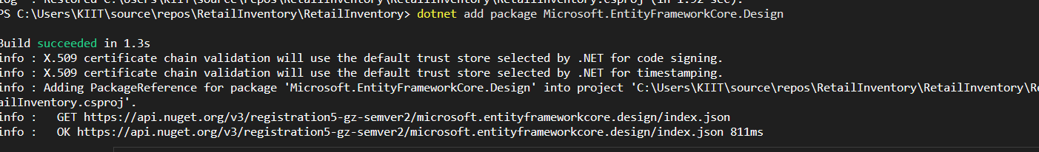

**Lab 2: Setting Up the Database Context for a Retail Store**

* **Models**

**1.Product.cs**

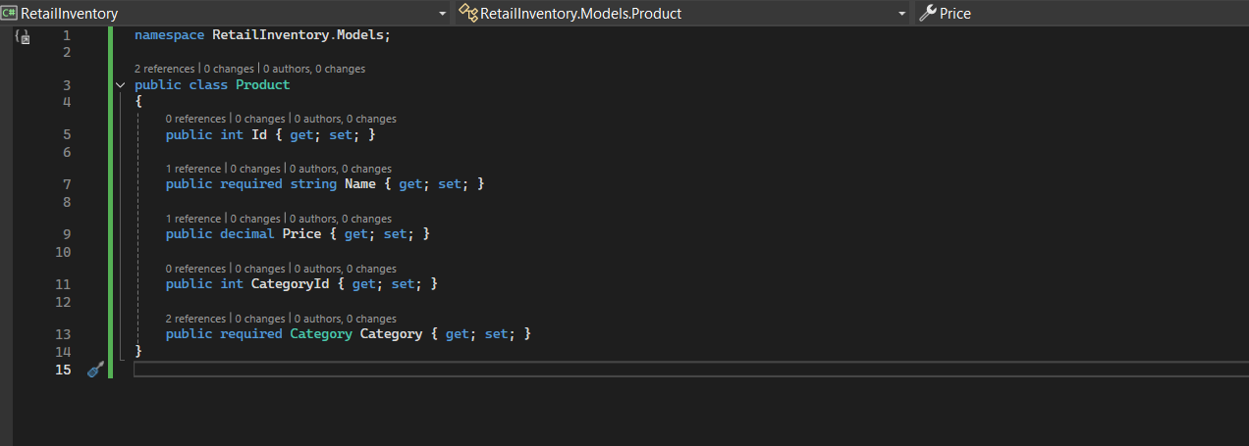

**2.Category.cs**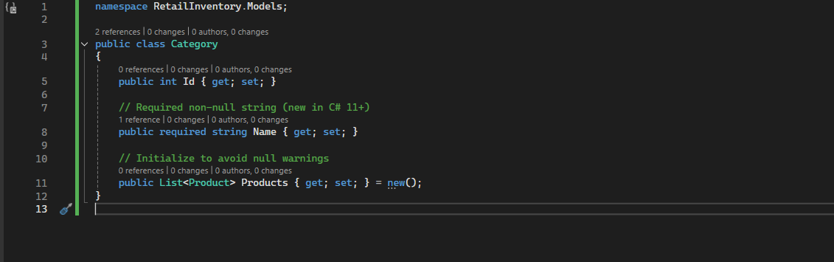

**3.AppDbContext**

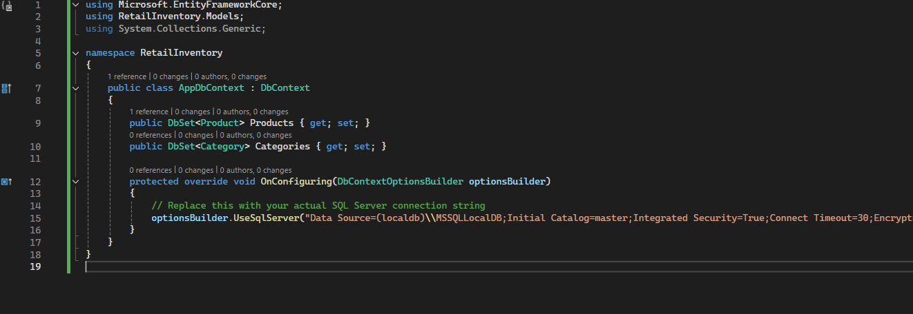

**Lab 3: Using EF Core CLI to Create and Apply Migrations**

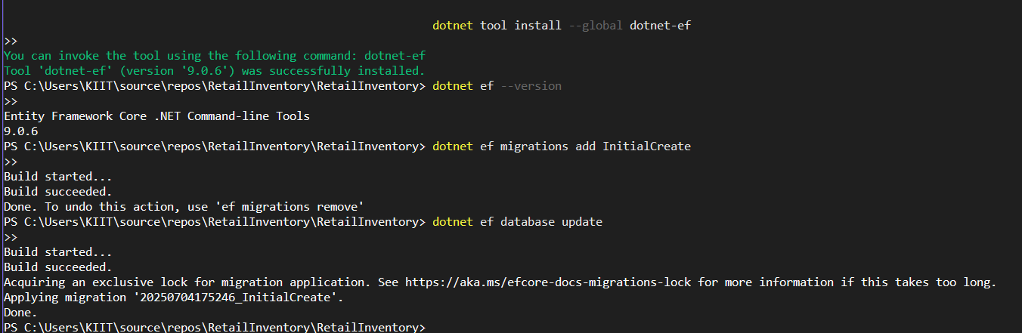

**Verify in SQL Server:**

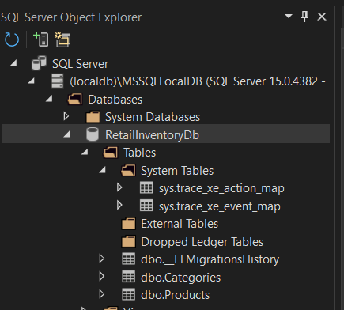

**Lab 4: Inserting Initial Data into the Database**

**Program.cs (Code)**

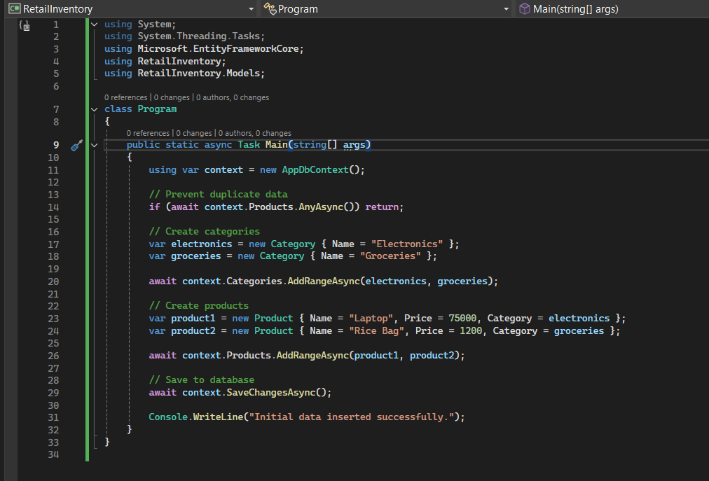

**Verify in SQL Server**

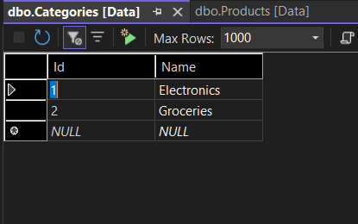

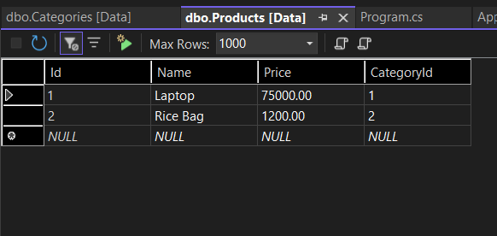

**lab 5: Retrieving Data from the Database**

Program.cs code-

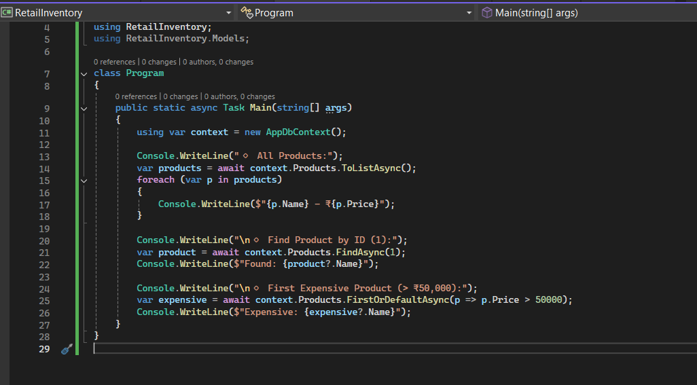

Output:-

