**Lab-7 (Task 3)**

* **Entering ID of product through home.aspx :-**

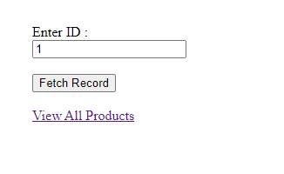

* **Details of product with corresponding id on product.aspx :-**

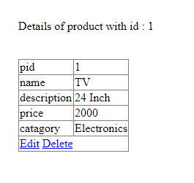

* **Displaying all the products’ details on allproduct.aspx :-**

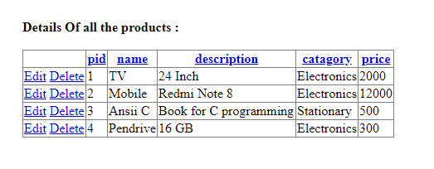

* **Editing & deleting record from GridView :-**

