**A PROJECT REPORT ON**

**QnA - Doubt Solving Forum**

**By**

**Mahammadayan Shaikh (CE124) (18CEUOG004)**

**B. Tech CE Semester - VI**

**Subject : Object Oriented Software Engineering**

**Guided By:**

**Prof. Mrudang T. Mehta**

**Associate Professor**

**Dept. Of Computer Engineering**



**Faculty of Technology**

**Department of Computer Engineering**

**Dharmsinh Desai University**



**Faculty of Technology**

**Department of Computer Engineering**

**Dharmsinh Desai University**

**CERTIFICATE**

This is to certify that the practical / term work carried out in the subject of **Object Oriented Software Engineering** and recorded in this journal is the bonafide work of

**Mahammadayan Shaikh (CE124) (18CEUOG004)**

of B.Tech semester **VI** in the branch of **Computer Engineering** during the academic year **2020-2021**.

Prof. Mrudang T. Mehta,

Associate Professor,

Dept. of Computer Engg.,

Faculty of Technology,

Dharmsinh Desai University, Nadiad

Dr. C. K. Bhensdadia,

Head,

Dept. of Computer Engg.,

Faculty of Technology,

Dharmsinh Desai University, Nadia

**Table Of Contents**

**Abstract**4

Purpose 4

Scope 4

**Introduction**5

Brief Introduction 5

Technology/Platform/Tools used 5

**Software Requirements Specification - SRS**6

Functional Requirements 6

**Design**10

Use Case Diagram 10

Class Diagram 10

State Diagram 11

ER Diagram 11

Activity Diagram 12

Sequence Diagram 13

Collaboration Diagram 13

Component Diagram 13

Deployment Diagram 14

Package Diagram 15

Data Dictionary 15

**Implementation Detail**18

Modules 18

Function prototypes which implements major functionality 19

**Testing**20

**Screenshots**22

**New Question**23

**Conclusion**27

**Limitation and Future Extensions**28

Limitations 28

Functionalities not implemented 28

Possible future extensions 28

**Bibliography**29

# 

# **Abstract**

This Doubt Solving forum is a web application for persons related to the CSE field. It provides a platform to users to ask their doubts regarding technical questions, technical issues or errors. Users can post their questions and other users who know the answer can post the answers. In this manner, this application provides a smooth way for getting solutions of their questions and makes debugging easy.

## **Purpose**

The purpose of this document is to collect and present ideas, requirements & analysis done in order to develop this system. This document provides a detailed overview of the system, details of the functionalities provided to users, target audience of the system and their user interfaces.

## **Scope**

The scope of the system is providing a handy web application to users for doubt solving. Any user with a registered account on the system can use the functionalities & get benefits of the provided features.

# 

# **Introduction**

## **Brief Introduction**

The doubt solving forum is a web application which reduces the time for debugging errors by providing a user friendly way of doubt solving. This application works around end users. Users can register themselves to the system and then they can get benefits of all features after successful login. Users can post the questions, post answers of the questions asked by other users, upvote the answer if they find it useful, downvote the answer if the answer is not useful or wrong, post the feedback regarding the application to the admin.

## **Technology/Platform/Tools used**

**Technology :**

* Dot net core framework
* SQL Server database.
* Javascript
* Bootstrap

**Platform :**

* Windows

**Tools :**

* Visual Studio

# 

# 

# 

# **Software Requirements Specification - SRS**

Total 2 types of users are there in system:

1. User
2. Admin

## **Functional Requirements**

**R1 Manage User Accounts**

**R 1.1 Create User Account**

Description :- New User can create his/her account on the system.

Input :- User’s information : Email Id & Password.

Output :- Confirmation message regarding successful account creation.

**R 1.2 Manage Login**

Description :- Registered users can login to the system through their credentials.

Input :- User’s credentials : Email Id & Password.

Output :- Redirect to home page on successful login. Error message in case of error.

**R 1.3 Forgot Password**

Description :- User can reset his/her password using this functionality.

Input :- User’s Email-Id.

Output :- Reset password link to be sent to user via mail.

**R 1.4 Delete Account.**

Description :- User can delete his/her account.

Input :- User selection.

Output :- Success message regarding deletion of account .

**R2 Manage Questions**

**R 2.1 Ask Questions**

Description :- User can ask question or doubt regarding their issues or errors.

Input :- User’s Question.

Output :- Confirmation message regarding posting of question.

**R 2.2 Search Questions.**

Description :- User can search for a question containing particular keywords

Input :- Search String.

Output :- Result of search query.

**R 2.3 View My Questions.**

Description :- User can view the list of questions which are posted by him/her.

Input :- User selection.

Output :- List of questions posted by user.

**R 2.4 Edit Questions.**

Description :- User can edit the question posted by him

Input :- Updated details of the question.

Output :- Confirmation message regarding updation.

**R3 Manage Answers**

**R 3.1 Post answers.**

Description :- User can post answers to the questions posted by other users.

Input :- Answer of the question.

Output :- Confirmation message regarding posting of answer.

**R 3.2 Edit Answers.**

Description :- User can edit the answer posted by him

Input :- Updated details of the answer.

Output :- Confirmation message regarding updation.

**R 3.2 Up-vote or down-vote answer.**

Description :- User can up-vote or down-vote the answer posted by other users

Input :- User Selection.

Output :- Confirmation regarding the action performed.

**R 4 Give Feedback.**

Description :- User can give feedbacks about the system to the admin.

Input :- Feedback message.

Output :- Confirmation message regarding posting of feedback.

**R 5 Manage Admin Panel.**

**R 5.1 View statistical data.**

Description :- Admin can view statistical data of the application like total users, total questions, total answers.

Input :- User selection.

Output :- Statistical data of the application.

**R 5.2 View Feedbacks.**

Description :- Admin can view feedbacks given by users.

Input :- User Selection.

Output :- Feedbacks given by user.

**R 5.3 Block/Unblock user.**

Description :- Admin can block/unblock a particular user.

Input :- User selection.

Output :- Updated list of users after performing requested action.

# 

# **Design**

## **Use Case Diagram**

## 

## **Class Diagram**

## 

## **State Diagram**

## 

## **ER Diagram**

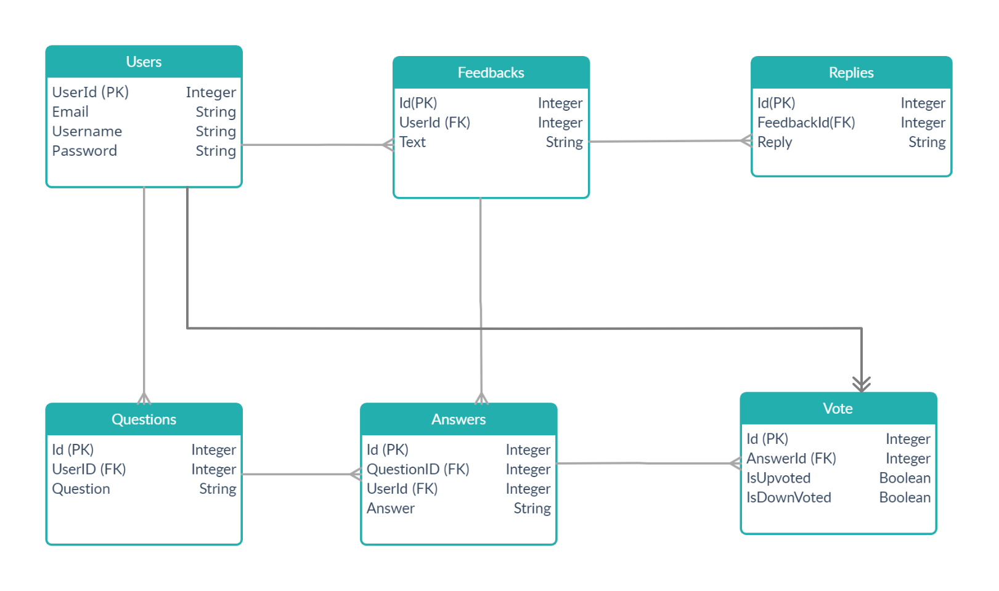

## **Activity Diagram**

## 

## 

## 

## 

## 

## 

## **Sequence Diagram**

## 

## **Collaboration Diagram**

## 

## 

## **Component Diagram**

## 

## **Deployment Diagram**

## 

## **Package Diagram**

## 

## **Data Dictionary**

1. **User**

|  |  |  |  |  |  |  |
| --- | --- | --- | --- | --- | --- | --- |
| **No** | **Field name** | **Data type** | **Required** | **Unique** | **PK / FK** | **Ref. Table** |
| 1 | UserId | string | true | true | PK | - |
| 2 | Email | string | true | true | - | - |
| 3 | Username | string | true | false |  | - |
| 4 | Password | string | true | false | - | - |

1. **Question**

|  |  |  |  |  |  |  |
| --- | --- | --- | --- | --- | --- | --- |
| **No** | **Field name** | **Data type** | **Required** | **Unique** | **PK / FK** | **Ref. Table** |
| 1 | QuestionId | int | true | true | PK | - |
| 2 | UserId | string | true | false | FK | User |
| 3 | QuestionText | string | true | false |  | - |

### 

1. **Answer**

|  |  |  |  |  |  |  |
| --- | --- | --- | --- | --- | --- | --- |
| **No** | **Field name** | **Data type** | **Required** | **Unique** | **PK / FK** | **Ref. Table** |
| 1 | AnswerId | int | true | true | PK | - |
| 2 | UserId | string | true | false | FK | User |
| 3 | QuestionId | string | true | true | - | - |
| 4 | AnswerText | string | false | false | - | - |

1. **Vote**

|  |  |  |  |  |  |  |
| --- | --- | --- | --- | --- | --- | --- |
| **No** | **Field name** | **Data type** | **Required** | **Unique** | **PK / FK** | **Ref. Table** |
| 1 | Id | int | true | true | PK | - |
| 2 | UserId | string | true | false | FK | User |
| 3 | AnswerId | int | true | false | FK | Answer |
| 4 | IsUpVoted | boolean | false | false | - | - |
| 5 | IsDownVoted | boolean | false | false | - | - |

1. **Feedback**

|  |  |  |  |  |  |  |
| --- | --- | --- | --- | --- | --- | --- |
| **No** | **Field name** | **Data type** | **Required** | **Unique** | **PK / FK** | **Ref. Table** |
| 1 | Id | int | true | true | PK | - |
| 2 | UserId | string | true | false | FK | User |
| 3 | Text | string | true | false | - | - |

1. **FeedbackReply**

|  |  |  |  |  |  |  |
| --- | --- | --- | --- | --- | --- | --- |
| **No** | **Field name** | **Data type** | **Required** | **Unique** | **PK / FK** | **Ref. Table** |
| 1 | Id | int | true | true | PK | - |
| 2 | Feedback | int | true | false | FK | Feedback |
| 3 | Text | string | true | false | - | - |

# 

# 

# **Implementation Detail**

## **Modules**

Total modules :- 4

1. **Account Module :-**

This module manages operations related to users’ accounts like login, signup and forgot password. Existing users can login to the system by providing their email-id and password. New users can create their account by providing the required details. If any user forgot a password then he/she can reset it using the forgot password. Admin can view statistical data and list of users of the system.

1. **Question Module :-**

This module manages operations related to questions. Users can post new questions. They can view a list of questions added by other users, questions added by the user himself/herself. They can update & delete their questions as well.

1. **Answer Module :-**

This module manages all answer related operations. Users can post answers of questions posted by others. They can view a list of all answers posted by other users for a particular question. Users can edit and delete their answers, too. Users can up-vote or down-vote the answer given by other users.

1. **Feedback Module :-**

This module manages all feedback related operations. Users can post the feedback regarding the system to admin. Admin can reply back to the feedbacks given by users.

## **Function prototypes which implements major functionality**

**- Function prototypes of Question Module**

* Question Add(Question question);
* Question GetQuestion(int id);
* IList<Question> GetQuestions();
* Question Update(Question question);
* Question Delete(int id);

**- Function prototypes of Answer Module**

* IEnumerable<Answer> GetAnswers();
* Answer Add(Answer answer);
* IEnumerable<Answer> GetAnswers(int qid);
* Answer GetAnswer(int id);
* void DeleteAnswer(int id);
* Answer Update(Answer answer);
* Vote VoteAnswer(Vote vote);
* void DeleteVoteByUserId(string userId);
* IEnumerable<Vote> GetVotes();

**- Function prototypes of Feedback Module**

* Feedback Add(Feedback feedback);
* IEnumerable<Feedback> GetFeedbacks();
* FeedbackReply PostReply(FeedbackReply feedbackReply);

## 

# **Testing**

Unit testing of each module was done after successfully completing the module. Each module was tested individually before integrating them with the whole system.

After integrating each module with the system, integration testing was done in order to check if modules are working properly together.

After completing all integrations, black-box testing of the whole system was carried out to ensure the system works in a correct manner.

**Black box testing of Major functions of the system**

1. **Log in to the system.**

**Case 1 :** Invalid Username or password entered by the user.

**Output :** Error message on the screen saying “Invalid credentials”

**Case 2 :** Valid credentials.

**Output :** The user is redirected to the Dashboard page.

1. **Register to system**

**Case 1 :** Username already exists.

**Output :** Error message on the screen saying “Username is taken”

**Case 2 :** Unique username is provided by the user.

**Output :** User registered successfully.

1. **Edit Question.**

**Case 1 :** User is not logged in.

**Output :** Redirected to the login page with error message “Please login..!”.

**Case 2 :** Provided question ID in url not exists at all.

**Output :** 404 Error page displayed.

**Case 3 :** Question is not posted by the logged in user.

**Output :** Access Denied page displayed.

**Case 4 :** Question Id is correct & it is posted by a logged in user.

**Output :** Edit question form is displayed loaded with question details.

1. **Vote Answer.**

**Case 1 :** User has already given a vote to the answer.

**Output :** User’s vote is cancelled successfully.

**Case 2 :** User has voted for the first time.

**Output :** User’s vote is saved and vote count to answer is modified.

# 

# 

# **Screenshots**

1. **Home Page**

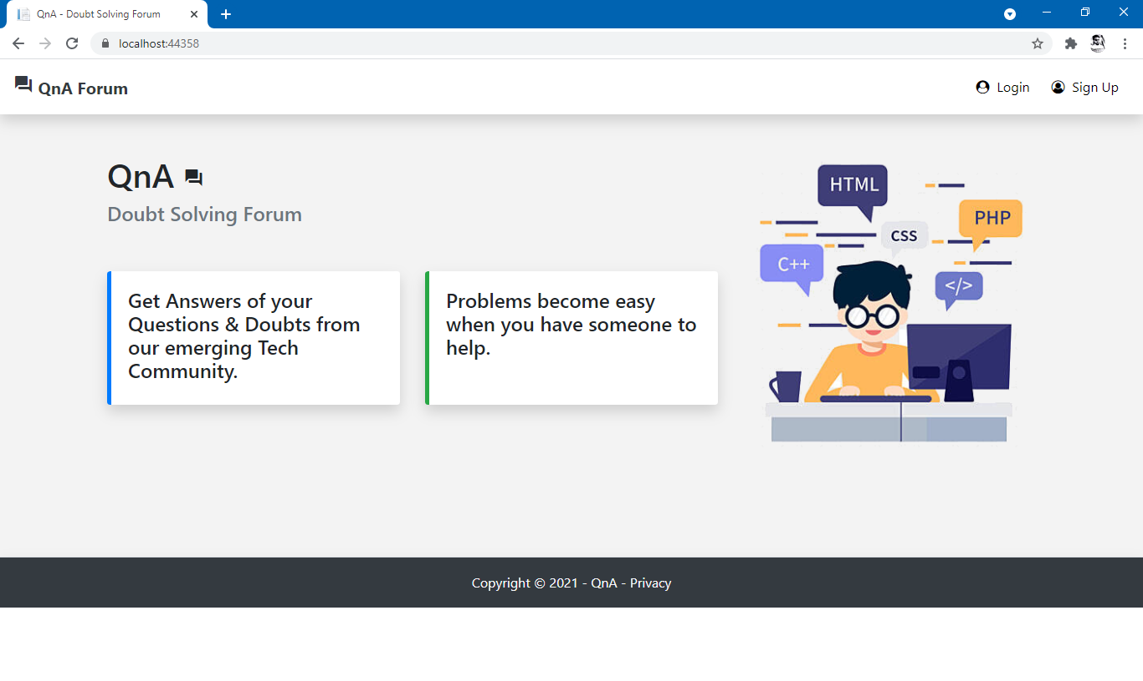

1. **Login**

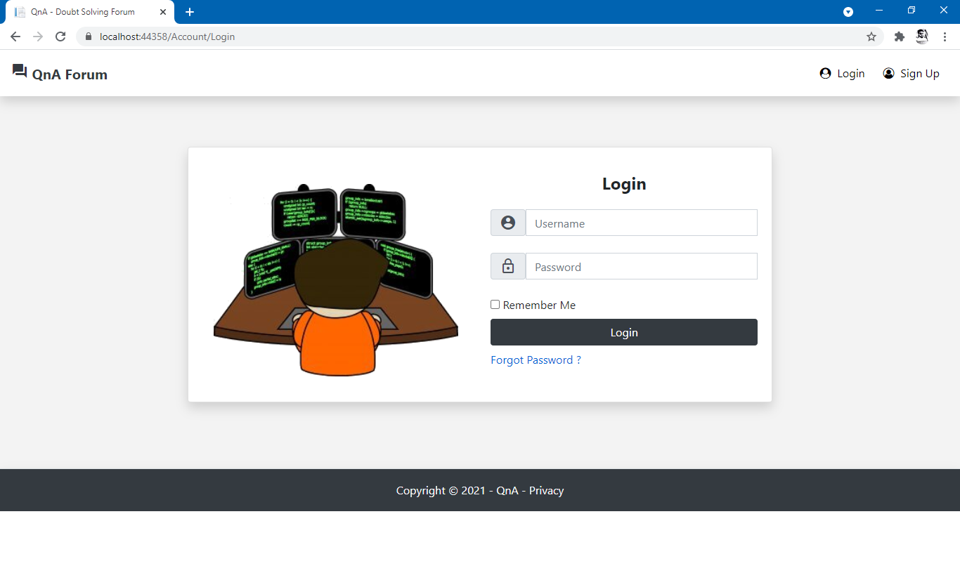

# **New Question**

# 

1. **Question List**

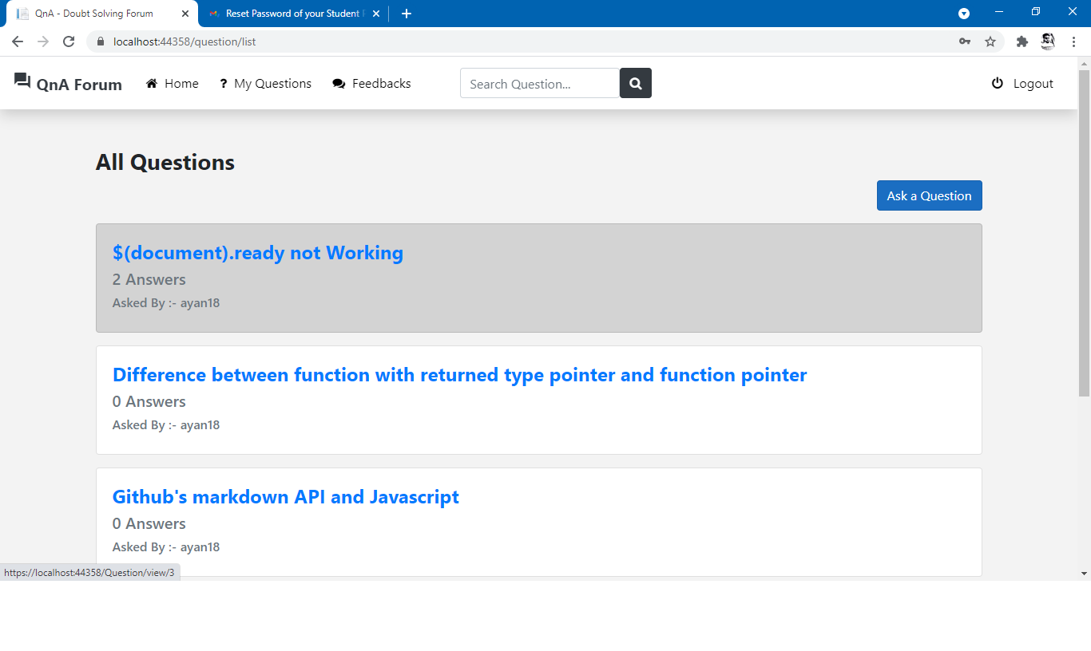

# 

1. **View Question**

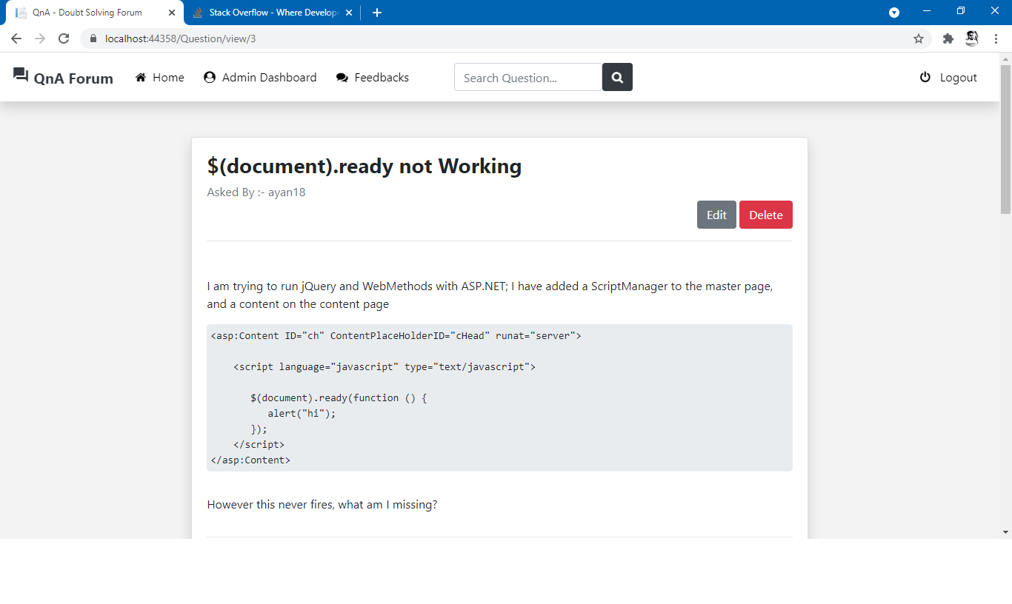

1. **Post Answer**

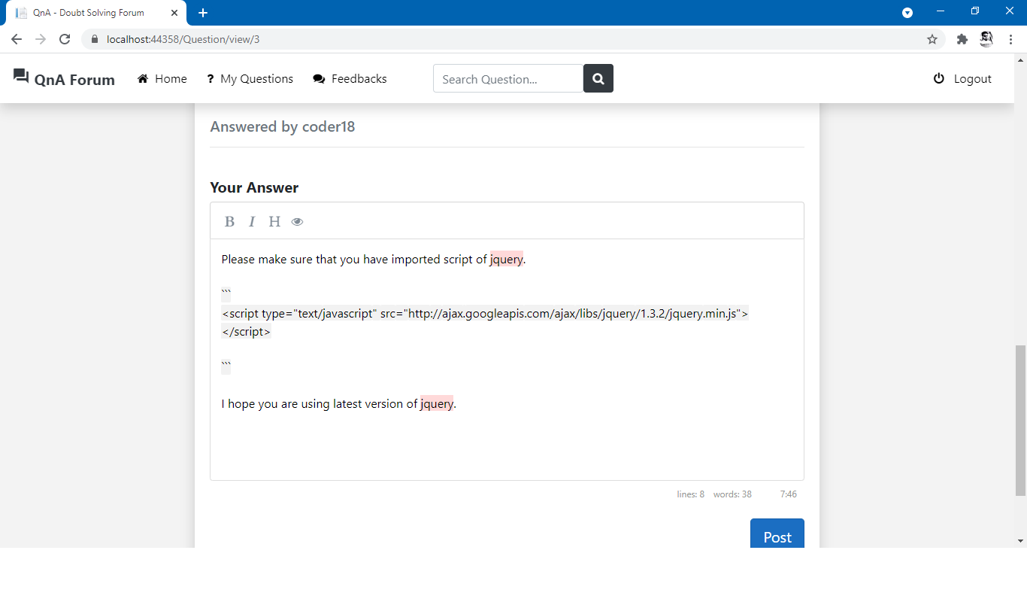

# 

1. **Answers’ List**

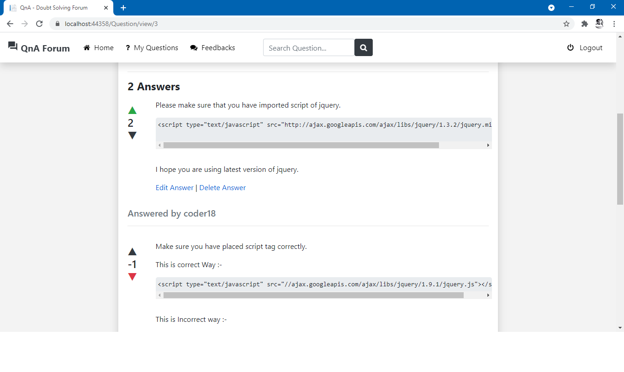

1. **Admin Dashboard**

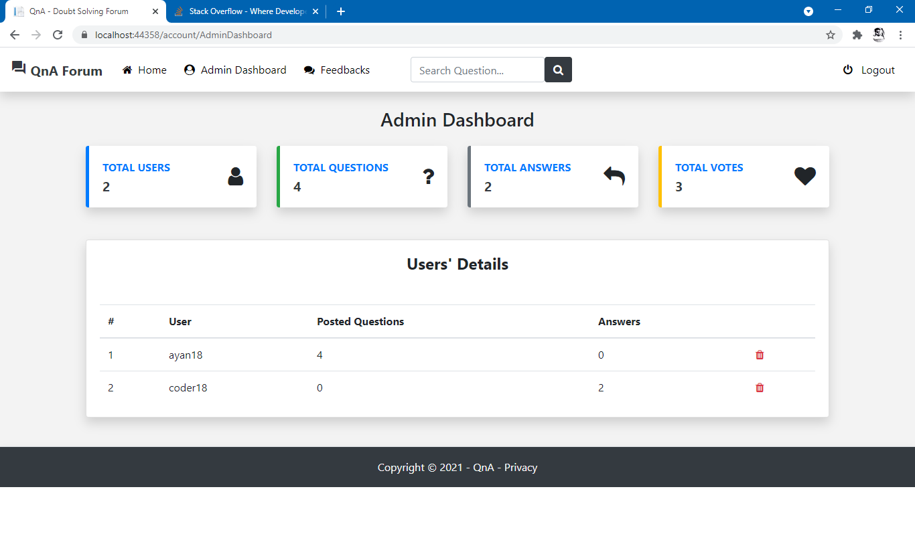

1. **Feedbacks**

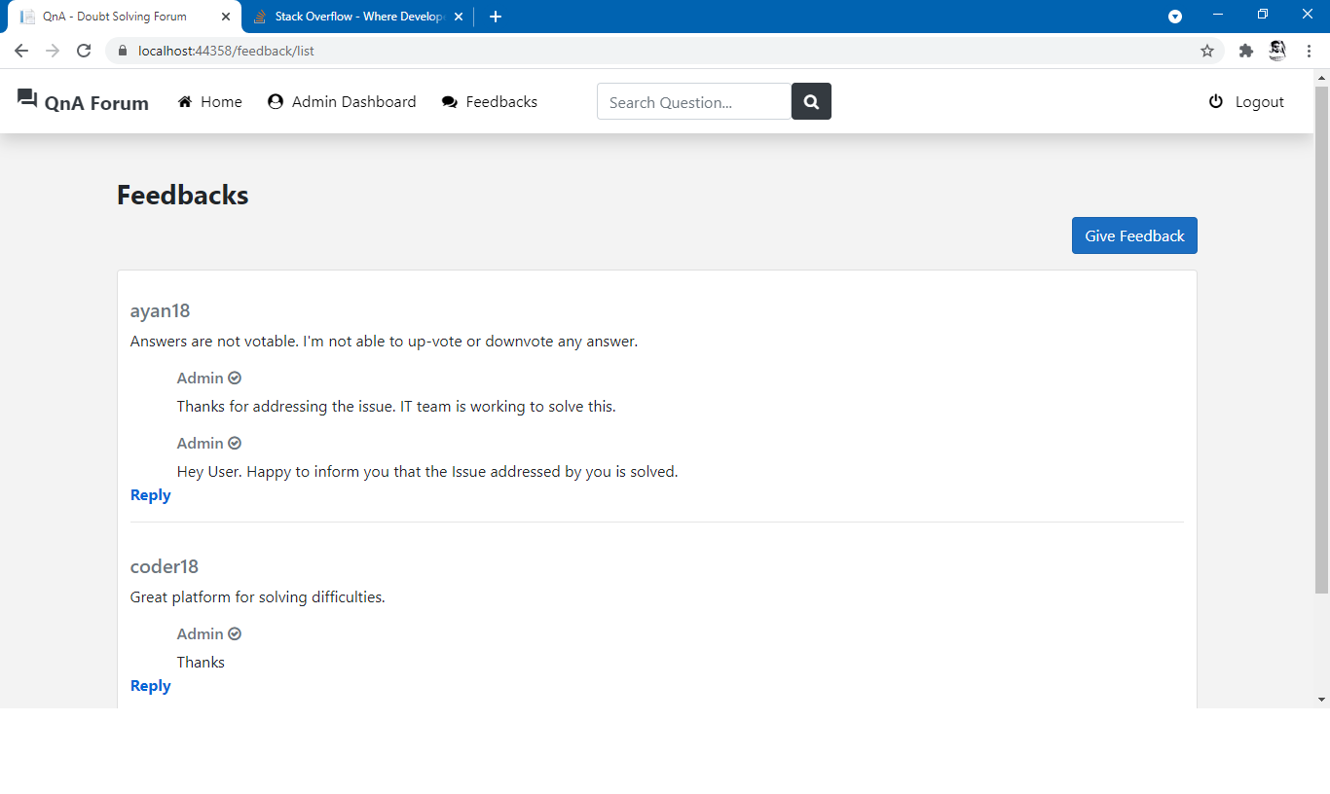

1. **Forgot Password**

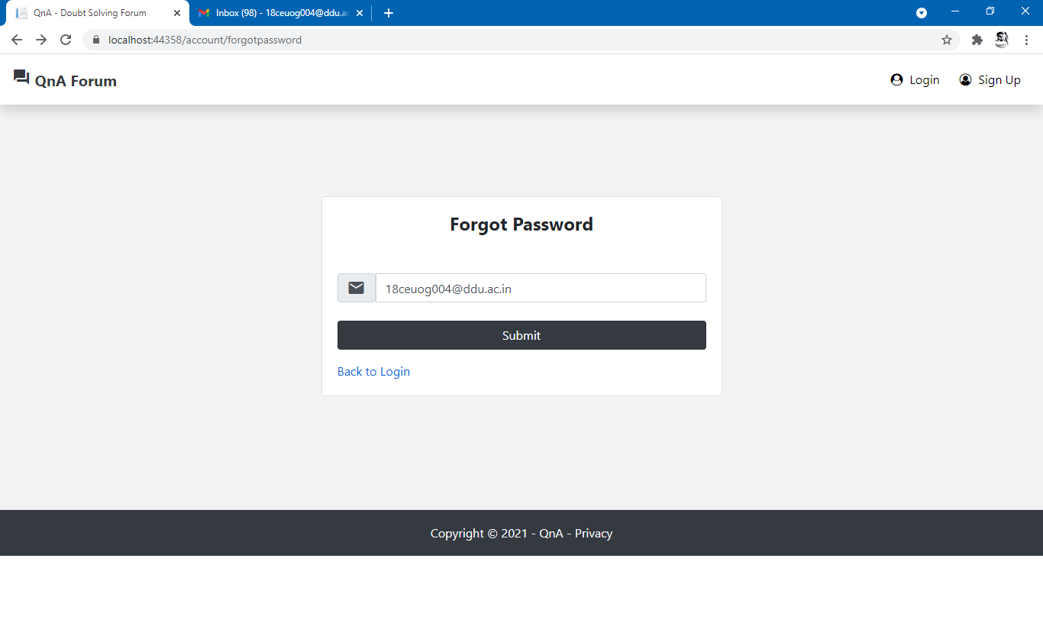

1. **Password reset Link Received via mail**

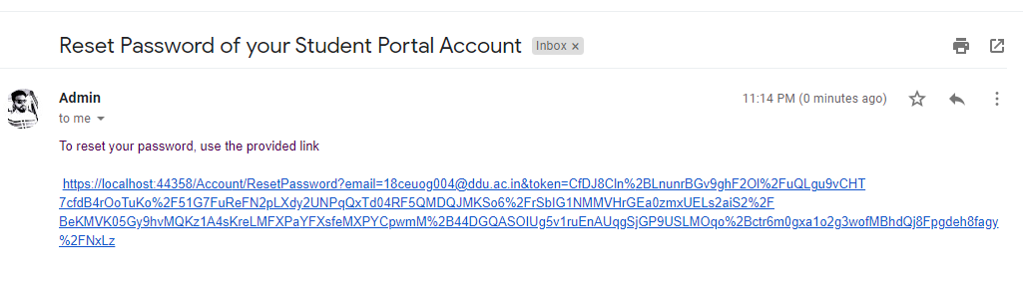

# **Conclusion**

**Functionalities implemented successfully :-**

* Login by user
* Registration by user
* Post Question
* View Questions asked by other users
* Edit users’ own Questions
* Delete users’ own Question
* View Answers of questions
* Up-vote/Down-vote answer
* Edit users’ own Answers
* Delete users’ own Answers.
* Give Feedback
* Reply to feedback by Admin
* View Statistical data by Admin
* Logout from the system

# 

# **Limitation and Future Extensions**

## **Limitations**

* Questions can’t be searched using categories.
* Reply on feedback can only be given by Admin.

## **Functionalities not implemented**

* Block the user by Admin.

## **Possible future extensions**

* Provide the option of attaching categories or labels with questions so that other users can easily search the answers of similar questions by providing the category names.

# 

# **Bibliography**

To build this project we have taken references from following websites,

* Framework used for development :-

[**https://docs.microsoft.com/en-us/dotnet/fundamentals/**](https://docs.microsoft.com/en-us/dotnet/fundamentals/)

* CSS framework for frontend designing :-

[**https://getbootstrap.com/**](https://getbootstrap.com/)

* For markdown editor :-

[**https://github.com/sparksuite/simplemde-markdown-editor**](https://github.com/sparksuite/simplemde-markdown-editor)