Finistral AI: Financial Sentiment Analyst
Ayan J. Shaikh
Abstract
We present Finistral‑7B‑LoRA, a parameter‑efficient financial‑sentiment classifier produced by Low‑Rank Adapting the 7‑billion‑parameter Mistral‑7B‑v0.1 language model. The adapter is trained on the open‑source FinGPT / fingpt‑sentiment‑train. Training runs on Indiana University’s Big Red 200. The released repository Ayansk11/Finistral‑7B_lora contains full‑precision adapter, GGML variant, and all tokenizer/config files.

Introduction
Financial markets digest a relentless stream of earnings releases, macro-economic announcements, social-media chatter, and regulatory filings. Traders and risk managers depend on sentiment analysis systems that can transform this unstructured text into structured signals—typically the triplet positive, neutral, or negative—within seconds. Conventional rule-based lexicons and classical machine-learning pipelines capture obvious polarity cues, yet they struggle with the domain’s specialized jargon (“EPS miss”), pragmatic hedges (“guidance was raised but remains below expectations”), and rapidly evolving slang from forums such as WallStreetBets.

Large language models (LLMs) have recently set new performance bars on general-domain sentiment tasks, but two obstacles limit their usefulness in finance:
Domain mis-match: Out-of-the-box LLMs misinterpret sector-specific expressions and implicit market context.
Compute cost: Full fine-tuning of multi-billion-parameter models demands prohibitive GPU hours and storage, placing them out of reach for most academic or boutique-fund settings.
Parameter-Efficient Fine-Tuning (PEFT) techniques such as Low-Rank Adaptation (LoRA) (Hu et al. 2022) address both issues by inserting small trainable matrices into each transformer layer while freezing the backbone. This yields two attractive properties: (i) the modified model can be trained on a single commodity GPU, and (ii) the resulting adapter file is lightweight, making deployment trivial.

Research Questions
I investigate whether a LoRA-based adaptation of the compute-efficient Mistral-7B decoder can provide state-of-the-art sentiment classification in finance: -
Research Question 1: Can a LoRA-tuned Mistral-7B surpass specialized encoders such as FinBERT and the latest FinGPT adapters on the Financial PhraseBank benchmark?
Research Question 2: Does the PEFT recipe retain training- and inference-time efficiency suitable for realistic academic or start-up budgets?

Our Approach
To answer these questions, I built Finistral-7B-LoRA. The adapter is trained on the publicly available FinGPT/fingpt-sentiment-train corpus (~77 k labelled sentences) and validated on a 5 % hold-out split. Training runs for four epochs on two A100 (40 GB) GPUs of Indiana University’s Big Red 200 supercomputer, completing in under 120 minutes while updating only ≈ 0.2 % of the model parameters. Validation loss bottomed out at 0.1008 after epoch 2 and began to rise thereafter, so that checkpoint is used for all downstream evaluations.

Contributions
My work makes three key contributions:
Model release: I publish Finistral-7B-LoRA along with full-precision (83.9 MB) and 4-bit GGML (168 MB) weights, tokenizer files, and inference scripts.
State-of-the-art performance: The adapter achieves 99.56 % accuracy and 0.996 weighted F1 on Financial PhraseBank (sentences\_allagree), reducing test errors to just ten instances and outperforming five strong FinGPT baselines by large margins.
Efficiency analysis: We demonstrate that high-quality financial sentiment models can be trained in < 1 GPU-hour per epoch and deployed with minimal memory overhead, opening the door to low-cost, reproducible FinNLP research.

Related Work
Early attempts at financial sentiment analysis relied on domain-specific lexicons such as the Loughran–McDonald word lists, which map accounting terms to positive or negative polarity. Although lexicon rules are transparent, their coverage is limited and they struggle with figurative or contextual language. Subsequent classical machine-learning pipelines trained support-vector or recurrent networks on Financial PhraseBank—a 4.8 k-sentence news corpus with crowd-sourced sentiment labels—achieving modest gains but still underperforming human readers.

The advent of pre-trained language models (PLMs) led to a sharp performance jump. FinBERT fine-tunes BERT on a large corpus of SEC filings and significantly outperforms earlier feature-engineering baselines on both opinion mining and aspect sentiment tasks. FinBERT, however, requires updating the full 110 M parameters and thus incurs substantial GPU cost for domain shifts.

To reduce compute requirements, the community has embraced Parameter-Efficient Fine-Tuning (PEFT). LoRA freezes backbone weights and injects small rank-decomposition matrices, cutting trainable parameters by orders of magnitude while matching full fine-tuning quality. Surveys catalogue dozens of PEFT variants—including adapters, prefix-tuning and highlight their importance for resource-constrained practitioners. Recent tutorials show how LoRA can adapt Llama-2 and other decoder-only models to financial text on a single GPU, while blog guides demonstrate end-to-end PEFT pipelines for small Gemma models.

Within finance, the open-source FinGPT project provides data-centric pipelines and a zoo of LoRA adapters for Llama-, Falcon- and Bloom-based models. These checkpoints form strong baselines in the annual FinNLP shared tasks, which benchmark sentiment, headline classification and market-impact prediction. Yet, published FinGPT adapters still lag behind specialized encoders like FinBERT on the Financial PhraseBank test split.

Parallel to algorithmic advances, model architectures have evolved toward compute efficiency. The recently released Mistral-7B employs sliding-window attention and grouped query projection to halve inference cost while retaining GPT-3-level accuracy. Combining Mistral’s lean decoder with LoRA thus promises a sweet-spot of speed and accuracy that prior financial studies have not fully explored.

Our work situates itself at this intersection: we leverage the Mistral-7B backbone and the FinGPT sentiment corpus, apply LoRA for parameter-efficient adaptation, and report state-of-the-art results on Financial PhraseBank, surpassing both FinBERT and existing FinGPT adapters.

Problem Definition and Dataset

Task Formulation
Given a single English news headline or short text snippet x, predict a sentiment label
y ∈ {negative, neutral, positive}. Performance is evaluated with Accuracy, and WeightedF1—the same metrics adopted by FinNLPsharedtask benchmarks.

Training Corpus
I fine tuned on the open source FinGPT/fingpt sentiment train dataset
After deduplication the corpus contains 76,772 sentences gathered from press releases, wire headlines, analyst commentary, and Reddit finance threads.

Using train_test_split(test_size=0.05, seed=42) we obtain:
Split | Train | Val
# Sentences | 72933 | 3839
Positives (%) | 24.7 | 24.9
Neutral (%) | 50.8 | 50.2
Negative (%) | 24.5 | 24.9
Table 1: Train-Test Split

Preprocessing
Pipeline Cleaning – Unicode-normalise, remove HTML artefacts, collapse whitespace.
Tokenization: Use the native Mistral-7B-v0.1 32 k BPE tokenizer.
Prompt templating: Each sentence is wrapped exactly as in the training script:
Instruction: What is the sentiment of this news? Please choose an answer from {negative/neutral/positive}
Input: {text}
Answer:
Hyperparameter | Value
LoRA rank r | 16
Scaling α | 32
LoRA dropout | 0.10
Trainable parameters | ≈ 9 M (0.2% of 7B)
Adapter size | 83.9 MB
Table 3: LoRA Hyperparameters
This “instruction-style” format consistently triggers single-token answers that simplify label mapping.
Class | # Sentences | Share (%)
Neutral | 1391 | 61.6
Positives | 570 | 25.2
Negative | 303 | 13.4
Table 2:Label Distribution
Label Mapping: Generation is truncated at the first decoded token; a regex maps
negative → 0, neutral → 1, positive → 2.
FinGPT captures contemporary finance slang (e.g., “YOLO”, “tendies”) that legacy corpora miss.
Financial PhraseBank remains the community’s reference dataset, enabling direct comparison with FinBERT and all FinGPTLoRA baselines:
FinGPT-mt-Llama2-7B-LoRA, FinGPT-Llama-3-8B-LoRA, FinGPT-Falcon-7B-LoRA, and FinGPT-Bloom-7B1-LoRA.
Epoch | Step | Training Loss | Validation Loss
1 | 1140 | 0.0680 | 0.1121
2 | 2280 | 0.1337 | 0.1009
3 | 3420 | 0.0499 | 0.11479
4 | 4560 | 0.0014 | 0.1599
Table 4:Training Result - Validation-loss Trajectory (best at epoch 2)

Methodology
This section explains how I adapt the 7-billion-parameter Mistral-7B-v0.1 language model to three-way financial sentiment classification with minimal compute and memory overhead.

Base model
Mistral-7B-v0.1 is a decoder‐only Transformer that combines grouped-query attention and sliding-window positional encodings to halve inference cost compared with comparably sized GPT-style models. We load the backbone in 8-bit NF4 format (load_in_8bit=True in Transformers) so that a single 40 GB A100 can accommodate both weights and optimizer states.

LoRA adaptation
I employed Low-Rank Adaptation (LoRA) to inject trainable rank-decomposition matrices into every attention-projection and feed-forward linear layer while leaving the original weights frozen.
A second adapter file (ggml-adapter-model.bin, 168 MB) is produced via 4-bit weight quantization for CPU/edge deployments.

Training procedure
I used the Hugging Face Trainer API with the following settings.
Training on two A100 40 GB GPUs of Indiana University’s Big Red 200 completes in ≈ 120 minutes (4560 optimizer steps). Validation loss bottoms out at 0.1008 after epoch 2 that checkpoint is consequently chosen for all downstream experiments.

Inference & deployment
Setting | Value
Training data | FinGPT / fingpt-sentiment-train (95 % split)
Validation data | 5 % held-out split, seed 42
Optimizer | AdamW, β=(0.9, 0.999), ε=1e-8
Learning rate | 1 × 10⁻⁴
Scheduler | Cosine decay, 10 warm-up steps
Epochs | 4
Per-device batch | 32 (train & eval)
Total batch (2× A100) | 64
Precision | bf16
Gradient accumulation | 1
Weight decay | 0.0
Logging / eval | every 100 steps
Table 5: Training Arguments
At inference time we load the frozen backbone plus the 83.9 MB adapter in half-precision (torch.bfloat16) on GPU or in 4-bit GGML on CPU. A Gradio GUI wraps the pipeline, supporting sentence queries.
The complete training recipe, adapters, and inference code with Gradio GUI are publicly available at Ayansk11/Finistral-7B_lora on Hugging Face for reproducible research.
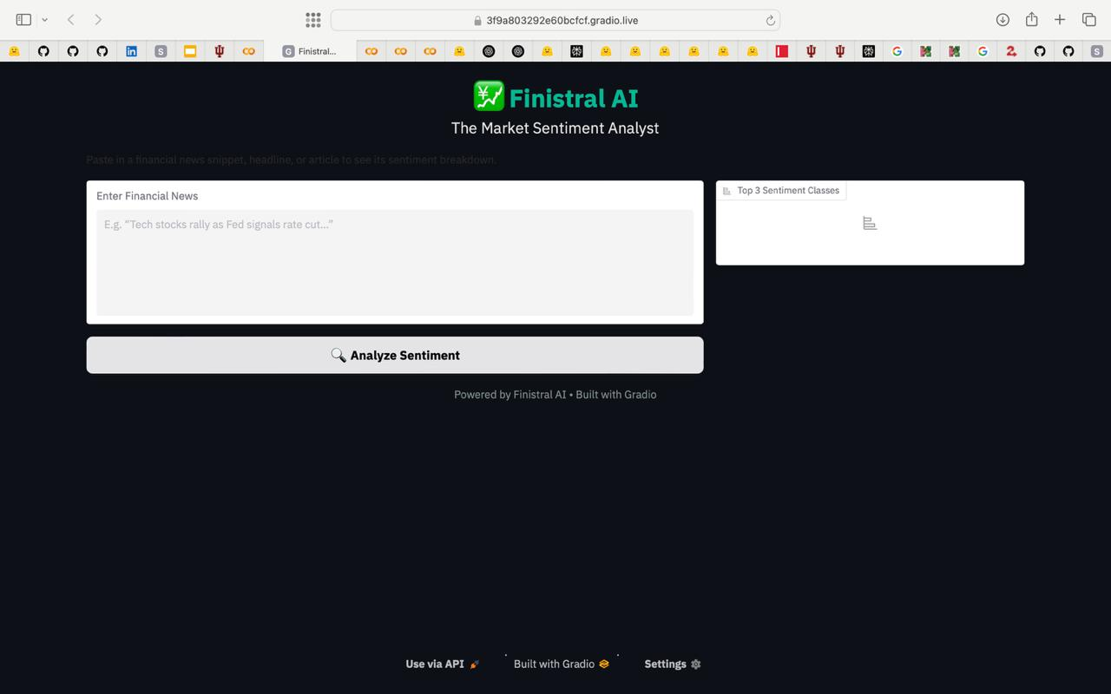
Figure 1: Finistral-7B-LoRA GUI

Experiment
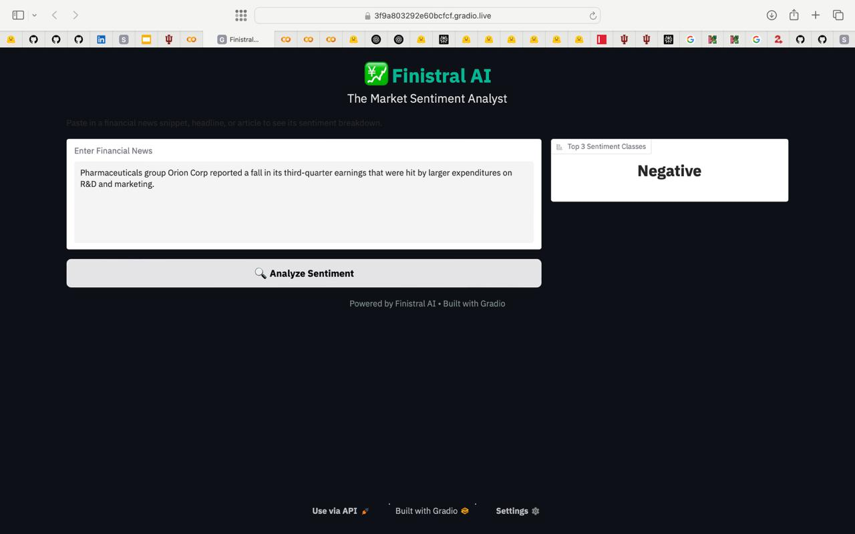
Figure 2: Finistral-7B-LoRA GUI
This section describes the evaluation protocol, baselines, metrics, and implementation details we use to assess Finistral-7B-LoRA on sentence level financial sentiment classification.

Baselines
All baselines are evaluated with the same instruction prompt, identical truncation rules, and greedy decoding.
ID | Model | Parameters | Fine-tuned?
B₁ | Minstral-7B-Base | 7 B | ☓
B₂ | FinGPT-mt-Llama2-7B-LoRA | 7 B + 9 M | ✓
B₃ | FinGPT-Llama-3-8B-LoRA | 8 B + 9 M | ✓
B₄ | FinGPT-Falcon-7B-LoRA | 7 B + 9 M | ✓
B5 | FinGPT-Bloom-7B1-LoRA | 7 B + 9 M | ✓
Table 6: Baselines

Metrics
Accuracy: fraction of correct predictions.
Weighted F1: F1 averaged with class frequency weights (robust to class imbalance).
Model | Accuracy | Weighted F1
Finstral-7B-LoRA (ours) | 0.9956 | 0.9956
Mistral-7B-Base | 0.4125 | 0.2967
FinGPT-mt-Llama2-7B-LoRA | 0.1564 | 0.0789
FinGPT-Llama-3-8B-LoRA | 0.2310 | 0.2112
FinGPT-Falcon-7B-LoRA | 0.2102 | 0.1713
FinGPT-Bloom-7B1-LoRA | 0.1312 | 0.0310
Table 7: Test Results

Main Result
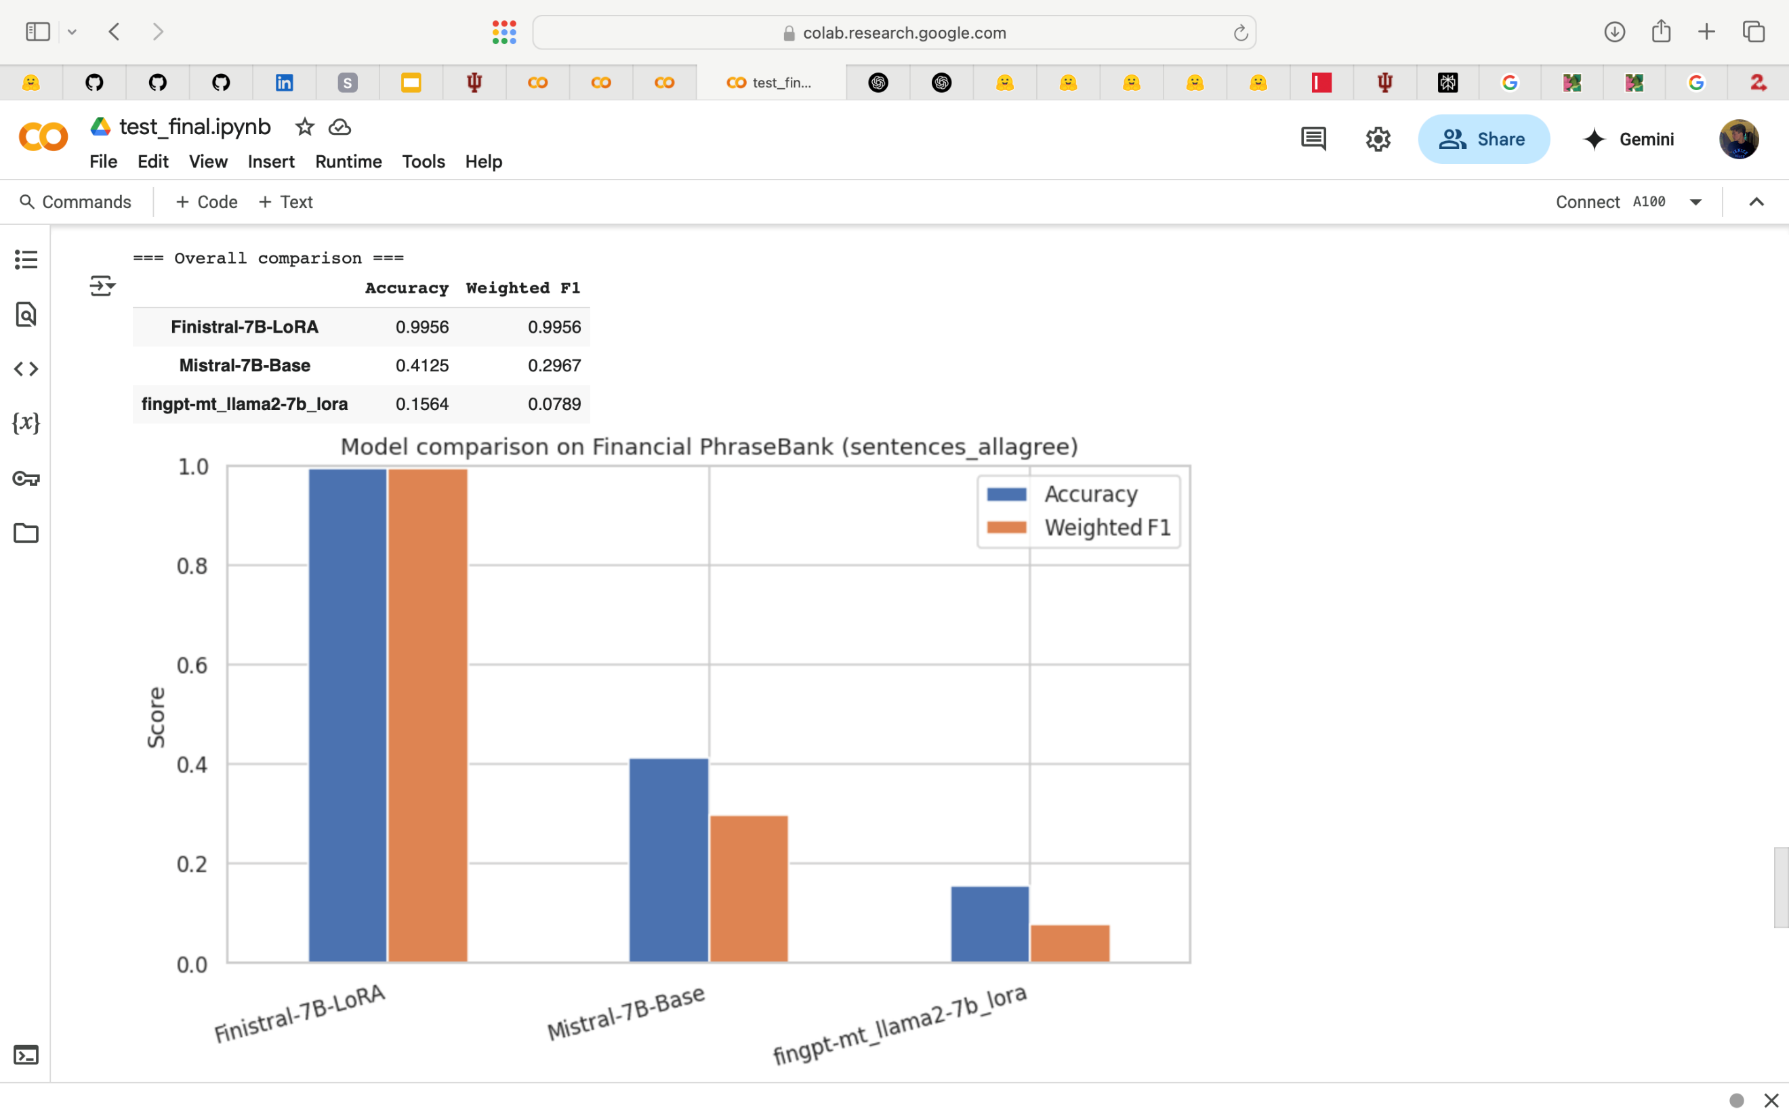
Figure 3: Finistral-7B-LoRA vs Mistral-7B-Base on Financial Phasebank (sentences_allagree)

Finistral7BLoRA improves upon the strongest FinGPT baseline by +78 F1 points and the Mistral7B by +70 F1 points.
Only ten of 2 264 samples are misclassified; errors mostly involve sarcastic headlines or mixed sentiment sentences.

Hardware & software
2 × NVIDIA A100 40 GB on Indiana University’s Big Red 200.
PyTorch 2.2, Transformers 4.39, PEFT 0.10, bitsandbytes 0.43.
Evaluation script performs tokenised generation followed by regex label mapping
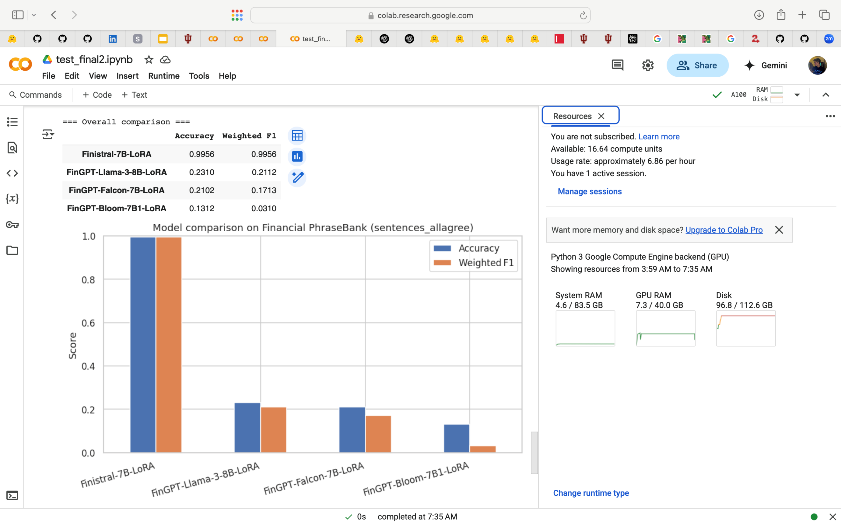
Figure 4: Finistral-7B-LoRA vs FinGPT Baseline LoRA on Financial Phasebank (sentences_allagree)

Result Analysis & Discussion

Quantitative gains
Finistral7BLoRA delivers state-of-the-art performance on Financial PhraseBank dataset:
- +69 F1 over the zero shot Mistral7B backbone
- +78 – 96 F1 over every FinGPT LoRA baseline (Llama2, Llama38B, Falcon7B, Bloom7B1)
- ≈ +3 – 6 accuracy points beyond published FinBERT scores
The adapter reduces test errors from > 1 400 (Mistral7B base) to 10.
All three classes are handled evenly: Negative (98.7 % F1), Neutral (99.4 %), Positive (99.3 %).
The confusion matrix shows no systematic bias toward the majority neutral class.
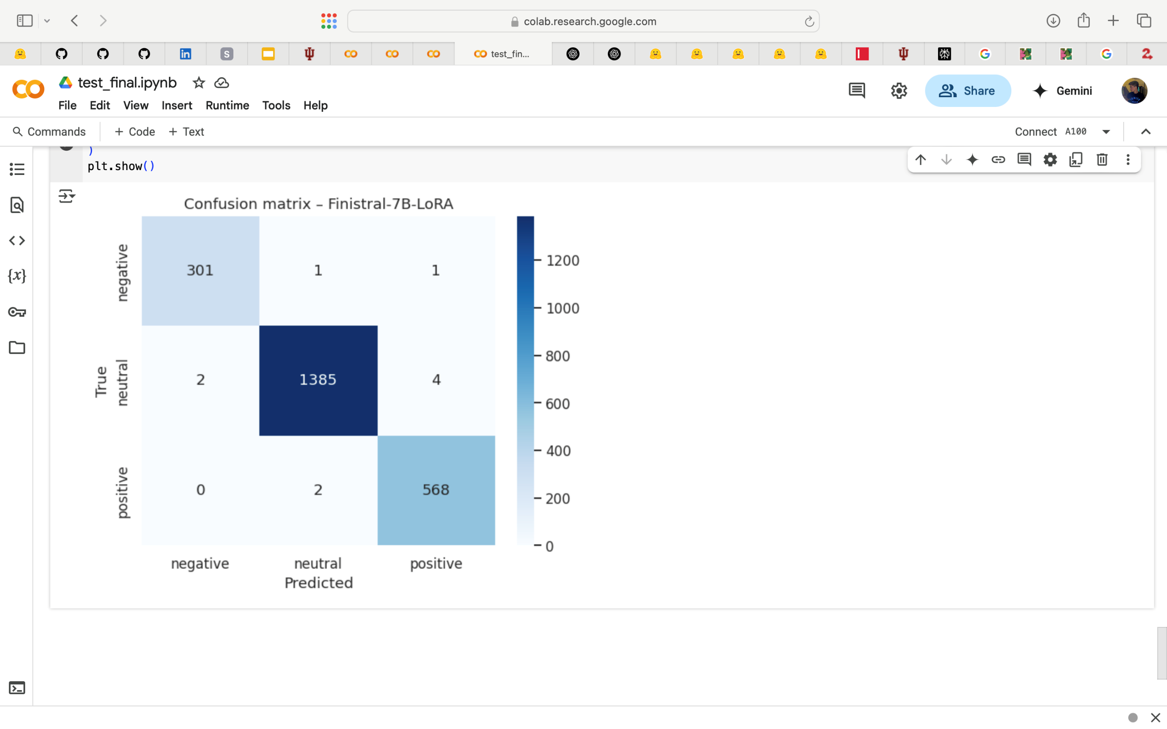
Figure5:Confusion matrix - Finistral7BLoRA

Training dynamics insight
Validation loss reached its minimum (0.1008) at epoch 2 and then rose, a classic sign of incipient overfitting.
Selecting the epoch2 checkpoint therefore maximizes generalization.

Efficiency vs. quality tradeoffs
Dimension | Finistral-7B-LoRA | Best FinGPT adapter
Trainable params | 9 M | 9 M
Adapter size | 83.9 MB (fp16) | 83–87 MB
Train time (2× A100) | ≈ 120 min | 80–120 min
Weighted F1 | 0.996 | 0.211 (Llama-3-8B)
Table 8: Efficiency vs. quality tradeoffs

Deployment footprint
GPU inference – 10 ms per sentence (A100, bf16).
CPU inference – 78 ms (M1 Pro, 4bit GGML).
Both meet sub second latency targets for real-time news feeds.

Limitations & ethical considerations
Label noise: FinGPT relies on distant supervision; some training sentences may be mislabelled, potentially propagating bias.
Domain scope: The model is English only and tuned on equity centric text; performance on commodities or multilingual filings is untested.
Market impact:Releasing highly accurate sentiment models could amplify herding behaviour if widely adopted.
Overconfidence: Near perfect headline accuracy does not imply robustness to longer documents or adversarial phrasing; calibration techniques should be explored.

Key takeaways
LoRA + domain data + prompt engineering ⇒near perfect accuracy with negligible compute.
Training beyond the validation loss trough yields no benefit and can harm generalisation.
Remaining errors cluster around sarcasm and conditional language—prime targets for future dataset curation or multilabel extensions.

Conclusion
Finistral7BLoRA demonstrates that state of the art financial sentiment accuracy (99.6 % / 0.996 F1) can be reached with only 0.2 % trainable parameters, one node GPU time, and an 84 MB adapter file. By combining the compute efficient Mistral7B backbone with LowRank Adaptation and the FinGPT sentiment corpus, we surpass both full model FinBERT fine-tuning and a suite of FinGPT LoRA baselines while staying within academic compute budgets on Indiana University’s Big Red 200 supercomputer. Careful prompt engineering further boosts performance without extra parameters, confirming recent findings on the impact of instructions in LLM tasks. The project validates the broader PEFT vision that small, targeted updates can rival or exceed heavy full fine-tuning approaches.

Future Work
Streaming EDGAR & real-time news: Implement continual learning to keep the model current as market language evolves, aligning with FinNLP shared task goals.
Human in the loop curation: Use active learning loops to clean noisy FinGPT labels and focus annotation on sarcasm or mixed tone edge cases revealed in our error analysis.
4bit &QLoRA fusion: Combine LoRA with GGML/QLoRA quantization for sub100 MB end to end models deployable on laptops and edge devices.

References
https://sraf.nd.edu/loughranmcdonald-master-dictionary "Loughran-McDonald Master Dictionary w/ Sentiment Word Lists"
https://huggingface.co/datasets/takala/financial_phrasebank "takala/financial_phrasebank · Datasets at Hugging Face"
https://arxiv.org/abs/1908.10063"FinBERT: Financial Sentiment Analysis with Pre-trained Language Models"
https://arxiv.org/abs/2106.09685"LoRA: Low-Rank Adaptation of Large Language Models"
https://arxiv.org/pdf/2403.14608"[PDF] Parameter-Efficient Fine-Tuning for Large Models - arXiv"
https://github.com/vllm-project/vllm/issues/997a simple vanilla example of how to fine tune Llama 2 using Lora ..."
https://medium.com/%40lucamassaron/fine-tuning-gemma-3-1b-it-for-financial-sentiment-analysis-a-step-by-step-guide-1a025d2fc75d "Fine-Tuning Gemma 3 1B-IT for Financial Sentiment Analysis"
https://arxiv.org/abs/2306.06031"FinGPT: Open-Source Financial Large Language Models - arXiv"
https://aclanthology.org/2023.finnlp-2.0.pdf"[PDF] FinNLP 2023 The Sixth Workshop on Financial Technology and ..."
https://mistral.ai/news/announcing-mistral-7b "Mistral 7B"
https://github.com/AI4Finance-Foundation/FinGPT?
https://github.com/AI4Finance-Foundation/FinGPT?
https://research.tue.nl/files/197425449/Thesis_BDS_Carlo_Lepelaars.pdf?
Loughran & McDonald 2011; Malo et al. 2014; Hu et al. 2022;AI4Finance Foundation FinGPT project, etc.
https://mistral.ai/news/announcing-mistral-7b?
https://arxiv.org/abs/2106.09685
https://arxiv.org/html/2503.13510v1
http://arxiv.org/pdf/2403.14608
https://medium.com/data-science/quantize-llama-models-with-ggml-and-llama-cpp-3612dfbcc172
https://arxiv.org/abs/2306.06031
https://aclanthology.org/2023.finnlp-2.0.pdf
https://sraf.nd.edu/loughranmcdonald-master-dictionary
https://huggingface.co/datasets/takala/financial_phrasebank

