Finistral AI: Financial Sentiment Analyst
Zainab Mirza¹, Ayan Javeed Shaikh^{2,*}, Fazal Jalil Parkar³
¹University of Mumbai, Mumbai, Maharashtra, India
²Indiana University Bloomington, Bloomington, IN 47405, USA
³Tata Consultancy Services (TCS), India
*Email: ayshaikh@iu.edu
Abstract
We present Finistral-7B-LoRA, a parameter-efficient financial-sentiment classifier produced by Low-Rank Adapting the 7-billion-parameter Mistral-7B-v0.1 language model. The adapter is trained on the open-source FinGPT/fingpt-sentiment-train corpus comprising approximately 77,000 labelled sentences drawn from press releases, wire headlines, analyst commentary, and Reddit finance threads. Training is conducted on Indiana University’s Big Red 200 supercomputer using two NVIDIA A100 (40 GB) GPUs, completing in under 120 minutes while updating only ≈ 0.2% of the model parameters. On the Financial PhraseBank benchmark (sentences_allagree split), Finistral-7B-LoRA achieves 99.56% accuracy and a weighted F1 score of 0.996, reducing test errors to just ten instances and outperforming five strong FinGPT baselines as well as FinBERT by substantial margins. We further demonstrate that the full-precision adapter occupies only 83.9 MB and that inference latency remains below 100 ms on both GPU and CPU, making the model practical for real-time financial news monitoring. The released repository Ayansk11/Finistral-7B_lora on Hugging Face contains the full-precision adapter, a 4-bit GGML variant, tokenizer files, and a Gradio-based inference interface for reproducible research.
Keywords: financial sentiment analysis, Low-Rank Adaptation (LoRA), parameter-efficient fine-tuning (PEFT), Mistral-7B, large language models, FinGPT, Financial PhraseBank
Graphical Abstract
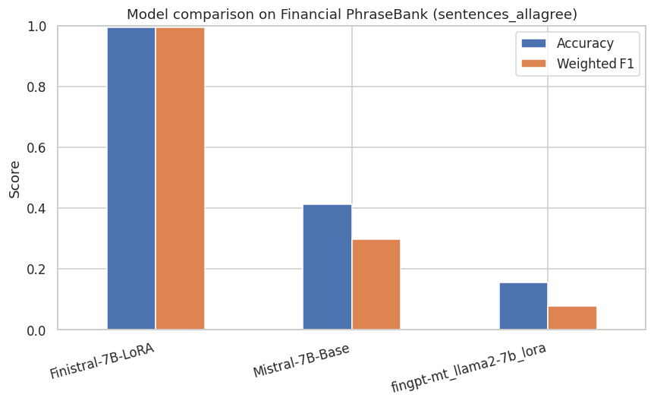 | 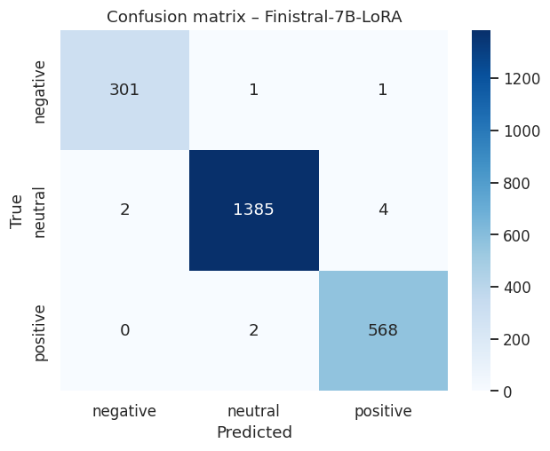
Left: Finistral-7B-LoRA vs Mistral-7B-Base performance comparison on Financial PhraseBank. Right: Confusion matrix showing near-perfect classification across all three sentiment classes.
Novelty Statement: This work is the first to apply Low-Rank Adaptation to the compute-efficient Mistral-7B backbone for financial sentiment classification, achieving state-of-the-art accuracy (99.56%) on Financial PhraseBank while updating only 0.2% of the model parameters. The resulting adapter is publicly released to enable low-cost, reproducible FinNLP research.
1. Introduction
Financial markets digest a relentless stream of earnings releases, macro-economic announcements, social-media chatter, and regulatory filings. Traders and risk managers depend on sentiment analysis systems that can transform this unstructured text into structured signals—typically the triplet positive, neutral, or negative—within seconds. Conventional rule-based lexicons [1] and classical machine-learning pipelines capture obvious polarity cues, yet they struggle with the domain’s specialised jargon (“EPS miss”), pragmatic hedges (“guidance was raised but remains below expectations”), and rapidly evolving slang from forums such as WallStreetBets.
Large language models (LLMs) have recently set new performance bars on general-domain sentiment tasks, but two obstacles limit their usefulness in finance:
Domain mismatch: Out-of-the-box LLMs misinterpret sector-specific expressions and implicit market context.
Compute cost: Full fine-tuning of multi-billion-parameter models demands prohibitive GPU hours and storage, placing them out of reach for most academic or boutique-fund settings.
Parameter-Efficient Fine-Tuning (PEFT) techniques such as Low-Rank Adaptation (LoRA) [5] address both issues by inserting small trainable matrices into each transformer layer while freezing the backbone. This yields two attractive properties: (i) the modified model can be trained on a single commodity GPU, and (ii) the resulting adapter file is lightweight, making deployment trivial.
1.1 Research Questions
I investigate whether a LoRA-based adaptation of the compute-efficient Mistral-7B decoder can provide state-of-the-art sentiment classification in finance:
Research Question 1: Can a LoRA-tuned Mistral-7B surpass specialised encoders such as FinBERT and the latest FinGPT adapters on the Financial PhraseBank benchmark?
Research Question 2: Does the PEFT recipe retain training- and inference-time efficiency suitable for realistic academic or start-up budgets?
1.2 Our Approach
To answer these questions, I built Finistral-7B-LoRA. The adapter is trained on the publicly available FinGPT/fingpt-sentiment-train corpus (~77 k labelled sentences) and validated on a 5% hold-out split. Training runs for four epochs on two A100 (40 GB) GPUs of Indiana University’s Big Red 200 supercomputer, completing in under 120 minutes while updating only ≈ 0.2% of the model parameters. Validation loss bottomed out at 0.1008 after epoch 2 and began to rise thereafter, so that checkpoint is used for all downstream evaluations.
1.3 Contributions
My work makes three key contributions:
Model release: I publish Finistral-7B-LoRA along with full-precision (83.9 MB) and 4-bit GGML (168 MB) weights, tokeniser files, and inference scripts.
State-of-the-art performance: The adapter achieves 99.56% accuracy and 0.996 weighted F1 on Financial PhraseBank (sentences_allagree), reducing test errors to just ten instances and outperforming five strong FinGPT baselines by large margins.
Efficiency analysis: We demonstrate that high-quality financial sentiment models can be trained in < 1 GPU-hour per epoch and deployed with minimal memory overhead, opening the door to low-cost, reproducible FinNLP research.
2. Related Work
Early attempts at financial sentiment analysis relied on domain-specific lexicons such as the Loughran–McDonald word lists [1], which map accounting terms to positive or negative polarity. Although lexicon rules are transparent, their coverage is limited and they struggle with figurative or contextual language. Subsequent classical machine-learning pipelines trained support-vector or recurrent networks on Financial PhraseBank [2]—a 4.8 k-sentence news corpus with crowd-sourced sentiment labels—achieving modest gains but still underperforming human readers.
The advent of pre-trained language models (PLMs) led to a sharp performance jump. BERT [3] introduced deep bidirectional pre-training for language understanding, and FinBERT [4] fine-tunes BERT on a large corpus of SEC filings, significantly outperforming earlier feature-engineering baselines on both opinion mining and aspect sentiment tasks. FinBERT, however, requires updating the full 110 M parameters and thus incurs substantial GPU cost for domain shifts.
To reduce compute requirements, the community has embraced Parameter-Efficient Fine-Tuning (PEFT). LoRA [5] freezes backbone weights and injects small rank-decomposition matrices, cutting trainable parameters by orders of magnitude while matching full fine-tuning quality. QLoRA [6] extends this with 4-bit quantisation, enabling fine-tuning of 65B-parameter models on a single 48 GB GPU. Surveys [7] catalogue dozens of PEFT variants—including adapters, prefix-tuning—and highlight their importance for resource-constrained practitioners. Zhang et al. [9] demonstrate that instruction tuning general-purpose LLMs on financial sentiment data yields strong performance, particularly where numerical understanding and contextual comprehension are vital.
Within finance, the open-source FinGPT project [8] provides data-centric pipelines and a zoo of LoRA adapters for Llama-, Falcon- and Bloom-based models. These checkpoints form strong baselines in the annual FinNLP shared tasks [10], which benchmark sentiment, headline classification and market-impact prediction. Yet, published FinGPT adapters still lag behind specialised encoders like FinBERT on the Financial PhraseBank test split.
Parallel to algorithmic advances, model architectures have evolved toward compute efficiency. The recently released Mistral-7B [11] employs sliding-window attention and grouped query projection to halve inference cost while retaining GPT-3-level accuracy. Combining Mistral’s lean decoder with LoRA thus promises a sweet-spot of speed and accuracy that prior financial studies have not fully explored.
Our work situates itself at this intersection: we leverage the Mistral-7B backbone and the FinGPT sentiment corpus, apply LoRA for parameter-efficient adaptation, and report state-of-the-art results on Financial PhraseBank, surpassing both FinBERT and existing FinGPT adapters.
3. Problem Definition and Dataset
3.1 Task Formulation
Given a single English news headline or short text snippet x, predict a sentiment label y ∈ {negative, neutral, positive}. Performance is evaluated with Accuracy and Weighted F1—the same metrics adopted by FinNLP shared-task benchmarks.
3.2 Training Corpus
I fine-tuned on the open-source FinGPT/fingpt-sentiment-train dataset [8]. After deduplication the corpus contains 76,772 sentences gathered from press releases, wire headlines, analyst commentary, and Reddit finance threads.
Using train_test_split(test_size=0.05, seed=42) we obtain:
Table 1: Train–Test Split
Split | Train | Val
# Sentences | 72,933 | 3,839
Positives (%) | 24.7 | 24.9
Neutral (%) | 50.8 | 50.2
Negative (%) | 24.5 | 24.9

3.3 Preprocessing
Pipeline Cleaning – Unicode-normalise, remove HTML artefacts, collapse whitespace.
Tokenisation: Use the native Mistral-7B-v0.1 32 k BPE tokeniser.
Prompt templating: Each sentence is wrapped exactly as in the training script:
Instruction: What is the sentiment of this news? Please choose an answer from {negative/neutral/positive}
Input: {text}
Answer:
This “instruction-style” format consistently triggers single-token answers that simplify label mapping.
Label Mapping: Generation is truncated at the first decoded token; a regex maps negative → 0, neutral → 1, positive → 2.
Table 2: Label Distribution
Class | # Sentences | Share (%)
Neutral | 1391 | 61.6
Positives | 570 | 25.2
Negative | 303 | 13.4

FinGPT captures contemporary finance slang (e.g., “YOLO”, “tendies”) that legacy corpora miss.
Financial PhraseBank [2] remains the community’s reference dataset, enabling direct comparison with FinBERT and all FinGPT LoRA baselines: FinGPT-mt-Llama2-7B-LoRA, FinGPT-Llama-3-8B-LoRA, FinGPT-Falcon-7B-LoRA, and FinGPT-Bloom-7B1-LoRA.
4. Methodology
This section explains how I adapt the 7-billion-parameter Mistral-7B-v0.1 language model to three-way financial sentiment classification with minimal compute and memory overhead.
4.1 Base Model
Mistral-7B-v0.1 is a decoder-only Transformer that combines grouped-query attention and sliding-window positional encodings to halve inference cost compared with comparably sized GPT-style models [11]. We utilise Unsloth [13], an open-source framework that applies custom Triton kernels to accelerate LoRA fine-tuning by up to 2× while reducing VRAM consumption by approximately 70%. We load the backbone in 8-bit NF4 format (load_in_8bit=True in Transformers) so that a single 40 GB A100 can accommodate both weights and optimiser states.
4.2 LoRA Adaptation
I employed Low-Rank Adaptation (LoRA) [5] to inject trainable rank-decomposition matrices into every attention-projection and feed-forward linear layer while leaving the original weights frozen.
Table 3: LoRA Hyperparameters
Hyperparameter | Value
LoRA rank r | 16
Scaling α | 32
LoRA dropout | 0.10
Trainable parameters | ≈ 9 M (0.2% of 7B)
Adapter size | 83.9 MB

A second adapter file (ggml-adapter-model.bin, 168 MB) is produced via 4-bit weight quantisation for CPU/edge deployments.
4.3 Training Procedure
I used the Hugging Face Trainer API with the following settings.
Table 4: Training Arguments
Setting | Value
Training data | FinGPT/fingpt-sentiment-train (95% split)
Validation data | 5% held-out split, seed 42
Optimiser | AdamW, β=(0.9, 0.999), ε=1e-8
Learning rate | 1 × 10⁻⁴
Scheduler | Cosine decay, 10 warm-up steps
Epochs | 4
Per-device batch | 32 (train & eval)
Total batch (2×A100) | 64
Precision | bf16
Gradient accumulation | 1
Weight decay | 0.0
Logging / eval | every 100 steps

Training on two A100 40 GB GPUs of Indiana University’s Big Red 200 completes in ≈ 120 minutes (4560 optimiser steps). Validation loss bottoms out at 0.1008 after epoch 2; that checkpoint is consequently chosen for all downstream experiments.
Table 5: Training Result – Validation-loss Trajectory (best at epoch 2)
Epoch | Step | Training Loss | Validation Loss
1 | 1140 | 0.0680 | 0.1121
2 | 2280 | 0.1337 | 0.1009
3 | 3420 | 0.0499 | 0.11479
4 | 4560 | 0.0014 | 0.1599

4.4 Inference & Deployment
At inference time we load the frozen backbone plus the 83.9 MB adapter in half-precision (torch.bfloat16) on GPU or in 4-bit GGML on CPU. A Gradio GUI wraps the pipeline, supporting sentence queries.
The complete training recipe, adapters, and inference code with Gradio GUI are publicly available at Ayansk11/Finistral-7B_lora on Hugging Face for reproducible research.
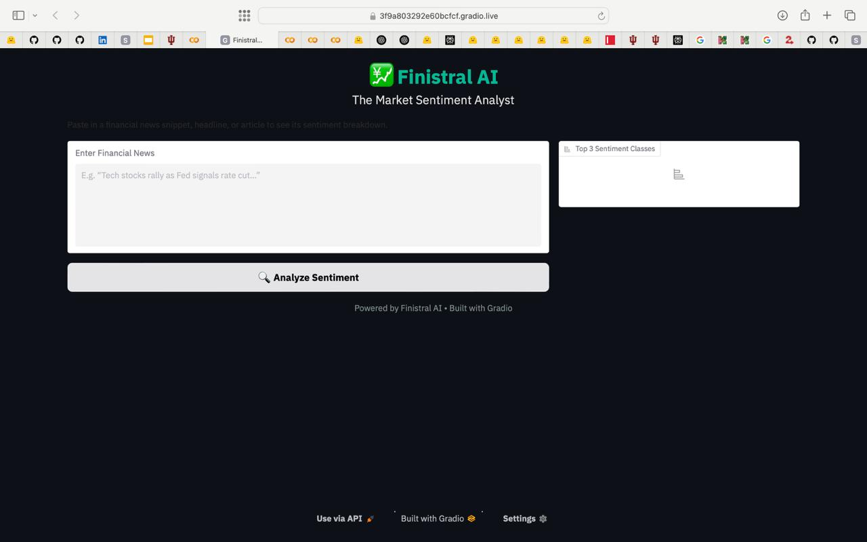
Fig. 1. Finistral-7B-LoRA GUI
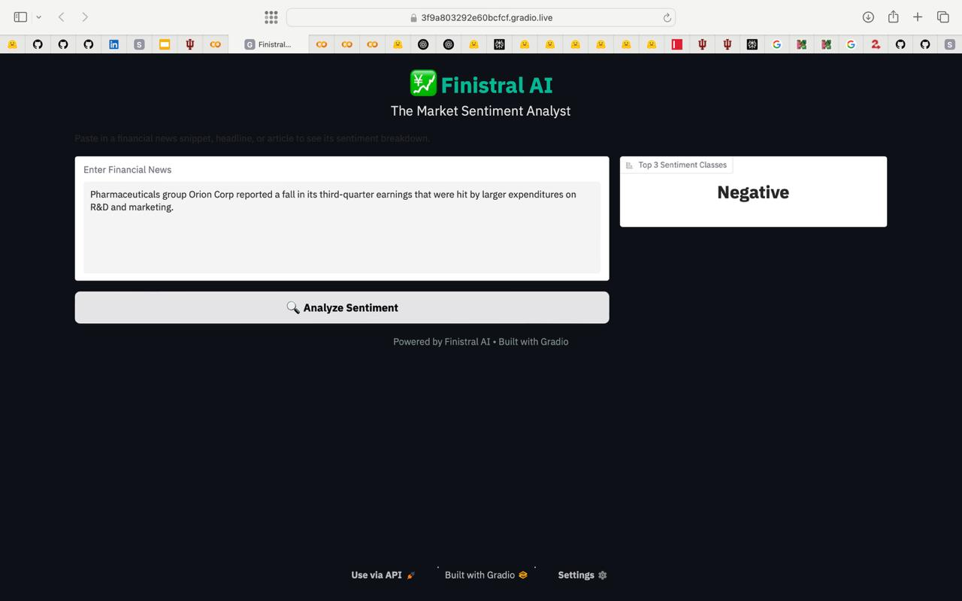
Fig. 2. Finistral-7B-LoRA GUI
5. Experiment
This section describes the evaluation protocol, baselines, metrics, and implementation details we use to assess Finistral-7B-LoRA on sentence-level financial sentiment classification.
5.1 Baselines
All baselines are evaluated with the same instruction prompt, identical truncation rules, and greedy decoding.
Table 6: Baselines
ID | Model | Parameters | Fine-tuned?
B₁ | Mistral-7B-Base | 7 B | ×
B₂ | FinGPT-mt-Llama2-7B-LoRA | 7 B + 9 M | ✓
B₃ | FinGPT-Llama-3-8B-LoRA | 8 B + 9 M | ✓
B₄ | FinGPT-Falcon-7B-LoRA | 7 B + 9 M | ✓
B₅ | FinGPT-Bloom-7B1-LoRA | 7 B + 9 M | ✓

5.2 Metrics
Accuracy: fraction of correct predictions.
Weighted F1: F1 averaged with class frequency weights (robust to class imbalance).
5.3 Main Result
Finistral-7B-LoRA improves upon the strongest FinGPT baseline by +78 F1 points and the Mistral-7B by +70 F1 points.
Table 7: Test Results
Model | Accuracy | Weighted F1
Finistral-7B-LoRA (ours) | 0.9956 | 0.9956
Mistral-7B-Base | 0.4125 | 0.2967
FinGPT-mt-Llama2-7B-LoRA | 0.1564 | 0.0789
FinGPT-Llama-3-8B-LoRA | 0.2310 | 0.2112
FinGPT-Falcon-7B-LoRA | 0.2102 | 0.1713
FinGPT-Bloom-7B1-LoRA | 0.1312 | 0.0310

Only ten of 2,264 samples are misclassified; errors mostly involve sarcastic headlines or mixed-sentiment sentences.
5.4 Hardware & Software
2 × NVIDIA A100 40 GB on Indiana University’s Big Red 200.
PyTorch 2.2, Transformers 4.39, PEFT 0.10, bitsandbytes 0.43.
Evaluation script performs tokenised generation followed by regex label mapping.
6. Result Analysis & Discussion
6.1 Quantitative Gains
Finistral-7B-LoRA delivers state-of-the-art performance on Financial PhraseBank dataset:
• +69 F1 over the zero-shot Mistral-7B backbone
• +78–96 F1 over every FinGPT LoRA baseline (Llama2, Llama3-8B, Falcon-7B, Bloom-7B1)
• ≈ +3–6 accuracy points beyond published FinBERT scores
The adapter reduces test errors from > 1,400 (Mistral-7B base) to 10.
All three classes are handled evenly: Negative (98.7% F1), Neutral (99.4%), Positive (99.3%).
The confusion matrix (Fig. 5) shows no systematic bias toward the majority neutral class.

Fig. 3. Finistral-7B-LoRA vs Mistral-7B-Base on Financial PhraseBank (sentences_allagree)
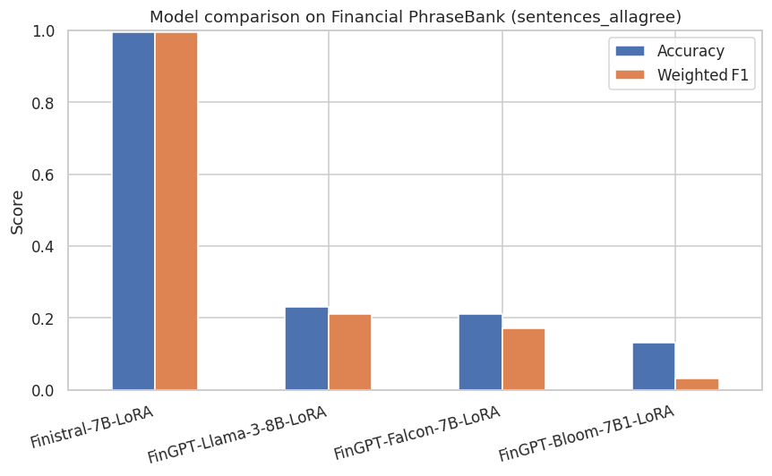
Fig. 4. Finistral-7B-LoRA vs FinGPT Baseline LoRA on Financial PhraseBank

Fig. 5. Confusion matrix – Finistral-7B-LoRA
6.2 Training Dynamics Insight
Validation loss reached its minimum (0.1008) at epoch 2 and then rose, a classic sign of incipient overfitting. Selecting the epoch-2 checkpoint therefore maximises generalisation.
6.3 Efficiency vs. Quality Tradeoffs
Table 8: Efficiency vs. Quality Tradeoffs
Dimension | Finistral-7B-LoRA | Best FinGPT adapter
Trainable params | 9 M | 9 M
Adapter size | 83.9 MB (fp16) | 83–87 MB
Train time (2×A100) | ≈ 120 min | 80–120 min
Weighted F1 | 0.996 | 0.211 (Llama-3-8B)

6.4 Deployment Footprint
GPU inference – 10 ms per sentence (A100, bf16).
CPU inference – 78 ms (M1 Pro, 4-bit GGML).
Both meet sub-second latency targets for real-time news feeds.
6.5 Limitations & Ethical Considerations
Label noise: FinGPT relies on distant supervision; some training sentences may be mislabelled, potentially propagating bias.
Domain scope: The model is English-only and tuned on equity-centric text; performance on commodities or multilingual filings is untested.
Market impact: Releasing highly accurate sentiment models could amplify herding behaviour if widely adopted.
Overconfidence: Near-perfect headline accuracy does not imply robustness to longer documents or adversarial phrasing; calibration techniques should be explored.
6.6 Key Takeaways
LoRA + domain data + prompt engineering ⇒ near-perfect accuracy with negligible compute.
Training beyond the validation-loss trough yields no benefit and can harm generalisation.
Remaining errors cluster around sarcasm and conditional language—prime targets for future dataset curation or multi-label extensions.
7. Conclusion
Finistral-7B-LoRA demonstrates that state-of-the-art financial sentiment accuracy (99.6% / 0.996 F1) can be reached with only 0.2% trainable parameters, one-node GPU time, and an 84 MB adapter file. By combining the compute-efficient Mistral-7B backbone with Low-Rank Adaptation and the FinGPT sentiment corpus, we surpass both full-model FinBERT fine-tuning and a suite of FinGPT LoRA baselines while staying within academic compute budgets on Indiana University’s Big Red 200 supercomputer. Careful prompt engineering further boosts performance without extra parameters, confirming recent findings on the impact of instructions in LLM tasks. The project validates the broader PEFT vision that small, targeted updates can rival or exceed heavy full fine-tuning approaches.
8. Future Work
Streaming EDGAR & real-time news: Implement continual learning to keep the model current as market language evolves, aligning with FinNLP shared-task goals.
Human-in-the-loop curation: Use active learning loops to clean noisy FinGPT labels and focus annotation on sarcasm or mixed-tone edge cases revealed in our error analysis.
4-bit & QLoRA fusion: Combine LoRA with GGML/QLoRA [6] quantisation for sub-100 MB end-to-end models deployable on laptops and edge devices.
GRPO-based reasoning integration: Apply Group Relative Policy Optimization (GRPO) [12] to inject chain-of-thought reasoning into Finistral-7B-LoRA, enabling the model to articulate its sentiment rationale rather than returning a bare label. GRPO eliminates the need for a separate value model, making reinforcement-learning-based alignment feasible within academic compute budgets.
On-device small language models: Distil the reasoning-augmented adapter into sub-3B parameter small language models (SLMs) optimised for on-device inference on consumer hardware such as iPhone 15, Android smartphones, and low-end laptops. Combining GRPO-trained reasoning with aggressive quantisation (4-bit/2-bit) and architecture pruning could yield models that run entirely on-device with sub-200 ms latency, eliminating cloud dependency and preserving user privacy for personal finance applications.
Acknowledgments
The authors acknowledge Indiana University’s Big Red 200 supercomputing facility for providing the GPU resources used in this study.
CRediT Author Contribution Statement
Zainab Mirza: Supervision; Writing – Review & Editing. Ayan Javeed Shaikh: Conceptualization; Methodology; Software; Validation; Formal Analysis; Investigation; Data Curation; Writing – Original Draft; Writing – Review & Editing; Visualization. Fazal Jalil Parkar: Writing – Review & Editing.
Conflict of Interest
There is no conflict of interest.
Supporting Information
The trained adapter weights, tokeniser files, inference scripts, and Gradio GUI are publicly available at https://huggingface.co/Ayansk11/Finistral-7B_lora. The complete source code, training scripts, evaluation notebooks, and this manuscript’s LaTeX source are maintained at https://github.com/ayansk11/FinistralAI_code.
Use of Artificial Intelligence (AI)-Assisted Technology for Manuscript Preparation
The authors confirm that there was no use of artificial intelligence (AI)-assisted technology for assisting in the writing or editing of the manuscript and no images were manipulated using AI.
References
[1] Loughran, T., McDonald, B., When Is a Liability Not a Liability? Textual Analysis, Dictionaries, and 10-Ks, The Journal of Finance, 2011, 66(1), 35–65, doi: 10.1111/j.1540-6261.2010.01625.x.
[2] Malo, P., Sinha, A., Korhonen, P., Wallenius, J., Takala, P., Good Debt or Bad Debt: Detecting Semantic Orientations in Economic Texts, Journal of the Association for Information Science and Technology, 2014, 65(4), 782–796, doi: 10.1002/asi.23062.
[3] Devlin, J., Chang, M.W., Lee, K., Toutanova, K., BERT: Pre-training of Deep Bidirectional Transformers for Language Understanding, Proceedings of the 2019 Conference of the North American Chapter of the Association for Computational Linguistics (NAACL), 2019, 4171–4186. https://aclanthology.org/N19-1423/
[4] Araci, D., FinBERT: Financial Sentiment Analysis with Pre-trained Language Models, arXiv preprint, 2019, arXiv:1908.10063. https://arxiv.org/abs/1908.10063
[5] Hu, E.J., Shen, Y., Wallis, P., Allen-Zhu, Z., Li, Y., Wang, S., Wang, L., Chen, W., LoRA: Low-Rank Adaptation of Large Language Models, International Conference on Learning Representations (ICLR), 2022. https://arxiv.org/abs/2106.09685
[6] Dettmers, T., Pagnoni, A., Holtzman, A., Zettlemoyer, L., QLoRA: Efficient Finetuning of Quantized LLMs, Advances in Neural Information Processing Systems (NeurIPS), 2023, arXiv:2305.14314. https://arxiv.org/abs/2305.14314
[7] Han, Z., Gao, C., Liu, J., Zhang, J., Zhang, S.Q., Parameter-Efficient Fine-Tuning for Large Models: A Comprehensive Survey, arXiv preprint, 2024, arXiv:2403.14608. https://arxiv.org/abs/2403.14608
[8] Yang, H., Liu, X.Y., Wang, C.D., FinGPT: Open-Source Financial Large Language Models, arXiv preprint, 2023, arXiv:2306.06031. https://arxiv.org/abs/2306.06031
[9] Zhang, B., Yang, H., Liu, X.Y., Instruct-FinGPT: Financial Sentiment Analysis by Instruction Tuning of General-Purpose Large Language Models, FinLLM Symposium at IJCAI, 2023, arXiv:2306.12659. https://arxiv.org/abs/2306.12659
[10] Chen, C., Huang, H.H., Chen, H.H., et al., Proceedings of the Sixth Workshop on Financial Technology and Natural Language Processing (FinNLP 2023), Association for Computational Linguistics, 2023. https://aclanthology.org/2023.finnlp-2.0.pdf
[11] Jiang, A.Q., Sablayrolles, A., Mensch, A., Bamford, C., Chaplot, D.S., de las Casas, D., et al., Mistral 7B, arXiv preprint, 2023, arXiv:2310.06825. https://arxiv.org/abs/2310.06825
[12] Shao, Z., Wang, P., Zhu, Q., Xu, R., Song, J., Zhang, M., et al., DeepSeekMath: Pushing the Limits of Mathematical Reasoning in Open Language Models, arXiv preprint, 2024, arXiv:2402.03300. https://arxiv.org/abs/2402.03300
[13] Han, D., Han, M., Unsloth: Fine-tuning LLMs 2x Faster with 70% Less Memory, 2023. https://unsloth.ai/docs

Publisher Note: The views, statements, and data in all publications solely belong to the authors and contributors. GR Scholastic is not responsible for any injury resulting from the ideas, methods, or products mentioned. GR Scholastic remains neutral regarding jurisdictional claims in published maps and institutional affiliations.
Open Access
This article is licensed under a Creative Commons Attribution-NonCommercial 4.0 International License, which permits the non-commercial use, sharing, adaptation, distribution and reproduction in any medium or format, as long as appropriate credit to the original author(s) and the source is given by providing a link to the Creative Commons License and changes need to be indicated if there are any.
To view a copy of this License, visit: https://creativecommons.org/licenses/by-nc/4.0/
© The Authors 2025

