**1)Created two new tables.**

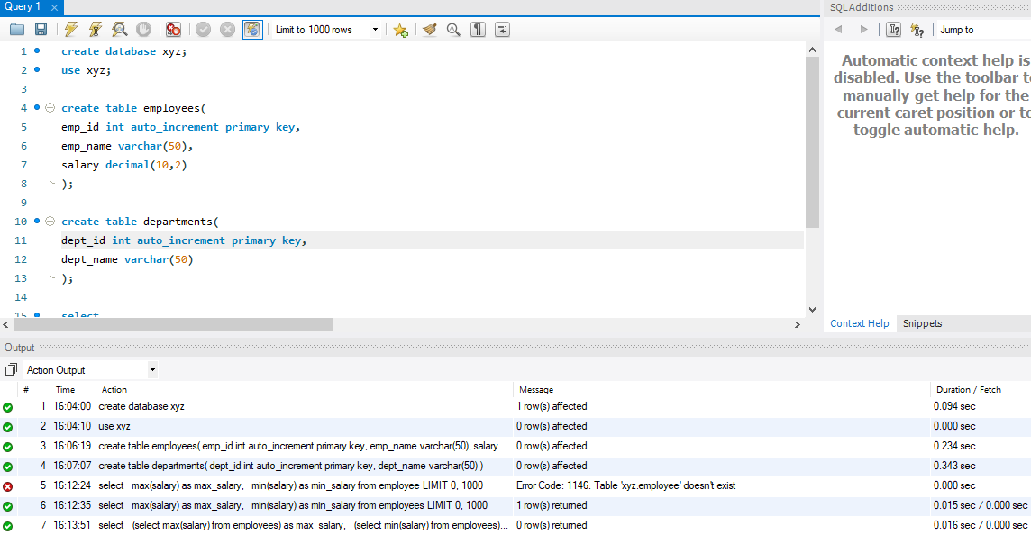

**2)Subquery to find max and min salary.**

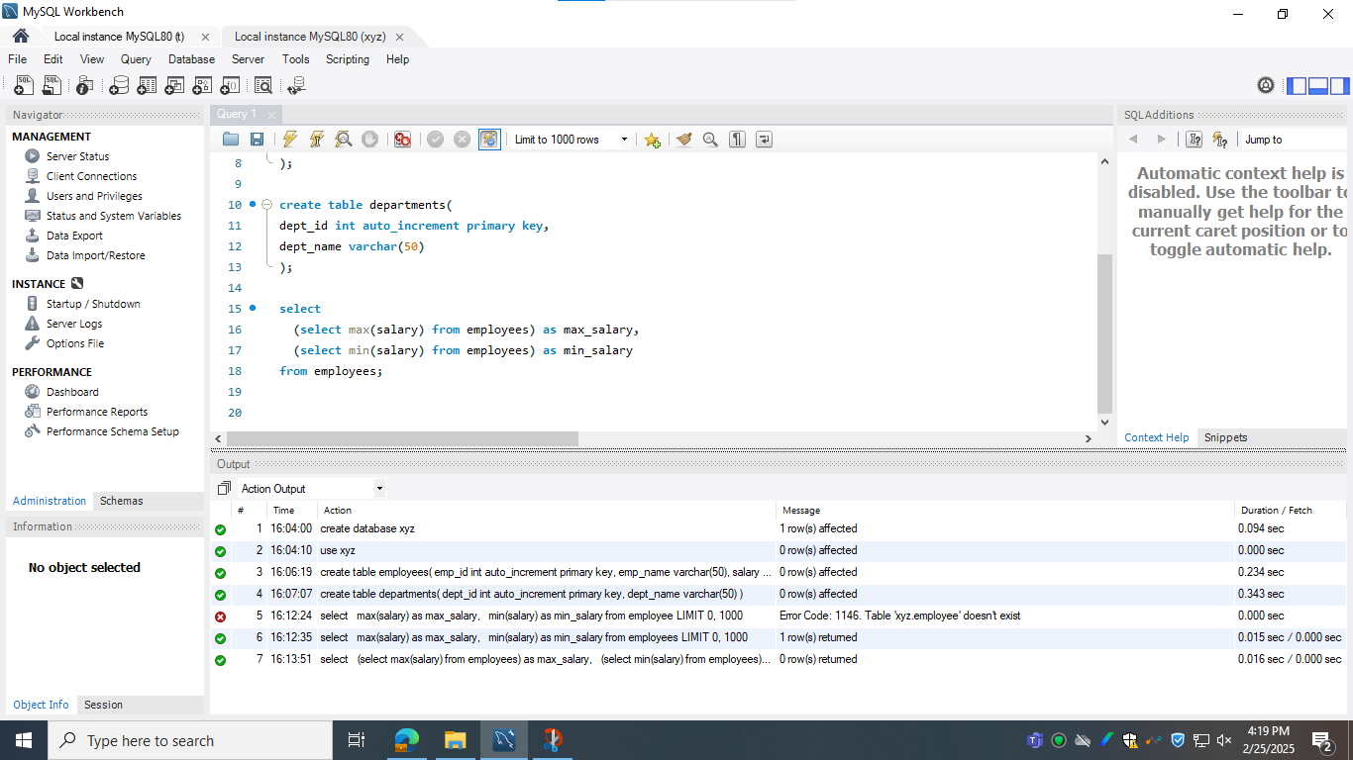

**3)Second highest salary using subquery and limit.**

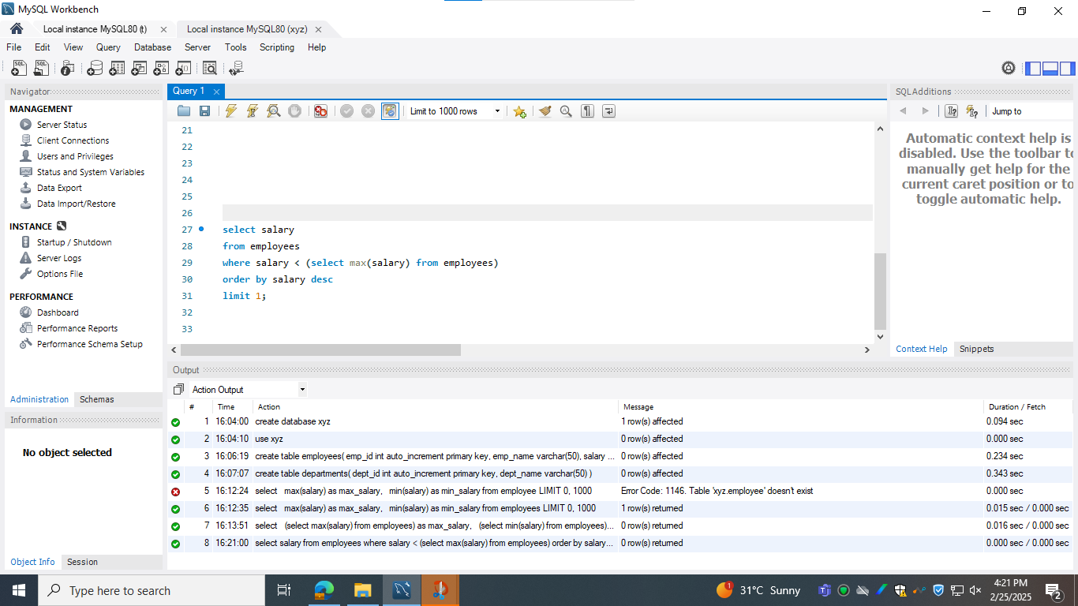

**4) Query for implementing all the joins.**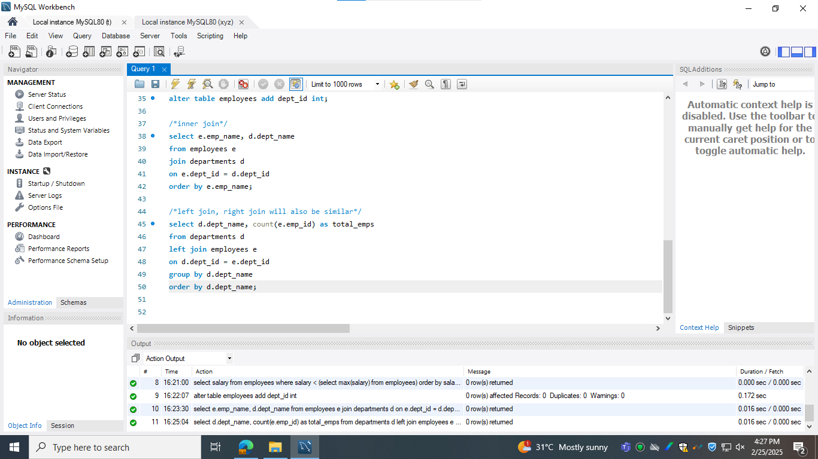

**5)Query to implement all aggregate functions.**

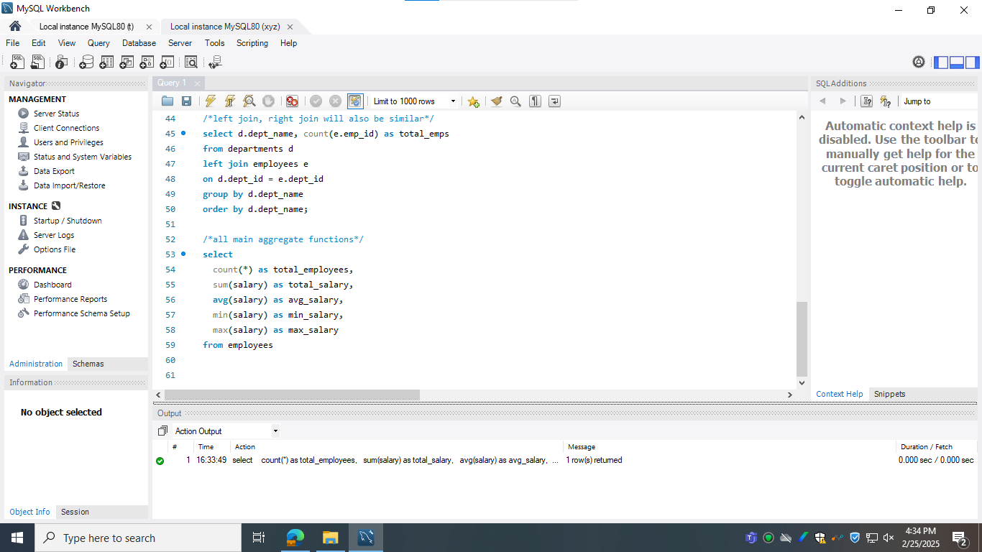

**6)Query using all string functio**