Title: EDA on Used Car Dataset

  - Subject: Python II (PCC-AI492)
  - Department: Artificial Intelligence
  - Name – Ayan Suvra Bosu
  - Roll no. – 38732524006
  - Date – 12/06/2026

Introduction:
The objective of this project is to perform EDA on Used Car Dataset. This analysis aims to understand the data, identify missing values and outliers, distribution pattern of the data, meaningful insights, and statistical inference.
The Dataset contains info about used car and attributes like year, fuel type, mileage, engine capacity, power, transmission type, owner category, and price.
Data Loading and Initial Inspection:
First, import required packages for preparation and further processing.
- Numpy
- Pandas
- Matplotlib
- Seaborn
Load dataset using pd.read_csv () with path. Look few records of the dataset and features by using pandas head, tail, sample, info, shape. Check columns name and data type of each column. Use describe () function to get a brief statistical summary of all numeric features.
Missing Data:
Look for missing values in each feature, by using isnull ().sum ()
Name 0
Location 0
Year 0
Kilometers_Driven 0
Fuel_Type 0
Transmission 0
Owner_Type 0
Mileage 2
Engine 46
Power 46
Seats 53
New_Price 6247
Price 1234

More than 85% data is missing in New_Price column, so exclude that feature using drop function. Also drop the rows with null values in price.
Feature Engineering:
Add a new feature ‘Brand’ for more scalability, by extracting text from ‘Name’ column.
brand = df['Name'].str.split().apply(lambda x:x[0])
df.insert(0, 'Brand', brand)

Removed text from numeric columns such as ‘Mileage’, ‘Engine’, ‘Power’ for more functionality.
df['Mileage'] = df['Mileage'].str.split().apply(lambda x : x[0])
df['Engine'] = df['Engine'].str.split().apply(lambda x : x[0])
df['Power'] = df['Power'].str.split().apply(lambda x : x[0])
Datatype and Filling Null Values:
Datatypes of ‘Mileage’, ‘Engine’, and ‘Power’ are in string, covert their types to float and integer for better understanding and analysis.
df['Power'] = df['Power'].astype('float')
df['Engine'] = df['Engine'].astype('int')
df['Mileage'] = df['Mileage'].astype('float')

Now, fill up the missing data by replacing them with mean or median.
df['Mileage'] = df['Mileage'].replace(np.nan ,df['Mileage'].median())
df['Engine'] = df['Engine'].replace(np.nan, df['Engine'].median())
df['Power'] = df['Power'].replace(np.nan, df['Power'].mean())

Modifying features name for better understanding using rename function
df.rename(columns={
'Mileage' : 'Mileage_kmpl',
'Engine' : 'Engine_CC',
'Power' : 'Power_bhp',
'Price' : 'Price_lakhs'
}, inplace=True)

Distribution Analysis:
Histograms and KDE plots were used to study the distribution of features.
- Power column shows right-skewed behavior (skew value = 1.943).
- Engine column also shows similar behavior (skew value = 1.429).
- Kilometers Driven column exhibits very high positive skewness.
- Most of the features are following Normal distribution.
Correlation Analysis:
Correlation analysis was performed using Pearson Correlation Coefficients and heat maps. It shows how columns correlate to each other.
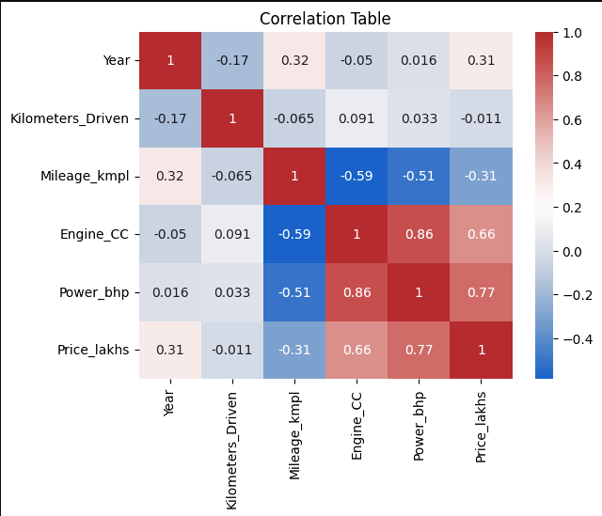
- Power and Engine has high positive correlation.
- Power and Price has a positive correlation.
- Engine and Price has a positive correlation.
- Mileage has negative correlation with Engine and Power.
These relation further can be confirmed by Scatter Plots and RegPlot.
GroupBy Analysis:
By performing GroupBy analysis, the key findings are
- About 800 units of total cars was sold in 2014.
- Average price of cars based on fuel type
  - CNG – 3.8 Lakh Rupees
  - Diesel – More than 12 Lakh
  - Electric – More than 12 Lakh
  - LPG – about 2 Lakh
  - Petrol – near 6 Lakh
- 71.4% cars are manual, only about 28.58% cars are automatic
- More than 80% people prefer new cars and 16% people purchase second hand cars
- Lamborghini has highest average price of 120 Lakh, second is Bentley with the price of 60 Lakh, followed by Porsche, Land, and Jaguar with 50 Lakh, 40 Lakh, and 40 Lakh respectively.
Statistical Inference and Outlier Detection:
It is performed to know about statistical insights of numerical features. Using describe () function, a brief statistical description is generated of the data frame including the numerical columns. Now, perform operations on each numeric columns for more understanding and outlier detection.
Kilometers Driven
count 6.019000e+03
mean 5.873838e+04
std 9.126884e+04
min 1.710000e+02
25% 3.400000e+04
50% 5.300000e+04
75% 7.300000e+04
max 6.500000e+06

Max value exhibits that there is an outlier on index 2328. The car, BMW X5 xDrive ,was driven about 6500000 KM.
Mileage
count 6019.000000
mean 18.134966
std 4.581528
min 0.000000
25% 15.170000
50% 18.150000
75% 21.100000
max 33.540000

Min value indicates that there are some cars with 0 Mileage (about 68 rows).
Power
count 6019.000000
mean 113.188560
std 53.232625
min 34.200000
25% 78.000000
50% 98.600000
75% 138.030000
max 560.000000

No outliers detected.
Box Plot of Numeric Columns
