**Pharmacy**

Database class project 2020/2021

|  |  |  |  |  |
| --- | --- | --- | --- | --- |
| Student Name in English | Student Name in Arabic | Student ID | Section | Work percentage |
| Aya Qartallo | اية نمر محمد قرطلو | 11819568 | 8-9:30 | 50% |
| Rand Ismail | رند يزيد مصطفى اسماعيل | 11820835 | 9:30-11 | 50% |
|  |  |  |  |  |

Date/time

---------------------------------------------This section is intended for the Instructor---------------------------------------

|  |  |
| --- | --- |
| **Topic** | **Mark** |
| Project Requirements and Modeling |  |
| Correctness of Database mapping |  |
| Functional Dependency and Normalization |  |
| Project Tools |  |
| Project Discussion |  |
| Project Completeness |  |
| Project Output Results or reporting (JasperReport, charts, graphs, etc.) |  |
| Project Administration and Management |  |
| Project Report |  |
| Project Idea |  |
| Project Complexity |  |
| Team work |  |
|  |  |
|  |  |
|  |  |

**Abstract:**

The purpose of this Pharmacy Management System project is to improve the maintenance and manipulation of the drugs in the medicals. The pharmacy management system will be used to minimize the time and resource by maintaining the details of the drug systemically so that the data can be used in possible quickest time. While the resource, which is minimized, are workforce, money, papers, etc. The system is user-friendly and will help the pharmacist. This Pharmacy Management System will reduce the burden on pharmacist and will make the system efficient by providing the more accurate details about drugs in the medical.

**Contents:**

Introduction ……………………………….…………………………………………………………………………...3

Requirements …………………………………………………………………………………………………………..4

Functional Dependency……………………………………………………………………………………………..5

UML Class Diagram for Pharmacy Database………………………………………………………………..8

Jasperreport Design……………………………………………………………………………………………..…….9 3NF……………………………………………………………………………………………………………………………..10

Discussion about Our Project GUI……………………………………………………………………………….11

Conclusion, tools and references………………………………………………………………………………….16

**Introduction:**

The design of the pharmacy management system is based on the computer, which will simplify the maintenance of the information, accessible and efficient. The Pharmacy Management System will provide the information about the end of the drugs in the medical so that the physician can order those drugs before the end. The pharmacist and nurses will get more accurate results at the time sell, about the details of the use of medicines and the dosages so that the system will become more reliable to use than the present system. The records of each work will be secure as to access the information the user must have to provide the ID and password in the system.

**Requirements**:

Each pharmacy has a name, a location, a unique phone number, medicines and drugs, a drug store and pharmacists, who works on it; we keep track of the start and finish time of their work. The pharmacist dispenses the medication to the patient according to the prescription. A drug store contains medicines which has a unique name, a unique barcode, a price, a producing company, an expiry and production date, a storage method, how to use it, the side effects, a suitable age, unit. The order has the name of medicine, date of order, unit, the quantity and the price. If the amount of this medicine in the drug store reaches the critical limit, the pharmacist will order more of this medicine from the supplier who has a name, a unique SSN, a unique phone number and address.

We store each pharmacist’s name, SSN, phone number, salary, sex, social status, address, birthdate and date of employment.

Some pharmacy store each patient’s name, SSN, birthdate, sex, phone number, blood type, address.

We want to keep track of the dependents of each pharmacist for insurance purposes. We keep each dependent’s first name, sex, birthdate, and relationship to the pharmacist.

**Functional Dependency:**

1. **Pharmacist Table**

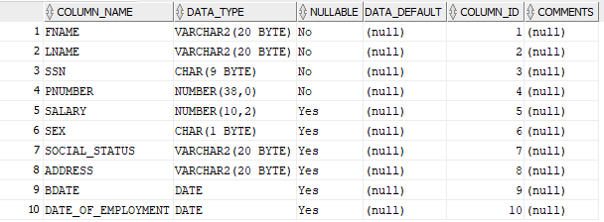

FNAME, LNAME🡪SSN

PNUMBER🡪SSN

1. **Patient Table**

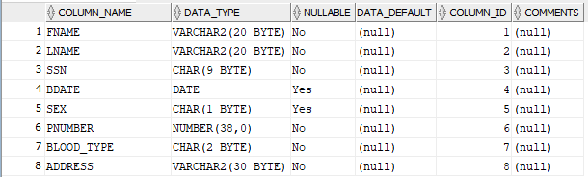

FNAME, LNAME🡪SSN

PNUMBER🡪SSN

1. **Order From Table**

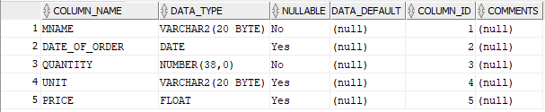

There is not functional dependence

1. **Medicine Table**

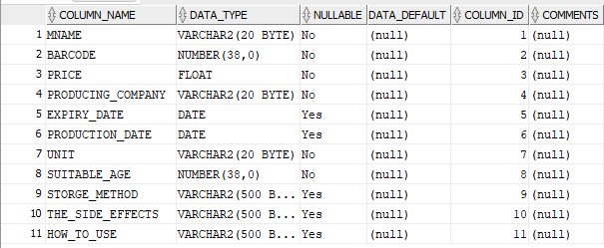

BARCODE🡪MNAME

1. **Drug Store Table**

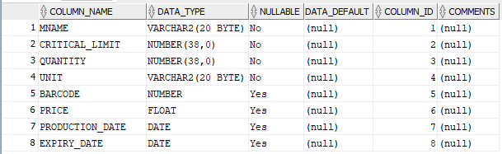

BARCODE🡪MNAME

1. **Supplier Table**

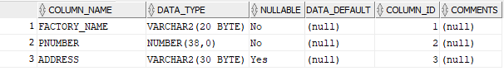

PNUMBER🡪FACTORY_NAME

1. **Dependent Table**

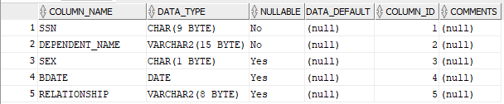

DEPENDENT_NAME🡪SSN

**UML Class Diagram for Pharmacy Database:**

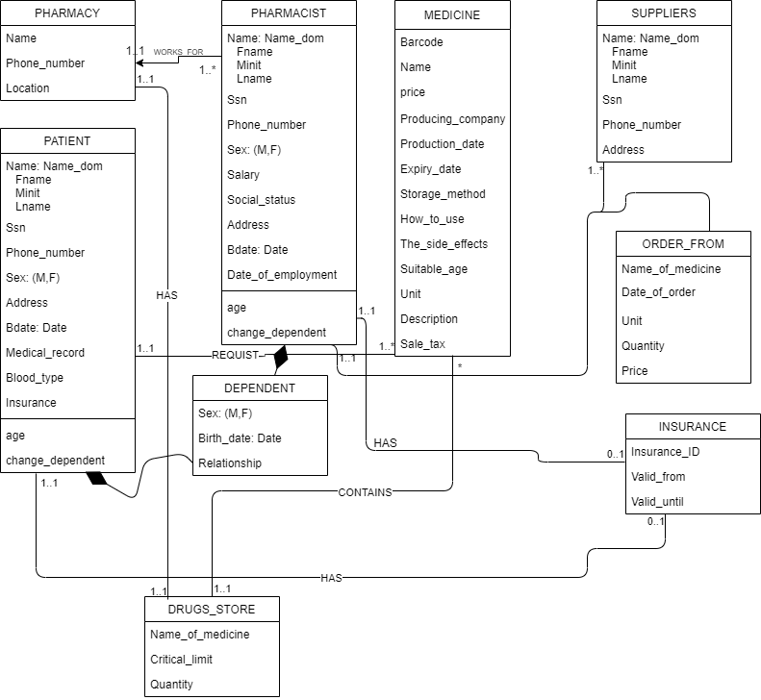

**Jasperreport Design:**

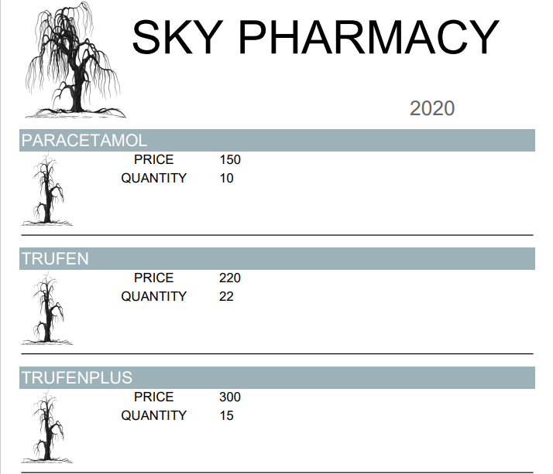

**3NF:**

ALL tables are in 3NF

1NF: they in which the intersection of every column and record contains only one value.

2NF: they don’t have any composite key.

3NF: there is no non-primary key column is transitively dependent n the primary key.

**Discussion About Our Project GUI:**

**Login interface**

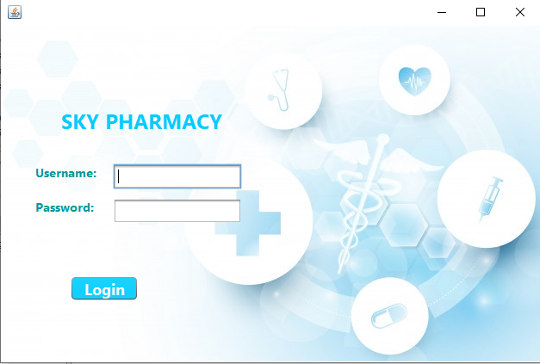

* The pharmacist will get the access to the system by use of this module. They will need to provide the information about the user ID and the password given to them at the time of registration.

**Main interface**



* On this interface, you will see four buttons when you click on one of them, another interface will appear for you that contains the information of the button that you clicked on.
* There is also a button to return to the previous interface

**Pharmacist interface**

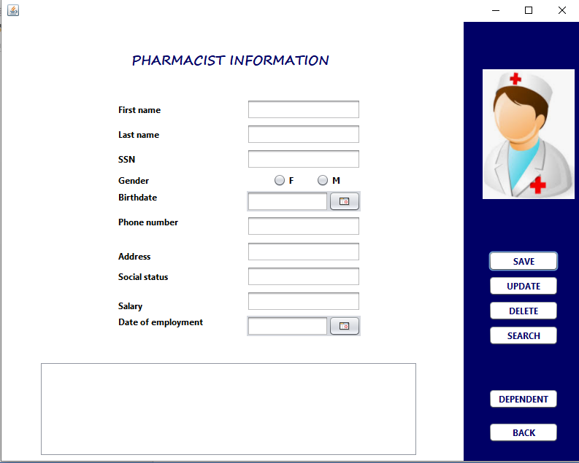

* In this interface, we can add, amend, delete or search for pharmacist information
* If the pharmacist has children, the Dependent button is pressed
* There is also a button to return to the previous interface

**Dependent interface**

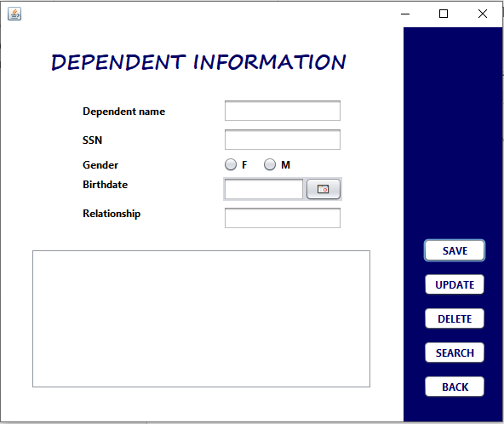

* When this interface appears, the pharmacist can add, edit, delete or search for his children's information
* There is also a button to return to the previous interface

**Patient interface**

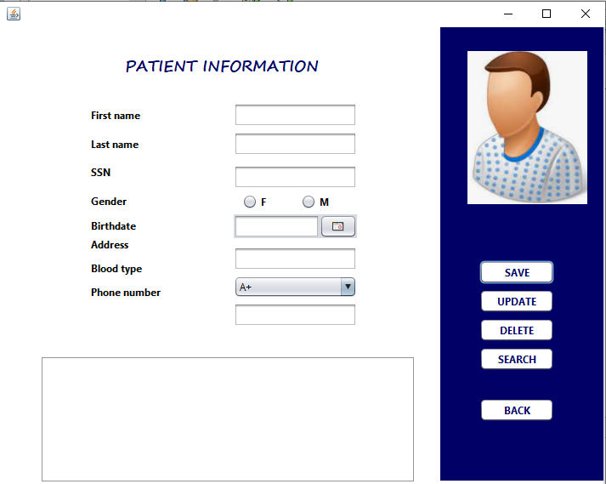

* In this interface, we can add, amend, delete or search for pharmacist information
* There is also a button to return to the previous interface

**Make order interface**

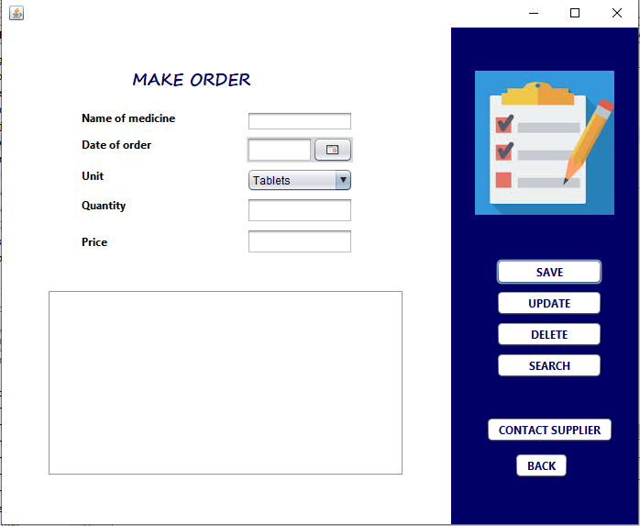

* In this interface, the pharmacist can request from the drug manufacturer a specific drug in the event that the quantity of this drug in the drug store reaches a minimum

**Supplier interface**

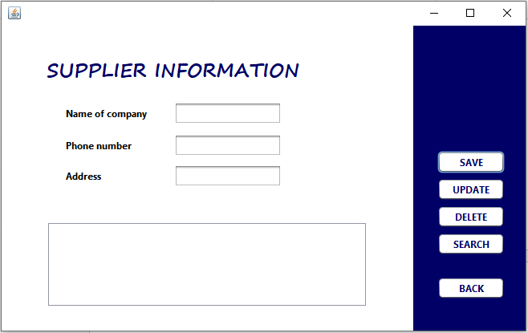

* In this interface, we can add, amend, delete or search for supplier information
* There is also a button to return to the previous interface

**Check store interface**

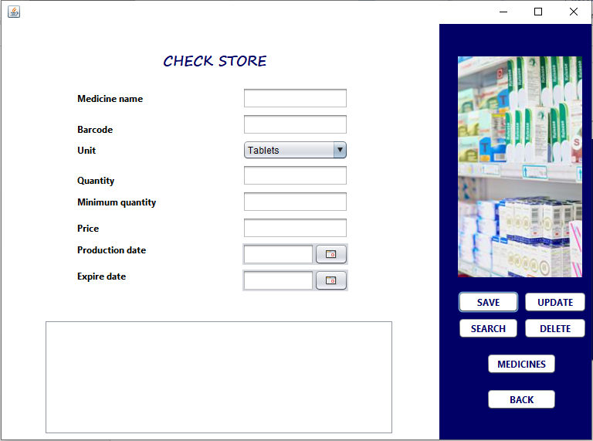

* Through this interface, we can add a new drug to the drug store and add general information about it, modify, delete or search for it by entering the name of the drug
* When you click on the Medicines button, it moves to the admin interface
* There is also a button to return to the previous interface

**Medicine interface**

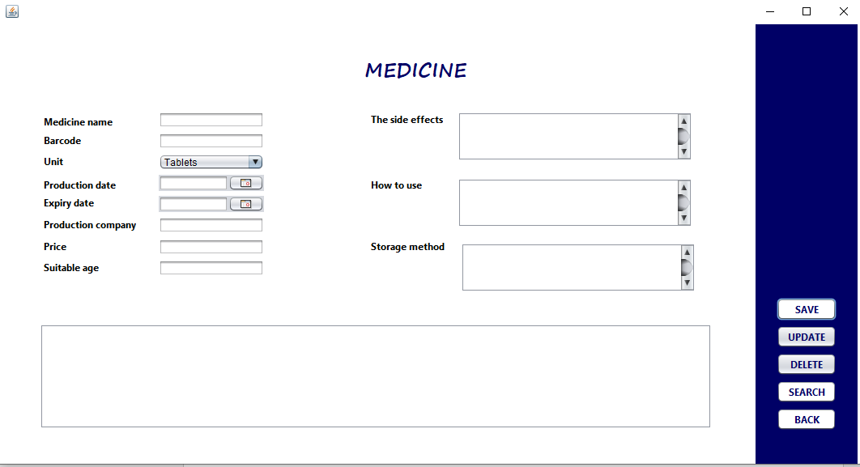

* In this interface, the information about each drug in the store is added, deleted, modified, or searched for it by entering the name of the drug
* There is also a button to return to the previous interface

**Conclusion:**

Pharmacy management system is actually a software which handle the essential data and save the data and actually about the database of a pharmacy and its management. This software help in effectively management of the pharmaceutical store or shop. It provide the statistics about medicine or drugs, which are in stocks which data, can also be updated and edited. It works as per the requirement of the user and have options accordingly. It allow user to enter manufacturing as well as the expiry date of medicine placing in stock and for sales transaction. The record of supplier’s supplies can also be saved in it. There are other function available too. The main purpose is effectively and easily handling of pharmacy data and its management.

**Tools Used in Our Project:**

1. Netbeans for programming the project

2. SQL developer and SQL plus for database

3. Drawio for UML diagram

4. Jasper soft studio for jasper report

5. Word documents

6. Text documents

**References:**

<https://stackoverflow.com/>

<https://www.youtube.com/channel/UCdUfh5Wwv_B5oRMIeTLscwg>