**Task 7**

1. Connect to database called “School”

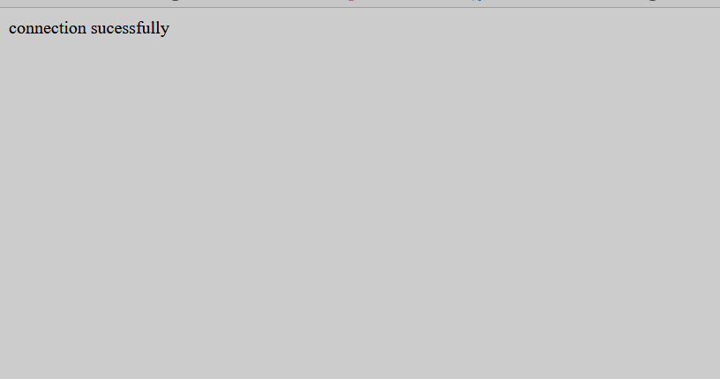

1. Select(retrieve) all students data from table student.



1. Try to print students data in HTML table
2. 