**Project report on**

**SNACK SQUAD**

**Customizable snack ordering and delivery app**

**Submitted**

**By**

**M.MANOJ KUMAR (Reg no:C0S41811)**

**M.DURKESWARAN (Reg no:C0S41805)**

**A.MOHAMMED AYAS AKBAR (Reg no:C0S41814)**

**H.JAVITH HUSSAIN (Reg no:C0S41808)**



**DEVANGA ARTS COLLEGE**

**ARUPPUKOTTAI- (626 101)**

**INTRODUCTION**

**OVERVIEW**

The increasing popularity of food delivery in colleges and universities, the traditional telephone order food has become inconvenient to the customers and the food delivery store. The online food ordering system provides convenience for the customers. It overcomes the disadvantage of the traditional queuing system. This android application increases the takeaway of foods than visitors. Therefore, this system enhances the speed and standardization of taking the order from the customer. It provides a better communication platform. The user details are noted electronically. Using this application, the customers need not go to the restaurant by themselves, but they can order the meals through Android mobiles anywhere. In this system there are four namely, Admin, Delivery boy, Restaurant manager and User. Admin can login, manage restaurants by adding, updating and deleting, manage delivery person by adding, updating and deleting. Admin can also check registered users and the orders total count. Delivery boy can login and see the allotted orders, they can upload the status of the order whether it is picked, on the way or delivered. Restaurant manager can login and update their restaurants details, they can even check for reviews and ratings given by users. They can manage menu by adding new items and deleting unwanted. Manager can manage orders by allotting to the delivery boy, can update status of delivery. Manager can see the payment done by electronic mode. Users can register and login. Users have option to choose the cuisine, hotels nearby. User will get details of restaurants like name, location and reviews. Users can select the food from the menu list, can add to favourites and can get processed further. User can view the history of their orders and the current orders status. User have online payment options. User will get notification of the order status

**PURPOSE**

Using this application, the customers need not go to the restaurant by themselves, but they can order the dishes through computers and Android mobiles anywhere. The online food ordering system provides convenience for the customers. It overcomes the disadvantage of the traditional queuing system. This android application increases the takeaway of foods than visitors. Therefore, this system enhances the speed and standardization of taking the order from the customer.

**PROBLEM DEFINITION & DESIGN**

**EMPATHY MAP**

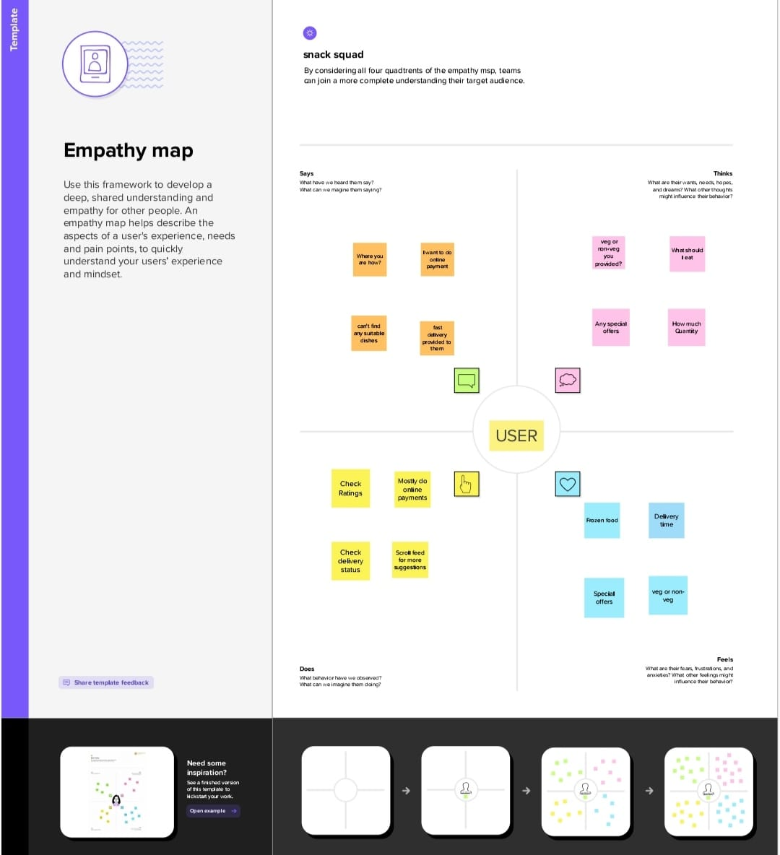

**IDEALIZATION AND BRAINSTROAM**

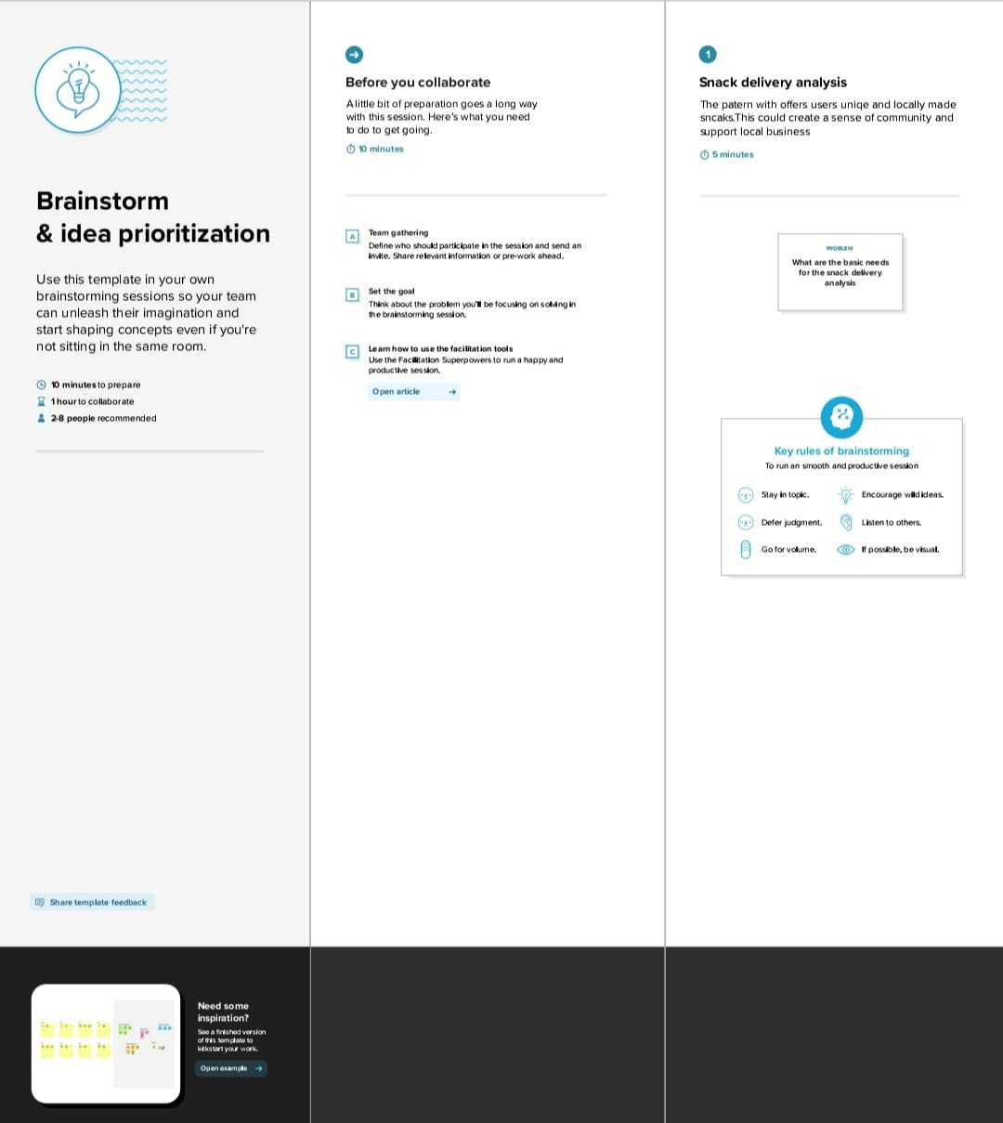

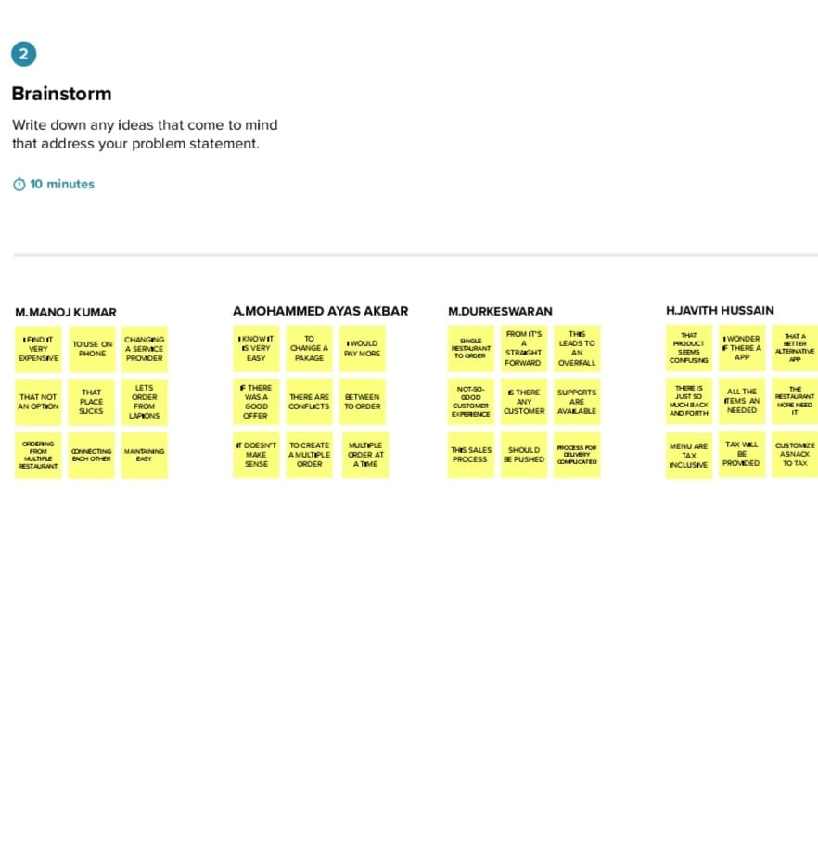

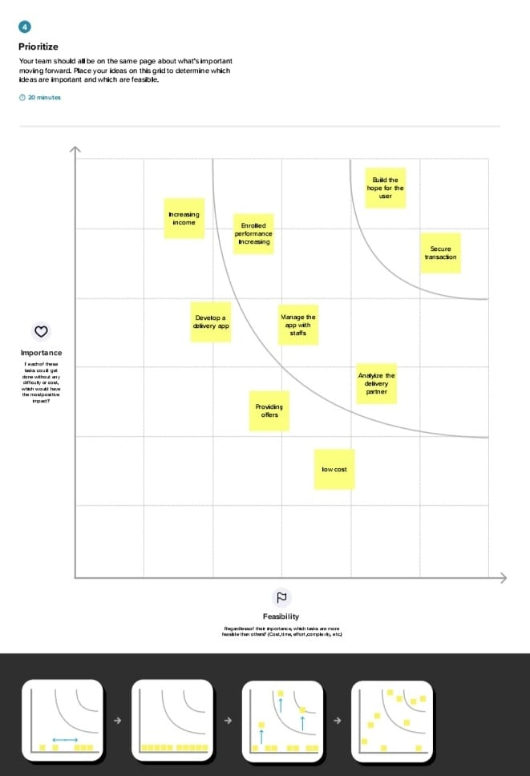

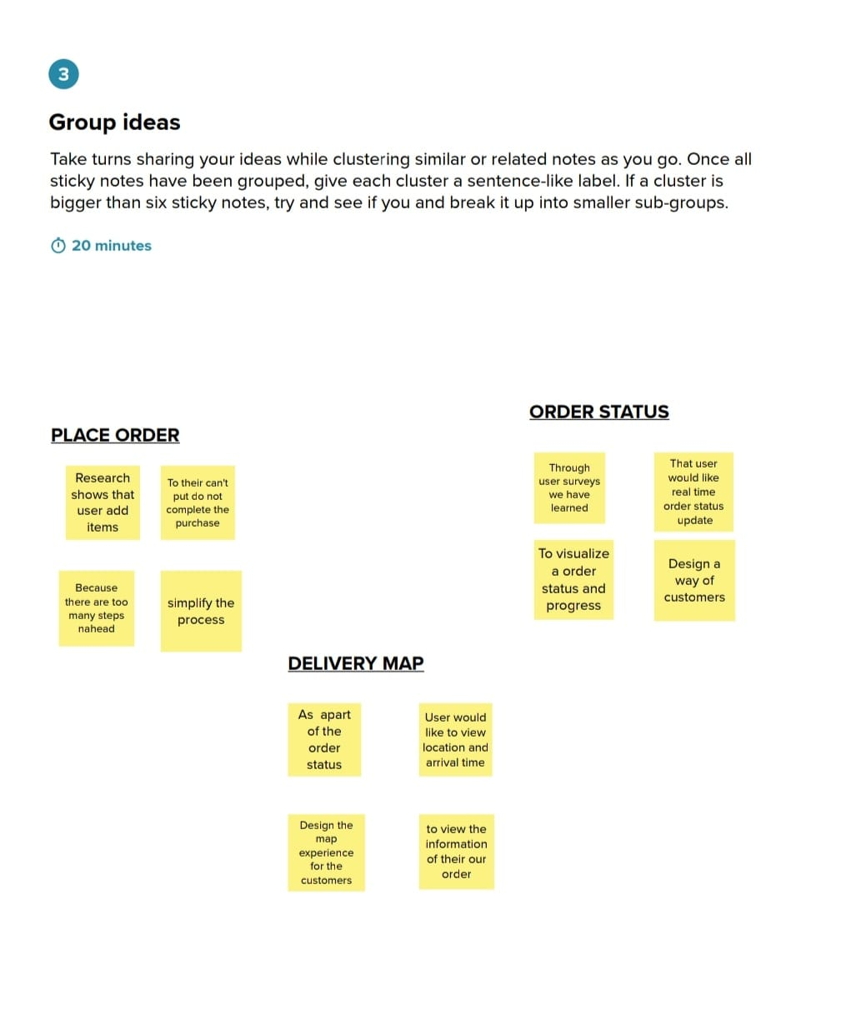

**RESULT**

**Sign up :**

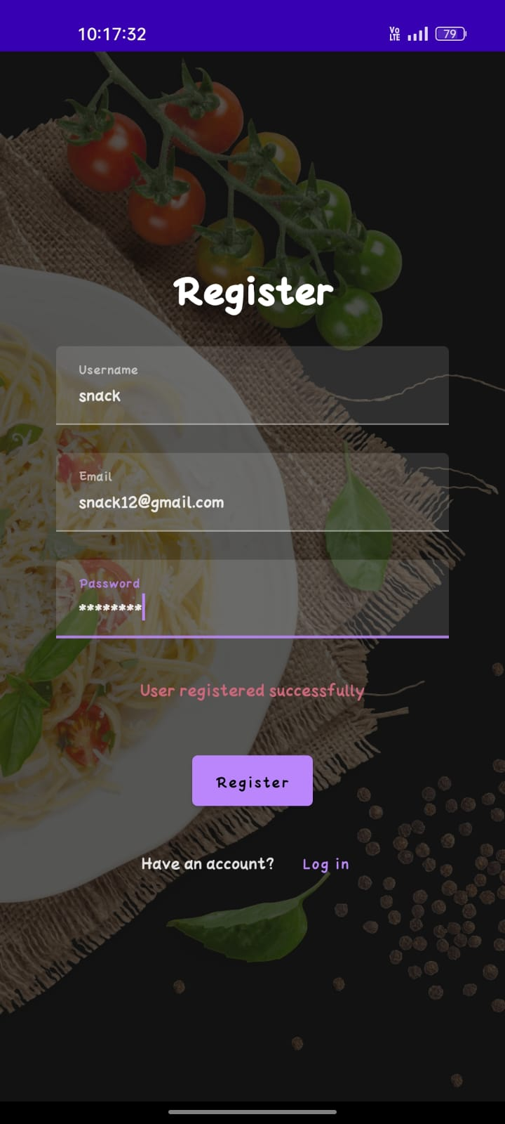

**Log in:**

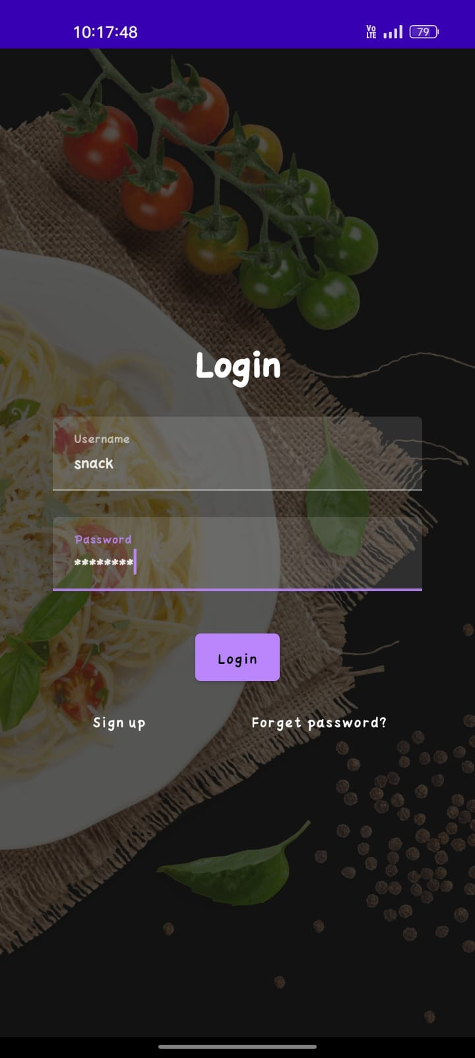

**INTERFACE:**

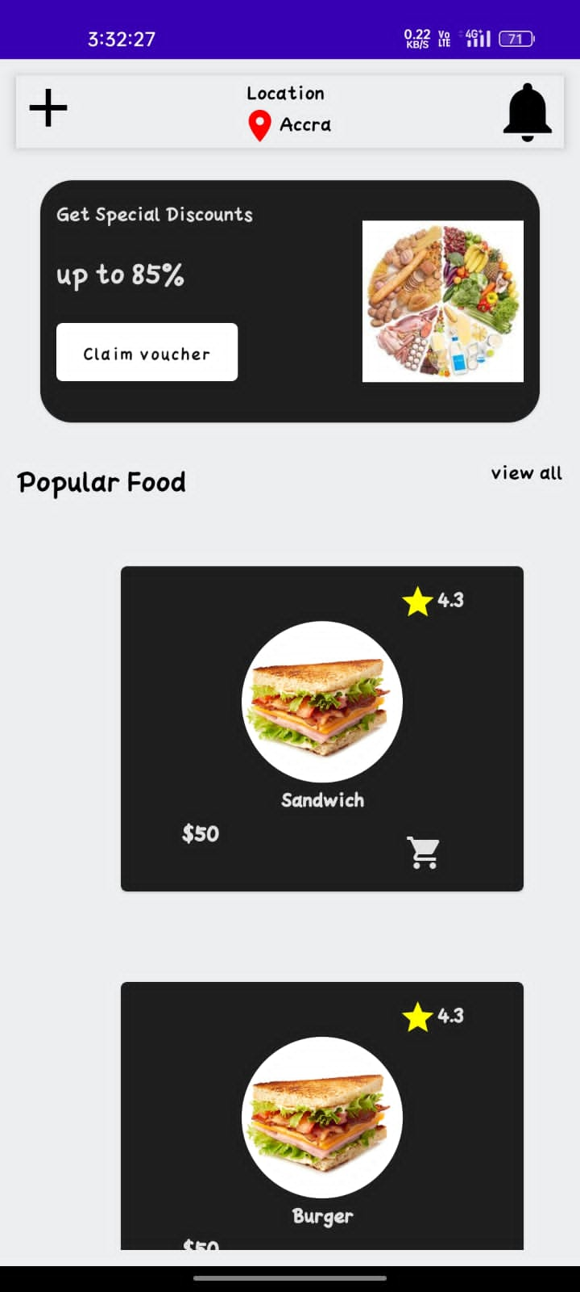

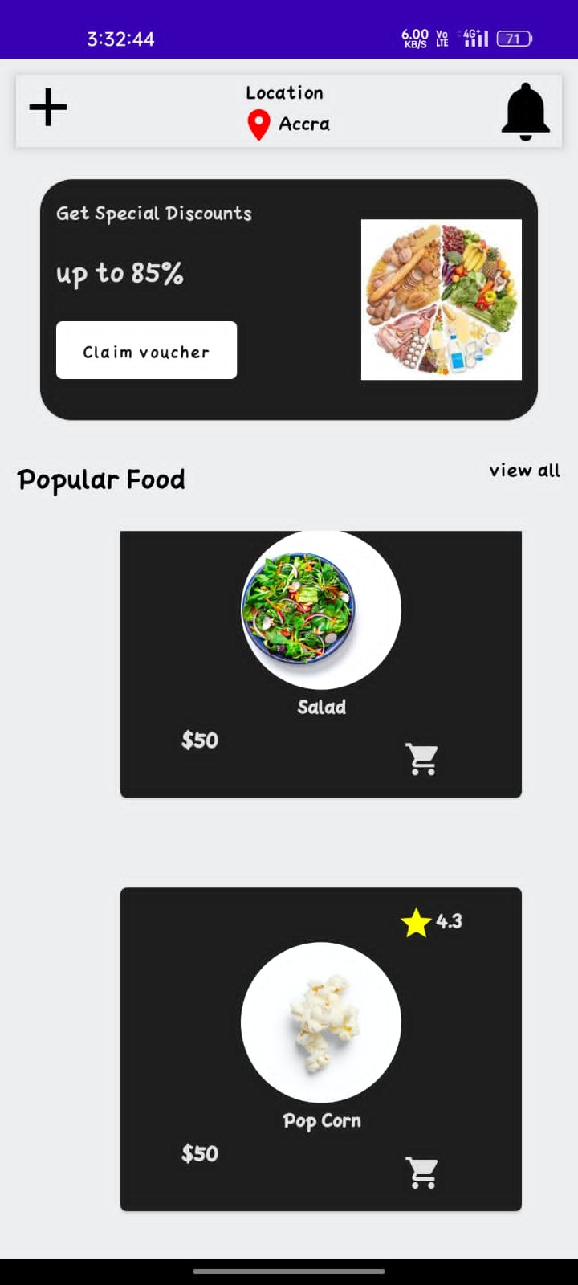

**ADVANTAGES & DISADVANTAGES**

**ADVANTAGES:**

Running an online food ordering system adds flexibility to the business, which will ultimately increase sales and profits.

* **Easy, fast, and comfortable:**

In short, your customers choose to order food online because it is really at their fingertips.

Anyone with a smartphone can order food online from their favorite restaurant. According to a **Harris poll**, millennials (under the age of 30) are your most important target audience today.

More than 97% of millennials use their phones for anything. Ordering food online comes into the same broad category.So using the online food ordering system is the easiest way to attract millennials.

* **Health benefits:**

One of the important benefits of food ordering systems is health benefits. Because the meal is planned, it is easy to determine the exact number of calories consumed in each meal. Many food ordering systems retain their menu for health benefits and weight loss, which can be very helpful for individuals who are trying to lose weight and start a healthy diet.

* **Safer and healthier:**

To reopen, food businesses will have to set up shop to meet the health and safety regulations of the Indian government. Owners must maintain social distances, use non-contact ordering and payment methods, and ensure surfaces are regularly cleaned.

Even if you are a small shop owner, Switching to the online ordering system for businesses means that your customers can order food without coming to the store and pay online without contact. This method not only brings profit to your business but also protects from the spread of covid-19.

* **Less chance for errors:**

One of the best advantages of an online food ordering system for customers is that it ensures prices are accurate and there is less room for error when it comes time to settle the bill.

This is because customers have to select an item in the menu at the appropriate price and make sure that the right amount is always paid.

This has some good benefits for your business; The chances of mischarging are low, less time in ordering errors, and helping to provide satisfactory service to customers.

* **More customers:**

As the new life progresses with technologies, online orders and payments are expected to be accepted.If your payment and menu method is hassle free, your regular customers will recommend you to their friends and will share on social media about your restaurant.

You can maximize your customers and your profits by providing a seamless customer experience.

* **Increased customer loyalty:**

If you give customers a reason to come back, they will choose your store over your competitor. You can promote their loyalty through the loyalty program.

According to a recent study, a personalized digital experience is also a great way to encourage customers to come back. According to a recent survey out Of the 1000 customers, 50% said they change brands that offer a worse online experience, and 73% expect online customization.

Through a restaurant online ordering system, you can give personalized offers to loyal customers, request reviews to increase your ratings, and get feedback on your service.

* **Higher customer spend:**

We all know that more and more customers are now engaging in digital products and services than ever before.

They also spend more when ordering online. Because reading the online menu is different from standing in line.

Customers have more time to make decisions. If they want a rich, gooey chocolate cake, they can order a lean latte without fearing the judgment of others. Even better if you have a carry-on bag!

Those who do not have food intolerance can take their time to read all the necessary information. This means customers are more likely to place large orders.

* **Highly customizable:**

Food ordering apps are highly customizable so you can easily advertise your logo, brand colors, or other features that make your business unique. Additionally, if you want to delete or add an item to the menu, you must sign in, make your changes, and it’s done.

**Disadvantages:**

While there are many advantages to the online food ordering system, there are also some disadvantages to online food ordering systems. They are

* **Price:**

One of the major drawbacks of online food ordering systems is price. When food is ordered for more than one person, the cost is usually equal to eating at a good restaurant every night. Many food ordering systems cost more than $ 20 per person per day. Even more expensive for some other food ordering systems. For individuals with a limited food budget, online food ordering systems are often too expensive.

* **Limited menu:**

Another disadvantage for food ordering systems is menu choices. Most food ordering systems have a limited number of meals. The menu changes every few weeks or months, but if you stick to the system for more than a few months the menu items will come back again and again. You should also eat the food provided for that week. If you do not want to eat that particular food, you may have to order another food from another place or eat food you do not like.

* **Preparation:**

The preparation factor may be a disadvantage to food ordering systems. Most food ordering systems give frozen food. They are usually easy to prepare, but they usually take more than an hour to cook because the food is frozen. To avoid long cooking times, you can remove the food from the freezer the day before. However, remember to eliminate food from the freezer to reduce cooking time.

* **Quality of food may be suffer:**

  One problem with the food ordering system is that the quality of the food served is often worse than eating at a restaurant. Often, food has to be fed over long distances, and over time, precious vitamins can be lost. Also, food from the ordering system is often served in plastic packaging, which may not be very appealing to your eyes compared to the food neatly placed on your plate in a restaurant.

* **Food may get cold:**

Due to the long ordering distances, your food may also be cold once it is finally delivered to your home.You need to reheat it or eat it cold.

This is especially true, if you order in an emergency the streets are often crowded and the ordering person will be stuck in traffic.

* **The vibe of the restaurant is missing:**

In some restaurants, there is also a good circumstance which you will miss if you order your food at home.

For example, if you spend your evening in a good Chinese restaurant, you will often feel like you are actually in China because the decoration and the whole atmosphere are in line with the Chinese way of life.If you order food at your home, you will lose all of these.

Also, from time to time, it would be great if you could take your partner or family to a nice restaurant for dinner to spend a good evening.

**Wrapping up:**

Despite some drawbacks, online food ordering systems generally benefit customers and restaurants. By trying out new restaurants (or ordering convenient meals) and helping restaurants attract new customers, customers can taste the delicacies foods as if they were in their bed. We understand both sides of this mess. brilliant technologies are here, Contact us to provide growth to your online food ordering system through mobile apps.

**Advantages:**

1. **Staffing cost is reduced:**

Customers can place an order from their mobile so that instead of an employee answering phone calls all the time. Once the restaurant receives the order, they prepare the food, and employees can spend their time in profitable ways.

1. **More sales and revenue:**

You are making your restaurant more competitive by making ordering more convenient. So that you can increase your customer base and boost your sales.

1. **Risk of disease transmission is low:**

Online food ordering systems make it easy to stay safe for both customers and staff. Customers can simply pick up their order from the pickup area within the restaurant and make a payment without any contact.

**Disadvantages:**

1. **Delivery men in danger:**

Delivery men deliver the food, if it is sunny or rainy, he is waiting outside the restaurant to take the order and deliver your order on time.

1. **Health issues:**

The attractive dishes sometimes make health issues due to their ingredients, and the hot food packed in plastic bags or boxes leads to health issues. If you get this type of food on regular basis, it may cause food poisoning and makes you obese too.

**DISADVANTAGE**

A hungry customer can spend on average an hour to decide what to eat! This scenario is especially true for multi-cuisine restaurants. Having so many options to choose from often overwhelm the customers, and many times results in a dropped sale - *can’t decide what to eat, close the website and order the good ol’ Whopper from Burger King!* By helping your customers with data-driven recommendations and suggestions. Restolabs online ordering provides insights and data on customers ordering patterns that you can utilize to help them make quick selection. If it’s a customer, then having a live chat feature can be a good strategy. Simply have a pop-up window asking “what would you like to have today”, and let their answers guide the recommendation window on the website or the app.

**The Payment**

A recurring problem that customers face when ordering food online is regarding payment. Some restaurant websites do not accept [multiple payment methods](https://www.restolabs.com/blog/restaurants-are-buying-cashless-trend-your-business-ready-make-shift), forcing customers to drop their orders. Security is another factor that people consider when purchasing anything online and if your payment gateway doesn’t assure it, they’ll have no reason to proceed further with their order. Even things like not showing a payment confirmation message or being redirected to another website can be exasperating. Then there are the issues of a difficult refund process in cases of failed payments or canceled orders.Begin with offering a plethora of payment options. While card payment and PayPal are the dominant methods of paying online, alternate methods like Paypal, Google Pay, Apple Pay, etc. are gaining popularity amongst tech-savvy customers. Offering convenience, speed, and security to your customers is essential for increasing conversions and sales.

**The Ordering Process**

Convenience is one reason why more customers than ever before prefer ordering their food online these days. But there are still plenty of websites which have been created without giving any thought to[**optimizing the user experience**](https://restolabs.com/blog/restaurant-technology/top-uiux-must-haves-online-ordering-websites-restaurants). Sometimes it can even be difficult to find the ‘Menu’ button on a site! At times there’s an information overload and at others too little. Most customers also consider websites that require customers to register on the site before placing an order troublesome.To [make the ordering process as smooth as possible](https://www.restolabs.com/how-it-works), you must be accessible on all platforms, including websites, mobile applications and social media. Keep the design clean and concise, with as few steps as possible required during the checkout process. A clear call to action on every page is a must to ensure your customers are able to complete the transaction successfully without having to move between pages.

**Delivery & Packaging**

When it comes to issues in delivery, they not only include delays, but also the quality and quantity of the food, packaging and unpleasant behavior by delivery persons.Always send freshly prepared food from the kitchen. Take care to ensure you use appropriate [packaging](https://restolabs.com/blog/restaurant-marketing/5-tips-help-you-make-your-delivery-packaging-attract-consumers)techniques for hot and cold food.

# Online Food Ordering Application

Online food ordering software designed specifically for food to go retailers, restaurants and takeaway.Online sustenance requesting is quickly expanding as clients take pleasure in the comfort of requesting online.Get our online food ordering app and add a new channel for sales.Using Celexsa’s online food ordering app customers place orders through PC, tablets and smartphones. They can access your menu items, select from them and place order online. Also payment will be done online. Order can be delivered or customers can come and pick their orders by themselves.Benefits of using online food ordering or restaurant ordering app is reduced labour costs, reduces walk away & long queues. This online ordering system for restaurants is designed for multisite food to go chains and independents like Restaurants, cafes & coffee shops, Fast food, take away, other catering services.Getting your business online opens up many more sales which will improve your reputation in market. With your online menu, existing clients will have an awesome new advantageous approach to order and new clients will soon discover you through famous web search engines. The system is branded to match in with your existing website.We help entrepreneurs to grow their business in digital world.

**CONCLUSION**

With online ordering on board you will enrichen your customer experience by making the process of ‘placing orders’ a lot easier. It will show that you value your customer’s time. Online ordering will guarantee a ‘level up’ to your web presence. And a good web presence will make you stand out in the search engine rankings and bring more customers to you.Online ordering will boost your productivity by eliminating the inefficient process of taking orders. It will help you to plan and implement an adaptive marketing campaign.Utilising the latest online ordering technology for your restaurant will also help you to tap into a massive customer base which is tech-savvy and believes in ‘online way’.

**FUTURE SCOPE**

Ordering food online gains popularity among the restaurant customers in recent decades due to its convenience. Earlier, it was a troublesome task for restaurant owners to receive orders over phone calls, initiate the process manually, and deliver it in a chaotic way. After the advent of online food ordering application, the ordering for customers and delivering for restaurateurs become easy and convenient. The advancements in technology have added more convenience to the system, and undoubtedly, the [online food ordering system](http://www.clouddish.com/products/customer-online-food-ordering-software.html) will decide the future of the food business.

**Drive sales online**

The arrival of smartphones and the usage of social media have brought the world closer. Even the small-scale businesses started using online platforms such as website, food-ordering applications, or even social media to receive orders from their restaurant customers and deliver food with ease. As people find it a more convenient way to receive their food at their doorstep, they start using it to order more often. Thereby, the restaurant business has bloomed with more online orders.

**Ease the ordering and delivering process**

Making calls and ordering food would be a waste of time where there is a possibility of missing orders. Even the customers will have no idea whether they will receive the food or not. The online food ordering system with ordering and tracking features has simplified the process of getting the order through online portals and delivering it in a feasible time that can be tracked by the customers in real-time.

**Outstrip conventional ordering method**

The food ordering system has provided a comfort that has outlawed the traditional way of ordering food. The restaurant business owners have started understanding the reality that the conventional way of receiving orders from customers will not work anymore. If they rely on that old method, then they will vanish from the market slowly. The advanced level of placing orders will come into practice with even more advancements like the implementation of **Artificial Intelligence** to **predict and forecast sales**, and IoT and Big Data analytics to recommend food to the restaurant customers with the data saved during their past visits.

**Outlaw aggregation model**

Besides, the restaurant owners have to spend a lump-sum amount for the aggregators (third-party) to reach their customers. There are a few businesses that connect the restaurants and the customers and allow customers to order food through their ordering portals by getting commission from the restaurant owners. This kind of business model will undoubtedly take a bigger part from your revenue. If the restaurant owners can use their own food-ordering system as a channel to reach their customers, they have to invest only for the application, and after that, they can receive orders and serve them the best with no monthly payments as commissions.With the technological advancements in the [online food ordering software](http://www.clouddish.com/products/customer-online-food-ordering-software.html), restaurants and the related businesses can handle the online orders effectively while handling the entire restaurant process. The restaurant business is one of the ever-growing businesses. The food-ordering system would be an add-on support for them to get more customers and grow ahead in the business.

**APPENDIX**

**SOURCE CODE**

|  |
| --- |
| **MAINPAGE CODE :**  Package come.example.snackordering  import android.content.Context  import android.content.Intent  import android.os.Bundle  import androidx.activity.ComponentActivity  import androidx.activity.compose.setContent  import androidx.compose.foundation.Image  import androidx.compose.foundation.layout.*  import androidx.compose.material.*  import androidx.compose.runtime.*  import androidx.compose.ui.Alignment  import androidx.compose.ui.Modifier  import androidx.compose.ui.graphics.Color  import androidx.compose.ui.layout.ContentScale  import androidx.compose.ui.res.painterResource  import androidx.compose.ui.text.font.FontFamily  import androidx.compose.ui.text.font.FontWeight  import androidx.compose.ui.unit.dp  import androidx.compose.ui.unit.sp  import androidx.core.content.ContextCompat  import com.example.snackordering.ui.theme.SnackOrderingTheme  class MainActivity : ComponentActivity()  {  private lateinit var databaseHelper: UserDatabaseHelper  override fun onCreate(savedInstanceState: Bundle?)  {  super.onCreate(savedInstanceState)  databaseHelper = UserDatabaseHelper(this)  setContent  {  SnackOrderingTheme  {  // A surface container using the 'background' color from the theme  Surface(  modifier = Modifier.fillMaxSize(),  color = MaterialTheme.colors.background)  {  RegistrationScreen(this,databaseHelper)  }  }  }  }  }  @Composable  fun RegistrationScreen(context: Context, databaseHelper: UserDatabaseHelper) {  Image(  painterResource(id = R.drawable.order), contentDescription = "",  alpha =0.3F,  contentScale = ContentScale.FillHeight,  )  var username by remember { mutableStateOf("") }  var password by remember { mutableStateOf("") }  var email by remember { mutableStateOf("") }  var error by remember { mutableStateOf("") }  Column(  modifier = Modifier.fillMaxSize(),  horizontalAlignment = Alignment.CenterHorizontally,  verticalArrangement = Arrangement.Center)  {  Text(  fontSize = 36.sp,  fontWeight = FontWeight.ExtraBold,  fontFamily = FontFamily.Cursive,  color = Color.White,  text = "Register"  )  Spacer(modifier = Modifier.height(10.dp))  TextField(  value = username,  onValueChange = { username = it },  label = { Text("Username") },  modifier = Modifier  .padding(10.dp)  .width(280.dp)  )  TextField(  value = email,  onValueChange = { email = it },  label = { Text("Email") },  modifier = Modifier  .padding(10.dp)  .width(280.dp)  )  TextField(  value = password,  onValueChange = { password = it },  label = { Text("Password") },  modifier = Modifier  .padding(10.dp)  .width(280.dp)  )  if (error.isNotEmpty()) {  Text(  text = error,  color = MaterialTheme.colors.error,  modifier = Modifier.padding(vertical = 16.dp)  )  }  Button(  onClick = {  if (username.isNotEmpty() && password.isNotEmpty() && email.isNotEmpty()) {  val user = User(  id = null,  firstName = username,  lastName = null,  email = email,  password = password  )  databaseHelper.insertUser(user)  error = "User registered successfully"  // Start LoginActivity using the current context  context.startActivity(  Intent(  context,  LoginActivity::class.java  )  )  } else {  error = "Please fill all fields"  }  },  modifier = Modifier.padding(top = 16.dp)  ) {  Text(text = "Register")  }  Spacer(modifier = Modifier.width(10.dp))  Spacer(modifier = Modifier.height(10.dp))  Row() {  Text(  modifier = Modifier.padding(top = 14.dp), text = "Have an account?"  )  TextButton(onClick = {  context.startActivity(  Intent(  context,  LoginActivity::class.java  )  )  })  {  Spacer(modifier = Modifier.width(10.dp))  Text(text = "Log in")  }  }  }  }  private fun startLoginActivity(context: Context) {  val intent = Intent(context, LoginActivity::class.java)  ContextCompat.startActivity(context, intent, null)  } |
|  |
|  |
|  |
|  |
|  |
|  |
|  |
|  |
|  |
|  |
|  |
|  |
|  |
|  |
|  |
|  |
|  |
|  |
|  |
|  |
|  |
|  |
|  |
|  |
|  |
|  |
|  |
|  |
|  |
|  |
|  |
|  |
|  |
|  |
|  |
|  |
|  |
|  |
|  |
|  |
|  |
|  |
|  |
|  |
|  |
|  |
|  |
|  |
|  |
|  |
|  |
|  |
|  |
|  |
|  |
|  |
|  |
|  |
|  |
|  |
|  |
|  |
|  |
|  |
|  |
|  |
|  |
|  |
|  |
|  |
|  |
|  |
|  |
|  |
|  |
|  |
|  |
|  |
|  |
|  |
|  |
|  |
|  |
|  |
|  |
|  |
|  |
|  |
|  |
|  |
|  |
|  |
|  |
|  |
|  |
|  |
|  |
|  |
|  |
|  |
|  |
|  |
|  |
|  |
|  |
|  |
|  |
|  |
|  |
|  |
|  |
|  |
|  |
|  |
|  |
|  |
|  |
|  |
|  |
|  |
|  |
|  |
|  |
|  |
|  |
|  |
|  |
|  |
|  |
|  |
|  |
|  |
|  |
|  |
|  |
|  |
|  |
|  |
|  |
|  |
|  |
|  |
|  |
|  |
|  |
|  |
|  |
|  |
|  |
|  |
|  |
|  |
|  |
|  |
|  |
|  |
|  |
|  |
|  |
|  |
|  |
|  |
|  |
|  |
|  |
|  |