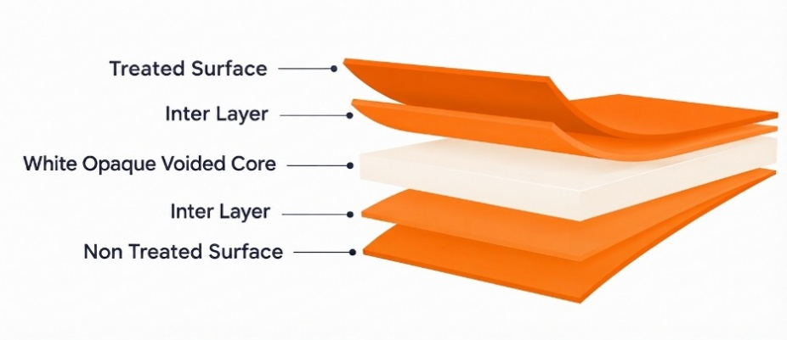
NSP Pearlized Sealable Film
PRODUCT OVERVIEW
NSP is a coextruded BOPP film specially designed for food packaging and lamination applications. It combines excellent opacity and whiteness with good dead-fold properties, high stiffness, and mechanical strength. The film also provides a wide sealing range and a glossy, high-quality surface, making it suitable for high-quality rotogravure and flexographic printing.

KEY FEATURES
- Very good opacity and whiteness
- Excellent web flatness
- Very good dead-fold properties
- Wide sealing range
- Excellent glossy surface
- High mechanical strength and stiffness

APPLICATIONS
- General-purpose food packaging
- Lamination applications
- High-quality rotogravure printing
- Flexographic printing

TECHNICAL DATA — TYPICAL VALUES
Property |  | Unit | Typical values |  |  |  |  |  |  | Test Method
Thickness |  | µm | 25 | 30 |  | 35 |  | 40 |  | NODA PLAST Lab
Unit Weight |  | g/m² | 17 | 20.4 |  | 23.28 |  | 27.2 |  | NODA PLAST Lab
Yield |  | m²/kg | 58.8 | 49 |  | 42 |  | 36.8 |  | NODA PLAST Lab
Density |  | g/cm3 | 0.68
Wetting Tension |  | mN/m | ≥ 38 |  |  |  |  |  |  | ASTM D2578
Whiteness Index |  | — | 89 |  | 90 |  | 90 |  | 92 | —
Opacity |  | % | 70 |  | 72 |  | 73 |  | 76 | DIN 53146
Gloss |  | — | 90 |  | 90 |  | 93 |  | 97 | ASTM D2457
COF Dynamic F-F (U-U) |  | — | ≤ 0.30 |  |  |  |  |  |  | DIN EN ISO 8295
Tensile Strength | MD | MPa | 103 |  |  |  |  |  |  | ASTM D882
Tensile Strength | TD | MPa | 141 |  |  |  |  |  |  | ASTM D882
Elongation at Break | MD | % | 140 |  |  |  |  |  |  | ASTM D882
Elongation at Break | TD | % | 32 |  |  |  |  |  |  | ASTM D882
Tensile modulus of elasticity | MD | MPa | 1050 |  |  |  |  |  |  | ASTM D 882
Tensile modulus of elasticity | TD | MPa | 1980 |  |  |  |  |  |  | ASTM D 882
TECHNICAL NOTES
The numerical values reported in this data sheet are obtained from the average of the values recorded in our laboratory tests. Before final use, we recommend technical tests to ensure the film's suitability for the intended use. NODA PLAST Film is not responsible for inappropriate use of the product, and its liability is limited to the exclusive replacement of the product, excluding any compensation or damages of any kind.

