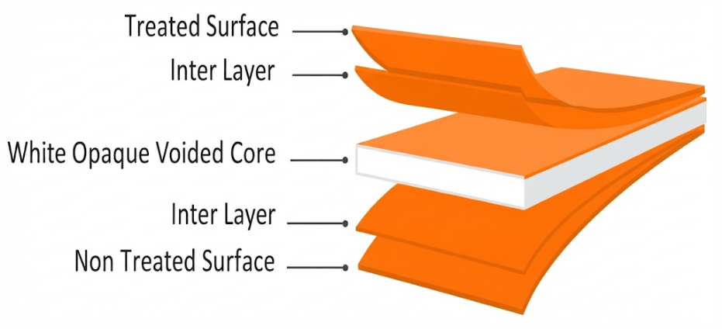
NLV LABEL VOIDED FILM
PRODUCT OVERVIEW
NLV is a coextruded BOPP film with a micro-voided core structure, developed as a lightweight substrate for label and packaging applications. The film combines a multilayer construction with a controlled surface structure to provide consistent performance during converting.

KEY FEATURES
- High opacity and whiteness
- Excellent web flatness
- High gloss on treated surface
- Rotogravure & flexographic printing
- High mechanical properties
- High stiffness
APPLICATIONS
- Wrap-Around Labels
- Over-Wrap
- Bottle & Container Labels
- Food & Beverage Labels
- Household Product Labels
- Personal Care Labels

TECHNICAL DATA — TYPICAL VALUES
Property |  | Unit | Typical values |  | Test Method
Thickness |  | µm | 38 | 47 | NODA PLAST Lab
Unit Weight |  | g/m² | 23.6 | 32 | NODA PLAST Lab
Yield |  | m²/kg | 42.4 | 31.25 | NODA PLAST Lab
Density |  | g/cm³ | 0.68 |  | —
Wetting Tension |  | mN/m | ≥ 38 |  | ASTM D2578
Whiteness Index |  | — | 90 | 92 | —
Opacity |  | % | 81 | 83 | DIN 53146
Gloss |  | — | 90 | 90 | ASTM D2457
COF Dynamic F-F (U-U) |  | — | ≤ 0.30 |  | DIN EN ISO 8295
Tensile Strength | MD | MPa | 103 |  | ASTM D882
Tensile Strength | TD | MPa | 141 |  | ASTM D882
Elongation at Break | MD | % | 140 |  | ASTM D882
Elongation at Break | TD | % | 32 |  | ASTM D882
Modulus of Elasticity | MD | MPa | 1080 |  | ASTM D882
Modulus of Elasticity | TD | MPa | 2000 |  | ASTM D882
TECHNICAL NOTES
The numerical values reported in this data sheet are obtained from the average of the values recorded in our laboratory tests. Before final use, we recommend technical tests to ensure the film's suitability for the intended use. NODA PLAST Film is not responsible for inappropriate use of the product, and its liability is limited to the exclusive replacement of the product, excluding any compensation or damages of any kind.

