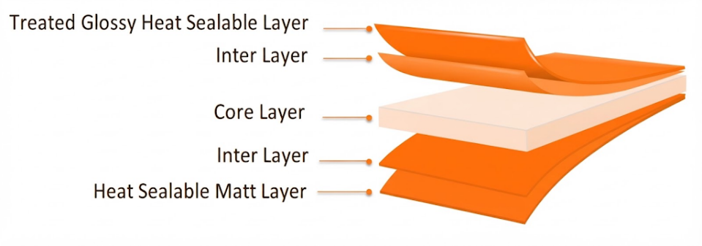
MATT-S Matt Film (Both Sides Sealable)
PRODUCT OVERVIEW
Matt-S is coextruded matt BOPP film with one side regular matt sealable layer and other side treated glossy heat sealable layer for good printability.

KEY FEATURES
- xcellent matte dispersion
- Wide sealing range
- Good seal strength
- High mechanical properties
- High stiffness
- Excellent web flatness
APPLICATIONS
- General-purpose packaging
- Lamination applications
- High-quality printed packaging
- Rotogravure printing
- Flexographic printing
TECHNICAL DATA — TYPICAL VALUES
Property |  | Unit | Typical values |  |  | Test Method
Thickness |  | µm | 20 | 25 | 30 | NODA PLAST Lab
Unit Weight |  | g/m² | 17.6 | 22.2 | 26.7 | NODA PLAST Lab
Yield |  | m²/kg | 56.8 | 45.5 | 37.5 | NODA PLAST Lab
Wetting Tension |  | mN/m | ≥ 38 |  |  | ASTM D2578
Gloss 45° |  | % | 10 |  |  | ASTM D2457
Haze |  | % | 72 |  |  | ASTM D1003
COF Dynamic F-F (U-U) |  | — | ≤ 0.30 |  |  | DIN EN ISO 8295
Tensile Strength | MD | MPa | 130 |  |  | ASTM D882
Tensile Strength | TD | MPa | 260 |  |  | ASTM D882
Elongation at Break | MD | % | 150 |  |  | ASTM D882
Elongation at Break | TD | % | 50 |  |  | ASTM D882
Tensile Modulus of Elasticity | MD | MPa | 2000 |  |  | ASTM D882
Tensile Modulus of Elasticity | TD | MPa | 3800 |  |  | ASTM D882
Thermal Shrinkage | MD | % | ≤ 5 |  |  | BMS TT 0.2
Thermal Shrinkage | TD | % | ≤ 3 |  |  | BMS TT 0.2
Seal strength 120°C / 1bar / 1s / flat seals (Untreated-Untreated) |  | N/15mm | > 2 |  |  | BMS TT 0.1
Heat Seal Range (U-U) |  | °C | 125-140 |  |  | Noda-PLAST Lab
TECHNICAL NOTES
The numerical values reported in this data sheet are obtained from the average of the values recorded in our laboratory tests. Before final use, we recommend technical tests to ensure the film's suitability for the intended use. NODA PLAST Film is not responsible for inappropriate use of the product, and its liability is limited to the exclusive replacement of the product, excluding any compensation or damages of any kind.

