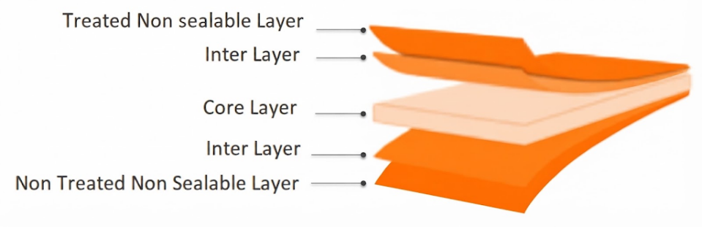
NLC Label Clear Film
PRODUCT OVERVIEW
NLC is coextruded Transparent BOPP film, one side Corona Treated and both sides non-sealable. Film is used for Over wrap and wrap around Labeling.

KEY FEATURES
- Excellent gloss and surface appearance
- Very good machinability
- High mechanical properties
- High stiffness
- Excellent web flatness
- Suitable for high-quality printing
APPLICATIONS
- General-purpose packaging
- General-purpose packaging
- Lamination applications
- High-quality rotogravure printing
- Flexographic printing

TECHNICAL DATA — TYPICAL VALUES
Property |  | Unit | Typical values |  |  | Test Method
Thickness |  | µm | 20 | 25 | 30 | NODA PLAST Lab
Unit Weight |  | g/m² | 18.2 | 22.7 | 27.3 | NODA PLAST Lab
Yield |  | m²/kg | 54.9 | 44 | 36.6 | NODA PLAST Lab
Wetting Tension |  | mN/m | ≥ 38 |  |  | ASTM D2578
Opacity |  | % | 1.8 | 2.2 | 2.5 | DIN 53146
Haze |  | % | 1.6 | 1.7 | 1.8 | ASTM D1003
Gloss 45° |  | % | 95 | 94 | 93 | ASTM D2457
COF Dynamic F-F (U-U) |  | — | ≤ 0.30 |  |  | DIN EN ISO 8295
Tensile Strength | MD | MPa | 160 |  |  | ASTM D882
Tensile Strength | TD | MPa | 290 |  |  | ASTM D882
Elongation at Break | MD | % | 180 |  |  | ASTM D882
Elongation at Break | TD | % | 60 |  |  | ASTM D882
Tensile Modulus of Elasticity | MD | MPa | 2000 |  |  | ASTM D882
Tensile Modulus of Elasticity | TD | MPa | 3800 |  |  | ASTM D882
Thermal Shrinkage | MD | % | ≤ 5 |  |  | BMS TT 0.2
Thermal Shrinkage | TD | % | ≤ 3 |  |  | BMS TT 0.2
TECHNICAL NOTES
The numerical values reported in this data sheet are obtained from the average of the values recorded in our laboratory tests. Before final use, we recommend technical tests to ensure the film's suitability for the intended use. NODA PLAST Film is not responsible for inappropriate use of the product, and its liability is limited to the exclusive replacement of the product, excluding any compensation or damages of any kind.

