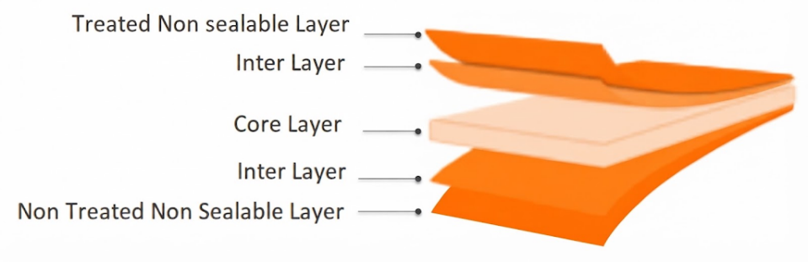
NNC Clear Non-Sealable Film
PRODUCT OVERVIEW
NNC is coextruded Transparent BOPP film, one side Corona Treated and both sides non-sealable. Film is commonly used for Textile packing and other nonfood stuff.

KEY FEATURES
- Excellent glossy finish
- Very good machinability
- High mechanical properties
- High stiffness
- Excellent web flatness
- No curling during processing
- Excellent printability

APPLICATIONS
- General-purpose packaging
- Lamination
- High-quality rotogravure printing
- Flexographic printing
TECHNICAL DATA — TYPICAL VALUES
Property |  | Unit | Typical values |  |  | Test Method
Thickness |  | µm | 20 | 25 | 30 | NODA PLAST Lab
Unit Weight |  | g/m² | 18.2 | 22.7 | 27.3 | NODA PLAST Lab
Yield |  | m²/kg | 54.9 | 44 | 36.6 | NODA PLAST Lab
Wetting Tension |  | mN/m | ≥ 38 |  |  | ASTM D2578
Opacity |  | % | 1.8 | 2.2 | 2.5 | DIN 53146
Haze |  | % | 1.6 | 1.7 | 1.8 | ASTM D1003
Gloss 45° |  | % | 95 | 94 | 93 | ASTM D2457
COF Dynamic F-F (U-U) |  | — | ≤ 0.30 |  |  | DIN EN ISO 8295
Tensile Strength | MD | MPa | 160 |  |  | ASTM D882
Tensile Strength | TD | MPa | 290 |  |  | ASTM D882
Elongation at Break | MD | % | 180 |  |  | ASTM D882
Elongation at Break | TD | % | 60 |  |  | ASTM D882
Tensile Modulus of Elasticity | MD | MPa | 2000 |  |  | ASTM D882
Tensile Modulus of Elasticity | TD | MPa | 3800 |  |  | ASTM D882
Thermal Shrinkage | MD | % | ≤ 5 |  |  | BMS TT 0.2
Thermal Shrinkage | TD | % | ≤ 3 |  |  | BMS TT 0.2
TECHNICAL NOTES
The numerical values reported in this data sheet are obtained from the average of the values recorded in our laboratory tests. Before final use, we recommend technical tests to ensure the film's suitability for the intended use. NODA PLAST Film is not responsible for inappropriate use of the product, and its liability is limited to the exclusive replacement of the product, excluding any compensation or damages of any kind.

