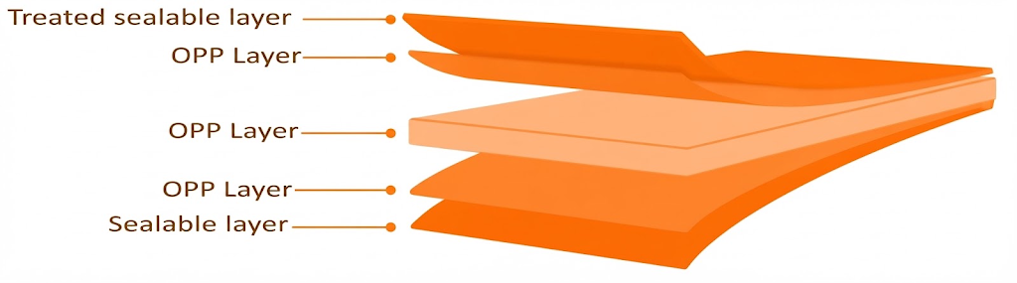
NSH Clear Heat Sealable Film
PRODUCT OVERVIEW
NSH is coextruded BOPP film, heat sealable & high COF suitable for food packaging and intended specially for pouches stacking.

KEY FEATURES
- Excellent transparency & gloss
- Wide sealing range & good seal strength
- Excellent hot tack
- Excellent web flatness
- High mechanical & optical properties
- High stiffness

APPLICATIONS
- General-purpose packaging
- Lamination
- High-quality rotogravure & flexographic printing
TECHNICAL DATA — TYPICAL VALUES
Property |  | Unit | Typical values |  |  |  |  |  |  | Test Method
Thickness |  | µm | 20 | 25 |  | 30 |  | 40 |  | NODA PLAST Lab
Unit Weight |  | g/m² | 18.2 | 22.7 |  | 27.3 |  | 36.5 |  | NODA PLAST Lab
Yield |  | m²/kg | 55 | 44 |  | 36.6 |  | 27.4 |  | NODA PLAST Lab
Wetting Tension |  | Dynes/cm | ≥ 38 |  |  |  |  |  |  | ASTM D2578
Haze |  | % | ≤ 3.5 |  | ≤ 3.5 |  | ≤ 3.5 |  | ≤ 3.5 | ASTM D1003
Gloss 45° |  | % | 86 |  | 85 |  | 82 |  | 82 | ASTM D2457
COF Dynamic F-F (U-U) |  | — | ≤ 0.50 |  |  |  |  |  |  | DIN EN ISO 8295
Tensile Strength | MD | MPa | 150 | 140 |  | 140 |  | 140 |  | ASTM D882
Tensile Strength | TD | MPa | 290 | 290 |  | 290 |  | 290 |  | ASTM D882
Elongation at Break | MD | % | 200 |  |  |  |  |  |  | ASTM D882
Elongation at Break | TD | % | 50 |  |  |  |  |  |  | ASTM D882
Thermal Shrinkage | MD | % | ≤ 5 |  |  |  |  |  |  | BMS TT 0.2
Thermal Shrinkage | TD | % | ≤ 3 |  |  |  |  |  |  | BMS TT 0.2
Heat Seal Range (U-U) |  | °C | 105-140 |  |  |  |  |  |  | NODA PLAST Lab
TECHNICAL NOTES
The numerical values reported in this data sheet are obtained from the average of the values recorded in our laboratory tests. Before final use, we recommend technical tests to ensure the film's suitability for the intended use. NODA PLAST Film is not responsible for inappropriate use of the product, and its liability is limited to the exclusive replacement of the product, excluding any compensation or damages of any kind.

