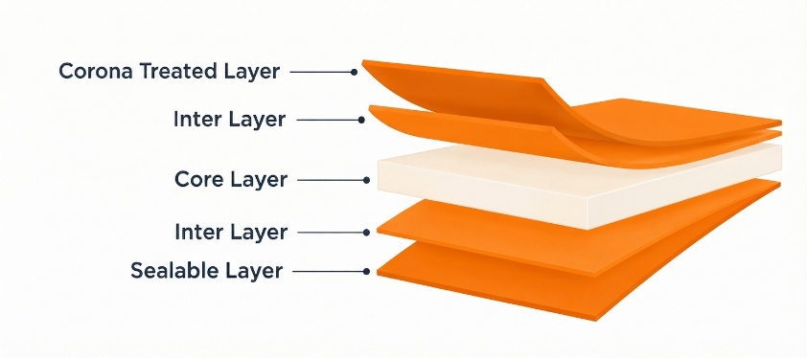
NSW Solid White Sealable BOPP Film
PRODUCT OVERVIEW
NSW is a solid white OPP film specially designed and formulated for food packaging applications. It combines excellent whiteness and gloss with good antistatic properties and reliable heat-sealing performance.
KEY FEATURES
- Excellent whiteness and high gloss
- Good antistatic properties
- Very good heat-sealing performance
- Suitable for demanding food packaging applications
APPLICATIONS
- Biscuit and cookie packaging
- Light- and UV-sensitive food packaging

TECHNICAL DATA — TYPICAL VALUES
Property |  | Unit |  | Typical values |  |  |  |  |  |  | Test Method
Thickness |  | µm | 18 | 20 | 25 |  | 30 |  | 40 |  | NODA PLAST Lab
Unit Weight |  | g/m² | 17.1 | 19.0 | 23.8 |  | 28.5 |  | 38.0 |  | NODA PLAST Lab
Yield |  | m²/kg | 58.5 | 52.6 | 42.0 |  | 35.1 |  | 26.3 |  | NODA PLAST Lab
Wetting Tension |  | dynes/cm | ≥ 38 |  |  |  |  |  |  |  | ASTM D2578
Transmittance |  | % | 44 | 43 |  | 40 |  | 38 |  | 34 | ASTM D 1003
Gloss @ 45° |  | % | 55 | 55 |  | 50 |  | 50 |  | 50 | ASTM D2457
COF Dynamic F-F (U-U) |  | — | ≤ 0.30 |  |  |  |  |  |  |  | DIN EN ISO 8295
Tensile Strength | MD | N/mm | 107 |  |  |  |  |  |  |  | ASTM D882
Tensile Strength | TD | N/mm | 205 |  |  |  |  |  |  |  | ASTM D882
Elongation at Break | MD | % | 220 |  |  |  |  |  |  |  | ASTM D882
Elongation at Break | TD | % | 60 |  |  |  |  |  |  |  | ASTM D882
Shrinkage at 120°C/5min | MD | % | ≤ 5.0 |  |  |  |  |  |  |  | NODA PLAST Lab
Shrinkage at 120°C/5min | TD | % | ≤ 3.0 |  |  |  |  |  |  |  | NODA PLAST Lab
Seal Strength  @ 130 °C 1 bar / 1 Sec | — | N/15mm | > 2.0 |  |  |  |  |  |  |  | NODA PLAST Lab
TECHNICAL NOTES
The numerical values reported in this data sheet are obtained from the average of the values recorded in our laboratory tests. Before final use, we recommend technical tests to ensure the film's suitability for the intended use. NODA PLAST Film is not responsible for inappropriate use of the product, and its liability is limited to the exclusive replacement of the product, excluding any compensation or damages of any kind.

