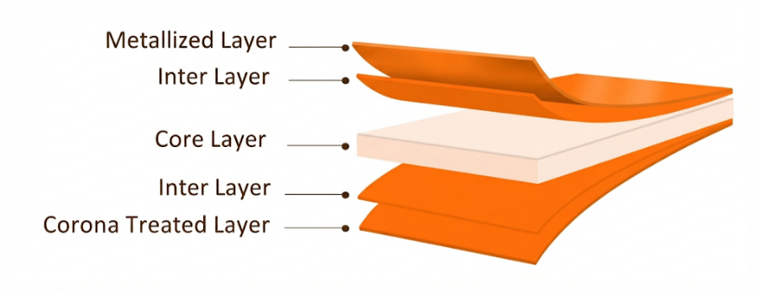
NSM-BM Metallized BOPP Film
PRODUCT OVERVIEW
NSM-BM, is Co-extruded BOPP film, one side metallized and Both side Treated, Film is dedicated for Trible Lamination and has moderate barrier suitable for food packaging as well goods with general use.

KEY FEATURES
- Excellent metal adhesion & homogeneous deposition
- Excellent web flatness

APPLICATIONS
- General-purpose packaging
- Triple lamination

TECHNICAL DATA — TYPICAL VALUES
Property |  | Unit | Typical values |  | Test Method
Thickness |  | µm | 18 | 20 | DIN ISO 4593
Unit Weight |  | g/m² | 16.4 | 18.2 | NODA PLAST Method
Yield |  | m²/kg | 60.97 | 54.9 | NODA PLAST Method
Wetting Tension |  | mN/m | ≥ 38 |  | ASTM D2578
Optical Density |  | — | > 2 |  | Modus T&D (T= Transmitted light)
OTR (23°C-0% RH |  | cc/(m2*day*atm) | < 80 |  | ASTM D3985
WVTR (38°C-90% RH) |  | g/(m2*day*atm) | < 0.8 |  | ASTM F 1249
COF Dynamic F-F (U-U) |  | — | ≤ 0.30 | ≤ 0.31 | DIN EN ISO 8295
Tensile Strength | MD | MPa | 150 |  | ASTM D882
Tensile Strength | TD | MPa | 290 |  | ASTM D882
Elongation at Break | MD | % | 180 |  | ASTM D882
Elongation at Break | TD | % | 60 |  | ASTM D882
Thermal Shrinkage | MD | % | ≤ 5 |  | Noda-Plast Method
Thermal Shrinkage | TD | % | ≤ 3 |  | Noda-Plast Method
TECHNICAL NOTES
The values in this Technical Data Sheet are typical or average values for reference only and are not guaranteed specifications. Actual values may vary due to normal manufacturing tolerances.
Customers are responsible for verifying the film’s suitability for their specific application and processing conditions. NODA PLAST makes no guarantee regarding the stated typical values or their suitability for a particular use.
STORAGE, HANDLING AND APPLICATION
Store NODA NSM-M / NSM-MB metallized film in a clean, dry, well-ventilated area below 30°C, protected from sunlight, heat, moisture, and temperature fluctuations.
Use FIFO (First-In, First-Out) stock management. Before processing, condition the film for at least 24 hours in the operating environment.
Recommended use: within 3 months of production, when stored under the recommended conditions.

