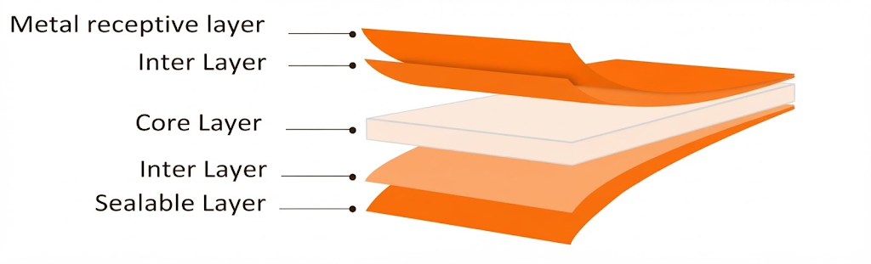
NSMM-M Metallized BOPP Film, One Side C. T
PRODUCT OVERVIEW
NSMM- M is coextruded BOPP film, one side heat sealable, other side metallized, moderate barrier suitable for food packaging and goods with general use.

KEY FEATURES
- Excellent metal band & homogeneous metal deposition
- Wide sealing range & good seal strength
- Excellent hot tack
- Excellent web flatness
- High mechanical properties & stiffness
APPLICATIONS
- General-purpose packaging
- Lamination
- High-quality rotogravure & flexographic printing
TECHNICAL DATA — TYPICAL VALUES
Property |  | Unit | Typical values |  |  |  | Test Method
Thickness |  | µm | 18 | 20 | 25 | 30 | DIN ISO 4593
Unit Weight |  | g/m² | 16.4 | 18.2 | 22.75 | 27.3 | NODA PLAST Lab
Yield |  | m²/kg | 60.97 | 54.9 | 43.9 | 36.6 | NODA PLAST Lab
Wetting Tension |  | mN/m | ≥ 38 |  |  |  | ASTM D2578
Optical Density |  | — | > 2 |  |  |  | Modus T&D (T= Transmitted light)
OTR (23°C-0% RH |  | cc/(m2*day*atm) | < 80 |  |  |  | ASTM D 3985
WVTR (38°C-90% RH) |  | g/(m2*day*atm) | < 0.8 |  |  |  | ASTM F 1249
COF Dynamic F-F (U-U) |  | — | ≤ 0.30 | ≤ 0.31 | ≤ 0.32 | ≤ 0.30 | DIN EN ISO 8295
Tensile Strength | MD | MPa | 150 |  |  |  | ASTM D882
Tensile Strength | TD | MPa | 290 |  |  |  | ASTM D882
Elongation at Break | MD | % | 180 |  |  |  | ASTM D882
Elongation at Break | TD | % | 60 |  |  |  | ASTM D882
Thermal Shrinkage | MD | % | ≤ 5 |  |  |  | BMS TT 0.2
Thermal Shrinkage | TD | % | ≤ 3 |  |  |  | BMS TT 0.2
TECHNICAL NOTES
The numerical values reported in this data sheet are obtained from the average of the values recorded in our laboratory tests. Before final use, we recommend technical tests to ensure the film's suitability for the intended use. NODA PLAST Film is not responsible for inappropriate use of the product, and its liability is limited to the exclusive replacement of the product, excluding any compensation or damages of any kind.

