????? ?????? ????? Gamification ????? ?????? ?????? ?? VitaMate
??? ??????? ???? ??????? ????????: ????? ???????? ?????? ?????? ?? ?? ???? ???? ??? UML/flow ???? ???? ??? ????? ?????? ?? ????? ?????? ??? ??? ??? UserScore ?? ????? ?????? ?? ???????.
????? ???????: 2026-05-08 11:17
1. ?????? ?????? ??????
?????? ??????? ??? gamification ?? ???? UserScore. ??? ?????? ???? total_points ? level ??? ??? ??????. ?? ???????? ????????? ??? ??? PointsService? ????? ????? ???? ??? ???????? ?? UserScoreRepository ?? ???? add_points ?? deduct_points.
???????? ??????? ??????? ?????: level = floor(total_points / 1000) + 1. ??????? ?? 0 ??? 999 ???? ???? Level 1? ?1000 ??? 1999 ???? Level 2? ?????.
?????? ????: ????? ???? total_points ???? ?? ???? ???? ??????? ??????. ???? ??????? ?? ??????? ?????? ???? ?? ???????? ???? ?? ???? ???????? ?? ?????.
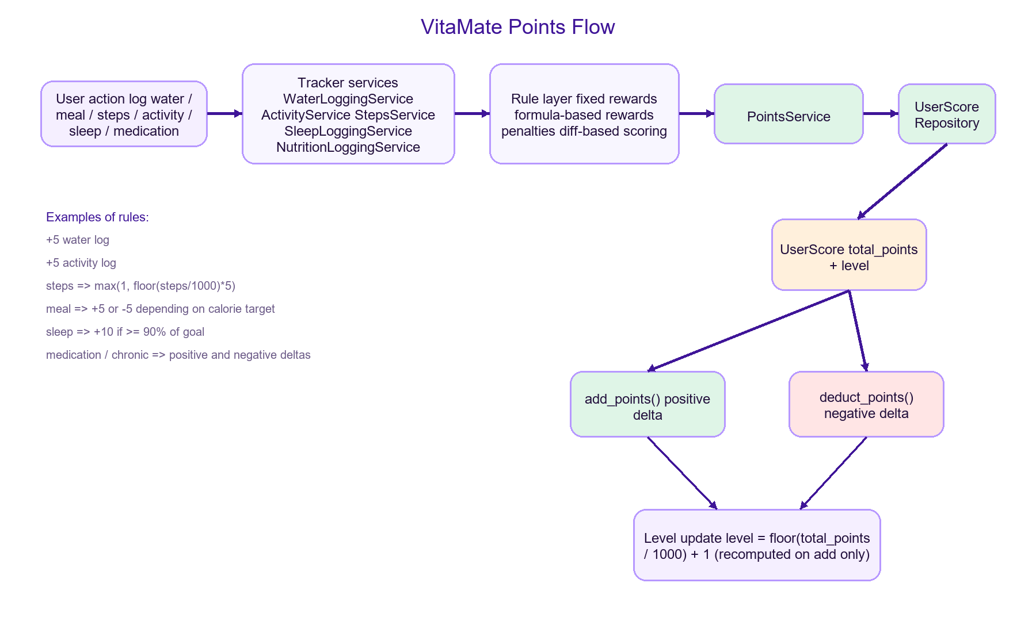
??? 1: ?????? ????? ?????? ?? ??? ???????? ??? ????? UserScore.
2. ??? ??? ?????? ??? UserScore
?? ??? ???? ?? ???? ?????? ?????? ????? ?????: ???? ????? ?????? ???? ?????? ?????? ?????? ?? ????? ?????. ??? ?????? ???? ????? ?????? ????????? ?? ?????? PointsService. ??? ??? ???? PointsService ??? ???????? ?????? ?? ????? ??? ?? ??? ???????? ?? ???? ?? ???? ??????? ????? total_points ????? level.
??? ????? ??????? ???? ?????? ????? ??? ???? Health State. ??? ????? ?? ???? UserScore ??????? ???? ???? ????? ??? read models ????????? ??? ???? ????? ??????? ?? Home ? Activity ? Stats ??????.
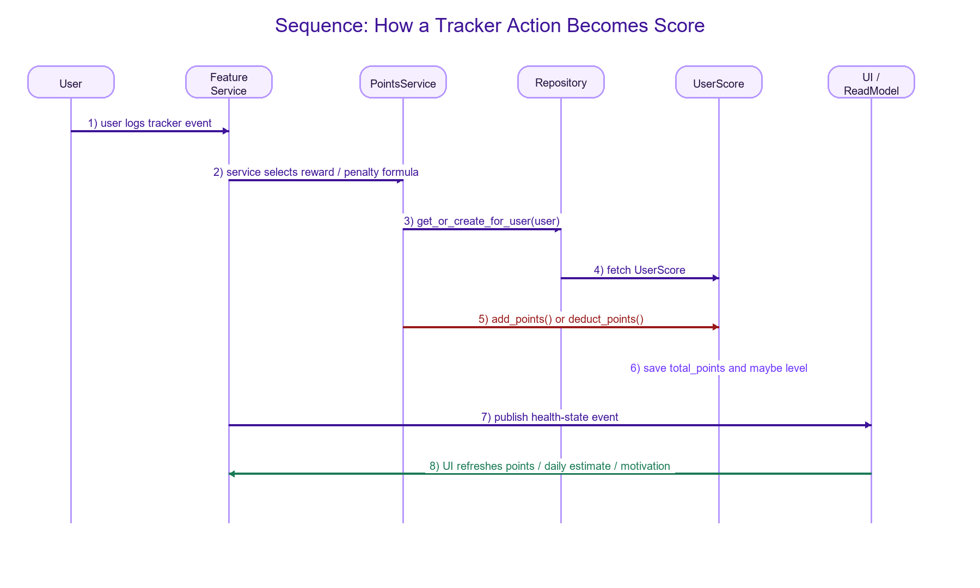
??? 2: Sequence ???? ???? ??? ????? ??????? ??????? ??? ???? ?? ??? ????? ????? ????????.
3. ????? ?????? ?????? ??? ?????
? ?????: ?? WaterLog ???? ???? +5 ????. ??????? ?? ????? ?? ???? ?????? ???????.
? ?????? ??????: ?? ActivityLog ???? ???? +5 ????. ?? Live Workout ?? ???? ???? ??? start? ?????? ???? ??? finish ??? ?????? ????? ??? ActivityLog.
? ???????: ???????? ?? max(1, floor(steps_count / 1000) * 5). ??? ?????? ?????? ??? ????? ????? ?????? ????? ??? ?? log_steps? ???? ??? ????? ???.
? ?????: ??? ??? ??? SleepLog ?? ??? ????? ???? 90% ?? ???? ?? ??? ?????? ???? ???????? ??? +10 ????.
? ???????: ??? ?? MealLog ????? ???? ?????? ????? ?????. ??? ???? ??????? ??? ????? ???? +5? ???? ?????? ????? ???? -5.
? ??????? ??? ??????: ???? +2 ???????? +3 ??? ??? ???????? ??? ????? +4 ??? ??? healthy replacement? ? +5 ??? ???? ?? baseline. ??? ??? ??????? ???? ??? ??? log? ?????? ??? ??? ???.
? ???????: taken_on_time = +3? taken_late = +1? missed = -2? skipped = 0? ? skipped ???? ??? = -1.
? ??????? ???????: ????? ???????? ?????? ?? ???? +5 ?? -3? ??????? ?????? ?? ???? +5 ?? +1 ??? ???? critical? ??? ???? ?????? streak ??????? ??????? ?????.
4. ?????? ??????? Level
??? Level ?? ????? ??? daily_points ??? ??? health score. ??????? ????? ??? ??? total_points ??????? ???? UserScore. ?? 1000 ???? ????? ???? ??????? ?????? 1.
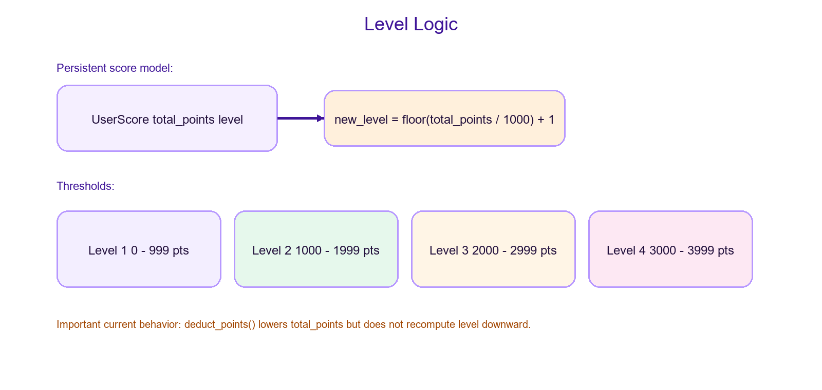
??? 3: ???? ??????? ?????? ??????? ??? total_points ???.
5. stored score ????? daily estimate
???? ??? ????? ??? ?????? ???????? ??????? ???? ?????? ??????? ???????? ?? ???????. total_points ? level ??? ??????? ??????. ??? daily_points ?? points_estimate ??? ????? ??????? ????? ????? ?? ???? ????? ???????.
?????? estimate_day_points ??????? ????: +5 ??? ???? ???? +???? ??????? ??? steps > 0? +5 ??? ???? ????? +5 ?? -5 ??? ??? ???????? ? +10 ??? ???? ??? ????? ????? 90% ?? ????. ?? ???? medication_points ?????? points_estimate ??????.
???? ?? ??? ?? ??????? ??????? ??? points ?? daily_points ?? points_estimate ?? ??? Daily Health Score? ???? ???? ????? ??????? ??????.
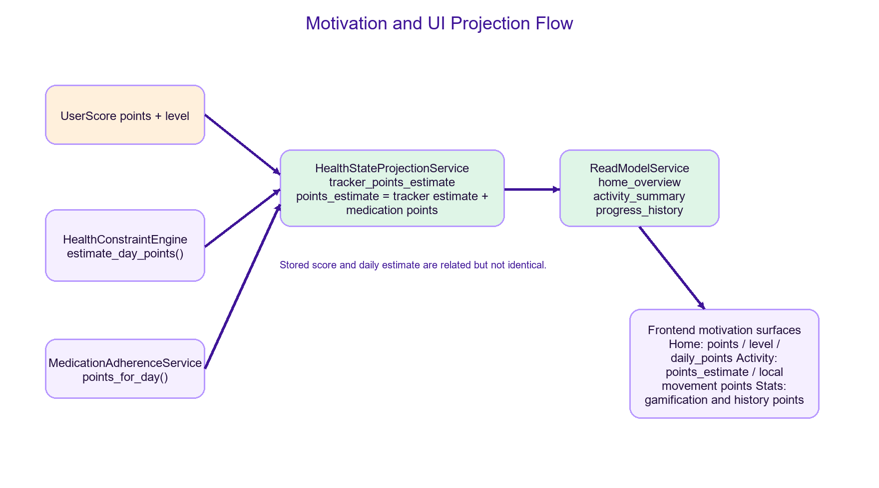
??? 4: ??? ????? ????? ????????? ??????? ?? ???? projections ?? ????? ?? Home ? Activity ? Stats.
6. ??????? ?? ???????
?? Home Overview ????? ????? ??????? ?????? ?? ???????: points ?????? ?? UserScore? ? level ?? UserScore? ? daily_points ?? projection ??????. ?? Activity ????? points_estimate ?????? ?????? ?? ????? ???? ???? ??? ??????? ???????? ???????. ?? Stats/Progress ????? gamification totals ???????? ??? history points_estimate ??? ???.
??? Daily Health Score ?? Home ??? ??? UserScore? ?? ???? ?? healthScore ??????? ?? activity/hydration/nutrition/sleep ?????? ???? dailyPoints ?? ???? ??? 0 ? 100. ???? ??? ??? ????? ??? Health Score ? Gamification Points.
7. ???? ??????? ??????? ????????
??? ?? ?????? ?????? ????? ???????? ?? ?????? ??????. ??? ?? ??? ??????? ?? ????? ???? ???? ???? ?? ??? ???? desired_points ?????? ?? ??? points_applied ??????? ?????? ??? points_diff. ???? ??????? ??? ????? ???? ?????? ?? ???? ????? ?????? ??? ??? ?????? ????? ??? ????? ???? ?????? ??? ?????? ?? ????? ??? ?????.
?????? ???????? ??? ?? ?? ????? ?????? ?? ConditionPointsAudit ?? ????? ?????? ???? metadata? ???? ???? ???? ????? ???? ?? ???? ?????? ?? ??? ????? ???????.
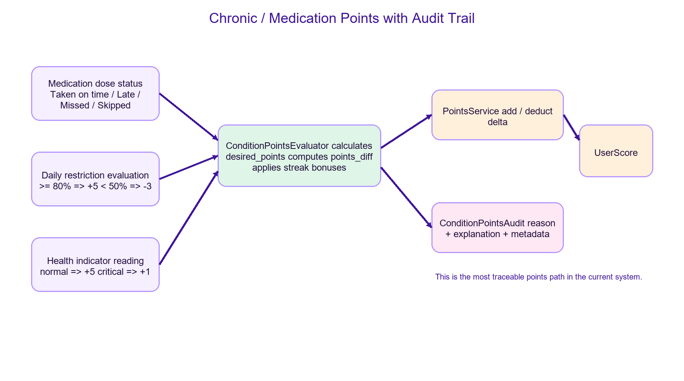
??? 5: ???? ???? ??????? ???????? ??????? ?? audit trail ?????? ??? deltas ???? streak bonuses.
8. ???? ????? ??????? ?????? ???? ??? ???????? ??
? ?????? ?????? ???? ????? ?? ????? ??????? ??????? ???? ???? ???? ????????.
? chronic ? medication ?????? ???? ????? ?????? ???????? diff-based scoring ? audit trail.
? steps ?? ???? ?????? ?????? ??? ?? ??? sync ???? ?? ??? ??? ??? ???????? ??????? ??? ????? ??? ??? ??????? ?????? ?? ??? ??????? ???.
? meal points ????? ?? ?? ????? ???? ???? ?????? ??????? ??????? ???? ???? ?? ???? ?????? ??????? ?????? ?? ??? ?????.
? update/delete ?? ??? ??????? ?? ?????? ???? ?????? ???????? ???? total_points ?? ???? ?????? reconciliation ????.
? level ?? ???? ??? ?????? ???? ???? ??????? ???????? ??? ?? ??????? ??????.
? ??? ????? ????? ?? ????? ???? ????? ???? ?????? ?? score ?????? ???? ?????? ????? rule ??? backend ? read model ? frontend ??????.
9. ??????? ???????? ???????? ???? Gamification
? gamification/services/points_service.py
? gamification/models.py
? core/services/tracking/activity_service.py
? core/services/tracking/steps_service.py
? core/services/tracking/sleep_service.py
? core/services/hydration/water_service.py
? core/services/nutrition/nutrition_service.py
? core/services/habits/unhealthy_habit_service.py
? core/services/chronic/condition_points_evaluator.py
? core/services/orchestration/health_state_projection_service.py
? core/services/orchestration/read_model_service.py
???????
???? gamification ?? VitaMate ???? ??? ?????: ????? ????? ???? ???? UserScore? ????? ??? ????? ??????? ????? ??? points_estimate ? daily_points. ?????? ???? ?? ????? ?????? ????????? ??? ??? PointsService? ?? ???? ?? UserScore? ?????? ????? ??? ??????? ??? read models ? projections. ???? ???? ?????? ?? chronic/medication ???? ???? ???? ?????? ?????? ???? ????? ????? ????? ???? ??????? ???? ????? ????? ???????? ??? reconciliation ??? ????? ??????? ?? ????????? ??? ??????? ???????? ???????.

Appendix: English Diagram Labels
Figure 1: Overall points flow from user action to UserScore.
Figure 2: Sequence of score update from feature service to UI refresh.
Figure 3: Level thresholds and current level recomputation behavior.
Figure 4: Motivation/UI projection flow for points, daily estimate, and score surfaces.
Figure 5: Chronic and medication scoring path with audit trail.

