Deadwood - measurements and calculations
(Field Guide)

Kamil Král, Dušan Adam, David Janík, Libor Hort, Pavel Šamonil, Pavel Unar, Tomáš Vrška

The Silva Tarouca Research Institute for Landscape and Ornamental Gardening, Department of Forest Ecology, Lidická 25/27, CZ-60200 Brno, Czech Republic

1. Deadwood types measured

All objects of deadwood measured in our study sites can be sorted by two binary classifications into the “Standing/Lying” and “Whole/Broken” class. According to their combination and other attributes (namely height) we distinguish the following principal deadwood types (tab. 1). These deadwood types may differ in the way of measurement, recorded attributes (tabs. 2, 3, 4) and volume calculation. In accordance with the living trees, the deadwood volume calculation always refers to the volume of stems only (not total above ground biomass of trees). Therefore, the lying branches are not measured. The key issue of the approach is however to keep the information on deadwood linked directly to tree individuals till their final decomposition. This allows assessing the tree species life-cycle on the level of individuals.

Deadwood type | GIS layer | GIS Repre-sentation | Diameter measurement | Volume calculation
Whole (complete) dead standing tree | Standing stems | Point | DBH | DBH allometric equation
Broken dead standing stem (snag) | Standing stems | Point | DBH, top diameter | DBH allometric equation
Whole (complete) dead lying tree | Lying stems | Polyline | DBH | DBH allometric equation
Base part of dead lying stem (fragment A) | Lying stems | Polyline | DBH, top diameter | DBH allometric equation
Further parts of dead lying stem (fragments B, C, D etc. …) | Lying stems | Polyline | Bottom & top diameter | Truncated cone / allometric equation
Stump | Stumps | Point | None | None
Tab.1 Deadwood types measured.

1.1. Whole dead standing tree
The whole dead standing individual with the preserved (complete) main stem (fig.1b).

Field measurements: diameter at the breast height (DBH; see fig.1b); height only optionally.

Volume calculation: forestry allometric equation using DBH, tree height and stem form factor, i.e. the same calculation as for whole living tree. The height is usually not measured, the fitted height of the height curve of the tree species in the stand is used instead.

1.2. Broken dead standing stem (snag)
A dead standing tree with the missing part of the main stem (i.e. snag). The snag is considered to be a stem remainder higher than 1.3 m with height records rounded to decimeters (fig.1d).

Field measurements: DBH, top diameter and height (see fig.1d). The top diameter can be measured on the ground (as a bottom diameter of a following fragment), if the following (unmistakable) stem part is lying nearby (e.g. fig.4, STEM_ID = 1, PIECE_ID = A and B).

Volume calculation: forestry allometric equation modified for a stem part. The DBH, top diameter, snag height and stem form factor are used.

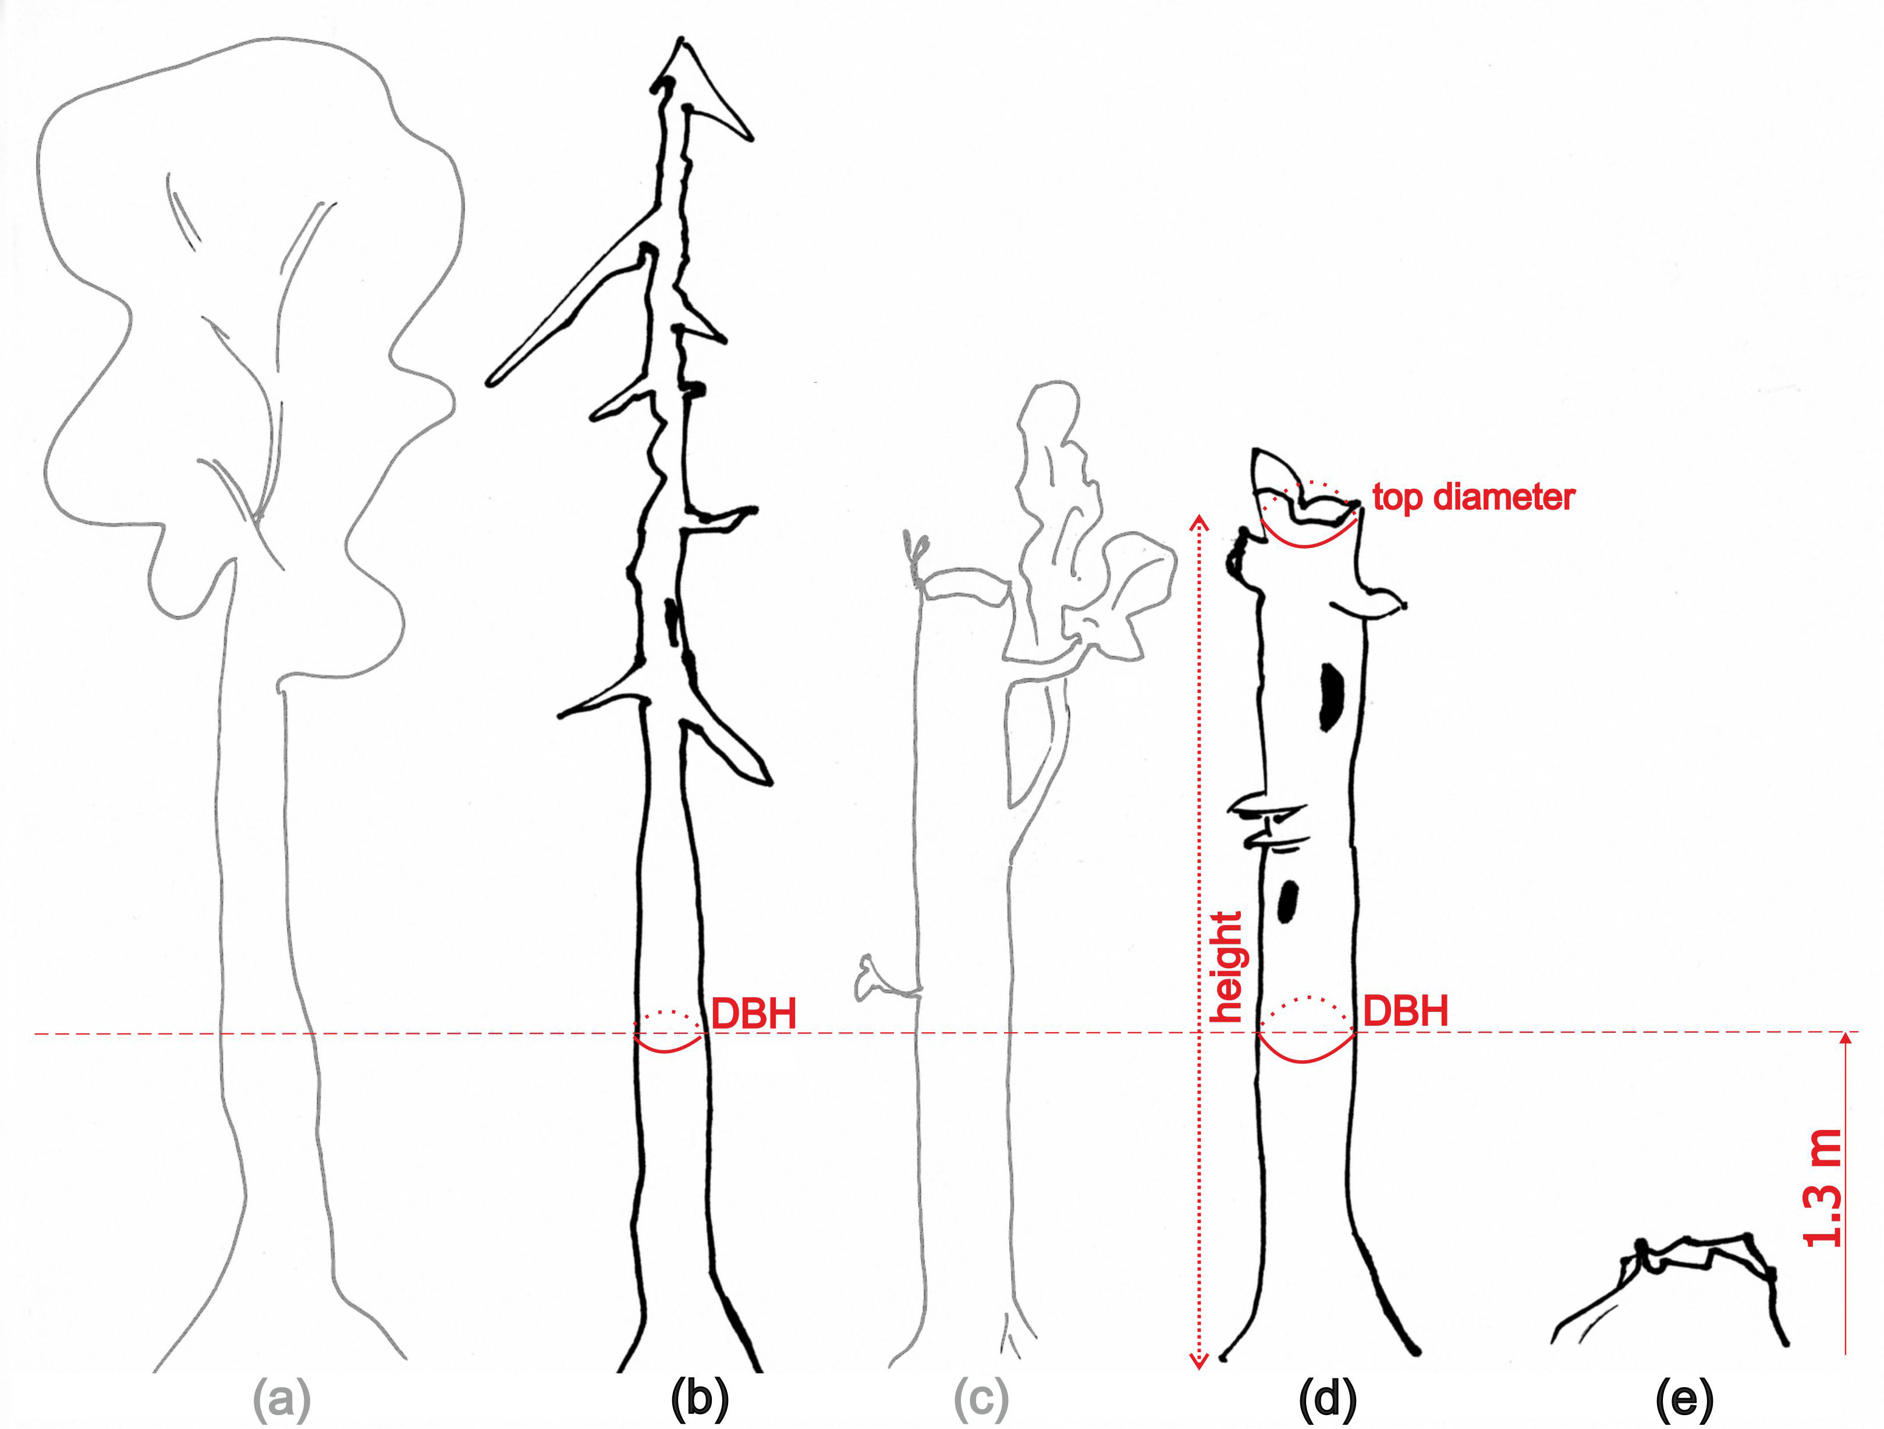

Fig.1: Living trees (in gray), standing deadwood (in black) and the attributes measured (in red): a) whole live standing tree; b) whole dead standing tree; c) broken living standing tree (breakage) - does not belong to deadwood!; d) broken dead standing stem - snag; e) stump.

1.3. Whole dead lying tree
The whole (complete) lying tree or the stem preserved till the top (fig.2a).

Field measurements: DBH; X,Y,Z coordinates of the stem bottom (above the root system) and the tree top (including the thin branches, if still present). As we record the orientation of the lying deadwood, the bottom and the top must be distinguished. Even fragmented stems may be recorded as whole lying tree, if all the fragments compose the complete stem (till the tree top) and their position preserve the continuity (fig.3c). In this case the X,Y,Z coordinates of the breakpoints should be measured as well. The length is not measured in the field, as being calculated in GIS from real X,Y,Z coordinates of the tree bottom and the tree top (possibly the breakpoints). Note: This could be a problem, if the planar system is used and only X,Y coordinates recorded (than the calculated length would not be real, but the length of the planar projection). The deadwood with and without breakpoints is treated equally, i.e. even when breakpoint coordinates are measured, the deadwood still has only one record in database, only DBH is measured and the volume calculation is the same as without breakpoints.

Volume calculation: forestry allometric equation using DBH, tree height (in this case the tree length from GIS) and the stem form factor, i.e. basically the same calculation as for whole living tree.

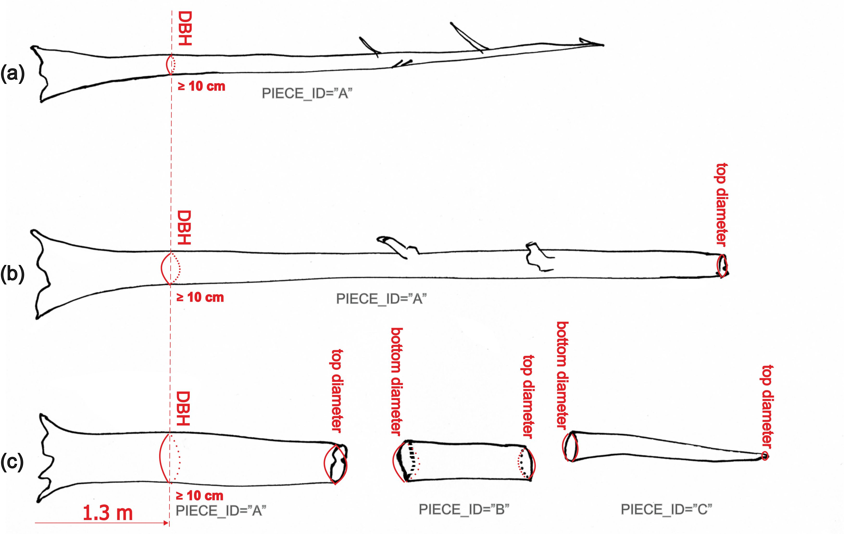

Fig.2: Lying deadwood (in black) and the attributes measured (in red): a) whole dead lying stem – complete; b,c) parts of dead lying stem – fragments.

1.4. Base part of dead lying stem (fragment A)
The base part of a lying stem (butt) with threshold DBH ≥ 10cm (fig.2b,c). All the stem base parts and only the stem base parts have always the PIECE_ID = “A”, therefore referred in the text also as “fragment A” or “base fragment” (see also the table 3). This kind of lying stem fragment is specific as the DBH is measured there and basal area may be calculated on it.

Field measurements: DBH and top diameter; X,Y,Z coordinates of the bottom and top (distinguishing them). Even multiply fragmented stem part may be recorded as one fragment, if the sub-parts preserve spatial continuity (fig.3e). In this case the X,Y,Z coordinates of the breakpoints should be measured as well. The length is not measured in the field, as being calculated in GIS from real X,Y,Z coordinates of the fragment bottom and top (possibly the breakpoints). Note: This could be a problem, if the planar system is used and only X,Y coordinates recorded (than the calculated length would not be real, but the length of the planar projection). The deadwood with and without breakpoints is treated equally, i.e. even if breakpoint coordinates are measured, the deadwood still has only one record in database, only DBH and the top diameter are measured and the volume calculation is the same as without breakpoints.
Volume calculation: forestry allometric equation modified for a stem part. The DBH, top diameter, fragment length (calculated in GIS) and stem form factor are employed.

1.5. Further parts of dead lying stem (fragments B, C, D, …)
Any further parts of the lying stem follow up (above) the stem base of DBH ≥ 10cm (fig.2c – PIECE_ID = “B” and “C”). The branches, however, are not measured (see also fig.4).

Field measurements: bottom and top diameter; X,Y,Z coordinates of the bottom and top (distinguishing them). Even multiply fragmented stem part may be recorded as one fragment, if the sub-parts preserve spatial continuity (fig.3e). If breakpoint coordinates are measured, the stem fragment still has only one record in database, only one bottom and one top diameter are measured and the volume calculation is the same as without breakpoints.

Volume calculation: general truncated cone equation using the bottom diameter, top diameter and the fragment length that is calculated in GIS (or still allometric equation).

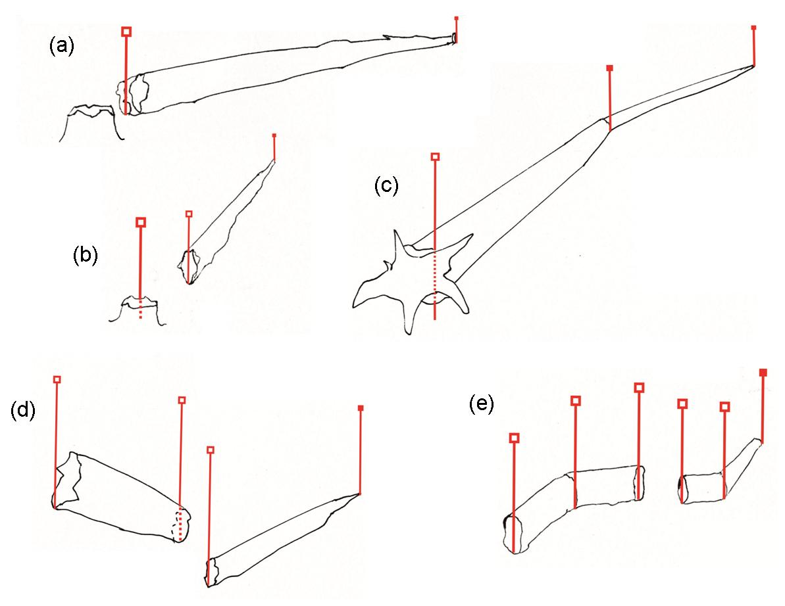
Fig.3: Measuring lying deadwood coordinates - laying the range pole (in red) to a stem: a) deadwood lying close to the stump – coordinates of the stump are not measured; b) deadwood lying far from the stump – coordinates of the stump are measured and the tree and stem ID recorded; c) whole dead lying stem with one breakpoint; d) two fragments of dead lying stem; e) two fragments of dead lying stem with one breakpoint each.

1.6. Stump
A stem base part (or its remnant) left ‘standing’ after the tree fall, which is lower than1.3 m (fig.1e). The stump survey has basically two reasons:

1) To find and keep original stem position prior to its fall if the position of the bottom of lying deadwood and its stump are significantly different (see fig.3b). This is important especially in case of sloping terrain, when the stem roll down after the tree fall. The stump carries information on original stem position. This information is used in some kind of spatial analysis, where the place of origin (growth) of current deadwood is more important than a place of actual deadwood deposition. The X,Y,Z coordinates and tree and stem IDs are hence recorded for the stump (table 4).

2) To document some accidental felling of trees in the past, if present (cutting surfaces are still traceable on stumps at some less preserved study sites). These stumps are differentiated in the database as ‘artificial’ and its possible to take them in consideration if required (e.g. disturbance history analysis).

The stumps are plotted in the stem map (using a cross instead of standard tree mark) just to improve the orientation in the field.

Field measurements: X,Y,Z coordinates.
Volume calculation: none

2. Recorded attributes

Properties of deadwood elements are described through recorded attributes (tables 2, 3 and 4) organized in appropriate GIS layers (see tab.1). The X,Y,Z coordinates are not explicitly listed in the attribute tables, although they are inherent part of any object recorded in the GIS layer and may be retrieved on demand.

Attribute | Type, Dimension,  Decimal places | Data source | Whole stem | Snag
DBH_CM | Numeric:3:0 | Measurements | Yes | Yes
TOP_DIAMETER_CM | Numeric:3:0 | Measurements | No | Yes
HEIGHT_M | Numeric:4:1 | Measurements | Sample | Yes
TREE_ID | Numeric:6:0 | Measurements | Yes | Yes
STEM_ID | Numeric:2:0 | Measurements | Yes | Yes
PIECE_ID | Text:1 | Measurements | Default “A” | Default “A”
SPECIES | Text:4 (Lookup table) | Measurements | Yes | Yes
VITALITY | Text:1 (Lookup table) | Measurements | Yes | Yes
INTEGRITY | Text:1 (Lookup table) | Measurements | Yes | Yes
DECOMPOSITION | Text:1 (Lookup table) | Measurements | Yes | Yes
FITTED_HEIGHT_M | Numeric:4:1 | Calculations | Yes | No
BASAL_AREA_M2 | Numeric:6:4 | Calculations | Yes | Yes
VOLUME_M3 | Numeric:5:2 | Calculations | Yes | Yes
Tab.2 Attributes of Standing deadwood.

Attribute | Type, Dimension,  Decimal places | Data source | Whole stem | Base fragment | Further fragments
DBH_CM | Numeric:3:0 | Measurements | Yes | Yes | No
BOTTOM_DIAM_CM | Numeric:3:0 | Measurements | No | No | Yes
TOP_DIAMETER_CM | Numeric:3:0 | Measurements | No | Yes | Yes
LENGTH_M | Numeric:4:1 | Automatic (GIS) | GIS | GIS | GIS
TREE_ID | Numeric:6:0 | Measurements | Yes | Yes | Yes
STEM_ID | Numeric:2:0 | Measurements | Yes | Yes | Yes
PIECE_ID | Text:1 | Measurements | Default “A” | Default “A” | Yes
SPECIES | Text:4 (Lookup tab.) | Measurements | Yes | Yes | Yes
INTEGRITY | Text:1 (Lookup tab.) | Measurements | Yes | Yes | Yes
WINDTHROW | Text:1 (Lookup tab.) | Measurements | Yes | Yes | No
DECOMPOSITION | Text:1 (Lookup tab.) | Measurements | Yes | Yes | Yes
BASAL_AREA_M2 | Numeric:6:4 | Calculations | Yes | Yes | No
VOLUME_M3 | Numeric:5:2 | Calculations | Yes | Yes | Yes
Tab.3 Attributes of Lying deadwood.

Attribute | Type, Dimension, Decimal places | Data source
TREE_ID | Numeric:6:0 | Measurements
STEM_ID | Numeric:2:0 | Measurements
ORIGIN | Text:1 (Lookup table) | Measurements
Tab.4 Attributes of Stumps.

The brief explanation of recorded attributes follows:
HEIGHT_M … standing stem height in meters
LENGTH_M … lying stem length in meters
DBH_CM … stem diameter at the breast height (1.3 m) in centimeters
BOTTOM_DIAM_CM … stem fragment diameter at the bottom end in centimeters
TOP_DIAMETER_CM … stem fragment diameter at the top end in centimeters

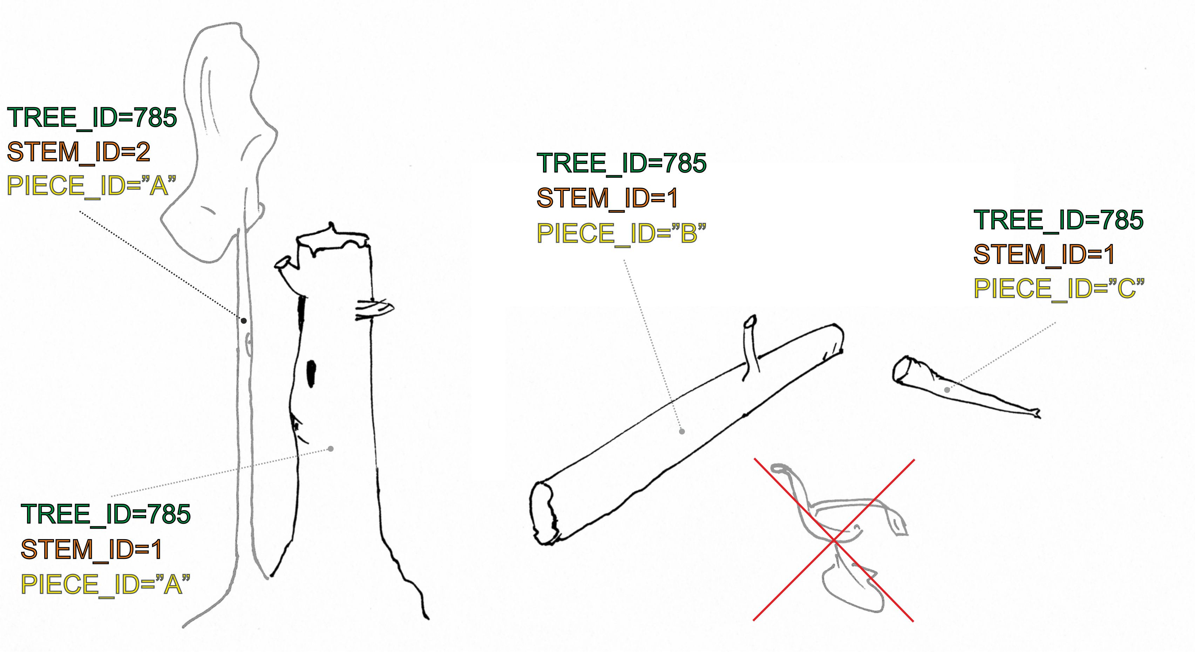
Fig.4: Identifying deadwood objects measured (in black) – example of two-stem tree No. 785, stem No. 1 is dead, stem No. 2 is still living; branches are not measured.

The unique identifier is built as the “trinity” of the identifying attributes: TREE_ID, STEM_ID and PIECE_ID (see tab.2, 3 and fig.4):
TREE_ID … unique identifier of a tree (within the plot) used for life-cycle tracking. Even if the tree is completely decomposed (disappears), once used TREE_ID is never used again.
STEM_ID … unique identifier of a stem (within the tree)
PIECE_ID … unique identifier of a fragment (within the stem). One letter is used in alphabetic order (e.g. A, B, C, D etc.). The “A” identifier is reserved for the stem base parts only. The linkage among fragments of one stem and stems of one tree is depicted in figure 4.
Such ID system allows keeping the link among different parts of one individual (either single or multi-stem tree), even if some parts are standing and others lying (and/or some are dead and some are still living). It also allows to evaluate the way of dying (standing/ falling) and falling of deadwood on the ground (all at one/ by parts). Above all it allows to follow the whole life cycle of individuals, including their decomposition.

SPECIES … tree species code (use relevant lookup table)

VITALITY … attribute determines whether stem element lives or does not live
“L” value –Living
“D” value – Deadwood

INTEGRITY … attribute showing completeness of a stem (see figs.1 and 2)
“C” value – Complete dead tree or completely preserved stem.
“F” value – Fragment of dead stem.

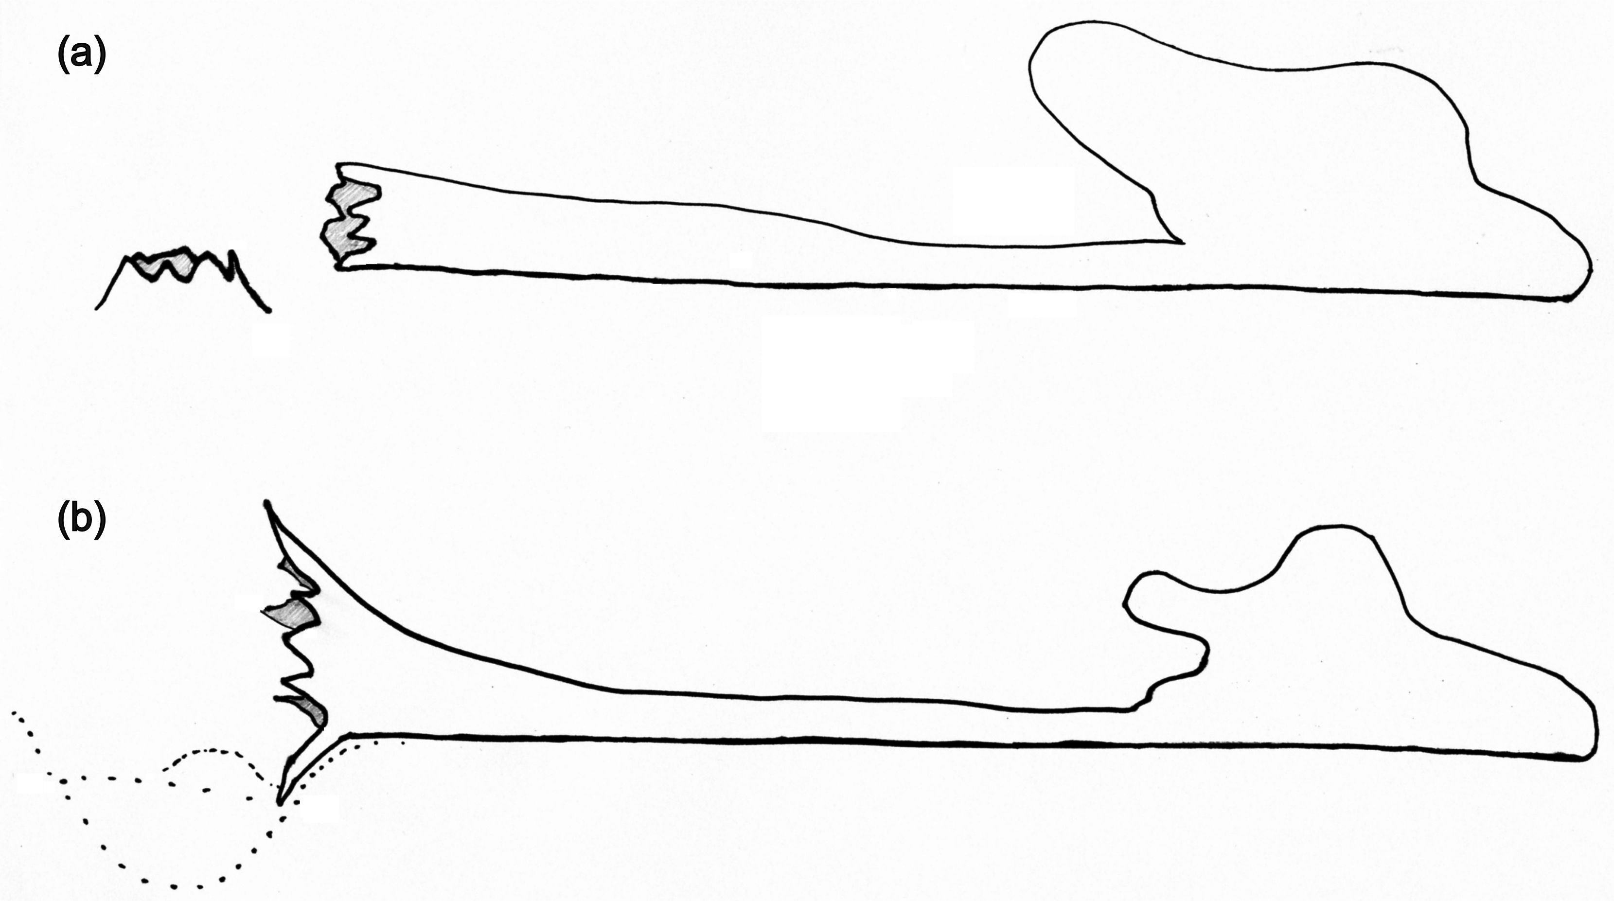

Fig.5: Lying deadwood base types: a) the non-windthrow; b) the windthrow.

WINDTHROW … attribute differentiates type of lying deadwood base according to the way of its fall – disturbance event: windthrow /non-windthrow (fig.5). It’s recorded for disturbance ecology studies.
“N” value –Non-windthrow (snag/stump remains)
“W” value – Windthrow (no stag/stump remains; while a pit/mound micro-relief is created).

DECOMPOSITION … there are three degrees of decay distinguished for the deadwood measured:
“H”value – hard: the species is still recognizable, the stem usually still has bark (not necessarily) and relatively healthy and hard wood (still hard woody biomass is the main distinctive feature).
“T”value – touchwood: the species can usually still be identified, the wood is not compact any more along the entire stem length with the core or outer mantle subjected to rot. Touchwood is relatively widely defined class, in practice everything that does not belong to ‘hard’ neither ‘disintegrated’ class.
“D” value – disintegrated: the wood is at a stage of advanced rot, the species cannot be identified any more, a kick into a stem results in stem breakage, there are often just “little graves” with the patchy vegetation. Note: When the disintegrated deadwood lost the cylindrical shape, the diameters are estimated only if it is the first census of the deadwood. In case of re-measurement, the diameters of the previous census are used. The deadwood length is always (re)calculated (from re-measured bottom and top coordinates).
If one stem or fragment exhibits more degrees of decay, the predominant decay degree is decisive.

ORIGIN … stump origin
“N” value – natural origin of stem fall
“A” value – artificial origin of stem fall (cut)

FITTED_HEIGHT_M … attribute calculated in PraleStat software (see http://pralestat.wz.cz) according to Naeslund’s regression function.
BASAL_AREA_M2 … attribute calculated in PraleStat software (see http://pralestat.wz.cz), area of circle is used for basal area estimation.
VOLUME_M3 … attribute calculated by PraleStat software (see http://pralestat.wz.cz), volume of particular deadwood types are calculated differently, as indicated in the text above.

