**First Draft of the ForestGEO Dead Wood Census Protocol**

**Blue Cats (David Janík, Kamil Král, Dušan Adam, Tomáš Vrška) & James Lutz**

1. **Introduction**

The condition of dead woody stems should be tracked from the time of tree death to the time of final decomposition. After stems die, the wood persists in the ecosystem, either as standing deadwood or woody debris on the ground. Deadwood plays the important role in the forest ecosystems, providing significantly different substrate, nutrient source, and microclimate to seedlings. Measurements for dead material on the forest floor can be used to estimate biomass and carbon pools in various categories etc. The current ForestGEO protocol captures the death of woody stems, but does not follow the decomposition process. Here we suggest methods to continue to follow the status of individual woody stems after the mortality and so extend the observation to the whole period of the woody stem existence in a forest ecosystem.

Specific deadwood dynamics (i.e., those tied to the original stem tag) are tracked only for the main stem, not branches. Calculations of dead wood volume, biomass, and carbon are made using allometric equations based on the diameter at breast height (hereafter DBH) of the main stem (similarly as for living trees, where the branches also remain unmeasured). This approach allows fundamental comparability of values derived for living and dead trees. For trees of the DBH equal or above to 10cm (hereafter census limit), that die after the plot establishment, pieces are tracked by linking them with the original tree and stem identification. For snags or logs above the census limit that have been already present at plot inception, those pieces of wood that are not clearly associated with tagged stems are measured, mapped and tagged.

BOX 1: Other dead tree parts (large branches, small branches, and leaves) are not considered individually, but can be sampled through representative transects. transect sampling for surface carbon pools is not included in this protocol document.

The logs above the census limit should be entered into a Geographic Information System (GIS), with additional tabular data taken that allows the woody debris to be mapped and its volume calculated. Sites not using a GIS can approximate the position of woody debris with the coordinates of the endpoints. Logs with DBH under the mapping limit of 10cm are not recorded.

ForestGEO Deadwood protocol is projected as the extension of Condit’s methodology and follow up standard CTFS protocol of live/standing trees census (Condit et al. 1998). Object of dead wood census are ‘Snags’ representing standing dead woody structures and ‘Logs’ as representative of lying woody structure. **Basic characteristics of each dead tree, i.e. position, species, DBH will be maintained in Tree table, deadwood-specific characteristics in related secondary tables Snag table and Log table. Records in Tree table are linked with records of secondary tables via Tree-Stem tag (unique key).**

**In addition, a new attribute field ‘BreakdownStatus’ is introduced in the Tree table. The lists of options for this field relevant to Snags and/or Logs are described below in appropriate subchapters.**

Each subchapter of object description has the same structure: (i) Definition, (ii) Recorded attributes and (iii) Table of attributes. The data attributes assume that researchers are using the CTFS database, or an operational database that preserves most of the integrity checks of the CTFS database. The fields of attribute tables need to be populated for cross-site comparisons, therefore field names suggested in this protocol should be obligatory. It is anticipated that the deadwood data most likely to be shared between collaborators is species, diameter, decay class, and volume of each piece, along with the quadrat(s) in which the piece is found. These data can either be used for forest dynamics studies, or used in calculations of biomass and carbon.

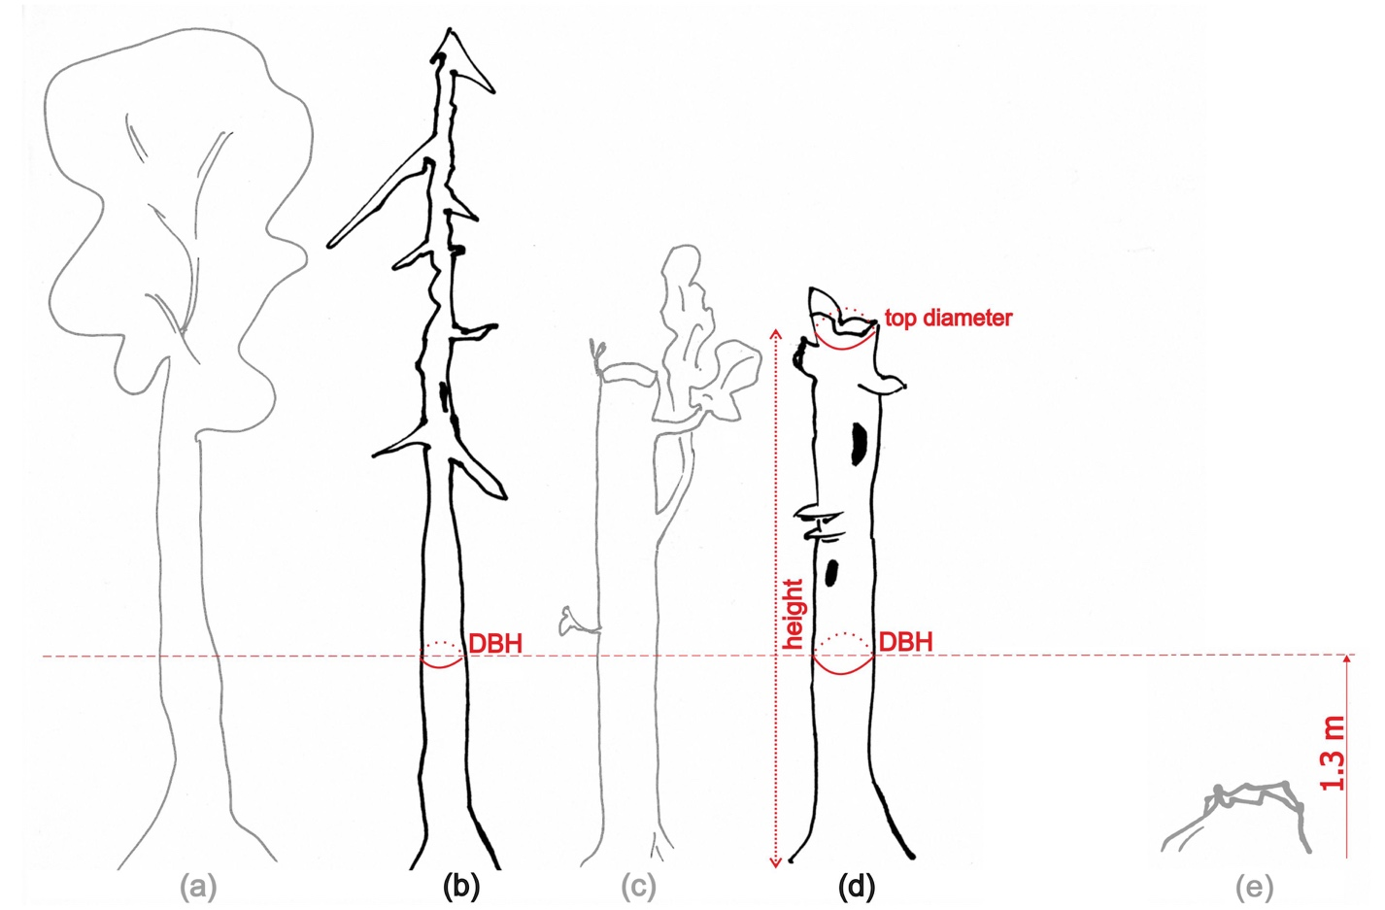

**Fig. 1.** Types of standing woody structures. Living trees (a) are covered in the standard CTFS protocol. Snags (b,d) are censused for snag-specific information. One type of snag is complete, having died standing (b). Living trees can also experience stem snap (c); stem snap is helpful to note during censuses, but if the tree has green foliage above the standard height of measurement, they are classed as living trees. Snags that have lost their top (d) need an explicit calculation of bole volume. Stumps (e) are dead remains of trees less than the standard measurement height; they carry information about original position of a tree only.

**2. Objects**

**2.1. Snags**

**Definition**

A snag is a standing dead woody stem that has DBH ≥10 cm and thus also a height taller than the standard height of DBH measurements (Fig. 1b,d). If the snag represents a tree that was alive at plot inception and has since died, the tag is maintained. In this case DBH may be <10 cm if a small tagged stem shrinks after death. If the tree with DBH ≥10 cm is dead at plot inception the tag is pinned on the snag. Snag data is maintained in the Tree table and Snag table. The Tree table contains the spatial information about the tree, species and DBH. In addition to the existing tree data in standard ForestGEO census presented in Tree table, the specific fields are added to Snag table.

BOX 2: If the top of the recorded snag has broken off, the lying piece is entered and described in the Log Table. Please see section 2.2.

**Recorded attributes**

1) BreakdownStatus – For standing woody structures following breakdown statuses may be used (maintained in the Tree table):

1. Intact – complete living stem, no traceable deadwood is linked to it;

2. Stem snap – living stem with broken main stem (possible origin of censused deadwood);

3. Not tracked – Snag of DBH < 10 cm at a time of mortality event;

4. Snag – Snag with DBH ≥ 10 cm;

4. Consumed – this status is assigned to the stems of DHB ≥ 10 cm that were recorded and described in the previous census and completely decomposed till the recent census.

Only if the BreakdownStatus is ‘Snag’, you proceed to other measurements.

2) Position – if the position is not known from the previous census the coordinates of the snag are measured and included into Tree table

BOX 3: To maximize the chances of identifying snags with DBH ≥ 10 cm during subsequent censuses, the tag should be hammered all the way to the bark/wood. During every five-year re-census of the plot, the same data (DBH, height, top diameter, and decay class) should be recorded. Diameters of snags can be subject to considerable variability between censuses due to bark separation from wood, swelling due to rain and changes in atmospheric humidity, and gradual loss of portions of the bark (sluffing).

3) Species – information about species is maintained in the Tree table.

4) DBH (resolution = 0.1 cm or 1 mm). Diameter should be measured using the same measurement methods as used for live trees and stored in the Tree table.

5) Integrity (INTEG) – an enumerated list with values for complete (C) or fragmented (F) to indicate whether the snag represents a whole tree (Integrity = C, Fig. 1b) or a fragment (Integrity = F, Fig. 1d). Maintained in Snag table.

6) Snag height (SH, resolution = 0.1 m). Height of the breakage (Integrity = F) of the main stem should be measured using the same measurement methods as used for live trees. This field is a numeric value with units of meters and resolution of 0.1 m (accuracy will be variable, but likely worse than 0.1 m). Maintained in the Snag table.

7) Top diameter (TD, resolution = 0.1 cm or 1 mm) If the leader is present (Integrity = C), top diameter is recorded as ‘0.0’. Any other diameter indicates some breakage of the main stem or leader (Integrity = F). The snag top diameter is ideally measured by using the large end diameter of the fallen top piece. If the top piece cannot be located, the top diameter is approximated, or measured with a laser. Maintained in Snag table.

Box 4: The units and resolution of snag top diameter are the same as those for DBH for data consistency, not because they can be measured to this accuracy.

8) Snag Decay class (SDC, Fig. 2) – this field is a numeric integer value with a foreign key to the snag decay class table (containing the definitions). Maintained in Snag table.

1- Freshly dead (0-5 years for many species); branches of 3rd order are present; the full height of stem is present unless there was damage prior to the mortality event or caused during the mortality event; fully barked (usually ≥80 % of stem surface); usually trees that died from suppression, bark beetle outbreak (coniferous), fungal infection (broadleaved), or those killed but not burned by fire. The species is still recognizable;

2- Branches of the first order are present; full tree height unless there was damage prior to or during the mortality event; partly barked (usually <80 % of stem surface; broadleaved trees should be still fully barked); the species can usually still be identified;

3- Only short basal rests of main branches; full height unless there was damage prior to the mortality event; bark missing or absent (usually ≤ 20 % of stem surface) in the case of coniferous;

4- No branches or small basal rests; height ≤80 % of even height curve (according to DBH); bark missing or absent (usually ≤20 % of stem surface) in the case of coniferous;

5- Stumps or short snags; the wood is at a stage of advanced rot.

9) Snag Volume (SVOL) – this field is a numeric value calculated from DBH, SH, and TD. Site-specific, species-specific allometric equations should be used if available. Otherwise, volume should be calculated by modeling the stem as a frustum of a cone in units of m3. Maintained in the Snag table.

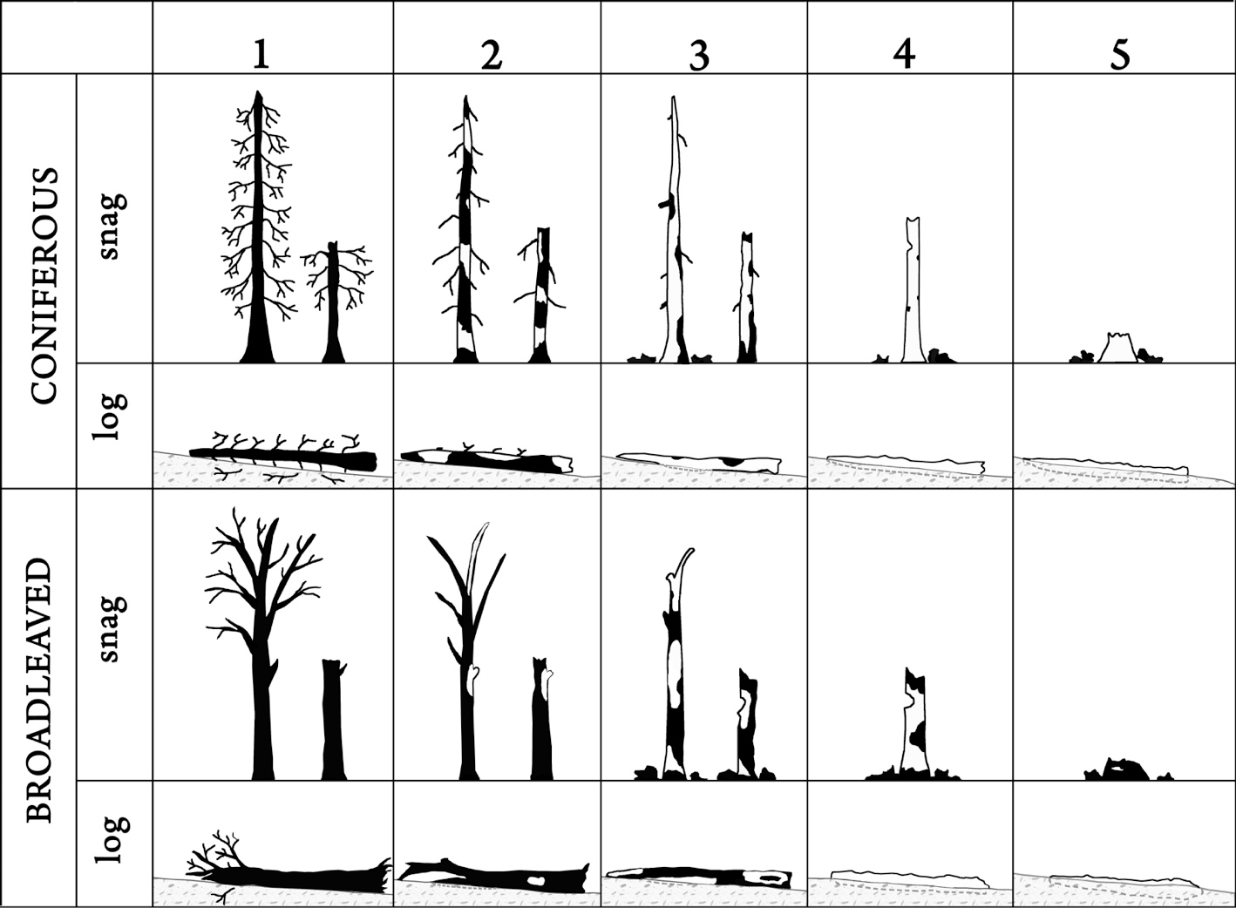

**Fig. 2.** Decay classes for standing and fallen coniferous and broadleaved trees. For decay classes 1, 2 and 3, the left snag is ‘Complete’ and the right snag is ‘Fragmented’. The fragmented stem would be joined by a piece of log on the ground somewhere. When individual pieces of deadwood appear to have characteristics of two decay classes, the class should be determined based on the closest fit to the descriptions.

**Table 1.** Attributes of theSnag table

|  |  |  |  |
| --- | --- | --- | --- |
| **Field Name** | **Attribute** | **Type, Code, Dimension** | **Note** |
| TREE_TAG | Tree Tag No. | VARCHAR | FK Tree table |
| STEM_TAG | Stem Tag No. | VARCHAR | FK Tree table |
| INTEG | Integrity | ENUM(‘C’,’F’) |  |
| SH | Snag height | DECIMAL(3,1) |  |
| TD | Top diameter | DECIMAL(5,2) |  |
| SDC | Snag decay class | ENUM(1,2,3,4,5) |  |
| SVOL | Snag volume | DOUBLE | Null |

**2.2. Logs**

**Definition**

Logs can either exist as fallen trees attaining the mapping limit of 10 cm DBH or as fragments – in this case the mapping limit is related to snag, or base part of the fallen tree. In reality only small number of lying trees appears as tree-in-one-piece, usually they are broken into more fragments - pieces, especially with course of decomposition over time. That’s why it is reasonable to apply a ‘piece approach’, where each piece of wood has the piece identifier and should be entered and described separately. All pieces of a lying stem are virtually merged together by tree/stem tag number. The piece of logs associated with the tree base is always a piece A, and subsequent pieces have increasing alphabetic character (B, C, D…) as they are further to the top of the tree. In the course of time the number of pieces of one stem may increase (fragmentation) or decrease (decomposition). The alphabetic identifier of the same piece (or its parts) thus may vary in subsequent censuses. The unique identification and tracking of individuals is thus intended only at the stem level.

Box 5: ‘Piece’ is a part of the main stem of a tree with DBH≥10 cm. The recorded piece is of a shape of (truncated) cylinder where the starting and final diameters should be measured. The chips, splinters or flakes from the stem are not recorded. The minimal length of piece is 1m. When it is reasonable to specify parts with different Ground contact it is possible to divide one piece into two pieces although they are not spatially interrupted. Then they are treated as two independent pieces and described separately in all attributes. Conversely, cracked pieces may be treated as one piece, if the ground contact is the same and there is no substantial displacement of its different parts.

Species and stem tag are inferred from the originating tree (former live tree with tag, tag is maintained), or, for wood on the ground at the plot inception, from field observations. In this case the species may stay unknown (indiscernible), but stem tag should be always pinned on the piece A to allow future individual-based re-census. When the piece of log have originated from a broken part of snag, the piece is labeled as piece B and tag is maintained by standing snag part. Primary information about the ‘parental’ tree of the log is maintained in the Tree table (position, species, DBH), other log-specific characteristics in Log Table.

**Recorded attributes**

1) Position – coordinates of the original (growth) position of the former live stem (or coordinates of the stem snap associated with deadwood on the ground). For trees that were alive in a former census this position is known, otherwise should be measured. In the field this position may be recognized as stem snap, snag, stump, hole (after decayed stump) or windthrow pit (Fig. 3). For logs on the ground at the plot inception the original position may be unknown, then the position of large end (starting point) of piece A is used as a proxy of the original stem position. This attribute is maintained in the Tree table.

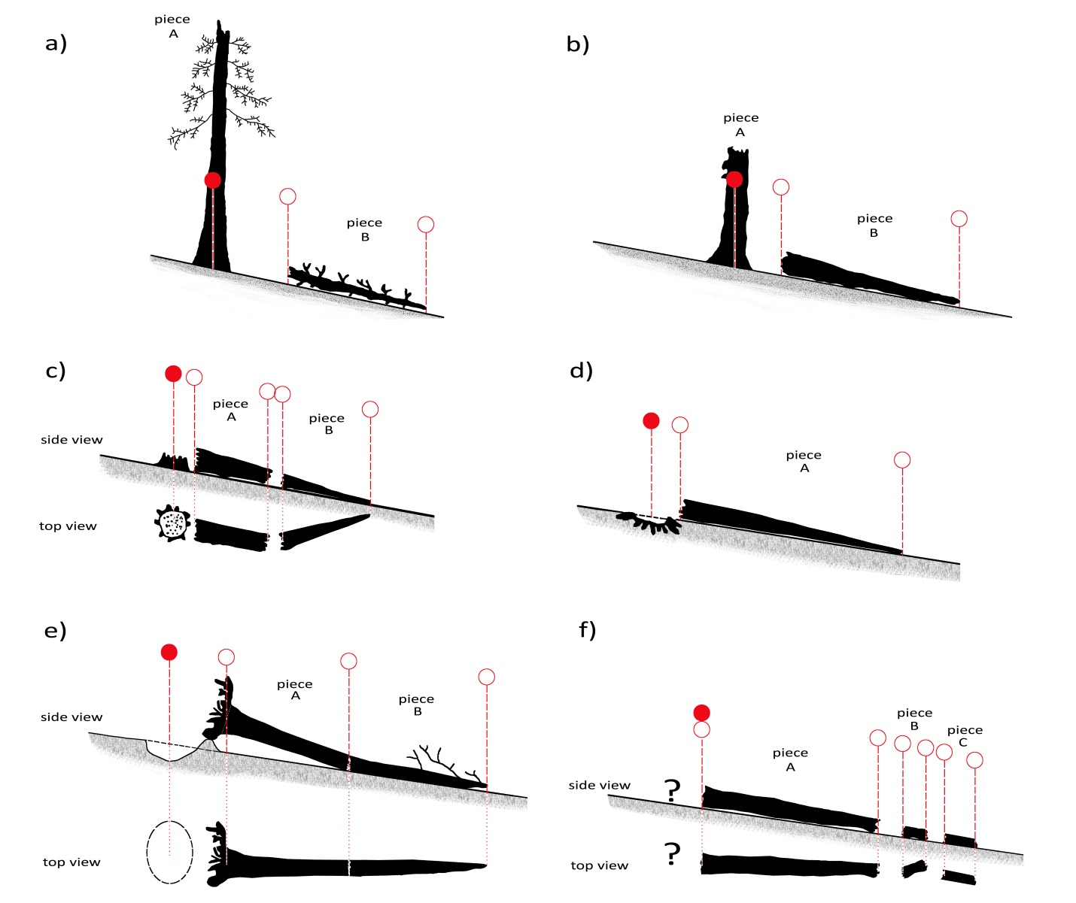

**Fig. 3.** Geospatial data requirements for logs. Original position of the former live tree (marked by solid circle) and actual position of each piece of the main stem (empty circle) should be recorded: a) piece originating from alive tree (stem snap); b) piece originating from a snag; c) log fragmented in two pieces, originating from stump; d) log and the original position of the stem represented by hole (remaining after decayed stump); e) windthrown stem and its original position represented by windthrow-pit; because of different ground contact of the stem parts they were recorded as two separate pieces; and f) old lying log fragmented in 3 pieces, original position of the stem is unknown – the position of the large end is then used as a proxy of the original stem position.

2) BreakdownStatus – for lying woody structures the BreakdownStatus mostly informs about the feature that represents its original (growth) position described above. This attribute is maintained in the Tree table.

1. Not tracked – Log of DBH < 10 cm at a time of mortality event;

2. Stem snap – the log (or piece) is associated with the living stem of DBH ≥10 cm with broken main stem (Fig. 3a);

3. Snag – the log is associated with the snag of DBH ≥ 10 cm (Fig. 3b);

4. Stump – the log is associated with the dead woody stem that is shorter than the standard height of DBH measurement. Stumps without connection to Logs are not recorded (Fig. 3c);

5. Hole - if a stem has suffered extensive rot, the stump can break off below the ground surface, leaving a hole (Fig. 3d);

6. Windthrow pit (‘WTPit’) – a micro-topographical form caused by a single uprooted tree (Fig. 3e);

7. Base of lying stem (’BLS’) - for logs on the ground at the plot inception the original position may be unknown, then the position of large end (starting point) of piece A is used as a proxy of the original stem position (Fig. 3f);

8. Consumed – status is assigned to the stems of DHB ≥ 10cm that were recorded and described in the previous census and completely decomposed till the recent census.

3) Species – maintained in the Tree table. For highly decayed logs of unknown origin the species may stay unrecognized.

4) DBH –The preferred method for measuring the diameter of wood pieces on the ground is a diameter tape. However, sometimes a diameter tape cannot be used because the piece is partially buried or covered with other debris. In that case diameter should be measured with calipers, along both the major axis of the wood ellipse and the minor axis of the wood ellipse. Where the wood is cylindrical, or where field crew can average the two diameters, only one measurement is sufficient, and in many cases only one measurement can be made. Attribute is maintained in the Tree table

5) Integrity – this value is an enumerated list, either ‘Complete’ or ‘Fragmented’. Maintained in the Log Table.

6) Piece identifier – this is an identifier allowing multiple pieces of logs to be associated with one originating stem. The piece of log associated with the stem base is always piece A, and subsequent pieces have increasing values as they are further to the top of the tree. The lying piece broken from Snag is assigned as B. Maintained in the Log Table.

BOX 6: The principal objective of dead wood size measurements is to compute a volume. If the tree is complete (Fig. 4a), then a DBH measurement can be used in conjunction with allometric equations to calculate volume. Allometric equations of sufficient detail can also be used if the base of the tree is intact and the top broken (Fig. 4b). When the fallen wood is fragmented into several pieces, the volume of each piece needs to be calculated (Fig. 4c). In all cases, the volume can also be determined by measuring the length and end diameters of the pieces. The volumes are computed in census data post-processing.

7) Piece position – position of each piece of the log is always determined by at least two points – start and end (Fig. 3). The piece position can be recorded either as simple coordinates, or as shapes in a Geographic Information System (GIS). Log pieces can be located relative to existing trees, using an azimuth-distance method such as is used for new recruitment too, or the standard location system used in the tree census on the plot. The location of piece endpoints can be in either plot coordinates, absolute coordinates (UTM, etc.), or both. Maintained in the Log Table.

8) Length - The length of deadwood is imputed from the surveyed location of the endpoints (Fig. 3), or can be measured in the field. Maintained in the Log Table.

9) Large end diameter - diameter should be measured using the same measurement methods as used for DBH. Maintained in the Log Table.

10) Small end diameter - diameter should be measured using the same measurement methods as used for DBH. If the leader is present, diameter is recorded as “0.0”. Any other diameter indicates some breakage of the piece. Maintained in the Log Table.

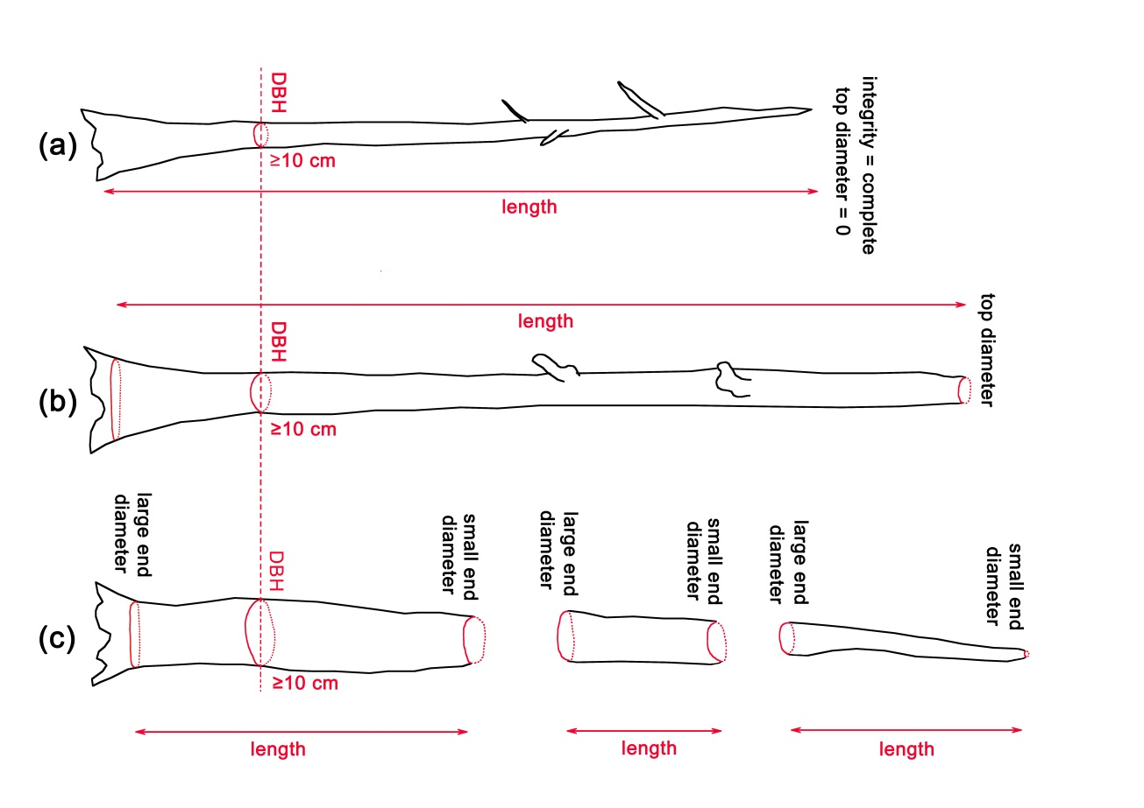

**Fig. 4.** Required measurements of logs for volume estimates of a complete log (a), incomplete log (b) and a log fragmented in pieces (c).

12) Log Decay Classes - There are five degrees of decomposition distinguished for standing and down deadwood, illustrated separately for coniferous and broadleaved tree species (Fig. 2). Decay class is recorded in the Log Table.

1- Freshly fallen tree (usually windthrow or a basal rot); texture – wood intact; branches of 2nd order are attached; fully barked (usually ≥80% of stem surface); species is still recognizable;

2- Texture – wood intact to partly hard or soft; branches of first order are partly attached; partly barked; the species can usually still be identified;

3- Texture – wood hard but in large pieces; the wood is not compact any more along the entire stem length with the core or outer mantle subjected to rot. The genus can often be recognized, but species identification is difficult;

4- Texture – wood chunks small, soft, and blocky; the wood is not compact and the cross-section is either elliptical or circular;

5- The wood is at a stage of advanced rot; texture – wood chunks soft and powdery; deadwood no longer has a cylindrical shape; the species cannot be identified any more, a kick into a stem results in stem breakage, there are often just “little graves” with the patchy vegetation.

13) Ground contact (GC)**:** can be an important determinant of decomposition rates. Therefore, one data parameter maintained for every piece of wood is its contact with the ground(Fig. 5) , either supported (main stem in the air = ‘Air’) or on the ground (‘Ground’). When it is reasonable to specify parts with different Ground contact it is possible to divide one piece into two pieces although they are not spatially interrupted. However, they are treated as two independent pieces and described separately in all attributes. Maintained in the Log Table.

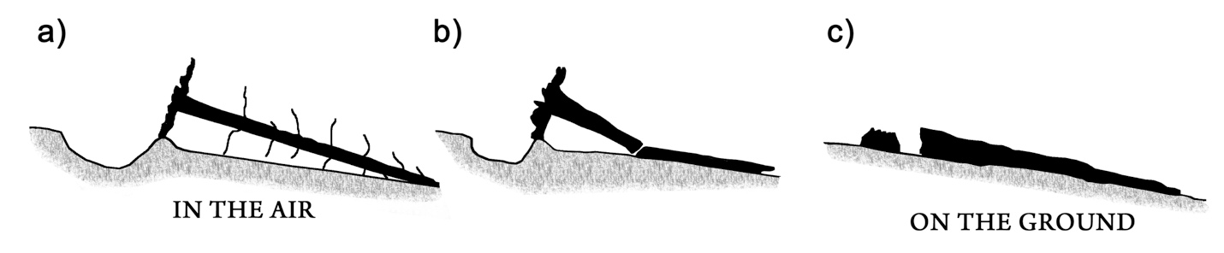**Fig. 5.** Ground contact of logs. When wood is initially on the ground, it is often supported by some combination of the roots, branches, or other logs (a). When wood has been down for some time, or when a bole fragments upon falling, pieces are often completely on the ground (c). When a bole is partially on the ground and partially supported (b), it should be recorded as two individual pieces, so that each piece can have the appropriate ground contact code.

14) Piece quadrats – this field is semi-colon separated list of quadrats where the piece is found. Although the quadrats, where the piece is present, can be derived from the geospatial data (Fig. 3), for quadrat level analyses, this tabular data field is useful for searches. Maintained in the Log Table.

BOX 7: The last records – there are two possible farewells for censused trees - inserting of status ‘Dead not tracked’ or ‘Consumed’: i) The status ‘Dead not tracked’ is used for small dead trees with DBH under mapping limit of 10 cm; ii) the status ‘Consumed‘ is assigned when a stem has completely decomposed and no traceable pieces remain in the plot. The status is recorded at the stem level (in the Tree Table), which signifies that the stem has unambiguously completed its lifecycle as woody entity. According to friendly to nature research we should remove the tags of the stems that have been ‘Consumed’ and from the lying logs with the status ‘Dead not tracked’.

15) Piece volume – this is the volume of the piece (in units of m3)calculated as a frustum of a cone or by allometric equations (see Box 6).

**Table 2.** Attributes of the Log Table

|  |  |  |  |
| --- | --- | --- | --- |
| **Field Name** | **Attribute** | **Type, Code, Dimension** | **Note** |
| TREE_TAG | Tree tag No. | VARCHAR | FK Tree table |
| STEM_TAG | Stem tag No. | VARCHAR | FK Tree table |
| PIECE_ID | Piece identifier | CHAR(1) |  |
| PIECE_LE_X | Piece position | DECIMAL(8,2) | Coordinates |
| PIECE_LE_Y | Piece position | DECIMAL(9,2) | Coordinates |
| PIECE_LE_Z | Piece position | DECIMAL(6,2) | Coordinates |
| PIECE_SE_X | Piece position | DECIMAL(8,2) | Coordinates |
| PIECE_SE_Y | Piece position | DECIMAL(9,2) | Coordinates |
| PIECE_SE_Z | Piece position | DECIMAL(6,2) | Coordinates |
| PIECE_LENGTH | Length | DECIMAL(3,1) | Not null |
| PIECE_LE_DIAM | Large end diameter | DECIMAL(5,2) | Not null |
| PIECE_SE_DIAM | Small end diameter | DECIMAL(5,2) | Not null |
| INTEG | Integrity | ENUM(‘Complete’,’Fragmented’) | Not null |
| LDC | Log decay class | ENUM(1,2,3,4,5) | Not null |
| GC | Ground contact | ENUM(‘Ground’,’Air’) | Not null |
| PIECE_QUAD | Piece quadrats | VARCHAR(25) | Not null |
| PIECE_VOL | Piece volume | DECIMAL(5,2) | Null |

**Table 3.** Attributeadditions to Tree table

|  |  |  |  |
| --- | --- | --- | --- |
| **Field Name** | **Attribute** | **Type, Code, Dimension** | **Note** |
| BREAK_STATUS | BreakdownStatus | ENUM(’NotTracked’,’Intakt’,’StemSnap’,’Snag',’Stump’,‘Hole’,’WTPit’,’BLS’, ’Consumed’) |  |