

CSE 499-A

Senior Design Project I

Project Proposal

**Section: 08**

|  |  |
| --- | --- |
| **Group Members** | |
| **Name** | **Id** |
| **MD Ayat Ullah** | **1331111042** |
| **Hossain Abdullah Taif** | **1510973042** |
| **Md. Sajid Hasan** | **1211076040** |

Thorax Disease Detection and Classification in Chest Radiology Using Neural Network

Lungs are the organs which are contained in the thoracic cavity, there are enveloped in two pleural membranes. Lung cancer is a cancer that starts in the lungs. Lung cancer can start in the cells lining the bronchi and parts of the lungs such as the bronchioles or alveoli, changes in the genes (DNA) inside the lung cells may cause the cells to grow faster, they form a tumor.

lung disease detection system is developed, this study classifies lung disease images as either lung cancer or pneumonia, this is accomplished by two stages of system, feature extraction and classification. Feature extraction is done through the use of Gabor filter, Gabor filters extract certain important features from the images Mean, Variance, Standard Deviation, Homogeneity, Energy, Contrast.

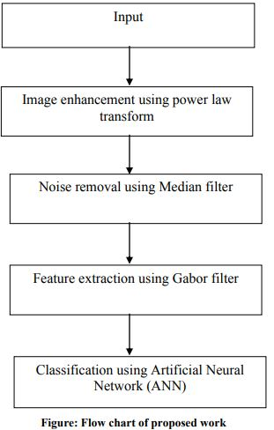

**Data preprocessing-**

Preprocessing is the process of improving or enhancing the quality of input image and make the feature extraction phase more reliable. The main motive of preprocessing stages is to remove noise present in input images. Here in the preprocessing stage median filter is used to remove noise from the input image and for image enhancement power law transform’s is been used.

**Feature extraction**

Images have a huge number of features and hence it is important to recognize and extract such features from input images. Feature extraction is the process done to reduce the complexity of processing. Here for feature extraction we use Gabor filter. Gabor filter extract local pieces of information which are then combined to recognize an object or ROI 2D Gabor filter function.

**Ψ(x, y) = f2 /πϒη**

**x'= xcosθ+ysinθ**

**y'=-xsinθ+ycosθ**

The Gabor filter will extract the features like Mean, Variance, Standard Deviation, Contrast, Correlation, Homogeneity, and Energy.

**CLASSIFIER**

The classifier is a mathematical function which is implemented using classification algorithm which maps input data to a particular category. There are various types of classifiers. One of which is Artificial Neural Network(ANN). Artificial neural network is a network of simple processing elements called neurons, which operates on their local data and communicates with other elements. Three types of ANN will be used here namely Feed forward Network, Radial Basis function and Multilayer perceptron Network.