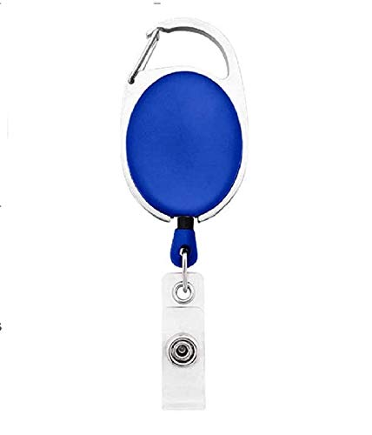

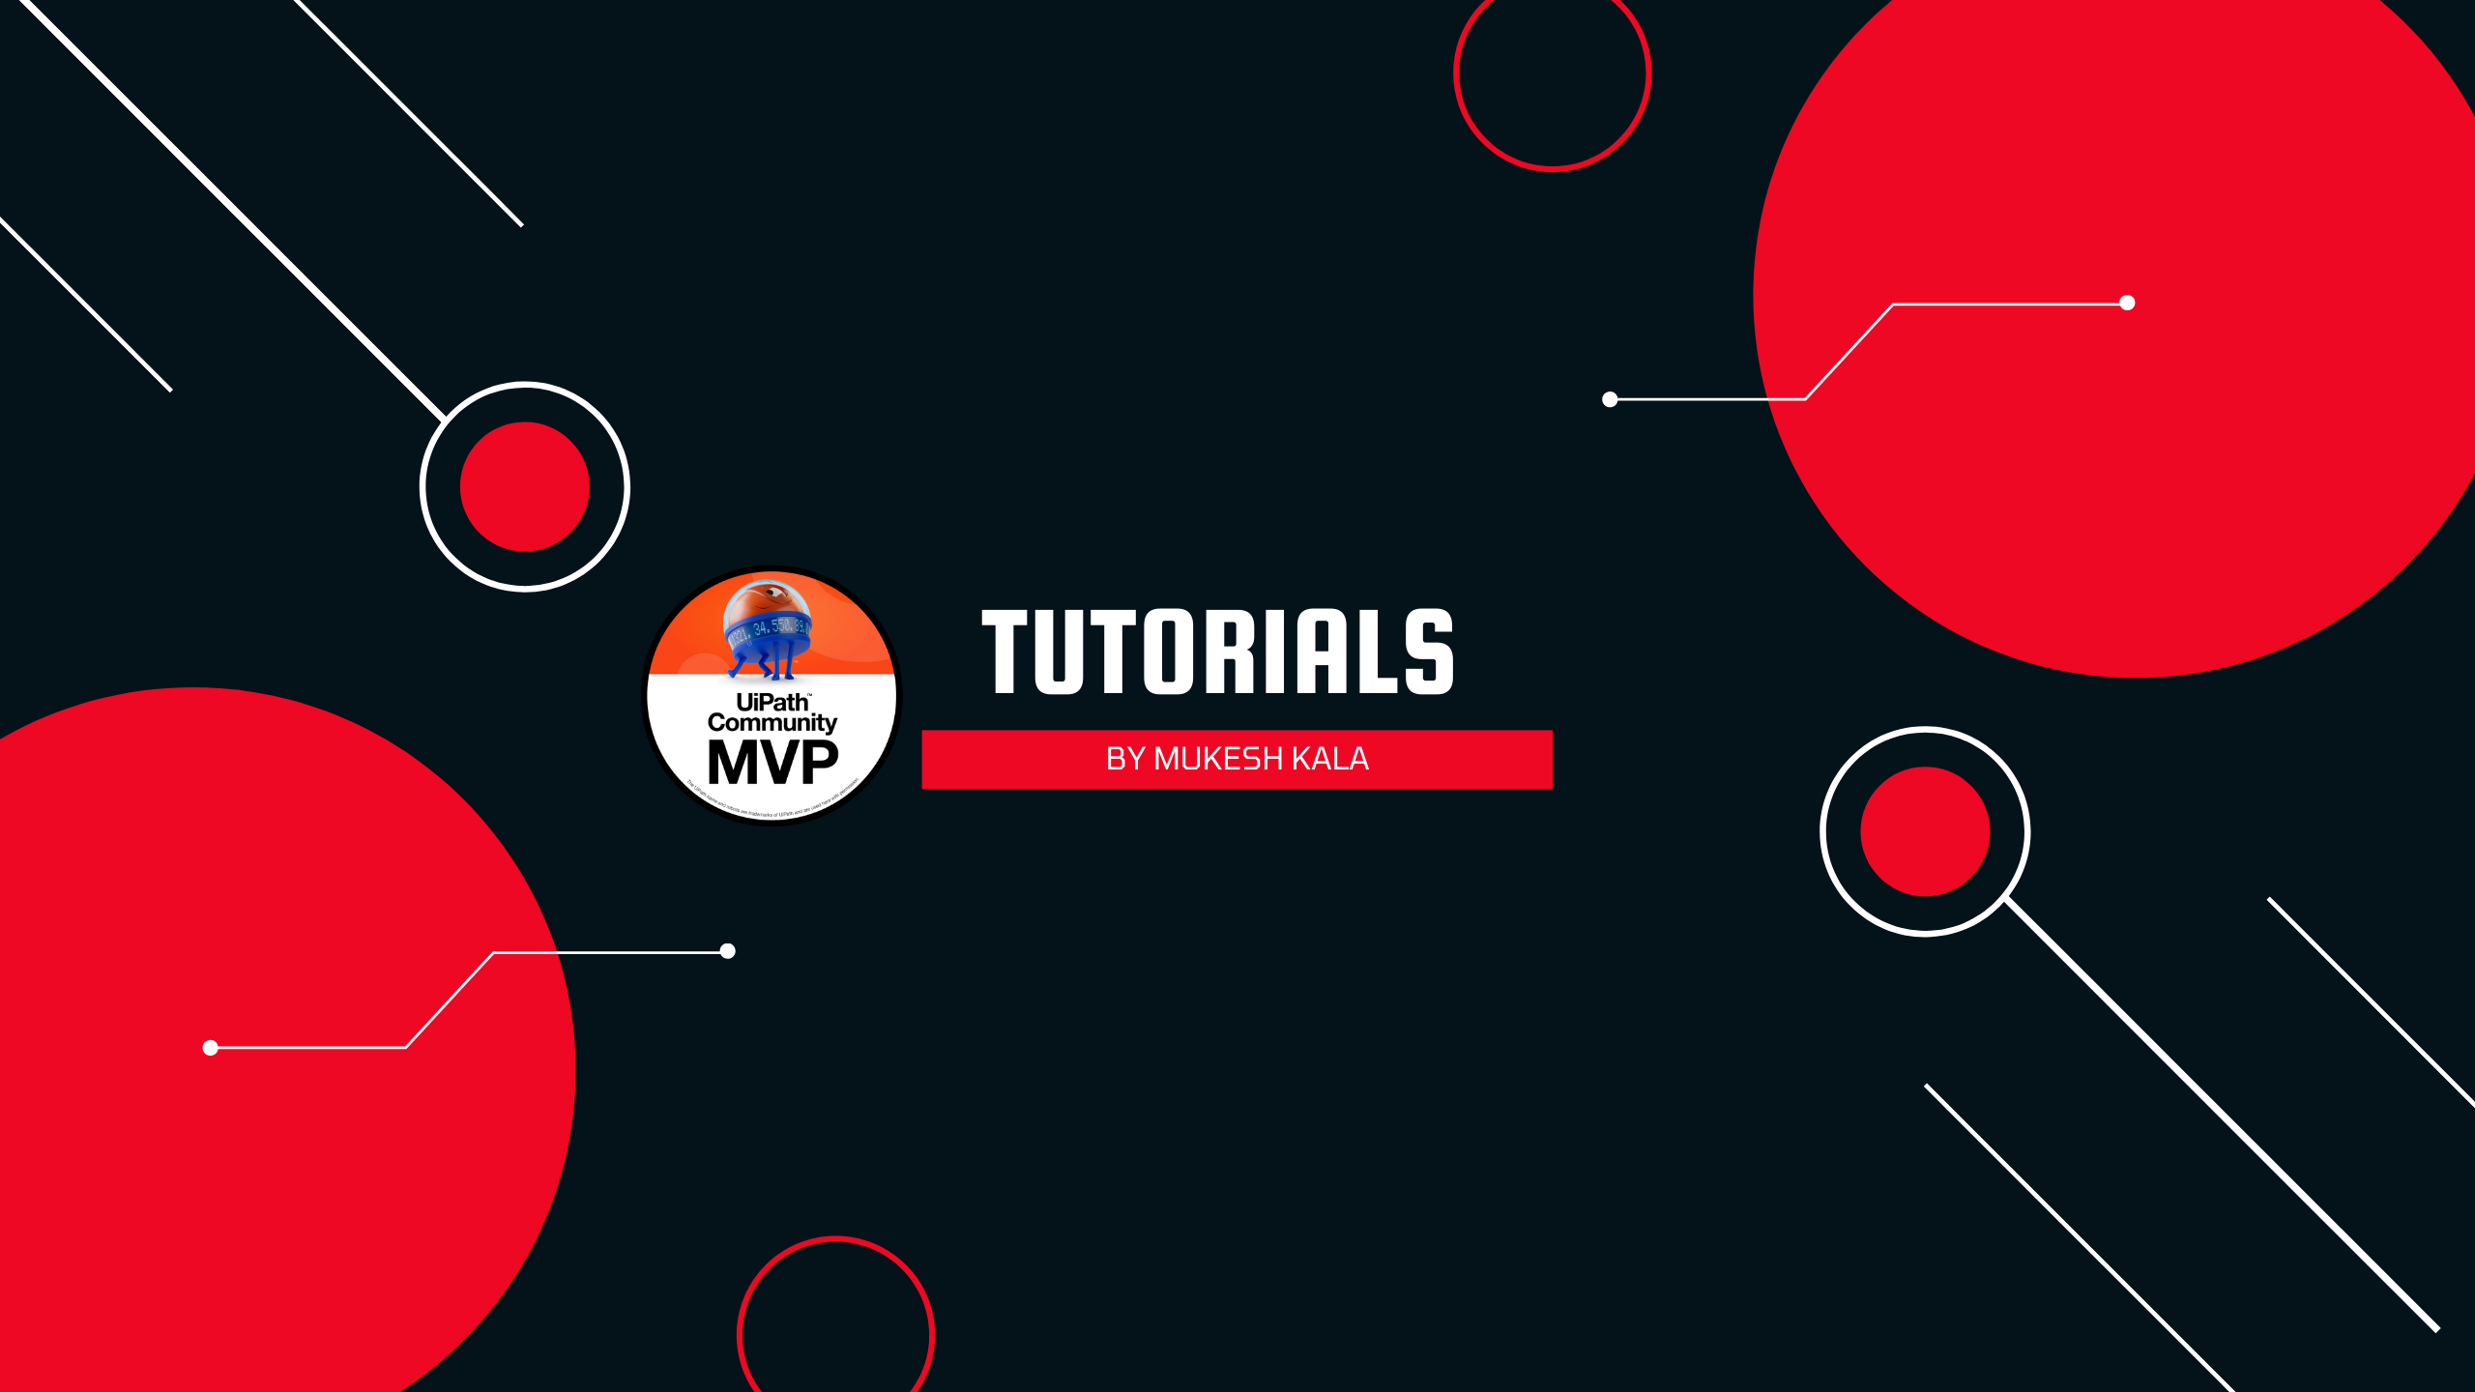

|  |  |
| --- | --- |
| **William Middlebrooks** | PHOTO |
| **Purchase** |
| **02/12/2022** |
| **A +ve** |
| **9080706050** |

Questions / Queries – Drop an email to mailmukeshkala@gmail.com