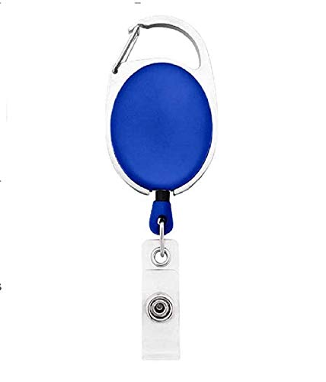



|  |  |
| --- | --- |
| **Sarah Neighbors** | PHOTO |
| **_Department** |
| **_DOJ** |
| **_BloodGrp** |
| **_Emergency** |

Questions / Queries – Drop an email to mailmukeshkala@gmail.com