Project Proposal
Project Title
Development of an Intelligent Social Learning Platform with Personalized Microlearning Pathways, Short-Form Video Generation, and Adaptive Knowledge Assessment (product name: YeahGrind)

1. Team Members and Responsibilities
Team Member | Responsibility
Katyshev Yernar | Backend and business logic: data model, REST API, content generation (skill maps, micro-units, questions), pathway engine, adaptive assessment engine, short-form video generation pipeline, AI gateway, Moodle integration, CI/CD
Balmagambet Ayat | Frontend and UX: progressive web application, user research and prototype, learning, video and quiz interfaces, social features (friends, feed, study groups), moderation console, accessibility, localization (English, Russian, Kazakh)
Supervisor: Makatov Arstan

2. Problem Statement
University students who study on their own mostly prepare in focused sessions shortly before deadlines and choose what to study by the nearest deadline, while course materials (lectures, chapters, slide decks) are long and follow one fixed order for everyone. Nothing tells a student which small step to take next, given what they already know, the minutes they have today and the next deadline in the Moodle LMS. Explanations in a convenient short format are rarely available for the student's own course material, because producing videos is expensive. Knowledge gaps often become visible only at the exam, and general-purpose chatbots that give answers on request can reduce later unaided performance [19]. Social features in learning apps are mostly leaderboards and streaks, which can punish students instead of helping them learn together [26].
This project designs a web platform that turns a learning goal or a university subject, optionally together with the student's own lecture notes, into a personalized pathway of micro-units. Each unit fits the time the student actually has, is explained by a short generated video, and is followed by an adaptive quiz that updates the student's mastery of each skill. Students study together through friends and study groups with cooperative goals. The existing products analyzed in Section 4 each cover one part of this cycle; none combines them for an arbitrary university subject.

3. Target Users
- Primary users: undergraduate students of Astana IT University (18+) who prepare for courses and exams on their own, in short study sessions, and who want explanations and feedback on their own subjects.
- Secondary users: members of study groups (2–8 students preparing for the same course or exam) who want a shared goal, shared materials and visible joint progress.
- Secondary users: content moderators (a team role during the pilot) who review generated content that failed validation or was reported by students.

4. Aim
To design, implement and evaluate a web platform that builds a personalized microlearning pathway for a student's goal or university subject, explains each micro-unit with a short generated video, assesses knowledge adaptively with a mastery estimate for every skill, and supports cooperative learning with friends and study groups, and to show that it gives higher learning gains and good usability compared with a non-adaptive baseline.

5. Objectives
- Derive the requirements from published evidence, existing systems, observation of the Moodle deadline process and interviews with three students.
- Design the system architecture, data model and REST API (OpenAPI contract).
- Implement content ingestion: a skill map with prerequisites (acyclic) and micro-units of 2–5 minutes, grounded in the student's material when it is provided.
- Implement the pathway engine: prerequisite-gated ordering, a daily check-in (energy, free minutes), placement of units into the day plan with Moodle deadlines, spaced review and an explanation for every recommended unit.
- Implement the short-form video generation pipeline: grounded script, validation, narration in English and Russian (Kazakh after a native-speaker check), slide frames, captions; 60–120 seconds per video.
- Implement adaptive knowledge assessment: an item bank per skill, Elo-based item selection, a mastery estimate per skill, a placement test, AI feedback on open answers and hints that never reveal the answer.
- Implement social learning: friends, an activity feed with private scores, sharing of units and videos, study groups with cooperative weekly goals, reporting and moderation.
- Evaluate the platform with component benchmarks and a learning and usability study against a non-adaptive baseline.

6. Expected Outcomes
- A working prototype (installable web application) consisting of:
- content ingestion and pathway engine,
- short-form video generation pipeline with validation and captions,
- adaptive assessment engine with mastery reports,
- social learning features and moderation,
- privacy controls and an interface in English, Russian and Kazakh.
- Documented system architecture, requirements, technology choices and API contract.
- Experimental evaluation: pathway simulation, offline evaluation of the assessment model on a public dataset, video pipeline reliability and accuracy, validity of generated questions, agreement of AI grading with human graders, and a learning and usability study with 12 students against the baseline.
- The complete set of pre-defense documentation (proposal, evidence, literature review, comparisons, requirements, diagrams, prototype materials, verification plan, project plan) in the Git repository.

7. Project Scope

In scope
- Responsive web application and installable PWA; sign-in with e-mail and with the university Microsoft account (Entra ID, restricted to the AITU tenant).
- Learning goals and university subjects (course names from the student's Moodle calendar export or typed in); optional own material as pasted text (up to 20,000 characters) or a text-based PDF.
- Skill map with prerequisites and micro-units with one objective each.
- Personalized pathway with daily check-in, Moodle deadlines, spaced review and explanations.
- Short generated videos (60–120 s) with narration, captions, transcript and a sources panel.
- Adaptive quizzes, placement test, mastery report, AI feedback on short answers and code (code is never executed).
- Friends, activity feed, sharing, comments, study groups with cooperative goals, reporting and a moderation queue.
- Experience points, levels and cosmetic avatar items without penalties for missed days; push reminders with quiet hours.
- Consent management, data export and account deletion; interface in English, Russian and Kazakh.

Out of scope
- Native iOS and Android applications (the PWA covers mobile use).
- Training or fine-tuning own language models; deep knowledge tracing.
- Photorealistic avatar videos and generative video models.
- Reading course content or grades from Moodle (only the student's own calendar export is used).
- Official grading, proctoring or certification; payments; a public social network beyond friends and study groups.

2. Evidence of Relevance

2.1. Purpose and method
This section records what supports the need for the platform and how that evidence affects the requirements. Four kinds of evidence are used: analysis of available published data (28 verified studies, Section 3), analysis of five existing products (Section 4), observation of the process by which an AITU student gets deadlines out of the Moodle LMS, and three semi-structured interviews with students. Verified findings are listed separately from design hypotheses, which the interviews confirmed or rejected. There is no external client; the academic stakeholder is the supervisor.

2.2. Analysis of available data
Table 2.1 summarizes the published findings that define the problem and the design. Numbers in brackets refer to the references of Section 3.
ID | Finding | Key figures | Effect on the design
E1 | Microlearning (single-objective units of a few minutes) is associated with gains in knowledge, retention and motivation, especially on mobile devices [1], [2]. | 40 and 26 studies in two systematic reviews | Micro-units of 2–5 min; mobile-first PWA
E2 | Attention to video falls after about six minutes; video added to practice helps far more than video that replaces teaching [3], [4]. | Median engagement ≤ 6 min (6.9 M sessions); g = 0.80 added vs 0.28 replacing (105 RCTs) | Videos of 60–120 s, always followed by questions
E3 | AI-generated teaching videos give learning comparable to human-made videos [6], [7]. | Similar exam results, 447 participants; no difference in gains, n = 83 | Generated video is a valid format
E4 | LLM-generated questions are mostly good, with predictable failures [8]. | 81.7 % of 651 GPT-4 MCQs passed all criteria | Automatic item checks and moderation
E5 | Quizzing with corrective feedback improves achievement; spacing improves recall [14], [15]. | g = 0.499 (222 studies, 48,478 students) | Quiz after each unit; spaced review
E6 | Ability and item difficulty can be estimated online with simple models [9], [10], [12]. | Elo used with > 15 M answers; ≈ 100 answers per item for stable difficulty | Elo-based adaptive assessment
E7 | Unrestricted AI answers harm later unaided performance; hint-only tutoring removes the harm [19]. | Practice +48 %, later exam −17 % (≈ 1,000 students) | Hints before answers; answer hidden until an attempt
E8 | A grounded, scaffolded AI tutor can outperform active learning in class [18]. | Effect 0.63–1.3 SD, N = 194 | Rubric-grounded feedback
E9 | Feedback is powerful but variable; LLM grading agrees moderately with humans [21], [22]. | Feedback effect 0.79; GPT-4 precision 0.91 on fully correct answers | Detailed rubrics, second grading pass, appeal
E10 | Gamification helps on average; broken streaks reduce later engagement [25], [26]. | Cognitive g = .49 | No penalties for missed days
E11 | Structured collaboration improves learning and collaboration skills [16], [17]. | g = 0.24 (learning), 0.72 (collaboration) | Cooperative study groups
E12 | Procrastination is driven by task aversiveness and low self-efficacy; time management relates to less procrastination [23], [24]. | r = .490 with lower procrastination | Small units; daily plan
E13 | Perceived control over data builds trust; generative AI needs labeling and human accountability [27], [28]. | 132 students; UNESCO guidance | Opt-in analytics, export and deletion, AI labels
Table 2.1. Findings from available published data

2.3. Observation of the current process
The process of getting personal assessment deadlines and course names from the AITU Moodle LMS (lms.astanait.edu.kz) into a personal calendar or study tool was walked through with a student account. It takes seven manual steps:
1. Open the LMS and sign in with the university Microsoft account (OpenID Connect with multi-factor authentication).
2. Open Calendar.
3. Choose Export calendar.
4. Select All events.
5. Select the period: Recent and next 60 days, or a custom range.
6. Press Get calendar URL.
7. Copy the personal URL and paste it into a calendar application.
Observations: the export works only through this hidden procedure; the URL is personal and gives access to the student's events without a further sign-in, so it must be treated as a secret; the export covers a chosen time window, so a one-time import becomes outdated and needs regular refresh; the events carry the course name, which gives a partial list of the student's courses; and the LMS shows what is due, but not what to study next or how ready the student is. These observations lead to the encrypted storage and three-times-a-day refresh of the calendar URL (FR-17), the subject list seeded from course names (FR-05) and the pathway that turns deadlines into study steps (FR-11, FR-12).

2.4. Interviews with students
Three semi-structured interviews were held in October 2026 with AITU students who are not involved in the project (Table 2.2): two transcribed conversations, one in Russian and one in English, and one set of written answers in English. The questions followed the interview guide in the project repository and asked about specific recent episodes: when and how long the student studied, how they chose what to study, how they learn a new topic, how they check what they know, how they study with others, how they react to AI feedback, leaderboards and streaks, and which language they prefer. The concept probe with prototype screens was not run, so no hypothesis relies on it. Names, teachers and courses are not recorded; the notes use the codes I-01 … I-03, and Russian quotes are translated.
Code | Profile | Date, mode, language | Summary of what the participant said
I-01 | IT student, second year or above; frequent AI user | Oct 2026; conversation, audio-recorded; Russian | Studies in long sessions and needs “full immersion”; checks Moodle every day; watches video when tired and reads when rested; wants the correct answer right away with an explanation; leaderboards motivate; uploads notes to AI; prefers English, Kazakh only for a Kazakh-language class.
I-02 | Student who prepares mainly for hard disciplines shortly before exams; fluent in Russian and English | Oct 2026; written answers; English | Reads all materials 1–2 days before an exam; follows the nearest Moodle deadline; combines a quick read with videos; wants explanations of wrong answers; studies with others only in projects; not affected by leaderboards or streaks; uploads notes to AI but expects no personal data leak.
I-03 | Student who studies with friends and holds a scholarship; heavy AI user | Oct 2026; conversation, transcribed; English | Works 2–3 hours per session and only watches topic videos in short breaks; reads for information and watches video to visualize; checks understanding by answering questions; wants the correct answer first, then the explanation; keeps scores private; motivated by grade stakes; shares only non-private information with AI; prefers English.
Table 2.2. Interview participants

2.5. Verified findings
- Published studies support microlearning, short video added to practice, retrieval practice with feedback, adaptive assessment with simple online models, cooperative learning and non-punitive motivation (E1–E13).
- AI-generated video and LLM-generated questions reach quality comparable to human-made materials, with characteristic errors that must be checked (E3, E4).
- Unrestricted AI answers harm learning, while guarded, grounded feedback helps (E7, E8).
- Getting Moodle deadlines into a study tool takes a manual seven-step export; the personal URL is a secret and the feed needs regular refresh (Section 2.3).
- None of the five analyzed products combines an adaptive microlearning pathway over an arbitrary university subject, generated short video, adaptive assessment, cooperative social learning, fitting into the student's day and Kazakh support (Section 4, gaps G1–G8).
- Interviews I-01 … I-03 contradicted H1, supported H9 and H10 and gave mixed results for H2–H8; new themes are AI mistakes (N1), video for tired moments and short breaks (N2) and deadlines and grade stakes as the main priority (N3) (Section 2.6).

2.6. Design hypotheses checked in the interviews
ID | Hypothesis | Status after interviews
H1 | Students study in short, fragmented windows (≤ 30 min) on most days. | Contradicted. All three study in long focused sessions (I-01, I-02, I-03); short breaks are used at most for topic videos (I-03).
H2 | Deadlines come from several channels; consolidating them is manual. | Mixed. Moodle is the only deadline source for all three; checking it is manual and daily (I-01).
H3 | Choosing the next study step is a real barrier to starting. | Mixed. I-02 follows the nearest deadline; I-03 sometimes does not know where to start; I-01 works down a to-do list.
H4 | For a new topic, students prefer a short video to long text if its sources are visible. | Mixed. All three combine text and video: video complements text (tired moments, examples, visualizing) but does not replace it.
H5 | Students discover gaps late and would use short adaptive quizzes that show progress. | Mixed. I-02 sometimes finds gaps; I-01 assumes understanding after finishing a task; I-03 finds no late gaps and checks understanding by answering questions.
H6 | Students prefer feedback that explains mistakes to receiving the full answer. | Mixed. All three want mistakes explained; I-01 and I-03 want the correct answer right after the attempt.
H7 | Students want to learn with peers, keep scores private and prefer cooperation to ranking. | Mixed. I-03 studies with friends and keeps scores private; I-02 wants to compare scores to discuss mistakes; I-01 is motivated by leaderboards.
H8 | Punitive mechanics (streak loss, league demotion) demotivate. | Mixed (not supported). No one reported demotivation; competition (I-01) and grade stakes (I-03) motivate; I-02 is unaffected.
H9 | Students share study context and answers with AI services, not their identity, and want control. | Supported. All three upload study notes to AI; I-02 expects that personal data does not leak; I-03 shares only non-private information.
H10 | Preferred language for the interface and video narration (Kazakh, Russian, English). | Supported. English suits all three and Russian also suits I-02; Kazakh is wanted only for a Kazakh-language subject (I-01).
Table 2.3. Design hypotheses and their status
A hypothesis is supported when at least three participants give a concrete supporting episode and none contradict it, contradicted when at least three contradict it, and mixed otherwise. With three participants, a hypothesis is supported only when all three support it. New themes mentioned by two or more participants become candidate requirements.

2.7. Effect on the requirements
The published evidence and the observation define the core design: micro-units fitted to free time (E1, E12), short videos always paired with practice (E2, E3), automatic validation and moderation of generated content (E4, E7), Elo-based adaptive quizzes with spaced review (E5, E6), feedback that teaches rather than answers (E7–E9), cooperative groups without penalties (E10, E11), and privacy controls (E13). The interview results set the priorities: a supported hypothesis keeps or raises the priority of its requirements, a contradicted one lowers it or changes the acceptance criteria. The interviews contradicted H1: all three participants study in long focused sessions, so the day plan groups several micro-units into one session and offers the unit video for short breaks and tired moments. H6 changed the feedback design: hints stay optional before an attempt, and the correct answer with its explanation is shown right after it. H9 and H10 confirmed the privacy requirements and the language priorities (English, then Russian; Kazakh by subject). Mixed results for H7 and H8 keep scores private by default, shared only on purpose, and leave ranking out of release 1. The mapping from each finding to requirements is given in Section 6.6.

3. Literature Review
Diploma project: intelligent social learning platform with personalized microlearning pathways, short-form video generation and adaptive knowledge assessment

3.1. Review Scope and Selection
This review examines the scientific literature relevant to the four parts of the topic — microlearning, short and AI-generated instructional video, adaptive knowledge assessment and social learning — together with the evidence on generative-AI tutoring and feedback on which the design depends. Procrastination, gamification and privacy are reviewed as supporting themes.
Twenty-eight sources were selected: 27 peer-reviewed publications and one intergovernmental guidance document. Twenty sources are from 2021–2026, reflecting the fast development of AI in education; six foundational works (2007–2016) are kept because current models and principles build on them. Every DOI was resolved through the Crossref API on 21 October 2026 and checked against title, authors, venue and pages, and every source was checked for retractions and corrections. One frequently cited 2025 meta-analysis on ChatGPT was excluded because it was retracted in April 2026. Content was read from the full text for 17 sources and from the abstract for 11. Discovery used Crossref, Semantic Scholar, OpenAlex, Europe PMC and arXiv. Inclusion required a peer-reviewed meta-analysis, systematic review, controlled experiment, large-scale log study or seminal model, a direct link to a platform feature, and readable content; preprints and low-visibility outlets were excluded when stronger evidence existed.

3.2. Microlearning
Monib et al. (2025) [1] systematically reviewed 40 peer-reviewed studies (2020–2024) and define microlearning as bite-sized, targeted content delivered within seconds or a few minutes. The included studies report cognitive gains (acquisition, retention, transfer), behavioral gains (completion, engagement) and affective gains (motivation, self-efficacy), and the authors propose a framework built on a specific objective, bite-sized content, an appropriate timeframe, interactivity, personalization and a suitable medium. Lee (2023) [2] reviewed 26 studies of mobile microlearning and found improvements in achievement, motivation and retention, while pointing to the need for content designed for small screens. Both reviews are qualitative: neither reports a pooled effect size, and most evidence comes from medicine and workplace training. The project therefore adopts one objective per unit, units sized to the student's free minutes and a mobile-first design, and measures its own learning effect with pre- and post-tests instead of relying on a pooled estimate.

3.3. Short Educational Video and AI-Generated Video
Guo, Kim and Rubin (2014) [3] analyzed 6.9 million video-watching sessions in edX courses: median engagement time was at most six minutes regardless of video length, and students often watched less than half of videos longer than nine minutes. Noetel et al. (2021) [4] meta-analyzed 105 randomised trials with 7,776 college students: replacing teaching with video gave small gains (g = 0.28), while adding video to existing teaching gave strong gains (g = 0.80). Mayer (2024) [5] summarizes the cognitive theory of multimedia learning and fifteen evidence-based design principles, including coherence (no decorative material), segmenting (one idea per segment), personalization (conversational wording) and generative activity (learners explain the idea in their own words).
Two recent experiments examine AI-generated video directly. Netland et al. (2025) [6] compared human-made and AI-generated teaching videos with 447 participants: exam results were similar, while the human-made videos received slightly better ratings of the learning experience. Leiker et al. (2023) [7] found no difference in learning gains between a synthetic AI presenter and a traditional instructor video in a microlearning course (n = 83; pre–post effect d = 0.91 in both groups). Both studies are short-term and single-domain and use immediate tests. For this project the evidence justifies generated videos of 60–120 seconds that follow Mayer's principles, are always followed by retrieval questions, are labeled as AI-generated, and are evaluated with a delayed retention test.

3.4. LLM-Generated Content, Feedback and Grading
Doughty et al. (2024) [8] compared 651 GPT-4 multiple-choice questions with 449 human-written questions for 246 learning objectives in Python courses. 81.7 % of the generated questions passed all quality criteria and were better aligned with the learning objectives, but more of them had several correct options (4.9 % vs 1.1 %) or distractors that gave the answer away (4.0 % vs 0.9 %). Hattie and Timperley (2007) [21] report an average feedback effect of 0.79 across 12 meta-analyses but also that a third of effects in one large meta-analysis were negative; feedback about the task and the process works, while praise about the person is the least effective. Grévisse (2024) [22] compared LLM grading of 2,288 short answers with a human grader: GPT-4 reached moderate agreement, a precision of 0.91 on fully correct answers and many false negatives on partially correct ones, and shorter rubric keys produced lower grades. The project therefore validates every generated question automatically (single correct key, give-away distractor check) before use, writes feedback as criterion → what was right or missing → next step without generic praise, uses detailed hidden rubrics, gives a second grading pass to borderline scores and lets students appeal.

3.5. Adaptive Assessment and Knowledge Tracing
Corbett and Anderson (1995) [9] introduced Bayesian knowledge tracing in the ACT Programming Tutor: each skill is learned or not, the probability of mastery is updated after every attempt with guess and slip parameters, and exercises are sequenced until each skill is mastered. Pelánek (2016) [10] shows that the Elo rating system, which treats each answer as a match between a student and an item, estimates student skill and item difficulty together with simple online updates; it is closely related to the Rasch model and was used in a geography practice system with more than 15 million answers. He also notes that Elo needs about 100 answers per item for stable difficulty estimates and is suited to adaptive practice and low-stakes testing. Abdelrahman et al. (2023) [11] survey knowledge tracing from Bayesian to deep models and point out that inconsistent dataset versions make published accuracy comparisons hard to interpret; deep models need large logs and are difficult to explain. Zhuang et al. (2026) [12] survey computerised adaptive testing and confirm that adaptive tests need fewer questions for more accurate assessment, but rely on a calibrated item bank. Da Silva et al. (2023) [13] reviewed educational recommender systems and found that only 37.5 % evaluated pedagogical effectiveness and 43.75 % did not address cold start. For a new platform with no answer logs, the project uses an Elo-style rating per learner and skill and per item, seeds difficulty from the generation level, keeps assessment low-stakes, and compares Elo with BKT and an IRT model offline on a public dataset. The pathway recommender is transparent and is evaluated by learning gain, not only by acceptance.

3.6. Retrieval Practice and Spaced Repetition
Yang et al. (2021) [14] meta-analyzed 222 classroom studies with 48,478 students: quizzing raised achievement with a medium effect (g = 0.499), strongest with corrective feedback, repeated testing and formats that match the final assessment. Settles and Meeder (2016) [15] trained a half-life regression model on 12.9 million Duolingo practice records; it reduced recall prediction error by more than 45 % compared with heuristic schedulers and raised daily engagement by 12 % in production. The evidence comes mostly from closed items and vocabulary. The project makes a quiz with corrective feedback the last step of every micro-unit, schedules reviews at expanding intervals as a simple baseline, and logs the features a trained spacing model would need.

3.7. Social and Collaborative Learning
Radkowitsch, Vogel and Fischer (2020) [17] meta-analyzed 53 experiments with 5,616 learners: computer-supported collaboration scripts improved domain learning (g = 0.24) and especially collaboration skills (g = 0.72), with no loss of motivation. Martin et al. (2022) [16] found that in online and blended courses social presence correlates only weakly with actual learning (r = .199) but more strongly with perceived learning (r = .432) and satisfaction (r = .447), while teaching presence has the strongest link with achievement (r = .353). The project therefore builds study groups around shared goals and light scripts rather than open chat, keeps scores private by default, and does not claim achievement effects for social features beyond what the evaluation measures.

3.8. Generative-AI Tutoring
Kestin et al. (2025) [18] ran a randomised crossover trial in an undergraduate physics course (N = 194): a GPT-4 tutor with expert-written prompts and step-by-step reference solutions produced median learning gains more than twice those of in-class active learning (effect 0.63–1.3 SD) in less time. Bastani et al. (2025) [19] ran a field experiment with about 1,000 high-school students: unrestricted GPT-4 access raised practice grades by 48 % but lowered later unassisted exam scores by 17 %, while a tutor that gave hints instead of answers removed this harm. Weidlich et al. (2025) [20] audited ChatGPT experiments and found that only a small minority described the treatment precisely, used a meaningful control and measured durable learning, so many reported effects cannot be attributed to the AI. The project adopts grounded, scaffolded feedback with hidden reference solutions, hints before answers, unassisted mastery checks, and an evaluation with a precisely described treatment, an active control and a delayed test.

3.9. Supporting Themes: Procrastination, Gamification and Privacy
Steel (2007) [23] meta-analyzed 691 correlations and found that task aversiveness, task delay, low self-efficacy and impulsiveness are the strongest predictors of procrastination. Aeon, Faber and Panaccio (2021) [24] meta-analyzed 158 studies: time management correlates with academic achievement (r = .262), lower procrastination (r = .490) and well-being (r = .313). Sailer and Homner (2020) [25] report positive effects of gamification on cognitive (g = .49), motivational (g = .36) and behavioral outcomes (g = .25), moderated by game fiction and social interaction. Silverman and Barasch (2023) [26] show across seven studies that highlighting a broken streak reduces later engagement, especially when people blame themselves, while repairable streaks soften the effect. Mutimukwe et al. (2022) [27] found that students' perceived privacy risk and control determine their trust and their willingness to disclose learning data, and UNESCO guidance (Miao & Holmes, 2023) [28] asks for labeling of AI-generated content, data protection and human accountability for AI decisions. These sources justify small low-aversiveness units and a daily plan, cooperative non-punitive rewards, opt-in analytics with export and deletion, AI labels and formative AI grades with human appeal.

3.10. Comparative Analysis
Table 3.1 summarizes each source's emphasis, what the project takes from it, and the remaining gap for this project.
Source | Type | What the project adopts | Remaining gap for this project
Monib et al. (2025) [1] | Systematic review | One objective per unit; personalized timeframe | No pooled effect size
Lee (2023) [2] | Systematic review | Mobile-first microlearning | Studies up to 2020; usability on small screens
Guo et al. (2014) [3] | Log study | Short videos; question after each video | Watch-time proxy; 2012 MOOCs
Noetel et al. (2021) [4] | Meta-analysis | Video added to practice, not replacing it | Possible publication bias
Mayer (2024) [5] | Theory review | Script template principles | Mostly laboratory evidence
Netland et al. (2025) [6] | Experiment | AI-generated video as a valid format | Immediate test only; one course
Leiker et al. (2023) [7] | Randomised experiment | Synthetic video in microlearning | Small sample; short course
Doughty et al. (2024) [8] | Comparative evaluation | Automatic checks of generated items | Python only; not tested live
Corbett & Anderson (1995) [9] | Model | Mastery thresholds; BKT as comparison model | No forgetting; per-skill fitting
Pelánek (2016) [10] | Methods review | Elo ability and difficulty estimation | Needs ~100 answers per item; low stakes
Abdelrahman et al. (2023) [11] | Survey | Interpretable models for little data | No new empirical comparison
Zhuang et al. (2026) [12] | Survey | Placement test design | Needs calibrated item bank
da Silva et al. (2023) [13] | Systematic review | Evaluate by learning gain; cold-start rule | 16 studies; journal-only
Yang et al. (2021) [14] | Meta-analysis | Quiz with corrective feedback after each unit | Classroom, mostly closed items
Settles & Meeder (2016) [15] | Model + A/B study | Spaced review; logging for a trained model | Vocabulary; very large data
Martin et al. (2022) [16] | Meta-analysis | Realistic claims for social features | Correlational; 19 studies
Radkowitsch et al. (2020) [17] | Meta-analysis | Scripted, goal-based groups | Mixed populations
Kestin et al. (2025) [18] | RCT | Grounded, scaffolded feedback | One course, two lessons
Bastani et al. (2025) [19] | Field experiment | Hints, not answers; unassisted checks | One school, one subject
Weidlich et al. (2025) [20] | Methodological audit | Active control; delayed test | Conceptual
Hattie & Timperley (2007) [21] | Review of meta-analyses | Feedback template without praise | Older meta-analyses
Grévisse (2024) [22] | Grading study | Detailed rubrics; second pass; appeal | One human grader; medicine
Steel (2007) [23] | Meta-analysis | Small, low-aversiveness steps | Correlational
Aeon et al. (2021) [24] | Meta-analysis | Daily plan for less procrastination | Mostly cross-sectional
Sailer & Homner (2020) [25] | Meta-analysis | Rewards tied to cooperation | High heterogeneity
Silverman & Barasch (2023) [26] | Experiments | No penalties for missed days | Consumer context
Mutimukwe et al. (2022) [27] | Survey + SEM | Opt-in analytics; visible control | Small, one country
UNESCO (2023) [28] | Policy guidance | AI labels; human accountability | Non-binding
Table 3.1. Comparison of selected sources

3.11. Research Gap
The literature establishes that short single-objective units, short video added to practice, retrieval practice with feedback and adaptive estimation of ability and difficulty each support learning, that AI-generated videos and questions can approach human quality when checked, that AI help must be guarded and grounded, and that structured cooperation helps more than competition. The reviewed works, however, study these elements separately: microlearning reviews do not use adaptive assessment, adaptive-assessment systems use fixed expert content, AI-video studies use one prepared course, and tutoring studies use single lessons.
The gap addressed here is the combination for a student's own university subject: a pathway of micro-units built from the student's goal or material and fitted into the day, explained by validated generated videos, assessed with an Elo-based adaptive quiz that updates mastery per skill, and supported by cooperative study groups — evaluated together against a non-adaptive baseline.

3.12. Proposed Contribution and Evaluation Implications
The project implements content ingestion with grounding, a transparent pathway engine, a validated short-form video pipeline, Elo-based adaptive assessment with LLM feedback under guardrails, and cooperative social features. The contribution is the engineering integration and its evaluation; no new learning theory or machine-learning model is claimed. Following [20], the evaluation describes the treatment precisely, uses an active control (the same content as static text with a fixed quiz) and measures learning both immediately and one week later. Component benchmarks measure what the literature identifies as risks: prerequisite violations of the pathway, prediction accuracy of the assessment model on a public dataset, factual errors in generated scripts, validity of generated questions and agreement of AI grading with human graders.

3.13. References
[1] Monib, W. K., Qazi, A., & Apong, R. A. (2025). Microlearning beyond boundaries: A systematic review and a novel framework for improving learning outcomes. Heliyon, 11(2), Article e41413. https://doi.org/10.1016/j.heliyon.2024.e41413
[2] Lee, Y.-M. (2023). Mobile microlearning: A systematic literature review and its implications. Interactive Learning Environments, 31(7), 4636–4651. https://doi.org/10.1080/10494820.2021.1977964
[3] Guo, P. J., Kim, J., & Rubin, R. (2014). How video production affects student engagement: An empirical study of MOOC videos. In Proceedings of the First ACM Conference on Learning @ Scale (pp. 41–50). ACM. https://doi.org/10.1145/2556325.2566239
[4] Noetel, M., Griffith, S., Delaney, O., Sanders, T., Parker, P., del Pozo Cruz, B., & Lonsdale, C. (2021). Video improves learning in higher education: A systematic review. Review of Educational Research, 91(2), 204–236. https://doi.org/10.3102/0034654321990713
[5] Mayer, R. E. (2024). The past, present, and future of the cognitive theory of multimedia learning. Educational Psychology Review, 36(1), Article 8. https://doi.org/10.1007/s10648-023-09842-1
[6] Netland, T., von Dzengelevski, O., Tesch, K., & Kwasnitschka, D. (2025). Comparing human-made and AI-generated teaching videos: An experimental study on learning effects. Computers & Education, 224, Article 105164. https://doi.org/10.1016/j.compedu.2024.105164
[7] Leiker, D., Gyllen, A. R., Eldesouky, I., & Cukurova, M. (2023). Generative AI for learning: Investigating the potential of learning videos with synthetic virtual instructors. In N. Wang, G. Rebolledo-Mendez, V. Dimitrova, N. Matsuda, & O. C. Santos (Eds.), Artificial intelligence in education: Posters and late breaking results, workshops and tutorials, industry and innovation tracks, practitioners, doctoral consortium and blue sky (pp. 523–529). Springer. https://doi.org/10.1007/978-3-031-36336-8_81
[8] Doughty, J., Wan, Z., Bompelli, A., Qayum, J., Wang, T., Zhang, J., Zheng, Y., Doyle, A., Sridhar, P., Agarwal, A., Bogart, C., Keylor, E., Kultur, C., Savelka, J., & Sakr, M. (2024). A comparative study of AI-generated (GPT-4) and human-crafted MCQs in programming education. In Proceedings of the 26th Australasian Computing Education Conference (pp. 114–123). ACM. https://doi.org/10.1145/3636243.3636256
[9] Corbett, A. T., & Anderson, J. R. (1995). Knowledge tracing: Modeling the acquisition of procedural knowledge. User Modeling and User-Adapted Interaction, 4(4), 253–278. https://doi.org/10.1007/BF01099821
[10] Pelánek, R. (2016). Applications of the Elo rating system in adaptive educational systems. Computers & Education, 98, 169–179. https://doi.org/10.1016/j.compedu.2016.03.017
[11] Abdelrahman, G., Wang, Q., & Nunes, B. (2023). Knowledge tracing: A survey. ACM Computing Surveys, 55(11), 1–37. https://doi.org/10.1145/3569576
[12] Zhuang, Y., Liu, Q., Bi, H., Huang, Z., Huang, W., Li, J., Yu, J., Liu, Z., Hu, Z., Hong, Y., Pardos, Z. A., Ma, H., Zhu, M., Wang, S., & Chen, E. (2026). Survey of computerized adaptive testing: A machine learning perspective. IEEE Transactions on Pattern Analysis and Machine Intelligence, 48(8), 8744–8763. https://doi.org/10.1109/TPAMI.2026.3672850
[13] da Silva, F. L., Slodkowski, B. K., da Silva, K. K. A., & Cazella, S. C. (2023). A systematic literature review on educational recommender systems for teaching and learning: Research trends, limitations and opportunities. Education and Information Technologies, 28(3), 3289–3328. https://doi.org/10.1007/s10639-022-11341-9
[14] Yang, C., Luo, L., Vadillo, M. A., Yu, R., & Shanks, D. R. (2021). Testing (quizzing) boosts classroom learning: A systematic and meta-analytic review. Psychological Bulletin, 147(4), 399–435. https://doi.org/10.1037/bul0000309
[15] Settles, B., & Meeder, B. (2016). A trainable spaced repetition model for language learning. In Proceedings of the 54th Annual Meeting of the Association for Computational Linguistics (Volume 1: Long Papers) (pp. 1848–1858). Association for Computational Linguistics. https://doi.org/10.18653/v1/P16-1174
[16] Martin, F., Wu, T., Wan, L., & Xie, K. (2022). A meta-analysis on the community of inquiry presences and learning outcomes in online and blended learning environments. Online Learning, 26(1). https://doi.org/10.24059/olj.v26i1.2604
[17] Radkowitsch, A., Vogel, F., & Fischer, F. (2020). Good for learning, bad for motivation? A meta-analysis on the effects of computer-supported collaboration scripts. International Journal of Computer-Supported Collaborative Learning, 15(1), 5–47. https://doi.org/10.1007/s11412-020-09316-4
[18] Kestin, G., Miller, K., Klales, A., Milbourne, T., & Ponti, G. (2025). AI tutoring outperforms in-class active learning: An RCT introducing a novel research-based design in an authentic educational setting. Scientific Reports, 15, Article 17458. https://doi.org/10.1038/s41598-025-97652-6
[19] Bastani, H., Bastani, O., Sungu, A., Ge, H., Kabakcı, Ö., & Mariman, R. (2025). Generative AI without guardrails can harm learning: Evidence from high school mathematics. Proceedings of the National Academy of Sciences, 122(26), Article e2422633122. https://doi.org/10.1073/pnas.2422633122
[20] Weidlich, J., Gašević, D., Drachsler, H., & Kirschner, P. (2025). ChatGPT in education: An effect in search of a cause. Journal of Computer Assisted Learning, 41(5), Article e70105. https://doi.org/10.1111/jcal.70105
[21] Hattie, J., & Timperley, H. (2007). The power of feedback. Review of Educational Research, 77(1), 81–112. https://doi.org/10.3102/003465430298487
[22] Grévisse, C. (2024). LLM-based automatic short answer grading in undergraduate medical education. BMC Medical Education, 24, Article 1060. https://doi.org/10.1186/s12909-024-06026-5
[23] Steel, P. (2007). The nature of procrastination: A meta-analytic and theoretical review of quintessential self-regulatory failure. Psychological Bulletin, 133(1), 65–94. https://doi.org/10.1037/0033-2909.133.1.65
[24] Aeon, B., Faber, A., & Panaccio, A. (2021). Does time management work? A meta-analysis. PLOS ONE, 16(1), Article e0245066. https://doi.org/10.1371/journal.pone.0245066
[25] Sailer, M., & Homner, L. (2020). The gamification of learning: A meta-analysis. Educational Psychology Review, 32(1), 77–112. https://doi.org/10.1007/s10648-019-09498-w
[26] Silverman, J., & Barasch, A. (2023). On or off track: How (broken) streaks affect consumer decisions. Journal of Consumer Research, 49(6), 1095–1117. https://doi.org/10.1093/jcr/ucac029
[27] Mutimukwe, C., Viberg, O., Oberg, L.-M., & Cerratto-Pargman, T. (2022). Students' privacy concerns in learning analytics: Model development. British Journal of Educational Technology, 53(4), 932–951. https://doi.org/10.1111/bjet.13234
[28] Miao, F., & Holmes, W. (2023). Guidance for generative AI in education and research. UNESCO. https://doi.org/10.54675/EWZM9535

4. Existing System Comparison
Purpose: show why a new solution is needed and ground the claims about the capabilities and limitations of current systems in evidence. All commercial ratings come from official product pages, help centers, pricing pages, privacy notices and app-store listings opened on 21 October 2026 (keys such as [DU3] refer to Section 4.7); academic systems are described from the publications in Section 3.

4.1. Comparison criteria
ID | Criterion | Description
C1 | Higher-education focus | Built for students, including university students
C2 | Personalized pathway | The next skill or content is chosen per learner from performance and goals
C3 | Microlearning format | Units of 10 minutes or less are the main format
C4 | Short video generated from learner material | Short videos can be generated from the learner's own material or topic
C5 | Adaptive knowledge assessment | Item difficulty adapts and a mastery estimate is kept
C6 | AI feedback on open answers | AI gives formative feedback on the learner's own free-text answers or code
C7 | Social learning (cooperative or punitive) | Friends, groups or discussion; whether competition can punish (demotion, loss)
C8 | Study schedule and LMS fit | Uses the learner's own LMS deadlines and fits lessons into free time
C9 | Privacy and data control | Export, deletion, opt-in analytics, use of data for AI training
C10 | Platforms, Kazakh/Russian, price | Web and mobile, Russian or Kazakh interface, free access
Table 4.1. Comparison criteria

4.2. Baseline
- Static course page and fixed quiz: the lecture files and slides of a course in the Moodle LMS, read in the given order, followed by a fixed quiz with correct/incorrect feedback. This is what an AITU student uses today without additional tools, and it is the control condition of the learning study (Section 9).
Criterion | Static course page + fixed quiz
Higher-education focus | Yes (university course)
Personalized pathway | No (same order for everyone)
Microlearning format | No (lectures and chapters)
Short video generated from learner material | No
Adaptive knowledge assessment | No (fixed quiz)
AI feedback on open answers | No (correct/incorrect only)
Social learning (cooperative or punitive) | Partial (course forum if the teacher enables it)
Study schedule and LMS fit | Partial (deadlines in the Moodle calendar; manual export)
Privacy and data control | University policy
Platforms, Kazakh/Russian, price | Web; free for students
Table 4.2. Baseline

4.3. Commercial systems
- Duolingo
Gamified microlearning with "bite-sized lessons that take just a few minutes to complete" [DU2]. Its Birdbrain model estimates how much a learner knows and how hard each exercise is, and chooses exercises at the right level [DU4]. Motivation is social and competitive: weekly leagues with promotion and demotion, friend streaks and friends quests [DU9][DU10][DU11]; mistakes cost hearts, and a missed day breaks the streak unless a Streak Freeze is bought [DU3].
- Khan Academy and Khanmigo
A free library of expert videos averaging 6–9 minutes with exercises [KH16]. A mastery system moves each skill between Attempted, Familiar, Proficient and Mastered and recommends which skills and videos to try next [KH17][KH15]. The AI tutor Khanmigo guides learners without giving answers and gives feedback on code and writing, but is sold to learners only with a US billing address [KH3][KH4].
- Quizlet
A study platform that generates flashcards, study guides and practice tests from typed notes, files or recorded lectures [QZ5][QZ6][QZ8]. Learn mode builds "a personalized study path based on your goals and how familiar you are" within one study set [QZ2]. "Study with friends" runs shared sessions in which each participant's score is visible to the group [QZ10].
- Coursera
University courses, certificates and degrees with lecture videos of about eight minutes inside courses of 4–12 hours [CO3][CO4]. Coursera Coach explains concepts and gives practice with feedback, and AI grading assesses essays and code against rubrics in selected regions [CO5][CO7][CO8]. Coursera for Campus connects to Moodle and other LMSs through institutional LTI [CO11].
- Google NotebookLM (Gemini Notebook)
An AI notebook in which the learner uploads sources and receives grounded answers, Video Overviews including a roughly 60-second "Short" format, flashcards and quizzes [NB1][NB2][NB4]. Video narration is not available in Kazakh, and generation can take more than 30 minutes [NB2]. There is no learning path or adaptive testing.
Criterion | Duolingo | Khan Academy + Khanmigo | Quizlet | Coursera | NotebookLM
Higher-education focus | Partial (general; maths grades 6–9) | Partial (school to college) | Yes (school and college students) | Yes (university courses) | Partial (students and professionals)
Personalized pathway | Partial (fixed path; ML-ordered exercises) | Yes (mastery-based next skills; own catalog) | Partial (path within one set) | Partial (fixed course sequence) | No
Microlearning format | Yes (few-minute lessons) | Yes (6–9 min videos) | Yes (card-based modes) | Partial (8 min videos in 4–12 h courses) | Partial (60 s Shorts, not lessons)
Short video generated from learner material | No (no video lessons) | Partial (pre-produced videos) | No (audio podcasts only) | Partial (instructor videos) | Yes (from sources; no Kazakh)
Adaptive knowledge assessment | Yes (knowledge and difficulty model) | Yes (mastery levels) | Yes (adaptive Learn) | Partial (fixed graded quizzes) | Partial (difficulty chosen by user)
AI feedback on open answers | Partial (Max plan) | Yes (US learners only) | Partial (paraphrase grading) | Yes (selected regions) | Partial (questions, no grading)
Social learning (cooperative or punitive) | Yes, punitive (demotion, hearts) | Partial (discussions) | Yes (scores visible to group) | Partial (peer review, forums) | Partial (sharing)
Study schedule and LMS fit | Partial (reminder) | Partial (teacher roster tools) | Partial (Classroom, spaced repetition) | Partial (institutional LTI) | Partial (teacher LTI)
Privacy and data control | Partial (ad tracking) | Partial (chats kept 365 days) | Partial (tracking declared) | Partial (AI training not addressed) | Partial (feedback kept 3 years)
Platforms, Kazakh/Russian, price | Web, mobile; RU; free with ads | Web, mobile; KK/RU demo; Khanmigo $4/mo US | Web, mobile; RU; free tier | Web, mobile; KK/RU app; $35/mo (KZ) | Web, mobile; RU; free plan
Table 4.3. Commercial systems

4.4. Academic Systems
- ACT Programming Tutor (Corbett & Anderson, 1995)
An intelligent tutor for programming (Lisp, Prolog, Pascal) that introduced Bayesian knowledge tracing: the probability that each rule is learned is updated after every attempt, and exercises are sequenced until each rule is mastered. Students finished exercises in as little as one-third of the time with equal or better test scores [9]. Chosen as the foundational mastery-based tutor.
- Math Garden (Klinkenberg, Straatemeier & van der Maas, 2011)
Computer adaptive practice of mathematics with a new item response model that estimates learner ability and item difficulty on the fly, used in a deployed online practice system [T114]. Chosen as the closest example of adaptive practice without prior item calibration.
- Outline Maps (Pelánek, 2016)
An adaptive geography practice system using the Elo rating system, with more than 1,200 items, more than 100,000 students and more than 15 million answers [10]. Chosen because it shows that Elo-based estimation works at scale.
- AI tutor for undergraduate physics (Kestin et al., 2025)
A GPT-4 tutor with expert-written prompts and step-by-step reference solutions, compared with in-class active learning in a randomised crossover trial (N = 194); learning gains were more than twice as high [18]. Chosen as the strongest evidence for grounded AI tutoring.
- GPT Tutor (Bastani et al., 2025)
A safeguarded GPT-4 tutor that gives hints instead of answers, tested in a field experiment with about 1,000 high-school students; unlike unrestricted GPT-4, it did not reduce later unassisted exam scores [19]. Chosen for its guardrail design.
- Synthetic-presenter microlearning course (Leiker et al., 2023)
A microlearning course on the EdApp platform with an AI-generated presenter video compared with a traditional instructor video (n = 83); there was no difference in learning gains [7]. Chosen as the closest example of generated video inside microlearning.
Criterion | ACT Programming Tutor | Math Garden | Outline Maps | Physics AI tutor | GPT Tutor | Synthetic video course
Higher-education focus | Partial (programming courses) | No (school maths) | No (general geography) | Yes (undergraduate physics) | No (high school) | Partial (adults)
Personalized pathway | Yes (until each rule mastered) | Partial (adaptive items) | Partial (adaptive items) | Partial (fixed lessons, scaffolded) | No | No
Microlearning format | Not described | Yes (short items) | Yes (short questions) | No (≈ 49 min lessons) | Not described | Yes
Short video generated from learner material | No | No | No | No | No | Partial (made by authors)
Adaptive knowledge assessment | Yes (BKT) | Yes (on-the-fly estimation) | Yes (Elo) | Not described | No | No
AI feedback on open answers | Partial (fixed exercises) | No (closed items) | No | Yes (grounded GPT-4) | Partial (hints only) | No
Social learning (cooperative or punitive) | No | Not described | Not described | No | No | No
Study schedule and LMS fit | No | No | No | No | No | No
Published evaluation | Faster completion, equal or better scores | Deployed system | > 15 M answers | RCT, 0.63–1.3 SD | Field experiment, ≈ 1,000 students | Experiment, n = 83
Table 4.4. Academic systems

4.5. Gap Analysis
- G1. Video generation and adaptivity sit in different products: NotebookLM generates videos but has no path or adaptive testing; adaptive systems use no video or pre-produced video only.
- G2. Adaptive assessment works only inside each vendor's own content; none estimates mastery for an arbitrary university subject.
- G3. AI feedback on open answers is restricted by region, plan or answer type.
- G4. Social mechanics are mostly competitive and can punish (demotion, hearts, visible scores).
- G5. No system fits learning into the student's day using free time and personal Moodle deadlines; LMS integrations are institutional.
- G6. Higher-education content does not come in microlearning form; microlearning products are school-level or general.
- G7. Kazakh support is patchy, and the strongest AI features are paid or region-locked.
- G8. No system meets all data-control points (opt-in analytics, full export, clear AI-training statement).
Academic systems show that each component works — mastery-based tutoring, adaptive practice without calibration, grounded AI tutoring, guarded hints and generated video in microlearning — but each was built and evaluated separately and on fixed content. YeahGrind combines them for the student's own subject and closes gaps G1–G8 (traceability in Section 6.6).

4.6. Summary
Criterion | Baseline | Best commercial coverage | YeahGrind (proposed)
Personalized pathway | No | Yes (Khan Academy, own catalog) | Yes (own subject, fitted into the day)
Short video generated from learner material | No | Yes (NotebookLM, no path) | Yes (inside the path, EN/RU/KK)
Adaptive knowledge assessment | No | Yes (Duolingo, Khan, Quizlet; own content) | Yes (Elo per skill and item)
AI feedback on open answers | No | Yes (Khanmigo US-only; Coursera selected regions) | Yes (rubrics, hints, appeal)
Social learning (cooperative or punitive) | Partial | Competitive (Duolingo, Quizlet) | Cooperative, private scores
Study schedule and LMS fit | Partial | Institutional LTI only | Personal Moodle deadlines + free time
Table 4.5. Summary of coverage

4.7. References
Reference keys follow the full comparison in the project repository (docs/04-existing-systems-comparison.md), where every system has its own key series (DU — Duolingo, KH — Khan Academy and Khanmigo, QZ — Quizlet, CO — Coursera, NB — NotebookLM). Only the sources cited in this document are listed, so the numbers within a series are not continuous.
[DU2] The Duolingo Method: 5 key principles (2 Feb 2023). https://blog.duolingo.com/duolingo-teaching-method/
[DU3] Duolingo 101: How to learn a language on Duolingo (2 Dec 2024). https://blog.duolingo.com/duolingo-101-how-to-learn-a-language-on-duolingo/
[DU4] Learning how to help you learn: Introducing Birdbrain! (7 Oct 2020). https://blog.duolingo.com/learning-how-to-help-you-learn-introducing-birdbrain/
[DU9] How Duolingo Leaderboards and Leagues Work (3 May 2023). https://blog.duolingo.com/duolingo-leagues-leaderboards/
[DU10] Duolingo's Best Social Features (6 Jun 2023). https://blog.duolingo.com/friends-social-features/
[DU11] Friends Quests Are Duolingo's Newest Social Feature (9 Sep 2022). https://blog.duolingo.com/friends-quests/
[KH3] Khanmigo for learners. https://www.khanmigo.ai/learners
[KH4] What features are available in the Learner, Parent, and Teacher Khanmigo subscription plans? https://support.khanacademy.org/hc/en-us/articles/25921448458893
[KH15] Khan Academy — App Store (US) listing (description, languages, no in-app purchases). https://apps.apple.com/us/app/khan-academy/id469863705
[KH16] How Khan Academy Videos Are Made to Help You Learn (Khan Academy Blog). https://blog.khanacademy.org/how-khan-academy-videos-are-made-to-help-you-learn/
[KH17] How do Khan Academy's Mastery levels work? https://support.khanacademy.org/hc/en-us/articles/5548760867853
[QZ2] Studying with Learn. https://help.quizlet.com/hc/en-us/articles/360030986971
[QZ5] Creating study sets with Smart Assist. https://help.quizlet.com/hc/en-us/articles/39606772122509
[QZ6] Studying with Study Guides. https://help.quizlet.com/hc/en-us/articles/18312306436365
[QZ8] Studying with Audio Notes. https://help.quizlet.com/hc/en-us/articles/47540466130829
[QZ10] Using Study with friends. https://help.quizlet.com/hc/en-us/articles/48158602540685
[CO3] How does Coursera work? https://www.coursera.org/about/how-coursera-works
[CO4] Supervised Machine Learning: Regression and Classification — course page (video counts and durations, forum, "Enroll for free"). https://www.coursera.org/learn/machine-learning
[CO5] Coursera Coach: Providing Essential Learner Support (18 Dec 2024). https://blog.coursera.org/coursera-coach-providing-essential-learner-support/
[CO7] AI Grading in Peer Reviews (5 Sep 2024). https://blog.coursera.org/ai-grading-in-peer-reviews-enhancing-courseras-learning-experience-with-faster-high-quality-feedback/
[CO8] New AI-powered innovations on Coursera (9 Sep 2025). https://blog.coursera.org/new-ai-powered-innovations-on-coursera/
[CO11] Coursera for Campus — Compare Plans (native LTI: Canvas, Blackboard, Moodle, D2L). https://www.coursera.org/campus/compare-plans
[NB1] Gemini Notebook — App Store (US) listing (description, 65 languages, in-app purchases, privacy label). https://apps.apple.com/us/app/google-notebooklm/id6737527615
[NB2] Generate Video Overviews in Gemini Notebook (Help; formats, language lists, generation time). https://support.google.com/notebooklm/answer/16454555?hl=en
[NB4] Generate Flashcards or Quizzes in Gemini Notebook (Help). https://support.google.com/notebooklm/answer/16958963?hl=en
Academic systems are cited with the numbers of Section 3 ([7], [9], [10], [18], [19]) and the technology sources of Section 5 ([T114]).

5. Technology Comparison

5.1 Scope
This section compares the technical alternatives for the platform. The selected technologies must support: one shared language for a two-person team; exactly-once answers and rewards; privacy (secrets on the server, no personal data and no training on student data at AI providers); good performance on phones; generation of 60–120 s videos in English, Russian and Kazakh under a monthly cost cap; adaptive assessment from the first day without calibration data; background and scheduled jobs (video rendering, Moodle refresh three times a day); and a small budget for a pilot of tens to a few hundred users.
Thirteen decisions are compared, each with three alternatives. Every option was scored 1–5 against seven criteria derived from these requirements, with weights summing to 100 %. Under each decision, Tables 5.1–5.13 give the criteria, their weights and the score of every option; the weighted total is Σ(weight × score) / 100, with a maximum of 5.00. Versions and prices were checked on official pages on 21 October 2026.

5.2 Application platform
Alternative | Strengths | Weaknesses
Next.js 16 (App Router) + TypeScript | One codebase and one language for UI and REST API; server rendering keeps phone bundles small; one deployment [T1][T3]. | No built-in dependency injection or module system; needs a disciplined domain-module layer.
NestJS 12 API + React (Vite) SPA | Strong backend structure (modules, guards, scheduler) [T4][T5]. | Two projects, two builds and two deployments; client-only rendering on phones.
Django 6.1 + DRF + React | Mature ORM, admin and security defaults [T6][T7]. | Python backend and TypeScript frontend: two toolchains for a two-person team.
Choice: Next.js 16 with TypeScript (strict), organized as a modular monolith; background jobs run in the web process after the response.
Weighted score 4.60 against 3.70 (NestJS) and 3.30 (Django). One language and one deployable unit fit two developers and mobile-first rendering; the weaker backend structure is compensated by explicit module boundaries.

Criterion | Weight | Next.js 16 | NestJS 12 + Vite SPA | Django 6.1 + DRF + React
Single-language TypeScript fit | 20% | 5 | 4 | 1
Delivery speed for 2 people in 7 months | 20% | 5 | 3 | 3
Mobile performance / PWA | 15% | 5 | 3 | 3
Structure for domain logic and jobs | 15% | 3 | 5 | 5
Security defaults and auth integration | 10% | 4 | 4 | 5
Hosting simplicity and cost | 10% | 5 | 3 | 3
Ecosystem maturity | 10% | 5 | 4 | 5
Weighted total | 100% | 4.60 | 3.70 | 3.30
Table 5.1. Weighted scoring: Application platform / server framework

5.3 Primary data storage
Alternative | Strengths | Weaknesses
PostgreSQL 18 | ACID transactions and serializable isolation; unique, check and foreign-key constraints for idempotent answers and rewards; jsonb for generated content [T9][T10][T11]. | Fixed schema and migrations.
MongoDB | Native document model; free Atlas tier [T12][T13]. | Multi-document transactions are discouraged as a design basis; no foreign keys; not supported by Prisma 7 [T69].
Cloud Firestore | Serverless, free daily quota [T14]. | No joins or unique constraints; transactions may re-run and fail offline; proprietary [T15].
Choice: PostgreSQL 18.
Weighted score 4.80 against 3.50 (MongoDB) and 2.50 (Firestore). Exactly-once answers and rewards and cascade deletion need database-level constraints.

Criterion | Weight | PostgreSQL 18 | MongoDB | Cloud Firestore
Transactional integrity for rewards and purchases | 25% | 5 | 3 | 2
Fit to a relational domain: users, tasks, quests, ledger, teams | 20% | 5 | 3 | 2
Flexibility for AI-generated JSON | 10% | 4 | 5 | 5
TypeScript ORM ecosystem | 10% | 5 | 3 | 2
Cost at pilot scale | 10% | 4 | 5 | 5
Lock-in / portability | 10% | 5 | 4 | 1
Analytics queries, export, cascade deletion | 15% | 5 | 3 | 2
Weighted total | 100% | 4.80 | 3.50 | 2.50
Table 5.2. Weighted scoring: Primary data storage

5.4 Data access layer
Alternative | Strengths | Weaknesses
Prisma ORM 7 | Declarative schema, generated typed client, mature migrations; serializable interactive transactions [T16][T18]. | Fast major-version churn: npm already installs the Prisma 8 CLI, so version 7 must be pinned [T17].
Drizzle ORM 0.45 | TypeScript schema, thin layer over SQL, savepoints [T20][T21]. | Still 0.x; version 1.0 in beta.
Raw SQL (node-postgres) | Full control; stable for years [T22][T23]. | Hand-written types and migrations; every transaction managed manually.
Choice: Prisma ORM 7, pinned to version 7. The team's previous coursework used Prisma 6; the starter schema is upgraded to Prisma 7 in sprint S1 (task YG-15), before Prisma 6 security support ends on 19 November 2026.
Weighted score 4.30 against 4.25 (Drizzle) and 3.55 (raw SQL). The margin over Drizzle is small; Prisma wins on migrations and onboarding.

Criterion | Weight | Prisma ORM 7 | Drizzle ORM 0.45 | Raw SQL (`pg`)
Type safety and developer experience | 20% | 5 | 5 | 2
Transactions and concurrency | 20% | 4 | 5 | 5
Migrations and schema management | 15% | 5 | 4 | 2
Learning curve for two people | 15% | 5 | 4 | 3
Release stability for 7 months | 15% | 3 | 3 | 5
SQL control for analytics queries | 10% | 3 | 4 | 5
Integration with auth adapters and tooling | 5% | 5 | 4 | 3
Weighted total | 100% | 4.30 | 4.25 | 3.55
Table 5.3. Weighted scoring: Data access layer

5.5 Component interaction (API style)
Alternative | Strengths | Weaknesses
REST + OpenAPI | Native in Next.js route handlers; documented contract for testers and the committee; per-endpoint authorization, rate limits and idempotency keys; HTTP caching [T3][T24]. | Types come from shared schemas rather than direct inference.
GraphQL | Flexible queries; schema and introspection. | N+1 problems, POST-only caching, need for depth and complexity limits; one endpoint complicates security [T27].
tRPC | End-to-end type inference without code generation [T25]. | No contract for non-TypeScript clients [T26].
Choice: REST over Next.js route handlers, described in OpenAPI, with request and response schemas shared between client and server (Zod).
Weighted score 4.70 against 3.45 (tRPC) and 3.05 (GraphQL).

Criterion | Weight | REST + OpenAPI | GraphQL | tRPC
Fit with Route Handlers, no extra runtime | 15% | 5 | 3 | 4
End-to-end type safety | 15% | 3 | 4 | 5
Documented contract for testers, reviewers, committee | 15% | 5 | 4 | 2
HTTP caching and debuggability | 10% | 5 | 2 | 3
Per-endpoint authorization, rate limits, idempotency keys | 15% | 5 | 2 | 4
Interoperability with non-TS clients (future native app, exports) | 15% | 5 | 4 | 2
Learning curve and effort | 15% | 5 | 2 | 4
Weighted total | 100% | 4.70 | 3.05 | 3.45
Table 5.4. Weighted scoring: Component interaction / API style

5.6 LLM provider
Alternative | Strengths | Weaknesses
OpenAI API (small current model) behind an adapter | Strict JSON-schema structured output, image input; no training on API data by default; about USD 11 per month at pilot load [T28][T29][T30][T32]. | Third-party processor; Responses state kept 30 days unless storage is disabled [T32].
Anthropic Claude API (Haiku 5.5) | GA structured output and image input; no training by default [T33][T34][T35][T37]. | Same list price but about 30 % more tokens for the same text [T33].
Self-hosted open model (Qwen3-VL-8B) | Data stays on own server [T39]. | GPU server about EUR 214 per month plus operations; weaker on rubric grading [T43].
Choice: OpenAI API through a provider-neutral adapter, with the Claude API as configured fallback; no names, e-mails or account IDs in prompts; provider storage disabled.
Weighted score 4.70 against 4.45 (Claude) and 3.00 (self-hosted).

Criterion | Weight | OpenAI | Claude | Self-hosted
Reliable JSON-schema output | 20% | 5 | 5 | 4
Image input for timetables | 15% | 5 | 5 | 3
Quality for content generation and rubric grading | 15% | 4 | 4 | 3
Cost at pilot scale | 15% | 5 | 4 | 1
Privacy: no training, minimal retention | 15% | 4 | 4 | 5
Operational effort for two people | 10% | 5 | 5 | 1
TypeScript SDK and ecosystem | 10% | 5 | 4 | 3
Weighted total | 100% | 4.70 | 4.45 | 3.00
Table 5.5. Weighted scoring: LLM provider for content generation, video scripts, questions and grading

5.7 Authentication
Alternative | Strengths | Weaknesses
Better Auth | Microsoft provider restricted by tenant ID, built-in e-mail and password, Prisma adapter, users in own database [T53][T54][T55]. | Younger project than Keycloak or Clerk.
Auth.js v5 | Tenant-specific Entra ID provider [T44]. | Still a beta; the project is now maintained by the Better Auth team, who recommend Better Auth for new projects [T46][T47].
Keycloak 26 | Mature OIDC/SAML broker [T50][T51]. | Separate JVM service with at least 750 MB of memory [T52].
Choice: Auth.js v5 with the Microsoft Entra ID provider restricted to the AITU tenant, the Credentials provider with bcrypt hashing and rate limiting, and the Prisma adapter. Clerk was also considered (3.85) but restricts a tenant only through SAML on a paid plan [T48][T49].
Weighted scores: Better Auth 4.70, Auth.js v5 4.25, Keycloak 4.10, Clerk 3.85. Better Auth leads on library criteria; Auth.js is kept for release 1 because the team already has a tested Auth.js integration with the AITU Entra ID tenant from previous coursework, and sign-in is the main delivery risk of sprints S1–S2. The exact version is pinned and authentication is isolated in one module; Better Auth is the planned migration target, reassessed at milestone M6.

Criterion | Weight | Better Auth 1.7 | Auth.js v5 | Keycloak 26 | Clerk
Entra ID restricted to the university tenant | 20% | 5 | 5 | 5 | 3
E-mail + password with users in own DB | 15% | 5 | 3 | 5 | 5
Cost at pilot scale | 15% | 5 | 5 | 3 | 3
Privacy, data ownership, lock-in | 15% | 5 | 5 | 5 | 2
Integration effort with Next.js + Prisma | 15% | 4 | 5 | 2 | 5
Maintenance status and maturity | 15% | 4 | 2 | 5 | 5
Operational effort | 5% | 5 | 5 | 2 | 5
Weighted total | 100% | 4.70 | 4.25 | 4.10 | 3.85
Table 5.6. Weighted scoring: Authentication

5.8 Hosting and deployment
Alternative | Strengths | Weaknesses
Railway | Web service and PostgreSQL in one private project; long-lived Node process for background jobs; git-push deployment [T56][T57][T59]. | No global edge network; slightly more expensive than a bare VPS.
Vercel | Best-in-class Next.js hosting [T61]. | Hobby cron runs only once a day; functions limited to 300 s; no first-party Postgres [T62][T63][T64].
VPS + Docker Compose | Cheapest and fully portable [T65][T66]. | Database, TLS, backups and patching are all on the team.
Choice: Railway with a web service (which also runs background jobs) and PostgreSQL 18; schedules from GitHub Actions.
Weighted score 4.40 against 3.65 (Vercel) and 3.60 (VPS).

Criterion | Weight | Railway | Vercel | VPS + Docker Compose
Managed PostgreSQL on the same platform | 20% | 4 | 3 | 2
Background and scheduled jobs: video rendering, LMS 3×/day, reminders | 20% | 5 | 3 | 5
Cost at pilot scale | 15% | 4 | 3 | 5
Operations burden for two people | 20% | 5 | 5 | 2
Next.js support | 10% | 4 | 5 | 4
Lock-in / portability | 10% | 4 | 3 | 5
Security of secrets and DB exposure | 5% | 4 | 4 | 3
Weighted total | 100% | 4.40 | 3.65 | 3.60
Table 5.7. Weighted scoring: Hosting and deployment

5.9 Pathway recommendation approach
Alternative | Strengths | Weaknesses
Rule-based weighted scoring | Works from day one; every recommendation explained by its factors; deterministic and testable. | Weights do not learn automatically.
Collaborative filtering (matrix factorisation) | Learns preferences from many users. | Cold start for new users and items; latent factors are hard to explain [T67].
Contextual bandit | Learns online per context. | Needs large interaction data (tens of millions of events in the reference study) and adds exploration to students' plans [T68].
Choice: Transparent rule-based scoring of eligible micro-units with prerequisite gating, plan fitting and generated reasons; consented logs allow learned policies to be evaluated later.
Weighted score 4.70 against 2.85 (bandit) and 2.00 (collaborative filtering).

Criterion | Weight | Rule-based weighted scoring | Collaborative filtering (MF) | Contextual bandit
Works from day one without history | 25% | 5 | 1 | 3
Explainability: "why this action?" | 20% | 5 | 2 | 3
Data needs vs pilot size | 15% | 5 | 1 | 2
Implementation and evaluation effort | 15% | 5 | 3 | 2
Personalization over time | 10% | 2 | 4 | 5
Privacy and ethics | 10% | 5 | 2 | 3
Testability and determinism | 5% | 5 | 3 | 2
Weighted total | 100% | 4.70 | 2.00 | 2.85
Table 5.8. Weighted scoring: Pathway recommendation approach

5.10 Short-form video generation
Alternative | Strengths | Weaknesses
Client-side rendering: LLM script → narration → canvas slides; MediaRecorder download | No server rendering or video storage; the player and the downloaded file look the same; only the TTS provider sees the script [T117][T118]. | Slide-style visuals; the saved file is MP4 or WebM depending on the browser, and recording takes real time [T119].
Server template pipeline: SVG frames → FFmpeg | H.264 MP4 everywhere with burned-in subtitles; ≈ USD 0.15 for 300 videos [T76][T77]. | Needs a worker container; FFmpeg filter graphs and fonts to learn.
Remotion | Any React/SVG animation with frame-exact timing; free license for teams of up to 3 [T71][T74]. | Headless Chrome needs more RAM/CPU, or AWS Lambda at ≈ USD 8–9 per 300 videos [T73].
Choice: Client-side rendering: the server produces a validated script and one narration track; the browser plays the slides in sync with the audio and records the same frames on request. The server template pipeline stays the upgrade path for server-side video files.
Weighted score 4.60 against 4.45 (server template pipeline) and 4.35 (Remotion).

Criterion | Weight | Client-side rendering | Server template pipeline + FFmpeg | Remotion
Russian/Kazakh/English narration and subtitles | 20% | 5 | 5 | 5
Cost per video and cost cap | 20% | 5 | 5 | 4
Pedagogical control: diagrams, code, formulas, timing tied to the script | 15% | 4 | 4 | 5
Implementation effort for 2 developers | 15% | 4 | 3 | 4
Rendering infrastructure and operations | 10% | 5 | 4 | 3
Privacy and vendor lock-in | 10% | 5 | 5 | 4
Accessibility and mobile delivery: subtitles, small files | 10% | 4 | 5 | 5
Weighted total | 100% | 4.60 | 4.45 | 4.35
Table 5.9. Weighted scoring: Short-form video generation approach

5.11 Text-to-speech
Alternative | Strengths | Weaknesses
Gemini TTS | 130 languages in Gemini 3.8 Flash TTS; WAV from one REST call with an API key; speaking style set in natural language [T121][T122]. | No dedicated kk-KZ voice; free tier ≈ 10 requests per day per model, and free-tier content may be used to improve Google products [T123][T124].
ElevenLabs | Strong expressive voices; Kazakh in v3/v4 models [T85]. | USD 40–80 per 1M characters for Kazakh-capable models; history kept by default [T86][T88].
Azure AI Speech | Dedicated kk-KZ Aigul and Daulet voices; 0.5M characters free per month; inputs not stored [T89][T90][T92]. | Separate Azure subscription and Speech resource.
Choice: Release 1: Gemini TTS behind a TTS adapter, one request per video and a fallback across Gemini models; the paid tier is enabled before the pilot. Azure AI Speech is the target: a native-speaker test decides whether Kazakh moves to its kk-KZ voices. Every video is labeled "AI-generated voice".
Weighted score 4.05 against 4.70 (Azure AI Speech, the target) and 3.55 (ElevenLabs). Gemini comes first because the team already has a working key and integration and needs no cloud subscription to start.

Criterion | Weight | Gemini TTS | ElevenLabs | Azure AI Speech
Kazakh (kk-KZ) availability and quality | 25% | 4 | 4 | 5
Russian and English quality | 10% | 5 | 5 | 4
Cost for the planned volume | 15% | 4 | 3 | 5
API stability during the project | 15% | 4 | 4 | 5
Privacy and data retention | 15% | 3 | 2 | 5
Integration effort | 10% | 5 | 4 | 4
Vendor consolidation | 10% | 4 | 3 | 4
Weighted total | 100% | 4.05 | 3.55 | 4.70
Table 5.10. Weighted scoring: Text-to-speech provider

5.12 Media storage
Alternative | Strengths | Weaknesses
PostgreSQL bytea (narration audio) | One storage system; deleted in the same transaction as its row; served by an authenticated route with range requests [T100][T101]. | Audio in every database backup; bytes stream through Node; the database grows ≈ 1.3 GB per 300 videos.
S3-compatible object storage (Cloudflare R2) | USD 0.015 per GB-month, free egress, range requests, presigned URLs, CDN through a custom domain [T93][T94][T95]. | A second storage system; eventually consistent deletion.
Volume on app host | Plain filesystem writes. | Blocks replicas; downtime on redeploy; 5 GB cap on Hobby [T99].
Choice: Release 1: narration audio in PostgreSQL bytea next to the video row, served with range support and deleted with the goal. Object storage is the target when stored media exceed about 5 GB, when server-side video files are added or when a CDN is needed.
Weighted score 3.80 against 4.55 (object storage, the target) and 3.20 (volume). At ≈ 1.3 GB for the pilot, a second storage system would add more operations than it saves.

Criterion | Weight | PostgreSQL `bytea` | S3-compatible object storage | Volume on app host
Cost per GB stored and delivered | 20% | 3 | 5 | 3
Streaming delivery: range requests, CDN | 20% | 3 | 5 | 3
Scalability and decoupling from the app server | 15% | 3 | 5 | 1
Durability and backup | 10% | 4 | 3 | 3
Consistency with database metadata and erasure | 10% | 5 | 4 | 4
Implementation effort | 15% | 5 | 4 | 5
Access control | 10% | 5 | 5 | 4
Weighted total | 100% | 3.80 | 4.55 | 3.20
Table 5.11. Weighted scoring: Media storage for narration audio

5.13 Background jobs
Alternative | Strengths | Weaknesses
In-process jobs with a database claim | No extra infrastructure; the domain row is the job, deduplicated by its unique key; work starts right after the response [T126]; schedules from GitHub Actions [T127]. | Hand-written retries (at most 3) and claim renewal; no global concurrency cap beyond daily limits.
pg-boss on a worker service | Retries with backoff, dead-letter queues, cron scheduling, enqueue in the same transaction [T102][T103]. | A worker service that, after client-side rendering, exists only for the queue.
BullMQ + Redis | Push-based; per-worker concurrency and rate limits [T106]. | Extra Redis with noeviction and AOF; enqueue not atomic with PostgreSQL [T107].
Choice: Release 1: in-process jobs with a conditional-update claim renewed between steps (stale jobs restarted, at most 3 attempts); GitHub Actions schedules for the Moodle refresh three times a day and reminders. pg-boss is the target when server-side rendering returns or job types grow.
Weighted score 4.20 against 4.35 (pg-boss, the target) and 3.70 (BullMQ). After client-side rendering, the remaining jobs are short API calls, so a separate worker adds little.

Criterion | Weight | In-process jobs with a DB claim | pg-boss on a worker | BullMQ + Redis
Retries, backoff, dead letter | 15% | 3 | 5 | 5
Idempotency and deduplication; enqueue atomic with the domain write | 20% | 5 | 5 | 3
Concurrency limits: renders, LLM/TTS rate limits | 15% | 3 | 4 | 5
Latency for user-triggered jobs (open-answer grading, video request) | 10% | 5 | 4 | 5
Visibility and monitoring | 10% | 4 | 4 | 4
Extra infrastructure and cost | 20% | 5 | 4 | 2
Learning curve and operations | 10% | 4 | 4 | 3
Weighted total | 100% | 4.20 | 4.35 | 3.70
Table 5.12. Weighted scoring: Background job processing

5.14 Adaptive assessment model
Alternative | Strengths | Weaknesses
Elo-style rating per learner–skill and per item | No calibration data needed at launch; constant-time updates; close to the Rasch model; easy to explain [T111][T114]. | Fewer psychometric guarantees than calibrated IRT; about 100 answers per item for stable difficulty.
Bayesian Knowledge Tracing per skill | Explicit probability of mastery [T112]. | Models skills, not items; parameters must be fitted per skill.
IRT-based computerised adaptive testing | Most informative item selection; fewer items [T113]. | Needs a calibrated item bank; assumes constant ability.
Choice: Elo-style rating; deep knowledge tracing is excluded because it needs large training logs [T115]. BKT and IRT are evaluated offline as comparison models.
Weighted score 4.70 against 3.90 (BKT) and 3.05 (IRT-based CAT).

Criterion | Weight | Elo-style rating | IRT-based CAT (1PL/2PL) | BKT per skill
Cold start: calibration data needed before launch | 25% | 5 | 2 | 3
Per-skill mastery estimate that tracks learning | 20% | 4 | 2 | 5
Adaptive item selection (pick the next question in the target success band) | 15% | 5 | 5 | 3
Explainability to learners and teachers (FR-13) | 10% | 5 | 3 | 4
Compute cost and online updates | 10% | 5 | 3 | 4
Ease of testing: deterministic unit tests, simulation | 10% | 5 | 3 | 4
Evidence in comparable systems | 10% | 4 | 5 | 5
Weighted total | 100% | 4.70 | 3.05 | 3.90
Table 5.13. Weighted scoring: Adaptive knowledge assessment model

5.15 Summary of selected technologies
Decision | Selected technology | Fallback / target
Application platform | Next.js 16 + TypeScript, modular monolith (background jobs in the web process) | NestJS API + React SPA
Data storage | PostgreSQL 18 | —
Data access | Prisma ORM 7 (upgraded from 6 in S1) | Drizzle ORM
API style | REST + OpenAPI, shared Zod schemas | —
LLM provider | OpenAI API behind an adapter | Anthropic Claude API
Authentication | Auth.js v5 + Microsoft Entra ID (AITU tenant) | Better Auth (migration target)
Hosting | Railway (web service, PostgreSQL) + GitHub Actions schedules | VPS + Docker Compose
Pathway | Rule-based weighted scoring | —
Video generation | LLM script → narration → canvas slides in the browser (MP4/WebM download) | Server template pipeline + FFmpeg
Text-to-speech | Gemini TTS behind an adapter (release 1) | Azure AI Speech (target)
Media storage | PostgreSQL bytea for narration audio (release 1) | S3-compatible object storage (target)
Background jobs | In-process jobs with a database claim (release 1) | pg-boss (target)
Adaptive assessment | Elo-style rating per learner–skill and item | BKT
Table 5.14. Selected technologies
The resulting architecture is: progressive web application → REST API (Next.js) → domain modules → PostgreSQL; background jobs in the web process generate content and video scripts with narration (LLM → grounding check → Gemini TTS), the browser renders and records the video, and scheduled jobs are triggered by GitHub Actions; sign-in through Auth.js v5 with the AITU Microsoft tenant; deployment on Railway.

5.16 Sources for the technology choices
All pages were read on 21 October 2026.
Keys [T1]–[T127] follow the complete source list of the technology comparison in the project repository (docs/05-technology-comparison.md). Only the sources cited in this document are listed, so the numbering is not continuous.
[T1] Next.js Blog, https://nextjs.org/blog
[T3] Next.js Docs: Route Handlers, https://nextjs.org/docs/app/getting-started/route-handlers
[T4] NestJS Docs, https://docs.nestjs.com/
[T5] NestJS releases, https://github.com/nestjs/nest/releases
[T6] Download Django, https://www.djangoproject.com/download/
[T7] DRF releases, https://github.com/encode/django-rest-framework/releases
[T9] PostgreSQL releases, https://www.postgresql.org/
[T10] PostgreSQL 18 Docs §13.2 Transaction Isolation, https://www.postgresql.org/docs/current/transaction-iso.html
[T11] PostgreSQL 18 Docs §8.14 JSON Types, https://www.postgresql.org/docs/current/datatype-json.html
[T12] MongoDB Manual: Transactions, https://www.mongodb.com/docs/manual/core/transactions/
[T13] MongoDB Atlas Pricing, https://www.mongodb.com/pricing
[T14] Cloud Firestore pricing, https://firebase.google.com/docs/firestore/pricing
[T15] Firestore transactions, https://firebase.google.com/docs/firestore/manage-data/transactions
[T16] Announcing Prisma ORM 7.0.0, https://www.prisma.io/blog/announcing-prisma-orm-7-0-0
[T17] Prisma ORM release status, https://www.prisma.io/docs/orm/release-status
[T18] Prisma v7 Transactions, https://www.prisma.io/docs/orm/v7/prisma-client/queries/transactions
[T20] Drizzle Transactions, https://orm.drizzle.team/docs/transactions
[T21] npm drizzle-orm, https://registry.npmjs.org/drizzle-orm
[T22] node-postgres Transactions, https://node-postgres.com/features/transactions
[T23] npm pg, https://registry.npmjs.org/pg
[T24] OpenAPI Specification v3.2.1, https://spec.openapis.org/oas/latest.html
[T25] tRPC Docs, https://trpc.io/docs
[T26] npm @trpc/server, https://registry.npmjs.org/@trpc/server
[T27] GraphQL Performance, https://graphql.org/learn/performance/
[T28] OpenAI API Pricing, https://developers.openai.com/api/docs/pricing
[T29] OpenAI model page, https://developers.openai.com/api/docs/models/gpt-6-luna
[T30] OpenAI Structured Outputs, https://developers.openai.com/api/docs/guides/structured-outputs
[T32] OpenAI Data controls, https://developers.openai.com/api/docs/guides/your-data
[T33] Claude pricing, https://platform.claude.com/docs/en/about-claude/pricing
[T34] Claude models overview, https://platform.claude.com/docs/en/about-claude/models/overview
[T35] Claude structured outputs, https://platform.claude.com/docs/en/build-with-claude/structured-outputs
[T37] Anthropic: Is my data used for model training?, https://privacy.claude.com/en/articles/7996868-is-my-data-used-for-training
[T39] Qwen3-VL-8B-Instruct model card, https://huggingface.co/Qwen/Qwen3-VL-8B-Instruct
[T43] Hetzner GPU server, https://www.hetzner.com/dedicated-rootserver/gex44/
[T44] Auth.js Microsoft Entra ID provider, https://authjs.dev/getting-started/providers/microsoft-entra-id
[T46] Auth.js is now part of Better Auth, https://better-auth.com/blog/authjs-joins-better-auth
[T47] npm next-auth, https://registry.npmjs.org/next-auth
[T48] Clerk pricing, https://clerk.com/pricing
[T49] Clerk Microsoft connection, https://clerk.com/docs/authentication/social-connections/microsoft
[T50] Keycloak downloads, https://www.keycloak.org/downloads
[T51] Keycloak Server Administration Guide, https://www.keycloak.org/docs/latest/server_admin/index.html
[T52] Keycloak in containers, https://www.keycloak.org/server/containers
[T53] Better Auth Microsoft, https://better-auth.com/docs/authentication/microsoft
[T54] Better Auth Prisma adapter, https://better-auth.com/docs/adapters/prisma
[T55] npm better-auth, https://registry.npmjs.org/better-auth
[T56] Railway pricing, https://railway.com/pricing
[T57] Railway plans, https://docs.railway.com/reference/pricing/plans
[T58] Railway cron jobs, https://docs.railway.com/reference/cron-jobs
[T59] Railway PostgreSQL, https://docs.railway.com/databases/postgresql
[T61] Vercel pricing, https://vercel.com/pricing
[T62] Vercel cron usage and pricing, https://vercel.com/docs/cron-jobs/usage-and-pricing
[T63] Vercel Functions limits, https://vercel.com/docs/functions/limitations
[T64] Postgres on Vercel, https://vercel.com/docs/postgres
[T65] Hetzner Cloud CPX, https://www.hetzner.com/cloud/regular-performance/
[T66] DigitalOcean Droplet pricing, https://www.digitalocean.com/pricing/droplets
[T67] Koren, Y., Bell, R., & Volinsky, C. (2009). Matrix factorization techniques for recommender systems. Computer, 42(8), 30–37. https://doi.org/10.1109/MC.2009.263
[T68] Li, L., Chu, W., Langford, J., & Schapire, R. E. (2010). A contextual-bandit approach to personalized news article recommendation. WWW '10, 661–670. https://doi.org/10.1145/1772690.1772758
[T69] Upgrade to Prisma ORM 7, https://www.prisma.io/docs/guides/upgrade-prisma-orm/v7
[T71] Remotion. LICENSE.md (Free License eligibility; Company License). https://github.com/remotion-dev/remotion/blob/main/LICENSE.md
[T72] Remotion. Remotion Company License pricing. https://www.remotion.pro/license
[T74] Remotion. Server-side rendering. https://www.remotion.dev/docs/ssr
[T75] npm registry. remotion (latest 4.0.537). https://registry.npmjs.org/remotion
[T76] FFmpeg. Download (FFmpeg 9.0.2, 18 Sep 2026). https://ffmpeg.org/download.html
[T77] FFmpeg. FFmpeg Filters Documentation: subtitles. https://ffmpeg.org/ffmpeg-filters.html#subtitles-1
[T78] HeyGen. AI Video Generator Pricing Compared (2026): Cost Per Minute (last updated 20 Oct 2026). https://www.heygen.com/blog/ai-video-generator-pricing
[T79] HeyGen Help Center. Voice: Languages We Support. https://help.heygen.com/en/articles/11391932-voice-languages-we-support
[T80] Synthesia. Pricing. https://www.synthesia.io/pricing
[T81] Synthesia Help Center. Synthesia stock voices. https://help.synthesia.io/en/articles/7194908-synthesia-stock-voices
[T82] OpenAI. Text to speech guide. https://developers.openai.com/api/docs/guides/text-to-speech
[T83] OpenAI. Deprecations (2026-10-01: Text-to-speech models). https://developers.openai.com/api/docs/deprecations
[T84] OpenAI. Model: gpt-realtime-2.1-mini. https://developers.openai.com/api/docs/models/gpt-realtime-2.1-mini
[T85] ElevenLabs. Models (language support per model). https://elevenlabs.io/docs/overview/models
[T86] ElevenLabs. API pricing. https://elevenlabs.io/pricing/api
[T88] ElevenLabs. Zero Retention Mode (Enterprise). https://elevenlabs.io/docs/eleven-api/resources/zero-retention-mode
[T89] Microsoft Learn. Language and voice support for the Speech service (text to speech). https://learn.microsoft.com/en-us/azure/ai-services/speech-service/language-support?tabs=tts
[T90] Microsoft Azure. Azure AI Speech pricing. https://azure.microsoft.com/en-us/pricing/details/cognitive-services/speech-services/
[T92] Microsoft Learn. Data, privacy, and security for text to speech. https://learn.microsoft.com/en-us/azure/ai-foundry/responsible-ai/speech-service/text-to-speech/data-privacy-security
[T93] Cloudflare. R2 pricing. https://developers.cloudflare.com/r2/pricing/
[T94] Cloudflare. R2: S3 API compatibility. https://developers.cloudflare.com/r2/api/s3/api/
[T95] Cloudflare. R2: Presigned URLs. https://developers.cloudflare.com/r2/api/s3/presigned-urls/
[T96] Cloudflare. R2: Public buckets. https://developers.cloudflare.com/r2/buckets/public-buckets/
[T97] Railway Docs. Storage Buckets. https://docs.railway.com/storage-buckets
[T99] Railway Docs. Volumes. https://docs.railway.com/reference/volumes
[T100] PostgreSQL 18 Documentation. Binary Data Types. https://www.postgresql.org/docs/current/datatype-binary.html
[T101] PostgreSQL 18 Documentation. TOAST. https://www.postgresql.org/docs/current/storage-toast.html
[T102] pg-boss (GitHub repository timgit/pg-boss). README. https://github.com/timgit/pg-boss
[T103] pg-boss. API: Queues (policies and options). https://pgboss.io/api/queues
[T104] pg-boss. API: Jobs (singletonKey, throttling, debouncing). https://pgboss.io/api/jobs
[T106] BullMQ. What is BullMQ. https://docs.bullmq.io/
[T107] BullMQ. Going to production. https://docs.bullmq.io/guide/going-to-production
[T111] Pelánek, R. (2016). Applications of the Elo rating system in adaptive educational systems. Computers & Education, 98, 169–179. https://doi.org/10.1016/j.compedu.2016.03.017 (accepted manuscript: https://www.fi.muni.cz/~xpelanek/publications/CAE-elo.pdf)
[T112] Corbett, A. T., & Anderson, J. R. (1995). Knowledge tracing: Modeling the acquisition of procedural knowledge. User Modeling and User-Adapted Interaction, 4(4), 253–278. https://doi.org/10.1007/BF01099821
[T113] Weiss, D. J., & Kingsbury, G. G. (1984). Application of computerized adaptive testing to educational problems. Journal of Educational Measurement, 21(4), 361–375. https://doi.org/10.1111/j.1745-3984.1984.tb01040.x
[T114] Klinkenberg, S., Straatemeier, M., & van der Maas, H. L. J. (2011). Computer adaptive practice of Maths ability using a new item response model for on the fly ability and difficulty estimation. Computers & Education, 57(2), 1813–1824. https://doi.org/10.1016/j.compedu.2011.02.003
[T115] Piech, C., Spencer, J., Huang, J., Ganguli, S., Sahami, M., Guibas, L., & Sohl-Dickstein, J. (2015). Deep knowledge tracing. arXiv:1506.05908. https://arxiv.org/abs/1506.05908
[T117] MDN Web Docs. HTMLCanvasElement: captureStream() method. https://developer.mozilla.org/en-US/docs/Web/API/HTMLCanvasElement/captureStream
[T118] MDN Web Docs. MediaRecorder. https://developer.mozilla.org/en-US/docs/Web/API/MediaRecorder
[T119] MDN Web Docs. MediaRecorder: isTypeSupported() static method. https://developer.mozilla.org/en-US/docs/Web/API/MediaRecorder/isTypeSupported_static
[T120] MDN Web Docs. AudioContext: createMediaStreamDestination() method. https://developer.mozilla.org/en-US/docs/Web/API/AudioContext/createMediaStreamDestination
[T121] Google AI for Developers. Gemini models (audio models: Gemini 3.8 Flash TTS, Gemini 3.8 Flash-Lite TTS). https://ai.google.dev/gemini-api/docs/models
[T122] Google AI for Developers. Speech generation (text-to-speech). https://ai.google.dev/gemini-api/docs/speech-generation
[T123] Google AI for Developers. Rate limits. https://ai.google.dev/gemini-api/docs/rate-limits
[T124] Google AI for Developers. Gemini API Additional Terms of Service (use of data on unpaid and paid services). https://ai.google.dev/gemini-api/terms
[T125] Google AI for Developers. Gemini Developer API pricing. https://ai.google.dev/gemini-api/docs/pricing
[T126] Next.js. Functions: after. https://nextjs.org/docs/app/api-reference/functions/after
[T127] GitHub Docs. Events that trigger workflows: schedule. https://docs.github.com/en/actions/writing-workflows/choosing-when-your-workflow-runs/events-that-trigger-workflows#schedule

6. Requirements Specification

6.1. Overview
The proposed platform builds a personalized microlearning pathway for a student's goal or university subject, explains each micro-unit with a short generated video, assesses knowledge adaptively and supports learning with friends and study groups.
System requirements are divided into two categories:
- Functional requirements describe the operations and capabilities that the system must provide.
- Non-functional requirements define measurable quality characteristics, including performance, video throughput, security, privacy, integrity, usability, accessibility and cost.
Each requirement has an identifier, a priority and acceptance criteria so that its implementation can be verified. Three priority levels are used:
- Must Have (M): essential functionality required to achieve the aim and the evaluation.
- Should Have (S): important functionality that improves usefulness or reliability.
- Could Have (C): optional functionality implemented if time allows.

6.2. Functional Requirements
ID | Functional Requirement | Priority | Acceptance Criteria
FR-01 | The system shall let a student register and sign in with e-mail and password. | M | Passwords stored as bcrypt/argon2 hashes; wrong password → 401; duplicate e-mail → 409; 5 failed attempts per minute → 429; a user cannot read another user's resources (403/404)
FR-02 | The system shall allow sign-in with Microsoft Entra ID restricted to the university tenant. | S | Other tenants rejected; first sign-in creates a profile; linking only from an authenticated session; no automatic merge by e-mail
FR-03 | The system shall ask for explicit, versioned consent before logging learning analytics, and allow withdrawal. | M | No analytics events stored before opt-in; consent stores policy version and time; withdrawal stops logging and deletes analytics; learning progress stays
FR-04 | The system shall let the student export all personal data and delete the account. | M | Export = one JSON file with all user-owned records; deletion cascades to all user-owned tables and generated private content (SQL assertion in test)
FR-05 | The system shall let the student create a learning goal or choose a university subject, and set level and daily time budget (5–60 min). | M | Values outside range → 422; subjects can be picked from course names found in the connected LMS calendar or typed in
FR-06 | The system shall accept source material as pasted text (≤ 20,000 characters). | M | Valid text → 201 with topic ID; longer → 413; empty → 422; text treated as data, not instructions (injection set passes)
FR-07 | The system shall accept a text-based PDF (≤ 10 MB) as source material. | C | Text extracted and processed as FR-06; scanned PDF → clear error message
FR-08 | The system shall build a skill map with prerequisites for the goal or material. | M | 5–30 skills; graph is acyclic (automated check); every skill has a name, description and ≥ 1 prerequisite link or is a root
FR-09 | The system shall segment content into micro-units. | M | Each unit has one learning objective, 2–5 min reading time (≤ 400 words) and ≥ 1 mapped skill; when material is given, every unit references its source span; on 10 sample documents ≥ 90 % of units meet the limits, and in a review of 20 units ≥ 80 % are judged coherent by two raters
FR-10 | The system shall offer a placement test (≤ 10 items) that initializes mastery. | S | After the test every assessed skill has an initial mastery value; the test can be skipped (priors apply)
FR-11 | The system shall compute a personalized pathway of micro-units. | M | Only units whose prerequisite skills have mastery ≥ threshold are eligible (100 % in 100 simulated learners); priority uses knowledge gap, goal relevance, review due date and deadline proximity; recomputed ≤ 2 s (p95) after each quiz
FR-12 | The system shall provide a daily check-in (energy 1–5, free minutes) and build today's micro-plan. | M | Total planned time ≤ free minutes; check-in ≤ 3 interactions, defaults from the previous day, skippable
FR-13 | The system shall show for each recommended unit why it was chosen. | M | One-sentence reason generated from the strongest priority factor ("Quiz in Databases in 3 days", "Review due: JOINs") plus factor breakdown on demand; reason matches computed factors in 100 % of tests
FR-14 | The system shall let the student accept or postpone a recommended unit. | S | Accept places it in the first free slot; postponing lowers its priority for today only; both are logged as feedback
FR-15 | The system shall schedule spaced review of learned skills. | S | A skill whose review is due and whose mastery fell below threshold re-enters the pathway in the next session; scheduler unit-tested on 10 scenarios
FR-16 | The system shall show micro-units, own tasks and LMS deadlines in a day plan and calendar (week/month). | S | Items carry a source label; time zone = profile time zone; E2E at 320/390/1440 px
FR-17 | The system shall connect the student's Moodle calendar via iCalendar URL and refresh it three times a day. | S | URL validated server-side, stored encrypted, never returned to the browser; changed or canceled events updated; deadlines raise priority of the related goal; disconnect deletes the URL
FR-18 | The system shall import a class timetable from a screenshot or text with preview and undo. | C | Nothing saved before confirmation; uncertain rows shown as warnings; undo removes only that batch
FR-19 | The system shall generate a short video (60–120 s) for a micro-unit: grounded script, narration, slide visuals and captions. | M | The video plays in the app with narration and captions, and can be saved as an MP4 or WebM file of 60–120 s with an audio track (container depends on the browser) plus a WebVTT caption file; on 20 test jobs ≥ 90 % succeed
FR-20 | The system shall run video generation as an asynchronous job with visible status and retry. | M | Request → 202 within 500 ms; status queued / running / succeeded / failed / needs_review; up to 3 automatic retries; the UI shows status and errors, never a blank state
FR-21 | The system shall validate generated scripts before rendering. | M | Each factual sentence maps to a source span (when material exists) or to the unit text; length 120–280 words; self-consistency check across two generations; on 20 scripts with 10 injected errors ≥ 80 % of errors are flagged; flagged scripts go to needs_review and are not published
FR-22 | The system shall reuse an existing video for the same unit version and language. | S | A second request returns the stored video without a new LLM/TTS call (call counter in test)
FR-23 | The system shall narrate in English (M), Russian (S) and Kazakh (C, enabled only after a native-speaker quality check). | S | EN end to end; RU tested on 5 units; KK flag off until the check is recorded
FR-24 | The system shall play videos with captions, transcript, speed control and a "sources" panel. | M | Captions on by default and switchable; transcript searchable; sources panel lists the source spans or states "generated from unit text"; keyboard accessible
FR-25 | The system shall maintain a question bank per skill (multiple choice and short answer) with a difficulty parameter. | M | ≥ 5 validated questions per skill in pilot topics; LLM-generated items pass schema, answer-key and distractor checks; unvalidated items are never served
FR-26 | The system shall select the next question adaptively. | M | Item chosen so that the predicted success probability is closest to 0.7 among eligible items of the current skills; no repeats within a quiz; stops when mastery confidence is reached or after 10 items; selection ≤ 500 ms p95
FR-27 | The system shall update ability, item difficulty and per-skill mastery after each answer. | M | Elo update of the learner's ability for the skill and of the item difficulty (graded score for open answers); mastery = predicted success on a typical item of the skill; values move in the expected direction for correct/incorrect answers (unit tests); repeated submissions with the same idempotency key change nothing
FR-28 | The system shall grade short open answers and code with AI against a hidden rubric. | S | Score 0–100 with one strength and one concrete improvement (no generic praise); code never executed; rubric never sent to the client; scores of 70–85 get a second grading pass; the student can appeal to a human reviewer; agreement with human graders ≥ 85 % pass/fail and κ ≥ 0.70
FR-29 | The system shall give hints before revealing an answer. | M | Up to 2 hints per item; the API refuses to return the correct answer before an attempt; hints contain no full answer (leak test set)
FR-30 | The system shall show a mastery report. | M | Mastery per skill, weak areas first, links to recommended units; values equal stored mastery (E2E with seeded learner)
FR-31 | The system shall let students add friends (request / accept) and block users. | M | Only accepted friends see friends-only items; blocked users disappear from feed and search
FR-32 | The system shall show an activity feed of friends' learning events with per-item visibility. | M | Feed contains only events from friends whose visibility allows it; default visibility "friends"; scores are hidden unless the owner shares them
FR-33 | The system shall let students share a unit or video with friends or a group, like and comment. | S | Shared item appears in recipients' feed; comment ≤ 500 characters; owner can delete comments on own items
FR-34 | The system shall support study groups with a shared goal and a cooperative weekly challenge. | S | Group progress = sum of members' completed units toward the goal; no individual ranking shown by default; owner can revoke invite link and remove members
FR-35 | The system shall let users report inappropriate content or incorrect generated content. | M | A report creates a record in the moderation queue within 5 s, with the content snapshot
FR-36 | The system shall provide a moderation queue for reported and unverified items. | S | Moderator can hide content, verify or reject generated items; rejected items are never served again; every action is logged
FR-37 | The system shall award XP, levels, character stats and coins for completed units and quizzes; offer cosmetic avatar skins. | S | Rewards computed on the server, once per unit (unique ledger key); purchases reject insufficient balance and duplicates; concurrent duplicates → exactly one reward
FR-38 | The system shall never penalise inactivity. | M | No mechanic removes XP, coins, mastery or progress after missed days; streaks, if shown, can be paused without loss
FR-39 | The system shall send opt-in push reminders for planned units and due reviews with per-device quiet hours. | S | No sends during quiet hours (time-zone aware); at most one reminder per item and device
FR-40 | The system shall offer the interface in English, Russian and Kazakh. | S | All strings externalised; CI check reports 0 missing keys for 3 locales; switching without reload
FR-41 | The system shall log pseudonymized learning interactions for evaluation (with consent). | M | Events: unit view, video watch %, question ID, correctness, response time; export contains no name or e-mail
Table 6.1. Functional requirements

6.3. Adaptive Assessment Mechanism
The assessment engine keeps an ability θ for every learner and skill and a difficulty b for every question, both updated online after each answer, following the Elo rating approach for adaptive educational systems [10]. No calibration data is needed at launch: a new question starts from the difficulty level assigned at generation (easy, medium, hard → −1, 0, +1).
The process for one quiz consists of the following steps:
1. The quiz is started for a micro-unit, a review or the placement test.
2. For every validated question of the targeted skills that has not been shown in this quiz, the engine computes the probability of a correct answer: P = 1 / (1 + e^−(θ − b)).
3. The question with P closest to 0.7 is shown; the answer key and rubric are never sent to the client.
4. The student may request up to two hints; the correct answer is not revealed before an attempt.
5. The answer is submitted with an idempotency key. Closed questions give y = 0 or 1; open answers are graded by the LLM against a hidden rubric and give y = score / 100.
6. Inside one transaction the engine stores the attempt (unique key) and updates θ ← θ + K(n)·(y − P) and b ← b − K(n)·(y − P), where K(n) = 0.8 / (1 + 0.05·n) decreases with the number of answers n.
7. The mastery of the skill is the predicted probability of solving a typical item of that skill: mastery = 1 / (1 + e^−(θ − b̃)), where b̃ is the median difficulty of its validated questions.
8. The quiz stops when every targeted skill has mastery ≥ 0.85 or ≤ 0.30 with at least three answers, or after ten questions; the pathway is then recomputed.
Example of the result returned after one answer:
{
"correct": true,
"explanation": "LEFT JOIN keeps all 50 students; the 8 without grades get NULL.",
"mastery": { "skill": "LEFT JOIN", "before": 0.62, "mastery": 0.78, "mastered": false },
"reward": { "xp": 5, "alreadyGranted": false }
}
Because difficulty estimates become stable only after about 100 answers per item [10], all assessment is low-stakes and formative. Scores of open answers between 70 and 85 receive a second grading pass, and students can appeal any grade to a human reviewer [22].

6.4. Short-Form Video Generation and Content Validation
Generated content is treated as a draft until it passes validation. A video is generated once for each micro-unit version and language and is then reused by every student.
1. The student opens a micro-unit; if a video for this unit version and language exists, it is returned at once.
2. Otherwise the video record is created with status "queued", the client receives 202, and the job starts right after the response.
3. The LLM writes a script of 120–280 words in 4–8 scenes as JSON; every sentence carries the number of the unit paragraph it is based on.
4. Validation: a second model pass checks every sentence against its paragraph, and schema and length checks are applied. A script with issues gets status "needs_review" and is narrated or published only after the goal owner approves or rewrites it.
5. Gemini TTS narrates the whole script in one request in the unit's language; scene and sentence timings follow from the audio length and word counts and drive the captions.
6. The browser draws 9:16 slide templates (title, points, term, example, recap) on a canvas in sync with the narration, with captions on by default, a searchable transcript and a sources panel.
7. On request, MediaRecorder records the same frames and the narration into an MP4 or WebM file of 60–120 s, and a WebVTT caption file is generated from the timings.
8. The narration is stored with the video record and served to goal members with range requests; the status becomes "succeeded". A job that stops (for example, after a redeploy) is restarted on the next status request; failures are retried up to three times, then marked "failed" with a message.
Generated questions follow the same rule: they start as drafts and must pass schema, single-correct-key and give-away-distractor checks before they can be served [8]. Students can report any video, question or feedback; reported and failed items enter the moderation queue, and rejected items are never served again.
Example of a validated script fragment:
{
"title": "LEFT JOIN — keep all rows",
"scenes": [{ "kind": "points", "heading": "LEFT JOIN", "sentences": [
{ "text": "A LEFT JOIN returns every row of the left table.", "ref": 2 },
{ "text": "Rows without a match get NULL in the right columns.", "ref": 2 }
] }]
}

6.5. Non-Functional Requirements
ID | Non-Functional Requirement | Priority | Acceptance Criteria
NFR-01 | Performance | M | Non-generation API endpoints p95 ≤ 500 ms at 50 concurrent virtual users
NFR-02 | Performance | M | Next-item selection ≤ 500 ms p95; pathway recomputation ≤ 2 s p95
NFR-03 | Video throughput | M | A 60–120 s video is ready in ≤ 5 min for p90 of jobs; failure rate < 10 % over 50 jobs after retries
NFR-04 | AI latency | S | Open-answer grading p95 ≤ 15 s; progress state after 300 ms; timeout 30 s with retry
NFR-05 | Security | M | OWASP ASVS 5.0 Level 1 checklist; secrets only on the server; ownership check on every resource; signed, expiring URLs for private media; secret scanning in CI
NFR-06 | Privacy | M | No names, e-mails or account IDs in AI/TTS requests; provider storage disabled where available; consent before analytics; Law of the RK No. 94-V
NFR-07 | Integrity | M | Rewards and mastery updates idempotent and transactional: 100 parallel duplicate submissions → one effect
NFR-08 | Usability | S | Mean SUS ≥ 70 (n = 12); a new user reaches the first micro-unit within 3 min of sign-up
NFR-09 | Accessibility | M | WCAG 2.2 AA for core flows; captions for every video; 0 critical/serious axe-core violations; full keyboard operation
NFR-10 | Responsiveness, PWA | M | Core flows at 320–1440 px without horizontal scroll; Lighthouse mobile performance ≥ 80; installable on Android and iOS
NFR-11 | Resilience | M | Failure of LLM, TTS, storage or LMS affects only the dependent feature; no fake AI output is ever shown
NFR-12 | Maintainability | S | TypeScript strict; ≥ 70 % line coverage of domain modules (pathway, assessment, pipeline, ledger); CI on every pull request
NFR-13 | Cost | S | Average LLM + TTS cost ≤ USD 0.05 per generated video and ≤ USD 0.30 per active user per month; per-user and global limits
NFR-14 | Observability | S | Structured logs with request ID; job and AI call metrics (latency, tokens, characters, outcome); alert at > 5 % error rate for 10 min
Table 6.2. Non-functional requirements

6.6. Requirements Verification and Traceability
Each mandatory requirement is associated with at least one test case (Section 9.5) and an implementation task in YouTrack.
Requirement Group | Verification Method | Expected Evidence
Accounts, consent, data rights (FR-01 – FR-04) | Integration tests with two users; SQL check after deletion | Test logs; 403/404 responses; empty user-owned tables
Goals, material, skill map, micro-units (FR-05 – FR-09) | Integration tests with recorded LLM responses; benchmark B4 | Acyclicity check; unit limits report; rater sheets
Pathway and micro-plan (FR-10 – FR-15) | Property-based tests; simulation benchmark B1 | Zero prerequisite violations and budget overruns; B1 report
Planning and Moodle deadlines (FR-16 – FR-18) | iCalendar fixture tests; E2E tests | Parsed events; encrypted URL; refresh logs
Video generation (FR-19 – FR-24) | Job tests with fake providers; ffprobe checks; benchmark B3 | Job states; MP4 and WebVTT properties; seeded-error recall
Adaptive assessment (FR-25 – FR-30) | Unit tests of Elo updates and selection; benchmarks B2 and B5 | Update directions; AUC/RMSE; grading agreement
Social learning and moderation (FR-31 – FR-36) | Integration and E2E tests | Visibility filtering; group progress; moderation audit log
Engagement and reminders (FR-37 – FR-39) | 100 parallel duplicate requests; fake clock | Exactly one reward; no sends in quiet hours
Localization and logging (FR-40, FR-41) | Missing-key check; export inspection | Zero missing keys; no identifiers in exports
Performance and AI latency (NFR-01 – NFR-04) | k6 load test; job timing | p95 latency report; p90 video time
Security, privacy, integrity (NFR-05 – NFR-07) | OWASP ASVS L1 checklist; payload inspection; concurrency tests | Checklist; AI request samples; test logs
Usability and accessibility (NFR-08 – NFR-10) | Learning and usability study; axe-core; Lighthouse | SUS scores; zero critical violations; Lighthouse report
Table 6.3. Requirements verification
Evidence (Section 2) or gap (Section 4) | Requirements
E1 microlearning; G6 higher-education micro-units | FR-05, FR-06, FR-09, FR-11
E2–E3 short and AI-generated video; G1 | FR-19 – FR-24
E4 errors in generated content; E7 guardrails | FR-21, FR-25, FR-29, FR-35, FR-36
E5 retrieval practice and spacing | FR-15, FR-25, FR-30
E6 adaptive assessment; G2 | FR-08, FR-10, FR-11, FR-26, FR-27
E8–E9 AI tutoring and grading; G3 | FR-28, FR-29
E10–E11 gamification and peer learning; G4 | FR-31 – FR-34, FR-37, FR-38
E12 procrastination; Section 2.3 observation; G5 | FR-12, FR-16, FR-17, FR-39
E13 privacy; G8 | FR-03, FR-04, FR-41, NFR-06
G7 Kazakh support and cost | FR-23, FR-40, NFR-13
H1–H10 interview hypotheses | Priorities of the requirements above (Section 2.6)
Table 6.4. Traceability from evidence to requirements
A mandatory requirement is considered fulfilled only when its acceptance criteria have been tested and the evidence has been recorded and linked to its YouTrack task.

7. Architecture and Diagrams
The platform is a modular monolith: one TypeScript codebase builds a web process (Next.js: progressive web application and REST API) that also runs background jobs after the response (content generation, video scripts and narration); scheduled jobs are triggered by GitHub Actions, and video frames are rendered in the browser. Domain modules own their tables and expose functions only. All diagrams are kept as editable PlantUML sources with SVG and PNG exports in the repository (diagrams/).

7.1. System context diagram
The system context diagram shows the platform as a single black box together with its users and the external systems it depends on.

External actors and systems:
Element | Type | Role
Student | Actor | Sets goals, studies micro-units, watches videos, takes adaptive quizzes, studies with friends.
Study-group member | Actor | Shares a goal and progress with a group; joins cooperative challenges.
Moderator | Actor | Reviews reported content and generated items that failed validation.
Microsoft Entra ID | External system | Sign-in with the university account (AITU tenant only).
Moodle LMS | External system | Personal calendar export with deadlines and course names.
LLM provider | External system | Skill maps, micro-units, scripts and questions; grading of open answers.
Gemini TTS (Google AI) | External system | Narration of video scripts in English and Russian; Kazakh after a native-speaker check.
GitHub Actions (schedules) | External system | Triggers the Moodle refresh three times a day and reminders through protected endpoints.
Object storage + CDN | External system | Videos, captions and thumbnails delivered by signed URLs.
Web Push services | External system | Reminders outside quiet hours.
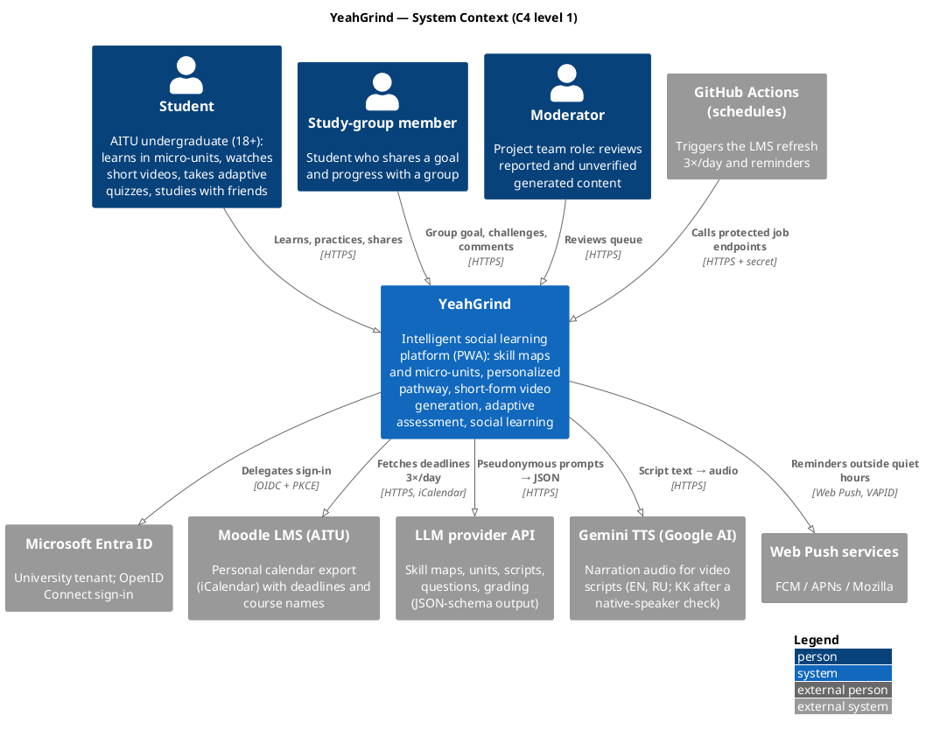
Figure 7.1. System context diagram

7.2. Use case diagram
The use case diagram shows twenty use cases in six areas: accounts and privacy, goals and content, pathway, micro-unit and video, assessment, and social learning with moderation.

Actors
Actor | Role
Student | Signs in, sets goals and material, takes the placement test and daily check-in, studies units and videos, takes quizzes, views mastery, adds friends, shares, reports.
Study-group member | Specialization of Student; creates and joins study groups and cooperative challenges.
Moderator | Hides content, verifies or rejects generated items.
External systems | Entra ID (sign-in), Moodle (deadlines), LLM provider (generation, feedback), TTS provider (narration), Scheduler (refresh, reminders).
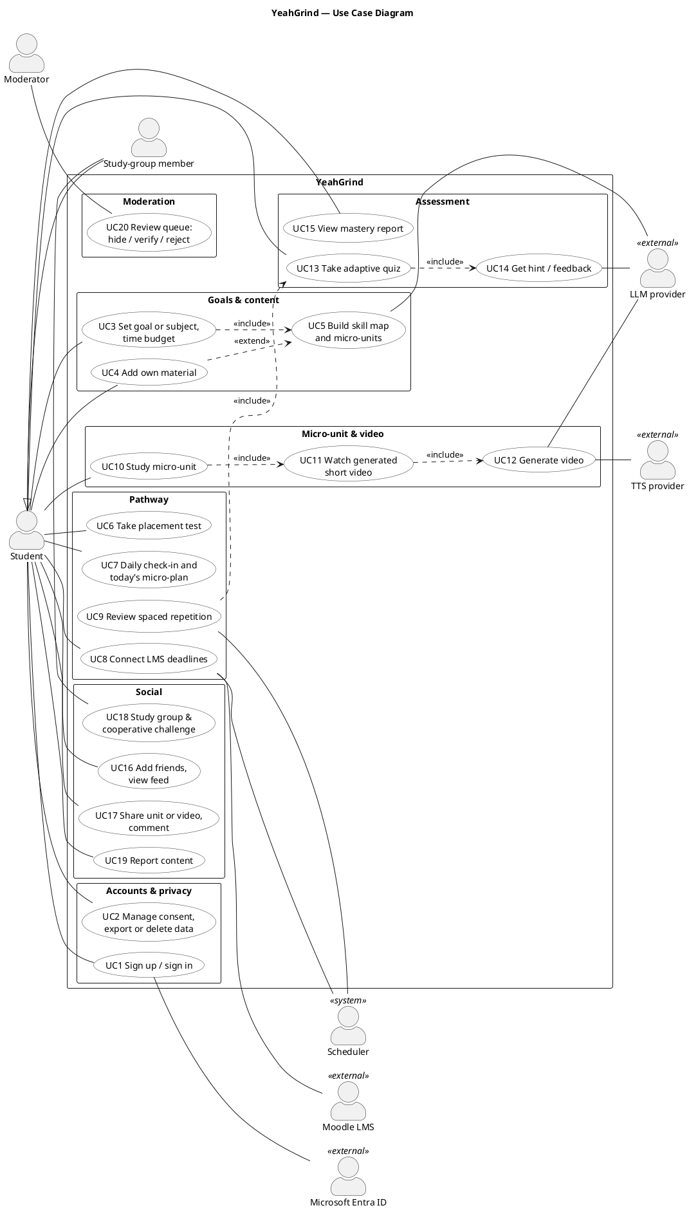
Figure 7.2. Use case diagram

7.3. Component diagram
The component diagram breaks the system into the client, the web application with its background jobs, and the external services.

Client (browser / installed PWA)
UI screens (today, path, unit with video, quiz, mastery, friends, groups, settings), a video player and recorder (canvas slides in sync with the narration, captions, MediaRecorder download), a per-account state cache and a service worker for the offline view of today's plan and push notifications.

Web application (Next.js)
API layer: REST handlers with schema validation and an ownership check on every resource. Auth: e-mail and Microsoft Entra ID. Domain modules: Identity & Consent, Content (goals, skill map, micro-units), Pathway engine (eligibility, priority, micro-plan, spaced review), Assessment engine (item bank, Elo ability and difficulty, mastery, reports), Video (job API, reuse), Social (friends, feed, groups), Moderation, Planning & Calendar, Rewards ledger and Notifications. Data access through Prisma.

Background jobs (web process, after the response)
Job runner that claims and renews job rows (at most 3 attempts); content generation (skill maps, units, questions); video job (script → validation → narration → timings and captions); AI gateway with provider adapters, JSON-schema validation, limits and cost metering; Moodle iCalendar importer. GitHub Actions schedules call protected endpoints for the Moodle refresh and reminders.

Key design rules
- Generated content is never served before validation; failed or reported items go to the moderation queue.
- Answers and rewards are idempotent: unique keys and transactions give exactly one effect per request.
- The answer key and rubric never leave the server; hints come before answers.
- AI requests contain no names, e-mails or account IDs.
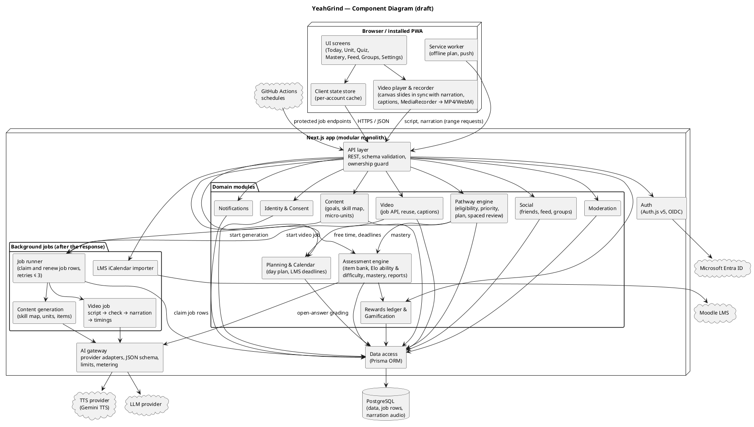
Figure 7.3. Component diagram (draft)

7.4. Data model
Core entities: Goal, SourceMaterial, Skill with prerequisites (an acyclic graph), versioned MicroUnit; Video unique per unit version and language; Question with difficulty and server-only key and rubric; Attempt with a unique idempotency key; Mastery with the Elo ability and the review date per user and skill; CheckIn and PlanItem; Friendship, FeedEvent with visibility, Comment, StudyGroup, Report; RewardLedger with a unique (user, reason, source) key; ConsentRecord. All user-owned rows are deleted together with the account.
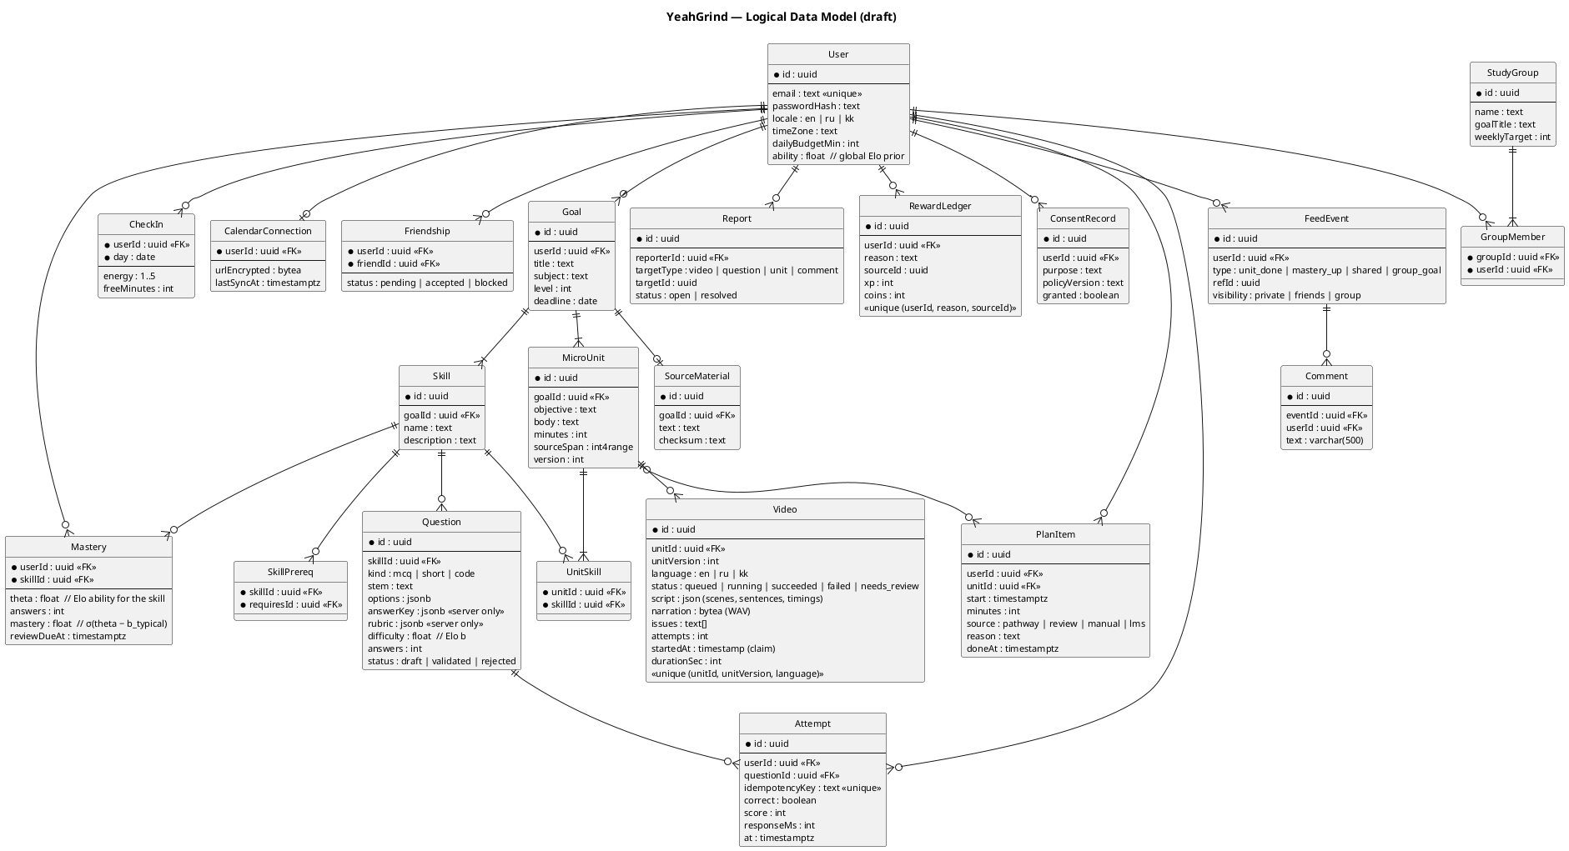
Figure 7.4. Logical data model (draft)

7.5. Key scenarios
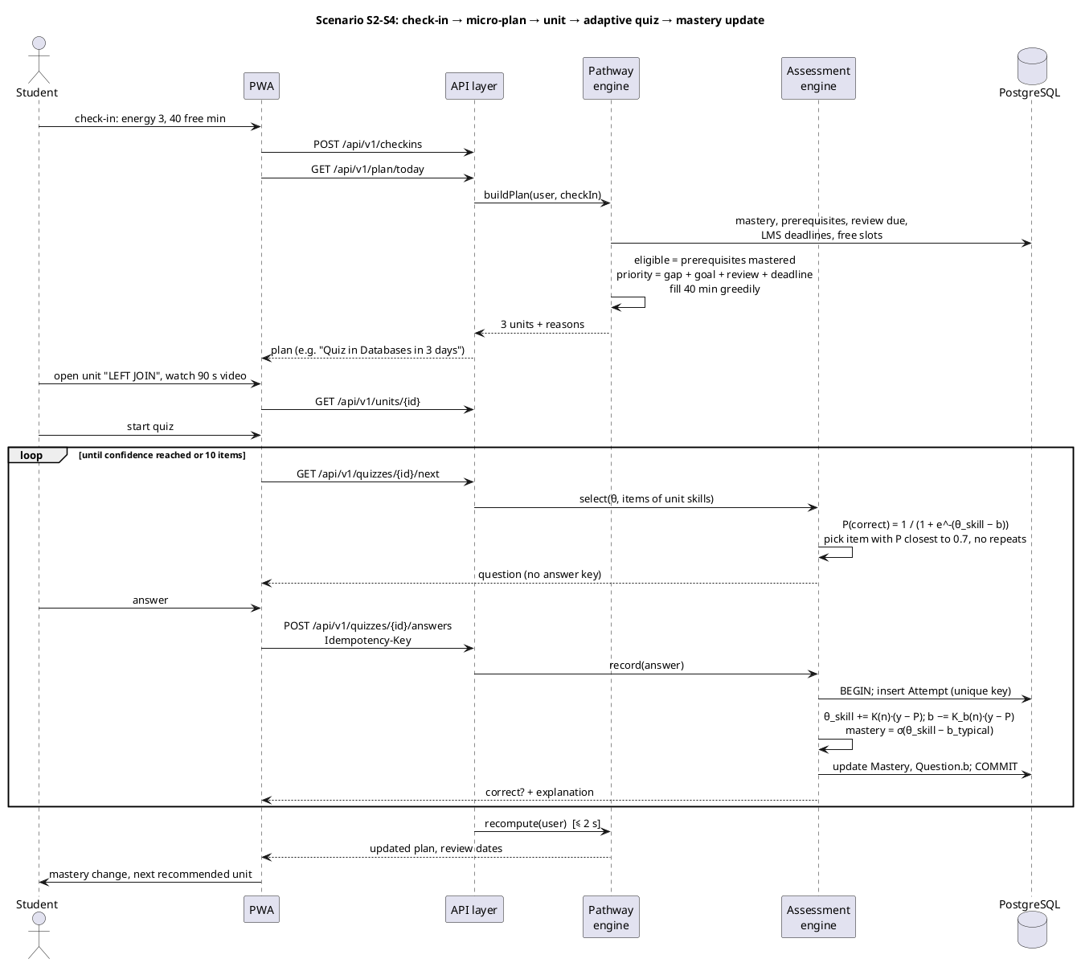
Figure 7.5. Check-in → micro-plan → micro-unit → adaptive quiz → mastery update
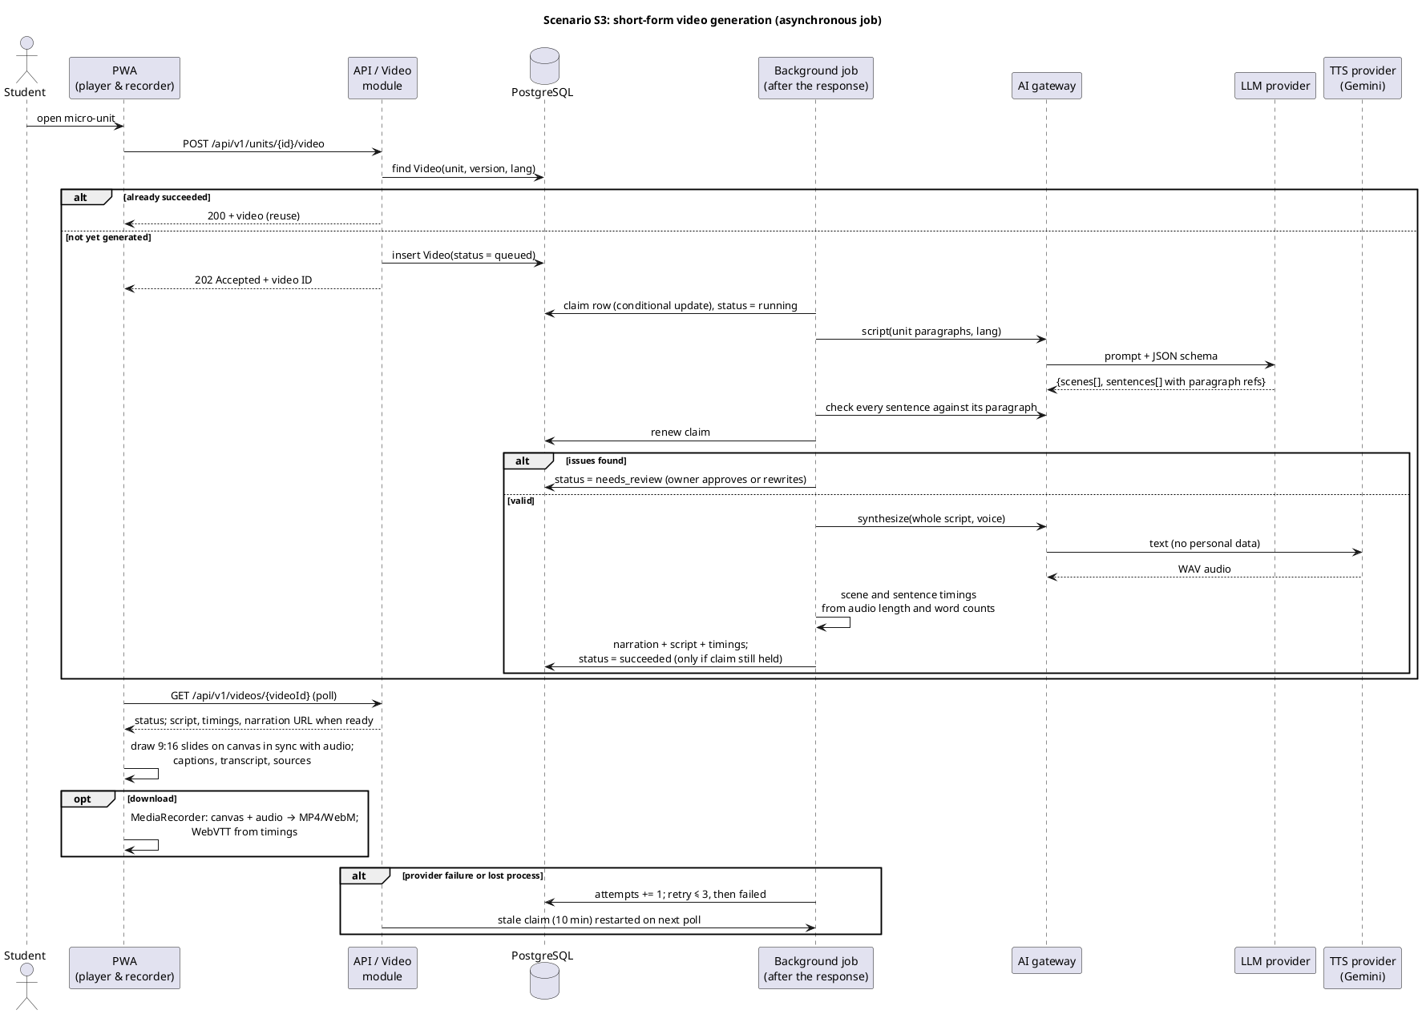
Figure 7.6. Asynchronous short-form video generation with validation and reuse

7.6. Deployment
A Railway project holds the web service, which also runs background jobs, and PostgreSQL 18 with daily backups on a private network; the database also stores the narration audio. GitHub Actions runs lint, type checking, tests and a build on every pull request, triggers the scheduled jobs and deploys on merge to main.
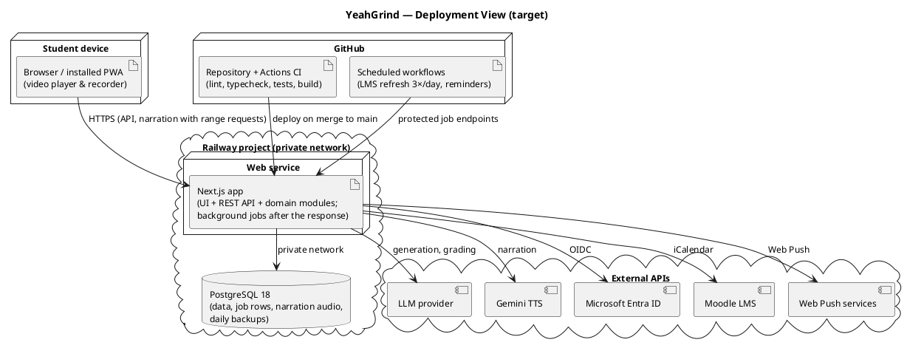
Figure 7.7. Deployment view

8. UI/UX Design
The YeahGrind interface is designed mobile-first, because most micro-sessions happen on a phone between classes. The mockups below show the key scenarios with one persona, Aigerim, a second-year student preparing for a Databases quiz on Friday. The visual language is monochrome with color only for state labels; every recommendation shows its reason, every generated item shows its sources and can be reported, and captions are on by default. The clickable prototype is in the repository (prototype/index.html).

8.1. Mobile Interface
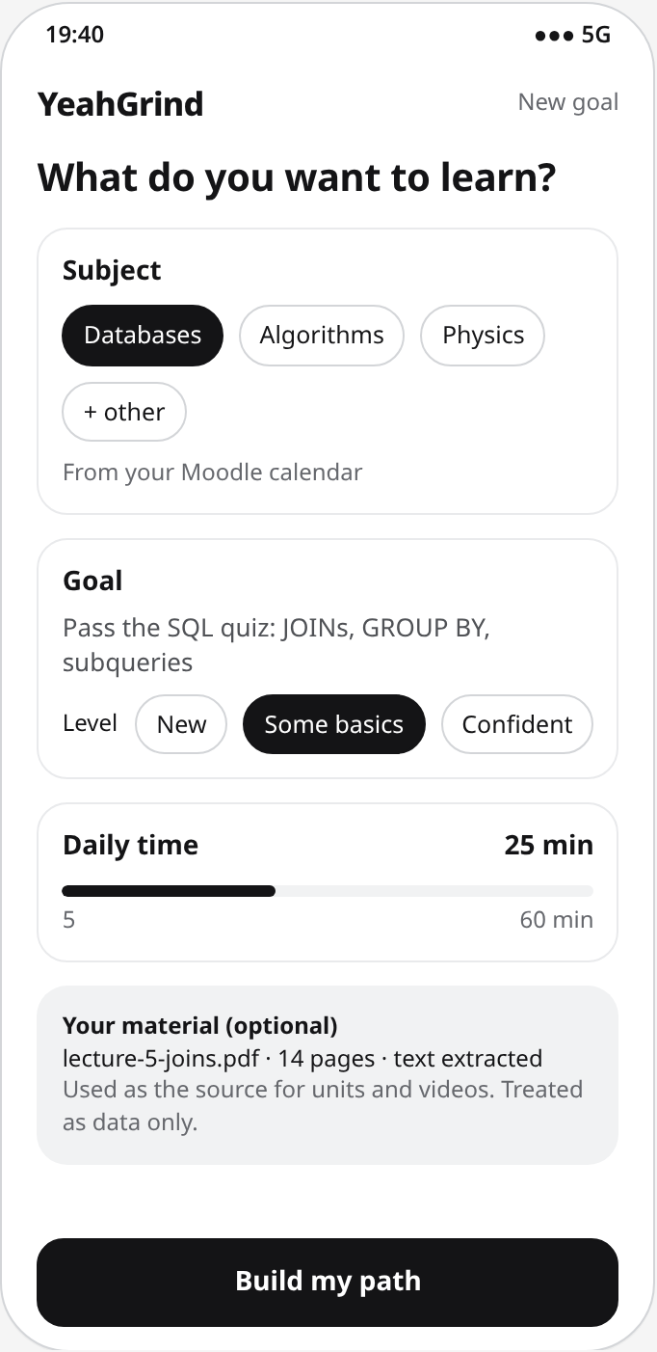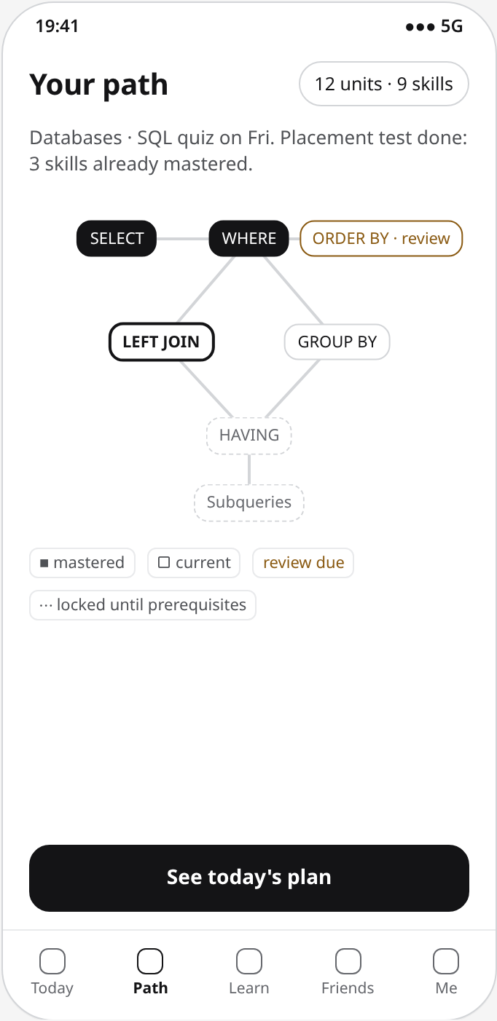
Figures 8.1 and 8.2. Goal, subject and own material; skill map with prerequisites and mastery states.
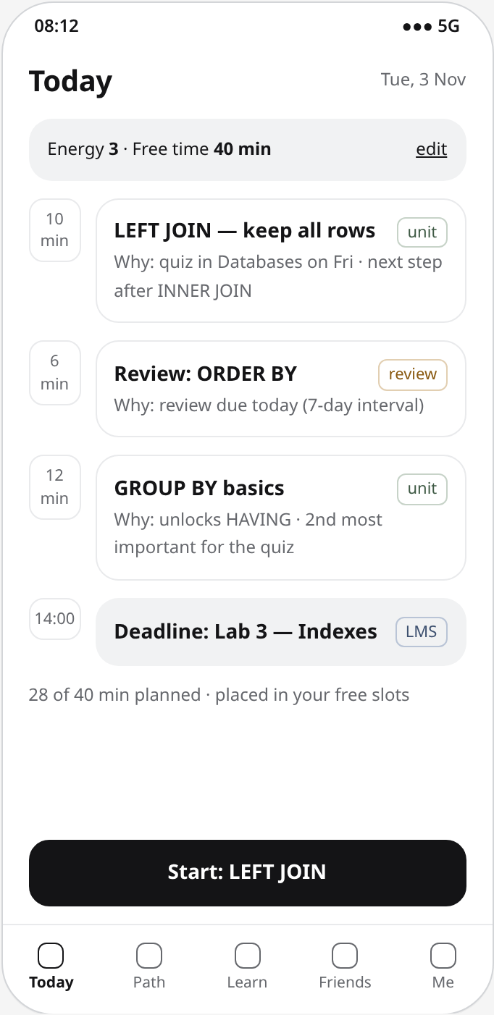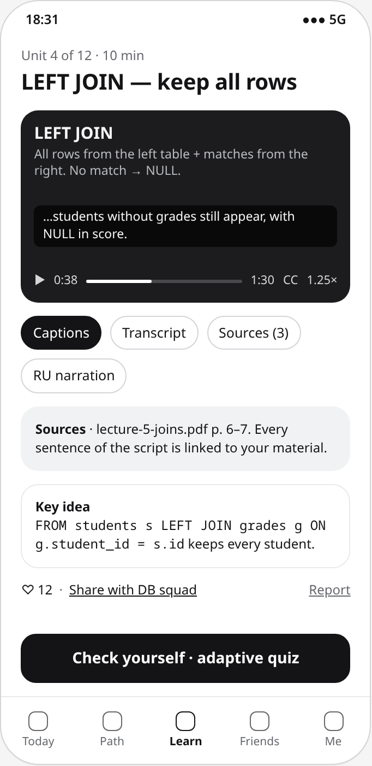
Figures 8.3 and 8.4. Daily check-in and micro-plan with reasons; micro-unit with a generated video, captions and sources.
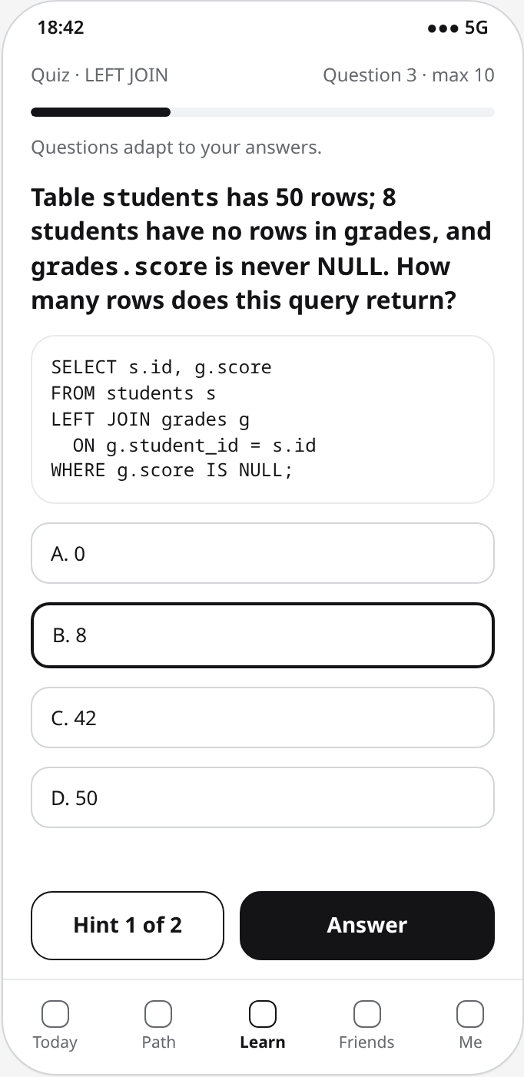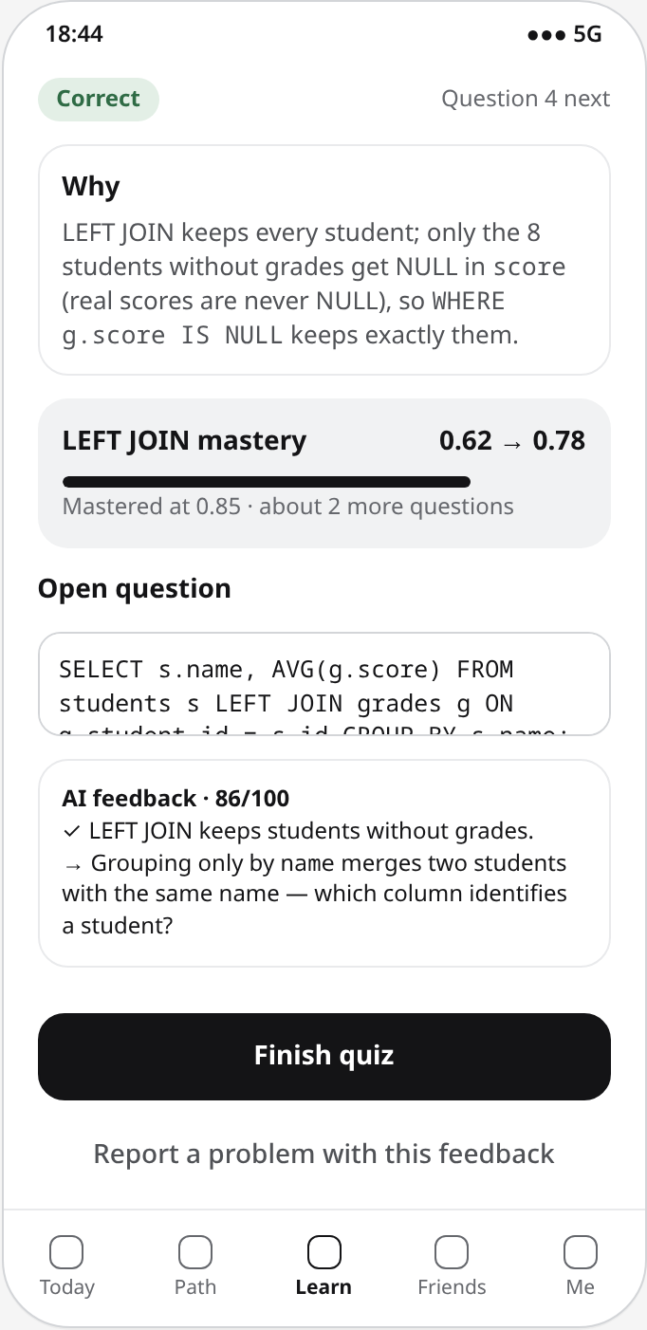
Figures 8.5 and 8.6. Adaptive quiz with hints; feedback, mastery change and AI feedback on an open answer.
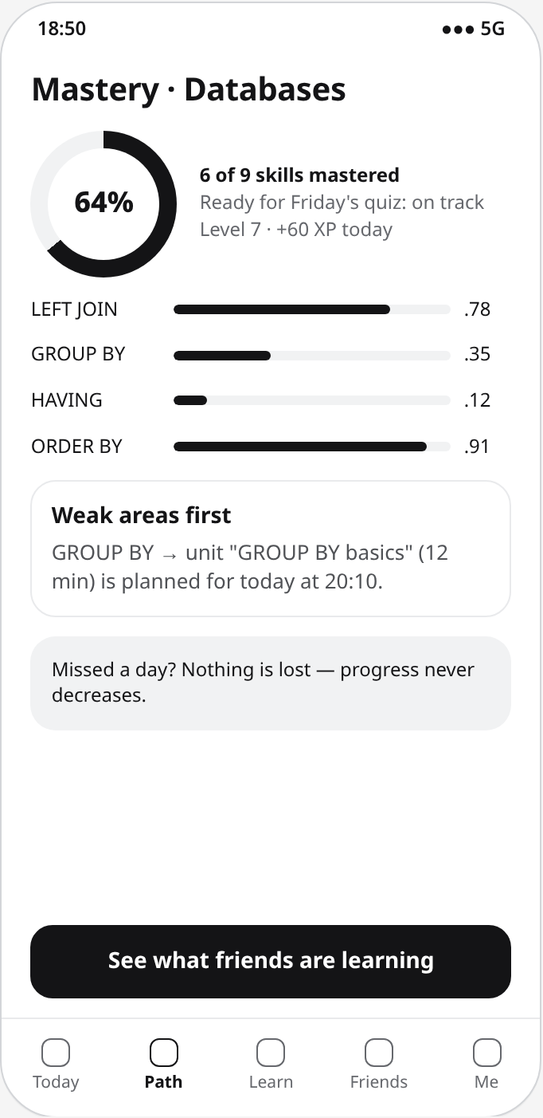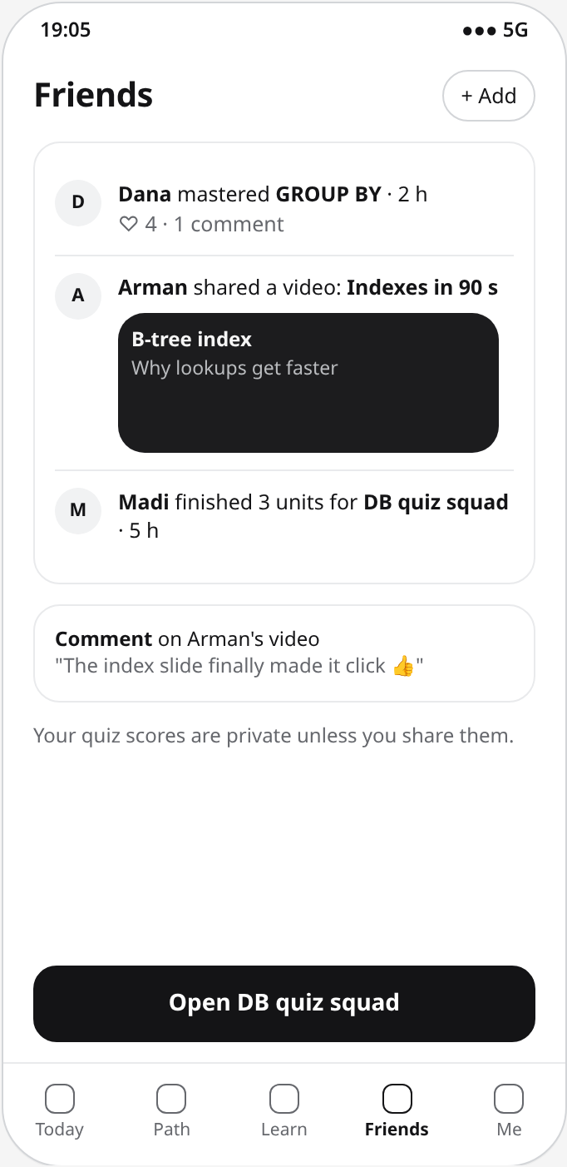
Figures 8.7 and 8.8. Mastery report with weak areas first; friends feed with shared videos and private scores.
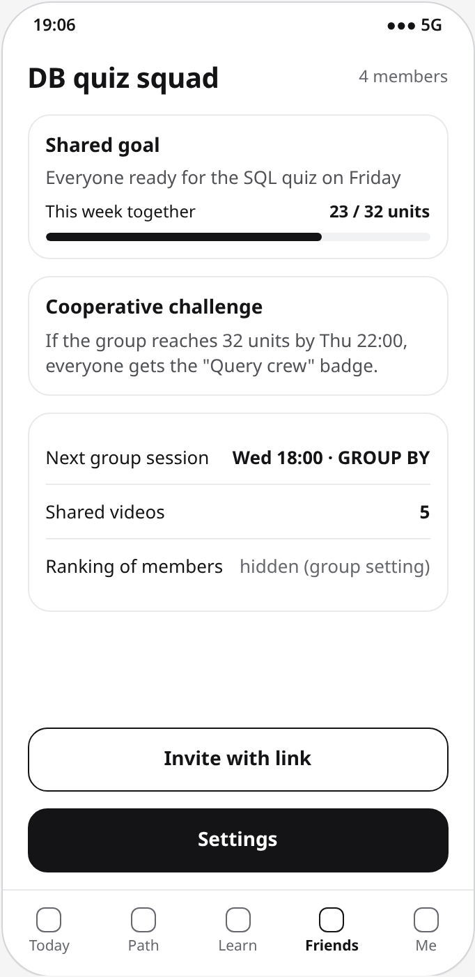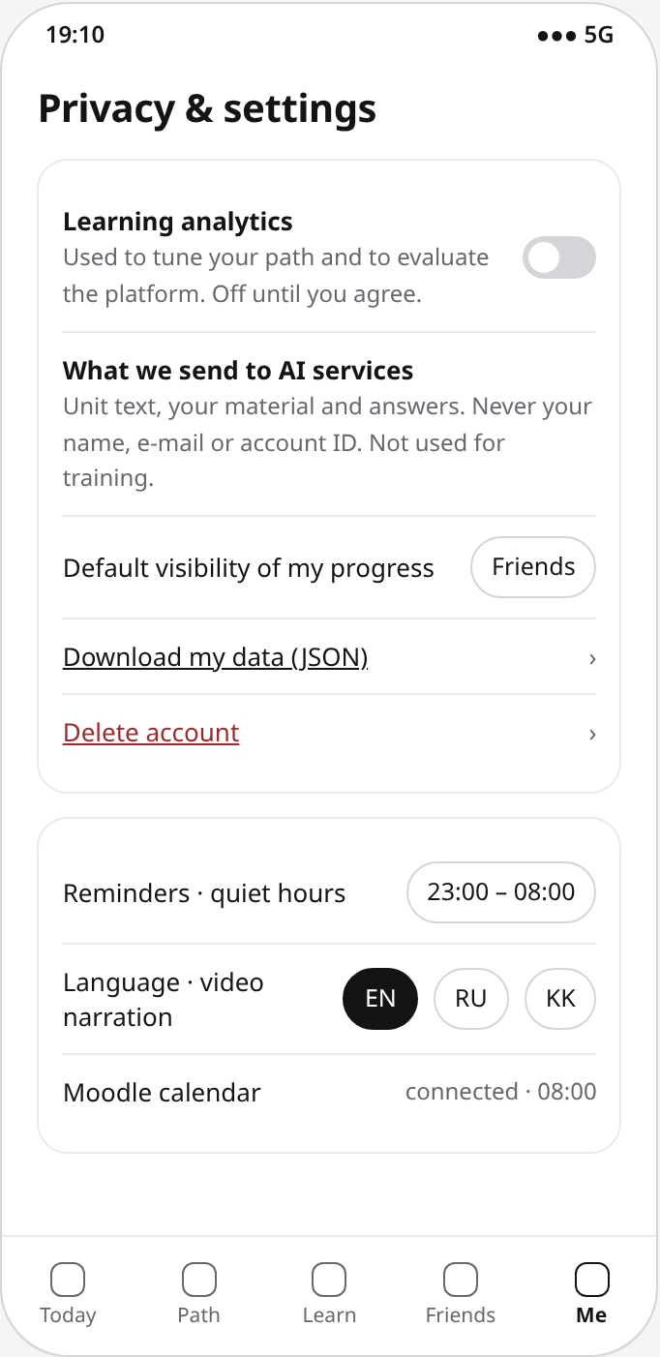
Figures 8.9 and 8.10. Study group with a cooperative weekly goal; privacy, language and reminder settings.

8.2. Moderation Console
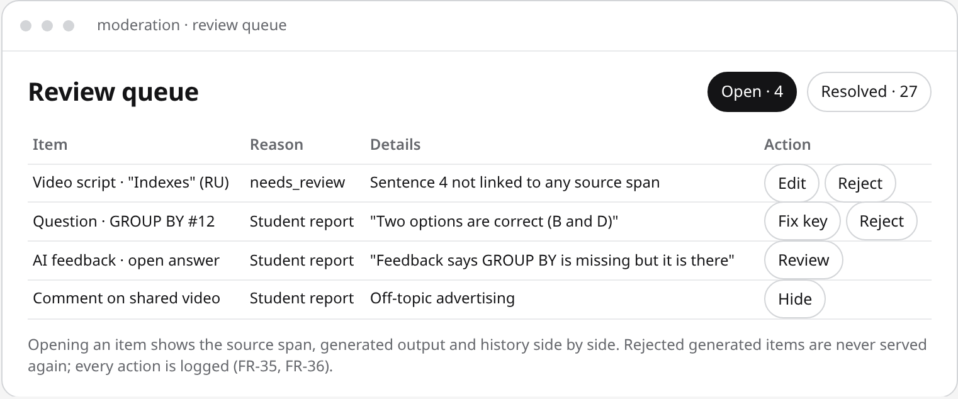
Figure 8.11. Moderation queue for scripts that failed validation and reported content.

9. Verification and Evaluation Plan

9.1. Evaluation Objective
The purpose of the evaluation is to determine whether the platform achieves its aim: a personalized microlearning pathway with generated short videos and adaptive assessment that gives better learning efficiency and good usability compared with a non-adaptive baseline. Particular attention is given to:
1. Correctness of the pathway: prerequisites respected, plans within the free time.
2. Quality of the adaptive assessment: prediction accuracy and number of questions needed.
3. Reliability, speed, accuracy and cost of video generation.
4. Validity of generated questions and units.
5. Agreement of AI grading with human graders and resistance to manipulation.
6. Learning gain, delayed retention and usability compared with the baseline.
7. Performance, integrity, security and accessibility.

9.2. Baseline Solution
The baseline is the way a student studies today without additional tools: the same unit texts presented as a static course page in a fixed order, followed by a fixed ten-question quiz with correct/incorrect feedback, without videos and without adaptivity. It is the active control condition of the learning study, so that the comparison isolates the effect of the pathway, the videos and the adaptive quiz [20].
Component benchmarks use their own baselines:
- Pathway: a fixed curriculum order and a random order of eligible units.
- Assessment model: a per-skill average-correctness predictor and a fixed random ten-question quiz; Bayesian knowledge tracing and a one-parameter IRT model are fitted offline as comparison models.
- AI grading: two human graders using the same rubric, and a keyword-overlap grader.
Both conditions of the learning study use the same unit texts, time limits and post-test questions. Differences in functionality are documented so that results are not attributed to unrelated implementation choices.

9.3. Evaluation Metrics
9.3.1. Normalized Learning Gain
Gain = (Post-test score − Pre-test score) / (Maximum score − Pre-test score)
Computed per participant and topic. The target is a higher median gain in the YeahGrind condition than in the baseline condition. A delayed retention score from a test one week later is reported in the same way.
9.3.2. Prerequisite Violations and Budget Overruns
Violations = Number of planned units whose prerequisite skills have mastery < 0.85
Measured in the pathway simulation (100 simulated learners per topic). The target is zero violations and zero plans that exceed the student's free minutes; units and minutes needed to reach goal mastery must be lower than for both baselines.
9.3.3. Prediction Accuracy of the Assessment Model
AUC and RMSE of next-answer prediction on the held-out 20 % of a public dataset
The Elo model must have a higher AUC and a lower RMSE than the baseline (95 % bootstrap confidence intervals). In simulation, the adaptive quiz must reach ≥ 90 % mastery classification accuracy with ≥ 30 % fewer questions than the fixed quiz.
9.3.4. Video Pipeline Reliability, Speed and Cost
Success rate (%) = Succeeded jobs / All jobs × 100; Generation time = Time ready − Time requested
Over a batch of 50 jobs the targets are ≥ 90 % success after retries, p90 generation time ≤ 5 min, duration 60–120 s with audio and captions, and ≤ USD 0.05 per video.
9.3.5. Seeded-Error Recall
Recall (%) = Injected factual errors flagged by validation / Injected errors × 100
Twenty scripts with ten injected errors (wrong numbers, swapped terms, unsupported claims). The target is ≥ 80 %. Three student raters also score 20 videos for accuracy and clarity (target ≥ 4.0 of 5).
9.3.6. Validity of Generated Questions
Validity (%) = Questions judged correct and unambiguous by both raters / Rated questions × 100
One hundred generated questions are rated before moderation; the target is ≥ 85 %, and no invalid item may ever be served.
9.3.7. Grading Agreement
Accuracy (%) = Pass/fail decisions equal to the human consensus / All answers × 100; Cohen's κ on pass/fail
On a reference set of 60 answers the targets are accuracy ≥ 85 %, κ ≥ 0.70, mean absolute score error ≤ 12, zero successful prompt injections and zero hints that reveal the full answer.
9.3.8. Usability and Performance
SUS score (0–100); p95 latency under load
Targets: mean SUS ≥ 70 and task success ≥ 85 % in the study; p95 ≤ 500 ms for non-generation endpoints at 50 virtual users; question selection ≤ 500 ms; pathway recomputation ≤ 2 s.

9.4. Experimental Environment
Parameter | Proposed Configuration
Version under test | Git tag of the evaluated release; commit hash recorded in every report
Local environment | Node.js 24 LTS, PostgreSQL 18 in Docker
Staging environment | Same configuration as production on Railway; separate database and storage bucket
AI settings | Fixed model versions, voices and temperature; each AI benchmark repeated three times
Devices | Android phone (Chrome) and iPhone (Safari) at 390 px; laptop at 1440 px
Pilot topics | SQL (JOIN, GROUP BY), Python basics, academic English
Pathway simulation | 100 simulated learners per topic; 9–15 skills per topic; budgets of 10–60 min
Assessment dataset | Public dataset of student answers with skill tags (ASSISTments 2009–2010), chronological 80/20 split
Video batch | 50 jobs, 3 topics × 2 languages (EN, RU); 5 Kazakh jobs for the native-speaker check
Grading reference set | 60 answers: 3 subjects × 4 exercises × 5 answer types
Load test | k6, 50 virtual users, 10 minutes, mixed scenario
Learning study | 12 AITU students, within-subject, counterbalanced; one 75-min session + 10-min test after 7 days
Table 9.1. Experimental environment

9.5. Test Cases
Test ID | Test Scenario | Expected Result
TC-01 | Registration, sign-in and access to another user's goal | Sign-in works; access to foreign resources returns 404
TC-02 | Sign-in with a Microsoft account from another tenant | Rejected; AITU accounts accepted
TC-03 | Learning activity before consent | No analytics event stored; progress stored
TC-04 | Account deletion | No user-owned row or private media object remains
TC-05 | Goal with pasted material containing injected instructions | Material treated as data; skill map valid and acyclic
TC-06 | Pathway with locked prerequisites | No unit of a locked skill is planned
TC-07 | Check-in with 40 free minutes | Planned time ≤ 40 min; every item has a reason
TC-08 | Review due for a mastered skill | Review item included in today's plan
TC-09 | Moodle calendar connection and refresh | Deadlines and course names imported; changed and canceled events updated; URL never returned
TC-10 | First request for a unit video | Status 202; job runs; MP4 60–120 s with audio and WebVTT
TC-11 | Second request for the same video | Status 200; no new LLM or TTS call
TC-12 | Script with an ungrounded sentence | Status needs_review; not visible to students; listed in moderation queue
TC-13 | LLM or TTS timeout during a video job | Retried up to 3 times, then failed with a message; no fake output
TC-14 | Kazakh video before the quality check | Status 409
TC-15 | Next-question selection | Item with P closest to 0.7; no repeats; ≤ 500 ms
TC-16 | Correct and incorrect answers | Ability and mastery move in the expected direction
TC-17 | Same answer submitted twice with one idempotency key | Stored result returned; no second update or reward
TC-18 | Request for hints and question data | No response contains the answer key or rubric
TC-19 | Open answer with a prompt-injection attempt | Graded by the rubric; injection has no effect
TC-20 | Feed with friends' and non-friends' events | Only permitted events shown; scores private
TC-21 | Study group progress | Group total shown; no member ranking by default
TC-22 | Moderator rejects a generated question | Question never served again; action logged
TC-23 | 100 parallel duplicate reward requests | Exactly one reward; no negative balance
TC-24 | Reminder during quiet hours | Not sent; delivered after quiet hours
TC-25 | Load test with 50 virtual users | p95 ≤ 500 ms; error rate < 1 %
TC-26 | Accessibility scan of core screens | Zero critical or serious axe-core violations
TC-27 | Learning and usability study vs baseline | Gain, retention, SUS and task metrics recorded for both conditions
Table 9.2. Test cases

9.6. Experimental Procedure

Step 1: Environment Preparation
The release is tagged and deployed to staging. Test databases, storage buckets and benchmark data sets are initialized so that no data from earlier runs is reused.

Step 2: Workload and Data
Simulated learners, the public assessment dataset split, the video batch, the seeded-error scripts and the grading reference set are prepared and versioned in tests/benchmarks.

Step 3: Execution
Automated tests and benchmarks are run; AI benchmarks are repeated three times with fixed model settings.

Step 4: Learning Study
Each participant gives consent, takes the pre-test, studies one topic in each condition (order counterbalanced), takes the post-test, performs the usability tasks and completes SUS and NASA-TLX; the retention test follows after seven days.

Step 5: Data Verification
Results are checked against logs; incomplete sessions and technical failures are reported, not silently removed.

Step 6: Metric Calculation
The metrics of Section 9.3 are calculated with versioned scripts; medians, interquartile ranges, effect sizes and confidence intervals are reported.

Step 7: Comparison and Reporting
Results are compared with the baselines; failed thresholds are recorded with a corrective YouTrack task in the evaluation report.

9.7. Expected Evaluation Outcomes
The platform is expected to demonstrate:
- Pathways that never violate prerequisites or the student's free time and reach goal mastery with fewer units than fixed or random orders.
- An Elo assessment model that predicts answers better than the baseline and needs fewer questions than a fixed quiz.
- Reliable, fast and cheap video generation in which validation catches most injected factual errors.
- Generated questions and AI grading of sufficient quality for formative, low-stakes use.
- Higher learning gain in the YeahGrind condition than in the baseline, with good usability.
The aim is considered demonstrated when the mandatory acceptance criteria are satisfied in the specified experiments. Any failed test, limitation or deviation from the acceptance criteria is included in the final evaluation report.

10. Project Management and Risks

10.1. Project Management Approach
The project is developed by a team of two Software Engineering students using a lightweight approach that combines milestones with two-week sprints. Milestones define the major deliverables; tasks are planned and reviewed every sprint.
The team uses the following tools:
- GitHub for source code, documentation, diagrams, pull requests and reviews.
- YouTrack (project YG) for task assignment, priorities, dependencies and progress tracking.
- GitHub Actions for lint, type checking, tests and builds on every pull request.

10.2. Team Responsibilities
Team Member | Primary Responsibility | Main Deliverables
Katyshev Yernar | Backend and business logic | Data model, REST API, authentication, AI gateway, job runner, content generation, pathway engine, assessment engine, video pipeline, Moodle importer, rewards ledger, CI/CD; benchmarks B1–B2; literature, technology, requirements and architecture documents
Balmagambet Ayat | Frontend, UX and social features | PWA screens (goal and path, micro-plan, video player, quiz and mastery, feed, groups, moderation, privacy), localization, accessibility; interviews, prototype, existing-system comparison; benchmarks B3–B5 and the learning and usability study
Table 10.1. Team responsibilities
Both members co-own the requirements, verification and project management documents. Every pull request is reviewed by the other member; important architectural decisions are taken together and recorded as decision records.

10.3. Git Repository Organization
The GitHub repository (https://github.com/ayatyeah/yeahgrind, private, with access for the supervisor and the committee) maintains the source code, documentation and evaluation materials. The structure is:
yeahgrind/
├── README.md
├── CONTRIBUTING.md
├── docs/ proposal, evidence, literature, comparisons, requirements,
│ architecture, UX, verification, management, decision records
├── diagrams/ editable PlantUML sources and SVG/PNG exports
├── prototype/ clickable mockups and screenshots
├── api/ OpenAPI contract and examples
├── src/ web, server modules, jobs, player, adapters
├── tests/ acceptance scenarios, unit, integration, e2e, load, benchmarks
├── config/ .env.example with placeholders
└── project-management/ YouTrack backlog import
Work follows one branch per YouTrack task (for example YG-29-assessment-engine), commit messages that start with the task ID (YG-29: Add Elo item selection with property tests), and pull requests reviewed by the other member before merging into main. Each pre-defense submission is tagged (pre-defense-1, pre-defense-2, final-pre-defense); tags are never moved.

10.4. YouTrack Project Organization
YouTrack organizes the work into workstreams; the initial backlog contains 56 tasks.
Workstream | Main Activities
Analysis and design | Proposal, evidence and interviews, literature, comparisons, requirements, architecture, prototype, verification plan
Platform foundation | Project skeleton, CI, data model, authentication, PWA shell, localization, day plan
Content and pathway | AI gateway, job runner, goals and material, skill maps and units, pathway engine, micro-plan, Moodle deadlines
Adaptive assessment | Question bank and validation, Elo engine, quiz and mastery interfaces, placement test, grading and hints
Short-form video generation | Script generation and validation, narration, rendering, storage, video player, reuse and cost metering
Social learning and privacy | Friends and feed, sharing, study groups, moderation, rewards, consent, export and deletion, reminders
Evaluation and thesis | Benchmarks B1–B6, learning and usability study, accessibility and security review, evaluation report, thesis
Table 10.2. YouTrack workstreams
Each task contains a description, the assigned member and reviewer, priority, estimate, sprint, deadline, related requirements, dependencies, acceptance criteria and links to the pull request or test evidence. The workflow is Open → In Progress → In Review → Done, with a Blocked state for unresolved dependencies.

10.5. Project Milestones
Milestone | Date | Completion Criteria
M1: Pre-defense 1 — analysis and design | 24 Oct 2026 | Documentation and prototype in the repository; YouTrack configured; supervisor review recorded
M2: Platform foundation | 23 Nov 2026 | CI, data model, authentication, PWA shell, AI gateway and job runner work on staging
M3: Content and pathway | 21 Dec 2026 | Goal → skill map → micro-plan works on staging; pathway simulation runs in CI
M4: Adaptive assessment and video scripts | 8 Feb 2027 | Adaptive quiz updates mastery and pathway; script validation tested
M5: Pre-defense 2 | February 2027 | Core scenarios end to end on staging, including generated videos
M6: Video, social and engagement | 22 Mar 2027 | All Must and Should requirements implemented
M7: Evaluation | 19 Apr 2027 | Benchmarks and the learning and usability study completed
M8: Final pre-defense | May 2027 | Final release, evaluation report and thesis; tag final-pre-defense
Table 10.3. Project milestones
Development runs in two-week sprints from 27 October 2026 to 17 May 2027, with a buffer for the winter exam session (22 December – 11 January). The dates of pre-defense 2 and the final pre-defense follow the department schedule.

10.6. Risk Management
Each risk is evaluated by its estimated probability and impact.
ID | Risk | Probability | Impact | Mitigation Strategy
R-01 | Scope (pathway + video + assessment + social) too large for two people | High | High | MoSCoW priorities; Could items only after M6; video limited to template slides; scope review every sprint
R-02 | Generated content contains factual errors | High | High | Grounding to source spans, self-consistency check, draft status for questions, moderation queue, report button, B3/B4 benchmarks
R-03 | Video generation too slow or too expensive | Medium | High | Asynchronous jobs, reuse per unit and language, per-user limits, short scripts, cost metering
R-04 | Kazakh narration quality is insufficient | Medium | Medium | Native-speaker check before enabling; KK interface independent of KK narration; alternative voice provider
R-05 | Adaptive assessment poorly calibrated at cold start | Medium | Medium | Elo with uncertainty-based step size; LLM difficulty priors; offline evaluation B2; placement test
R-06 | AI grading inaccurate or manipulable | Medium | High | Hidden rubrics, injection test set, κ threshold, report and review
R-07 | Copyright or privacy problems with uploaded material | Medium | Medium | Material private to the owner by default; sharing only of generated units; terms of use; deletion with the account
R-08 | Social features enable harassment or spam | Low | Medium | Friends-only default, blocking, reports, moderation queue, comment limits
R-09 | Duplicate rewards or inconsistent mastery under concurrency | Medium | High | Idempotency keys, unique constraints, transactions, concurrency tests
R-10 | LLM/TTS provider outage or API change | Medium | Medium | Provider adapters, fallback providers, feature-level degradation
R-11 | Not enough participants for interviews or the study | Medium | Medium | Early recruitment across programs; short sessions; flexible time
R-12 | Uneven contribution visibility in Git history | Medium | Medium | Own accounts; PR review by the other member; weekly board review
Table 10.4. Risk register
Risks are reviewed at every sprint review; their probability, impact and mitigation are updated as implementation progresses.

10.7. Project Dependencies
Activity | Dependency
Content generation, questions, video scripts | AI gateway and job runner
Adaptive quiz | Validated question bank
Pathway engine | Skill maps, mastery estimates, Moodle deadlines
Video rendering and delivery | Validated scripts, TTS provider with Russian and Kazakh voices, browser recording support
Kazakh narration | Native-speaker listening test
Microsoft sign-in | App registration in the university tenant
Benchmark B2 | Public assessment dataset with a license for research use
Benchmarks B3–B5 | Student raters and a second human grader
Learning and usability study | Stable release on staging; 12 participants; validated pre/post tests
Final documentation | Completed implementation and evaluation report
Table 10.5. Project dependencies
Dependencies are represented in YouTrack as linked issues; tasks on the critical path receive priority.

10.8. Progress Monitoring and Traceability
Every important task is linked to its requirement and verification test. For example:
FR-26: Adaptive next-question selection
- Implementation task: YG-29 Assessment engine: Elo ability and difficulty, item selection, stopping rule.
- Responsible member: Katyshev Yernar; reviewer: Balmagambet Ayat.
- Verification tests: TC-15, TC-16, TC-17; benchmark B2.
- Evidence: code, property-based test logs, benchmark report.
A task is completed when its deliverable is in the repository, its acceptance criteria are satisfied, related tests pass, evidence is recorded and the YouTrack issue is updated with the pull request link.

10.9. Expected Project Management Outcomes
The process gives clear responsibilities, structured milestones and transparent progress. The Git history preserves every implementation and documentation change with its author and reviewer, YouTrack shows task ownership and dependencies, and the requirements and verification documents give measurable completion criteria for every deliverable.

11. Supervisor Feedback
The supervisor reviews the deliverables before each pre-defense and at milestones M2, M4 and M6; the planned checkpoints are listed in Table 11.1, and each comment is added as a new row on the day it is given. Every comment is recorded below as given, together with the decision, the responsible member and the task or commit that addresses it.

11.1. Questions for the supervisor
1. Is the scope appropriate for two people, and which Could requirements should be dropped first?
2. Are the pilot topics (SQL, Python basics, academic English) and the pre/post tests acceptable, and who can act as the second human grader?
3. Is the evaluation design acceptable: component benchmarks plus a learning and usability study with 12 students against the static-course baseline?
4. Does the study with students require approval from the university ethics committee?
5. Is template-based video (script, narration, slides, captions) sufficient for the short-form video generation part of the topic?
6. What is the expected date of pre-defense 2 and which deliverables are expected?

11.2. Feedback log
Date | Deliverable | Supervisor comment | Decision | Task / commit
24 Oct 2026 (planned) | Pre-defense 1 package and the questions in 11.1 | Recorded after the review | — | YG-12
23 Nov 2026 (planned) | M2 platform foundation | Recorded after the review | — | YG-14 – YG-21
8 Feb 2027 (planned) | M4 adaptive assessment and video scripts | Recorded after the review | — | YG-28 – YG-33
22 Mar 2027 (planned) | M6 video, social and engagement | Recorded after the review | — | YG-34 – YG-45
Table 11.1. Supervisor feedback log (planned checkpoints)

