

Aquaspectra

Satellite-Based Coastal Spectral Change Analysis for Prioritizing Environmental Monitoring in the United Arab Emirates

TECHNICAL RESEARCH REPORT
Proof-of-Concept Study
Arab Youth Space Hackathon 2026 | Challenge 813
Case Study: Al Raha Bay / Al Muneera, Abu Dhabi
Team AquaSpectra
October 2026

Study status: exploratory satellite analysis; no field-confirmed harmful algal bloom detection or validated forecasting.

Contents
Abstract 2
1. Introduction and Research Motivation 3
2. UAE Environmental and Space-Sector Relevance 3
3. Research Questions and Scope 3
4. Study Area and Satellite Data 4
4.1. Why spectral bands matter 6
5. Implemented Methodology 8
5.1. Preliminary water-candidate selection 9
5.2. NDCI calculation 11
5.3. Moving-window spatial smoothing 11
5.4. Temporal change and spatial grouping 12
6. Mathematical Formulation and Worked Example 12
7. Results and Interpretation 13
7.1. Exploratory comparison with unsupervised machine learning 16
7.2. Multispectral spectral-response interpretation 17
8. Scientific Limitations and Data Quality 17
9. System Demonstration and Deliverables 18
10. Future Development and Validation Roadmap 18
Phase I: Improve water and quality masks 18
Phase II: Connect the satellite product to field measurements 18
Phase III: Broaden temporal and sensor coverage 18
Phase IV: Evaluate optional machine learning 18
Phase V: Pilot decision support 19
11. Conclusion 19
References 19
Appendix A. Figure and Output Register 20

Abstract
Satellite observations offer broad coastal coverage, but they do not automatically tell environmental teams where to deploy field crews. AquaSpectra investigates a focused and testable question: can changes in multispectral satellite imagery be converted into a short, interpretable list of coastal locations worth investigating? We implemented a retrospective proof of concept (PoC) using four Sentinel-2 Level-2A acquisitions dated 29 March, 3 April, 6 April and 28 April 2023 in the Al Raha Bay coastal vicinity of Abu Dhabi. The workflow extracts nine spectral bands, applies a shared preliminary candidate-water mask, calculates the Normalized Difference Chlorophyll Index (NDCI), smooths local values with a 5 × 5 moving window, and compares 29 March against 3 April. A 90th-percentile change threshold selected 344 priority pixels from 3,435 valid comparisons. Eight-connected component labeling, with a minimum component size of five pixels, produced five candidate monitoring regions. The largest (Region 2) contained 189 pixels and had an estimated area of 15,094.8 m². These findings demonstrate the feasibility of transparent spatial prioritization, not the identification of a harmful species, toxin, or confirmed algal bloom. The study outlines a path toward verified masks, field sampling, multi-sensor observations and operational evaluation.
Keywords: Sentinel-2; coastal monitoring; multispectral remote sensing; NDCI; spatial smoothing; connected components; UAE; environmental decision support.

1. Introduction and Research Motivation
Coastal environmental monitoring is fundamentally a problem of scale. A satellite can repeatedly observe a wide shoreline, whereas laboratory testing and field surveys can cover only a limited number of places and times. The practical question is therefore not simply whether an image contains unusual colors, but whether image-derived measurements can help a scientist decide which location should be investigated first.
Potential harmful algal blooms (HABs) are one reason this problem matters. However, water color and red-edge spectral responses are influenced by several processes other than algae, including suspended sediment, shallow seabed reflectance, changing water depth, atmospheric conditions and acquisition geometry. AquaSpectra was designed to treat a spectral anomaly as a reason for closer investigation rather than as a biological diagnosis. This distinction is essential for a credible environmental application.
This work is an engineering and exploratory scientific demonstration: starting from satellite pixels, it produces georeferenced candidate regions, summary statistics and an interactive view. The study deliberately does not report model accuracy because no labeled ground-truth dataset or supervised model was used.

2. UAE Environmental and Space-Sector Relevance
The UAE has extensive coastal activity involving ports, recreation, fisheries, tourism, desalination infrastructure and sensitive marine ecosystems. A scalable screening tool could help environmental authorities allocate limited field capacity more efficiently. In a future operational setting, an analyst could examine the candidate map, assess uncertainty, and direct sampling to the most relevant coordinates. That could reduce unnecessary review of broad coastal scenes; a future pilot, rather than assumptions, must measure the actual time savings.
For the space sector, AquaSpectra demonstrates the value chain between Earth-observation infrastructure and on-the-ground decisions: multispectral satellite measurements are transformed into a reproducible map of locations requiring follow-up. The project does not claim that satellites alone can identify toxic organisms. Its value is in the traceability of every decision, from spectral bands and mask thresholds to spatial regions and geographic coordinates.

3. Research Questions and Scope
The primary question is whether a transparent multispectral workflow can identify geographically coherent locations with elevated short-term NDCI change. Supporting questions are: (1) How can we construct a consistent candidate-water mask? (2) How does spatial averaging reduce noisy pixel-scale values (3) Can connected-component analysis turn scattered high-change pixels into actionable candidate areas?
The scope is retrospective and local. Four dates were inspected for context, while the main region-selection result compares 29 March and 3 April 2023. The five candidate regions are not independently detected on each of the four dates. The PoC has no labels, in-situ chlorophyll measurements, toxin assays, validated cloud masks, or prediction targets.

4. Study Area and Satellite Data
The study focuses on a coastal area near Al Raha Bay and Al Muneera Island in Abu Dhabi, United Arab Emirates. This location was selected as a case study to investigate whether changes in satellite-derived spectral measurements could help identify coastal areas requiring closer environmental monitoring.
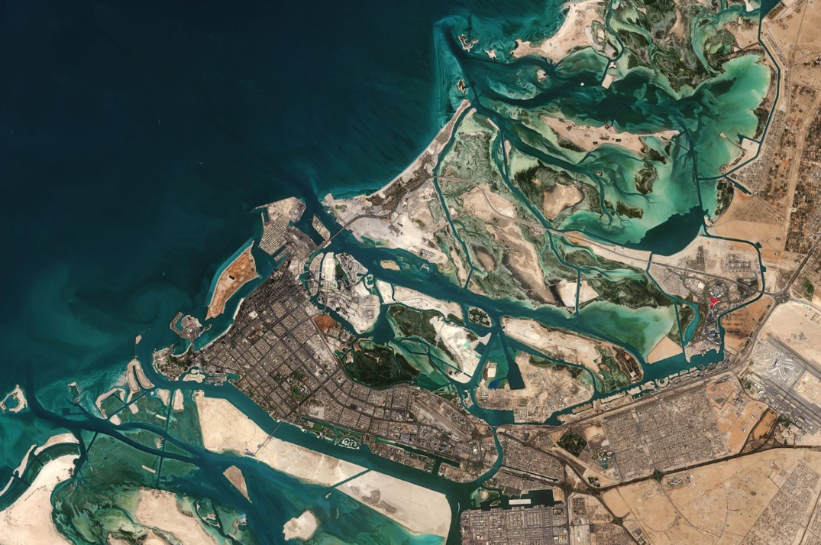
Figure 1. Satellite View of the Abu Dhabi Coastal Region, United Arab Emirates. An overview of Abu Dhabi's coastline, islands, and surrounding marine waters, illustrating the broader geographic context of the AquaSpectra study area near Al Raha Bay and Al Muneera Island.
Source: Satellite imagery of Abu Dhabi, UAE. Original image provider and acquisition date to be confirmed.

Multispectral satellite imagery was obtained from the Copernicus Data Space Ecosystem, using the Copernicus Browser. The selected imagery comes from the European Space Agency's Sentinel-2 mission and consists of Level-2A products, which provide atmospherically corrected surface reflectance measurements.
Four acquisition dates were included in the analysis: 29 March, 3 April, 6 April, and 28 April 2023. For each date, nine spectral bands were examined: B02, B03, B04, B05, B06, B07, B08, B8A, and B11.
The images were processed in Python using Google Colab. Rather than relying on visual differences alone, the study examined spectral measurements at the pixel level to select candidate water pixels, calculate the Normalized Difference Chlorophyll Index (NDCI), and compare changes across dates.
The principal change-detection analysis compared 29 March with 3 April 2023. The other two dates were retained for additional temporal exploration. The resulting maps identify candidate monitoring areas, not confirmed harmful algal blooms.
Data source: Copernicus Data Space Ecosystem — Copernicus Browser (https://browser.dataspace.copernicus.eu/).
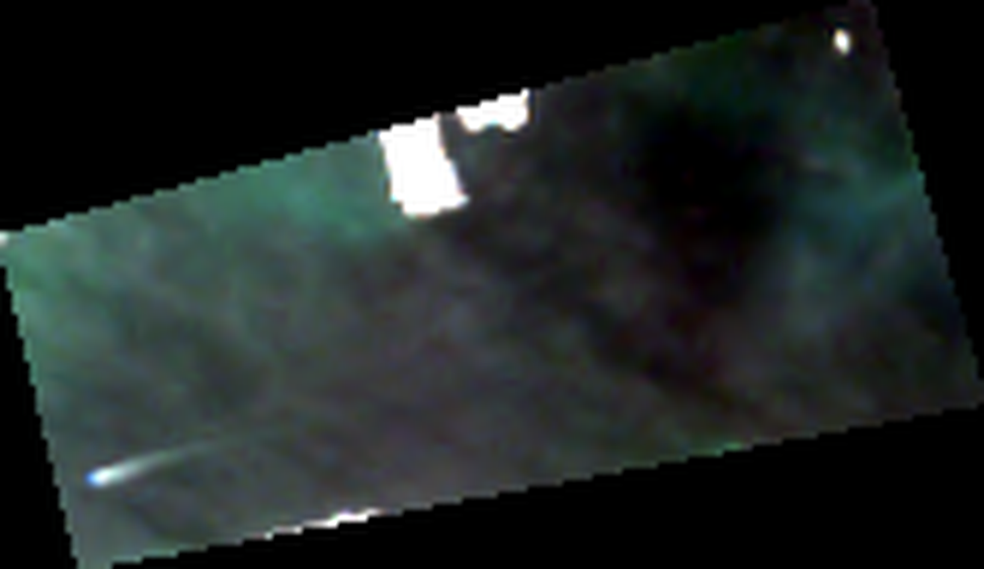
Figure 2. Original Sentinel-2 true-color composite (B04, B03 and B02) of the Al Raha Bay study subset, 29 March 2023. Prepared from the project’s Copernicus imagery; image colors are contrast-stretched for visualization and are not used in quantitative analysis.
For broader geographic context, an International Space Station astronaut photograph of Al Raha Bay and Al Muneera Island is available as NASA image ISS065-E-74285 (26 May 2021). It is a contextual photograph, not an input to this study. See the NASA image source in the references.
Acquisition | Role in analysis
29 March 2023 | Baseline for the principal change comparison
3 April 2023 | Follow-up for the principal change comparison
6 April 2023 | Exploratory comparison; data-quality caution
28 April 2023 | Exploratory later-date context

4.1. Why spectral bands matter
A spectral band is a measurement of reflected light over a defined wavelength range. A normal color image displays three bands, whereas multispectral imagery captures additional parts of the spectrum that respond differently to water, vegetation, sediment and surface conditions. Sentinel-2 is multispectral, not hyperspectral: the plotted values are discrete band observations, and connecting them with a line does not mean every intervening wavelength was measured.
Band | Approx. center (nm) | Interpretive role
B02 | 490 | Blue; visible-water and atmosphere-sensitive response
B03 | 560 | Green; candidate-mask positivity check
B04 | 665 | Red; denominator/input to NDCI
B05 | 705 | Red edge; numerator/input to NDCI
B06 | 740 | Red edge; additional spectral context
B07 | 783 | Red edge; additional spectral context
B08 | 842 | Near infrared; NDWI cross-check
B8A | 865 | Narrow near infrared; additional context
B11 | 1610 | Shortwave infrared; preliminary low-SWIR water criterion

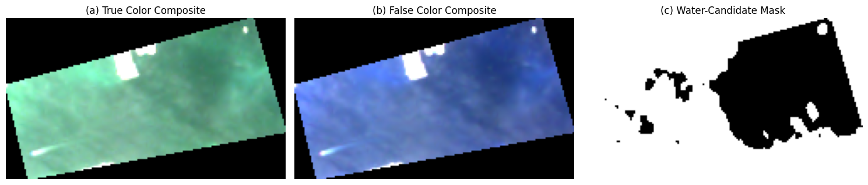
Figure 3. Three representations of the same satellite scene: true-color, false-color and a preliminary candidate-water mask. The mask is not independently validated as a land–water classification.
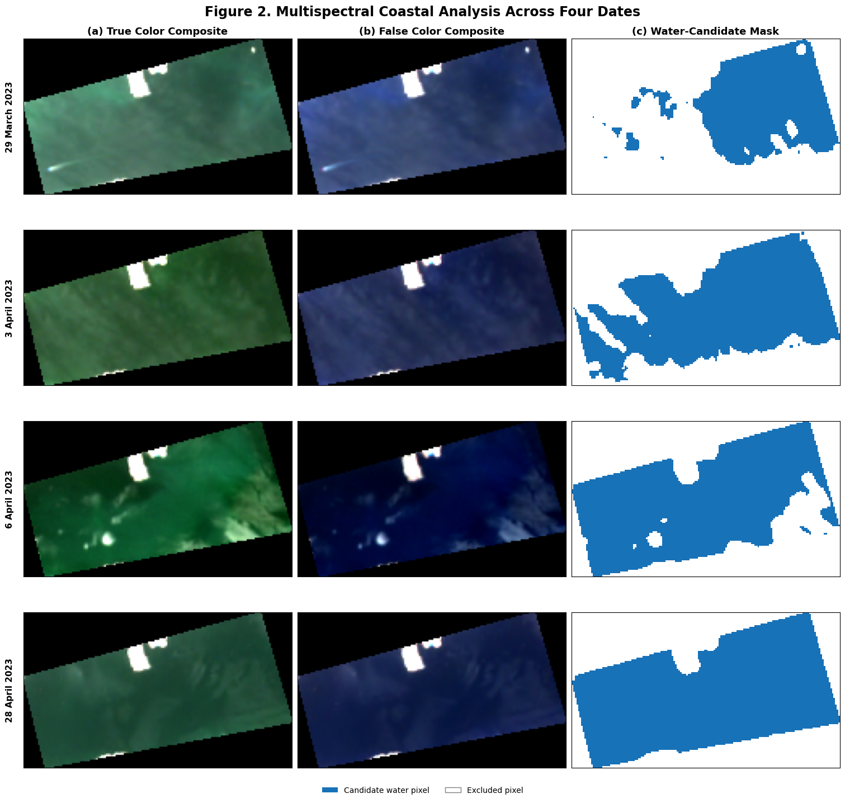
Figure 4. True-color, false-color and candidate-water masks for the four available acquisitions. Date-specific masks are visual diagnostics; the principal change analysis uses a shared mask.

5. Implemented Methodology
Figure 5 summarizes the implemented procedure. It intentionally excludes model training, data-labeling, histogram equalization, and other processing operations that were not established as part of the reproducible analysis. A minimum connected-component size of five pixels is included because it was applied in the baseline processing path.

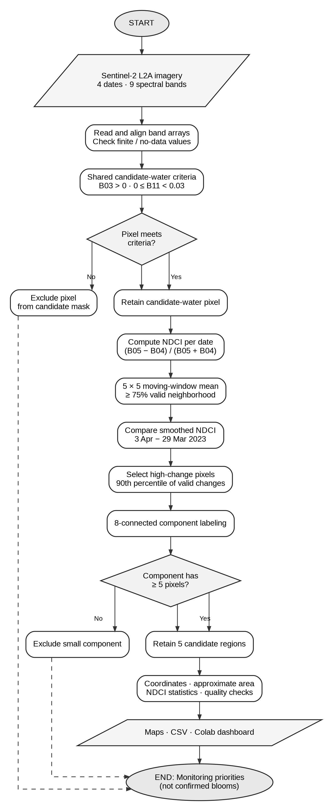
Figure 5. Implemented method: excluded pixels and small components do not enter the retained region outputs.

5.1. Preliminary water-candidate selection
Water absorbs shortwave-infrared radiation strongly under many conditions, making B11 useful as a screening cue. The proof of concept uses finite observations with B03 > 0 and B11 between 0 and 0.03, applying the condition consistently across the four dates. This is a candidate mask, not a proven shoreline segmentation. Bright coastal structures, mixed pixels, shallow water, haze or other artifacts may still affect selection. Pixels failing the criteria are excluded from the candidate analysis; they do not return to the retained set.
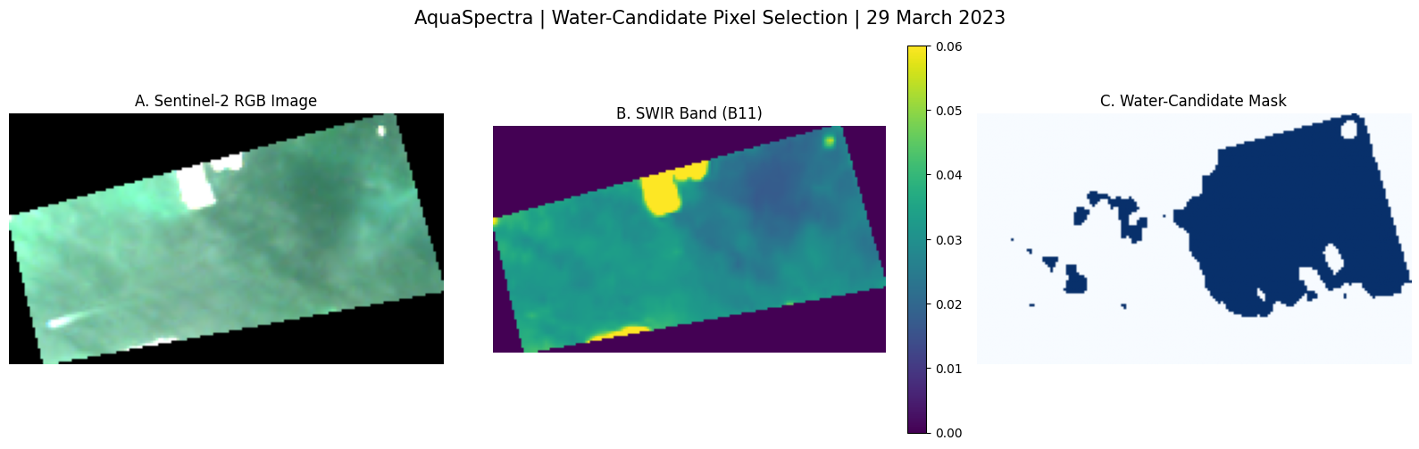
Figure 6. Preliminary selection of candidate-water pixels: original RGB image, SWIR B11 measurement and binary candidate mask. The selection is based on spectral criteria rather than manually labeled water polygons.
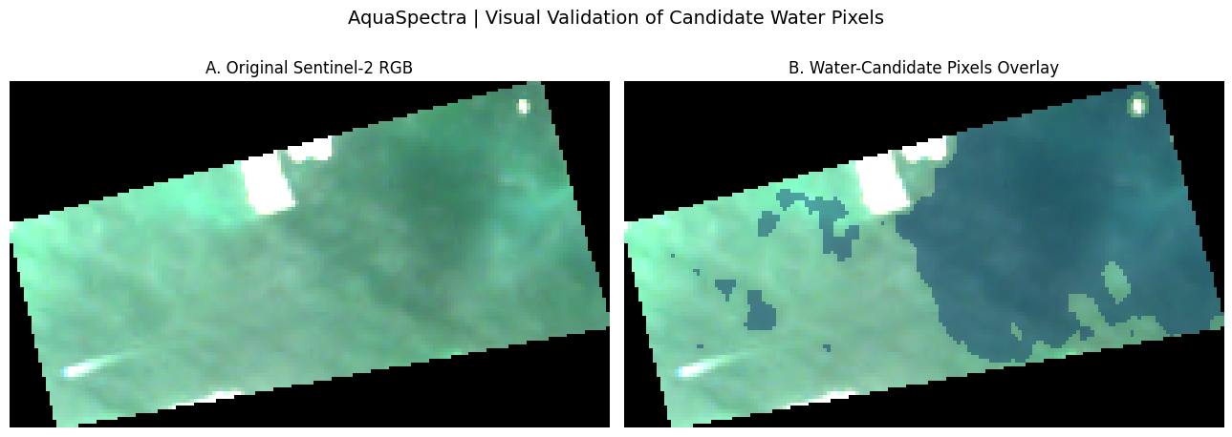
Figure 7. Visual overlay of the preliminary candidate-water selection on the satellite image. The overlay is a qualitative inspection, not ground-truth validation.
As an additional diagnostic, the normalized difference water index (NDWI) was inspected using green and near-infrared bands. Positive NDWI values for the five retained regions were consistent with a water-like spectral response in this particular subset. However, this is not independent evidence that every selected pixel represents open water.
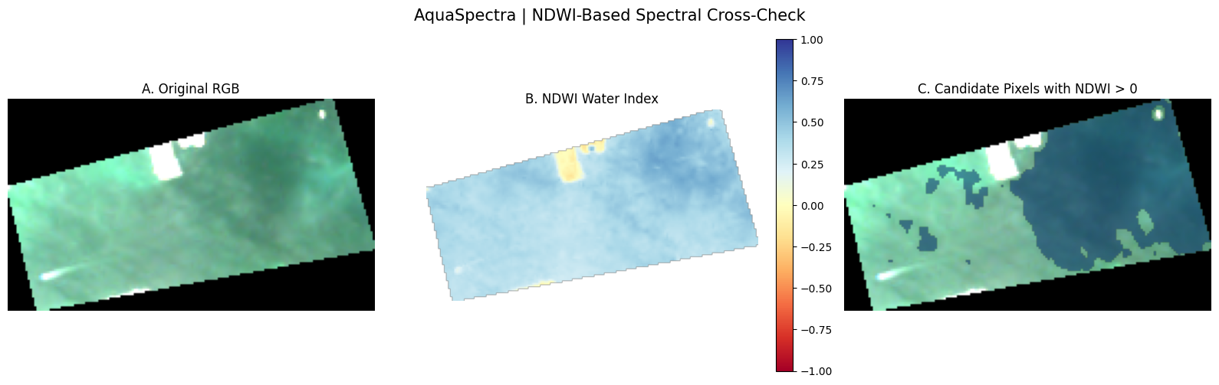
Figure 8. Exploratory NDWI cross-check of the candidate areas. A water-like index response supports further investigation but does not establish a validated water mask.

5.2. NDCI calculation
The Normalized Difference Chlorophyll Index compares red-edge and red-band responses. Because it is a normalized ratio, NDCI can increase even when absolute values of both bands decrease, provided their relative balance changes. This is important when interpreting the mean spectral curves. The index can be associated with chlorophyll-sensitive optical variation under appropriate conditions, but no chlorophyll concentration is estimated or validated in this study.

5.3. Moving-window spatial smoothing
A single pixel may reflect noise, mixed materials or short-scale variability. For each eligible location, the workflow averages NDCI values over a 5 × 5 neighborhood, requiring at least 75% of observations to be valid. Because a full window contains 25 positions, at least 19 valid observations are needed. The window shifts across the image; this is spatial averaging, not the shifted-window self-attention mechanism used in some transformer architectures. The result emphasizes spatially coherent patterns but may suppress small, localized features.
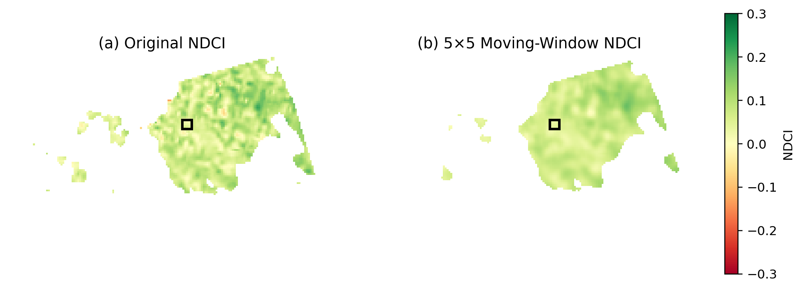
Figure 9. Original and 5 × 5 smoothed NDCI for the follow-up date. The outlined square illustrates one neighborhood; the algorithm repeats the operation across eligible image positions.

5.4. Temporal change and spatial grouping
For the principal comparison, smoothed NDCI on 29 March is subtracted from smoothed NDCI on 3 April at pixels valid in both dates. The 90th percentile of valid change values defines a data-dependent threshold. Pixels meeting or exceeding the threshold are retained as priorities. Eight-connected component labeling joins touching pixels, including diagonal neighbors. Components smaller than five pixels are excluded. This is a deterministic image-analysis algorithm, not unsupervised machine-learning clustering or a trained classifier.

6. Mathematical Formulation and Worked Example
The following equation images present the mathematical operations implemented in the AquaSpectra proof of concept. Equations 2–5 describe this project’s processing choices; they are not reproduced from a single external publication.
Equation 1 — Normalized Difference Chlorophyll Index
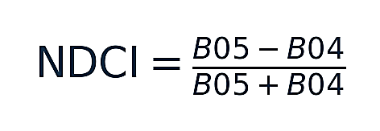
B05 is the red-edge band and B04 is the red band. Only valid, nonzero-denominator observations are considered.
Equation 2 — Moving-window average
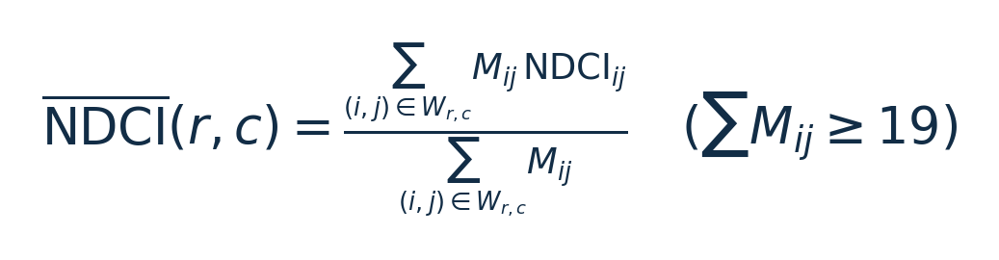
The output is calculated only when at least 19 of the 25 positions contain valid observations.
Equation 3 — Temporal difference
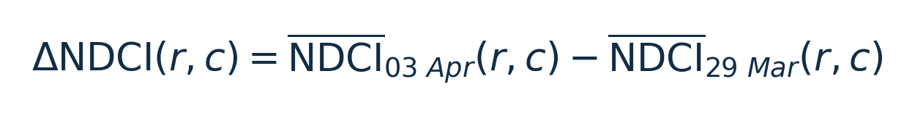
A positive difference indicates a relative increase in the index at the same raster location.
Equation 4 — High-change selection
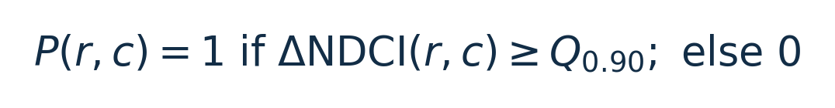
The threshold is estimated from the eligible comparison pixels, not from a universal ecological limit.
Equation 5 — Approximate region area
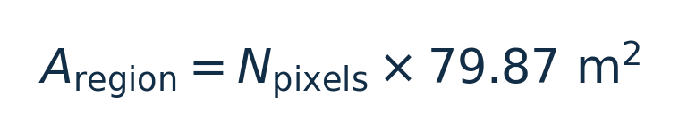
This area estimate uses the pixel area implied by the supplied raster transform, assuming the projected coordinate system is metre-based.
Worked example (illustrative numbers, not a measured AquaSpectra pixel): if B05 = 0.021 and B04 = 0.019, then NDCI = (0.021 − 0.019) / (0.021 + 0.019) = 0.002 / 0.040 = 0.05. If the later smoothed NDCI were 0.18 and the earlier value 0.04, the temporal change would be 0.14. A change of 0.14 would fall below the verified 0.1454 priority threshold. The example explains the arithmetic; it does not claim these band values occurred in the data.

7. Results and Interpretation
The verified baseline comparison contains 3,435 valid smoothed-change pixels. Its 90th-percentile threshold is approximately 0.1454, selecting 344 high-change pixels. After eight-connected grouping and the minimum five-pixel criterion, five candidate regions remain. Region 2 has the largest footprint and the highest mean NDCI change in the retained set. Because the regions were selected for elevated change by construction, their high values cannot be treated as independent evidence of a bloom.
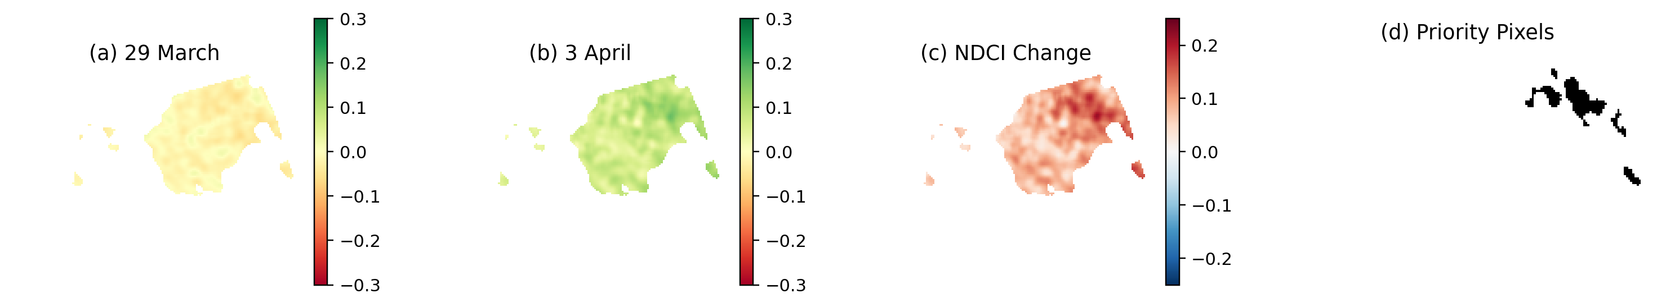
Figure 10. NDCI change between 29 March and 3 April and the selected priority pixels selected using the baseline 344-pixel workflow.
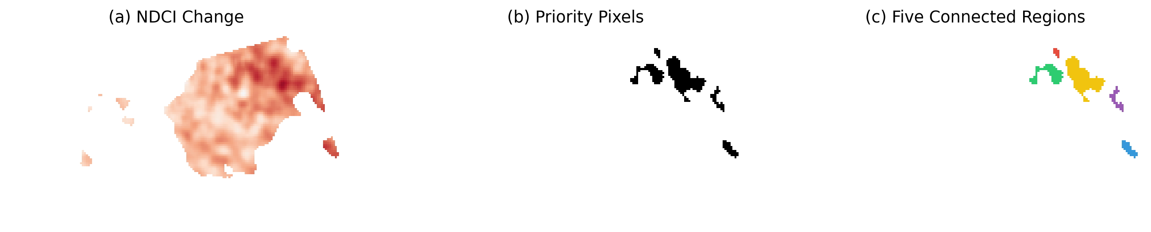
Figure 11. Connected-component labeling groups priority pixels into five spatially coherent monitoring candidates.
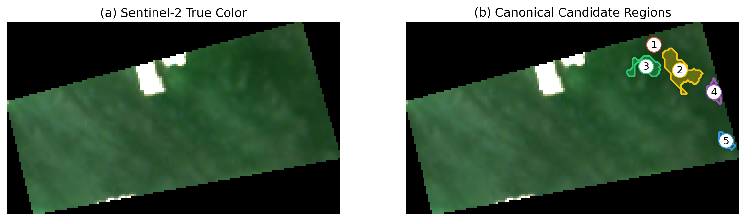
Figure 12. The five retained candidate regions overlaid on the satellite true-color image. The outlines indicate locations that could be considered for field verification. .

Region | Pixels | Approx. area (m²) | Latitude | Longitude | Mean change
1 | 11 | 878.5 | 24.458531 | 54.605167 | 0.1507
2 | 189 | 15094.8 | 24.457537 | 54.606345 | 0.1656
3 | 79 | 6309.5 | 24.457664 | 54.604834 | 0.1598
4 | 31 | 2475.9 | 24.456689 | 54.607884 | 0.1543
5 | 34 | 2715.5 | 24.454753 | 54.608463 | 0.1598

Table 3. Georeferenced summary of the five retained candidate regions. Coordinates indicate approximate region centers; areas are derived from the raster transform and are not surveyed shoreline polygons.
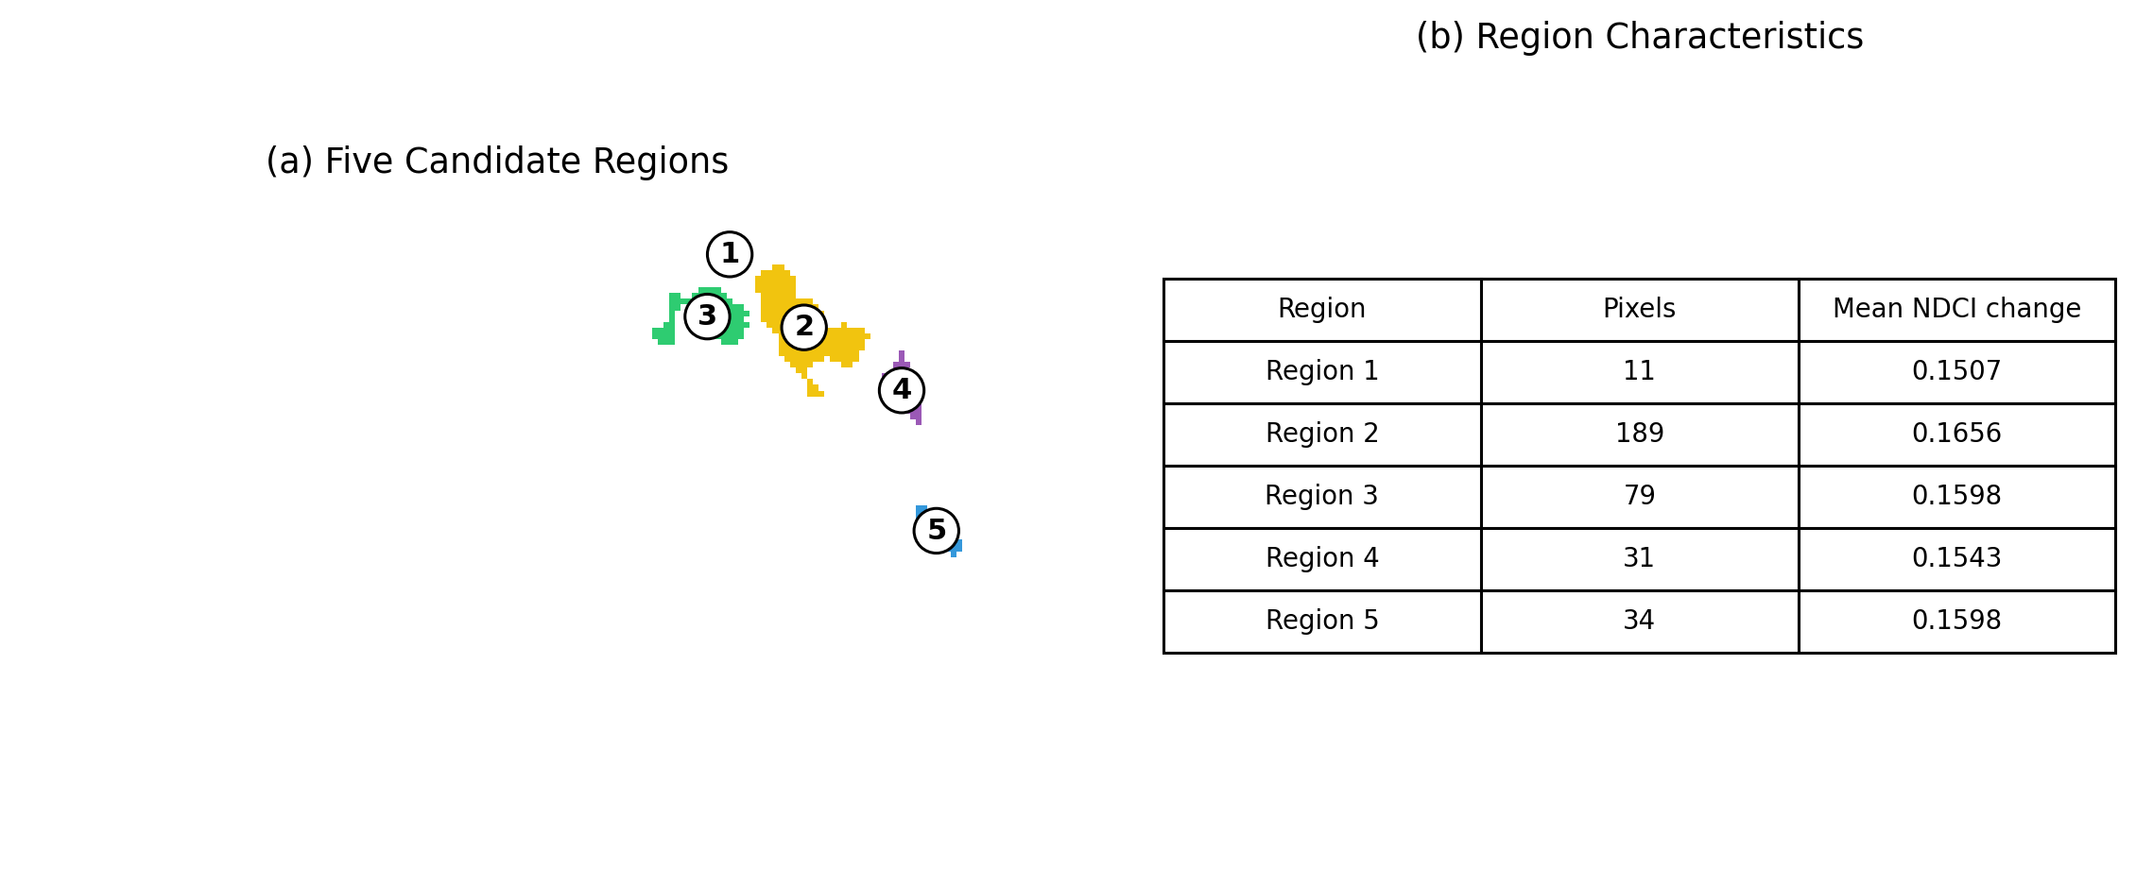
Figure 13. Comparison of candidate region characteristics using the baseline results. Region 2 has the largest pixel count and estimated area.
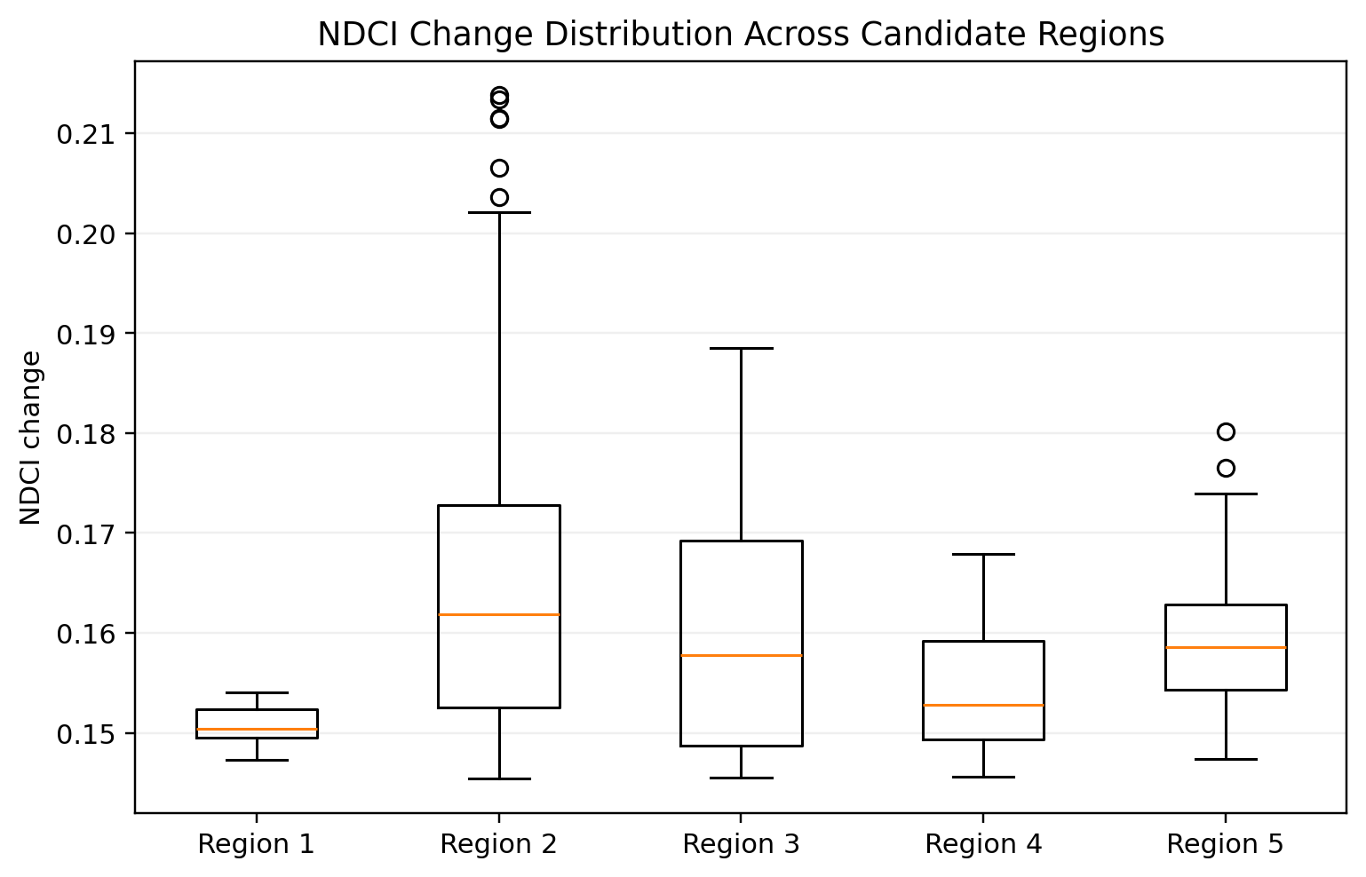
Figure 14. Distribution of NDCI change values within the five selected regions. The boxplot describes within-region variability and outliers; it is not a classifier performance evaluation.
The region-level distribution is important because a single average can conceal heterogeneity. Region 2 has a relatively high central tendency and a wider spread, whereas Region 1 contains only 11 pixels and therefore offers a much smaller sample for interpreting variability. Region 3 lies farther from the preliminary mask boundary than Regions 4 and 5, making boundary contamination a comparatively greater concern for the latter two.

7.1. Exploratory comparison with unsupervised machine learning
Method | Selected pixels | Overlap with baseline | Interpretation
NDCI top-10% baseline | 344 | 344 | Threshold-based monitoring priorities
Isolation Forest | 344 | 155 | Statistical outliers; partly different locations
K-means higher-change cluster | 1,286 | 344 | Broad cluster containing all baseline pixels
we implemented Isolation Forest and K-means as supplementary exploratory methods using the same 3,435 valid comparison pixels. The original 344-pixel NDCI baseline and five connected regions were preserved. Features were smoothed NDCI on 29 March, smoothed NDCI on 3 April, and their difference; the three features were standardized before model fitting.
Isolation Forest used a size-controlled 344-pixel anomaly selection. K-means identified a 1,286-pixel higher-change cluster. The comparisons measure agreement with the original screening rule, not accuracy in detecting algal blooms.
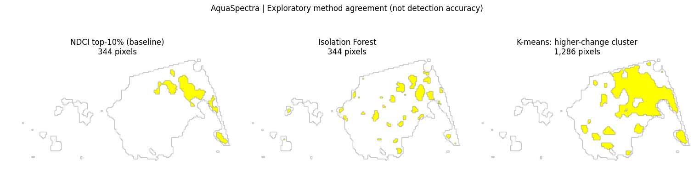
Figure 16. Side-by-side spatial comparison of the NDCI baseline, Isolation Forest, and the higher-change K-means cluster, using identical eligible pixel positions. Yellow indicates selected pixels; this is not a detection-accuracy map.

Observed agreement: Isolation Forest shares 155 of the 344 baseline pixels (Jaccard similarity 0.2908); the K-means cluster includes all 344 baseline pixels among its 1,286 selected pixels (Jaccard similarity 0.2675). No field-confirmed chlorophyll or harmful-algal-bloom labels were available, so these values cannot establish which method is scientifically more accurate.

7.2. Multispectral spectral-response interpretation
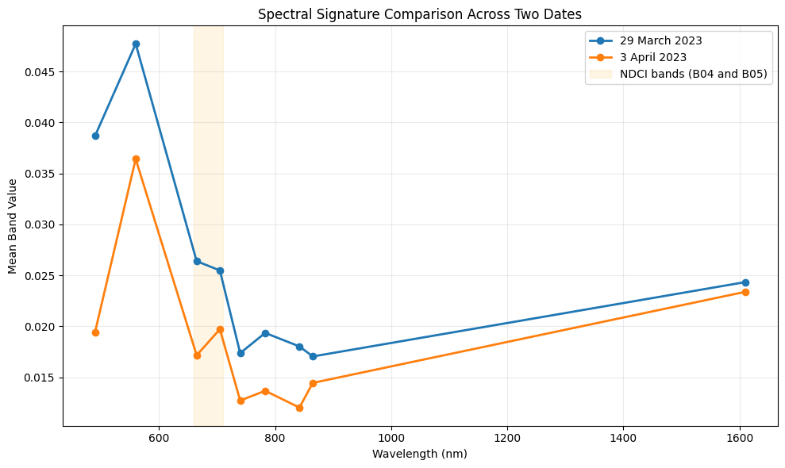
Figure 15. Mean values for the nine available spectral bands across shared candidate-water pixels on 29 March and 3 April. Lines are visual guides between discrete band measurements, not continuous hyperspectral measurements.
The spectral profiles for the two dates differ across visible, red-edge and near-infrared bands. The visible-band values on 3 April are generally lower in this scene, but the relative relationship between B04 and B05 changes. Since NDCI is a ratio, the direction of the index difference need not match the direction of each individual band. These mean band values should not be described as calibrated reflectance unless the raster scaling and processing metadata have been verified.

8. Scientific Limitations and Data Quality
The water mask is preliminary, and no independent coastline labels or field observations were used to quantify false selections. The study covers a small spatial subset and only four acquisitions. Differences may reflect sediment, bathymetry, tide, sun glint, atmospheric effects, spatial misregistration, changing viewing conditions or actual biological change. The 6 April imagery showed conspicuous zero values in several near-infrared/red-edge bands, warranting a quality warning rather than unqualified interpretation. The reported five regions come from the March–April pair and should not be portrayed as repeated bloom detections on all four dates.
There is no training/test split, no segmentation ground truth, no confusion matrix, no detection accuracy, no toxin assay and no demonstrated prediction lead time. Accordingly, terms such as “confirmed HAB,” “forecast,” “AI classification accuracy,” and “automated early warning” would overstate the evidence. The current output is a spatial screening and monitoring-priority product.

9. System Demonstration and Deliverables
The PoC runs in a Google Colab notebook and produces reproducible raster-based analyses, summary tables, geographic coordinates and a lightweight interactive dashboard. The dashboard allows exploration by date and region, while the colored candidate-region boundaries originate from the principal 29 March–3 April comparison. The dashboard is a research prototype, not an operational service connected to live satellite feeds.
Deliverable | What it demonstrates
Colab notebook (.ipynb) | Executable analysis pipeline and exploratory figures
Region CSV | Coordinates, approximate areas and descriptive spectral statistics
Change and region maps | Spatial prioritization and traceable visual evidence
Interactive notebook dashboard | Date/region exploration and visual inspection
Technical research report | Scientific method, evidence, limitations and roadmap

10. Future Development and Validation Roadmap

Phase I: Improve water and quality masks
Validate coastal water boundaries against independent shoreline or manually reviewed reference data; introduce appropriate cloud, shadow, sun-glint and no-data screening; document reflectance scaling and acquisition geometry. Recompute sensitivity to mask thresholds.

Phase II: Connect the satellite product to field measurements
Partner with UAE environmental stakeholders to collect time-matched samples at candidate and control locations. Measure chlorophyll-a, turbidity and relevant species/toxins where scientifically appropriate. Build a labeled dataset that distinguishes harmless spectral changes from harmful biological events.

Phase III: Broaden temporal and sensor coverage
Extend from four historical scenes to an acquisition-aware time series, including Sentinel-2 and potentially ocean-color sensors such as Sentinel-3 OLCI. Incorporate weather, currents and water-temperature context when available.

Phase IV: Evaluate optional machine learning
Only after obtaining credible labels, compare the deterministic baseline with suitable classification or forecasting models. Use spatial and temporal holdouts, and report precision, recall, false-alert rates and lead time. A complex model is not automatically preferable to an interpretable threshold baseline.

Phase V: Pilot decision support
Develop a web-facing monitoring interface with confidence and quality flags, downloadable coordinates and analyst review. Test whether it reduces the time required to choose sampling locations without increasing missed events.

11. Conclusion
AquaSpectra demonstrates how a modest, but reproducible Earth-observation workflow can turn multispectral image differences into a small set of geographically defined monitoring priorities. In the Al Raha Bay proof of concept, 344 selected pixels became five candidate regions, each with a location, estimated area and descriptive change statistics. These results do not establish the presence of a harmful algal bloom. It is a transparent starting point for a more useful question: where should environmental scientists investigate next. With field validation and stronger quality controls, thisframework could contribute to evidence-based coastal monitoring in the UAE.

References
Mishra, S., & Mishra, D. R. (2012). Normalized difference chlorophyll index: A novel model for remote estimation of chlorophyll-a concentration in turbid productive waters. Remote Sensing of Environment, 117, 394–406. https://doi.org/10.1016/j.rse.2011.10.016
European Space Agency (ESA). Sentinel-2 MSI: Instrument and spectral bands. Sentinel Online. https://sentinels.copernicus.eu/web/sentinel/missions/sentinel-2
Copernicus Data Space Ecosystem. Sentinel-2 Level-2A surface reflectance products and processing documentation. https://documentation.dataspace.copernicus.eu/
McFeeters, S. K. (1996). The use of the Normalized Difference Water Index (NDWI) in the delineation of open water features. International Journal of Remote Sensing, 17(7), 1425–1432. https://doi.org/10.1080/01431169608948714
Project primary sources: AquaSpectra PoC notebook; four supplied Sentinel-2 band stacks; canonical verified region CSV and generated diagnostic figures (October 2026).
NASA Johnson Space Center, Earth Science and Remote Sensing Unit. (2021, May 26). ISS Expedition 65 astronaut photograph ISS065-E-74285: Al Raha Bay and Al Muneera Island, Abu Dhabi. Wikimedia Commons archival copy: https://commons.wikimedia.org/wiki/File:ISS065-E-74285_-_View_of_United_Arab_Emirates_-_Abu_Dhabi_-_Masdar_City_Solar_Photovoltaic_Farm_-_Al_Raha_Bay_-_Al_Muneera_Island_-_Al_Raha_Channel_(cropped).jpg

Appendix A. Figure and Output Register
Figure 1. Satellite overview of the Abu Dhabi coastal region
Figure 2. Original Sentinel-2 true-color study area (29 March 2023)
Figure 3. Three-panel multispectral scene
Figure 4. Four-date multispectral scene
Figure 5. Implemented method flowchart
Figure 6. Candidate-water selection
Figure 7. Mask overlay
Figure 8. NDWI diagnostic
Figure 9. Moving-window smoothing
Figure 10. Canonical temporal change
Figure 11. Connected regions
Figure 12. Regions over true-color
Figure 13. Region characteristics
Figure 14. Region boxplot
Figure 15. Mean spectral signatures
Figure 16. Unsupervised machine-learning method comparison
Reporting note: Historical exploratory images created with the alternative 347-pixel selection were not used as evidence for the canonical five-region quantitative results. The canonical region plots, tables and summary statistics in this report use 344 pixels.

