4 VMs created. All running on Ubuntu16 + Java + Python.

nodeA, nodeB and nodeC are installed with Cassandra and configured with same Cassandra cluster.

The VM ‘PyClient_Cassandra’ is only installed with Python Cassandra driver.

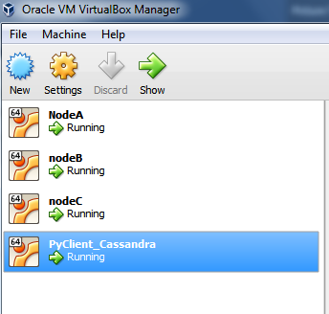

IP Address of the VMS below:

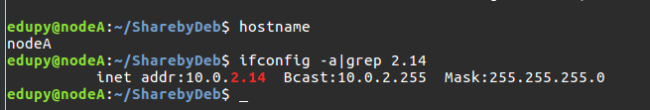

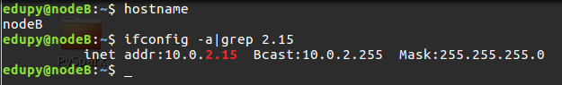

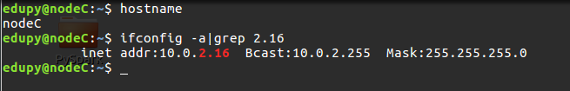

Following configurations done for hostname resolution of neighbors:

nodeA ip: 10.0.2.14

/etc/hostname:: nodeA

/etc/hosts:  10.0.2.15 nodeB 10.0.2.16 nodeC

nodeB ip: 10.0.2.15

/etc/hostname:: nodeB

/etc/hosts:  10.0.2.14 nodeA 10.0.2.16 nodeC

nodeC ip: 10.0.2.16

/etc/hostname:: nodeC

/etc/hosts:  10.0.2.14 nodeA 10.0.2.15 nodeB

**Cassandra client:**

A VM with IP 10.0.2.17.

Cassandra is NOT installed. Its installed with Python2.7 and Python Cassandra-driver.

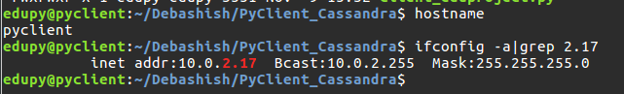

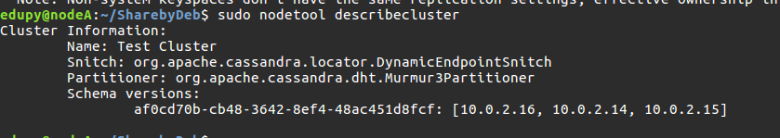

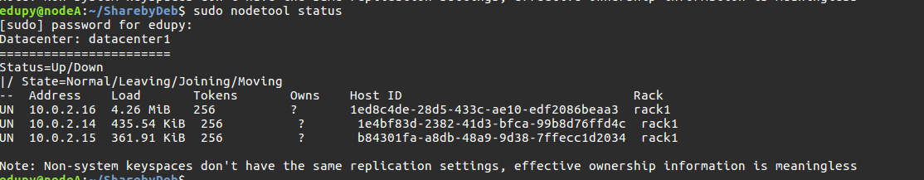

cqlsh:playlist> DESCRIBE KEYSPACEs;

playlist system_auth debkey1 system_distributed

system_schema system debkey3 system_traces

cqlsh:playlist> DESCRIBE TABLEs;

statistics users track_by_id track_by_genre

track_by_artist artists_by_first_letter playlist_tracks

cqlsh:playlist> DESCRIBE playlist;

CREATE KEYSPACE playlist WITH replication = {'class': 'SimpleStrategy', 'replication_factor': '2'} AND durable_writes = true;

CREATE TABLE playlist.statistics (

counter_name text PRIMARY KEY,

counter_value counter

) WITH bloom_filter_fp_chance = 0.01

AND caching = {'keys': 'ALL', 'rows_per_partition': 'NONE'}

AND comment = ''

AND compaction = {'class': 'org.apache.cassandra.db.compaction.SizeTieredCompactionStrategy', 'max_threshold': '32', 'min_threshold': '4'}

AND compression = {'chunk_length_in_kb': '64', 'class': 'org.apache.cassandra.io.compress.LZ4Compressor'}

AND crc_check_chance = 1.0

AND dclocal_read_repair_chance = 0.1

AND default_time_to_live = 0

AND gc_grace_seconds = 864000

AND max_index_interval = 2048

AND memtable_flush_period_in_ms = 0

AND min_index_interval = 128

AND read_repair_chance = 0.0

AND speculative_retry = '99PERCENTILE';

CREATE TABLE playlist.track_by_artist (

artist text,

track text,

track_id uuid,

genre text,

music_file text,

starred boolean,

track_length_in_seconds int,

PRIMARY KEY (artist, track, track_id)

) WITH CLUSTERING ORDER BY (track ASC, track_id ASC)

AND bloom_filter_fp_chance = 0.01

AND caching = {'keys': 'ALL', 'rows_per_partition': 'NONE'}

AND comment = ''

AND compaction = {'class': 'org.apache.cassandra.db.compaction.SizeTieredCompactionStrategy', 'max_threshold': '32', 'min_threshold': '4'}

AND compression = {'chunk_length_in_kb': '64', 'class': 'org.apache.cassandra.io.compress.LZ4Compressor'}

AND crc_check_chance = 1.0

AND dclocal_read_repair_chance = 0.1

AND default_time_to_live = 0

AND gc_grace_seconds = 864000

AND max_index_interval = 2048

AND memtable_flush_period_in_ms = 0

AND min_index_interval = 128

AND read_repair_chance = 0.0

AND speculative_retry = '99PERCENTILE';

CREATE TABLE playlist.users (

username text PRIMARY KEY,

password text,

playlist_names set<text>

) WITH bloom_filter_fp_chance = 0.01

AND caching = {'keys': 'ALL', 'rows_per_partition': 'NONE'}

AND comment = ''

AND compaction = {'class': 'org.apache.cassandra.db.compaction.SizeTieredCompactionStrategy', 'max_threshold': '32', 'min_threshold': '4'}

AND compression = {'chunk_length_in_kb': '64', 'class': 'org.apache.cassandra.io.compress.LZ4Compressor'}

AND crc_check_chance = 1.0

AND dclocal_read_repair_chance = 0.1

AND default_time_to_live = 0

AND gc_grace_seconds = 864000

AND max_index_interval = 2048

AND memtable_flush_period_in_ms = 0

AND min_index_interval = 128

AND read_repair_chance = 0.0

AND speculative_retry = '99PERCENTILE';

CREATE TABLE playlist.artists_by_first_letter (

first_letter text,

artist text,

PRIMARY KEY (first_letter, artist)

) WITH CLUSTERING ORDER BY (artist ASC)

AND bloom_filter_fp_chance = 0.01

AND caching = {'keys': 'ALL', 'rows_per_partition': 'NONE'}

AND comment = ''

AND compaction = {'class': 'org.apache.cassandra.db.compaction.SizeTieredCompactionStrategy', 'max_threshold': '32', 'min_threshold': '4'}

AND compression = {'chunk_length_in_kb': '64', 'class': 'org.apache.cassandra.io.compress.LZ4Compressor'}

AND crc_check_chance = 1.0

AND dclocal_read_repair_chance = 0.1

AND default_time_to_live = 0

AND gc_grace_seconds = 864000

AND max_index_interval = 2048

AND memtable_flush_period_in_ms = 0

AND min_index_interval = 128

AND read_repair_chance = 0.0

AND speculative_retry = '99PERCENTILE';

CREATE TABLE playlist.track_by_id (

track_id uuid PRIMARY KEY,

artist text,

genre text,

music_file text,

track text,

track_length_in_seconds int

) WITH bloom_filter_fp_chance = 0.01

AND caching = {'keys': 'ALL', 'rows_per_partition': 'NONE'}

AND comment = ''

AND compaction = {'class': 'org.apache.cassandra.db.compaction.SizeTieredCompactionStrategy', 'max_threshold': '32', 'min_threshold': '4'}

AND compression = {'chunk_length_in_kb': '64', 'class': 'org.apache.cassandra.io.compress.LZ4Compressor'}

AND crc_check_chance = 1.0

AND dclocal_read_repair_chance = 0.1

AND default_time_to_live = 0

AND gc_grace_seconds = 864000

AND max_index_interval = 2048

AND memtable_flush_period_in_ms = 0

AND min_index_interval = 128

AND read_repair_chance = 0.0

AND speculative_retry = '99PERCENTILE';

CREATE TABLE playlist.playlist_tracks (

username text,

playlist_name text,

sequence_no timestamp,

artist text,

genre text,

track_id uuid,

track_length_in_seconds int,

track_name text,

PRIMARY KEY ((username, playlist_name), sequence_no)

) WITH CLUSTERING ORDER BY (sequence_no ASC)

AND bloom_filter_fp_chance = 0.01

AND caching = {'keys': 'ALL', 'rows_per_partition': 'NONE'}

AND comment = ''

AND compaction = {'class': 'org.apache.cassandra.db.compaction.SizeTieredCompactionStrategy', 'max_threshold': '32', 'min_threshold': '4'}

AND compression = {'chunk_length_in_kb': '64', 'class': 'org.apache.cassandra.io.compress.LZ4Compressor'}

AND crc_check_chance = 1.0

AND dclocal_read_repair_chance = 0.1

AND default_time_to_live = 0

AND gc_grace_seconds = 864000

AND max_index_interval = 2048

AND memtable_flush_period_in_ms = 0

AND min_index_interval = 128

AND read_repair_chance = 0.0

AND speculative_retry = '99PERCENTILE';

CREATE TABLE playlist.track_by_genre (

genre text,

artist text,

track text,

track_id uuid,

music_file text,

starred boolean,

track_length_in_seconds int,

PRIMARY KEY (genre, artist, track, track_id)

) WITH CLUSTERING ORDER BY (artist ASC, track ASC, track_id ASC)

AND bloom_filter_fp_chance = 0.01

AND caching = {'keys': 'ALL', 'rows_per_partition': 'NONE'}

AND comment = ''

AND compaction = {'class': 'org.apache.cassandra.db.compaction.SizeTieredCompactionStrategy', 'max_threshold': '32', 'min_threshold': '4'}

AND compression = {'chunk_length_in_kb': '64', 'class': 'org.apache.cassandra.io.compress.LZ4Compressor'}

AND crc_check_chance = 1.0

AND dclocal_read_repair_chance = 0.1

AND default_time_to_live = 0

AND gc_grace_seconds = 864000

AND max_index_interval = 2048

AND memtable_flush_period_in_ms = 0

AND min_index_interval = 128

AND read_repair_chance = 0.0

AND speculative_retry = '99PERCENTILE';

cqlsh:playlist>

From Python client VM:

1. Using python based Cassandra driver:
   1. Connect to the keyspace ‘playlist’
   2. Fetch and display all the records from a table
   3. Fetch and display filtered records from a table
   4. Insert multiple records into the table and verify it by fetching the records.
   5. Use ConsistencyLevel ‘Quorum’ and ‘Local’
   6. Use load_balancing_policy= DCAwareRoundRobinPolicy
   7. Use load_balancing_policy= RoundRobinPolicy
   8. Use SimpleStatement

Output of Cassandra client script:

