

Use-Case
Author: OOPeraTeam
Date: 2024-12-22

Use-Case (Model)
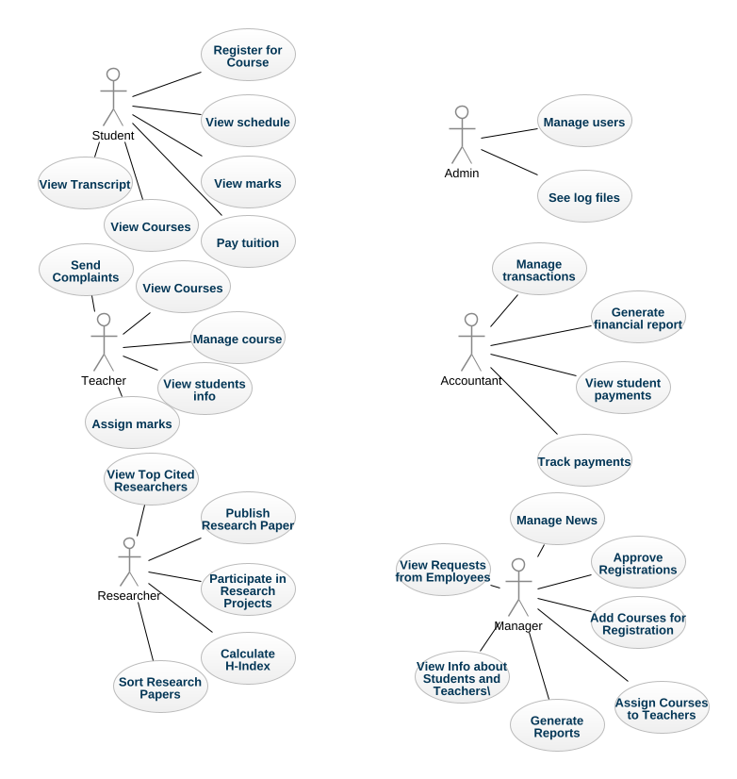
usecase-diagram
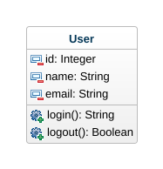
class-diagram

1. Accountant (Actor)
In Use-Case
Associations
Accountant_Track payments - track payments : Track payments [0..1] - see definition
Accountant_Manage transactions - manage transactions : Manage transactions [0..1] - see definition
Accountant_View student payments - view student payments : View student payments [0..1] - see definition
Accountant_Generate financial report - generate financial report : Generate financial report [0..1] - see definition

2. Add Courses for Registration (UseCase)
In Use-Case
Associations
Manager_Add Courses for Registration - manager : Manager [0..1] - see definition

3. Admin (Actor)
In Use-Case
Associations
Admin_Manage student schedules - manage student schedules : See log files [0..1] - see definition
Admin_Manage courses - manage courses : Manage users [0..1] - see definition

4. Approve Registrations (UseCase)
In Use-Case
Associations
Manager_Approve Registrations - manager : Manager [0..1] - see definition

5. Assign Courses to Teachers (UseCase)
In Use-Case
Associations
Manager_Assign Courses to Teachers - manager : Manager [0..1] - see definition

6. Assign marks (UseCase)
In Use-Case
Associations
Teacher_Assign marks - teacher : Teacher [0..1] - see definition

7. Calculate H-Index (UseCase)
In Use-Case
Associations
Researcher_Calculate H-Index - researcher : Researcher [0..1] - see definition

8. Generate Reports (UseCase)
In Use-Case
Associations
Manager_Generate Reports - manager : Manager [0..1] - see definition

9. Generate financial report (UseCase)
In Use-Case
Associations
Accountant_Generate financial report - accountant : Accountant [0..1] - see definition

10. Manage News (UseCase)
In Use-Case
Associations
Manager_Manage News - manager : Manager [0..1] - see definition

11. Manage course (UseCase)
In Use-Case
Associations
Teacher_Manage course - teacher : Teacher [0..1] - see definition

12. Manage transactions (UseCase)
In Use-Case
Associations
Accountant_Manage transactions - accountant : Accountant [0..1] - see definition

13. Manage users (UseCase)
In Use-Case
Associations
Admin_Manage courses - admin : Admin [0..1] - see definition

14. Manager (Actor)
In Use-Case
Associations
Manager_Add Courses for Registration - add Courses for Registration : Add Courses for Registration [0..1] - see definition
Manager_Assign Courses to Teachers - assign Courses to Teachers : Assign Courses to Teachers [0..1] - see definition
Manager_Generate Reports - generate Reports : Generate Reports [0..1] - see definition
Manager_Approve Registrations - approve Registrations : Approve Registrations [0..1] - see definition
Manager_Manage News - manage News : Manage News [0..1] - see definition
Manager_View Info about Students and Teachers\ - view Info about Students and Teachers\ : View Info about Students and Teachers\ [0..1] - see definition
Manager_View Requests from Employees - view Requests from Employees : View Requests from Employees [0..1] - see definition

15. Participate in Research Projects (UseCase)
In Use-Case
Associations
Researcher_Participate in Research Projects - researcher : Researcher [0..1] - see definition

16. Pay tuition (UseCase)
In Use-Case
Associations
Student_Pay tuition - student : Student [0..1] - see definition

17. Publish Research Paper (UseCase)
In Use-Case
Associations
Researcher_Publish Research Paper - researcher : Researcher [0..1] - see definition

18. Register for Course (UseCase)
In Use-Case
Associations
Student_Register for Course - student : Student [0..1] - see definition

19. Researcher (Actor)
In Use-Case
Associations
Researcher_Publish Research Paper - publish Research Paper : Publish Research Paper [0..1] - see definition
Researcher_Calculate H-Index - calculate H-Index : Calculate H-Index [0..1] - see definition
Researcher_Participate in Research Projects - participate in Research Projects : Participate in Research Projects [0..1] - see definition
Researcher_Sort Research Papers - sort Research Papers : Sort Research Papers [0..1] - see definition
Researcher_View Top Cited Researchers - view Top Cited Researchers : View Top Cited Researchers [0..1] - see definition

20. See log files (UseCase)
In Use-Case
Associations
Admin_Manage student schedules - admin : Admin [0..1] - see definition

21. Send Complaints (UseCase)
In Use-Case
Associations
Teacher_Send Complaints - teacher : Teacher [0..1] - see definition

22. Sort Research Papers (UseCase)
In Use-Case
Associations
Researcher_Sort Research Papers - researcher : Researcher [0..1] - see definition

23. Student (Actor)
In Use-Case
Associations
Student_Pay tuition - pay tuition : Pay tuition [0..1] - see definition
Student_Register for Course - register for Course : Register for Course [0..1] - see definition
Student_View schedule - view schedule : View schedule [0..1] - see definition
Student_View Courses - view Courses : View Courses [0..1] - see definition
Student_View Transcript - view Transcript : View Transcript [0..1] - see definition
Student_View marks - view marks : View marks [0..1] - see definition

24. Teacher (Actor)
In Use-Case
Associations
Teacher_Send Complaints - send Complaints : Send Complaints [0..1] - see definition
Teacher_Manage course - manage course : Manage course [0..1] - see definition
Manage attendance_Teacher - manage attendance : View Courses [0..1] - see definition
Teacher_Create course - create course : View students info [0..1] - see definition
Teacher_Assign marks - assign marks : Assign marks [0..1] - see definition

25. Track payments (UseCase)
In Use-Case
Associations
Accountant_Track payments - accountant : Accountant [0..1] - see definition

26. User (Class)
In Use-Case
Attributes
id : Integer [1]
name : String [1]
email : String [1]
Operations
login : String
logout : Boolean

27. View Courses (UseCase)
In Use-Case
Associations
Manage attendance_Teacher - teacher : Teacher [0..1] - see definition

28. View Courses (UseCase)
In Use-Case
Associations
Student_View Courses - student : Student [0..1] - see definition

29. View Info about Students and Teachers\ (UseCase)
In Use-Case
Associations
Manager_View Info about Students and Teachers\ - manager : Manager [0..1] - see definition

30. View Requests from Employees (UseCase)
In Use-Case
Associations
Manager_View Requests from Employees - manager : Manager [0..1] - see definition

31. View Top Cited Researchers (UseCase)
In Use-Case
Associations
Researcher_View Top Cited Researchers - researcher : Researcher [0..1] - see definition

32. View Transcript (UseCase)
In Use-Case
Associations
Student_View Transcript - student : Student [0..1] - see definition

33. View marks (UseCase)
In Use-Case
Associations
Student_View marks - student : Student [0..1] - see definition

34. View schedule (UseCase)
In Use-Case
Associations
Student_View schedule - student : Student [0..1] - see definition

35. View student payments (UseCase)
In Use-Case
Associations
Accountant_View student payments - accountant : Accountant [0..1] - see definition

36. View students info (UseCase)
In Use-Case
Associations
Teacher_Create course - teacher : Teacher [0..1] - see definition

