1. ‘Bath’ on the dropdown on search is empty please check
2. Please remove 2bhk from dropdown on Property Type
3. Front End Fixes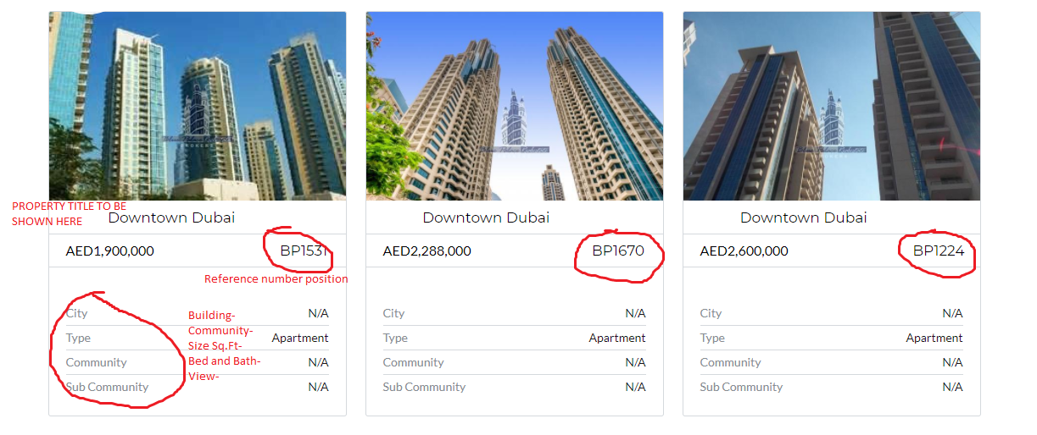
4. All the forms should go to [info@bluepalacerealestate.com](mailto:info@bluepalacerealestate.com)
5. Property detail page should show the same info shown on thumbnail plus the description
6. On Backend, Agent list shows the agent as well as Owners

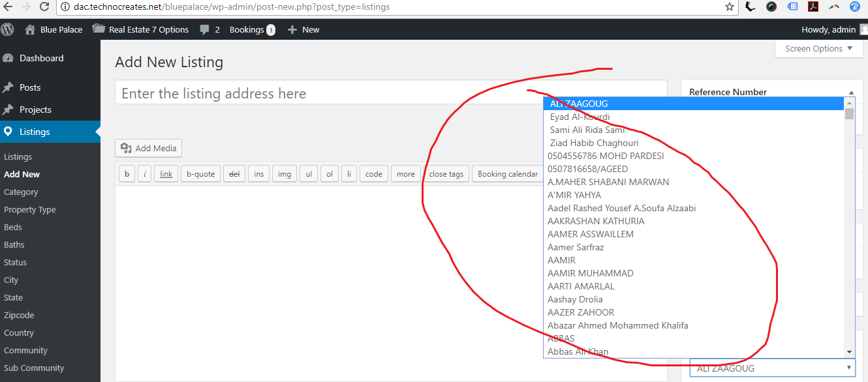

**Agent and Owners should be separate**

1. Building List is not coming as dropdown as it is for Community subcommunity
2. How can one entry if Community/Subcommunity/Building if required? Can we have add option?