CREATE TABLE public.transport

(

"ID" integer NOT NULL DEFAULT nextval('"transport_ID_seq"'::regclass),

"Type" character varying(32) COLLATE pg_catalog."default" NOT NULL DEFAULT 12

)

ALTER TABLE public.transport

ADD COLUMN "ID" integer NOT NULL DEFAULT nextval('"transport_ID_seq"'::regclass);

ALTER TABLE public.transport

ADD COLUMN "Type" character varying(32) COLLATE pg_catalog."default" NOT NULL DEFAULT 12;

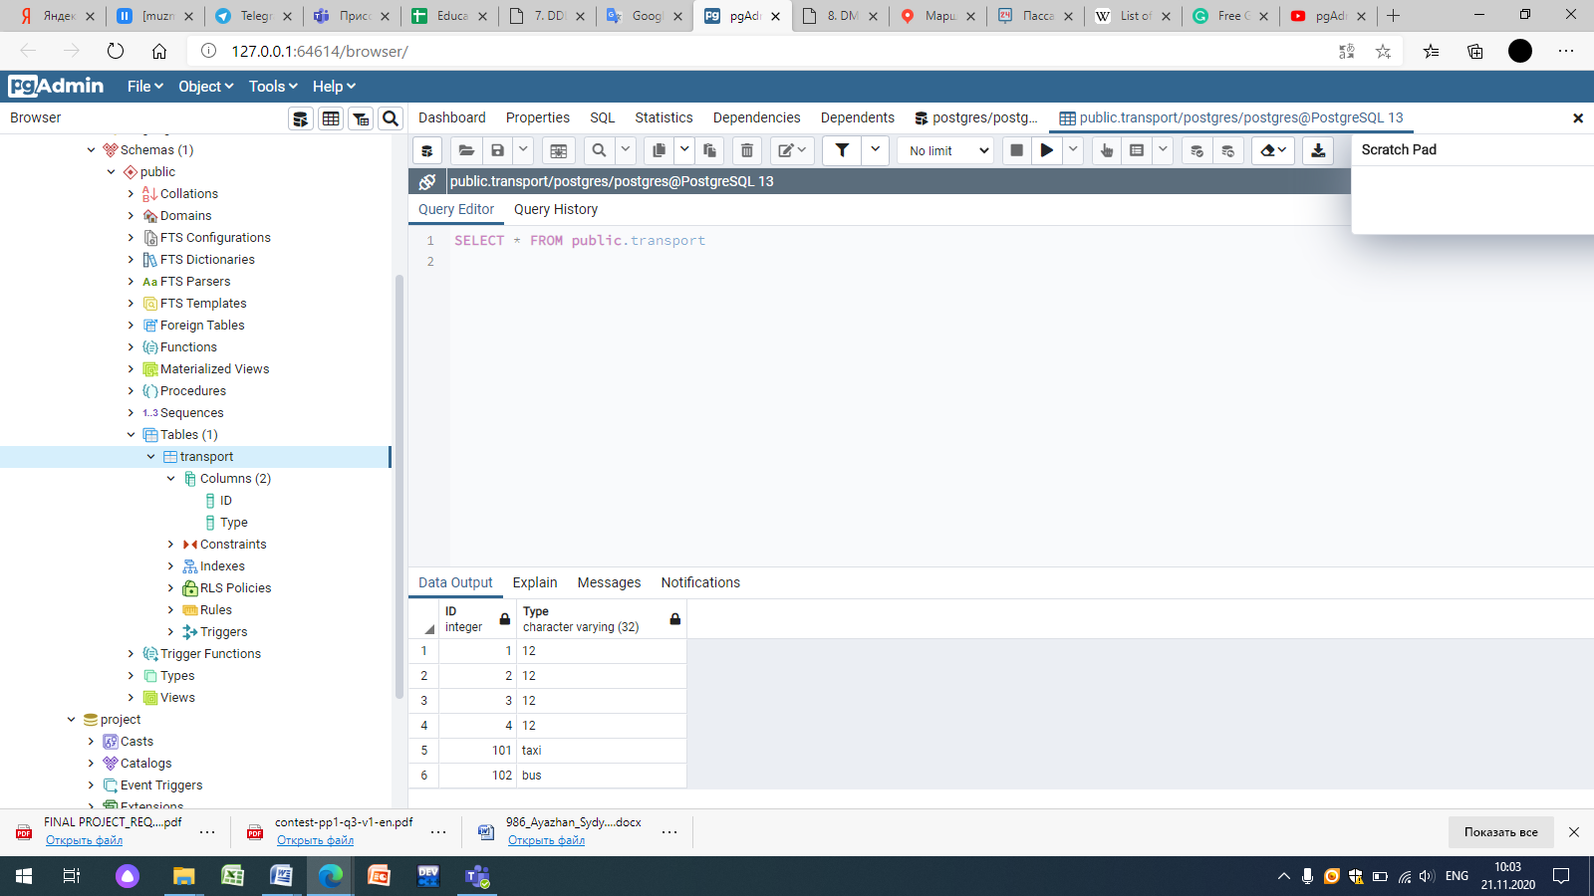

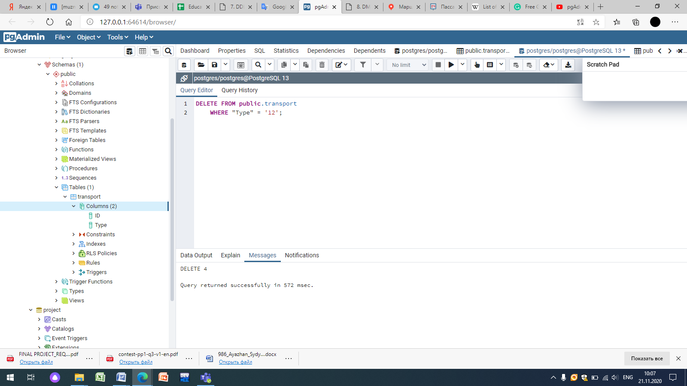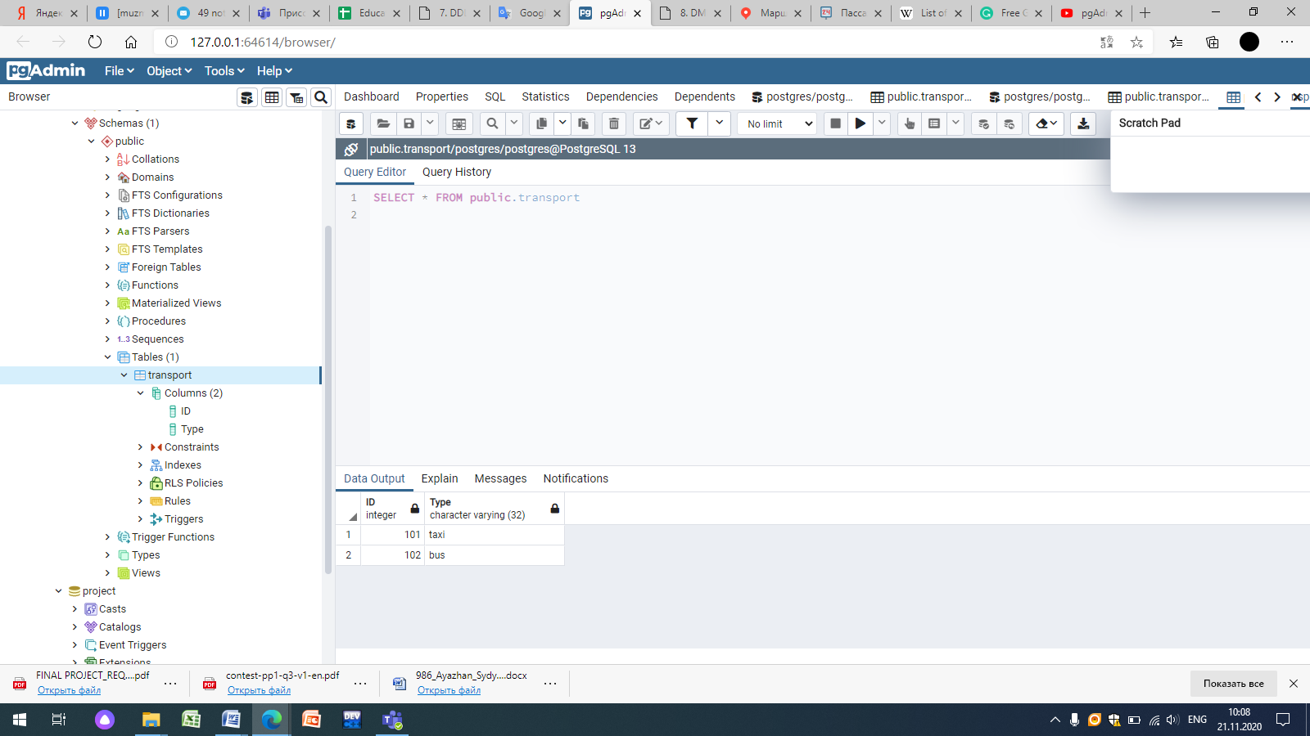

CREATE TABLE public."Bus"

(

"Id" serial,

type character varying(12) NOT NULL,

"number" integer NOT NULL,

colour character varying(32),

numer_of_seats bigint NOT NULL,

available_seats bigint,

PRIMARY KEY ("Id")

);

INSERT INTO public."Bus"(

"Id", type, "number", colour, numer_of_seats, available_seats)

VALUES (1001, 'small', '89', 'white', '15', '5');

INSERT INTO public."Bus"(

"Id", type, "number", colour, numer_of_seats, available_seats)

VALUES (1002, 'big', '35', 'green', '25', '12');

INSERT INTO public."Bus"(

"Id", type, "number", colour, numer_of_seats, available_seats)

VALUES (1003, 'public', '84', 'yellow', '35', '20');

INSERT INTO public."Bus"(

"Id", type, "number", colour, numer_of_seats, available_seats)

VALUES (1004, 'small', '15', 'white', '15', '3');

INSERT INTO public."Bus"(

"Id", type, "number", colour, numer_of_seats, available_seats)

VALUES (1005, 'normal', '135', 'red', '20', '5');

INSERT INTO public."Bus"(

"Id", type, "number", colour, numer_of_seats, available_seats)

VALUES (1006, 'big', '27', 'green', '25', '17');

INSERT INTO public."Bus"(

"Id", type, "number", colour, numer_of_seats, available_seats)

VALUES (1007, 'small', '32', 'white', '15', '6');

INSERT INTO public."Bus"(

"Id", type, "number", colour, numer_of_seats, available_seats)

VALUES (1008, 'normal', '65', 'red', '20', '7');

INSERT INTO public."Bus"(

"Id", type, "number", colour, numer_of_seats, available_seats)

VALUES (1009, 'normal', '77', 'red', '20', '11');

INSERT INTO public."Bus"(

"Id", type, "number", colour, numer_of_seats, available_seats)

VALUES (1010, 'public', '112', 'yellow', '35', '18');

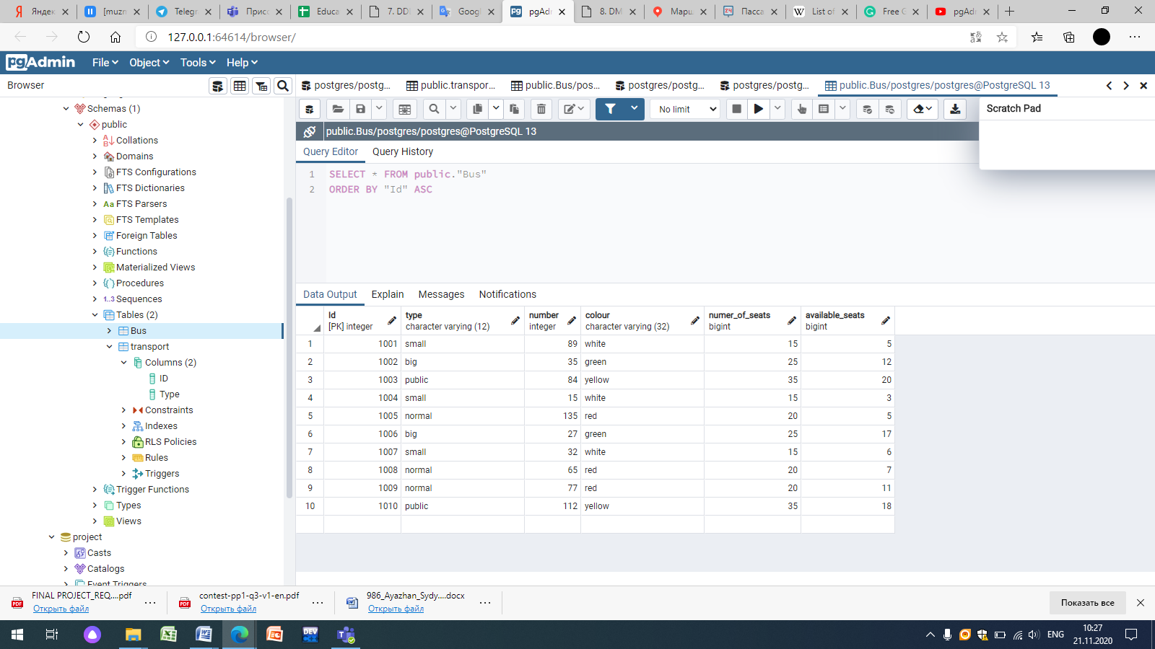

CREATE TABLE public.taxi

(

"Id" integer NOT NULL DEFAULT nextval('"taxi_Id_seq"'::regclass),

colour character varying(12) COLLATE pg_catalog."default" NOT NULL,

"number" character varying(32) COLLATE pg_catalog."default" NOT NULL,

brand character varying(32) COLLATE pg_catalog."default" NOT NULL,

made_in character varying(25) COLLATE pg_catalog."default" NOT NULL,

made_data date NOT NULL,

total_seats bigint NOT NULL,

CONSTRAINT taxi_pkey PRIMARY KEY ("Id")

)

INSERT INTO public.taxi(

"Id", colour, "number", brand, made_in, made_data, total_seats)

VALUES (1001, 'white', 'AA5623IH', 'Audi', 'UK', '26.04.2002', '4');

INSERT INTO public.taxi(

"Id", colour, "number", brand, made_in, made_data, total_seats)

VALUES (1002, 'grey', 'HNQU733', 'Audi', 'Spain', '15.12.2004', '4');

INSERT INTO public.taxi(

"Id", colour, "number", brand, made_in, made_data, total_seats)

VALUES (1003, 'red', 'A999AA16', 'Mercedes-Benz', 'Russian', '06.01.1999', '4');

INSERT INTO public.taxi(

"Id", colour, "number", brand, made_in, made_data, total_seats)

VALUES (1004, 'sapphirine', 'K444AY777', 'Opel', 'Russian', '17.08.1997', '4');

INSERT INTO public.taxi(

"Id", colour, "number", brand, made_in, made_data, total_seats)

VALUES (1005, 'black', 'A004AA02', 'Opel', 'Russian', '23.03.2008', '4');

INSERT INTO public.taxi(

"Id", colour, "number", brand, made_in, made_data, total_seats)

VALUES (1006, 'blue', 'P717KP', 'Matiz', 'Uzbekistan', '15.07.2005', '2');

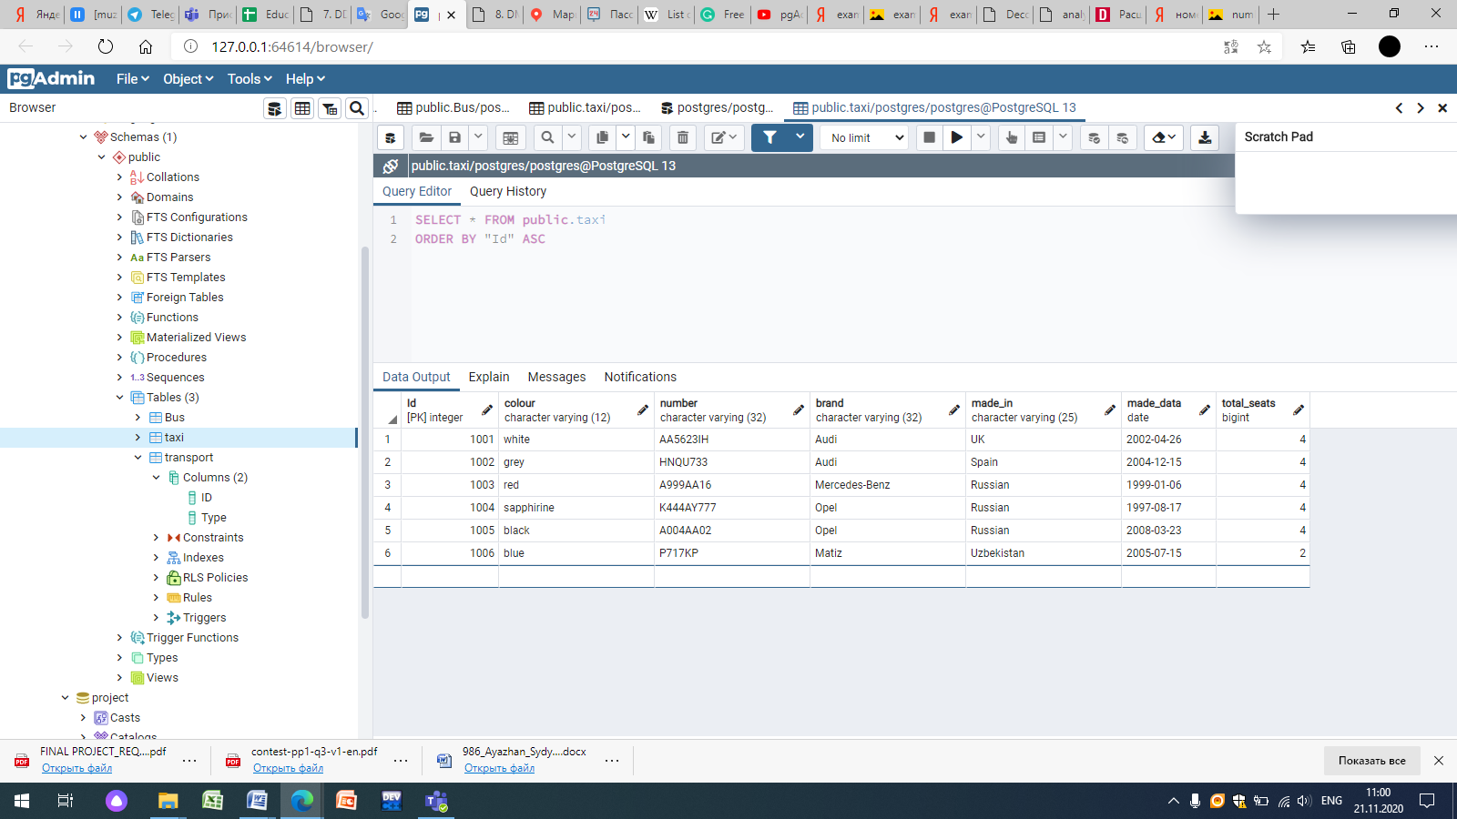

CREATE TABLE public.clients

(

"Id" integer NOT NULL DEFAULT nextval('"clients_Id_seq"'::regclass),

first_name character varying(25) COLLATE pg_catalog."default" NOT NULL,

last_name character varying(32) COLLATE pg_catalog."default" NOT NULL,

telephone_number bigint NOT NULL,

age integer NOT NULL,

CONSTRAINT clients_pkey PRIMARY KEY ("Id")

)

INSERT INTO public.clients(

"Id", first_name, last_name, telephone_number, age)

VALUES (101, 'Aruzhan', 'Ali', 87075662312, 19);

INSERT INTO public.clients(

"Id", first_name, last_name, telephone_number, age)

VALUES (102, 'Raushan', 'Berdieva', 87752669878, 37);

INSERT INTO public.clients(

"Id", first_name, last_name, telephone_number, age)

VALUES (103, 'Arman', 'Kuanysh', 87058562312, 25);

INSERT INTO public.clients(

"Id", first_name, last_name, telephone_number, age)

VALUES (104, 'Askhat', 'Ali', 87075669812, 17);

INSERT INTO public.clients(

"Id", first_name, last_name, telephone_number, age)

VALUES (105, 'Alima', 'Kudaibergenova', 87755668791, 56);

INSERT INTO public.clients(

"Id", first_name, last_name, telephone_number, age)

VALUES (106, 'Kali', 'Bekish', 870756458963, 47);

INSERT INTO public.clients(

"Id", first_name, last_name, telephone_number, age)

VALUES (107, 'Asyl', 'Bolat', 87785232356, 15);

INSERT INTO public.clients(

"Id", first_name, last_name, telephone_number, age)

VALUES (108, 'Asiya', 'Kalymova', 87075662568, 68);

INSERT INTO public.clients(

"Id", first_name, last_name, telephone_number, age)

VALUES (109, 'Zhaksylyk', 'Bolmanov', 87018953647, 23);

INSERT INTO public.clients(

"Id", first_name, last_name, telephone_number, age)

VALUES (110, 'Bekbergen', 'Aliev', 87478962548, 32);

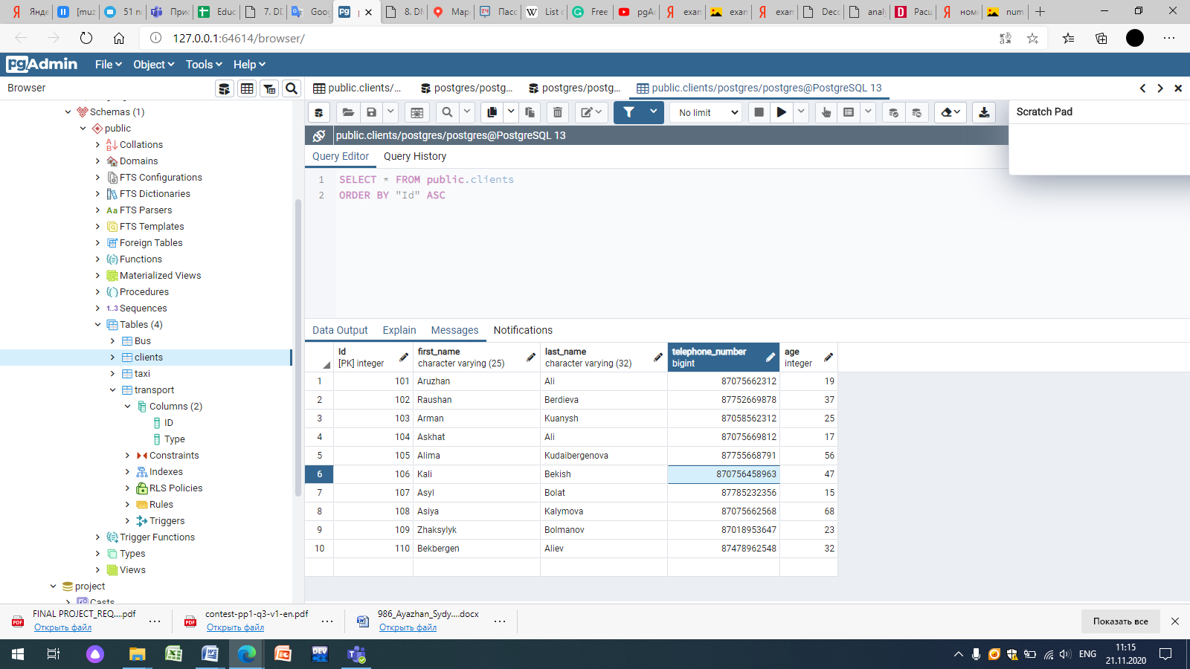

UPDATE public.clients

SET telephone_number=87075645893

WHERE "Id" = 106;

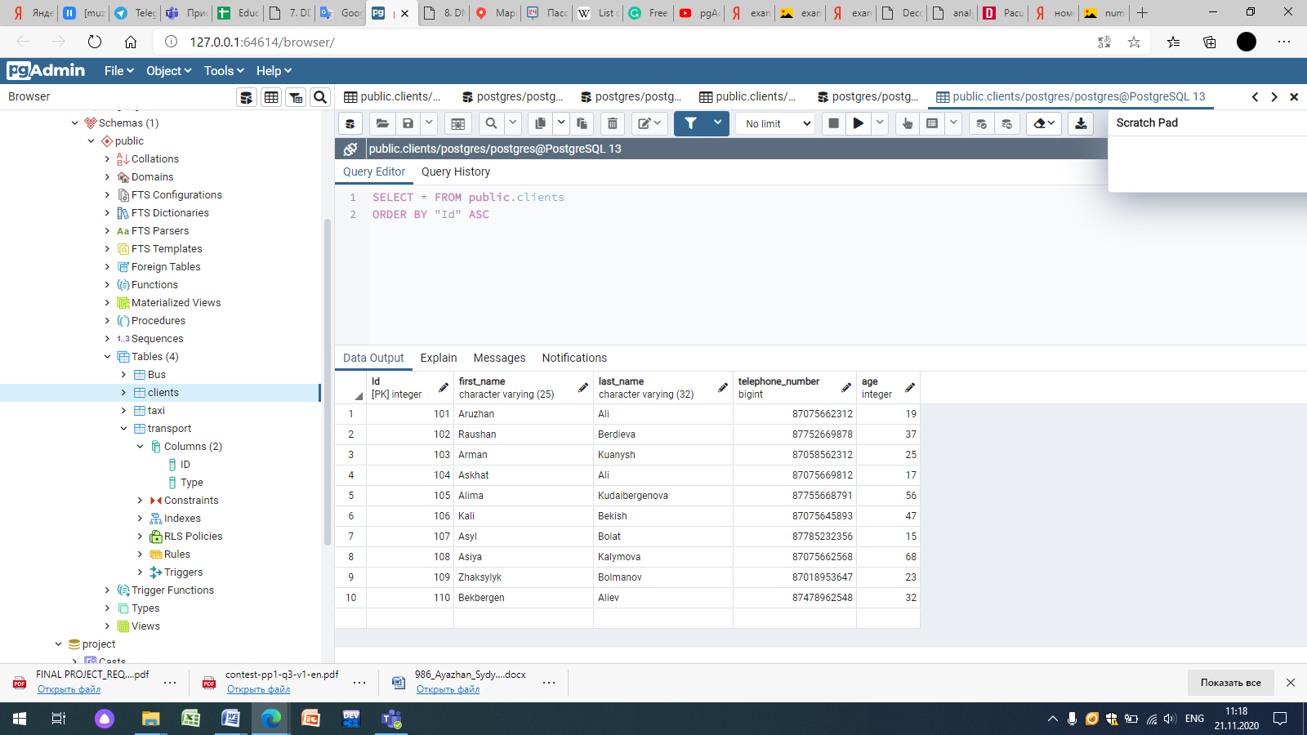

CREATE TABLE public.clients

(

"Id" integer NOT NULL DEFAULT nextval('"clients_Id_seq"'::regclass),

first_name character varying(25) COLLATE pg_catalog."default" NOT NULL,

last_name character varying(32) COLLATE pg_catalog."default" NOT NULL,

telephone_number bigint NOT NULL,

age integer NOT NULL,

"location_Id" integer NOT NULL DEFAULT nextval('"clients_location_Id_seq"'::regclass),

CONSTRAINT clients_pkey PRIMARY KEY ("Id"),

CONSTRAINT "location_Id" FOREIGN KEY ("location_Id")

REFERENCES public.location_of_user ("Id") MATCH SIMPLE

ON UPDATE NO ACTION

ON DELETE NO ACTION

NOT VALID

)

TABLESPACE pg_default;

ALTER TABLE public.clients

OWNER to postgres;

-- Index: fki_location_Id

-- DROP INDEX public."fki_location_Id";

CREATE INDEX "fki_location_Id"

ON public.clients USING btree

("location_Id" ASC NULLS LAST)

TABLESPACE pg_default;

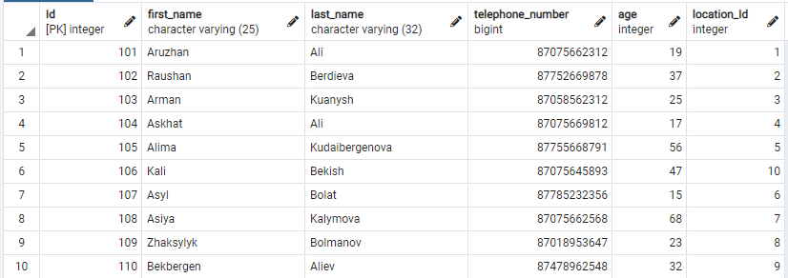

CREATE TABLE public.location_of_user

(

"Id" integer NOT NULL DEFAULT nextval('"location_of_user_Id_seq"'::regclass),

"Street" character varying(65) COLLATE pg_catalog."default" NOT NULL,

number_of_near_building bigint NOT NULL,

near_stop character varying(55) COLLATE pg_catalog."default" NOT NULL,

CONSTRAINT location_of_user_pkey PRIMARY KEY ("Id")

)

INSERT INTO public.location_of_user(

"Id", "Street", number_of_near_building, near_stop)

VALUES (1, 'Tauke_Khan', 32, 'Mega');

INSERT INTO public.location_of_user(

"Id", "Street", number_of_near_building, near_stop)

VALUES (2, 'Baitursynova', 25, 'Bayan-Sulu');

INSERT INTO public.location_of_user(

"Id", "Street", number_of_near_building, near_stop)

VALUES (3, 'Konayeva', 89, 'Nauryz_park');

INSERT INTO public.location_of_user(

"Id", "Street", number_of_near_building, near_stop)

VALUES (4, 'Momyshuly', 56, 'Abay_park');

INSERT INTO public.location_of_user(

"Id", "Street", number_of_near_building, near_stop)

VALUES (5, 'Seifullin', 1, 'Shymkent_plaza');

INSERT INTO public.location_of_user(

"Id", "Street", number_of_near_building, near_stop)

VALUES (6, 'Tauke_Khan', 118, 'Ladushki');

INSERT INTO public.location_of_user(

"Id", "Street", number_of_near_building, near_stop)

VALUES (7, 'Tashenova', 15, 'Akbar');

INSERT INTO public.location_of_user(

"Id", "Street", number_of_near_building, near_stop)

VALUES (8, 'Adyrbekova', 56, 'Samal');

INSERT INTO public.location_of_user(

"Id", "Street", number_of_near_building, near_stop)

VALUES (9, 'Baidibek_Bi', 36, 'Alleya');

INSERT INTO public.location_of_user(

"Id", "Street", number_of_near_building, near_stop)

VALUES (10, 'Nursultan', 78, '56.School');

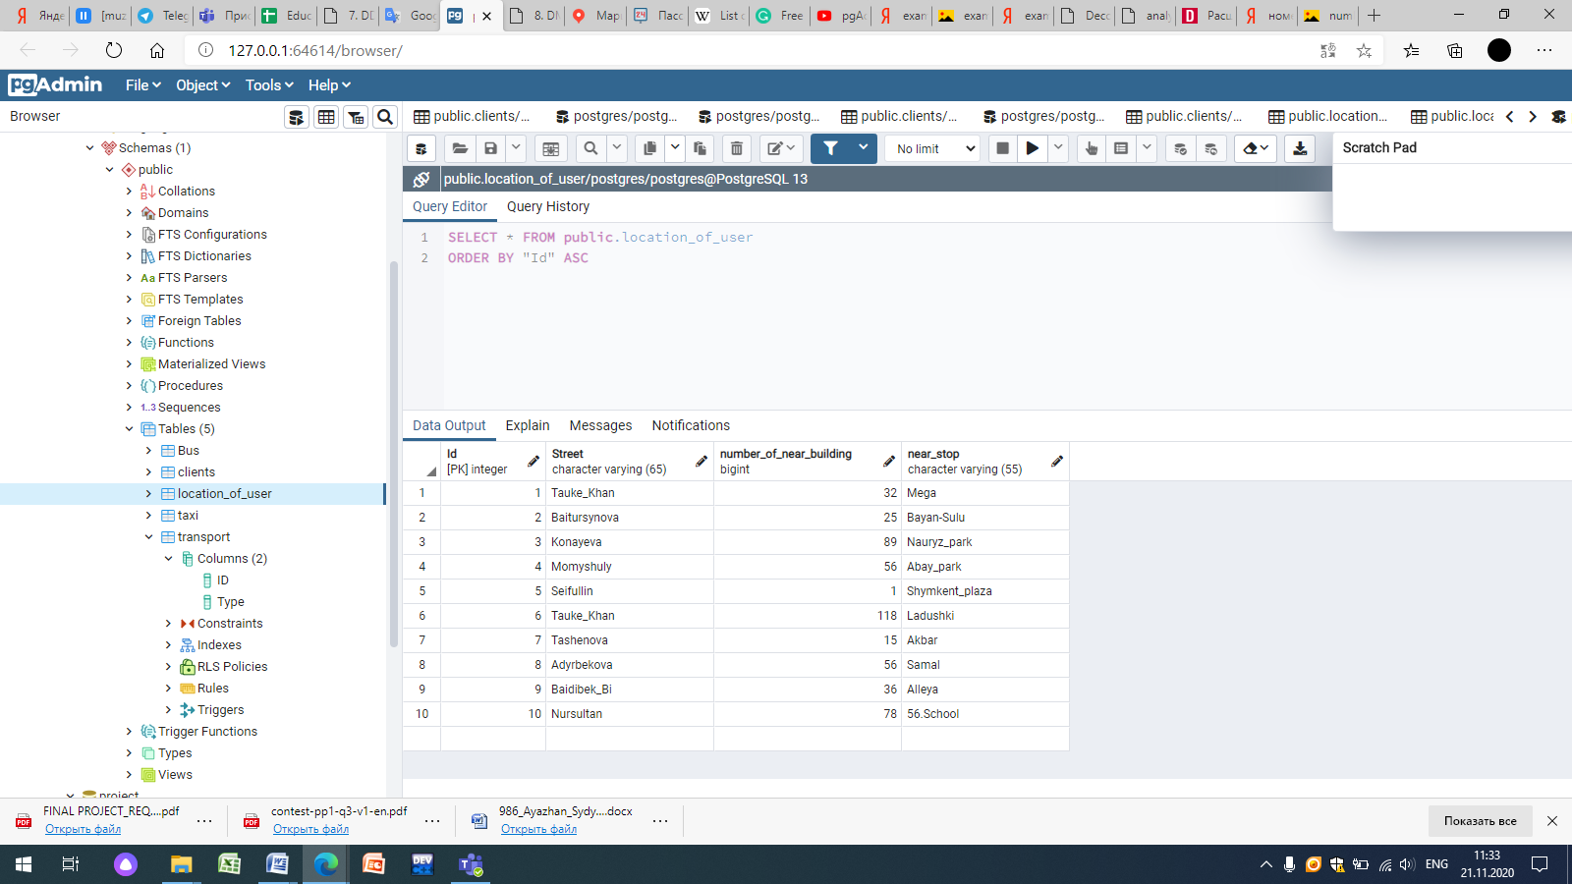

CREATE TABLE public."Destination"

(

"Id" integer NOT NULL DEFAULT nextval('"Destination_Id_seq"'::regclass),

address character varying(255) COLLATE pg_catalog."default" NOT NULL,

near_bus_stop character varying(55) COLLATE pg_catalog."default" NOT NULL,

CONSTRAINT "Destination_pkey" PRIMARY KEY ("Id")

)

INSERT INTO public."Destination"(

"Id", address, near_bus_stop)

VALUES (01, 'Kaldayakova, 5', 'Abay_park');

INSERT INTO public."Destination"(

"Id", address, near_bus_stop)

VALUES (02, 'Ryskulova, 12', 'Avtonur');

INSERT INTO public."Destination"(

"Id", address, near_bus_stop)

VALUES (03, 'Ilyaeva, 65', 'Technodom');

INSERT INTO public."Destination"(

"Id", address, near_bus_stop)

VALUES (04, 'Al-Farabi, 23', 'Gulzhan');

INSERT INTO public."Destination"(

"Id", address, near_bus_stop)

VALUES (05, 'Mametova, 89', 'Ogonek');

INSERT INTO public."Destination"(

"Id", address, near_bus_stop)

VALUES (06, 'Vostok, 42', 'Vostok');

INSERT INTO public."Destination"(

"Id", address, near_bus_stop)

VALUES (07, 'Sever, 123', '65_School');

INSERT INTO public."Destination"(

"Id", address, near_bus_stop)

VALUES (08, 'Ryskulova, 36', 'Aigul');

INSERT INTO public."Destination"(

"Id", address, near_bus_stop)

VALUES (09, 'Adyrbekova, 5', 'Kazyna');

INSERT INTO public."Destination"(

"Id", address, near_bus_stop)

VALUES (10, 'Gagarin, 22', 'Voskhod');

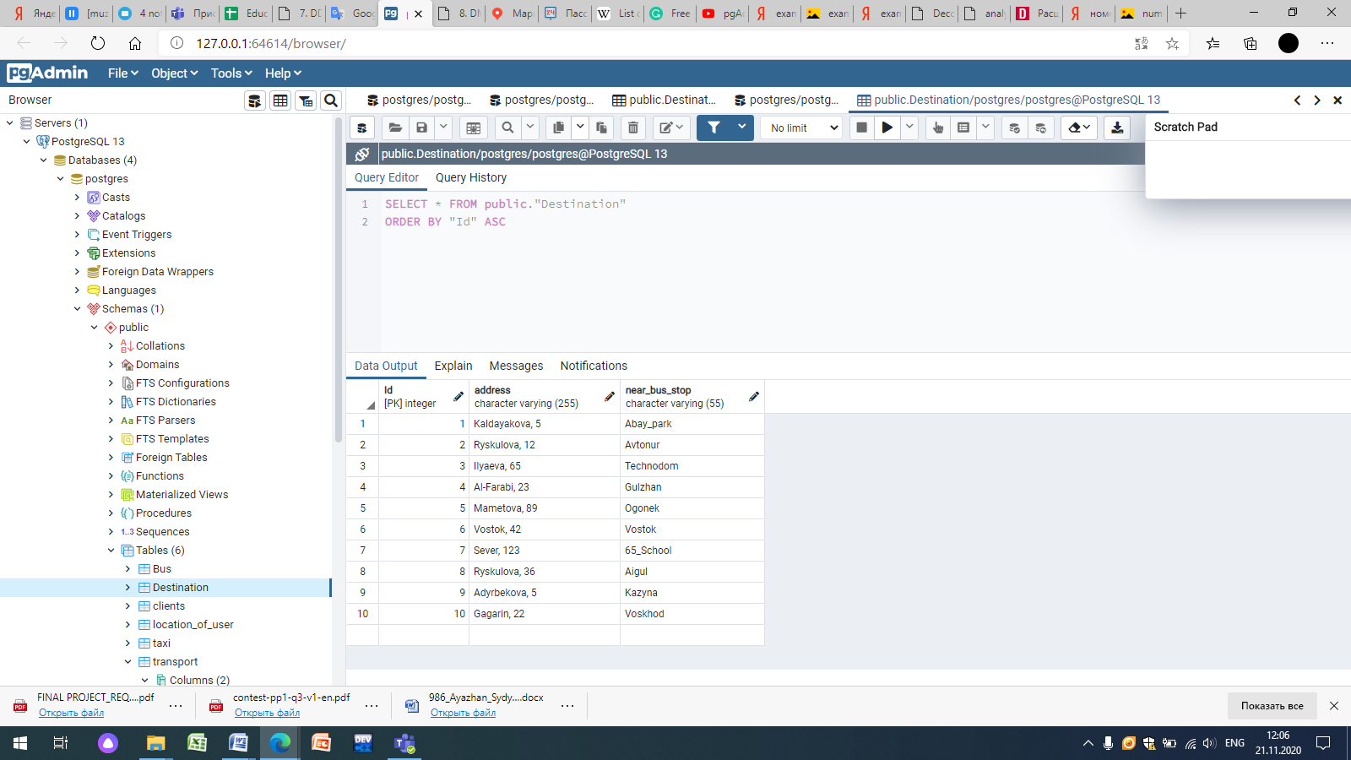

CREATE TABLE public."Time"

(

"Id" integer NOT NULL DEFAULT nextval('"Time_Id_seq"'::regclass),

sending_time character varying(255) COLLATE pg_catalog."default" NOT NULL,

arrival_time character varying(255) COLLATE pg_catalog."default" NOT NULL,

CONSTRAINT "Time_pkey" PRIMARY KEY ("Id")

)

INSERT INTO public."Time"(

"Id", sending_time, arrival_time)

VALUES (001, '11:30', '12:30');

INSERT INTO public."Time"(

"Id", sending_time, arrival_time)

VALUES (002, '20:30', '21:20');

INSERT INTO public."Time"(

"Id", sending_time, arrival_time)

VALUES (003, '06:20', '07:30');

INSERT INTO public."Time"(

"Id", sending_time, arrival_time)

VALUES (004, '18:50', '19:15');

INSERT INTO public."Time"(

"Id", sending_time, arrival_time)

VALUES (005, '11:30', '12:30');

INSERT INTO public."Time"(

"Id", sending_time, arrival_time)

VALUES (006, '09:30', '09:45');

INSERT INTO public."Time"(

"Id", sending_time, arrival_time)

VALUES (007, '20:30', '21:40');

INSERT INTO public."Time"(

"Id", sending_time, arrival_time)

VALUES (008, '15:37', '16:00');

INSERT INTO public."Time"(

"Id", sending_time, arrival_time)

VALUES (009, '06:30', '08:15');

INSERT INTO public."Time"(

"Id", sending_time, arrival_time)

VALUES (010, '11:30', '11:50');

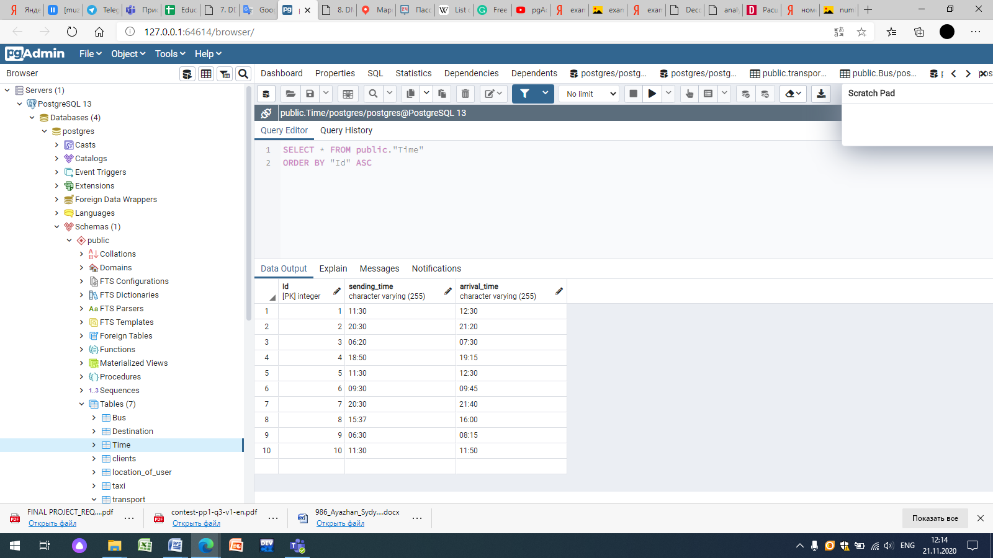

CREATE TABLE public."Fare"

(

"Id" integer NOT NULL DEFAULT nextval('"Fare_Id_seq"'::regclass),

by_taxi character varying(55) COLLATE pg_catalog."default" NOT NULL,

by_bus character varying(55) COLLATE pg_catalog."default" NOT NULL,

on_foot character varying(12) COLLATE pg_catalog."default" NOT NULL,

CONSTRAINT "Fare_pkey" PRIMARY KEY ("Id")

)

INSERT INTO public."Fare"(

"Id", by_taxi, by_bus, on_foot)

VALUES (1, '700', '70', 'free');

INSERT INTO public."Fare"(

"Id", by_taxi, by_bus, on_foot)

VALUES (2, '600', '140', 'free');

INSERT INTO public."Fare"(

"Id", by_taxi, by_bus, on_foot)

VALUES (3, '700', '50', 'free');

INSERT INTO public."Fare"(

"Id", by_taxi, by_bus, on_foot)

VALUES (4, '1000', '140', 'impossible');

INSERT INTO public."Fare"(

"Id", by_taxi, by_bus, on_foot)

VALUES (5, '1200', '70', 'free');

INSERT INTO public."Fare"(

"Id", by_taxi, by_bus, on_foot)

VALUES (6, '500', '50', 'impossible');

INSERT INTO public."Fare"(

"Id", by_taxi, by_bus, on_foot)

VALUES (7, '1000', '70', 'free');

INSERT INTO public."Fare"(

"Id", by_taxi, by_bus, on_foot)

VALUES (8, '900', '140', 'impossible');

INSERT INTO public."Fare"(

"Id", by_taxi, by_bus, on_foot)

VALUES (9, '1300', '100', 'impossible');

INSERT INTO public."Fare"(

"Id", by_taxi, by_bus, on_foot)

VALUES (10, '600', '50', 'free');

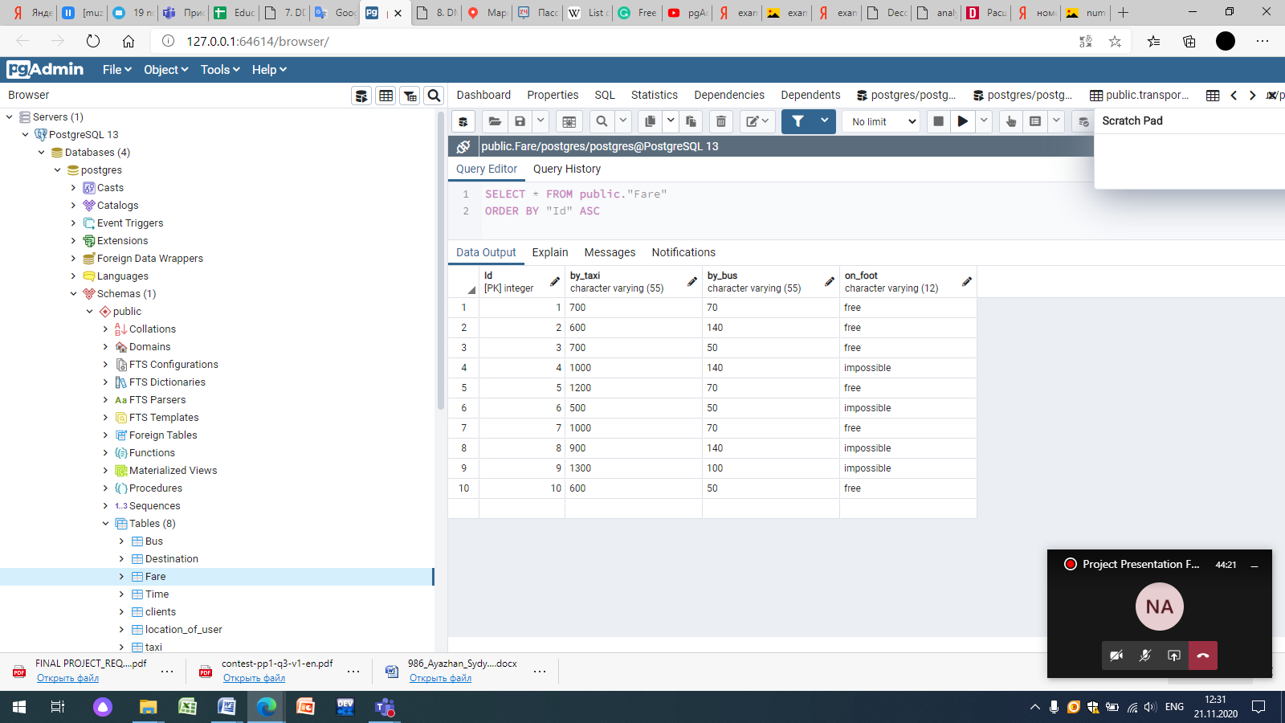

CREATE TABLE public."Fare"

(

"Id" integer NOT NULL DEFAULT nextval('"Fare_Id_seq"'::regclass),

by_taxi character varying(55) COLLATE pg_catalog."default" NOT NULL,

by_bus character varying(55) COLLATE pg_catalog."default" NOT NULL,

on_foot character varying(12) COLLATE pg_catalog."default" NOT NULL,

"time_Id" integer NOT NULL DEFAULT nextval('"Fare_time_Id_seq"'::regclass),

CONSTRAINT "Fare_pkey" PRIMARY KEY ("Id"),

CONSTRAINT "time_Id" FOREIGN KEY ("time_Id")

REFERENCES public."Time" ("Id") MATCH SIMPLE

ON UPDATE NO ACTION

ON DELETE NO ACTION

NOT VALID

)

TABLESPACE pg_default;

ALTER TABLE public."Fare"

OWNER to postgres;

-- Index: fki_time_Id

-- DROP INDEX public."fki_time_Id";

CREATE INDEX "fki_time_Id"

ON public."Fare" USING btree

("time_Id" ASC NULLS LAST)

TABLESPACE pg_default;

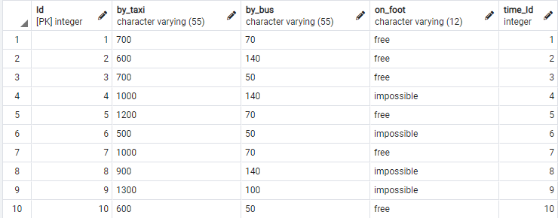

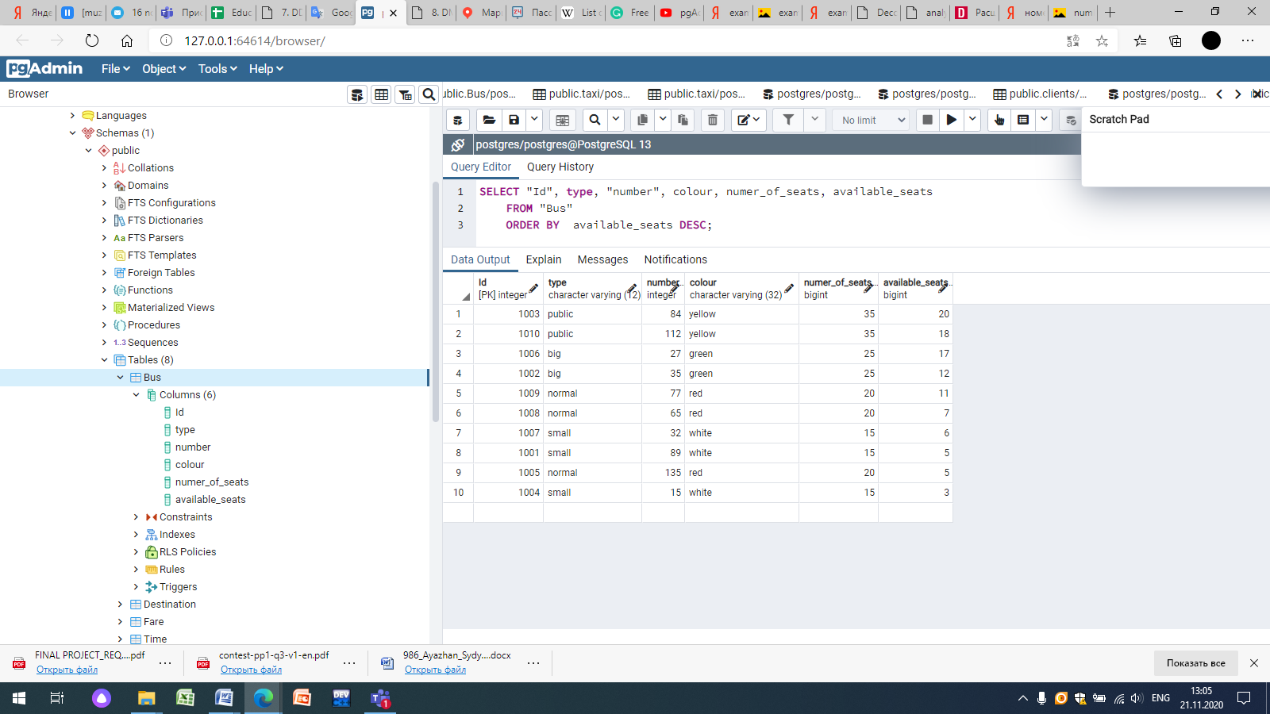

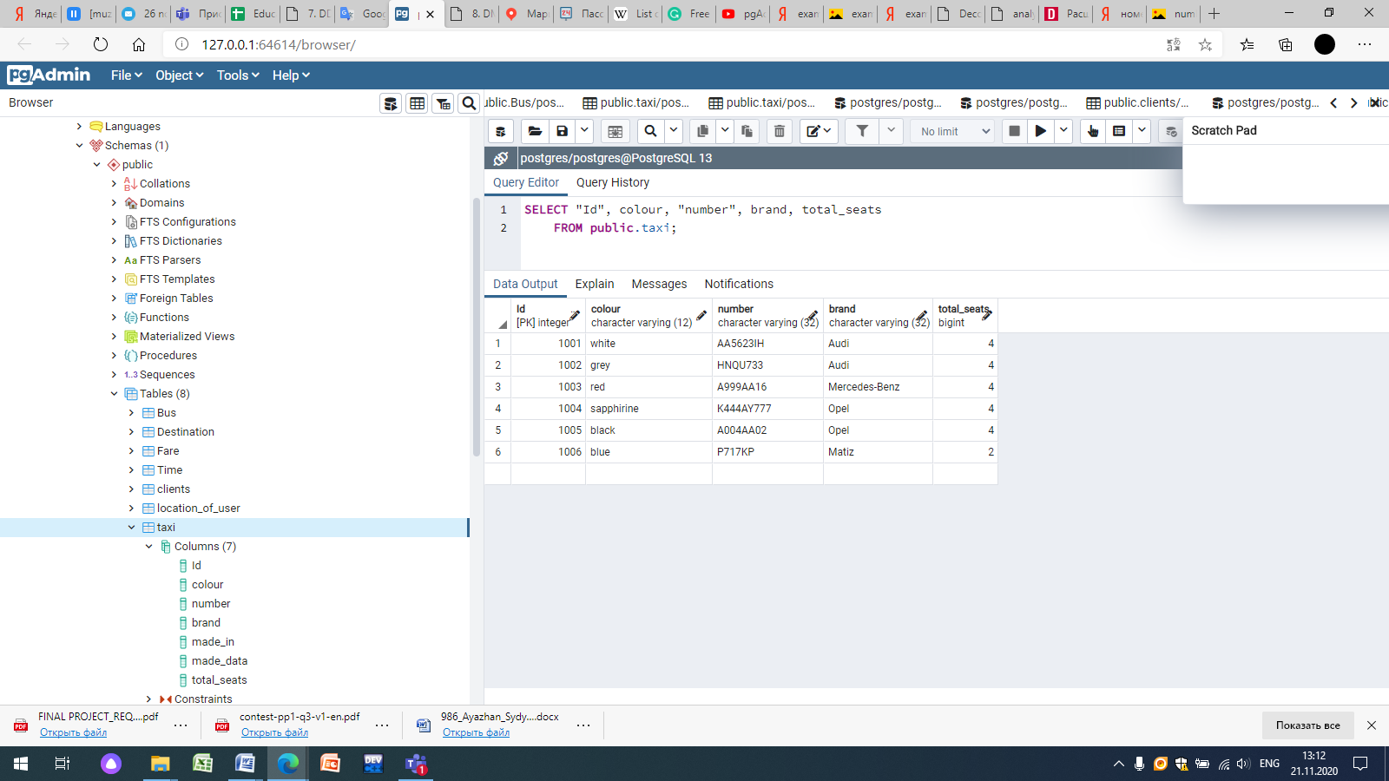

SELECT Fare.Id, Fare.by_taxi, Fare.by_bus, Time.sending_time, Time.arrival_time

FROM Fare

Inner Join Time

ON Fare.time_id = Time.Id;

