# **Overview**

* **About our team**
  + **Members and their roles** 
    - Ayazhan Ualieva – [204060@astanait.edu.kz](mailto:204060@astanait.edu.kz) – Laying out the home page
    - Razieva Suraiyo – [204033@astanait.edu.kz](mailto:204033@astanait.edu.kz) – Laying out the menu
    - Sharimov Rassul – [204111@astanait.edu.kz](mailto:204111@astanait.edu.kz) – Laying out the booking
    - Ayazhan Asetovna - [204074@astanait.edu.kz](mailto:204074@astanait.edu.kz) – Responsible for design (CSS part)
    - Ayaulim Zhumakhan – [204124@astanait.edu.kz](mailto:204124@astanait.edu.kz) – Responsible for documentation

**Communication strategy** – meeting and brainstorming minutes

Online- Teams meeting

Offline- Meetings in university

* **Motivation** – to get the desired result in the form of satisfying grade in order to avoid retake and save the GPA (the honest answer)
* **High-level project scope** – the design was inspired by Kaganat canteen’s website ,
* **Target audience/market** – it could serve as the website of our canteen of Astana IT University
* **Project goals and team interests**

Briefly describe the goals of the project and what will your team gain from doing this project. This will give an idea of what you are trying to achieve, which will enable the most appropriate solutions.

For example:

Project goals

* To create functional and responsive website
* To create the digital version of canteen
* To inhance our web development skills

Team interests

* Understand HTML tags and CSS by building an canteen website
* Improve team working skills by collaborating with members of the group

# **Phases**

Phase 1 – Conduct a group meeting, thoroughly discuss the overview of the project, make rough plans, visual, define the purpose and main points of the site, that we plan to create. Also, during this meeting, each participant got a different task. After that, we appointed the next meeting, before which everyone had to work out the first steps of their task and make a report during the meeting.

Phase 2 – The main goal of the second phase of our work was that, we had to see the draft versions of the work that everyone did, within three days. We gave each other feedback, shared our opinions about each other's work, said what could be added, changed in our works.

Also, each member asked a question about his part of the project, that is, he asked what he did not understand and we tried to give advice on how to improve it.

Phase 3 – The final phase was that, taking into account all the nuances and comments of each other, we had to finish the project and combine the codes into one whole. Also, everyone shared their final result of the code, and we worked on incomprehensible moments, walked through the code, parsed each other's codes.

# **Content structure**

**Site map**

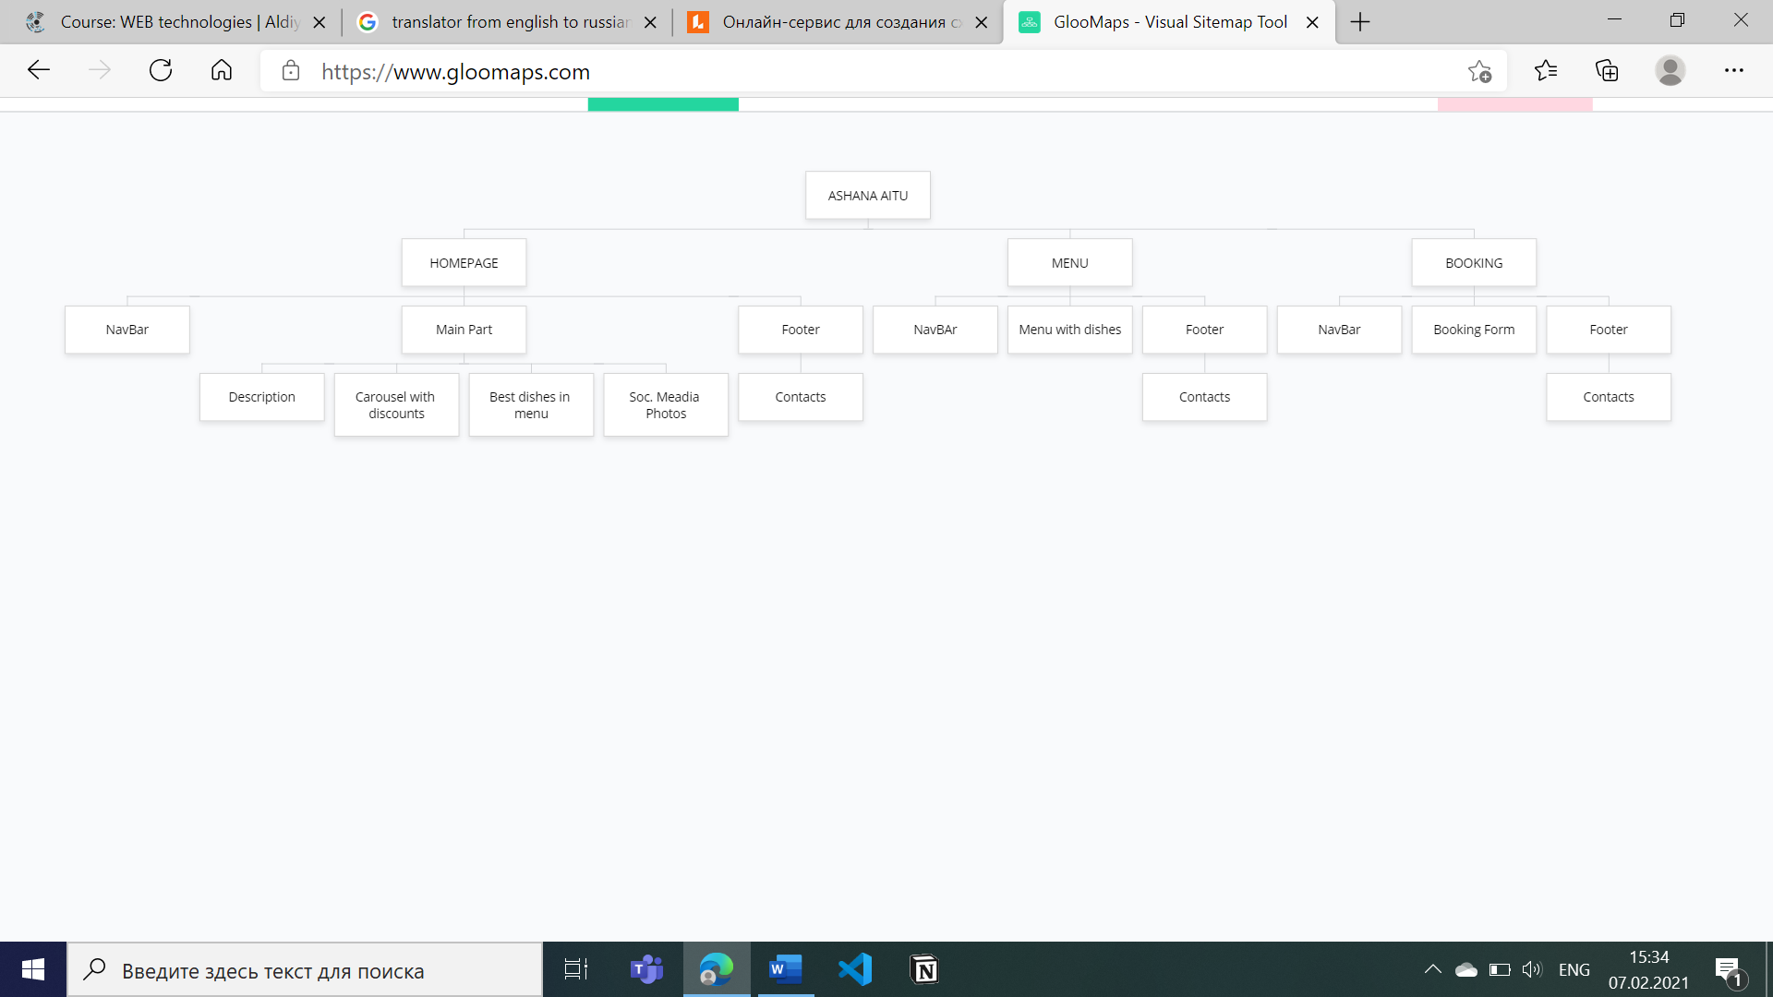

**Content type**

* Canteen
* Food
* Drinks
* Delievery

**Design**

* Reference links to social networks
* Image files
* Carousel with images
* Input forms
* Bootstrap

**style guide :**

* Colours: blue,white
* typography rules: open sans
* animations: hover
* background image
* spacing

**Functionality**

In the navigation bar and footer, all buttons and icons works correctly and direct to the desired pages.

Carousel and hover functions works correctly.

**Hosting**

* We have chosen GitHub for this .
* The steps that should be taken to submit the work:
* Sign up to your Github
* Create a public repository
* Upload all files regarding to website:html,css,images and etc
* Commit changes ,save them
* Copy and paste the link to submission point

**Accessibility**

We tried to make a website so that people could read and see it conveniently. We used calm colors that would not irritate people's eyes. We tried to use the fonts most accessible to the eyes and chose the right sizes for them.

**Deadlines**

* Phase 1 – February 2, 19:00
* Phase 2 – February 5, 17:00
* Phase 3 – February 6, 14:00

# **Summary**

In fact, the project was difficult, even considering the fact that there were 5 members in the team. The teamwork was very good. Everyone did their part on time and with high quality. Our problem was that there was not enough time to implement the dream project, since in addition to this subject we have 6 subjects, so we did not finish many things as we would like. We hope for your understanding and a good rating.