
SafePulse
Data-Driven Emergency Response System.
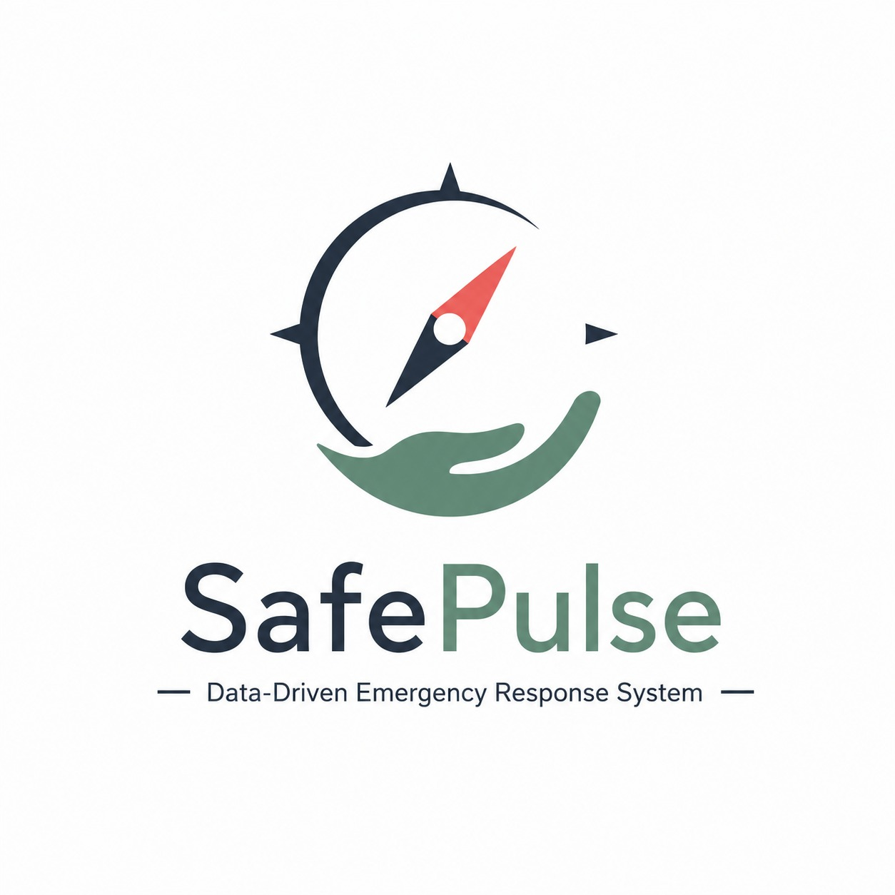Team Members
Shadab Patel
Hasib Shaikh
Ayaz Khan

1. PRODUCT OVERVIEW
1.1 Product Name:
SafePulse – Data-Driven Emergency Response System
1.2 Product Description:
SafePulse is a data-driven emergency guidance system designed to help users understand what actions to take during emergency situations. The system provides structured and easy-to-understand guidance based on information provided by the user about the emergency.
During an emergency, people may panic or may not know the appropriate first-aid steps to follow. SafePulse aims to reduce this confusion by guiding the user through a series of simple questions, analyzing the provided information, determining an appropriate urgency level, and presenting relevant first-aid guidance.
SafePulse is designed to assist users during situations such as burns, heavy bleeding, choking, cardiac emergencies, and serious injuries while encouraging professional medical assistance when the situation may require it.
1.3 Problem Statement:
During emergencies, people often struggle to determine what actions they should take immediately. Panic, lack of first-aid knowledge, and difficulty finding reliable information can delay appropriate action.
Searching the internet during an emergency may also result in large amounts of information that can be difficult to understand or apply quickly.
Therefore, there is a need for a simple system that can collect basic information about an emergency, analyze the situation, and provide clear and structured guidance to the user.
1.4 Proposed Solution
SafePulse addresses this problem by providing an interactive emergency guidance system.
The user first selects the type of emergency and then answers a few simple questions related to the situation. The system processes the responses and determines an appropriate urgency level and response pathway.
The system then provides step-by-step first-aid guidance and recommends seeking professional medical assistance when the situation is potentially serious.
1.5 Product Goals
The primary goals of SafePulse are:
- To provide quick and structured emergency guidance.
- To simplify access to relevant first-aid information.
- To analyze basic emergency-related information using data-driven techniques.
- To classify the situation according to an appropriate urgency level.
- To provide clear step-by-step guidance.
- To encourage professional medical assistance when required.
- To create a simple and accessible interface that can be used during stressful situations.
2. TARGET USERS AND USER JOURNEY
2.1 Target Users
SafePulse is intended for a broad range of users, including:
- General public
- Students
- Parents and families
- Travelers
- Individuals with limited first-aid knowledge
- Bystanders assisting an injured or unwell person
The system is designed to be simple enough for users without medical or technical knowledge.
2.2 User Journey
The basic user journey of SafePulse is:
Emergency Occurs
↓
Open SafePulse
↓
Select Emergency Type
↓
Answer Simple Questions
↓
System Processes the Information
↓
Determine Urgency Level
↓
Display Recommended Response
↓
Provide Step-by-Step First-Aid Guidance
↓
Recommend Professional Medical Assistance if Required
This workflow allows the user to move from identifying the emergency to receiving relevant guidance without having to search through multiple sources of information.
3. CORE FEATURES AND REQUIREMENTS
🚨 Emergency Prioritization — High-Priority Questions

Overview

SafePulse is designed to avoid making users go through a long questionnaire during a potentially serious emergency. The system first asks a small number of high-priority questions that check for critical indicators.

If the responses suggest a potentially life-threatening situation, SafePulse immediately directs the user toward appropriate emergency action and first-aid guidance, without requiring the user to complete the remaining detailed assessment.

If no critical indicators are identified, the user continues to the normal/detailed assessment, where SafePulse can analyze the situation and determine an appropriate urgency level.

Flow

Emergency → Quick Assessment → High-Priority Questions

↙️ Critical indicators detected
→ Immediate Emergency Guidance / Action

↘️ No critical indicators
→ Detailed Assessment → Data/ML Analysis → Urgency Level → Guidance

🎯 Main principle

“The more time-sensitive the situation, the fewer unnecessary steps SafePulse should require.”
3.1 Emergency Selection
The system allows the user to select the type of emergency they are experiencing or witnessing.
Possible emergency categories include:
- Heavy Bleeding
- Burns
- Choking
- Cardiac Emergency
- Serious Injury
Additional emergency categories can be added in future versions.
3.2 Situation-Based Questions
After selecting an emergency, SafePulse presents a small number of simple questions related to the selected situation.
For example, for a burn, the system may collect information about relevant characteristics such as the affected area, severity indicators, and cause of the burn.
The questions should be:
- Simple to understand
- Quick to answer
- Relevant to the selected emergency
- Designed to collect information required for the response pathway
3.3 Data Processing and Analysis
The information provided by the user is processed by the system to identify the appropriate response pathway.
The system uses relevant emergency-scenario data and selected features to support urgency classification.
User Information → Data Processing → Classification → Urgency Level → Response Pathway
3.4 Urgency Classification
SafePulse classifies the situation into an appropriate urgency level based on the information provided.
The proposed levels are:
Urgency Level | General Response
Low | Provide basic first-aid guidance and monitoring information.
Moderate | Provide first-aid guidance and recommend considering professional medical assistance.
High | Provide immediate guidance and strongly recommend professional medical assistance.
The exact classification criteria will be determined using reliable emergency/first-aid guidance and the project's dataset and model.
3.5 Step-by-Step Guidance
After determining the response pathway, SafePulse presents the relevant guidance in a simple step-by-step format.
The instructions are designed to avoid unnecessary technical language and make the information easier to follow during stressful situations.
3.6 Professional Medical Assistance
When a situation is identified as potentially serious, SafePulse clearly recommends seeking professional medical assistance.
The system is intended to support users with immediate guidance and is not intended to replace qualified medical professionals or emergency services.
4. FUNCTIONAL REQUIREMENTS
The following functional requirements define what SafePulse should be able to do:
FR-01: The system shall allow the user to select an emergency category.
FR-02: The system shall display questions relevant to the selected emergency.
FR-03: The system shall accept and process the user's responses.
FR-04: The system shall analyze the collected information using the defined data-processing and classification approach.
FR-05: The system shall determine an appropriate urgency level.
FR-06: The system shall display the recommended response pathway.
FR-07: The system shall provide relevant step-by-step first-aid guidance.
FR-08: The system shall notify the user when professional medical assistance should be sought.
FR-09: The system should provide a simple and easy-to-understand user interface.
FR-10: The system should allow additional emergency categories to be added in future versions.
5. NON-FUNCTIONAL REQUIREMENTS
SafePulse should satisfy the following non-functional requirements:
5.1 Performance
The system should process user responses and display the appropriate result within a short period of time.
5.2 Usability
The interface should be simple, clear, and easy to use, particularly when the user may be under stress.
5.3 Reliability
The guidance provided by the system should be based on reliable and validated emergency/first-aid information.
5.4 Accessibility
Information should be presented using clear text, readable layouts, and simple terminology.
5.5 Security
Any user information collected by the system should be handled responsibly and only used for the intended functionality.
5.6 Scalability
The system architecture should allow additional emergency categories, datasets, and features to be added in future versions.
6. DATA SCIENCE AND MACHINE LEARNING COMPONENT
6.1 Role of Data Science
Data Science is an important component of SafePulse because the system is designed to analyze emergency-related information and determine an appropriate response pathway.
Instead of functioning only as a static first-aid information website, SafePulse uses structured emergency-scenario data to support its classification process.
The basic data flow is:
Emergency Dataset
↓
Data Cleaning and Preparation
↓
Feature Selection
↓
Model Training
↓
Classification
↓
Urgency Level
↓
Recommended Response Pathway
6.2 Input Data
Depending on the emergency type, possible input features may include:
- Emergency category
- Relevant symptoms
- Severity indicators
- Extent of injury
- Duration or timing
- Cause or mechanism of injury
- Breathing or consciousness-related information where relevant
- Other user responses relevant to the selected scenario
The exact features will depend on the dataset and the emergency category being implemented.
6.3 Model Output
The system's classification component can produce:
Predicted Urgency Level + Recommended Response Pathway
For example:
Input: Burn + relevant severity indicators
↓
Data Processing / Classification
↓
Output: High Urgency
↓
Response: Immediate guidance + recommendation for professional medical assistance
6.4 Example Scenario
Consider a user who selects Burns.
The system asks relevant questions about the situation. The user provides their responses, which are processed by the system.
Based on the relevant features, the system determines an appropriate urgency category and displays the corresponding guidance.
Example Output:
Urgency: HIGH
Follow the immediate first-aid guidance provided and seek professional medical assistance.
7. SYSTEM WORKFLOW
The overall working of SafePulse can be represented as follows:
User
↓
Select Emergency
↓
Answer Questions
↓
Input Validation
↓
Data Processing
↓
ML / Classification System
↓
Urgency Classification
↓
Response Pathway Selection
↓
First-Aid Guidance
↓
Professional Medical Assistance Recommendation
This workflow ensures that the information displayed to the user is based on the situation they have described rather than simply displaying the same generic information for every emergency.
8. USER INTERFACE REQUIREMENTS
The SafePulse interface should prioritize simplicity and readability.
8.1 Home Screen
The home screen should provide:
- SafePulse branding
- Emergency selection options
- Clear instructions
- Easily identifiable emergency categories
Example categories:
Bleeding | Burns | Choking | Cardiac Emergency | Injury
8.2 Question Screen
The question screen should:
- Display one or more simple questions.
- Provide clearly visible answer options.
- Avoid unnecessary information.
- Allow the user to proceed to the next question easily.
8.3 Result Screen
The result screen should display:
- Urgency level
- Recommended response
- Step-by-step guidance
- Professional medical assistance recommendation where appropriate
The urgency level should be visually clear so that the user can understand the result quickly.
9. EXAMPLE USE CASE
Use Case: Burn Emergency
Step 1: Emergency Selection
The user opens SafePulse and selects:
Burns
Step 2: Information Collection
The system asks a few relevant questions about the burn and the circumstances surrounding it.
Step 3: Analysis
The user's responses are processed by the system.
Step 4: Classification
The system determines the appropriate urgency level based on the available information and classification approach.
Step 5: Guidance
The system displays relevant first-aid guidance in a step-by-step format.
Step 6: Professional Assistance
If the situation indicates a potentially serious emergency, SafePulse recommends seeking professional medical assistance.
10. SUCCESS CRITERIA
The success of SafePulse can be evaluated using the following criteria:
- Users can reach relevant emergency guidance through a small number of steps.
- Users can understand the questions without requiring medical knowledge.
- The system correctly processes the provided information.
- The classification component performs appropriately on the project's test data.
- Relevant guidance is displayed clearly.
- Potentially serious situations are appropriately directed toward professional medical assistance.
- The system remains simple and usable during stressful situations.
11. FUTURE SCOPE
Future versions of SafePulse can include additional features such as:
11.1 Emergency Calling
Integration with emergency calling services to help users contact appropriate emergency responders.
11.2 Location-Based Assistance
The system could use the user's location to provide information about nearby hospitals or emergency facilities.
11.3 Voice Interaction
Voice-based interaction could allow users to answer questions without needing to type or navigate the interface extensively.
11.4 Multiple Languages
Support for multiple regional languages could make the system accessible to a wider population.
11.5 Conversational AI
A conversational interface could allow users to describe an emergency in natural language and receive structured guidance.
11.6 Wearable Integration
Future versions could potentially integrate with smartwatches or other wearable devices for additional emergency-related information.
11.7 Expanded Emergency Categories
The system could be expanded to support additional emergency scenarios and datasets.
12. LIMITATIONS
SafePulse is designed as an emergency guidance and response-support system. It does not replace doctors, paramedics, emergency responders, or other qualified medical professionals.
The accuracy of the system depends on the quality of the available data, classification approach, and medical guidance used during development.
Users should seek professional medical assistance whenever an emergency may be serious or life-threatening.
13. CONCLUSION
SafePulse aims to provide a simple, structured, and data-driven approach to emergency guidance. By combining user-provided information, emergency-scenario data, classification techniques, and step-by-step first-aid guidance, the system can help users understand the appropriate response pathway during stressful situations.
The project combines Data Science, Machine Learning, and user-focused design to address a practical real-world problem. With further development, SafePulse can be expanded with emergency calling, location-based services, voice interaction, multilingual support, and additional emergency scenarios.
14. REFERENCES
- Verified first-aid and emergency-care guidelines
- Publicly available emergency/medical datasets
- Machine Learning and Data Science documentation
- Software libraries and frameworks used in development
- APIs or external services used by the system

