**API For ClinicalTrails Data**

<https://github.com/syedgufran95/apiclinicaltrials>

<https://github.com/ayazwani/creatingapi>

We defined five endpoints in our API using python flask and request modules

1: Endpoint 1 was created to convert XML files to a single CSV.

2: Endpoint 2 was created to upload an XML file from the source to the destination on the local machine

3. Endpoint 3 was created to append uploaded files to an already created CSV.

4. Endpoint 4 was created to parse the file. It can take arguments and return those specified fields or can return all the field if no argument is supplied

5. Endpoint 5 was created to find the nct_id and return its information.

EndPoints

* */*
* */upload*
* */append*
* */parse*
* */find*

/

This Function Converts all the XML files into CSV and returns the status

http://127.0.0.1:5000/

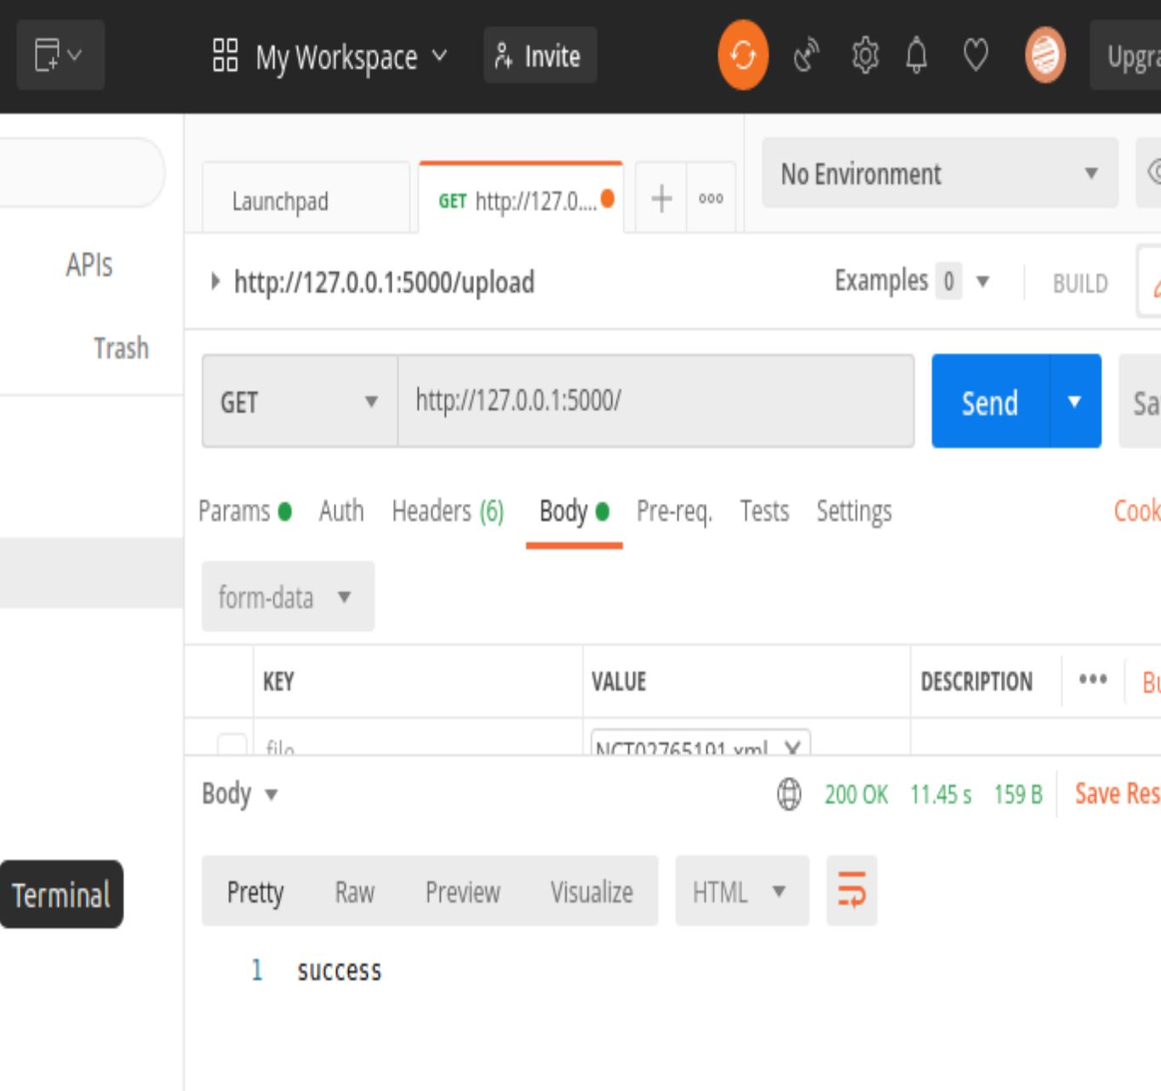

/upload

It takes post request and returns the status code for the operation

<http://127.0.0.1:5000/upload>

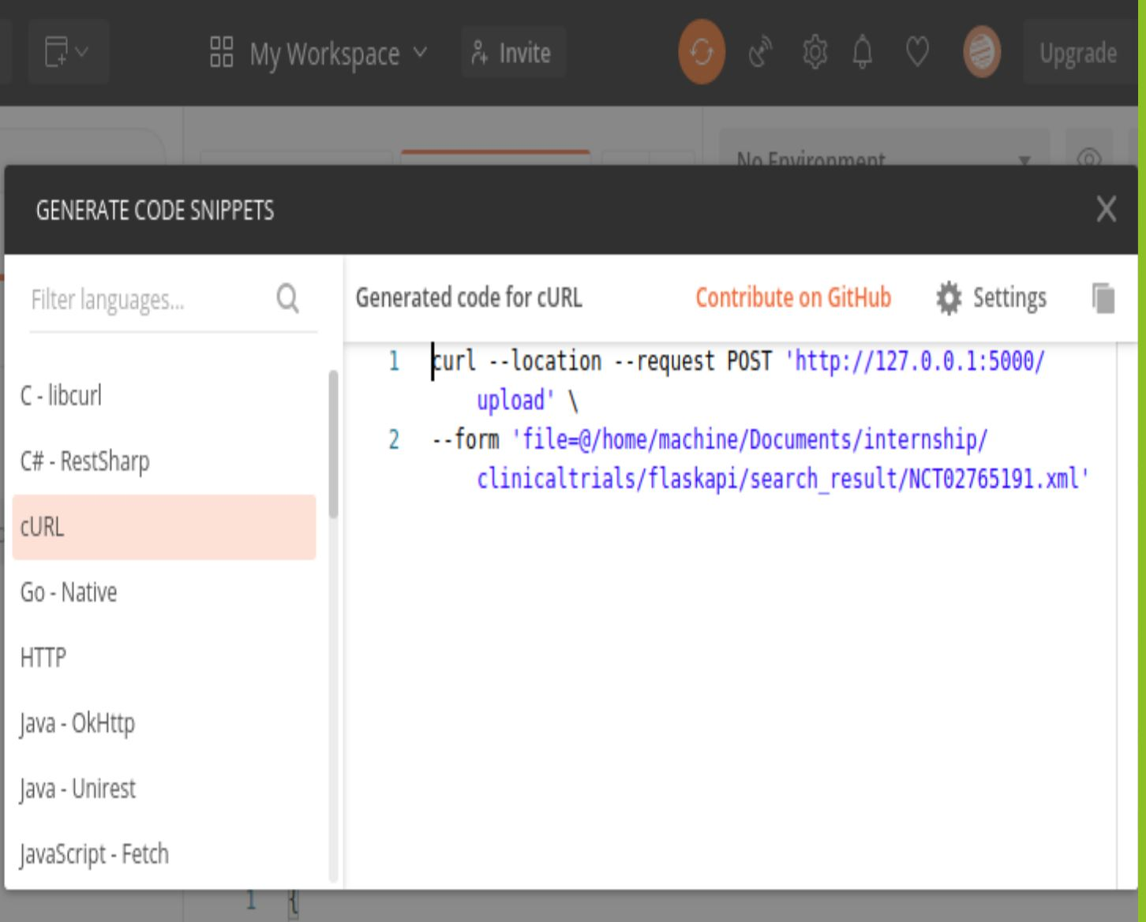

/append

It takes the XML file and searches its nct_id

If found returns message already present

And if not, it appends the XML file to the CSV.

<http://127.0.0.1:5000/append>

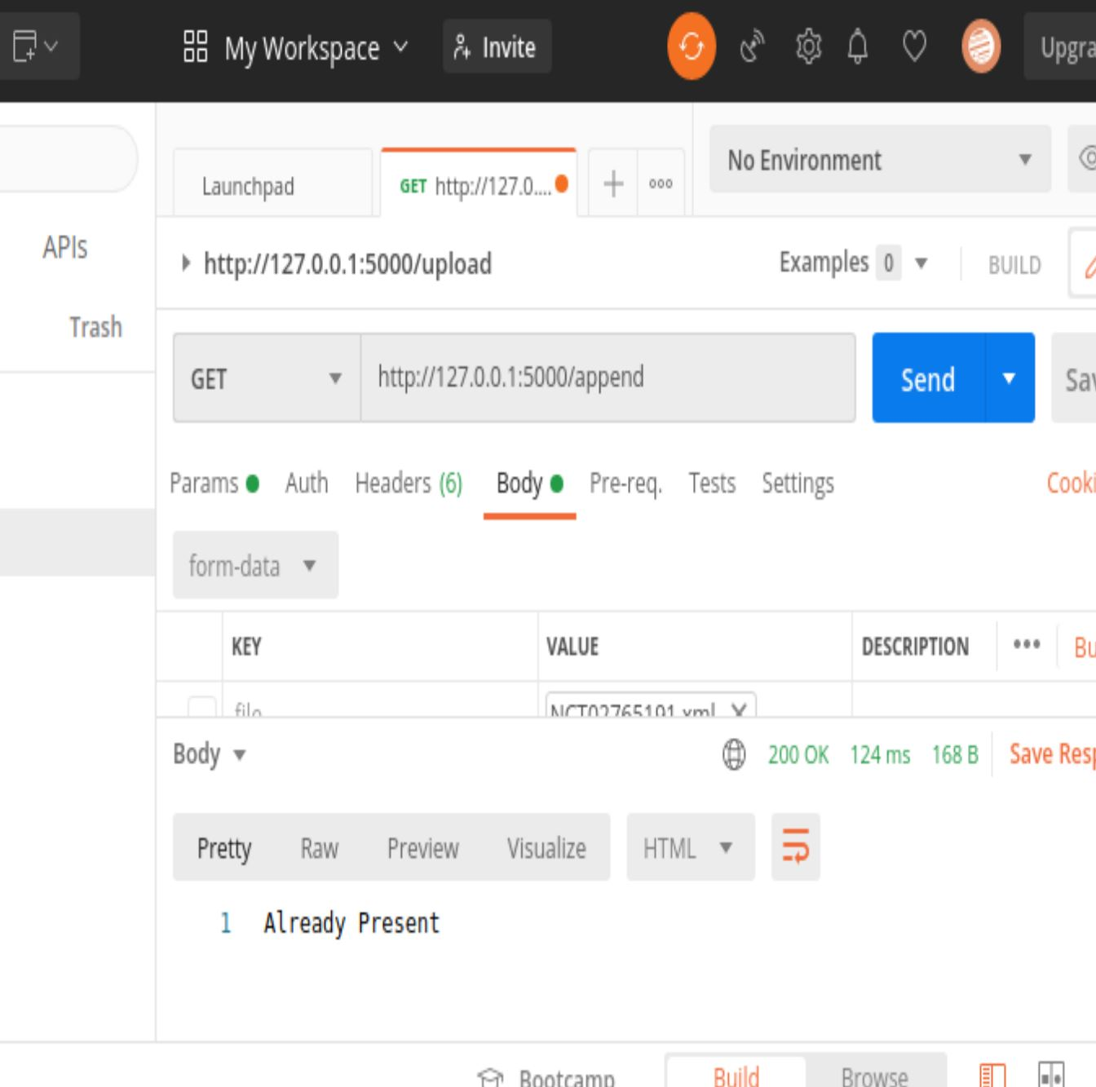

/parse

If no argument is supplied it returns the all the data in the CSV in JSON format

If the argument is supplied it returns all the columns specified with nct_id.

CSV has total of 9 fields(nct_id, overall_status, start_date, completion_date, condition, Study design info, eligibility, has_expanded_access, enrollment)

<http://127.0.0.1:5000/parse>

<http://127.0.0.1:5000/parse?parsearg1=condition&arg2=start_date>

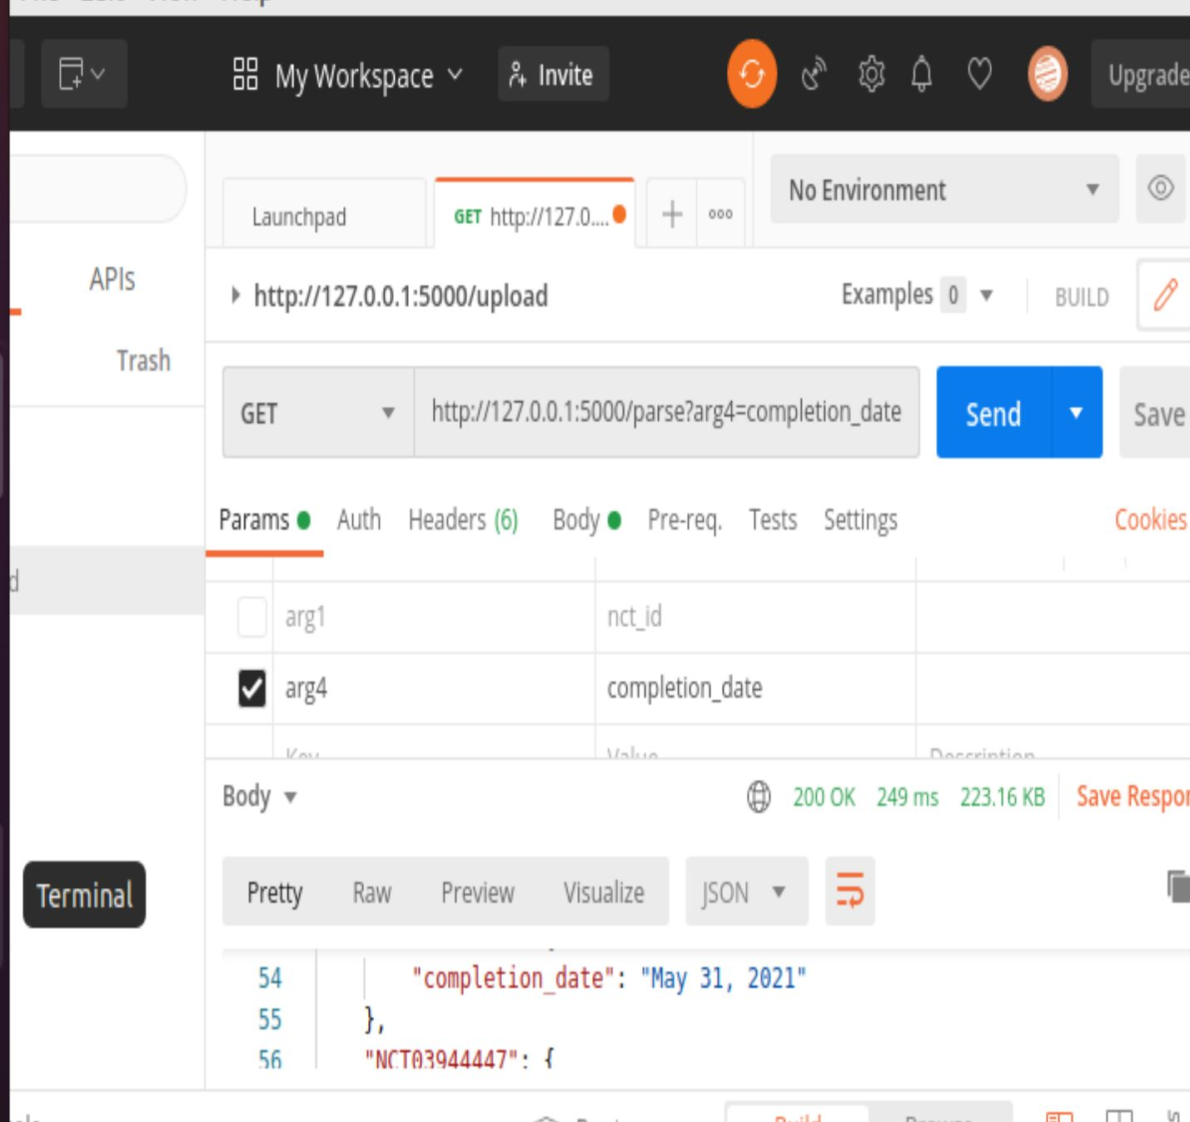 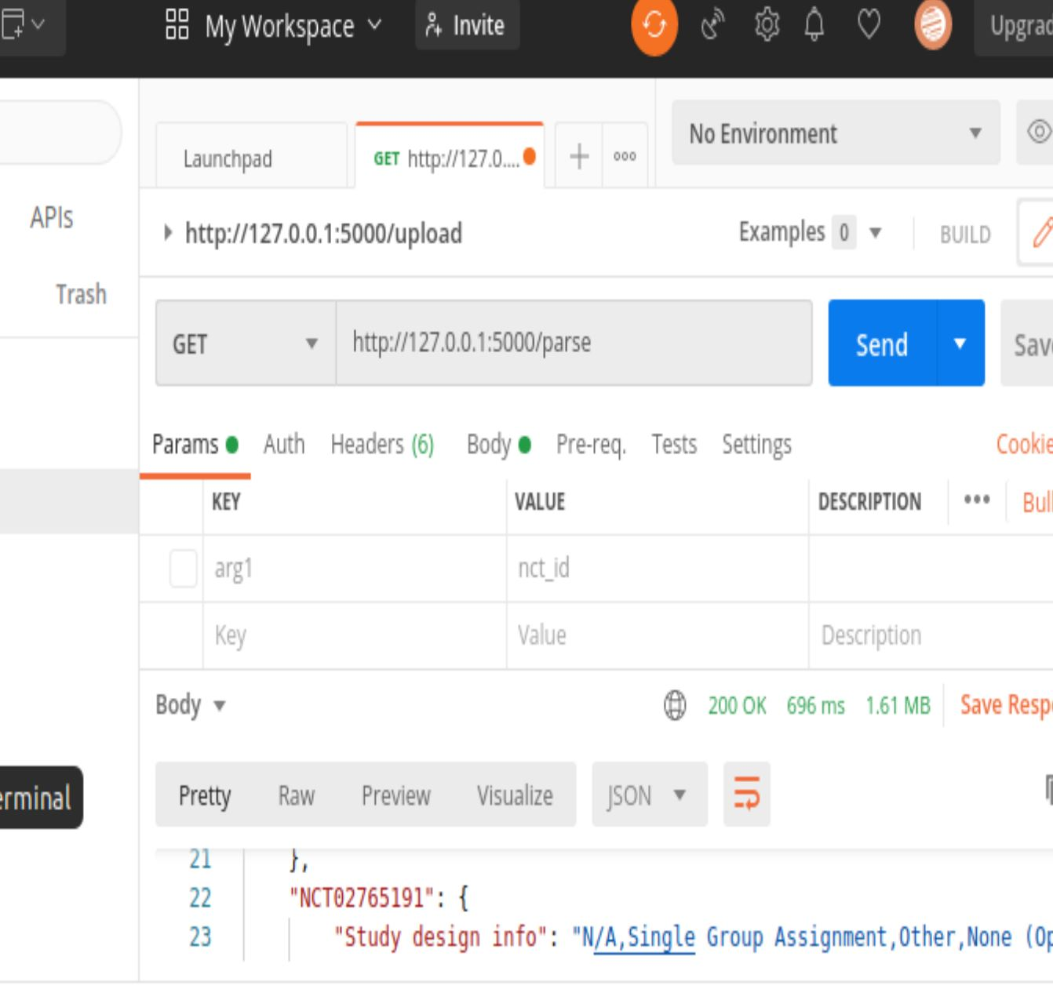

/find

It takes nct_id and finds the nct_id in the CSV and return all the data relating to nct_id

